 |  | 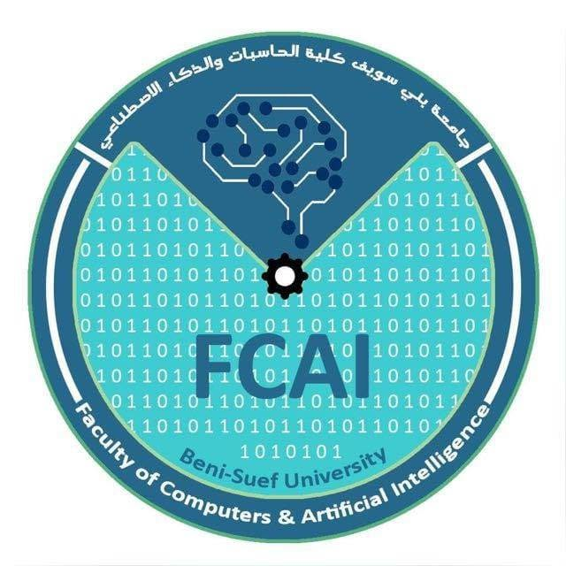

Faculty of Computers and Artificial Intelligence
Beni-Suef University, Egypt
────────

CrimeLens
Smarter Surveillance, Faster Response
A Graduation Project Submitted in Partial Fulfillment of the Requirements for the Degree of Bachelor of Science in Computer Science & Artificial Intelligence
Presented by :
Mohamed Emad El Deen  Mohamed Mahmoud Alam  Abdalla Mohamed Swesy  Ahmed Mohamed Sadawu | Abdelrahman Amer Sayed  Ahmed Salama Ahmed  Mohamed Ahmed Atia

Supervised by :
Project Supervisor: Dr. Mohamed Salah Reda
Project Supervisor: Dr. Ahmed El-Naggar
Teaching Assistant: Osama Hefny
2025 - 2026

