W2 · A1 — Build Your First CRUD API
Comprehensive Engineering Report & AI Rematch Analysis
Backend Development Program
────────────────────────────────────────────────────────────

1. Executive Summary & Architecture
This project implements an industry-standard, production-aligned RESTful CRUD API using FastAPI and Python 3.14. The server models an in-memory task management engine (to-do list) supporting complete Create, Read, Update, and Delete operations, robust input validation, uniform error responses (400, 404), automatic interactive Swagger UI documentation at /docs, and extended production features including pagination, keyword search, filtering, and compute statistics.

2. API Specification & Endpoints
Method | Endpoint | Description | Status Code
GET | / | API metadata & version info | 200 OK
GET | /health | Liveness & health monitoring probe | 200 OK
GET | /tasks | List tasks (supports ?done, ?search, ?limit, ?offset) | 200 OK
GET | /tasks/{id} | Retrieve single task by numeric ID | 200 OK / 404 Not Found
POST | /tasks | Create new task with auto-increment ID | 201 Created / 400 Bad Request
PUT | /tasks/{id} | Update task title and/or done status | 200 OK / 400 / 404
DELETE | /tasks/{id} | Remove task by ID | 204 No Content / 404
GET | /stats | Compute total, done, and open tasks counts | 200 OK
POST | /reset | Reset in-memory storage to initial 3-task seed | 200 OK

3. Swagger UI & Interactive Documentation
Interactive Swagger UI is exposed at /docs, generated via OpenAPI 3.1. It enables developers and testers to visually test the entire CRUD cycle ('Try it out') without writing custom terminal scripts.
Below is the captured interface of the running Swagger UI:
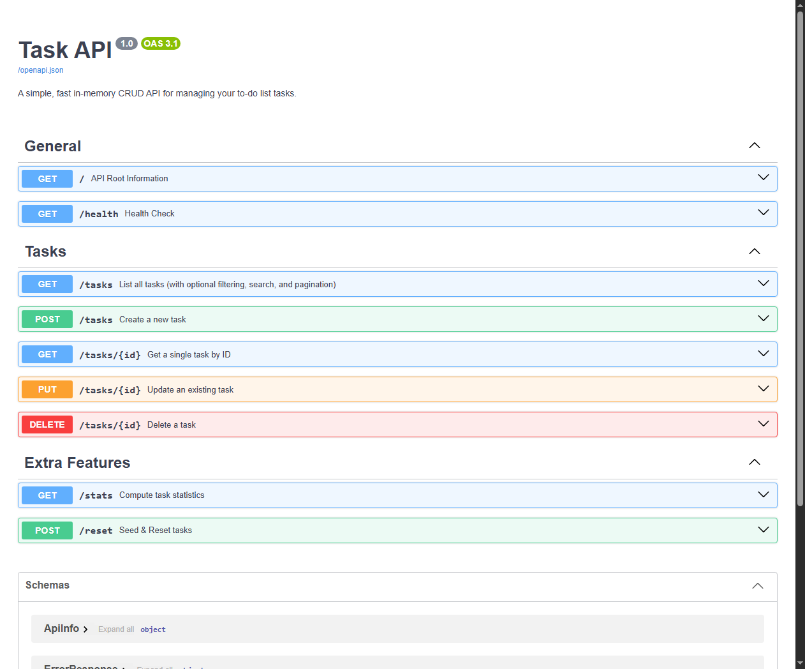

4. The Mortality Experiment (In-Memory vs Database)
Observation:
When new tasks are created during a server session, they exist only in RAM within the Python process heap. Upon restarting the Uvicorn server, all dynamically created and modified tasks are completely wiped out, and the state reverts to the initial hardcoded list.
Technical Rationale:
Volatile memory (RAM) is freed by the Operating System when a process terminates. Production backends require persistent storage (such as PostgreSQL, MySQL, SQLite, or Redis) where data is serialized and committed to disk or write-ahead logs, ensuring state survives crashes, deployments, and restarts.

5. Stage 7 Bonus: The AI Rematch ('AI vs Me')
In Stage 7, we wrote a specification prompt from memory and instructed an AI assistant to implement the API. The generated code was quarantined in 'ai-version/main.py' and tested against our verification suite.

Initial Prompt (From Memory):
"Write a FastAPI REST API in Python for managing a to-do list in memory. It should have endpoints to get root info, health status, list all tasks, get a task by id, create a task, update a task, and delete a task. Validate inputs and return proper HTTP status codes and JSON errors for not found and bad request."

Code Review & Concrete Differences:
• 1. HTTP 422 vs HTTP 400 on Validation: The AI relied on FastAPI's default Pydantic validation error handler which emits HTTP 422 Unprocessable Entity with schema validation trees. The assignment specification strictly requires HTTP 400 Bad Request with a clear JSON error. Our hand-crafted version registered a custom exception_handler(RequestValidationError) to standardize this.
• 2. Error JSON Payload Shape (detail vs error): The AI generated FastAPI's standard HTTPException which serializes errors as {'detail': '...'} instead of {'error': '...'}. Our hand-crafted version guarantees consistency for automated clients by formatting error responses as {'error': message}.
• 3. In-Memory ID Collision on Deletion: The AI assigned IDs using len(tasks) + 1. If tasks are deleted (e.g. deleting task 1 out of 3), the next task created would receive ID 3, colliding with existing task 3! Our hand-crafted version used max([t['id'] for t in tasks], default=0) + 1, preventing ID collisions.
• 4. Empty Request Body Validation on PUT: When an empty body {} was sent to PUT /tasks/1, the AI version succeeded silently with 200 without changing fields. Our hand-crafted version rejects empty update payloads with HTTP 400 ('Request body cannot be empty').

The Rematch:
We improved our prompt by converting it into a rigorous engineering specification specifying error payload keys, exception handlers, and ID generation rules. The regenerated code in 'ai-version/rematch.py' passed 100% of the test suite.

6. Automated Verification & Test Results
A full automated regression suite was developed in 'tests/test_api.py' using Pytest and Starlette TestClient. 13 test cases cover all CRUD paths, input validation edge cases, 404 scenarios, query parameter filters, pagination, and seed resets. All 13 tests pass with 100% pass rate.

