Started 31 January 2026, date of current version 4 February 2026
Studio Management System: A Comprehensive Solution for Managing Photography Services and Orders
NAJM ALDEN¹, FAROQ², WZYR³, NAWAF⁴, ABDULRAHMAN MOHAMMED⁵

¹Team Leader: Project supervision, phase validation, appendix preparation, and team coordination using GitHub and Git.
²Introduction, System, Description, Project Objectives
³Detailed Analysis
⁴Analysis Summary Table
⁵Entity-Relationship Diagram (ERD)

Project Objectives:
With the rapid digital transformation, photographic studios face increasing challenges in managing customers, orders, and large volumes of images while ensuring fast delivery and high service quality. Many studios still rely on traditional or scattered tools, which often results in data loss, inefficient workflows, and delays in order processing and delivery.
Studio Management System is an integrated and reliable system designed to efficiently manage photographic studios. It focuses on core administrative and operational features such as user and customer management, order tracking, scheduling, and secure photo archiving, all within a centralized platform.
The system helps organize studio operations, reduce manual work, improve workflow efficiency, and ensure accurate tracking of orders and images. By providing a structured and secure environment for managing studio data, it enhances productivity, minimizes errors, and improves overall customer satisfaction..
System Description:
The workflow begins when a customer visits the studio in person or contacts the reception desk. The receptionist registers the customer in the system by entering basic information such as the customer’s name and phone. After that, the receptionist creates a new order for the customer.
During order creation, the receptionist selects the type of service, which may include:
- Photography session
- Laser printing on objects
- Printing services
Each order contains essential details, including:
- Scheduled date and time
- Quantity
- Total amount
- Remaining balance
- Order status
- Discount (if applicable)
Once the order is created, it is forwarded to the relevant staff. The photographer receives photography-related orders and updates the order status as the work progresses. Similarly, the printing staff receives printing orders and confirms the completion of the printing process through the system.
The manager has full visibility over system operations and can monitor orders, track workflow progress, and review sales and order reports to support decision-making.
Order delivery is strictly controlled. Orders are delivered to customers only upon in-person attendance or according to predefined delivery rules specified during the order fulfillment process, ensuring accountability and proper handover.
Project Objectives:
The system aims to:
- Manage customer information and studio services in a structured manner.
- Create and track different types of orders with complete financial and scheduling details.
- Facilitate coordination between studio staff by managing order statuses.
- Provide management with reports on sales and orders.
- Ensure controlled and secure delivery of completed orders.
- Reduce manual work and operational errors while improving customer satisfaction.
Detailed Analysis:
1. Customer: has the following attributes:
id unique key (INT)
full_name (VARCHAR2)
phone (INT)
address (VARCHAR2)

2. Order: has the following attributes:
id unique key (INT)
customer_id (INT)FK
discount_amount (INT)
start_at (TIMESTAMP)
end_at ( TIMESTAMP)
status (VARCHAR2)
price (INT)
description (VARCHAR2)

3. Image_Session inherent from Order: has the following attributes:
session_type (VARCHAR2)
scheduled_at (TIMESTAMP)
duration (INT)
emp_id (INT)

4. Laser inherent from Order: has the following attributes:
material (VARCHAR2)
file_path (VARCHAR2)

5. Print inherent from Order: has the following attributes:
print_type (VARCHAR2)
qty (INT)
size (VARCHAR2)
paper_type (VARCHAR2)
design_file_url (VARCHAR2)

6. Coupons: has the following attributes:
id unique key (INT)
discount (INT)
code (VARCHAR2)
status (VARCHAR2)
note (VARCHAR2)
start_at (TIMESTAMP)
end_at ( TIMESTAMP)

7. Invoice: has the following attributes:
id unique key (INT)
order_id (INT)FK
issued_at ( TIMESTAMP)
net_amount (INT)

8. Payments: has the following attributes:
id unique key (INT)
invoice_id (INT)FK
amount (INT)
method (VARCHAR2)
paid_at (TIMESTAMP)
reference_no (VARCHAR2)

9. Employee: has the following attributes:
id unique key (INT)
name (VARCHAR2)
address (VARCHAR2)
phone (VARCHAR2)
salary (DECIMAL)
hire_date (DATE)
title (VARCHAR2)
sex (VARCHAR2) values: male, female

10. Skills: has the following attributes:
id unique key (INT)
title (VARCHAR2)

11. Skills_Employees: has the following attributes:
skill_id (INT)FK
emp_id (INT)FK
years (DATE)

12. Roles: has the following attributes:
id unique key (INT)
role_type (VARCHAR2)

13. Employees_Roles: has the following attributes:
emp_id (INT)FK
role_id (VARCHAR2)FK
added_date (DATE)

14. Attendance: has the following attributes:
id unique key (INT)
emp_id (INT)FK
check_in (TIMESTAMP)
check_out (TIMESTAMP)
date (DATE)
status (VARCHAR2)

relation between entities:
Customer ↔ Order
- Relation Type: has
- Cardinality: 1:M
- Business Rule:
One customer may have zero or many orders.
Each order must belongs to exactly one customer.

Employee(reciver) ↔ Order
- Relation Type: create
- Cardinality: 1:M
- Business Rule:
Each Employee may create zero or many order.
Each order must belong to exactly one order.

Employee(photographer) ↔ Image_Session
- Relation Type: handles
- Cardinality: 1:M
- Business Rule:
One employee may handle zero or many image sessions.
Each image session must be handled by exactly one employee.

Order ↔ Invoice
- Relation Type: has
- Cardinality: 1:1
- Business Rule:
One order may have zero or one invoice (before issuing, it can be none).
Each invoice must belong to exactly one order.

Invoice ↔ Payments
- Relation Type: has
- Cardinality: 1:M
- Business Rule:
One invoice may have zero or many payments (unpaid/partial/instalments).
Each payment must belong to exactly one invoice.

Employee ↔ Roles
- Relation Type: assigned
- Cardinality: M:M
- Business Rule:
One employee may have one or many roles.
Each role record must belong to exactly one or many employee.

Employee ↔ Attendance
- Relation Type: has / logs
- Cardinality: 1:M
- Business Rule:
One employee may have zero or many attendance records.
Each attendance record must belong to exactly one employee.

Employee ↔ Skills
- Relation Type: has
- Carnality: M:M
- Business Rule:
One employee may have one or many skills.
Each skill must belong to exactly one or many employee.
-------------------------------------------------------------------
Employee(Admin) ↔ Coupon
- Relation Type: Create
- Cardinality: 1:M
- Business Rule:
One employee may create zero or many Coupon.
Each Coupon must be created by exactly one employee.

Analysis Summary Table:
Entity Name | Entity Description | Attribute Name | Attribute Description | Data Type | Constraints (PK, FK, NOT NULL, Unique, etc.)
Customer | Represents a client who requests photography, printing, or laser services from the studio. | id | Unique identifier  for each Customer. | INT | PK
 |  | full_name | The complete name of the Customer. | VARCAHR2(50) | NOT NULL
 |  | phone | Customer phone INT | VARCAHR2(15) | NOT NULL
 |  | address | The location for each Customer | VARCAHR2(60) | NOT NULL

Entity Name | Entity Description | Attribute Name | Attribute Description | Data Type | Constraints (PK, FK, NOT NULL, Unique, etc.)
order | Represents a customer request that includes services, pricing, schedule, and current status. | id | Unique identifier for each order | INT | PK
 |  | customer_id | Foreign key for customer | INT | FK
 |  | discount_amount | Amount of discount applied to the order | INT | Optional , default = 0
 |  | start_at | Timestamp when the order | Timestamp | NOT NULL
 |  | end_at | Timestamp when the order was completed | Timestamp | NOT NULL
 |  | status | Current status of order | VARCHAR(10) | NOT NULL
 |  | price | Total price of the order after discount | INT | NOT NULL
 |  | Discription | Notes and discriptin about the order | VARCHAR(200) | Optional

Entity Name | Entity Description | Attribute Name | Attribute Description | Data Type | Constraints (PK, FK, NOT NULL, Unique, etc.)
Image_Session |  | Session _type | Photography session | VARCAHR (15) | NOT NULL
 |  | Scheduled_at | Sion tDate and time when the image session is scheduled | Timestamp | NOT NULL
 |  | duration | Duration of the image session (in minutes) | INT | NOT NULL
 |  | emp_id | Identifier of the employee assigned to the image session | INT | FK

Entity Name | Entity Description | Attribute Name | Attribute Description | Data Type | Constraints (PK, FK, NOT NULL, Unique, etc.)
Laser | Represents a laser printing service applied to specific materials as part of an order. | material | Type of materail used for the laser servace | VARCAHR (15) | NOT NULL
 |  | file_path | The path for image | VARCAHR (225) | NOT NULL

Entity Name | Entity Description | Attribute Name | Attribute Description | Data Type | Constraints (PK, FK, NOT NULL, Unique, etc.)
Print | Represents a printing service with defined type, quantity, size, and design file | print_type | Type of cord | VARCAHR (10) | NOT NULL
 |  | qty | Quantity of Prints requested | INT | NOT NULL
 |  | size | Size of Print | VARCAHR( 10) | NOT NULL
 |  | paper_type | Paper type used for printing the Print | VARCHAR(20) | NOT NULL
 |  | design_file _ulr | File path or ulr of the Print desing file | VARCHAR(225) | NOT NULL

Entity Name | Entity Description | Attribute Name | Attribute Description | Data Type | Constraints (PK, FK, NOT NULL, Unique, etc.)
Coupons | Represents discount codes that can be applied to orders within a specific time period. | id | Unique identifier for each coupon | INT | PK
 |  | discount | Discount value applied by the coupon | INT | NOT NULL
 |  | Code | Unique coupon code used by Customer | VARCAHR (10) | NOT NULL
 |  | status | Current status of the coupon | VARCHAR(10) | NOT NULL
 |  | note | Note to description about the coupon | VARCAHR( 10) | Optional
 |  | start_at | Date and time when the coupon become valid | Timestamp | NOT NULL
 |  | end_at | Date and time when the coupon become  exprice | Timestamp | NOT NULL

Entity Name | Entity Description | Attribute Name | Attribute Description | Data Type | Constraints (PK, FK, NOT NULL, Unique, etc.)
Invoice | Represents the official billing document generated for an order | id | Unnique identifier for each invoice | INT | PK
 |  | order_id | Identifier of the order associated with the invoice | INT | FK, NOT NULL
 |  | issued_at | Date and time when the invoice was isssued | Timestamp | NOT NULL
 |  | net_amount | Final amount to be paid after discount and adjustments | INT | NOT NULL

Entity Name | Entity Description | Attribute Name | Attribute Description | Data Type | Constraints (PK, FK, NOT NULL, Unique, etc.)
Payments | Represents payment transactions made against an invoice using a specific method. | Id | Unnique identifier for each payment | INT | PK
 |  | Invoice_id | Identifier of the order associated with the payment | INT | FK, NOT NULL
 |  | Amount | Amount paid by the the customer | INT | NOT NULL
 |  | Method | Payment method by all type payment | VARCHAR(20) | NOT NULL
 |  | Paid_at | Date and time the payment | Timestamp | NOT NULL
 |  | Reference | Reference INT for the paymenet transaction | VARCHAR(10) | Optional. Unique

Entity Name | Entity Description | Attribute Name | Attribute Description | Data Type | Constraints (PK, FK, NOT NULL, Unique, etc.)
Employee | Represents a studio staff member responsible for executing services and operations. | Id | Unnique identifier for each employee | INT | PK
 |  | Name | Full name of the employee | VARCHAR(50) | NOT NULL
 |  | Adress | Adress of the employee | VARCHAR(40) | NOT NULL
 |  | Phone | Phone of the employee | VARCHAR(15) | NOT NULL
 |  | salary | Monthly salary of the employee | DECIMAL | NOT NULL
 |  | Hire _date | Date when the employee was hired | Date | Not NULL
 |  | Title | Job title or posision of the employee | VARCHAR( 20) | NOT NULL
 |  | Sex | The employee may Man / woman | VARCHAR(5) | NOT NULL

Entity Name | Entity Description | Attribute Name | Attribute Description | Data Type | Constraints (PK, FK, NOT NULL, Unique, etc.)
Skills | Represents a professional skill that an employee can possess | Id | Unique identifier for each Skill | INT | PK
 |  | Title | Name of the Skills of employee | VARCHAR(30) | NOT NULL , Unique

Entity Name | Entity Description | Attribute Name | Attribute Description | Data Type | Constraints (PK, FK, NOT NULL, Unique, etc.)
Employee skills | Represents the relationship between employees and their skills with experience duration. | Skill _Id | Identifier of the skill | INT | FK, NOT NULL
 |  | emp_id | Identifier of the employee | INT | FK, NOT NULL
 |  | Years | INT of years the employee has experience in the skill | INT | NOT NULL

Entity Name | Entity Description | Attribute Name | Attribute Description | Data Type | Constraints (PK, FK, NOT NULL, Unique, etc.)
Role | Represents system roles that define employee responsibilities and permissions. | Id | Unique Identifier for each the Role | INT | P K, NOT NULL
 |  | Role _type | Type or name of the Role | VARCHAR(20) | NOT NULL

Entity Name | Entity Description | Attribute Name | Attribute Description | Data Type | Constraints (PK, FK, NOT NULL, Unique, etc.)
Employee_Role | Represents the assignment of roles to employees over time | emp_Id | Identifier for the employee | INT | FK, NOT NULL
 |  | Role _id | Identifier of the role assigned to the employee | VARCHAR(20) | FK, NOT NULL
 |  | Added _date | Date when the role was assigned to the employee | Date | NOT NULL

Entity Name | Entity Description | Attribute Name | Attribute Description | Data Type | Constraints (PK, FK, NOT NULL, Unique, etc.)
Attendance | Represents employee daily attendance records including check-in and check-out times. | Id | Unique Identifier for each attendace recorder t | INT | PK, NOT NULL
 |  | emp_ id | Identifier of the employee | INT | FK, NOT NULL
 |  | check_in | Timestamp when the employee checkin | Timestamp | Optional
 |  | Check_out | Timestamp when the employee checkout | Timestamp | Optional
 |  | Date | Date of the attendance record | Date | NOT NULL
 |  | Status | Status of the attendance | VARCAHR(20) | NOT NULL
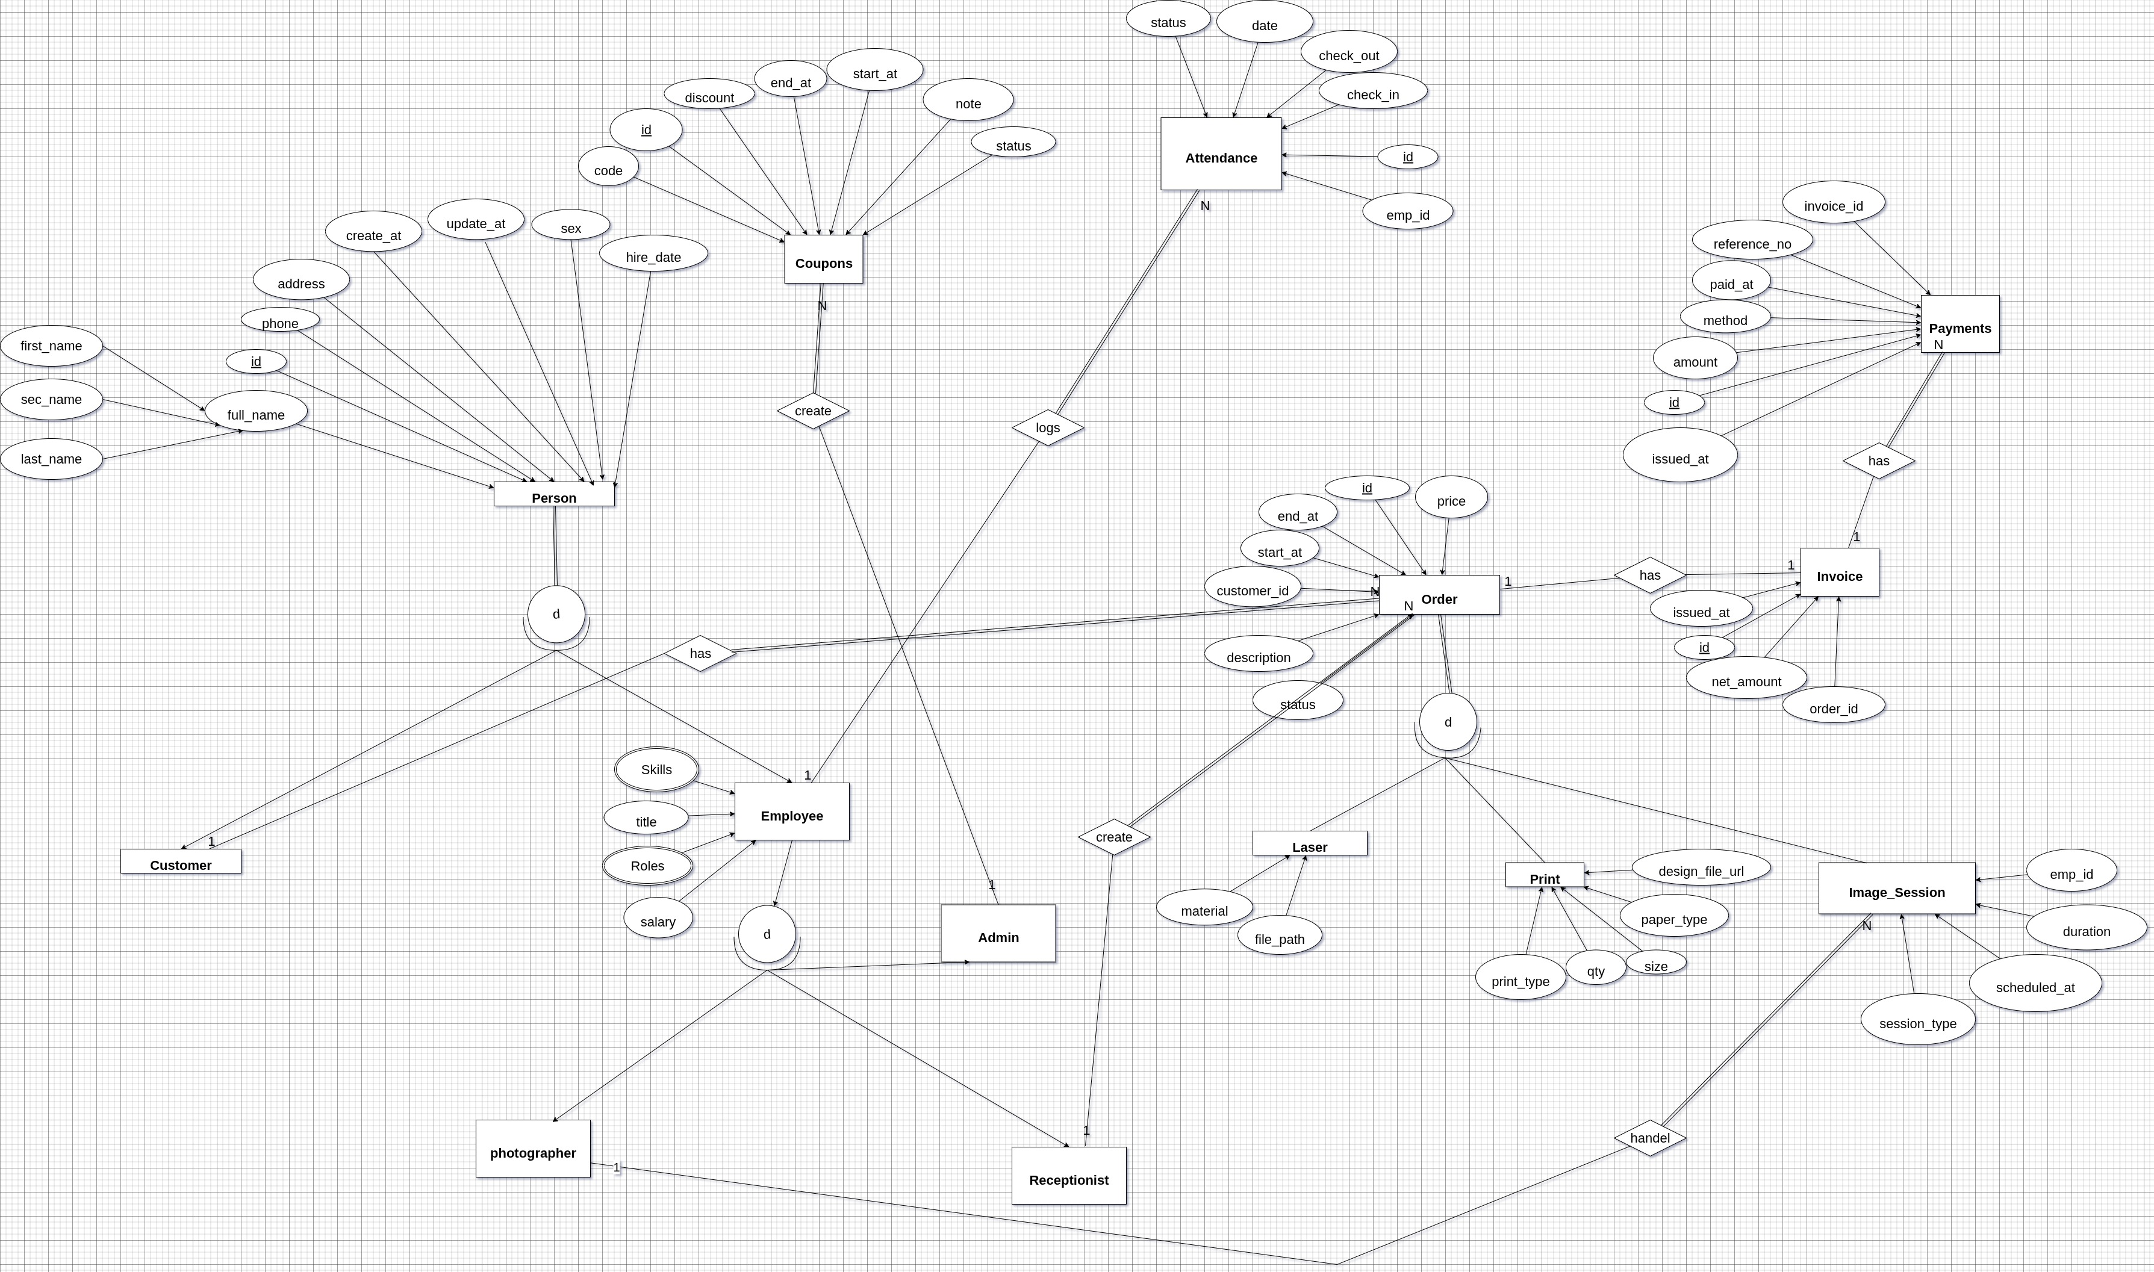
Interview Questions:

في بداية المقابلة تحدثنا مع موظف الاستقبال ولم نستطع أن نجد منه المعلومات الكافية إلى أن أتى المسؤول عن الاستويو (أبو رامي) والذي كان يخطط لبناء نظام منذ 10 سنوات لكن باءت المحاولة بالفشل لأن العمل كان فردي ولم يبنى على أسس موثوقة ويريد فكرة مشابهة مثل نظام كلاكت لحسابات وادارة استوديوهات التصوير :
أسئلة المقابلة :
- ماهي الأقسام الرئيسية داخل الاستوديو :
الأقسام الرئيسية داخل الاستوديو هي تصوير فوتغرافي وقسم الطباعة لطباعة الأوراق والمستندات والعروض الدعائية واللوحات قسم نحت الليزر قص ديكورات وما إلى ذلك

- ما هي الأدوار أو الوظائف المتاحة في الاستوديو :
يوجد لدينا موظف الاستقبال ومهمته يستلم ويسجل الطلبات ويرسل الطلب لكل قسم حسب مهمته إذا كان الطلب من تصوير يتم تحويله للدور الأعلى وإذا كان طلب طباعة يتم تحويله لقسم الطباعة وإذا كان طلب نحت وتشكيل يتم إرساله للموظف في قسم المنحوتات بالليزر ويتم تحديد الكمية والموعد والسعر لكل طلب

- ماهي أنواع الجلسات التي تقدمونها داخل الاستوديو؟ :
بالنسبة للجلسات داخل الاستوديو إما تصوير داخلي داخل الاستوديو أو طلب خارجي يعني نرسل المصور إلى مكان محدد وفق موعد محدد مثلا دعوات حفلات التخرج ...

- كيف تتم عملية الدفع والتعامل مع الحسابات ؟ :
يمكن للعميل إذا كان الطلب كبير أن يقدم عربونا كبداية للتأكيد على بدئ العمل أما الطلبات العادية مثل طباعة مستند أو تصوير مستعجل 4*6 فيتم تسديد المبلغ كاملا أولا والدفع إما نقدي أو كاش

- بالنسبة لبيانات صور العملاء هل يتم الاحتفاظ بها؟ :
صور العملاء الرجال يتم الاحتفاظ بها لمدة 3 أشهر أما صور العوائل فتحذف فور إنجاز العمل
- كيف يتم تسليم الطلبات للعملاء :
التسليم يتم بالحظور الشخصي أو بالبطاقة الشخصية إذا العميل طلب ذلك
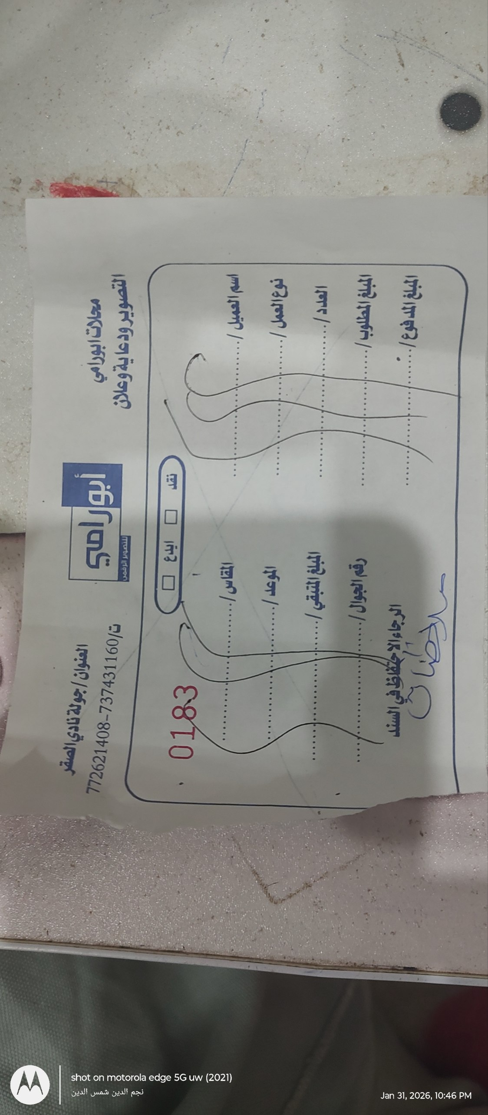
Images:




