Faculty of Artificial Intelligence Engineering | 

Reinforcement Learning-Based Autonomous Navigation System for a Mobile Robot with SLAM Integration

Prepared by:
Mohammad Osama Twati
Supervised by:
Dr. Louay Saleh Eng. Sara Hamdan
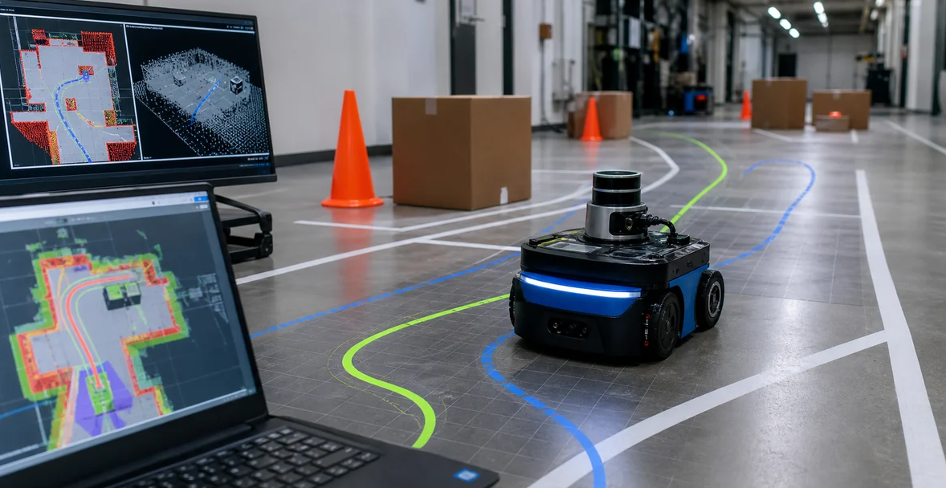
General Introduction
Traditional navigation systems such as Nav2 rely on costmaps and manually tuned parameters, and may fail in narrow environments. In contrast, Reinforcement Learning (RL) teaches the robot a navigation policy through trial and error, Figure (1). However, training directly on a real robot is costly and risky, so simulation software is used for training. The simulation-to-reality gap (sim-to-real gap) must then be addressed when transferring the policy to the real world.
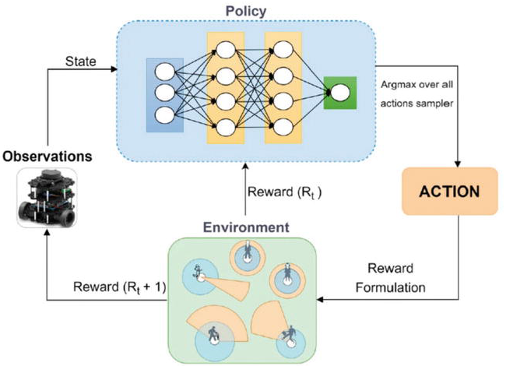
Figure (1)- RL policy Generation for Robot Navigation
The research began with the following question:
How can we train the robot on a navigation and obstacle-avoidance policy in the advanced Isaac Sim simulator and then transfer it to a resource-constrained real robot (Raspberry Pi 5)?
How will its performance compare with Nav2?
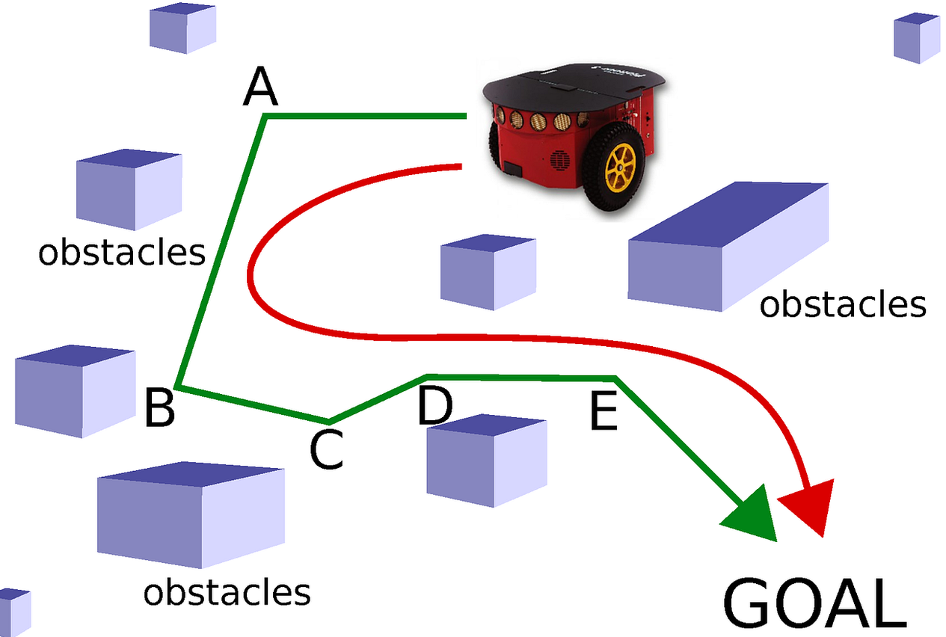
Figure (2)- Obstacle avoidance task
To answer this question, we will follow this approach:
The robot will be trained in Isaac Sim in diverse environments. The trained policy will then be exported in ONNX format and run on a Raspberry Pi 5 within a ROS 2 Jazzy node, following these stages:
- Model the robot, its sensors, and diverse environments in Isaac Sim.
- Train the PPO reinforcement learning algorithm using curriculum learning with noise injection.
- Export the policy produced by training in ONNX format.
- Deploy the policy on the robot and test it in a ROS 2 environment.
- Conduct a quantitative evaluation and comparison with Nav2.

Graphical Abstract
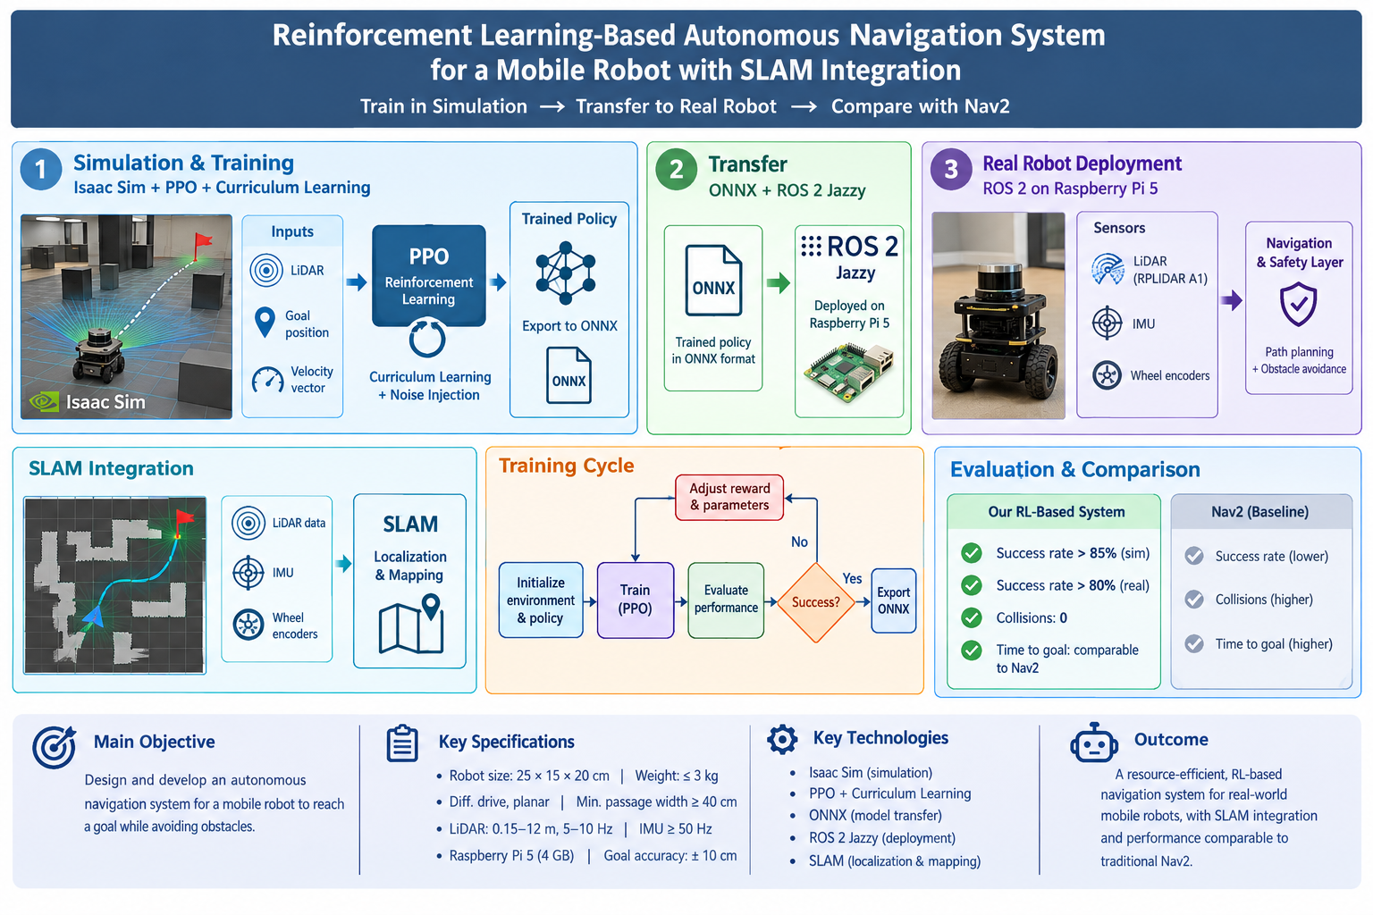

Project Objectives
Main project objective:
- Design and develop an autonomous navigation system for a mobile robot that can move and plan a path to reach a specified goal while avoiding obstacles.
Specific objectives:
- Use Simultaneous Localization and Mapping (SLAM) to determine the robot's position and map the surrounding environment.
- Model the robot in the Isaac Sim simulation environment and train it on an intelligent motion policy using reinforcement learning based on the PPO algorithm.
- Transfer the algorithm and deploy it on the physical robot.
- Deploy the policy in ONNX format on ROS 2 Jazzy, then quantitatively compare its performance with Nav2 to compare reinforcement-learning-based navigation with traditional navigation.
Specifications
Environment:
Indoor environment with a flat floor and static obstacles, and a test area of at least 6 × 4 m.
Technical Specifications:
- Dimensions (length × width × height): 25 × 15 × 20 cm.
- Mass: ≤ 3 kg
- Motion: Differential drive, planar (two-dimensional).
- Minimum passage width ≥ 40 cm.
Performance and Payload:
- Payload: Sensors and battery only.
- Motors and Power:
  - Linear speed: 0.1 to 0.4 metres per second.
  - Angular speed ≥ 1 radian per second.
- Goal-reaching accuracy: ± 10 cm.
Sensors:
- LiDAR: RPLIDAR A1, 360-degree range, with a detection range of 0.15 to 12 metres.
- LiDAR scan frequency: 5 to 10 Hz.
- IMU: rate ≥ 50 Hz, with heading error ≤ 2 degrees.
- Encoder: on each wheel, with distance error ≤ 2%.
- Processing and Control Unit:
  - Unit: Raspberry Pi 5 with 4 GB of memory.
Simulation and Training:
- Simulator: Isaac Sim, with a model matching the robot dimensions (25 × 15 × 20 cm).
- Inputs: LiDAR readings, goal position, and the robot's velocity vector.
Evaluation:
- Success rate: above 85% in simulation and 80% in the real world.
- Collisions: 0.
- Time to goal: comparable to the Nav2 baseline.
Block Diagram
The following block diagram shows the simulation environment (Isaac Sim) and the physical robot (ROS 2 Jazzy on Raspberry Pi 5), and how the trained policy is transferred in ONNX format to the robot, where it operates with sensor inputs and the safety layer.
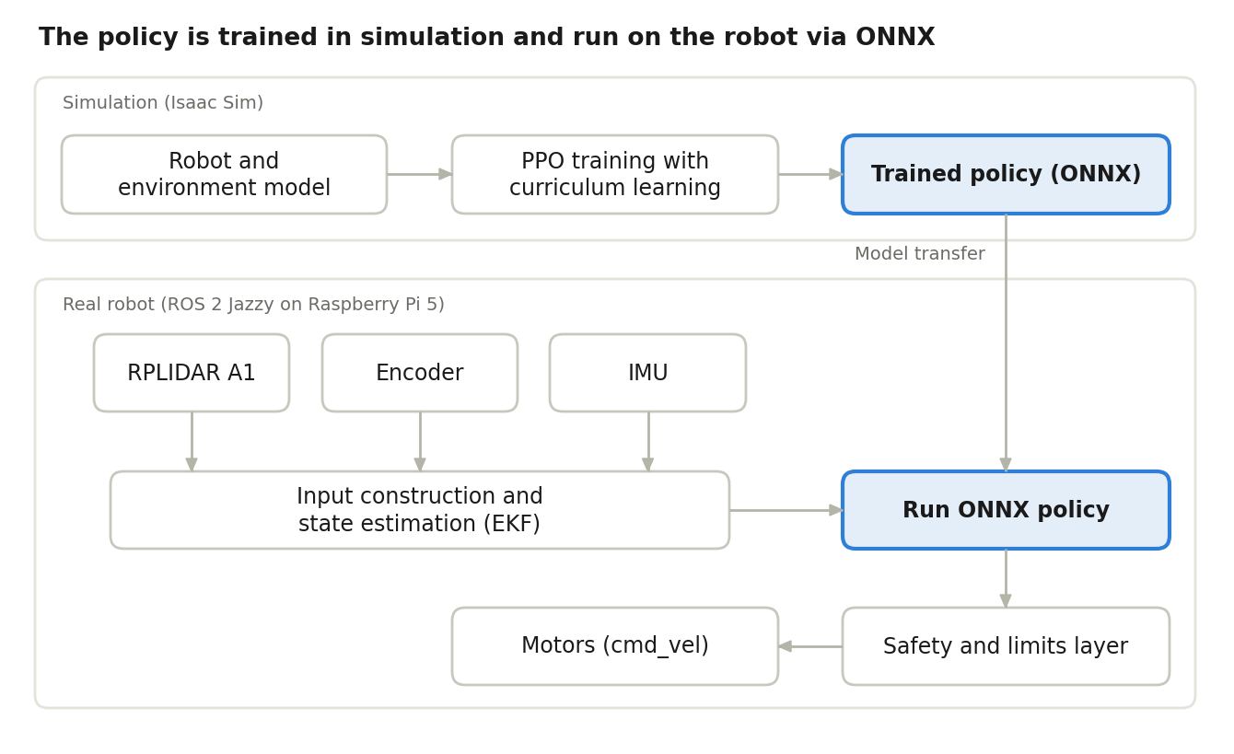
Figure (3) – Block diagram of the transfer from the NVIDIA environment to the ROS 2 environment

Flowchart
The following flowchart shows the training cycle, which is repeated while adjusting the reward until performance succeeds in simulation and on the robot, followed by evaluation and comparison with Nav2.
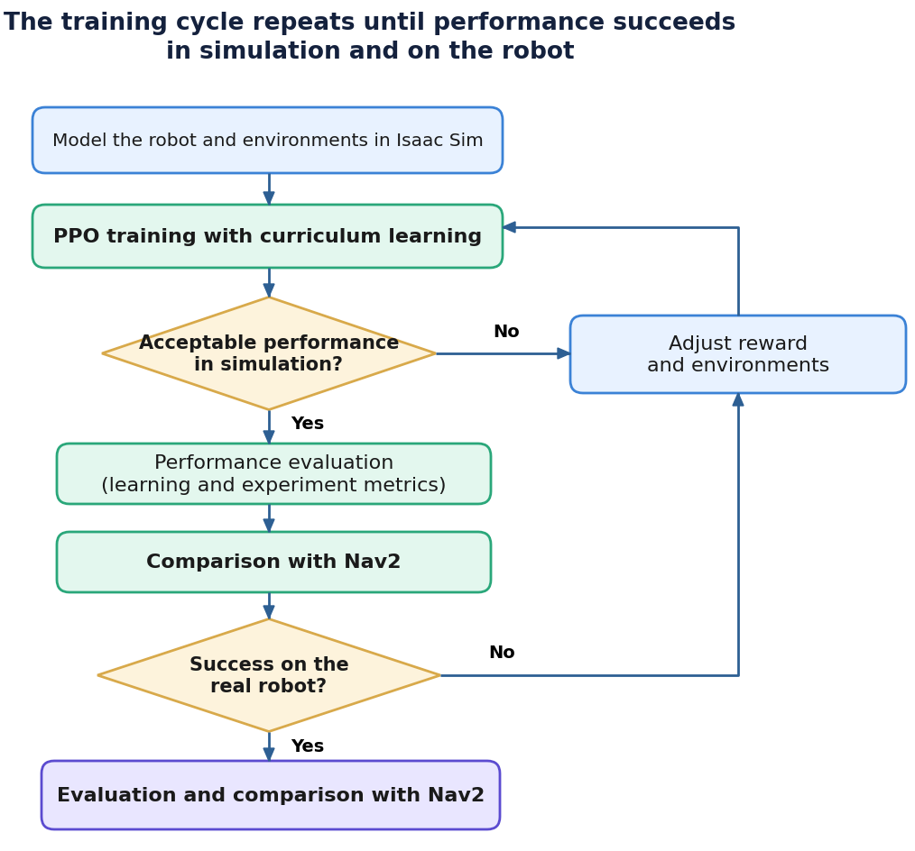

Literature Review
Traditionally, the navigation problem is divided into global and local planning, with obstacles avoided using local planners. This is the common approach in Nav2, but it requires substantial manual tuning. Recently, reinforcement-learning navigation algorithms have emerged, using methods such as DQN, DDPG, PPO, CPO, and others for robot navigation. PPO is often preferred for its stability, but the best choice varies with the environment and reward function. Most studies remain in simulation or test only a small number of real-world trials.
After reviewing numerous research articles, we identified the following research gap:
Research Gap
The review of the selected papers indicates challenges in generalizing navigation policies trained in simulation when transferring them to a physical robot, as well as the need to evaluate performance under defined and repeatable test conditions. Therefore, this project will focus on studying the effect of varying simulation conditions and sensor noise on policy performance, and quantitatively comparing it with Nav2 on the physical robot, within the available resources.
The following table presents the main recent research papers reviewed:
Comparison of Research Papers
Paper | Platform | Algorithm | Sensors | Key Results | Limitations
(Taheri et al., 2024) | Gazebo | PPO with ResBlocks versus DDPG | LiDAR (10 compressed measurements) | Simple environment: PPO 100% and DDPG 98.46%. Complex environment: DDPG 93.65% and PPO 67.81%. | Simulation only, with a small number of evaluation episodes.
(Arce Llobera et al., 2026) | Isaac Sim/Lab | PPO with a GRU layer | LiDAR (128 beams) and IMU (yaw angle) | Trained 750 robots in parallel in about 4 hours, compared with more than 50 hours previously; collisions decreased from 24% to 11% in one environment. | Simulation only; SLAM uses LiDAR only, without loop closure.
(Gao et al., 2025) | Gazebo, then a physical TurtleBot3 | D3QN (high level) and CPO (low level) | LiDAR and wheel odometry | 97% success in a narrow home environment where standalone PPO and CPO failed (0%); collision-free real-world trials. | Collisions with pedestrians in dense crowds, and few real-world trials (30 and 10 attempts).
(Salimpour et al., 2025) | Isaac Sim, then Gazebo | PPO (MLP and LSTM) | LiDAR and odometry | Zero-shot transfer to TurtleBot 4 Lite, with success in 7 to 10 out of 10 trials in static environments; comparison with Nav2 in Gazebo. | Weak performance with dynamic obstacles, and no quantitative comparison with Nav2 in the real world.

Work Completed in August and September 2026
The Gazebo simulator was replaced with NVIDIA Isaac Sim after receiving a grant of 90 hours of simulation on the cloud platform, provided as computing credits by NVIDIA. Training was moved to cloud GPUs. The robot intended for use was also modeled in the simulator, with the design kept as close as possible to the well-known TurtleBot family, Figure (4), which is widely used in research papers for later comparison.
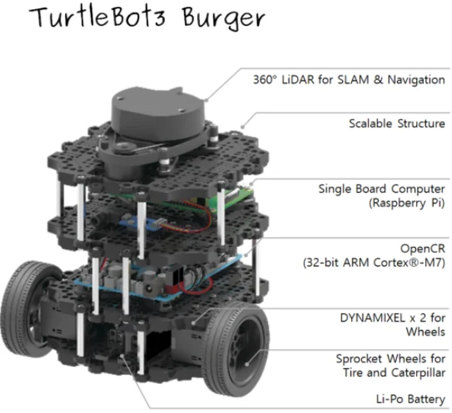
Figure (3)- TurtleBot3 Burger
A literature review was prepared, and a set of research papers was collected using the following selection criteria: use of RL; a similar robot (wheels + 2D LiDAR); inclusion of a real-robot experiment; and recent publication in peer-reviewed journals.
The ROS 2 Jazzy environment was also set up, and the Isaac Sim simulator was installed.
Project Timeline
- Semester project: simulate and model the robot in Isaac Sim and prepare the literature review; import the robot into the simulator and prepare the environments.
The semester project is being carried out through the following stages:
- Work environment setup: set up ROS 2 Jazzy, install Isaac Sim, and work with it through the cloud platform.
- Literature review: collect and compare research papers according to the selection criteria and identify the research gap.
- Robot modeling: model the robot with dimensions (25 × 15 × 20 cm) in Isaac Sim, approximating the TurtleBot family of robots.
- Adding sensors: add LiDAR, IMU, and encoder sensors to the robot model in the simulator.
- Preparing simulation environments: build diverse environments and obstacles for use in subsequent training.
- Report writing: document completed work and submit the semester project.

References
- Salimpour, S., Peña-Queralta, J., Paez-Granados, D., Heikkonen, J. and Westerlund, T. (2025) Sim-to-Real Transfer for Mobile Robots with Reinforcement Learning: from NVIDIA Isaac Sim to Gazebo and Real ROS 2 Robots. arXiv:2501.02902 https://doi.org/10.48550/arXiv.2501.02902.
- Taheri, H., Hosseini, S.R. and Nekoui, M.A. (2024) Deep Reinforcement Learning with Enhanced PPO for Safe Mobile Robot Navigation. arXiv:2405.16266 https://doi.org/10.48550/arXiv.2405.16266.
- Arce Llobera, M., Placed, J.A., De Paula, M. and De Cristóforis, P. (2026) Massive Parallel Deep Reinforcement Learning for Active SLAM. arXiv:2603.25834 https://doi.org/10.48550/arXiv.2603.25834.
- Gao, J., Pang, X., Liu, Q. and Li, Y. (2025) Hierarchical Reinforcement Learning for Safe Mapless Navigation with Congestion Estimation. arXiv:2503.12036 https://doi.org/10.48550/arXiv.2503.12036.

