Egyptian E-Learning University

Faculty of Computers & Information Technology

Project title
HYBRID AI-IDS
By
Name Amy Yousef Fawzy | ID 2200621
Name Shahd Yahia Mohamed | ID 2102473
Name Wesal Shazly Abdelkarem | ID 2200623
Name Shahd Ahmed Ragab | ID 2200611
Name Mariam Adel Kamal | ID 2200628
Name Peter Atef Hafez | ID 2200556
Name Gerges Nashaat Habeeb | ID 2200558
Name Amir Akram Zakaria | ID 2200635
Supervised by
Dr. Shaimaa Ashmawy
Assistant
Eng. Ahmed Mohamed Essa

Contents
Abstract 3
Acknowledgments 4
Introduction 5
Literature Review / Related Work 8
Proposed system 10
Implementation 16
Testing & Evaluation 19
Results & Discussion 28

Abstract

Hybrid AI-Based Intrusion Detection System (Hybrid AI-IDS) is a graduation project that aims to improve network and web security by addressing the limitations of traditional intrusion detection systems. Conventional IDS solutions often suffer from low detection accuracy, high false alarm rates, and difficulty in detecting new or unknown attacks, which makes them less effective in modern environments.

The main objective of this project is to design a hybrid intrusion detection system that combines multiple detection approaches to provide better and more reliable protection. The proposed system integrates network-based and web-based intrusion detection and relies on artificial intelligence techniques to analyze system activities and identify suspicious behavior. This hybrid approach helps in improving detection performance while reducing false positives and response time.

The system is designed to operate in real time and handle large amounts of data efficiently. Evaluation is performed using standard benchmark datasets and simulated traffic scenarios. The results show that the proposed Hybrid AI-IDS achieves better overall detection performance compared to traditional IDS methods, making it a more effective and practical cybersecurity solution

Acknowledgments

We would like to express our sincere thanks to our project supervisors Eng. Ahmed Eissa and Dr. Shaimaa Ashmawy, for their guidance, support, and valuable feedback throughout the work on this project. Their advice and continuous encouragement played an important role in helping us complete this project successfully.

We would also like to thank the faculty members and staff of the Computer Science department at the Egyptian E-Learning University for providing us with the necessary knowledge, resources, and academic environment during our studies and the development of this project.

Introduction

  - Introduction
The rapid growth of computer networks and web applications has made cybersecurity very important for both organizations and individuals. Networks face many types of attacks that can cause data loss, service interruption, or unauthorized access. For this reason, securing systems and networks is now a basic and necessary requirement.
Intrusion Detection Systems (IDS) are widely used to monitor network and system activities and to identify any suspicious behavior. However, traditional IDS methods have several problems, such as low detection accuracy, a high number of false alarms, and weak ability to detect new or unknown attacks. These limitations reduce their effectiveness in modern and complex network environments.
To address these challenges, this project proposes a Hybrid AI-Based Intrusion Detection System (Hybrid AI-IDS). The proposed system uses artificial intelligence techniques to improve the accuracy and reliability of intrusion detection and to better handle both known and unknown security threats.
  - Background and motivation for the project.
With technology evolving, networks and web applications have become essential in daily life and business. This growth has also increased the complexity and frequency of cyberattacks. Traditional intrusion detection systems rely on fixed rules, making them effective only against known threats. This project aims to develop a hybrid intrusion detection system that combines different approaches to improve accuracy, reduce false alarms, and enhance overall security monitoring.
  - Importance of the problem being addressed
Cyberattacks are increasing rapidly with the growth of computer networks and web applications. These attacks can cause data loss, service interruption, and security risks for organizations and users. Therefore, having an effective intrusion detection system is very important.
Traditional IDS solutions face challenges such as low accuracy and high false alarm rates, which reduce their efficiency. Improving intrusion detection systems helps in detecting attacks faster and reducing potential damage. For this reason, developing an intelligent intrusion detection system is important for improving cybersecurity and protecting systems and data..
  - Problem Statement
Many existing intrusion detection systems are not efficient enough in real environments. They generate a large number of false alerts, which makes it hard to focus on real attacks. They also face difficulties when dealing with large amounts of network and web traffic at the same time. As a result, these systems may fail to provide reliable and timely intrusion detection.Objectives
- Main Objective:
The main objective of this project is to design and implement a hybrid intrusion detection system that improves the detection of cyberattacks using artificial intelligence techniques
- Specific Objectives:
• Improving intrusion detection accuracy.
• Reducing false positive alerts.
• Detecting unknown and previously unseen attacks.
• Supporting real-time monitoring and analysis.
• Providing a more reliable and efficient security solution compared to traditional IDS.

  - Brief overview of the proposed solution.
This project proposes a hybrid intrusion detection system that aims to overcome the limitations of traditional IDS. The proposed system combines different detection approaches to improve accuracy and reduce false alerts. It focuses on monitoring network and web activities to detect suspicious behavior in a more reliable way. By using artificial intelligence techniques, the system provides better intrusion detection performance compared to traditional methods.

Literature Review / Related Work

- Summary of existing research and technologies related to my project.
Intrusion Detection Systems (IDS) are commonly used to detect suspicious activities in networks and systems. Traditional IDS mainly depend on predefined rules and signatures to detect known attacks. These systems are simple and widely used, but they require continuous updates and manual effort.
Recently, artificial intelligence techniques have been used in IDS to improve detection performance. AI-based systems can analyze data patterns and help in detecting abnormal behavior more effectively than traditional methods.
- Gaps in current solutions that my project aims to fill.
Although existing IDS solutions provide basic security, they still suffer from several problems. Many systems generate a large number of false alerts, which makes them less practical. In addition, some solutions are not efficient when handling large amounts of data or real-time traffic. These issues limit the effectiveness of current IDS solutions
- Summary
This chapter briefly reviewed existing IDS technologies and highlighted the main gaps in current solutions. These limitations motivate the need for a hybrid intrusion detection system, which is discussed in the next chapter

Proposed system

  - Approach used to solve the problem
The proposed system adopts a hybrid AI-based Intrusion Detection System (IDS) to overcome the limitations of traditional security solutions, such as low detection accuracy, high false positive rates, and slow response times. The main idea is to combine Artificial Intelligence techniques with real-time data streaming and automated incident response to provide accurate and scalable intrusion detection.
The system follows a multi-layered approach that integrates both Network-based IDS (NIDS) and Web-based IDS (WIDS). Network traffic and web requests are continuously monitored, analyzed, and classified using machine learning and deep learning models. In addition, anomaly detection techniques are applied to identify unknown and zero-day attacks that are
not covered by predefined

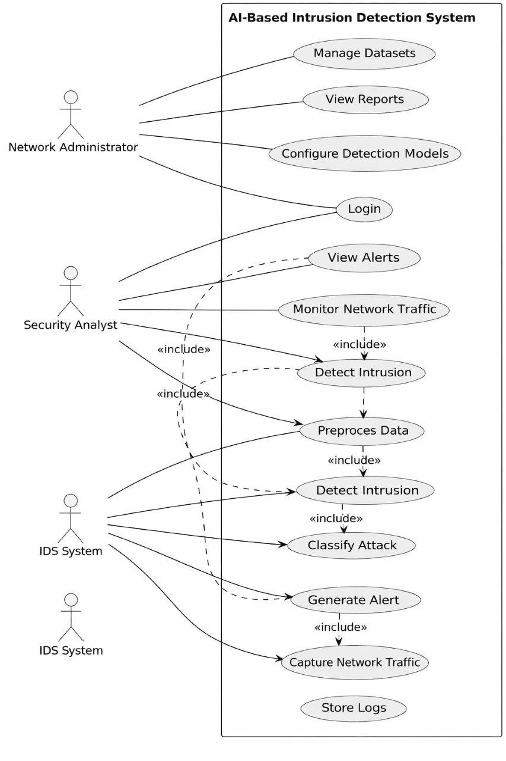

(Use case diagram)

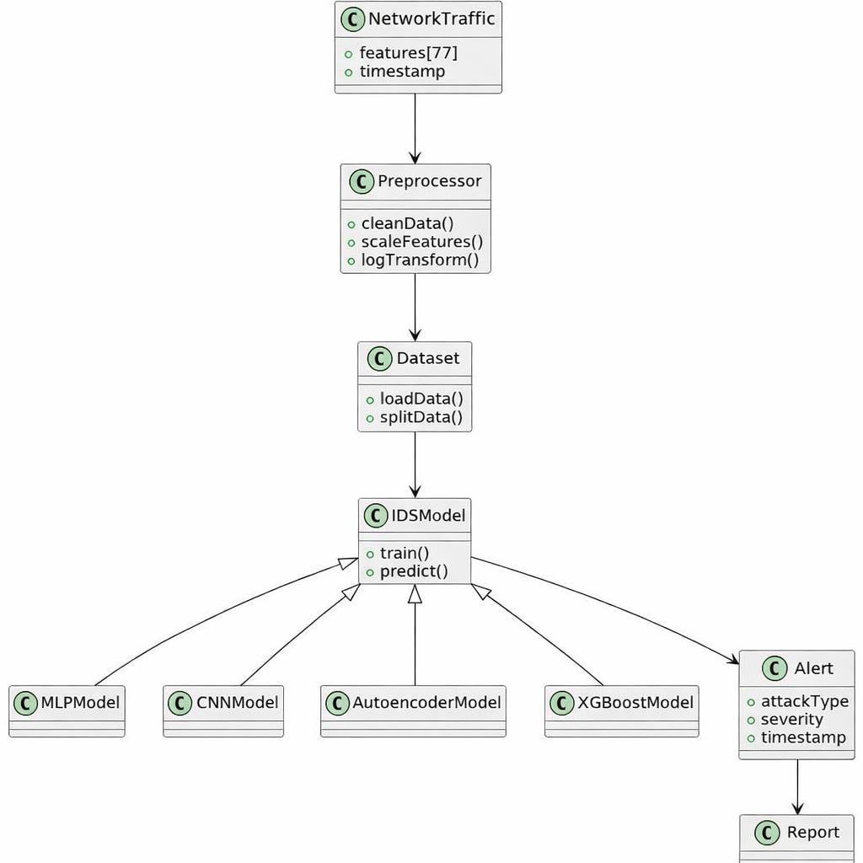

(Class diagram)
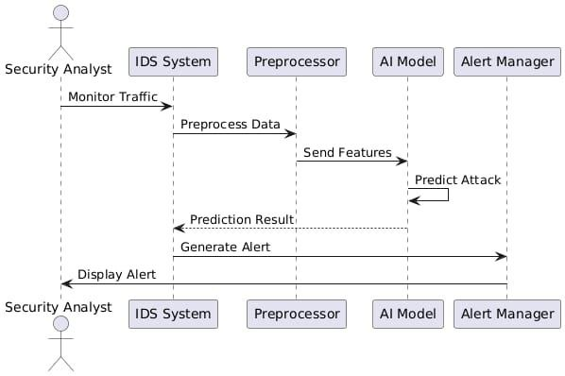

(Sequence diagram)

3.3 Algorithms and Frameworks Used Algorithms:

Convolutional Neural Network (CNN): Used to extract spatial features from network traffic data and detect
known attack patterns.

Long Short-Term Memory (LSTM): Used to analyze sequential and temporal patterns in network traffic.

Autoencoder(Unsupervised Learning): Learns normal traffic behavior and detects anomalies based on reconstruction error, making it effective for zero-day attack detection.

Frameworks and Tools:
Apache Kafka – real-time data streaming
Apache Flink – stream processing and feature extraction
Feast – feature store for ML pipelines
Elasticsearch / ClickHouse – data storage
Kibana / Grafana – monitoring and visualization
TheHive / Cortex – automated incident response

Implementation

  - Technologies, tools, and programming languages used
To build a system capable of handling high-speed network traffic and complex threat patterns, the following technologies were utilized:
Network Sensors: Zeek and Suricata are used to capture network traffic and generate detailed logs.
Web Protection: ModSecurity is implemented to provide HTTP and Web Application Firewall (WAF) logs.
Data Pipeline:
Filebeat: For log collection and forwarding.
Apache Kafka: Acts as the real-time streaming platform to ensure no data is lost during transit.
Processing & Feature Management:
Apache Flink: Used for real-time stream processing and feature extraction.
Feast: Employed as a Feature Store to manage and serve machine learning features efficiently.
AI Inference:
FastAPI: Serves the AI models as web services.
ONNX Runtime: Used to execute pretrained models with high performance.
Storage & Visualization:
Elasticsearch / ClickHouse: Used for long-term data storage.
Kibana / Grafana: Used to create interactive dashboards for monitoring threats..
  - Key components/modules of the system.
The implementation is divided into several interconnected modules that transform raw network packets into actionable security insights:
4.2.1 Data Acquisition & Streaming Layer
Traffic is captured via SPAN or PCAP captures. Logs are then forwarded by Filebeat into Kafka topics, which serves as the central nervous system for data movement.

4.2.2 AI Detection Engines
The core of the system consists of three specialized detection components:
Network IDS: Utilizes pretrained CNN (Convolutional Neural Networks) and LSTM (Long Short-Term Memory) models to identify patterns in network traffic.
Web IDS: A specific pretrained model dedicated to analyzing web-based threats.
Anomaly Detection: An unsupervised Autoencoder model is used to identify unknown or "zero-day" attacks that do not match known signatures.
Fusion Layer: This component combines the outputs from the various models to provide a final decision on whether an event is an intrusion.
4.2.3 Automated Response Layer
Once a threat is detected, the system integrates with TheHive and Cortex. This allows for automated alerting and speeds up the incident response time, addressing the limitations of manual analysis.
  - Challenges faced and how they were resolved.
During the implementation, several critical challenges were addressed:
Low Detection Accuracy: Resolved by replacing traditional signature-based methods with AI-powered models like CNN and LSTM.
High False Positive Rates: Addressed by using unsupervised learning (Autoencoders) to better distinguish between normal behavior and actual threats.
Real-Time Scalability: Handling large-scale traffic was achieved through the use of Apache Flink and Kafka, which provide low-latency analysis for high volumes of data.

Testing & Evaluation

AI Component Section

1. Dataset Description
- Dataset: CICIDS2017 (Canadian Institute for Cybersecurity Intrusion Detection System).
- Purpose: Evaluate intrusion detection models for multiple attack types.
- Features: 77 numerical features extracted from network traffic.
- Classes:
.Multi-class setting :14 attack types (excluding benign traffic): Bot, DDoS, DoS GoldenEye, DoS Hulk, DoS Slowhttptest, DoS Slowloris, FTP-Patator, Heartbleed, Infiltration, PortScan, SSH-Patator, Web Attack – Brute Force, Web Attack – SQL Injection, Web Attack – XSS.
.Binary setting (Autoencoder): Benign vs Attack.
- Data Format: Parquet files.
Note on Feature Selection:
• For Deep Learning models (MLP and CNN-1D,Autoencoder), explicit feature selection is not performed.
- Data Preprocessing & Augmentation
Preprocessing Steps:
· Label normalization: remove whitespaces, replace special characters, convert to title case.
· Duplicate removal using drop_duplicates().
· Missing value handling: remove rows with NaN values.
· Benign traffic exclusion: focus only on attack detection.
· Feature scaling: StandardScaler → zero mean, unit variance.
· Feature transformation: logarithmic scaling (log1p) applied to highly skewed traffic features

Adaptive Data Augmentation:
• Applied Gaussian noise to underrepresented attack classes.
• Different targets for MLP and CNN to balance learning.
Attack Type | MLP Target | CNN Target | Noise Level
Web Attack – XSS | 1,500 | 4,000 | 0.0015–0.004
Web Attack – SQL Injection | 600 | 1,000 | 0.004–0.005
Heartbleed | 200 | 300 | 0.002
Infiltration | 200 | 300 | 0.002
Web Attack – Brute Force | 600 | 1,200 | 0.004–0.005
• Rationale: CNN benefits from higher augmented data due to convolutional learning.
• Stratified train-test split: 80/20, random state=42.

3. Model Architectures & Parameters

3.1 Multi-Layer Perceptron (MLP)
Layer | Type | Units | Activation | Dropout | Parameters
Input | Input | 77 | - | - | -
Hidden 1 | Dense | 256 | ReLU | 0.2 | 19,968
Hidden 2 | Dense | 128 | ReLU | 0.2 | 32,896
Hidden 3 | Dense | 64 | ReLU | - | 8,256
Output | Dense | 14 | Softmax | - | 910
Total |  |  |  |  | 62,030
• Optimizer: Adam, learning rate 0.001
• Loss function: Sparse Categorical Crossentropy
• Class weights: adjusted for rare attacks.
• Early stopping: patience 10, restore best weights

3.2 1D Convolutional Neural Network (CNN-1D)
Layer | Type | Filters / Units | Kernel | Activation | Dropout / BN | Parameters
Input | Input | - | - | - | - | -
Conv1D-1 | Conv1D | 64 | 3 | ReLU | BN + Dropout 0.3 | 256
Conv1D-2 | Conv1D | 64 | 3 | ReLU | BN + Dropout 0.3 | 12,416
Conv1D-3 | Conv1D | 32 | 3 | ReLU | BN | 6,176
GlobalAvgPool1D | Pooling | - | - | - | - | 0
Dense-1 | Dense | 128 | - | ReLU | Dropout 0.3 | 4,224
Dense-2 | Dense | 64 | - | ReLU | - | 8,256
Output | Dense | 14 | - | Softmax | - | 910
Total | - | - | - | - | - | ~40,000
· Optimizer: Adam, learning rate 0.001
· Loss function: Focal Loss (γ=2, α=0.25).
· Class weights: slight adjustment for rare attacks.
· Early stopping: patience 10, restore best weights.

3.3 Autoencoder (Anomaly Detection Model)
Layer | Type | Units | Activation | Dropout / BN
Input | Input | 77 | – | –
Encoder-1 | Dense | 256 | ReLU | BN + Dropout 0.2
Encoder-2 | Dense | 128 | ReLU | BN + Dropout 0.2
Bottleneck | Dense | 64 | ReLU | –
Decoder-1 | Dense | 128 | ReLU | BN + Dropout 0.2
Decoder-2 | Dense | 256 | ReLU | –
Output | Dense | 77 | Linear | –

3.4 XGBOOST(Sugnature based_all attacks)
Layer / Component | Type | Units / Estimators | Activation / Function | Dropout / Subsample | Parameters / Notes
Input | Features | X_final.shape[1] | - | - | Number of features after feature selection
Boosting Trees 1-1200 | XGBoost Trees | 1200 | multi:softprob | subsample=0.85, colsample_bytree=0.85 | max_depth=7, min_child_weight=5, reg_alpha=1.0, reg_lambda=1.5, learning_rate=0.04
Output | Softmax | NUM_CLASSES | Softmax | - | Probability output for each class

Training & Evaluation

Batch size: 256

Epochs: up to 50 with early stopping

Metrics recorded: accuracy, precision, recall, F1-score
Confusion Matrices:
High-resolution heatmaps generated for both MLP , Autoencoder, XGBOOST and CNN

MLP:
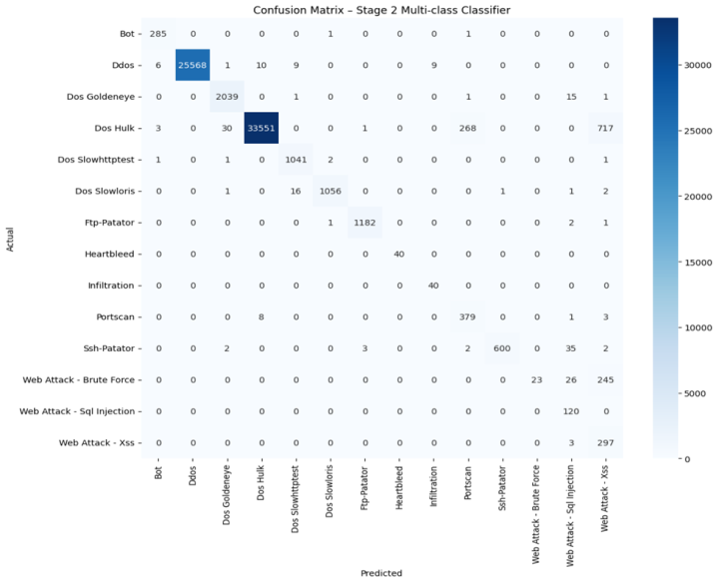
CNN:
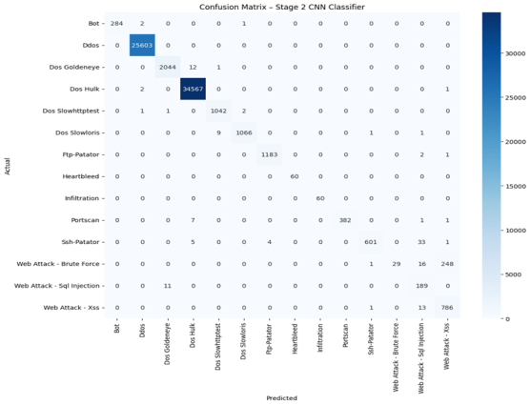

AUTOENCODER:
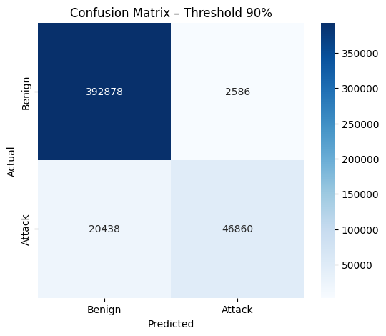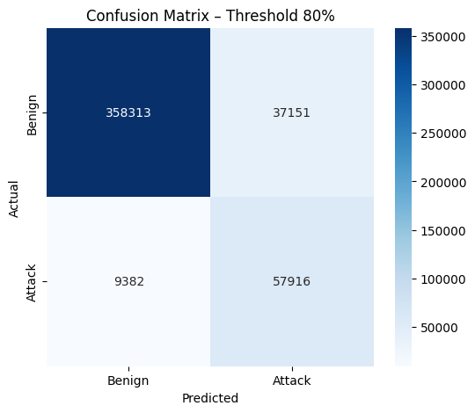

XGBOOST(ALL):
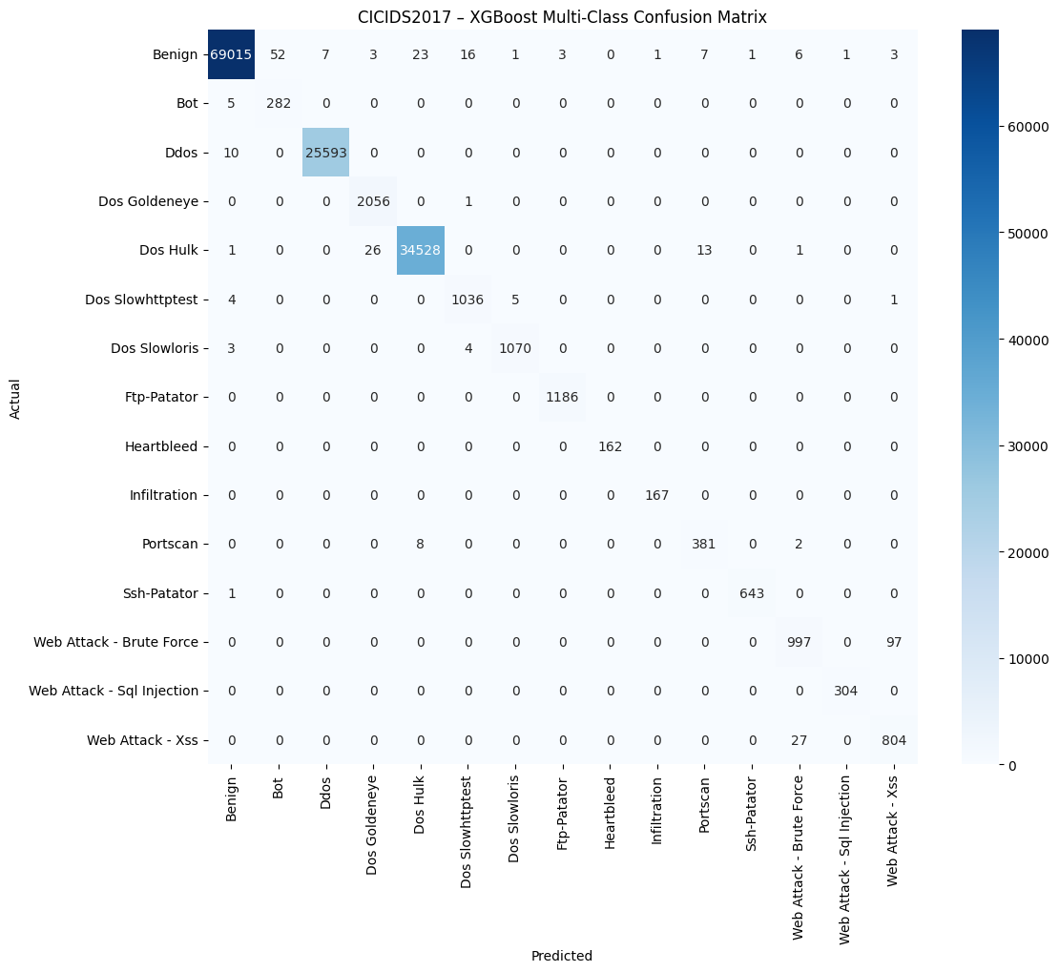

XGBOOST(ALL_Another way):
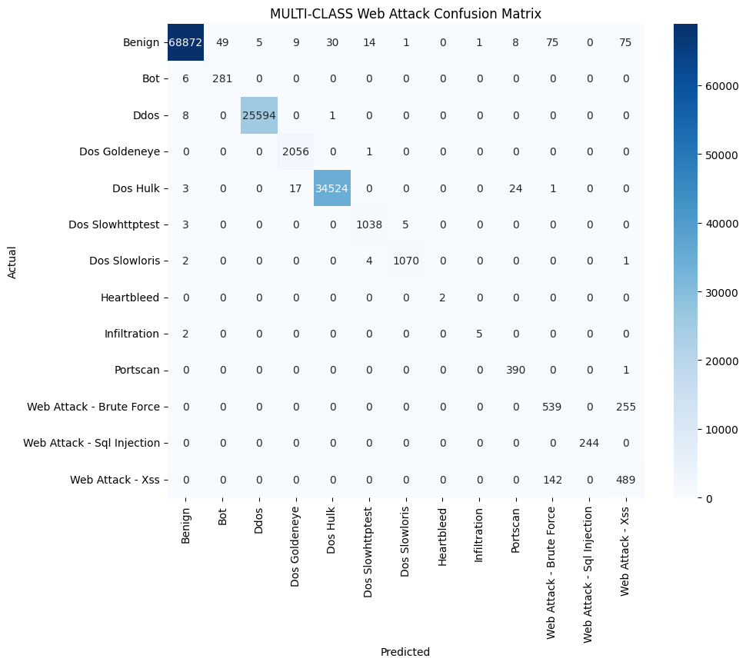

XGBOOST(WEB_ATTACKS):
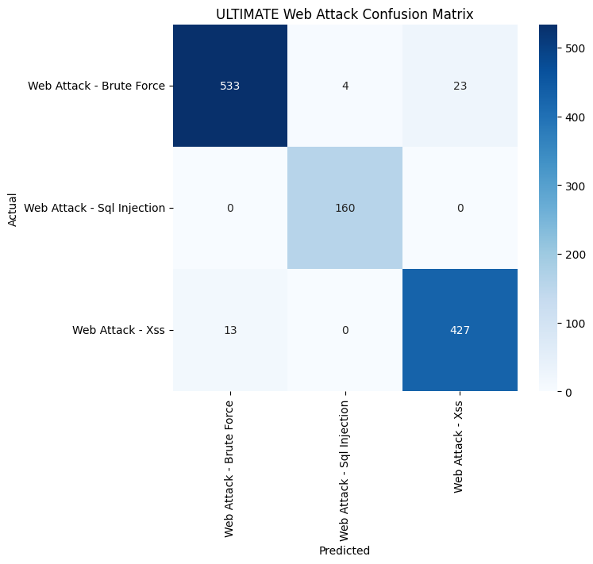

Malicious Traffic Detection

API response showing that the system successfully classified the input network traffic as DoS Hulk, indicating that the intrusion detection model correctly identified a maliSwagger cious attack

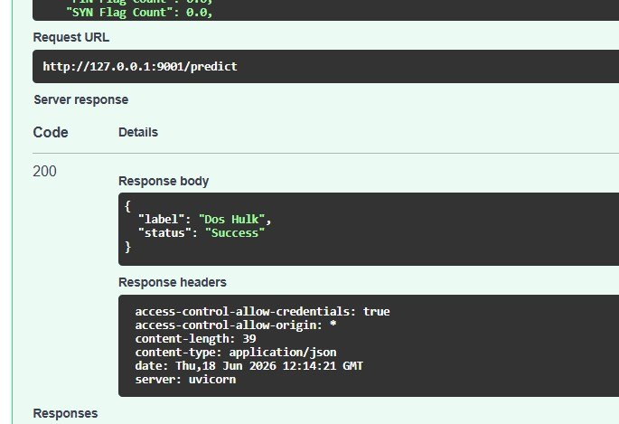

Benign Traffic Detection
Swagger API response showing that the system successfully classified the input network traffic as Benign, confirming that normal traffic is correctly recognized by the machine learning model

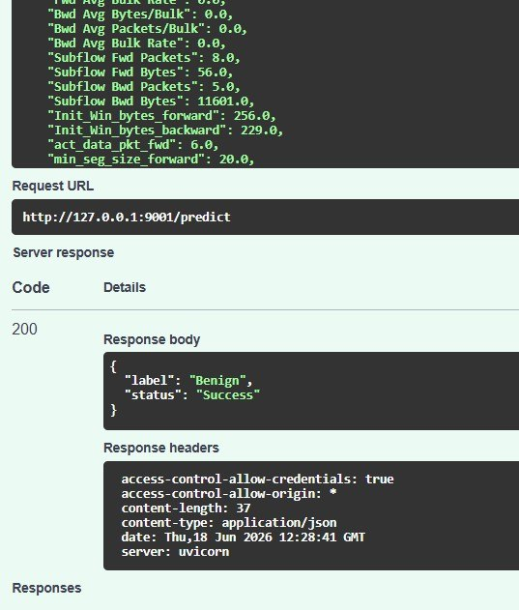

Results & Discussion

5. Results & Analysis
Model | Accuracy | Macro Precision | Macro Recall | Macro F1 | Parameters
MLP | 98% | 0.87 | 0.92 | 0.84 | 62,030
CNN-1D | 99% | 0.96 | 0.92 | 0.91 | ~40,000
MLP:
Class | Precision | Recall | F1-score | Support
Bot | 0.97 | 0.99 | 0.98 | 287
Ddos | 1.00 | 1.00 | 1.00 | 25,603
Dos Goldeneye | 0.98 | 0.99 | 0.99 | 2,057
Dos Hulk | 1.00 | 0.97 | 0.98 | 34,570
Dos Slowhttptest | 0.98 | 1.00 | 0.99 | 1,046
Dos Slowloris | 1.00 | 0.98 | 0.99 | 1,077
Ftp-Patator | 1.00 | 1.00 | 1.00 | 1,186
Heartbleed | 1.00 | 1.00 | 1.00 | 40
Infiltration | 0.82 | 1.00 | 0.90 | 40
Portscan | 0.58 | 0.97 | 0.73 | 391
Ssh-Patator | 1.00 | 0.93 | 0.96 | 644
Web Attack - Brute Force | 1.00 | 0.08 | 0.15 | 294
Web Attack - Sql Injection | 0.59 | 1.00 | 0.74 | 120
Web Attack - Xss | 0.23 | 0.99 | 0.38 | 300
CNN :
Class | Precision | Recall | F1-score | Support
Bot | 1.00 | 0.99 | 0.99 | 287
Ddos | 1.00 | 1.00 | 1.00 | 25,603
Dos Goldeneye | 0.99 | 0.99 | 0.99 | 2,057
Dos Hulk | 1.00 | 1.00 | 1.00 | 34,570
Dos Slowhttptest | 0.99 | 1.00 | 0.99 | 1,046
Dos Slowloris | 1.00 | 0.99 | 0.99 | 1,077
Ftp-Patator | 1.00 | 1.00 | 1.00 | 1,186
Heartbleed | 1.00 | 1.00 | 1.00 | 60
Infiltration | 1.00 | 1.00 | 1.00 | 60
Portscan | 1.00 | 0.98 | 0.99 | 391
Ssh-Patator | 1.00 | 0.93 | 0.96 | 644
Web Attack - Brute Force | 1.00 | 0.10 | 0.18 | 294
Web Attack - Sql Injection | 0.74 | 0.94 | 0.83 | 200
Web Attack - Xss | 0.76 | 0.98 | 0.86 | 800

TRAIN CNN (Benign,attacks):
Class | Precision | Recall | F1-score | Support
Benign | 0.97 | 0.96 | 0.97 | 4589
Bot | 0.98 | 0.88 | 0.92 | 287
Ddos | 1.00 | 1.00 | 1.00 | 25603
Dos Goldeneye | 1.00 | 0.99 | 0.99 | 2057
Dos Hulk | 1.00 | 1.00 | 1.00 | 34569
Dos Slowhttptest | 0.99 | 0.94 | 0.97 | 1046
Dos Slowloris | 0.95 | 0.99 | 0.97 | 1077
Ftp-Patator | 1.00 | 1.00 | 1.00 | 1186
Heartbleed | 1.00 | 1.00 | 1.00 | 60
Infiltration | 1.00 | 0.83 | 0.91 | 60
Portscan | 0.99 | 0.96 | 0.98 | 391
Ssh-Patator | 1.00 | 0.92 | 0.96 | 644
Web Attack - Brute | 1.00 | 0.14 | 0.25 | 294
Web Attack - Sql Injection | 0.76 | 0.73 | 0.74 | 200
Web Attack - Xss | 0.75 | 0.99 | 0.85 | 800
 | Precision | Recall | F1-score | Support
Accuracy | - | - | 0.99 | 72863
Macro Avg | 0.96 | 0.89 | 0.90 | 72863
Weighted Avg | 0.99 | 0.99 | 0.99 | 72863
AUTOENCODER:
Threshold | Class | Precision | Recall | F1-score | Support
80% | Benign | 0.97 | 0.91 | 0.94 | 395,464
 | Attack | 0.61 | 0.86 | 0.71 | 67,298
85% | Benign | 0.96 | 0.95 | 0.96 | 395,464
 | Attack | 0.75 | 0.79 | 0.77 | 67,298
90% | Benign | 0.95 | 0.99 | 0.97 | 395,464
 | Attack | 0.95 | 0.70 | 0.80 | 67,298
92% | Benign | 0.93 | 1.00 | 0.96 | 395,464
 | Attack | 0.98 | 0.58 | 0.73 | 67,298
95% | Benign | 0.90 | 1.00 | 0.95 | 395,464
 | Attack | 0.98 | 0.37 | 0.54 | 67,298
Threshold | Accuracy | Macro Precision | Macro Recall | Macro F1 | Weighted F1
80% | 0.90 | 0.79 | 0.88 | 0.83 | 0.91
90% | 0.95 | 0.95 | 0.84 | 0.89 | 0.95

XGBOOST)All):
Class | Precision | Recall | F1-score | Support
Benign | 1.00 | 1.00 | 1.00 | 69139
Bot | 0.84 | 0.98 | 0.91 | 287
Ddos | 1.00 | 1.00 | 1.00 | 25603
Dos Goldeneye | 0.99 | 1.00 | 0.99 | 2057
Dos Hulk | 1.00 | 1.00 | 1.00 | 34569
Dos Slowhttptest | 0.98 | 0.99 | 0.99 | 1046
Dos Slowloris | 0.99 | 0.99 | 0.99 | 1077
Ftp-Patator | 1.00 | 1.00 | 1.00 | 1186
Heartbleed | 1.00 | 1.00 | 1.00 | 162
Infiltration | 0.99 | 1.00 | 1.00 | 167
Portscan | 0.95 | 0.97 | 0.96 | 391
Ssh-Patator | 1.00 | 1.00 | 1.00 | 644
Web Attack - Brute Force | 0.97 | 0.91 | 0.94 | 1094
Web Attack - Sql Injection | 1.00 | 1.00 | 1.00 | 304
Web Attack - Xss | 0.89 | 0.97 | 0.93 | 831
Accuracy | - | - | 1.00 | 138,557
Macro Avg | 0.97 | 0.99 | 0.98 | 138,557
Weighted Avg | 1.00 | 1.00 | 1.00 | 138,557
XGBOOST(web _attacks):
Class | Precision | Recall | F1-score | Support
Web Attack - Brute Force | 0.98 | 0.95 | 0.96 | 560
Web Attack - Sql Injection | 0.98 | 1.00 | 0.99 | 160
Web Attack - Xss | 0.95 | 0.97 | 0.96 | 440
Accuracy | - | - | 0.97 | 1160
Macro Avg | 0.97 | 0.97 | 0.97 | 1160
Weighted Avg | 0.97 | 0.97 | 0.97 | 1160
XGBOOST(ALL_Another):
Class | Precision | Recall | F1-score | Support
Benign | 1.00 | 1.00 | 1.00 | 69,139
Bot | 0.85 | 0.98 | 0.91 | 287
Ddos | 1.00 | 1.00 | 1.00 | 25,603
Dos Goldeneye | 0.99 | 1.00 | 0.99 | 2,057
Dos Hulk | 1.00 | 1.00 | 1.00 | 34,569
Dos Slowhttptest | 0.98 | 0.99 | 0.99 | 1,046
Dos Slowloris | 0.99 | 0.99 | 0.99 | 1,077
Heartbleed | 1.00 | 1.00 | 1.00 | 2
Infiltration | 0.83 | 0.71 | 0 .77 | 7
Portscan | 0.92 | 1.00 | 0.96 | 391
Web Attack - Brute Force | 0.71 | 0.68 | 0.70 | 794
Web Attack - Sql Injection | 1.00 | 1.00 | 1.00 | 244
Web Attack - Xss | 0.60 | 0.77 | 0.67 | 631
Accuracy | – | – | 0.99 | 135,847
Macro Avg | 0.91 | 0.93 | 0.92 | 135,847
Weighted Avg | 1.00 | 0.99 | 0.99 | 135,847

