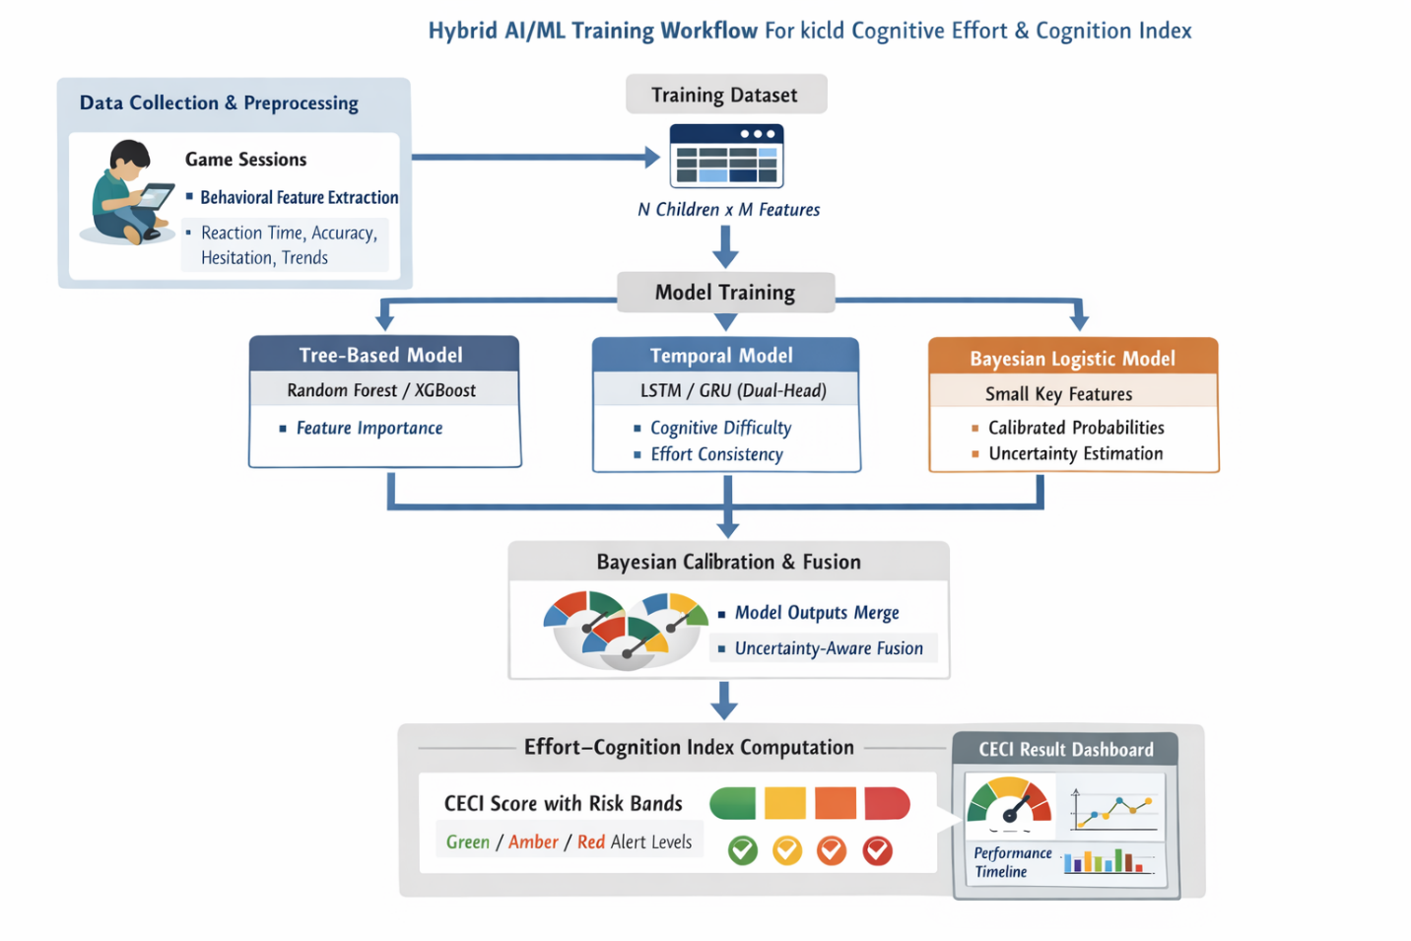No single model can simultaneously capture longitudinal effort patterns, provide interpretable feature insights, and produce calibrated uncertainty, which is why a hybrid approach is necessary for reliable early childhood screening.
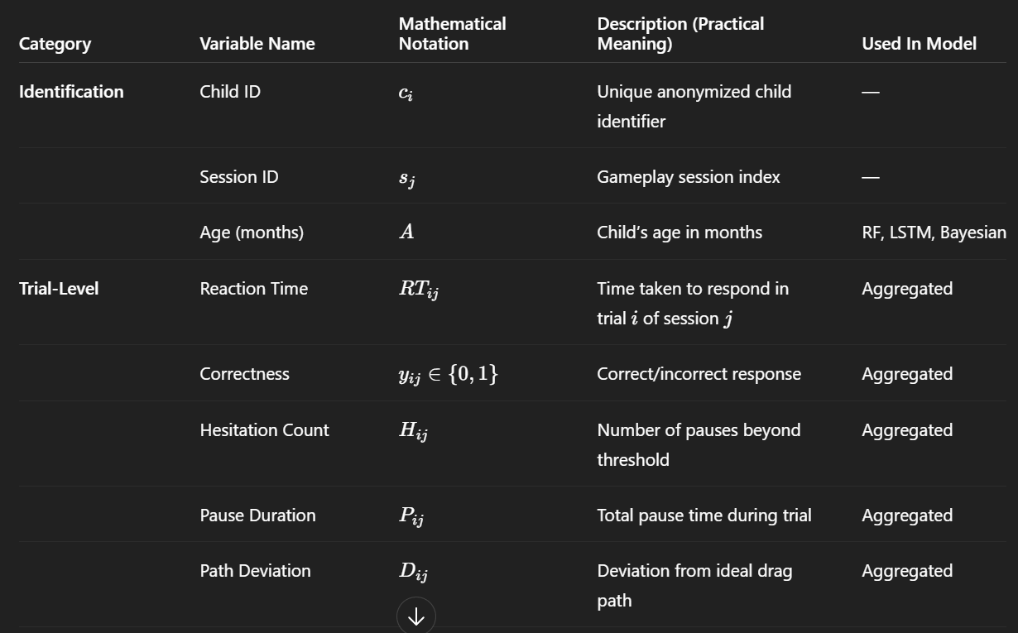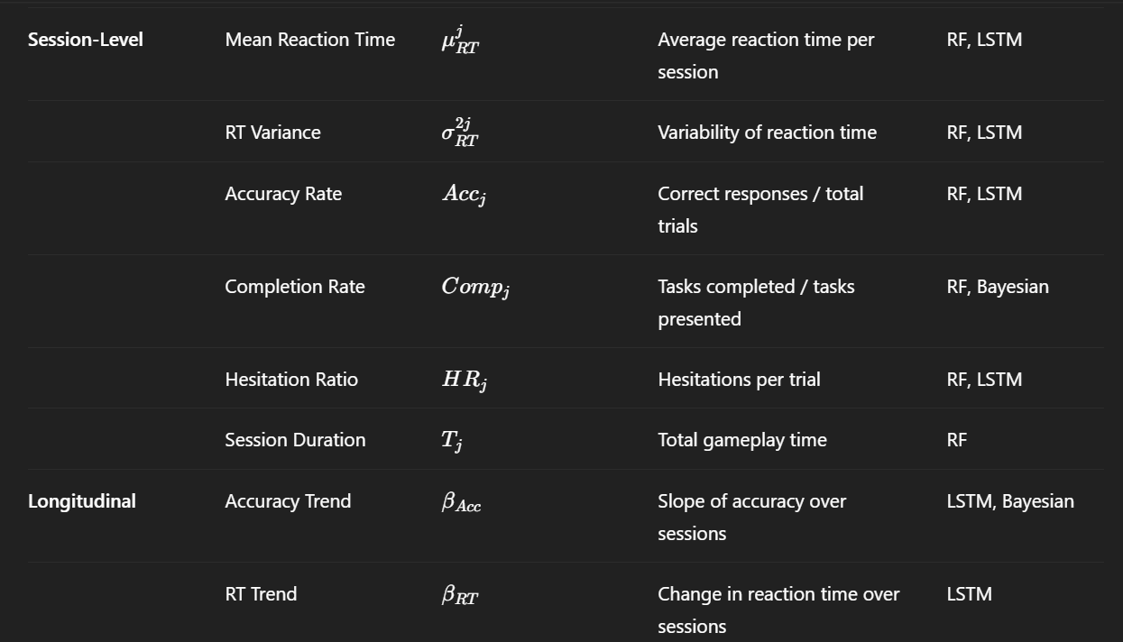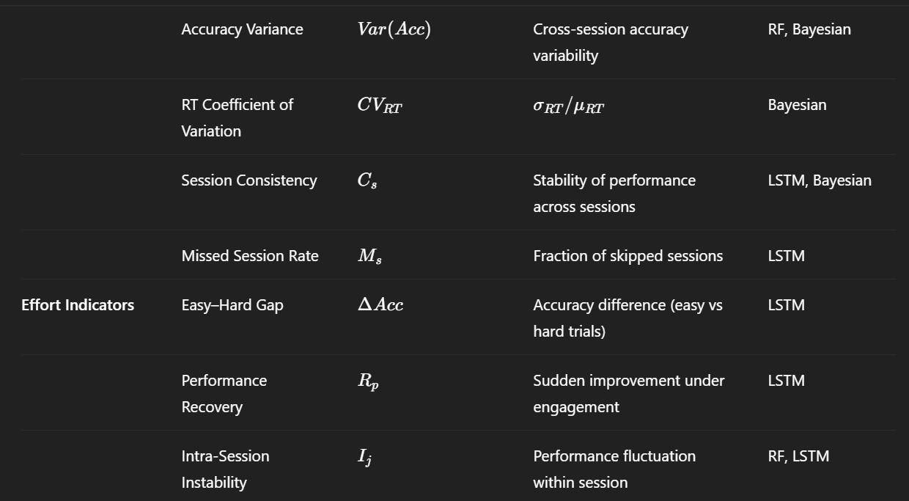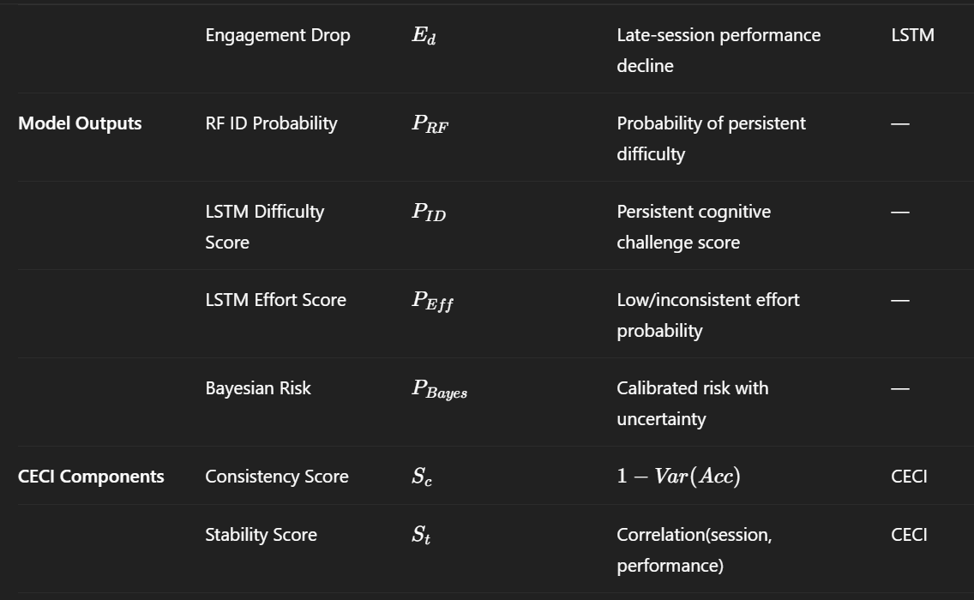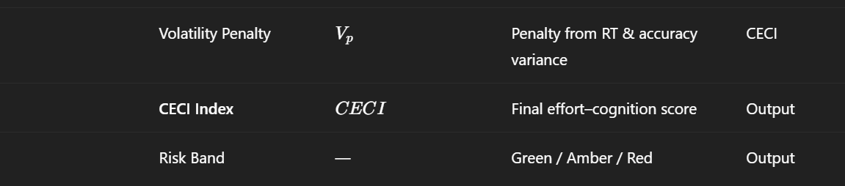
For understanding:
Left Block — Behavioral Data Input
What the diagram shows
- Multi-session gameplay data
- Reaction time, accuracy, hesitation, engagement
- Sessions collected over days/weeks
Why this matters
- A single snapshot is unreliable in children
- Variability itself is a diagnostic signal
This raw data feeds three parallel learning paths, not one.

Middle-Left Block — Tree-Based Model (RF / XGBoost)
Diagram role
- Takes aggregated, tabular features
- Outputs baseline risk score
- Produces feature importance
Why it exists
- Works well with small datasets
- Highly interpretable
- Answers: “Which behaviors matter most?”
Limitation shown implicitly
- No temporal awareness
- Cannot model session order
Middle-Right Block — Temporal Model (LSTM / GRU)
Diagram role
- Takes ordered session vectors
- Learns trends, volatility, recovery
- Dual outputs:
  - Persistent difficulty
  - Low / inconsistent effort
Why it exists
- Effort consistency is a time-based phenomenon
- Captures:
  - Improvement vs stagnation
  - Fluctuation vs stability
Limitation shown
- Less interpretable
- Can be over-confident with limited data

Upper Block — Bayesian Logistic Model (Calibration Layer)
Diagram role
- Consumes a small set of key features
- Outputs calibrated probability + uncertainty
- Activated especially for borderline cases
Why it exists
- Prevents overconfident predictions
- Adds safety in early screening
- Ideal when:
  - Models disagree
  - Data is sparse
  - Risk is high
Right Block — Fusion into CECI
Diagram role
- Combines outputs from:
  - RF/XGBoost
  - LSTM/GRU
  - Bayesian model
- Produces a single interpretable score
CECI bands
- Green → Likely effort variability
- Amber → Monitor closely
- Red → Recommend specialist referral
Key idea
➡️ Multiple perspectives → one stable decision cue
Bottom Block — Human Decision Loop

Diagram role

Parents / teachers see simple indicators
Therapists see explanations + trends
Decisions influence next sessions
Why this is critical?
System supports humans
Does not replace diagnosis
Allows continuous reassessment

