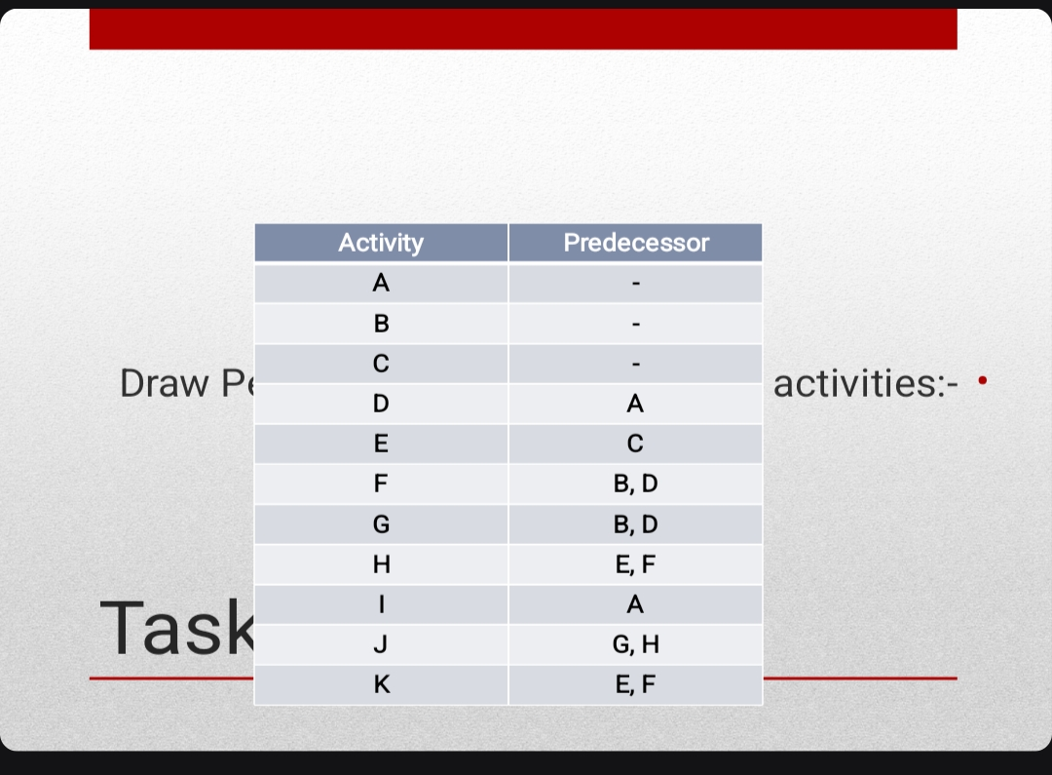

A
B
C
E
H
G
F
D
K
I
J

