
Faculty of Engineering and Technology
Electrical and Computer Engineering Department
Machine Learning and Data Science - ENCS5341

Assignment #3
Label Contradiction Prediction
Prepared by:
Fadi Bassous 1221005
Taima Nasser 1222640
Instructor: Dr. Yazan Abu Farha

Section: 2
Date: 6/1/2025

Abstract
Detecting internal inconsistencies in human-generated data is a common challenge in practical machine learning applications, particularly when labels are weakly supervised or derived from heuristic rules. In this project, we address the task of identifying contradictory entries in student-generated travel descriptions using contextual features such as season, weather, time of day, and activity type. Rather than relying solely on rule-based logic, we generate consistency labels using interpretable domain rules and then frame the problem as a supervised classification task to evaluate whether machine learning models can learn and generalize inconsistency patterns beyond explicit if–else conditions. We evaluate a K-Nearest Neighbors baseline alongside Random Forest and an Artificial Neural Network using consistent preprocessing and stratified train–test splits. Performance is assessed using accuracy, class-wise precision and recall, macro-averaged F1-score, and ROC–AUC. The results show that Random Forest achieves the strongest overall performance with excellent class separability and robustness, while the ANN provides a competitive non-linear alternative. Error analysis reveals that most misclassifications arise from ambiguous or underspecified inputs rather than systematic model failures, demonstrating how machine learning can complement rule-based systems by learning scalable, data-driven representations of inconsistency in structured human-generated data.

Table of Content
Abstract 2
Table of Content 3
List of Figures 4
List of Tables 5
Introduction 1
Task Description 1
Models Explored 1
Evaluation Metrics 1
Exploratory Data Analysis 2
Experiments and Results 4
1. Experimental Setup 4
2. Baseline Model: K-Nearest Neighbors (KNN) 4
3. Proposed Model 1: Random Forest 5
4. Proposed Model 2: Artificial Neural Network (ANN) 6
5. Model Comparison and Interpretation 8
Analysis 9
Conclusions and Discussion 10

List of Figures
Figure 1 Distribution of Consistency Labels 2
Figure 2 Season, Weather, Time of Day and Activity Bucket Distribution 2
Figure 3 Comparative analyses 3
Figure 4 Distribution of Contradiction Rates per Student 3
Figure 5 Correlation Heatmap of Encoded Features 3
Figure 6 KNN K=1 Test Set Confusion Matrix 4
Figure 7 KNN K=3 ROC Curve 4
Figure 8 KNN K=1 ROC Curve 4
Figure 9 KNN K=3 Test Set Confusion Matrix 5
Figure 10 Tuned Random Forest Test Set Confusion Matrix 5
Figure 11 Tuned Random Forest ROC Curve 5
Figure 12 Learning Curves of the ANN (Training vs. Validation Metrics) 6
Figure 13 ANN Test Set Confusion Matrix 6
Figure 14 ANN ROC Curve 7

List of Tables
Table 1 Model Performance Comparison 9

Introduction

Task Description
This project focuses on detecting logical contradictions in structured, travel-related student data by examining the consistency between attributes such as season, weather, time of day, and activity. While many inconsistencies can be identified using deterministic rules, rule-based checks are used as weak supervision to generate labels for training supervised machine learning models. The models are then evaluated on their ability to generalize beyond explicit rules, handle ambiguity, and remain robust to noise and incomplete logic.
The project has two objectives:
- Design interpretable rule-based logic for contradiction labeling.
- Assess the ability of supervised learning models to replicate and extend this logic.

Models Explored
Three supervised models were evaluated using a consistent train–test split:
- K-Nearest Neighbors (KNN): A simple baseline based on feature similarity.
- Random Forest (RF): A non-linear ensemble model capable of capturing complex feature interactions, tuned using GridSearchCV.
- Artificial Neural Network (ANN): A feedforward network implemented in Keras, with architecture and regularization optimized using Keras Tuner.

Evaluation Metrics
Due to class imbalance, multiple metrics were used beyond accuracy:
- Precision, Recall, and F1-score (with emphasis on contradiction recall)
- Macro-averaged metrics
- Confusion matrices
- ROC AUC
These metrics provide a balanced and comprehensive assessment of contradiction detection performance.

Exploratory Data Analysis
The EDA aimed to understand data balance, feature distributions, and factors associated with contradictory records.
The target variable Consistency_Label is imbalanced, with most samples labeled Consistent (86.7%) and a smaller portion Contradictory (13.3%) (Fig. 1). This imbalance suggests that accuracy alone is insufficient for evaluation.
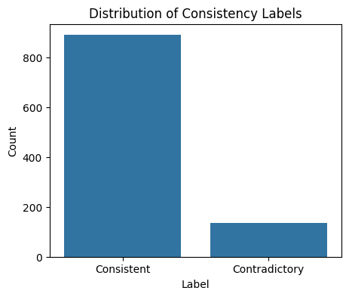
Figure 1 Distribution of Consistency Labels
Feature distributions (Figs. 2) show that the dataset is dominated by common and well-defined conditions such as Summer, Sunny weather, and Afternoon/Evening. Rare categories, including Winter, Snowy, Night, and Not Clear, appear less frequently and introduce sparsity. Activity labels are highly skewed toward Sightseeing, while several activities occur only a few times.
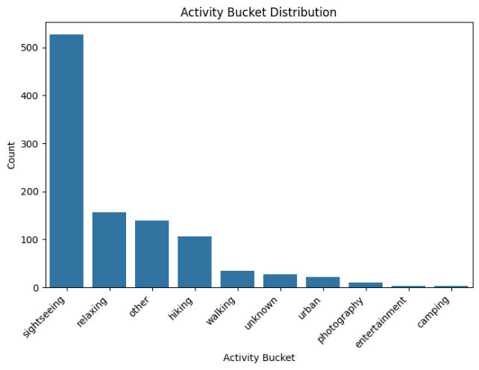
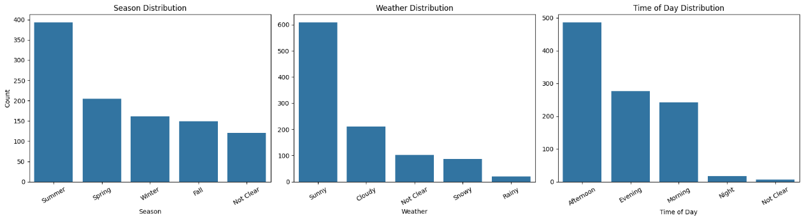

Figure 2 Season, Weather, Time of Day and Activity Bucket Distribution
Comparative analyses (Figs. 3 Comparative analyses) reveal that contradictions occur more often under Winter, Snowy, and Not Clear conditions, while Sunny weather and Summer season are largely consistent. Evening and Night scenarios exhibit relatively higher inconsistency rates.
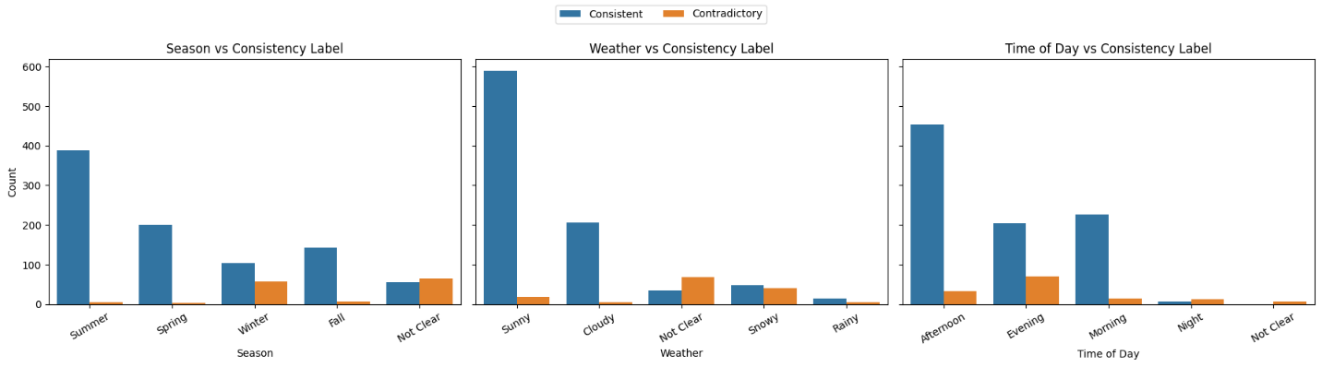
Figure 3 Comparative analyses
Student-level analysis (Fig. 4) shows nearly uniform contributions across students, with most contradiction rates below 20%, indicating that inconsistencies arise from ambiguous scenarios rather than individual annotator bias.
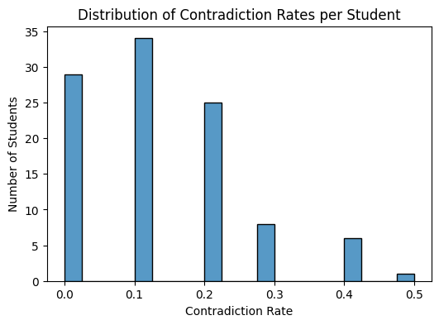
Figure 4 Distribution of Contradiction Rates per Student
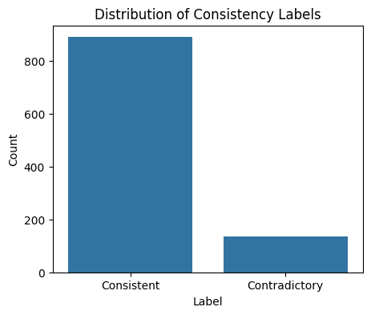
Finally, the correlation heatmap (Fig. 5) confirms that Not Clear and Snowy conditions are positively correlated with contradictions, while clear and favorable conditions are negatively correlated.

Figure 5 Correlation Heatmap of Encoded Features

Experiments and Results

Experimental Setup
All models were trained and evaluated using a stratified 80/20 train–test split to preserve the consistency label distribution. Categorical features (Season, Weather, Time of Day, Activity) were one-hot encoded, and distance-based models additionally used feature standardization. The binary target indicated whether an entry was consistent or contradictory. Hyperparameter tuning was performed using cross-validation on the training set, and final results were reported on the test set.

Baseline Model: K-Nearest Neighbors (KNN)
KNN was used as a baseline due to its simplicity and interpretability. Two configurations were evaluated: k = 1 and k = 3, using Euclidean distance and distance-based weighting.
Both models achieved perfect performance on the training set, indicating memorization. On the test set, KNN performed well overall, with k = 1 outperforming k = 3, particularly in recall for the contradictory class. The ROC AUC scores for both configurations were approximately 0.91, indicating good but not exceptional discrimination.
KNN served as a useful reference point but showed limitations in generalization, especially for rare or ambiguous contradiction cases.
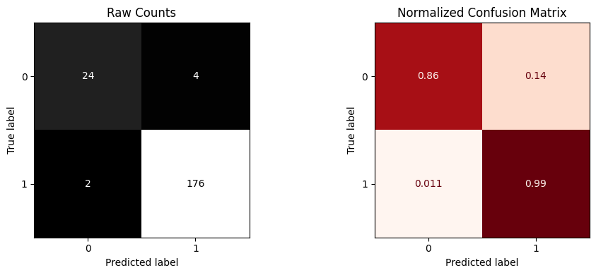
Figure 6 KNN K=1 Test Set Confusion Matrix
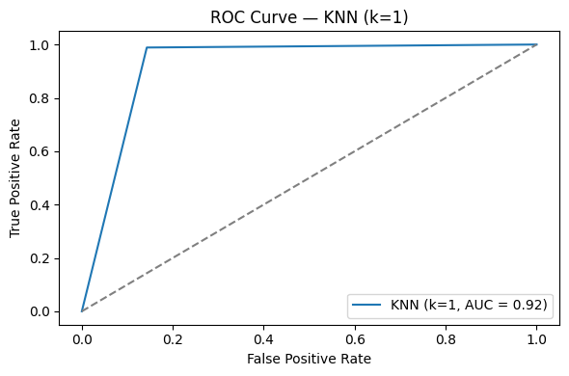
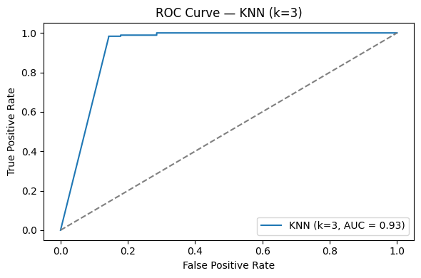
Figure 7 KNN K=3 ROC Curve

Figure 8 KNN K=1 ROC Curve
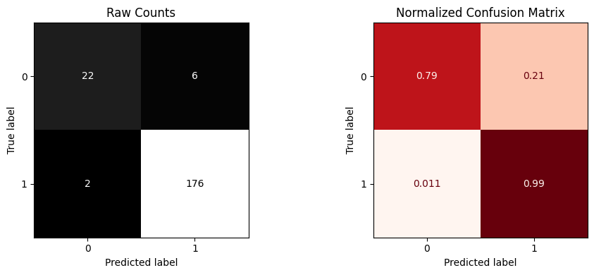

Figure 9 KNN K=3 Test Set Confusion Matrix

Proposed Model 1: Random Forest
Random Forest was selected as the primary model due to its strong suitability for structured, one-hot encoded categorical data. It effectively captures non-linear interactions between contextual features (season, weather, time of day, and activity) without requiring feature scaling and is robust to noise introduced by weak supervision. Class weighting further improved its ability to detect the relatively rare contradictory cases.
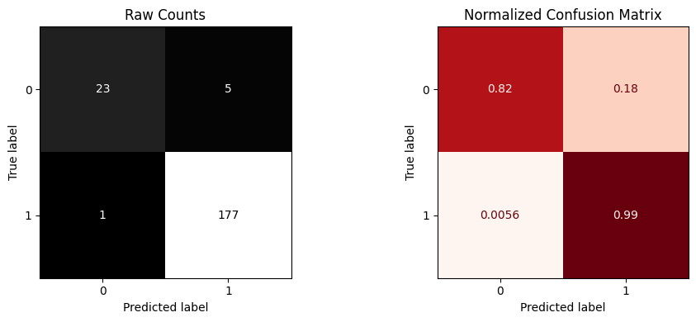
On the test set, the model achieved 98% accuracy, with strong performance on both classes. For the contradictory class, it obtained a precision of 0.96, recall of 0.86, and F1-score of 0.91, while the consistent class achieved an F1-score of 0.99. The macro-averaged F1-score was 0.95, and the ROC–AUC reached 0.996, indicating excellent class separability. Overall, the results demonstrate strong generalization with no significant overfitting.

Figure 10 Tuned Random Forest Test Set Confusion Matrix
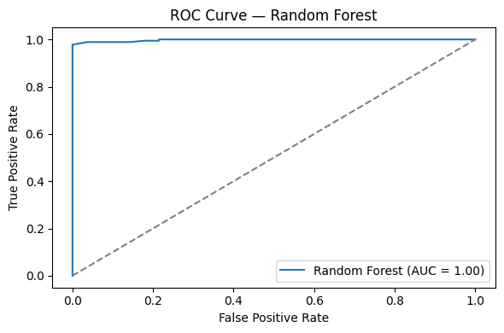

Figure 11 Tuned Random Forest ROC Curve

Proposed Model 2: Artificial Neural Network (ANN)
An Artificial Neural Network (ANN) was explored to model non-linear relationships in the high-dimensional feature space created by one-hot encoded categorical variables. The ANN was trained on the same standardized inputs used for KNN, and its architecture was optimized using Keras Tuner to ensure a fair comparison.
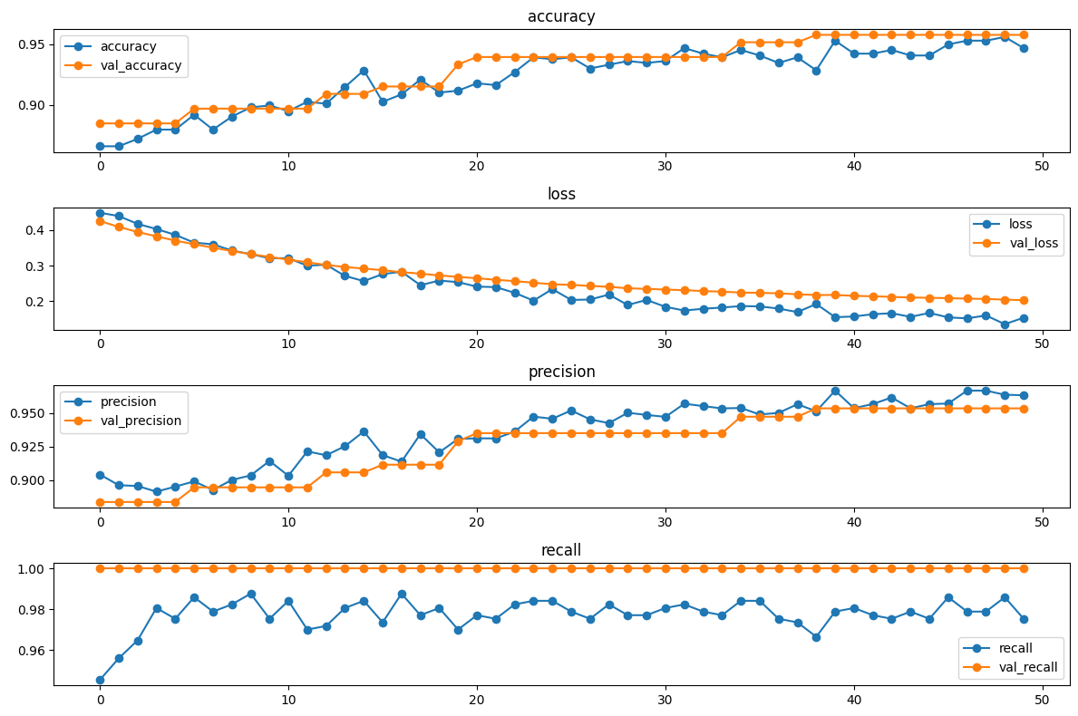
On the test set, the ANN achieved 96% accuracy, with balanced performance on the contradictory class (precision 0.86, recall 0.86, F1-score 0.86) and strong results for the consistent class (F1-score 0.98). The macro-averaged F1-score was 0.92, and the ROC–AUC reached 0.969. Learning curves showed smooth convergence with minimal gaps between training and validation metrics, indicating good generalization without evident overfitting.
Figure 12 Learning Curves of the ANN (Training vs. Validation Metrics)

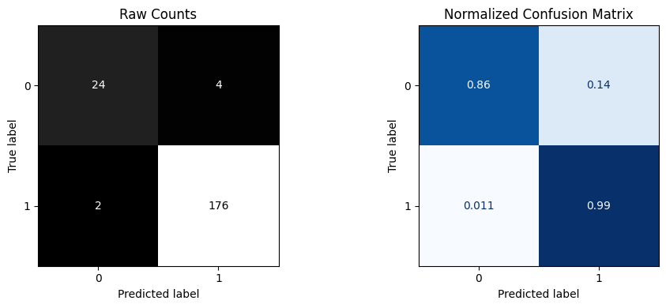

Figure 13 ANN Test Set Confusion Matrix

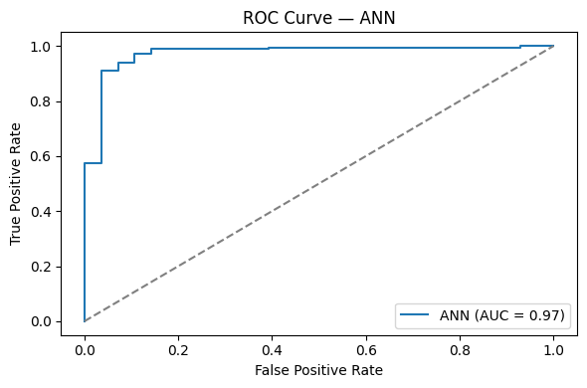
Figure 14 ANN ROC Curve

Model Comparison and Interpretation
Three models were evaluated for detecting internal contradictions in student-generated travel descriptions: KNN, Random Forest, and an Artificial Neural Network (ANN), all using the same stratified train–test split. The KNN baseline showed strong training performance but weaker generalization, with lower ROC–AUC due to sensitivity to noise and class imbalance in the high-dimensional feature space.
Random Forest achieved the best overall performance, with the highest accuracy and ROC–AUC, indicating excellent class separability and stable generalization. It effectively captured non-linear interactions between contextual features, and hyperparameter tuning resulted in only minor performance changes, confirming model robustness.
The ANN improved substantially over KNN and demonstrated smooth training and validation convergence without overfitting. Although slightly below Random Forest in ROC–AUC, it maintained strong recall for contradictory cases. Overall, Random Forest was selected as the most reliable model, with ANN as a strong alternative and KNN serving primarily as a baseline.
Model | Accuracy | Recall (Contradictory) | Precision (Contradictory) | Macro F1 | ROC–AUC
KNN (k = 1) | 0.97 | 0.82 | 0.92 | 0.92 | 0.905
KNN (k = 3) | 0.96 | 0.79 | 0.92 | 0.91 | 0.907
ANN | 0.96 | 0.86 | 0.86 | 0.92 | 0.969
RF | 0.98 | 0.86 | 0.96 | 0.95 | 0.996
Table 1 Model Performance Comparison

Analysis
Model error analysis focused on understanding misclassifications using confusion matrices, class-specific recall, and ROC curves, with particular emphasis on the contradictory class. Since contradictions are less frequent and inherently ambiguous, recall and false-negative errors were treated as the primary indicators of model limitations.
Across all models, the most common errors were false negatives, where contradictory samples were predicted as consistent. These errors occurred mainly in cases involving Winter, Snowy, or Not Clear conditions, where contradictions are less explicit and rule-based labels are weaker. This suggests that some inconsistencies reflect genuine contextual ambiguity rather than clear logical conflicts.
The KNN model showed the highest sensitivity to local noise, misclassifying contradictory cases when neighboring samples belonged to the majority class. This behavior is evident in its confusion matrices and relatively lower ROC–AUC scores. The ANN reduced this issue by learning higher-level feature interactions, resulting in more balanced errors and stable training behavior, as confirmed by smooth learning curves and aligned training–validation metrics.
Random Forest produced the fewest errors overall. Its confusion matrix shows high true positive rates for both classes, and its near-perfect ROC–AUC indicates strong class separability. Remaining errors were concentrated in overlapping feature combinations rather than random noise, indicating that performance is primarily limited by data ambiguity and weak supervision, not model capacity.
Overall, the error analysis confirms that Random Forest is the most robust model for this task, while ANN offers a strong alternative. The remaining misclassifications highlight the need for clearer labels or richer contextual features rather than more complex models.

Conclusions and Discussion
This project investigated the detection of logical contradictions in structured, student-generated travel descriptions using supervised learning models trained on weakly supervised labels. Exploratory analysis showed that contradictions are relatively rare and are strongly associated with ambiguous or extreme conditions such as Snowy or Not Clear weather and season. Among the evaluated models, Random Forest achieved the best overall performance, delivering the highest accuracy, macro F1-score, and ROC–AUC, while maintaining strong recall for the contradictory class. The ANN provided competitive results and demonstrated good generalization, whereas KNN served as a useful baseline but showed limited robustness in high-dimensional, imbalanced settings.
Despite strong performance, several limitations remain. The dataset is imbalanced, with contradictory cases forming a small minority, which can bias models toward predicting consistency. Additionally, contradiction labels are derived from rule-based logic, which introduces noise and subjectivity, particularly for borderline cases. Some feature categories are also sparsely represented, limiting the model’s ability to learn reliable patterns for rare scenarios. Finally, while ROC–AUC and F1-score provide useful insights, they may not fully capture the semantic severity of certain contradictions.
Future work could focus on improving label quality through manual verification or multi-level contradiction categories, incorporating additional contextual features (e.g., location or activity constraints), and exploring cost-sensitive or semi-supervised learning approaches to better handle ambiguity. These extensions could further enhance robustness and generalization in real-world consistency detection tasks.

