CIS 517 – Data Mining
Course Project 2026–2027
Predicting Online Shoppers’ Purchasing Intention
Statistical analysis, preprocessing, outlier analysis and classification with Logistic Regression, Decision Tree and Random Forest

Group 4

Table of Contents

Figure 1. Class distribution of the target variable Revenue 7
Figure 2Histograms of the numeric attributes 7
Figure 3: Pearson correlation matrix of numeric attributes and Revenue 8
Figure 4Missing-value check results. 9

1. Introduction
The shopper might go to an online store, browse through product pages, take some time to compare the products, and then decide whether or not to purchase something. These browsing patterns can help us understand what separates sessions that end in a purchase from those that don’t. In this project, we will use Python to explore and preprocess the Online Shoppers Purchasing Intention dataset. Then we develop three classification models to predict the outcome of a shopping session, and compare their performance. We employed logistic regression, decision tree and random forest as models.
The dataset consists of 12,330 shopping sessions and 18 columns. Each row is a session. The 17 input features describe things like whether the visitor was new or returning, the number of product pages the visitor viewed and the time spent on those pages. The target variable, Revenue, indicates whether the session ended with a purchase. Table 1 lists the attributes of the dataset.

Table 1: Attributes of the dataset
Attribute | Type | Description
Administrative, Informational, ProductRelated | Numeric (count) | Number of pages of each category visited in the session
…_Duration (3 attributes) | Numeric (seconds) | Total time spent on each page category
BounceRates | Numeric (0–1) | Average bounce rate of the pages visited (left after one page)
ExitRates | Numeric (0–1) | Average exit rate of the pages visited
PageValues | Numeric | Average value of the pages visited during a session (Google Analytics)
SpecialDay | Numeric (0–1) | Closeness of the visit to a special day (e.g. Mother’s Day)
Month | Categorical | Month of the visit (10 months; January and April are not recorded)
OperatingSystems, Browser, Region, TrafficType | Categorical (codes) | Integer codes; the numbers are labels, not quantities
VisitorType | Categorical | Returning_Visitor, New_Visitor or Other
Weekend | Binary | Whether the visit was on a weekend
Revenue (target) | Binary | Whether the session ended with a purchase

2. Task 1 – Python Packages and Code Structure
All the work was done in a single Python script, cis517_tasks_1_2.py, which is organised into sections that follow the project tasks (Task 1 and Task 2). Running the script reproduces every number, table and figure in this report. The packages used and the reason for using each one are shown in Table 2.
Table 2: Python packages used in the task1 and task 2
Package | Used for
pandas | Loading the CSV file, exploring the data (head), grouping, one-hot encoding (get_dummies), result tables
numpy | Calculating the percentage of sessions that ended in a purchase using np.mean().
matplotlib / seaborn | Bar chart of purchase outcomes, histograms, and a correlation heatmap.

The script imports the required packages, creates folders for the figures and results, loads the dataset, and displays its shape and first five rows.
os.makedirs("figures", exist_ok=True) # folder for the plots
os.makedirs("results", exist_ok=True) # folder for the result tables
df = pd.read_csv("online_shoppers_intention.csv")
print("Shape (rows, columns):", df.shape) # (12330, 18)
print(df.head())

To evaluate every model in exactly the same way, a small helper function evaluate() was written. It predicts the test set, calculates five metrics and saves them in a list that later becomes the comparison table:
def evaluate(name, model, X_te, y_te):
y_pred = model.predict(X_te) # predicted class (0/1)
y_prob = model.predict_proba(X_te)[:, 1] # probability of purchase
scores = {"Model": name,
"Accuracy": accuracy_score(y_te, y_pred),
"Precision": precision_score(y_te, y_pred),
"Recall": recall_score(y_te, y_pred),
"F1-score": f1_score(y_te, y_pred),
"ROC-AUC": roc_auc_score(y_te, y_prob)}
results.append(scores)
print(classification_report(y_te, y_pred, digits=3))
return y_pred, y_prob

Choice of metric. Only about 15.5% of sessions end with a purchase, so a model that always predicts “no purchase” would already reach about 84.5% accuracy while being useless. For this reason, the F1-score of the purchase class (the balance between precision and recall) is used as the main metric for tuning and comparison
This function is defined in Task 1. After the three models are trained in Task 5, the function is used to evaluate each model on the same test set. The results are compared in Task 6.

3. Task 2 – Statistical Analysis of the Dataset

3.1 Descriptive statistics
Pandas functions were used to calculate the mean, standard deviation, median, minimum and maximum of the numeric attributes.
Table 3: Descriptive statistics of the numeric attributes (min = 0 for all)
Attribute | Mean | Std | Median | Max
Administrative | 2.32 | 3.32 | 1.00 | 27.00
Administrative_Duration | 80.82 | 176.78 | 7.50 | 3398.75
Informational | 0.50 | 1.27 | 0.00 | 24.00
Informational_Duration | 34.47 | 140.75 | 0.00 | 2549.38
ProductRelated | 31.73 | 44.48 | 18.00 | 705.00
ProductRelated_Duration | 1194.75 | 1913.67 | 598.94 | 63973.52
BounceRates | 0.02 | 0.05 | 0.00 | 0.20
ExitRates | 0.04 | 0.05 | 0.03 | 0.20
PageValues | 5.89 | 18.57 | 0.00 | 361.76
SpecialDay | 0.06 | 0.20 | 0.00 | 1.00

Observations:
- There are no missing values – every column has 12,330 non-null values.
- The median time spent on product-related pages was 598.94 seconds (about 10 minutes). The longest recorded time was 63,973.52 seconds (about 17.8 hours).
- In this dataset, BounceRates and ExitRates both ranged from 0.00 to 0.20. SpecialDay ranged from 0 to 1 and indicates how close a visit was to a special day.

3.2 Categorical attributes

For the categorical attributes, the frequency and percentage of each category were calculated using value_counts(). May is the most frequent month (27.3% of sessions), 85.6% of sessions are from returning visitors, and 76.7% occur on weekdays. OperatingSystems, Browser, Region and TrafficType are stored as integers, but these numbers represent categories rather than quantities. Therefore, frequencies and percentages were used to describe these attributes instead of means.

3.3 Target variable and class imbalance
Of the 12,330 sessions, 1,908 ended in a purchase (15.47%) and 10,422 ended without a purchase (84.53%). Purchase sessions therefore represent the minority class in this dataset.
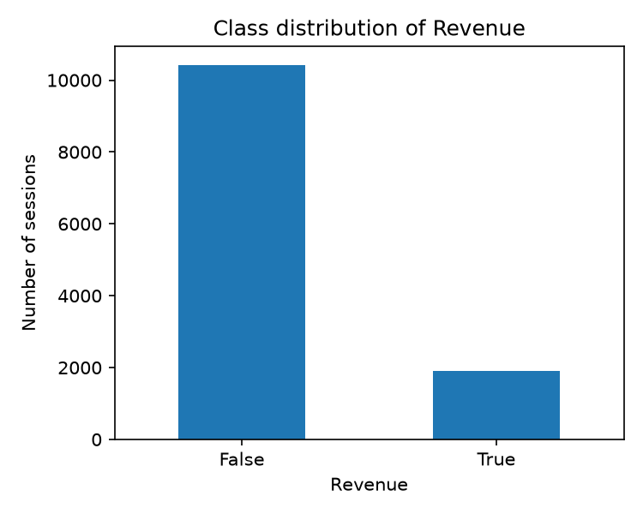
Figure 1. Class distribution of the target variable Revenue

3.4 Distributions and correlation
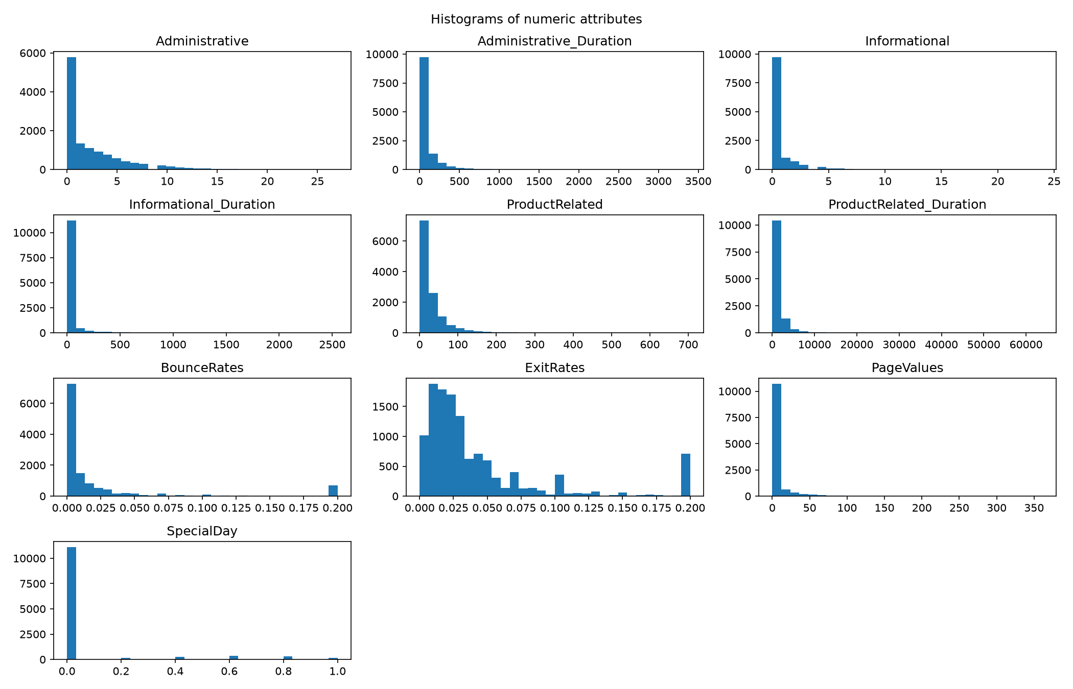
Figure 2Histograms of the numeric attributes
Figure 2 shows that in most sessions, visitors viewed relatively few product-related pages and spent a short time on them. In a few sessions, visitors viewed many more pages or spent much longer on them. The Pearson correlation matrix (Figure 3) shows that:
- PageValues has the strongest positive correlation with Revenue among the numeric attributes shown (r = 0.49).
- ExitRates (r = −0.21) and BounceRates (r = −0.15) are negatively correlated with Revenue. Higher values of these attributes are associated with a lower likelihood of purchase.
- BounceRates and ExitRates are highly correlated with each other (r = 0.91), as are ProductRelated and ProductRelated_Duration (r = 0.86).

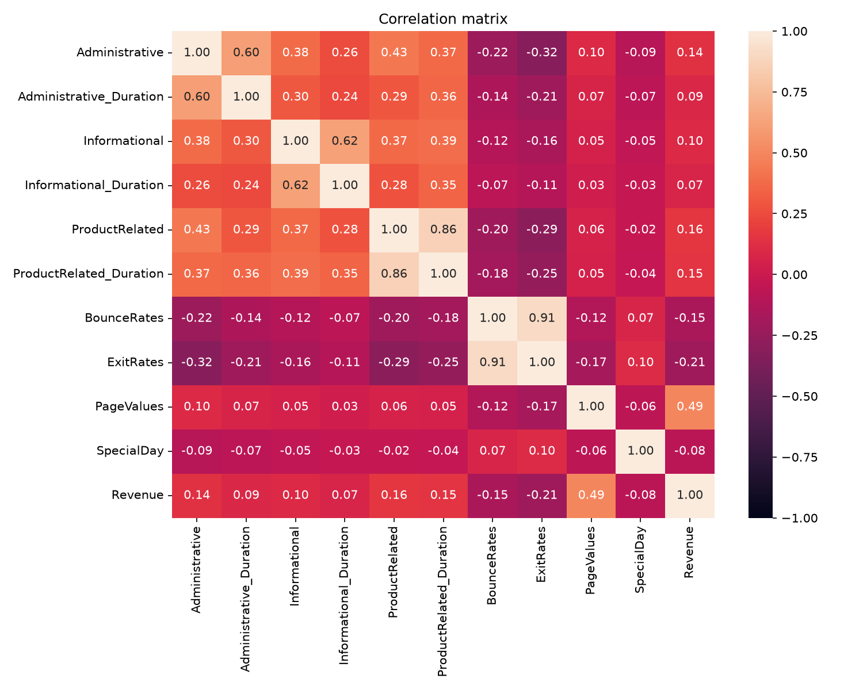
Figure 3: Pearson correlation matrix of numeric attributes and Revenue

4. Task 3 – Data Preprocessing

4.1 Checking the Data and Missing Values
We checked the dataset with the help of the methods info(), shape, and isnull().sum(). The dataset consists of 12,330 records and 18 columns. There were no missing values detected, so no filling or removal of missing values was required.
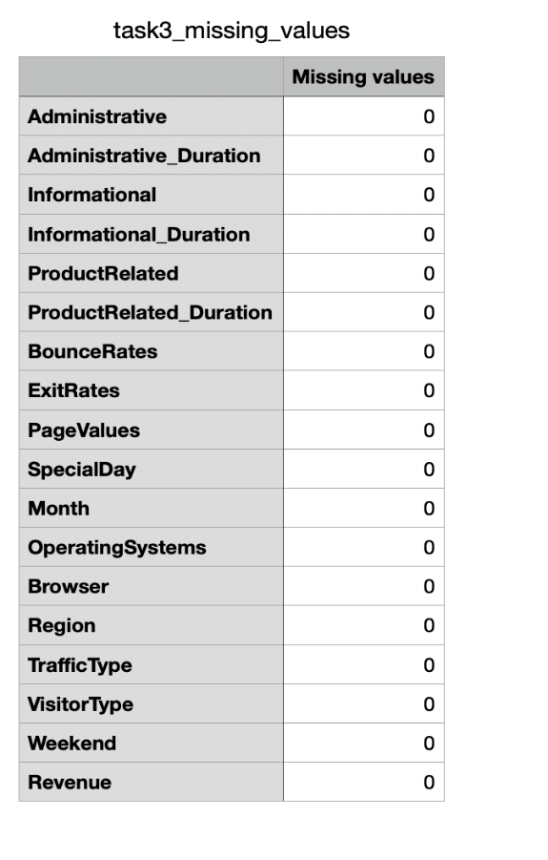
Figure 4Missing-value check results.
4.2 Converting the Data Types
We changed Month, OperatingSystems, Browser, Region, TrafficType, and VisitorType attributes to categorical data type which implies that these features represent categories rather than numerical quantities. Weekend and Revenue were transformed from boolean values to integers, where the value 0 corresponds to False and the value 1 corresponds to True.
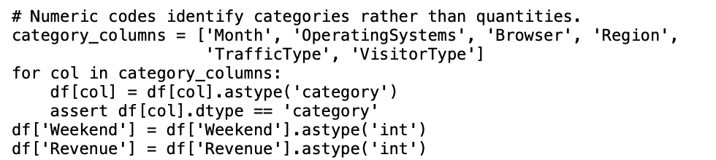
Figure 5 Categorical and Boolean data type conversion
.
4.3 Preparing Features and the Target
We isolate Revenue as the target variable (y), while the remaining attributes were used as input features (X). We applied the pd.get_dummies(X, drop_first=True) method to perform one-hot encoding for categorical features. After encoding, X contained 68 input features.
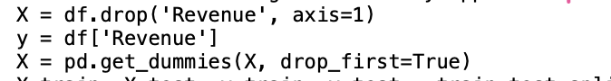
Figure 6Feature–target separation and one-hot encoding
4.4 Splitting Into Training and Testing Dataset
We performed the splitting of the dataset utilizing the method train_test_split() to form 80% training and 20% testing datasets. The value of random_state for the split was set to 42. The training dataset consists of 9,864 sessions, while the testing one includes 2,466 sessions.The same split should be used for all models to ensure a fair comparison.

Figure 7: Splitting the dataset into training and testing sets
.
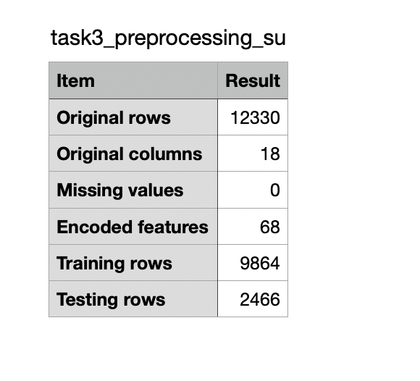
Figure 8: Summary of preprocessing results

5. Task 4 – Outlier Analysis

5.1 Outlier Detection Method
The Interquartile Range (IQR) method was used to identify potential outliers in the numerical attributes of the dataset.
The IQR is calculated as the difference between the third quartile (Q3) and the first quartile (Q1):
IQR = Q3 − Q1
Values outside the lower and upper bounds are considered potential outliers:
- Lower Bound = Q1 − 1.5 × IQR
- Upper Bound = Q3 + 1.5 × IQR
This method was selected because it is suitable for identifying extreme values in numerical data without assuming a normal distribution.

5.2 Evaluation of Detected Outliers
Having determined the probable outliers using the IQR method, numerical variables were analyzed to establish the effect of extreme values on the dataset.

Not all outliers stand for erroneous data. Some extreme values may reflect actual browsing behavior of customers (e.g. long visits to a website, number of product pages visited).

Thus, simply eliminating the observations may lead to losses of useful information.
Rather than omitting the affected rows, the outlier handling technique was used to minimize the effect of extreme values while retaining the affected rows.

5.3 Outlier Treatment
Following the assessment of the identified outliers, capping method was implemented in order to diminish the impact of extreme values found in the dataset.

The method was utilized to four attributes with the following names: Administrative, Administrative Duration, ProductRelated, and ProductRelated_Duration.

In the capping operation, instead of eliminating the records containing extreme values, data that went beyond the limit was replaced along the limits.

The boundaries for capping were calculated on the training dataset and hen applied to both the training and testing datasets.
The boxplots below illustrate the distribution of the selected attributes before and after applying the capping method.
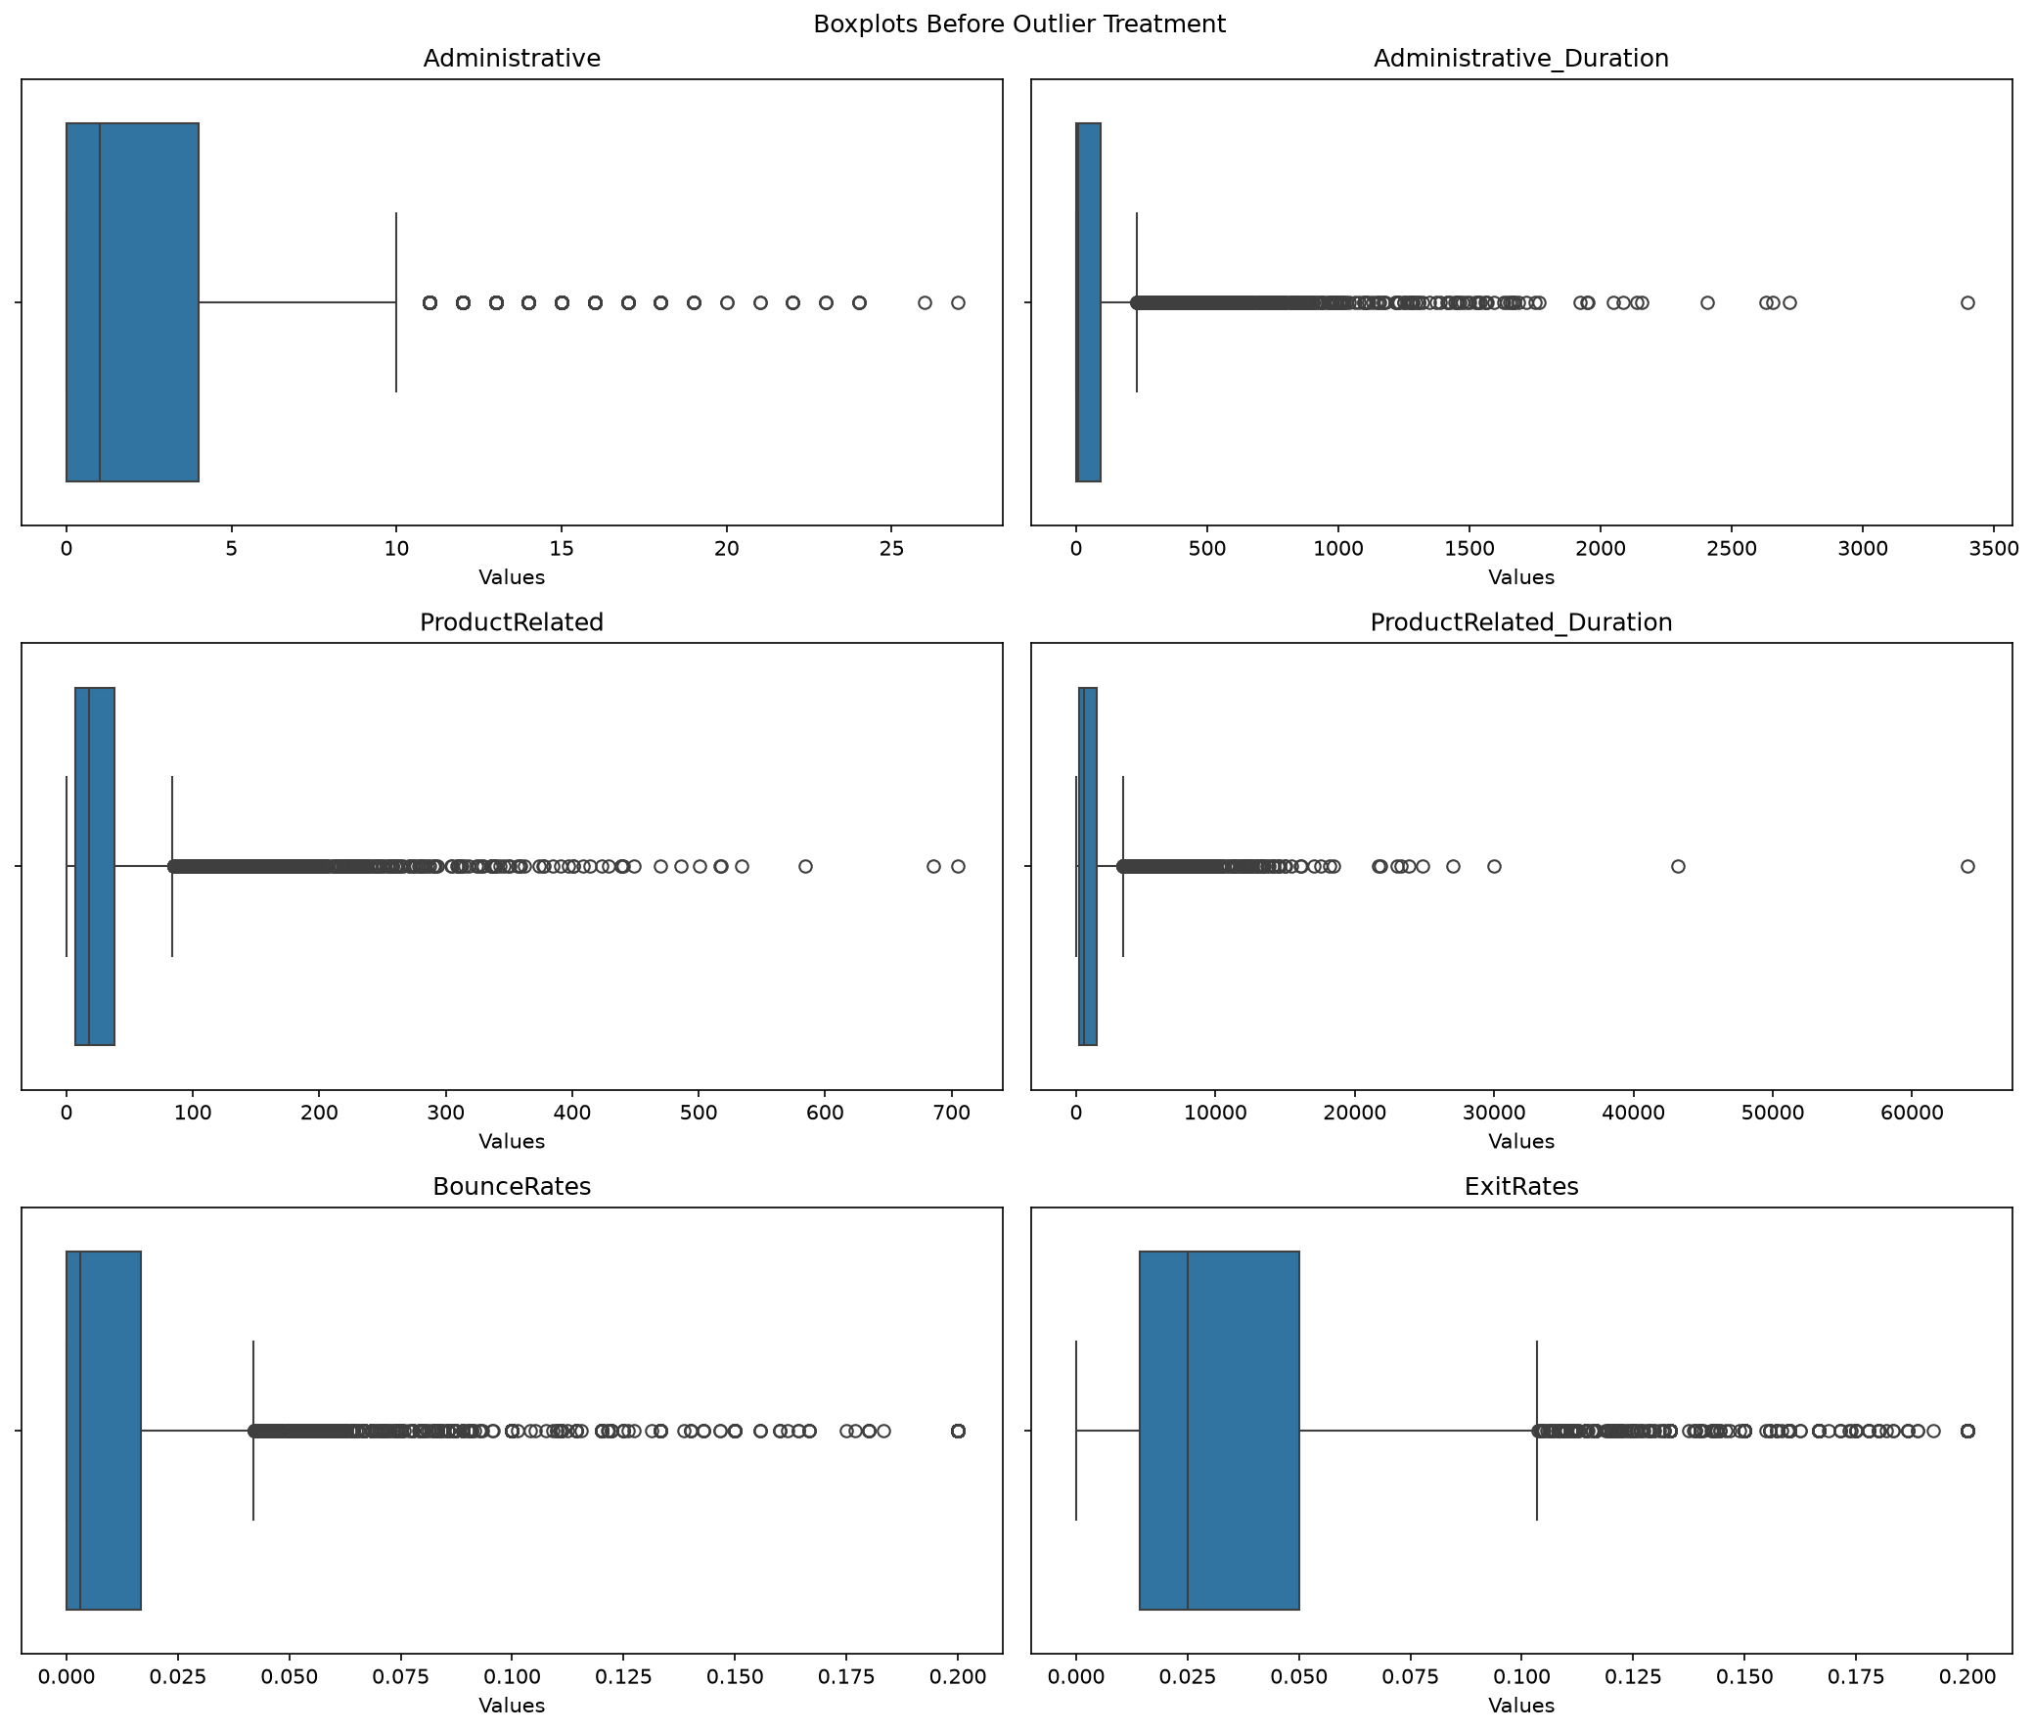
Figure 9. Boxplots Before Outlier Treatment
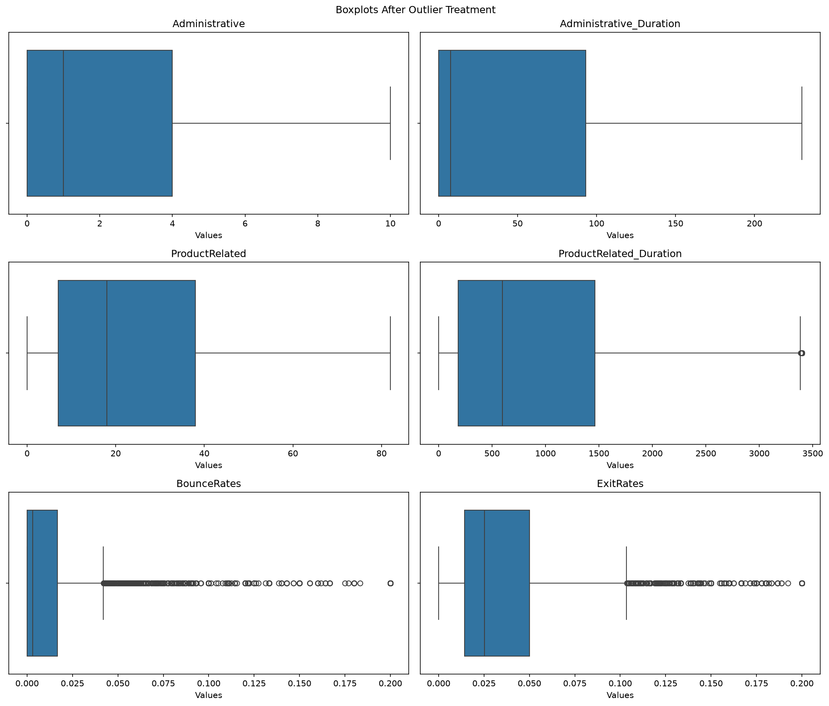
Figure 10Boxplots After Outlier Treatment

After applying the capping method, the boxplots show a noticeable reduction in the range of extreme values for the four selected attributes. This indicates that the influence of extreme values was reduced while the original records were retained in the dataset.

6. Task 5 – Classification Models and Tuning
There were three models of classification used in this case to determine if an online shopping activity would lead to purchase. The models used were logistic regression, decision tree and random forest. All three models were used in their basic settings as well as in the optimized variant after tuning with the help of GridSearchCV software. Assessment was done on models based on the following metrics: accuracy, precision, recall, F1-score and ROC-AUC.

6.1 Logistic Regression
6.1.1 Model Setup
Logistic Regression is the first classification algorithm to be used for predicting whether a session in an online shopping platform would lead to a purchase (Revenue = True) or no purchase (Revenue = False).

A Pipeline approach has been taken to implement the model by including the two components of StandardScaler and LogisticRegression. StandardScaler was used to standardize all the input features before the training, while LogisticRegression was used for doing binary classification. Maximum iterations were set at the number of 1000 allowing the model to make enough iterations to converge.

6.1.2 Important Parameters
The Logistic Regression model uses several important parameters that affect its training and classification performance. The main parameters considered in this project are presented in Table X.
Table 4: Important Parameters of Logistic Regression
Parameter | Description
C | Controls the strength of regularization. Smaller values indicate stronger regularization.
max_iter | Specifies the maximum number of iterations allowed for model convergence.
class_weight | Determines the weights assigned to different classes. The balanced option adjusts weights based on class frequencies.
StandardScaler | Standardizes input features before they are passed to the model.

6.1.3 Tuning or Performance Enhancement
GridSearchCV method was employed for optimization of the Logistic Regression model by checking different parameter combinations. A 5-fold Stratified Cross-Validation technique was adopted where F1-score served as the assessment measure to define the optimal parameter setting.
The search involved otherwise C and class_weight. The best set of parameters was C = 10 and class_weight = 'balanced' with the maximum cross validation F1-score of 0.6032.
The balanced class weight was introduced to tackle the imbalance problem of purchase and non-purchase sessions.
Table 5: Best Hyperparameters of Logistic Regression
Setting | Value
Tuning Method | GridSearchCV
Cross-Validation | 5-Fold Stratified
Scoring Metric | F1-score
Best C | 10
Best class_weight | balanced
Best CV F1-score | 0.6032

6.1.4 Evaluation Results
The Logistic Regression model was evaluated using the test dataset before and after parameter tuning. The evaluation results are presented in Table X to show the differences between the baseline and tuned models.
Table 6: Performance Evaluation of Baseline and Tuned Logistic Regression
Evaluation Metric | Baseline | Tuned
Accuracy | 0.8694 | 0.8504
Precision | 0.7306 | 0.5357
Recall | 0.3431 | 0.7664
F1-score | 0.4669 | 0.6306
ROC-AUC | 0.8872 | 0.9002

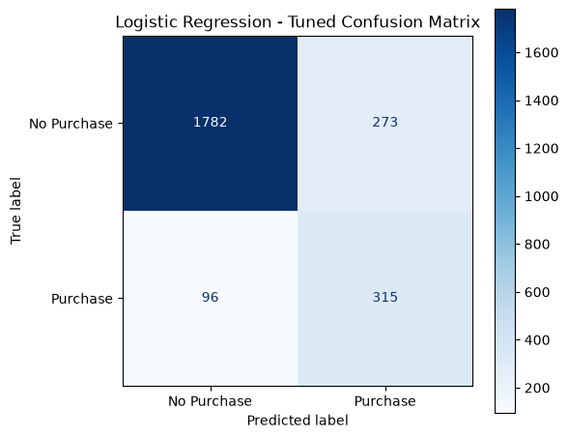
Figure 11: Confusion Matrix of the Tuned Logistic Regression Model.

6.1.5 Short Interpretation
The Logistic Regression model that had been fine-tuned managed to get a better F1-score number of 0.6306 versus 0.4669 for the baseline model. The increase in Recall was considerable, from 0.3431 all the way till 0.7664, which meant the tuned model successfully identified more of the true purchase sessions. However, Precision declined from 0.7306 to 0.5357, meaning the model had misclassified more sessions as being purchase sessions when in reality they were not. Even though the Accuracy figure experienced only a slight decline, the positive impact that the tuning has had on Recall and F1 suggests that the tuning improved the model’s ability to detect purchase sessions.

6.2 Decision Tree

6.2.1 Model Setup
In the second classification model, Decision Tree was utilized to determine if an online shopping session would yield a purchase or not. The model processes data by dividing it into smaller segments based on the parameters and decision rules. For the implementation of the DecisionTreeClassifier, the training data was used and random_state was established on 42 for result replication.

6.2.2 Important Parameters
The Decision Tree model uses several important parameters that control how the tree is constructed and how data is divided into decision nodes. The main parameters are described in Table X.
Table 7: Important Parameters of Decision Tree
Parameter | Description
criterion | Determines the function used to measure the quality of a split.
max_depth | Controls the maximum depth of the decision tree.
min_samples_split | Specifies the minimum number of samples required to split an internal node.
min_samples_leaf | Specifies the minimum number of samples required at a leaf node.
class_weight | Adjusts the weights assigned to different classes.

6.2.3 Tuning or Performance Enhancement
The tuning of the Decision Tree model was done by way of GridSearchCV which was used to examine the various parameter combinations. The 5-fold Stratified Cross-Validation technique was then employed to evaluate the various configurations with the F1-score serving as the evaluation parameter.
The best configuration for the particular problem was identified to be when the parameters criterion = 'gini', max_depth = 5, min_samples_split = 2, min_samples_leaf = 10, and class_weight = None were used. The parameters gave rise to a value of 0.6438 as the highest cross-validation F1 score.

Table 8: Best Hyperparameters of Decision Tree
Setting | Value
Tuning Method | GridSearchCV
Cross-Validation | 5-Fold Stratified
Scoring Metric | F1-score
Best criterion | gini
Best max_depth | 5
Best min_samples_split | 2
Best min_samples_leaf | 10
Best class_weight | None
Best CV F1-score | 0.6438

6.2.4 Evaluation Results
The Decision Tree model was evaluated using the test dataset before and after parameter tuning. The evaluation results are presented in Table X to show the differences between the baseline and tuned models.
Table 9: Performance Evaluation of Baseline and Tuned Decision Tree
Evaluation Metric | Baseline | Tuned
Accuracy | 0.8556 | 0.8925
Precision | 0.5696 | 0.7450
Recall | 0.5474 | 0.5401
F1-score | 0.5583 | 0.6262
ROC-AUC | 0.7324 | 0.9145
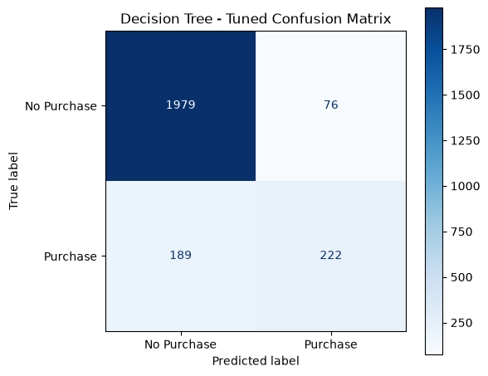
Figure 12: Confusion Matrix of the Tuned Decision Tree Model.

6.2.5 Short Interpretation
The calibrated Decision Tree model attained a greater F1-score of 0.6262 versus a score of 0.5583 of the original model. The accuracy rose from a value of 0.8556 to 0.8925 and Precision increased from 0.5696 to 0.7450 indicating that the recalibrated model made more precise purchase forecasting than the baseline one. Notably, Recall experienced a minor decrease from 0.5474 to 0.5401, thus indicating the recalibrated model classified a smaller number of actual purchase sessions. ROC-AUC also rose from the value of 0.7324 to 0.9145 thus indicating improved capability to tell the purchase from the non-purchase sessions in general.

6.3 Random Forest

6.3.1 Model Setup
The third classification model employing Random Forest was selected in the purpose of forecasting the outcome of an online shopping session - whether a purchase was finally completed or not. The predictive model is based on an ensemble of several decision trees leading to the final prediction. The implementation of RandomForestClassifier included the application of the training dataset, as well as the definition of values such as random_state - 42 and n_jobs - -1 to allow parallel processing.
6.3.2 Important Parameters
The Random Forest model uses several important parameters that control the number of trees, their structure, and how the model handles class imbalance. The main parameters considered in this project are described in Table X.
Table 10: Important Parameters of Random Forest
Parameter | Description
n_estimators | Specifies the number of decision trees in the forest.
max_depth | Controls the maximum depth of each decision tree.
min_samples_split | Specifies the minimum number of samples required to split an internal node.
min_samples_leaf | Specifies the minimum number of samples required at a leaf node.
class_weight | Adjusts the weights assigned to different classes. The balanced option accounts for class frequencies.
random_state | Controls randomness to ensure reproducibility of results.
n_jobs | Specifies the number of CPU jobs used for computation. A value of -1 uses all available processors.

6.3.3 Tuning or Performance Enhancement
The Random Forest model was tuned using GridSearchCV with various parameters. A 5-fold Stratified Cross-Validation method was used in which we used F1-score as the evaluation parameter.
The configuration which gave the best result was with n_estimators = 200, max_depth = None, min_samples_split = 2, min_samples_leaf = 1, and class_weight = 'balanced'. The resulting best F1-score for this configuration was 0.6842.
The class weight is given as balanced to consider the imbalance between purchase and non-purchase sessions.
Table 11: Best Hyperparameters of Random Forest
Setting | Value
Tuning Method | GridSearchCV
Cross-Validation | 5-Fold Stratified
Scoring Metric | F1-score
Best n_estimators | 200
Best max_depth | None
Best min_samples_split | 2
Best min_samples_leaf | 1
Best class_weight | balanced
Best CV F1-score | 0.6842

6.3.4 Evaluation Results
An evaluation of the Random Forest model was carried out on the test data set both pre and post the tuning of parameters. The findings of this evaluation are summarized in Table X in which the difference between the baseline model and the tuned model is highlighted.
Table 12: Performance Evaluation of Baseline and Tuned Random Forest
Evaluation Metric | Baseline | Tuned
Accuracy | 0.8933 | 0.8905
Precision | 0.7701 | 0.6628
Recall | 0.5134 | 0.6983
F1-score | 0.6161 | 0.6801
ROC-AUC | 0.9176 | 0.9231
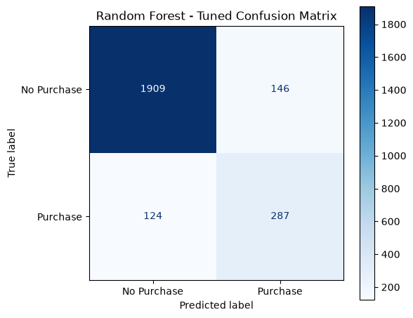
Figure 13: Confusion Matrix of the Tuned Random Forest Model.

6.3.5 Short Interpretation
The Random Forest model after tuning performed better than the baseline model achieving the F1-score of 0.6801 versus 0.6161, respectively. The score for Recall increased from 0.5134 to 0.6983, consequently indicating greater detection of the real purchase activities by the tuned model. ROC-AUC demonstrated an increase from 0.9176 to 0.9231 which indicates a slight growth in separating purchase and non-purchase activities. At the same time, the Accuracy score went down from 0.8933 to 0.8905, and the same tendency is observed for Precision which decreased from 0.7701 to 0.6628. Overall, the tuned model possessed a better balance of Precision and Recall leading to a greater value of the F1-score in general.

7. Task 6 – Model Comparison

8. Conclusion

