**Solutions**

In chemistry , a solution is a homogeneous mixture composed of two or more substance . In such a mixture, a solute is dissolved in another substance, known as solvent. The solvent does the dissolving.

**Types of solutions ;**

Usually, the substance present in a greatest amount is considered the solvent, Solvents can be gases, liquids, or solids. The solution has the same physical state as the solvent.

**Gas**

If the solvent is a gas, only gases are dissolved under all given set of conditions. An example for a gaseous solution is air ( oxygen and other gases dissolved in nitrogen ). Since interactions between molecules play almost no role, dilute gases form rather trivial solutions. In part of the literature, they are not even classified as solutions, but addressed as mixtures.

**Liquid**

If the solvent is a liquid, then gases, liquids, and solids can be dissolved, Examples are : Liquid in liquid, solid in liquid.. Counter examples are provided by liquid mixtures that are not homogeneouses:Colloids, suspensions, emulsions, are not considered solutions.

Body fluids are examples for complex liquid solutions, containing many different solutes. They are electrolytes since they contain solute ions ( e.g. potassium and sodium). Furthermore, they contain solute molecules like sugar and urea , Oxygen and carbon dioxide are also essential components of blood chemistry. Where significant changes in their concentrations can be a sign of illness or injury.

**Solid**

If the solvent is solid then gases, liquids, and solids can be dissolved :

Liquid in solid , solid in solid.

**Solubility**

The ability of one compound to dissolve in another compound is called solubility .When a liquid is able to completely dissolve in another liquid the two liquids are miscible. Two substances that can never mix to form a solution are called immiscible.

All solutions have a positive entropy of mixing . The interactions between different molecules or ions may be  energetically favored or not. If interactions are unfavorable, then the [free energy](https://en.wikipedia.org/wiki/Thermodynamic_free_energy) decreases with increasing solute concentration. At some point the energy loss outweighs the entropy gain, and no more solute particles can be dissolved; the solution is said to be [saturated](https://en.wikipedia.org/wiki/Saturation_(chemistry)). However, the point at which a solution can become saturated can change significantly with different environmental factors, such as [temperature](https://en.wikipedia.org/wiki/Temperature), [pressure](https://en.wikipedia.org/wiki/Pressure), and contamination. For some solute-solvent combinations a [supersaturated](https://en.wikipedia.org/wiki/Supersaturated) solution can be prepared by raising the solubility (for example by increasing the temperature) to dissolve more solute, and then lowering it (for example by cooling).

Usually, the greater the temperature of the solvent, the more of a given solid solute it can dissolve. However, most gases and some compounds exhibit solubilities that decrease with increased temperature. Such behavior is a result of an [exothermic](https://en.wikipedia.org/wiki/Exothermic) [enthalpy of solution](https://en.wikipedia.org/wiki/Enthalpy_of_solution). Some [surfactants](https://en.wikipedia.org/wiki/Surfactant) exhibit this behaviour. The solubility of liquids in liquids is generally less temperature-sensitive than that of solids or gases.

**Factor affecting solubility**

**1. Temperature**

Basically , solubility increase with temperature . it is the case for most of the solvents . The situation is though different for gases . With increase of the temperature they became less soluble in each other and in water, but more soluble in organic solvents.

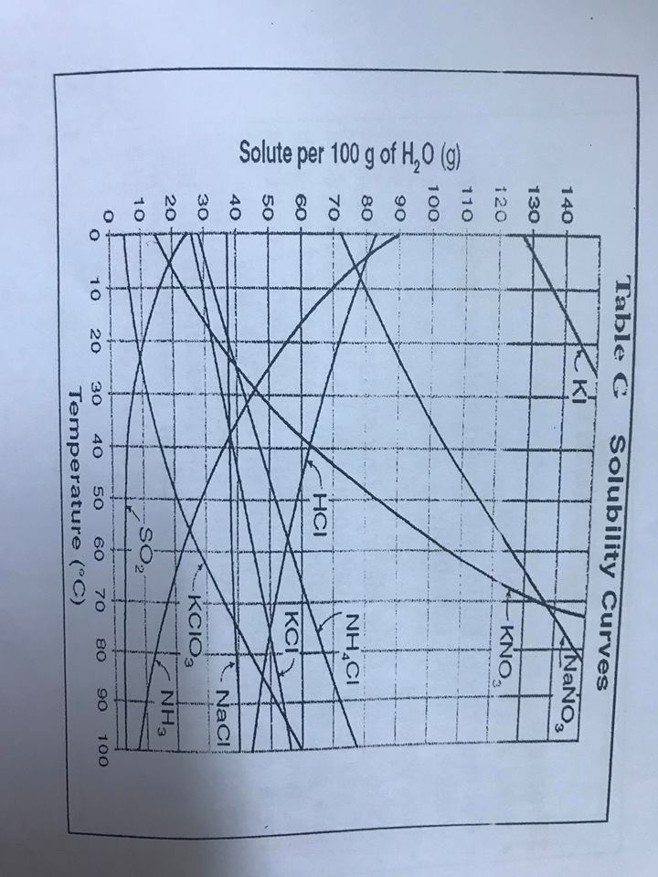

**2.Polarity**

In most cases solutes dissolve in solvents that have a similar polarity. Chemists use a popular aphorism to describe this feature of solutes and solvents: **"Like dissolves like"**. Non-polar solutes do not dissolve in polar solvents .

### 3. pressure

### . Solid and liquid solutes

. For majority of solid and liquid solutes, pressure does not affect solubility.

### . Gas solutes

. As for gasses the Henry's law states that solubility of gas is directly proportional to the pressure of this gas. This is mathematically presented as: p = kc, where k is a temperature dependent constant for a gas. A good proof of Henry's law can be observed when opening a bottle of carbonated drying. When we decrease the pressure in a bottle, the gas that was dissolved in the drink bubbles out of it.

## 4. Molecular size

The larger the molecules of the solute are, the larger is their molecular weight and their size. It is more difficult it is for solvent molecules to surround bigger molecules. If all of the above mentioned factors ale excluded, a general rule can be found that larger particles are generally less soluble. If the pressure, and temperature are the same than out of two solutes of the same polarity, the one with smaller particles is usually more soluble.

**5. stirring**

## .Stirring increases the speed of dissolving

.Stirring does not have an affect on solubility of a substance, but everyone knows that if he puts sugar in his tea and does not stir, it will not dissolve. Actually, if we left the tea to stand for a long enough time, the sugar would dissolve. Stirring only increases the speed of the process - it increases move of the solvent what exposes solute to fresh portions of it, thus enabling solubility. As molecules in liquid substances are in constant move, the process would take place anyway, but it would take more time.

**Strength of solutions**

. Strength of a solution is defined as the amount of the solute in gms , present in one liter of the solution . It is expressed as gL 1-

. Mathematically ,

Mass of solute in g

Strength = --------------------------------------------

Volume of solution in Litres

**Concentrations**

In chemistry , concentration is the measure of how much of a given substance is mixed with another **substance**. This can apply to any sort of chemical mixture , but most frequently the concept is limited to homogeneous solutions , where it refers to the amount of solute in the solvent .

There are three categories of concentrations :

1. Dilute concentration

2. Unsaturated

3.saturated

4. Supersaturated

**Dilute Solution**

A dilute solution is the term that is used to describe a solution that contains a small amount of solute as compared to the amount that could dissolve . The amount of solute dissolve in the solvent is minimal , Which means that the mixture contains more of the solvent than the solute .

**Unsaturated solution**

An unsaturated solution is a solution which can dissolve at a given temperature is an unsaturated solution . A solution that can dissolve more solute . Water can be an unsaturated solution .

An unsaturated solution , then , can hold more solute , if you add more . Our saturated salt solution above is unsaturated right up until the point that is stops dissolving . so to make any unsaturated solution you simply add less than the total amount of solute that the solution can hold .

**Saturated solution**

A saturated solution is one that can simply hold no more solute . you can make a saturated solution of salt water , for example , by just adding more and more salt to a glass until it can't dissolve any more and starts to remain on the bottom in solid form.

**Supersaturation solutions**

Supersaturation is a state of a solution that contains more of the dissolve material than could be dissolved by the solvent under normal circumstances. It can also refer to a vapor of a compound that has a higher (partial) pressure than the vapor pressure of that compound.

A supersaturated solution is unstable . over time , they will tend to precipitate out some solute until they are only saturated again. Sometimes this can be prevented by not providing any surface for molecules of solute to aggregate on . Conversely , it can be accelerated by adding 'seeds ' for the solute to stick to some beers do this for bigger "head" on their supersaturated .

The formation of gallstones involves the precipitation of cholesterol from a supersaturated solution.

