**Analytical chemistry :-**

Analytical chemistry is a measurement science consisting of powerful ideas and methods that are useful in all fields of science and medicine . Consider a few examples . The concentration of oxygen and of carbon dioxide are determined in millions of blood samples every day and used to diagnose and treat illnesses . Quantities of hydrocarbons , nitrogen oxides , and carbon monoxide present in automobile exhaust gases are measured to assess the effectiveness of smog – control devices . Quantitative measurements of ionized calcium in blood serum help diagnose parathyroid disease in humans . Analysis of steel during its production permits adjustment in the concentrations of such elements as carbon , Nickel , and Chromium to achieve a desired strength , hardness , corrosion resistance and ductility .

Chemists unravel the mechanisms of chemical reactions through reaction rate studies . The rate of consumption of reactants or formation of products in chemical reaction can be calculated from quantitative measurements made at equal time intervals. The interdisciplinary nature of chemical analysis makes it a vital tool in medical , industrial , government , and academic laboratories throughout the world . The central role of analytical chemistry in this enterprise and many others is illustrated in figure

**Quantitative and qualitative Analytical methods :-**

We compute the results of typical quantitative analysis from two measurements .

1- The mass or the volume of sample being analyzed .

2-The measurement of some quantity that is proportional to the amount of analyte in the sample , such as mass , volume intensity of light , or electrical charge . This second measurement usually complete the analysis and we classify analytical methods according to the nature of this final measurement. .

a- Gravimetric methods :Determine the mass of the analyte or some compound chemically related to it .

b- Volumetric methods :- The volume of solution containing sufficient reagent to react completely with the analyte is measured by titrimetric methods .

c- Electroanalytical methods :- Involve the measurement of such electrical properties as potential , current , resistance , and quantity of electrical charge .

d- Spectroscoopic methods :- Based on measurement of the interaction between electromagnetic methods are based on measurement of the interaction of such radiation. By analytes .

**Gravimetric analysis**

Describes a set of methods in analytical chemistry for the quantitative determination of an analyte based on the mass of a solid . A simple example is the measurement of solids suspended in a water sample : A known volume of water is filtered , and the collected solids are weighed .

In most cases , the analyte must first be converted to a solid by precipitation with an appropriate reagent . The precipitate can then be collected by filtration , washed , dried to remove traces of moisture from the solution , and weighed .

**Types of Gravimetric methods:**

1- precipitation gravimetry :

A gravimetric method in which the signal is the mass of a precipitate .

2- Electrogravimetry

A gravimetric method in which the signal is the mass of an electrodeposit on the cathode or anode in an electrochemical cell .

3- Volatilization gravimetry

A gravimetric method in which the loss of a volatile species gives rise to the signal .

4- particulate gravimetry

A gravimetric method in which the mass of a particulate analyte is determined following its separation from its matrix.

**Precipitation gravimetry :**

The steps required in gravimetric analysis , after the sample has been dissolved , can be summarized as follows :

1-preparation of the solution.

2-precipitation .

3- Digestion .

4- Filtration .

5- Washing .

6- Drying or igniting .

7-Weighing

8-calculation .

**1- preparation of the solution :**

This may involve several steps including adjustment of the PH of the solution in order for the precipitate to occur quantitatively and get a precipitate of desired properties , removing interferences , adjusting the volume of the sample to suit the amount of precipitating agent to be added .

**2-precipitation .**

This requires addition of a precipitating agent solution to the sample solution . Upon addition of the first drops of the precipitating agent , supersaturation occurs , then nucleation starts to occur where every few molecules of precipitate aggregate together forming a nucleous . At this point , addition of extra precipitating agent will either form new nuclei or will build up on existing nuclei to give a precipitate. This can be predicted by

Von Weimarn ratio where , according to this relation the particle size is inversely proportional to a quantity called the relative supersaturation where :

**Relative Supersaturation (RSS)=(Q-S)/S**

The Q is the concentration of reactants before precipitation , S is the solubility of precipitate in the medium from which it is being precipitated .

**3- Digestion of the precipitate :**

The precipitate is left hot (below boiling ) for 30 min to 1 hour in order for the particles to be digested . Digestion involves dissolution of small particles and reprecipitation on larger ones resulting in particle growth and better precipitate characteristics .

**4- washing and filtering the precipitate :**

It is crucial to wash the precipitate very well in order to remove all adsorbed species which will add to weight of precipitate . One should be careful nor to use too much water since part of the precipitate may be lost . Also , in case of colloidal precipitates we should not use water as a washing solution since peptization would occur . Filtration should be done in appropriate sized Goosh or ignition filter paper .

**5- Drying and Ignition:** The purpose of drying (heating at about 120-150 C in oven) or ignition in a muffle furnace at temperatures ranging from 600-1200 C is to get a material with exactly known chemical structure so that the amount of analyte can be accurately determined.

Q/ Why we prefer precipitates of large particles ?

Precipitates consisting of large particles are generally desirable for gravimetric work because these particles are casy to filter and wash free of impurities. In addition, precipitates of this type are usually purer than are precipitates made up of fine particles.

**Impurities in Precipitates:**

Precipitates tend to carry down from the solution other constituents that are normally soluble, causing the precipitate to become contaminated. This process is called coprecipitation. In other coprecipitation is a phenomenon in which otherwise soluble compounds are removed from solution during precipitate formation.

**Types of coprecipitation :**

1- surface adsorption.

2-mixed –crystal formation ,

3- occlusion.

4- mechanical entrapment in colloidal.

**Homogeneous precipitation :**

Precipitation from homogeneous solution is a technique in which a precipitating agent is generated in a solution of analyte by a slow chemical reaction . Local reagent excesses do not occure because the precipitating agent appears gradually and homogeneously throughout the solution and reacts immediately with the analyte. As a result, the relative supersaturation is kept low during the entire precipitation. In general, homogeneously formed precipitates, both colloidal and crystalline, are better suited for analysis than a solid formed by direct addition of a precipitating reagent.

**FACTORS AFFECTING PRECIPITATION :**

1-Choice of precipitant : The precipitant should be such that it produces a precipitate which is completely ansoluble.

2- Effect off temperature : The solubility product of substance is constant only when its temperature is unaltered, Usually the solubility increases with the increase in temperature .

3- Amount of precipitant: The amount of precipitant added is also of great importance.

4- Effect of PH : The solubility of the precipitate with the change in PH of the solution is inevitable . The effect depends on the type of precipitate.

5- Effect of complex formation.

**Types of Precipitating Agents :**

1- Inorganic Precipitating Agents :

These reagents typically form slightly soluble salts or hydrous oxides with the analyte. As you can see the many entries for each reagent, few inorganic reagents are selective.

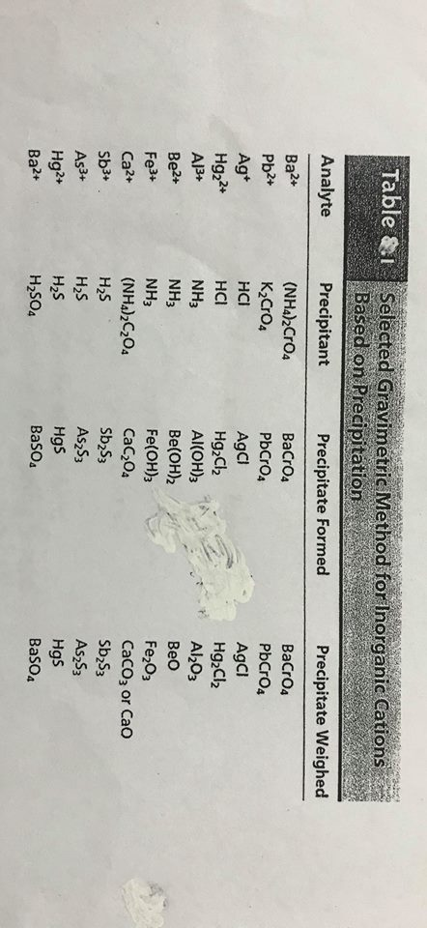

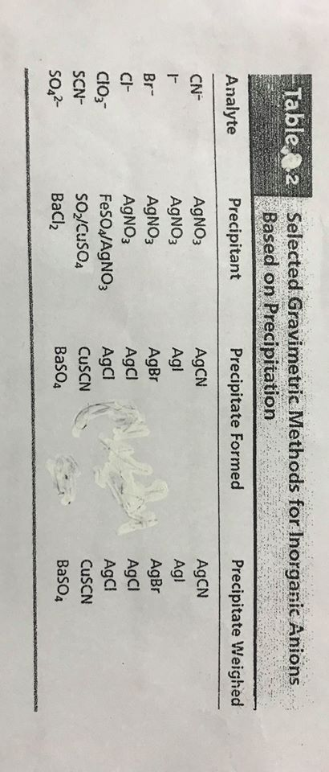

2-organic precipitating Agents

Numerous organic reagents have been developed for the gravimetric determination of inorganic species. Some of these reagents are significantly more selective in their reaction than the inorganic reagents.

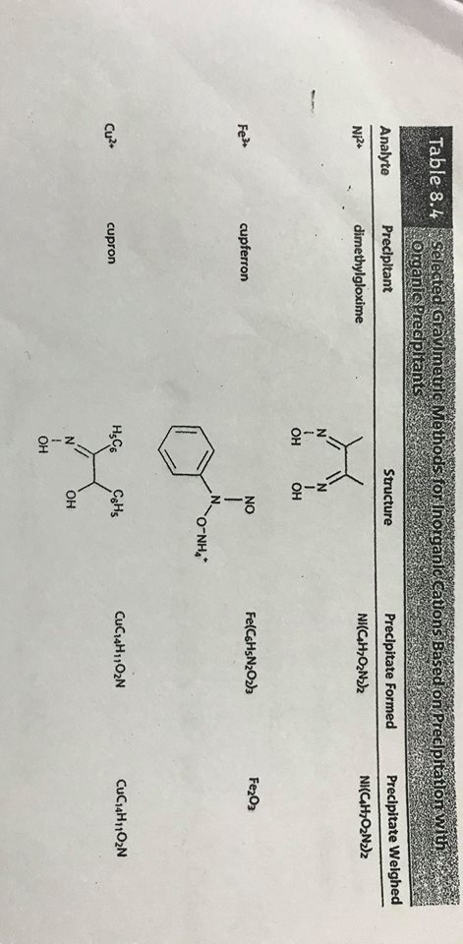

**Ideal Properties of Precipitating Reagents:**

1- Specific. 2-Selective. 3- Readily Filtered. 4- Low Solubility. 5- Unreactive with the atmosphere, 6- Known composition after being heated,

**CALCULATIONS:**

Solubility Product Constant, Ksp :

Ksp: is the equilibrium constant for solid substance dissolving in an aqueous solution. It represented the level at which a solute dissolves in solution.

Consider the general dissolution reaction below (in aqueous solutions):

aA(s)  cC(aq) + dD(aq)

To solve for the Ksp it necessary to take the molarities or concentration of the products (cC and dD ) and multiply them . This is shown below :

Ksp = [C]C [D]d

Not that the reactant aA, is not included in the Ksp equation. Solids are not included when calculating equilibrium constant expressions, because their concentrations do not change the expression; any change in their concentrations are insignificant, and therefore omitted.

NOTES;

**Condition Nature of Solution Possibility of precipitation**

Ion product < Ksp unsaturated solution no precipitation occurs

Ion product = kSP saturated solution saturated solution at equilibrium

Ion product > KSP supersaturated solution precipitation occurs

Ex/ The solubility of barium sulphate at 298 K is 1.05 × 10-5 mol dm-3 .Calculate the solubility product.

The equilibrium is ; BaSO4  Ba2+(aq) + SO42-(aq)

Notice that each mole of barium sulphate dissolves to give 1 mole of barium ions and 1 mole of sulphate ions . That means;

[Ba2+] = [SO42-] =1.05 × 10-5 mol. dm-3

Allyou need to do now is to put these values into the solubility product expression, and do the simple sum.

Ksp = [Ba2+] [SO42-] = {1.05 × 10-5} {1.05 × 10-5} = 1.10 × 10-10 mol2 dm-6

EX/The concentration of magnesium hydroxide at 298 K is 1.71 × 10-4 mol . dm-3

Calculate the solubility product .

The equilibrium is ; Mg(OH)2(S)  Mg2+(aq) + 2OH-(aq)

For every mole of magnesium hydroxide that dissolves, you will get one mole of magnesium ions, but twice that number of hydroxide ions; So the concentration of ions; [Mg2+] = 1.71 × 10-4 mol . dm-3 [OH-] = 2 × 1.71 × 10-4 mol .dm-3=3,42 ×10-3 mol . dm-3

Now put these numbers into the solubility product expression and do the sum.

Ksp =[Mg2+] [OH-]2 = {1.71 ×10-4} ×{3.4 ×10-4}2 =2.00 ×10-11 mol3. Dm-9

Calculating concentration from solubility products ;

Example/ If the solubility product of magnesium hydroxide is 2.00 ×10-11mol3.dm-9 at 298K, Calculate its solubility in mol,dm-3 at that temperature.

Mg{OH}2  Mg2+{aq} + 2OH-{aq}

The trick this time is to give the unknown solubility a symbol like s . If the concentration of dissolved magnesium hydroxide is mol.dm-3,then;

[Mg2+] = s mol. dm-3 [OH-] =2S mol . dm-3

Ksp = [Mg2+][OH-]2 = {s} × {2s}2 2.00 ×10-11 = 4s3

2.00 ×10-11

S3 =ـــــــــــــــــــــــــــ

4

s3 =5.00 ×10-12

S =1,71 ×10-4 mol .dm-3

Ex/ Determine the KSP of calcium fluoride {CaF2}, given that its molar solubility is 2.14 ×10-4 mol per liter,

CaF2{S}  Ca2+{aq} +2F-{aq}

Ksp = [Ca2+][F-]2

There is a 1:1 molar ratio between CaF2 AND Ca2+ , but there is a 1:2 molar ratio between CaF2 and F- . This means that , when 2.14 ×10-4moleper liter of CaF2 dissolves, it produces 2.14 ×10-4mole per liter of Ca2+and it produces 4.28 ×10-4mole per liter of F- in solution.

KSP = {2.14 ×10-4} {4.28 ×10-4}2 =3.92 ×10-11

×××× In the usual gravimetric procedure a precipitate is weighed , and from this value, the weight of the analyte in the sample is calculated with the aid of a gravimetric factor {GF}. The GF is the ratio of the formula weight of the substance sought to that of the substance weighed

Formula weight {substance sought }:

Gravimetric Factor {GF} =ــــــــــــــــــــــــــــــــــــــــــــــــــــــــــــــــــــــــــــــــــــــ

Formula weight {substance weighed }

Usually, the purpose of a quantitative analysis is to determine the percentage of a certain element or ion {A} in a sample, which can be calculated as:

Weight of precipitate × GF ×100

% A = ـــــــــــــــــــــــــــــــــــــــــــــــــــــــــــــــــــــــــــــ

Weight of sample

=