**اسم الطالب : أيمن محمد نبيل محمد**

**سكشن : 2**

**قسم هندسة الحاسبات ونظم التحكم**

**Lab 6 – Task**

**NBA Basketball Counter**

**……………………………………….**

**Screenshot of the circuit**

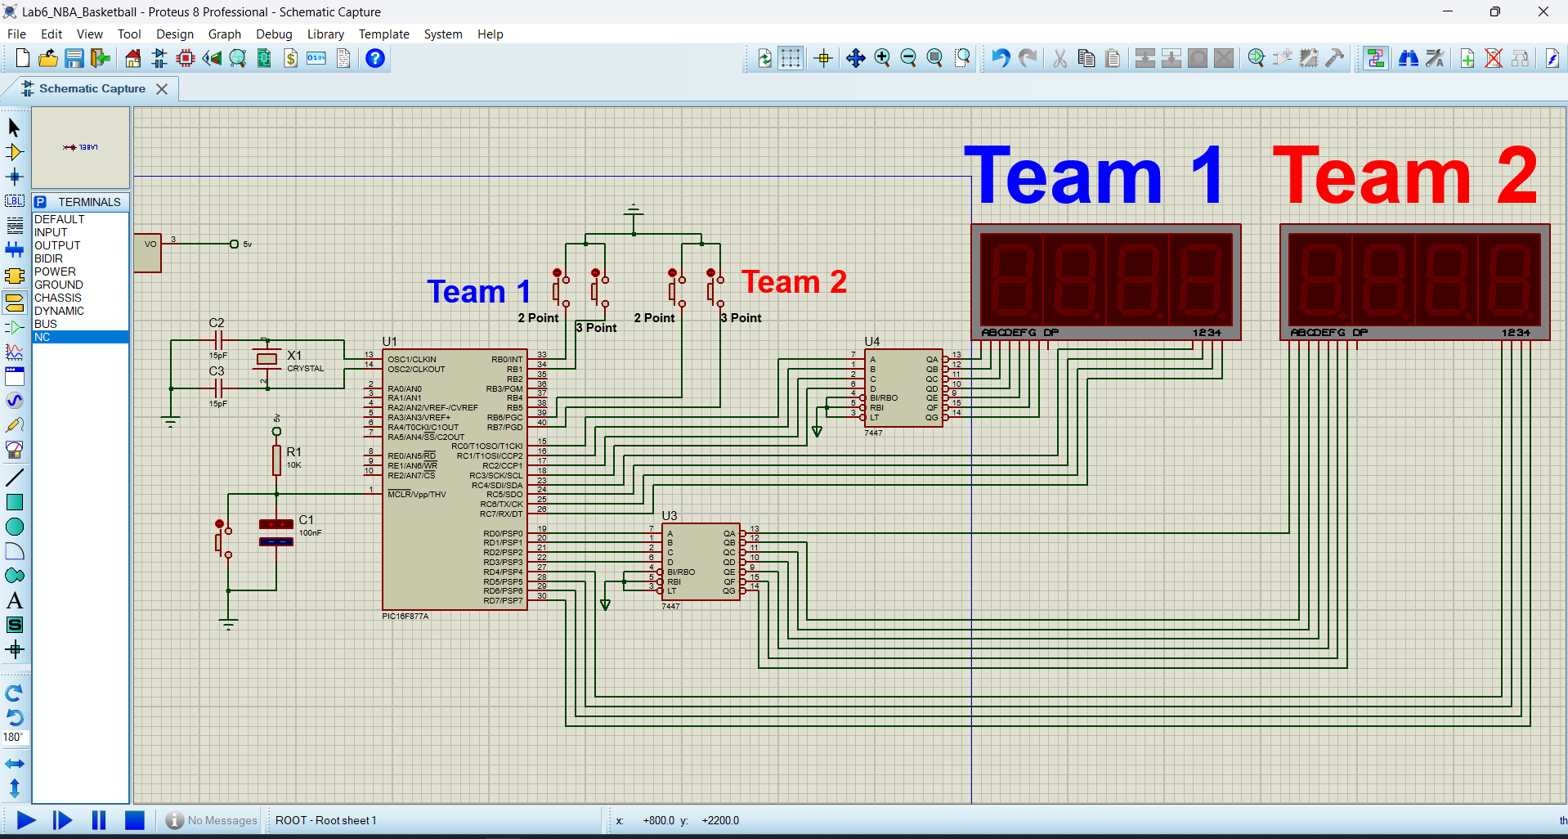

**Code:**

**/\***

**\* File: main.c**

**\* Author: engay**

**\***

**\* Created on April 17, 2024, 5:38 AM**

**\*/**

**#include <xc.h>**

**#define _XTAL_FREQ (8000000)**

**#define Team1_2 PORTBbits.RB0**

**#define Team1_3 PORTBbits.RB1**

**#define Team2_2 PORTBbits.RB6**

**#define Team2_3 PORTBbits.RB7**

**#define Team1_Seg PORTC**

**#define Team1_D1 PORTCbits.RC7**

**#define Team1_D2 PORTCbits.RC6**

**#define Team1_D3 PORTCbits.RC5**

**#define Team2_Seg PORTD**

**#define Team2_D1 PORTDbits.RD7**

**#define Team2_D2 PORTDbits.RD6**

**#define Team2_D3 PORTDbits.RD5**

**#define ON 1**

**#define OFF 0**

**#define Sev_delay_time 10**

**#define delay __delay_ms**

**void Team1_Display(unsigned char num)**

**{**

**// First Digit num%10**

**Team1_Seg=num%10;**

**Team1_D1=ON;**

**Team1_D2=OFF;**

**Team1_D3=OFF;**

**delay(Sev_delay_time);**

**// Second Digit (num/10)%10**

**Team1_Seg=(num/10)%10;**

**Team1_D1=OFF;**

**Team1_D2=ON;**

**Team1_D3=OFF;**

**delay(Sev_delay_time);**

**// Third Digit (num/100)%10**

**Team1_Seg=(num/100)%10;**

**Team1_D1=OFF;**

**Team1_D2=OFF;**

**Team1_D3=ON;**

**delay(Sev_delay_time);**

**}**

**void Team2_Display(unsigned char num)**

**{**

**// First Digit num%10**

**Team2_Seg=num%10;**

**Team2_D1=ON;**

**Team2_D2=OFF;**

**Team2_D3=OFF;**

**delay(Sev_delay_time);**

**// Second Digit (num/10)%10**

**Team2_Seg=(num/10)%10;**

**Team2_D1=OFF;**

**Team2_D2=ON;**

**Team2_D3=OFF;**

**delay(Sev_delay_time);**

**// Third Digit (num/100)%10**

**Team2_Seg=(num/100)%10;**

**Team2_D1=OFF;**

**Team2_D2=OFF;**

**Team2_D3=ON;**

**delay(Sev_delay_time);**

**}**

**void initial_condition(void)**

**{**

**unsigned char num = 3000/(Sev_delay_time*6);**

**while(num)**

**{**

**Team1_Display(101);**

**Team2_Display(103);**

**num--;**

**}**

**Team1_Display(0);**

**Team2_Display(0);**

**return;**

**}**

**void main(void) {**

**TRISB=0xff;**

**OPTION_REGbits.nRBPU = 0;**

**TRISC=0x00;**

**TRISD=0x00;**

**initial_condition();**

**unsigned char team1=0,team2=0;**

**while(1)**

**{**

**if(Team1_2==0)**

**{**

**team1+=2;**

**while(Team1_2==0);**

**}**

**if(Team1_3==0)**

**{**

**team1+=3;**

**while(Team1_3==0);**

**}**

**if(Team2_2==0)**

**{**

**team2+=2;**

**while(Team2_2==0);**

**}**

**if(Team2_3==0)**

**{**

**team2+=3;**

**while(Team2_3==0);**

**}**

**Team1_Display(team1);**

**Team2_Display(team2);**

**}**

**return;**

**}**