Name: Ayman Mohamed Elashry

Learn-In-Depth Diploma

Unit 4 Lesson 2

**Report About: Collision Avoidance**

Here I did this report about collision avoidance system with two ways:

1. Collision Avoidance System with one block.
2. Collision Avoidance System with multiple blocks.

**Collision Avoidance System with one block**

**My Photos about it:**

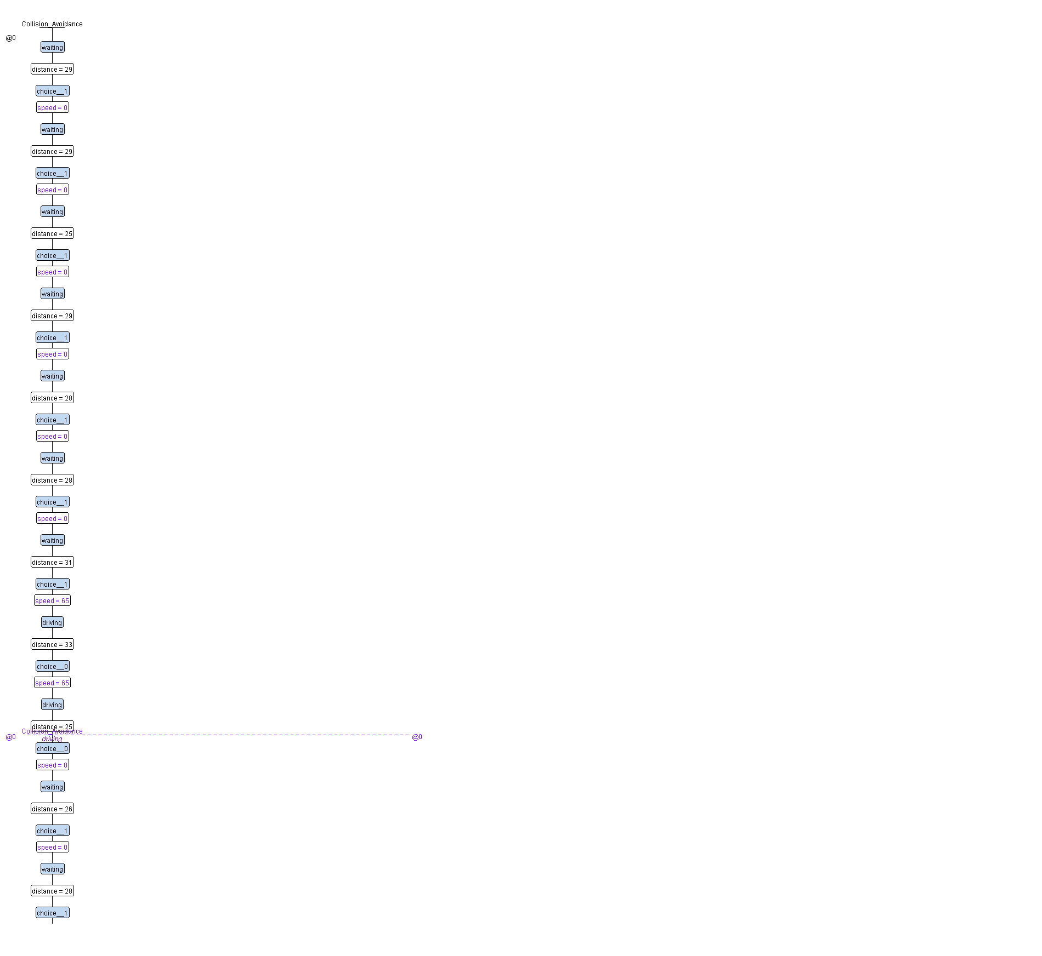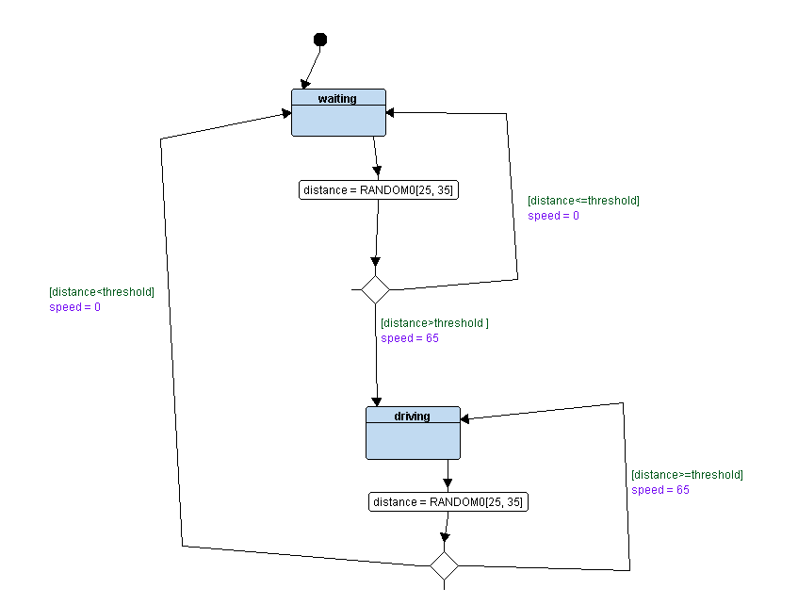

**My Log:**

UltraSonic_init

DC_Motor_init

Waiting State: distance = 33, Speed = 65

Driving State: distance = 34, Speed = 65

Driving State: distance = 34, Speed = 65

Driving State: distance = 26, Speed = 0

Waiting State: distance = 32, Speed = 65

Driving State: distance = 30, Speed = 0

Waiting State: distance = 30, Speed = 0

Waiting State: distance = 35, Speed = 65

Driving State: distance = 26, Speed = 0

Waiting State: distance = 25, Speed = 0

Waiting State: distance = 32, Speed = 65

Driving State: distance = 32, Speed = 65

Driving State: distance = 30, Speed = 0

Waiting State: distance = 33, Speed = 65

Driving State: distance = 31, Speed = 65

Driving State: distance = 32, Speed = 65

Driving State: distance = 28, Speed = 0

Waiting State: distance = 32, Speed = 65

Driving State: distance = 34, Speed = 65

Driving State: distance = 27, Speed = 0

Waiting State: distance = 32, Speed = 65

Driving State: distance = 32, Speed = 65

Driving State: distance = 33, Speed = 65

Driving State: distance = 35, Speed = 65

Driving State: distance = 31, Speed = 65

Driving State: distance = 32, Speed = 65

Driving State: distance = 33, Speed = 65

Driving State: distance = 30, Speed = 0

Waiting State: distance = 31, Speed = 65

Driving State: distance = 32, Speed = 65

Driving State: distance = 27, Speed = 0

Waiting State: distance = 26, Speed = 0

Waiting State: distance = 34, Speed = 65

Driving State: distance = 35, Speed = 65

Driving State: distance = 35, Speed = 65

Driving State: distance = 27, Speed = 0

Waiting State: distance = 29, Speed = 0

Waiting State: distance = 34, Speed = 65

Driving State: distance = 32, Speed = 65

Driving State: distance = 30, Speed = 0

Waiting State: distance = 29, Speed = 0

Waiting State: distance = 32, Speed = 65

Driving State: distance = 30, Speed = 0

Waiting State: distance = 31, Speed = 65

Driving State: distance = 32, Speed = 65

Driving State: distance = 25, Speed = 0

Waiting State: distance = 30, Speed = 0

Waiting State: distance = 25, Speed = 0

Waiting State: distance = 30, Speed = 0

Waiting State: distance = 29, Speed = 0

**Collision Avoidance System with multiple blocks.**

**My Photos about it:**

Figure 1DC_Motor

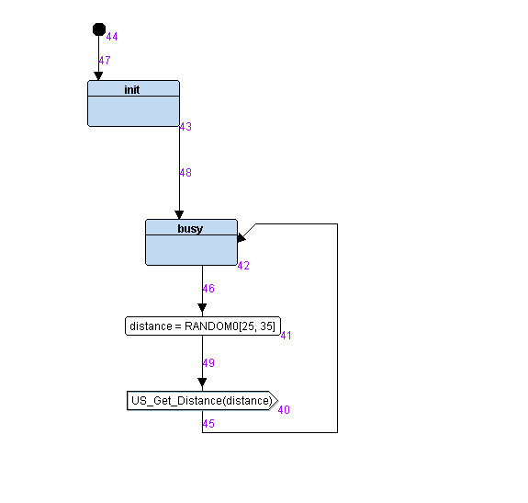

Figure 2UltraSonic.

Figure 3Collision_Avoidance_Mechanism

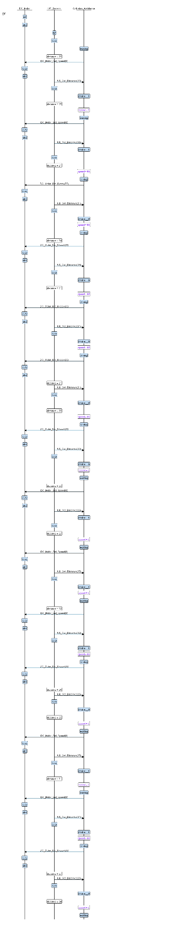

**My Log:**

US_init

DC_Motor_init (idle State)

------------------------------------------------

US_Busy state : distance = 33

DC_Motor is Busy , Speed = 65

Waiting_State: distance = 33 , I switched to the driving state with speed = 65

------------------------------------------------

------------------------------------------------

US_Busy state : distance = 34

DC_Motor is Busy , Speed = 65

Driving_State: distance = 34 , I am still in the driving state with speed = 65

------------------------------------------------

------------------------------------------------

US_Busy state : distance = 34

DC_Motor is Busy , Speed = 65

Driving_State: distance = 34 , I am still in the driving state with speed = 65

------------------------------------------------

------------------------------------------------

US_Busy state : distance = 26

DC_Motor is Busy , Speed = 0

Driving_State: distance = 26 , I switched to the waiting state with speed = 0

------------------------------------------------

------------------------------------------------

US_Busy state : distance = 32

DC_Motor is Busy , Speed = 65

Waiting_State: distance = 32 , I switched to the driving state with speed = 65

------------------------------------------------

------------------------------------------------

US_Busy state : distance = 30

DC_Motor is Busy , Speed = 0

Driving_State: distance = 30 , I switched to the waiting state with speed = 0

------------------------------------------------

------------------------------------------------

US_Busy state : distance = 30

DC_Motor is Busy , Speed = 0

Waiting_State: distance = 30 , I am still in the waiting state with speed = 0

------------------------------------------------

------------------------------------------------

US_Busy state : distance = 35

DC_Motor is Busy , Speed = 65

Waiting_State: distance = 35 , I switched to the driving state with speed = 65

------------------------------------------------

------------------------------------------------

US_Busy state : distance = 26

DC_Motor is Busy , Speed = 0

Driving_State: distance = 26 , I switched to the waiting state with speed = 0

------------------------------------------------

------------------------------------------------

US_Busy state : distance = 25

DC_Motor is Busy , Speed = 0

Waiting_State: distance = 25 , I am still in the waiting state with speed = 0

**Thank you for your time.**

**Ayman Mohamed Elashry**

**Learn-In-Depth**