Mastering Embedded Systems Online Diploma

[www.learn-in-depth.com](http://www.learn-in-depth.com)

First Term (Final Project 1)

Eng. Ayman Mohamed Elashry

My Profile:

<https://www.learn-in-depth-store.com/certificate/engaymanvip%40gmail.com>

The Project contains:

* Case study.
* Method.
* Requirements.
* System Analysis.
* System Design.

First, I will start with the case study.

**Case Study**

Project Notes for High-Pressure Alarm System Integration

The client has requested the development of a product to assist pilots in the cabin by providing high-pressure alerts through an opening alarm. As part of this project, I am tasked with designing a programmable circuit that will be integrated into the airplane system. However, there are some critical points to consider:

* Controller Activation Signal:

The controller must have an electric signal for activation. Ensure that you can deactivate this model, when necessary, as it is not currently modeled.

* Controller Maintenance:

Maintenance procedures for the controller are not modeled. Before deploying the system model, thoroughly check the pressure sensor’s sensitivity and verify the alarm’s status.

* Power Interruptions:

Avoid power cuts to the system, as they may lead to unexpected behavior.

Please review these notes carefully, as I cannot assume responsibility for any damage incurred during implementation.

**Method**

I will choose V Model Software Development

[Picture Reference](https://en.wikipedia.org/wiki/V-model)

**System Requirements**

Here I will make a system requirements diagram.

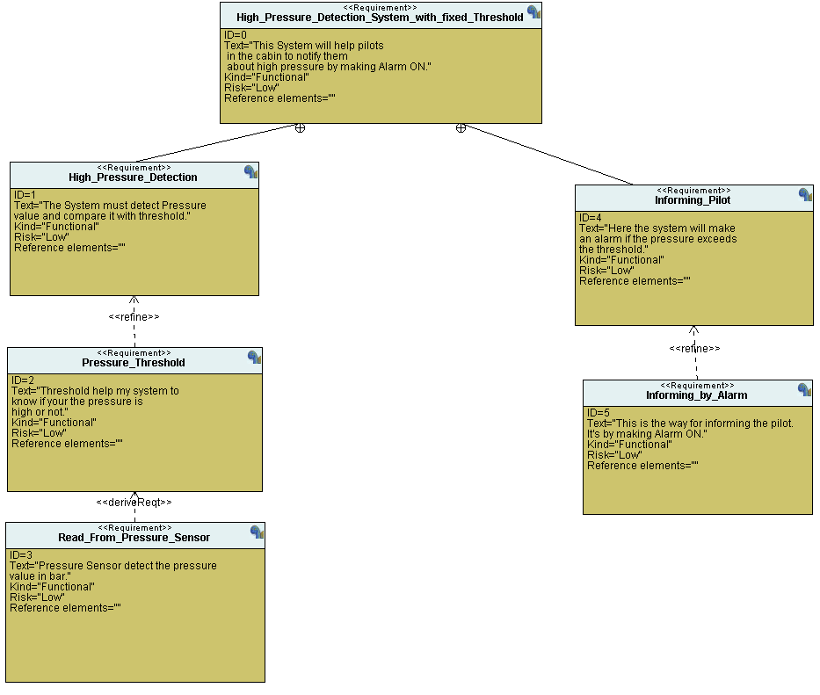

This is my Requirement diagram for the required system.

**System Analysis**

**Use Case Diagram:**

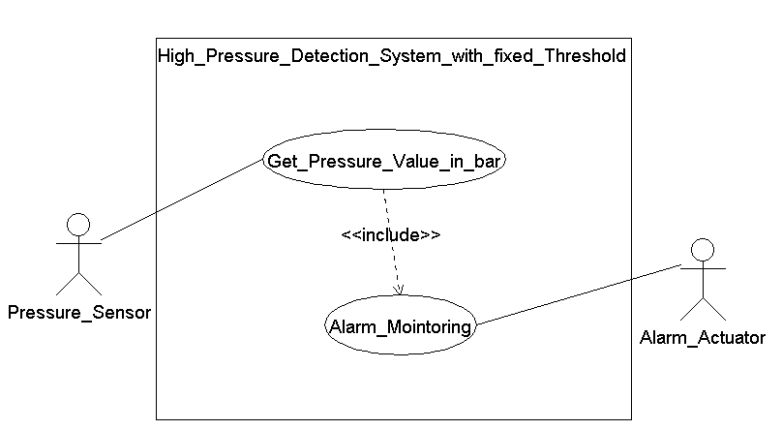

**Activity Diagram:**

**Sequence Diagram:**

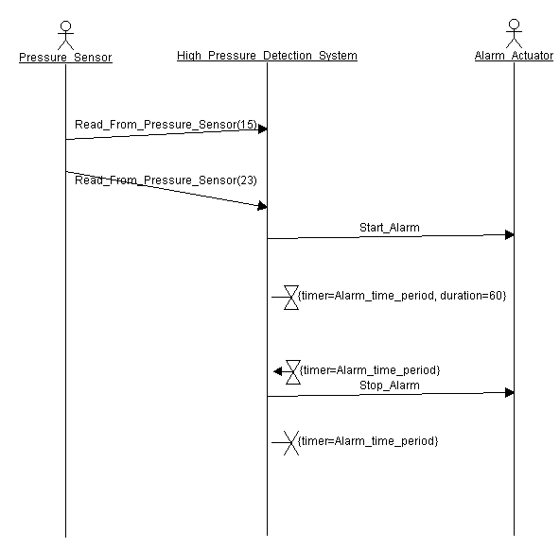

**System Design:**

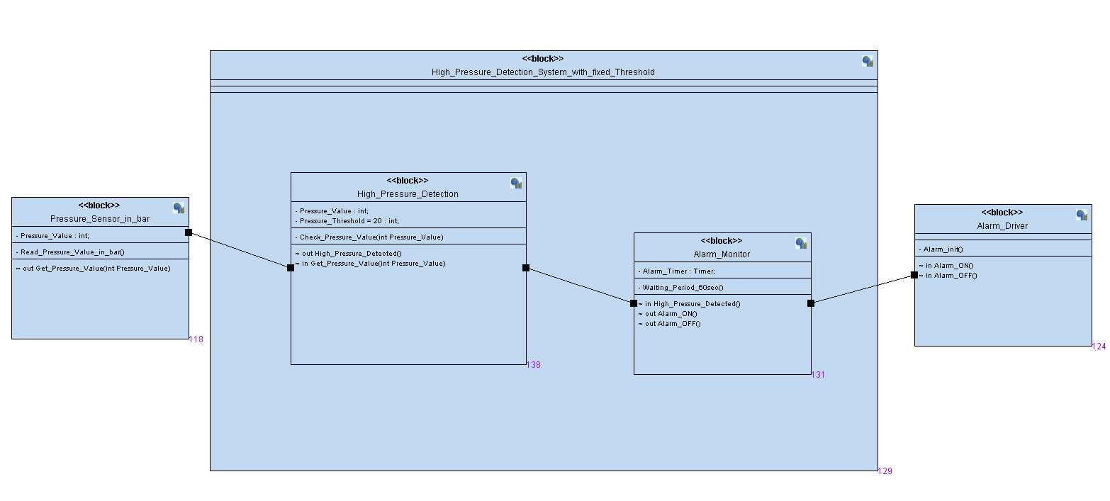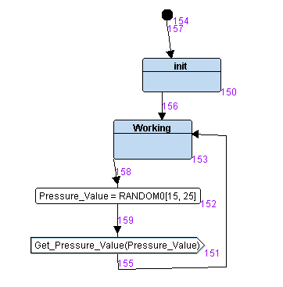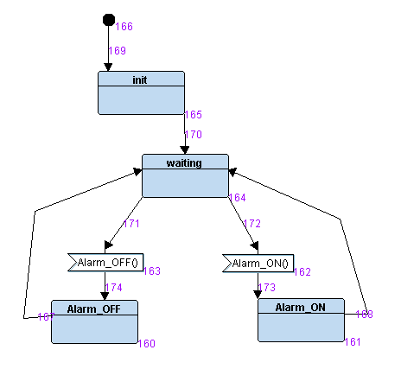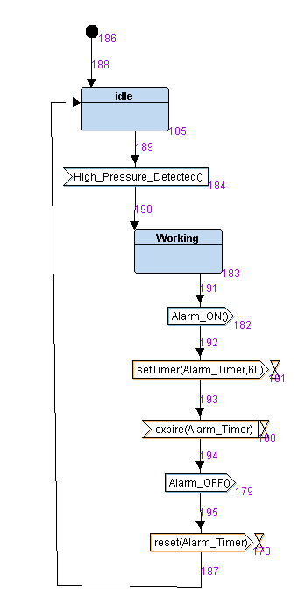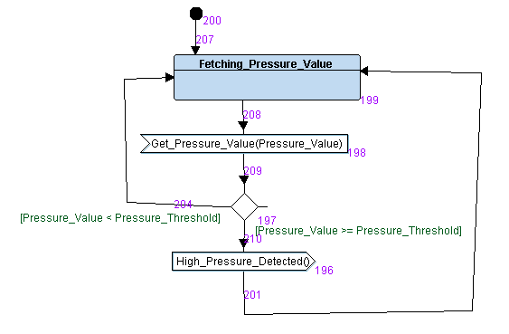

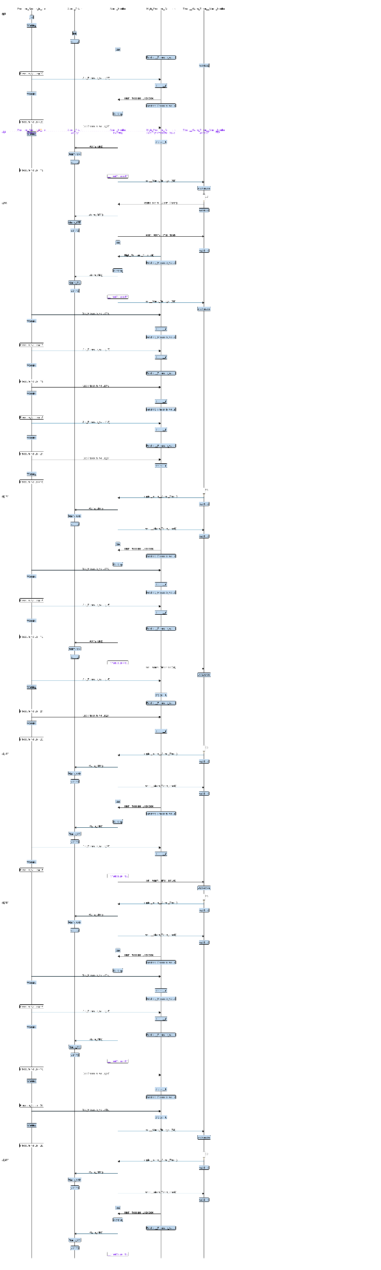Interactive Simulation

Implementation with Embedded C Programming

Here I have an important note:

This API :

uint32_t getPressureVal();

doesn’t work.

So, I tested my logic with values I made in the C code while writing the code.

Please review this API.

