Instrumentação e Medicao

Estaçao Metereologica

Relatorio de Campo

LM35 - Temperatura

Em consenso pelo grupo, decidiu-se que a faixa de temperatura para medições seria entre 5°C a 40°C (faixa da temperatura de São Paulo). Dentro dessa faixa, pegaremos 6 pontos: 5°C, 12°C, 19°C, 26°C, 33°C, 40°C. Para cada ponto serão feitas 9 medições.

R=100,4 Kohm

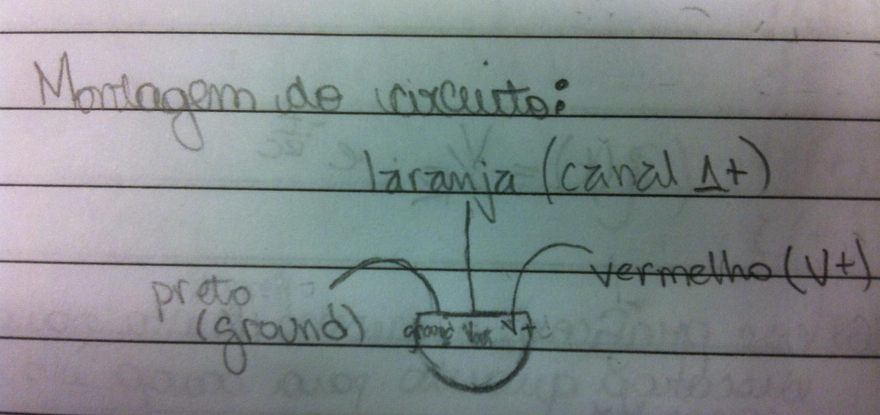

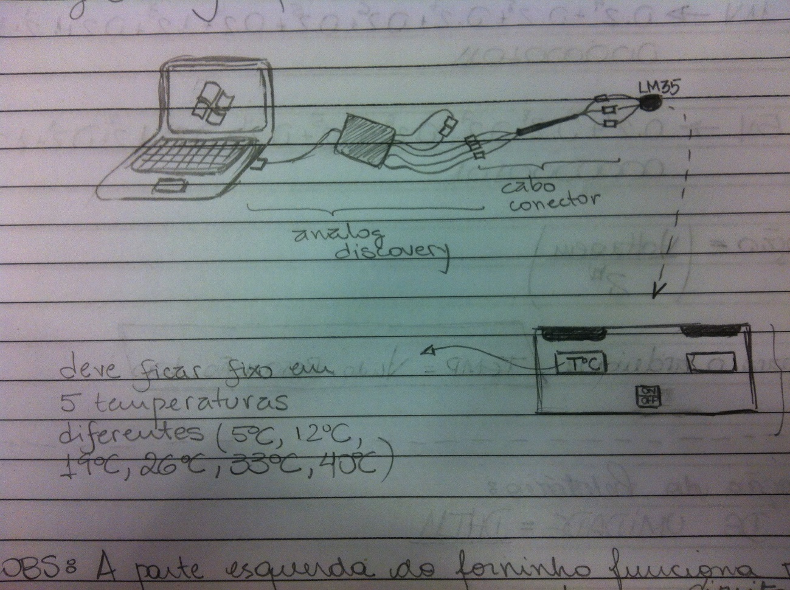

|  |  |  |  |  |  |  |  |  |  |  |
| --- | --- | --- | --- | --- | --- | --- | --- | --- | --- | --- |
| **T/°C 6pontos** | **Tensão (V) 9medições** | | | | | | | | | **T(média)** |
| **5** | **0,063** | **0,064** | **0,064** | **0,064** | **0,064** | **0,064** | **0,064** | **0,064** | **0,064** | **6,390** |
| **12** | **0,134** | **0,135** | **0,135** | **0,139** | **0,139** | **0,136** | **0,141** | **0,136** | **0,136** | **13,682** |
| **19** | **0,208** | **0,204** | **0,205** | **0,204** | **0,204** | **0,205** | **0,204** | **0,204** | **0,205** | **20,475** |
| **26** | **0,270** | **0,271** | **0,273** | **0,274** | **0,272** | **0,272** | **0,273** | **0,272** | **0,272** | **27,200** |
| **33** | **0,345** | **0,343** | **0,342** | **0,341** | **0,343** | **0,343** | **0,341** | **0,343** | **0,343** | **34,260** |
| **40** | **0,446** | **0,442** | **0,447** | **0,441** | **0,436** | **0,442** | **0,442** | **0,442** | **0,444** | **44,250** |

|  |  |  |  |  |  |  |  |
| --- | --- | --- | --- | --- | --- | --- | --- |
| **T(média)** | **Variância = Somatória (V-V(médio))2/8** | **Desvio Padrão()** | **Erro-Padrão da Média () Inceteza Tipo A** | **() Incerteza Tipo B1** | **() Incerteza Tipo B2** | **Incerteza Combinada de B   = (+)1/2** | **Incerteza Combinada Total          V = (A2+B2)1/2** |
| **6,390** | **45,02** | **6,710** | **2,2366** | **0,0003** | **0,1667** | **0,1667** | **2,242819** |
| **13,682** | **206,41** | **14,367** | **4,7890** | **0,0003** | **0,1667** | **0,1667** | **4,791912** |
| **20,475** | **462,24** | **21,500** | **7,1666** | **0,0003** | **0,1667** | **0,1667** | **7,168524** |
| **27,200** | **815,75** | **28,561** | **9,5204** | **0,0003** | **0,1667** | **0,1667** | **9,521890** |
| **34,260** | **1294,21** | **35,975** | **11,9917** | **0,0003** | **0,1667** | **0,1667** | **11,992887** |
| **44,250** | **2158,95** | **46,464** | **15,4882** | **0,0003** | **0,1667** | **0,1667** | **15,489055** |

|  |  |  |  |  |  |  |  |  |  |  |  |  |  |
| --- | --- | --- | --- | --- | --- | --- | --- | --- | --- | --- | --- | --- | --- |
| σ2 | 1/σ2 | S | x/σ2 | Sx | x2/σ2 | Sx2 | y/σ2 | Sy | xy/σ2 | Sxy |  | a | b |
| 5,030 | 0,199 | 0,284 | 1,0 | 2,6 | 4,970 | 39,963 | 1,270 | 3,0 | 6,352 | 44,110 | 4,747 | 1,022 | 1,274 |
| 22,962 | 0,044 | 0,5 | 6,271 | 0,596 | 7,150 |
| 51,388 | 0,019 | 0,4 | 7,025 | 0,398 | 7,570 |
| 90,666 | 0,011 | 0,3 | 7,456 | 0,300 | 7,800 |
| 143,829 | 0,007 | 0,2 | 7,571 | 0,238 | 7,861 |
| 239,911 | 0,004 | 0,2 | 6,669 | 0,184 | 7,378 |

DHT22 - Umidade

|  |  |  |  |  |  |
| --- | --- | --- | --- | --- | --- |
| Umidade de Referencia | | | | | |
| T (°C) | KOH | K(CH3COO) | Ca(NO3)2 | NaCl | KCl |
| **5** | **13** | **25** | **61** | **76** | **88** |
| **15** | **9** | **24** | **58** | **76** | **86** |
| **20** | - | **23** | **56** | **75** | **85** |
| **25** | 8 | **23** | **53** | **76** | **85** |
|  |  |  |  |  |  |
| Umidade Sensor DHT22 | | | | | |
|  | KOH | K(CH3COO) | Ca(NO3)2 | NaCl | KCl |
|  | **28,6** | **21,9** |  | **78,2** |
| T (°C) |  | 21,1°C | 21,9°C |  | 23,1°C |

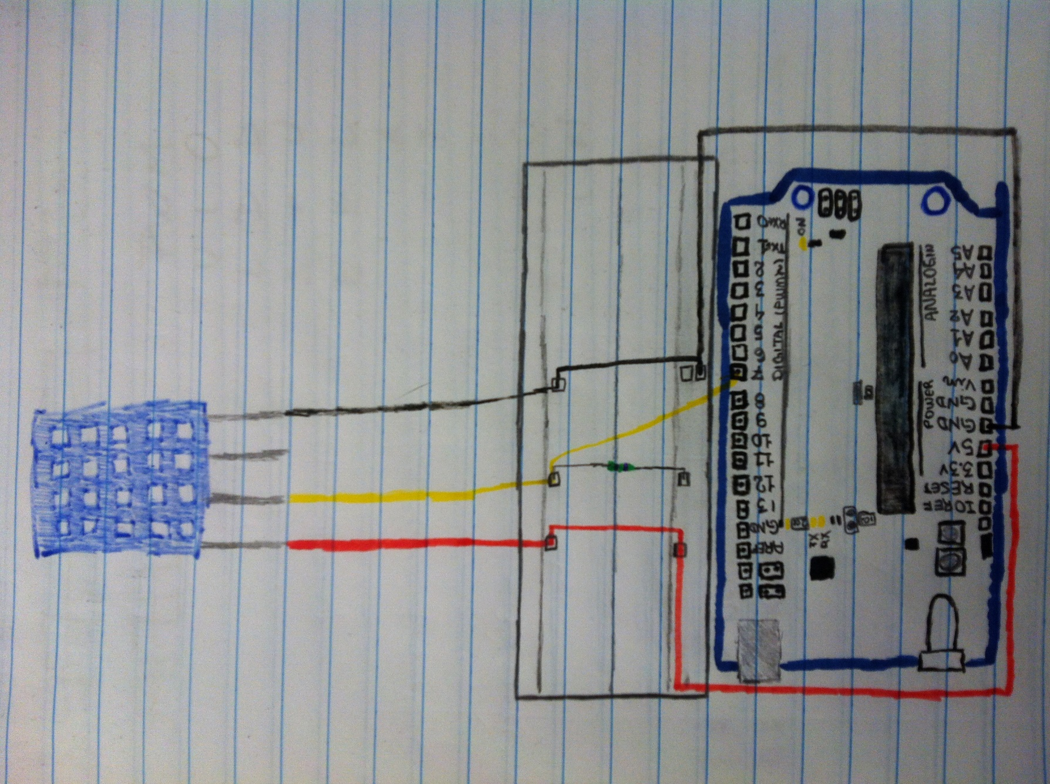

Pressão – BMP180

Sensor de Chuva -

Circuito Integrado

#include <Wire.h>

#include "Barometer.h"

#include <LiquidCrystal_I2C.h>

#include <Adafruit_BMP085.h>

// LCD //

#define LCD_ADDR 0x27 // I2C address

#define EN 2 // LCD En (Enable)

#define RW 1 // LCD Rw (Read/write)

#define RS 0 // LCD Rs (Reset)

#define D4 4 // LCD data 0

#define D5 5 // LCD data 1

#define D6 6 // LCD data 2

#define D7 7 // LCD data 3

#define BACKLIGHT_PIN 3

#define BACKLIGHT_POL POSITIVE //ligar ou nao o backlight (luz de fundo). Valor pode ser POSITIVE ou NEGATIVE

#define COLUNAS 16 // quantidade de colunas do LCD

#define LINHAS 2 // quantidade de linhas do LCD

LiquidCrystal_I2C lcd(LCD_ADDR, EN, RW, RS, D4, D5, D6, D7, BACKLIGHT_PIN, BACKLIGHT_POL);

// LM 35 //

int pinoSensor = A0;

int valorLido = 0;

float temperatura = 0;

// DHT 22 //

#include "DHT.h"

#define DHTPIN 53

#define DHTTYPE DHT22

DHT dht(DHTPIN, DHTTYPE);

// BMP 180 //

Adafruit_BMP085 bmp;

int cont = 0;

float pressao = 0;

void setup() {

Serial.begin(9600);

//LCD

lcd.begin(COLUNAS,LINHAS);

lcd.print(" Grupo 8");

delay(1000);

lcd.clear();

//DHT 22

dht.begin();

if (!bmp.begin()) {

Serial.println("Could not find a valid BMP085 sensor, check wiring!");

while (1) {}

}

}

void loop(){

// Medicao DHT 22

float h = dht.readHumidity();

float t = dht.readTemperature();

if (isnan(h) || isnan(t)) {

lcd.print("Failed to read!");

return;

}

// Medicao LM35

valorLido = analogRead(pinoSensor);

temperatura = (valorLido * 0.00488);

temperatura = temperatura * 100;

// Medicao BMP 180

pressao = bmp.readTemperature();

// Serial

Serial.print("Umidade: ");

Serial.print(h);

Serial.print(" Temperatura: ");

Serial.print(temperatura);

Serial.print(" Pressure: ");

Serial.print(pressao, 0); //whole number only.

Serial.println(" Pa");

Serial.print(" Medicao n: ");

Serial.print(cont);

Serial.println("");

// LCD

lcd.print("Umidade: DHT22 ");

lcd.setCursor(0,1);

lcd.print(h);

lcd.setCursor(6,1);

lcd.print("%");

delay(3000);

lcd.clear();

lcd.setCursor(0,0);

lcd.print("Temp: LM35 ");

lcd.setCursor(0,1);

lcd.print(temperatura);

lcd.setCursor(6,1);

lcd.print("C");

delay(3000);

lcd.clear();

lcd.setCursor(0,0);

lcd.print("Pressao: BMP 180");

lcd.setCursor(0,1);

lcd.print(pressao);

lcd.setCursor(6,1);

lcd.print("Pa");

delay(3000);

lcd.clear();

cont++;

delay(2000);

lcd.clear();

}

