CHAPTER FOUR
SOFTWARE DESIGN

4.0 Introduction
Chapter Three analysed the requirements of the AI Agent for Real Estate Recommendation and Price Prediction System and modelled its processes and data. This chapter translates that analysis into a design that can be implemented. It presents the architectural design of the system, the design of the user interface, the way in which data are stored, the design of the database, including normalization, the transformation of the entity relationship diagram into relations and the data dictionaries, and the design of the forms and reports of the system.

4.1 Architectural Design
The system follows a three-layer web architecture, shown in Figure 4.1. The presentation layer is the web browser, through which the Public Visitor, the Customer, the Property Manager and the Administrator reach the public portal and the three role-based areas. The application layer is a single Next.js application written in TypeScript. It contains the React user interface, a middleware component that authenticates users and restricts each area to its role, the Route Handlers that provide the backend services, and the three AI modules identified in Chapter Three. The data layer consists of the Prisma ORM, the MySQL database and the file storage that holds property images.
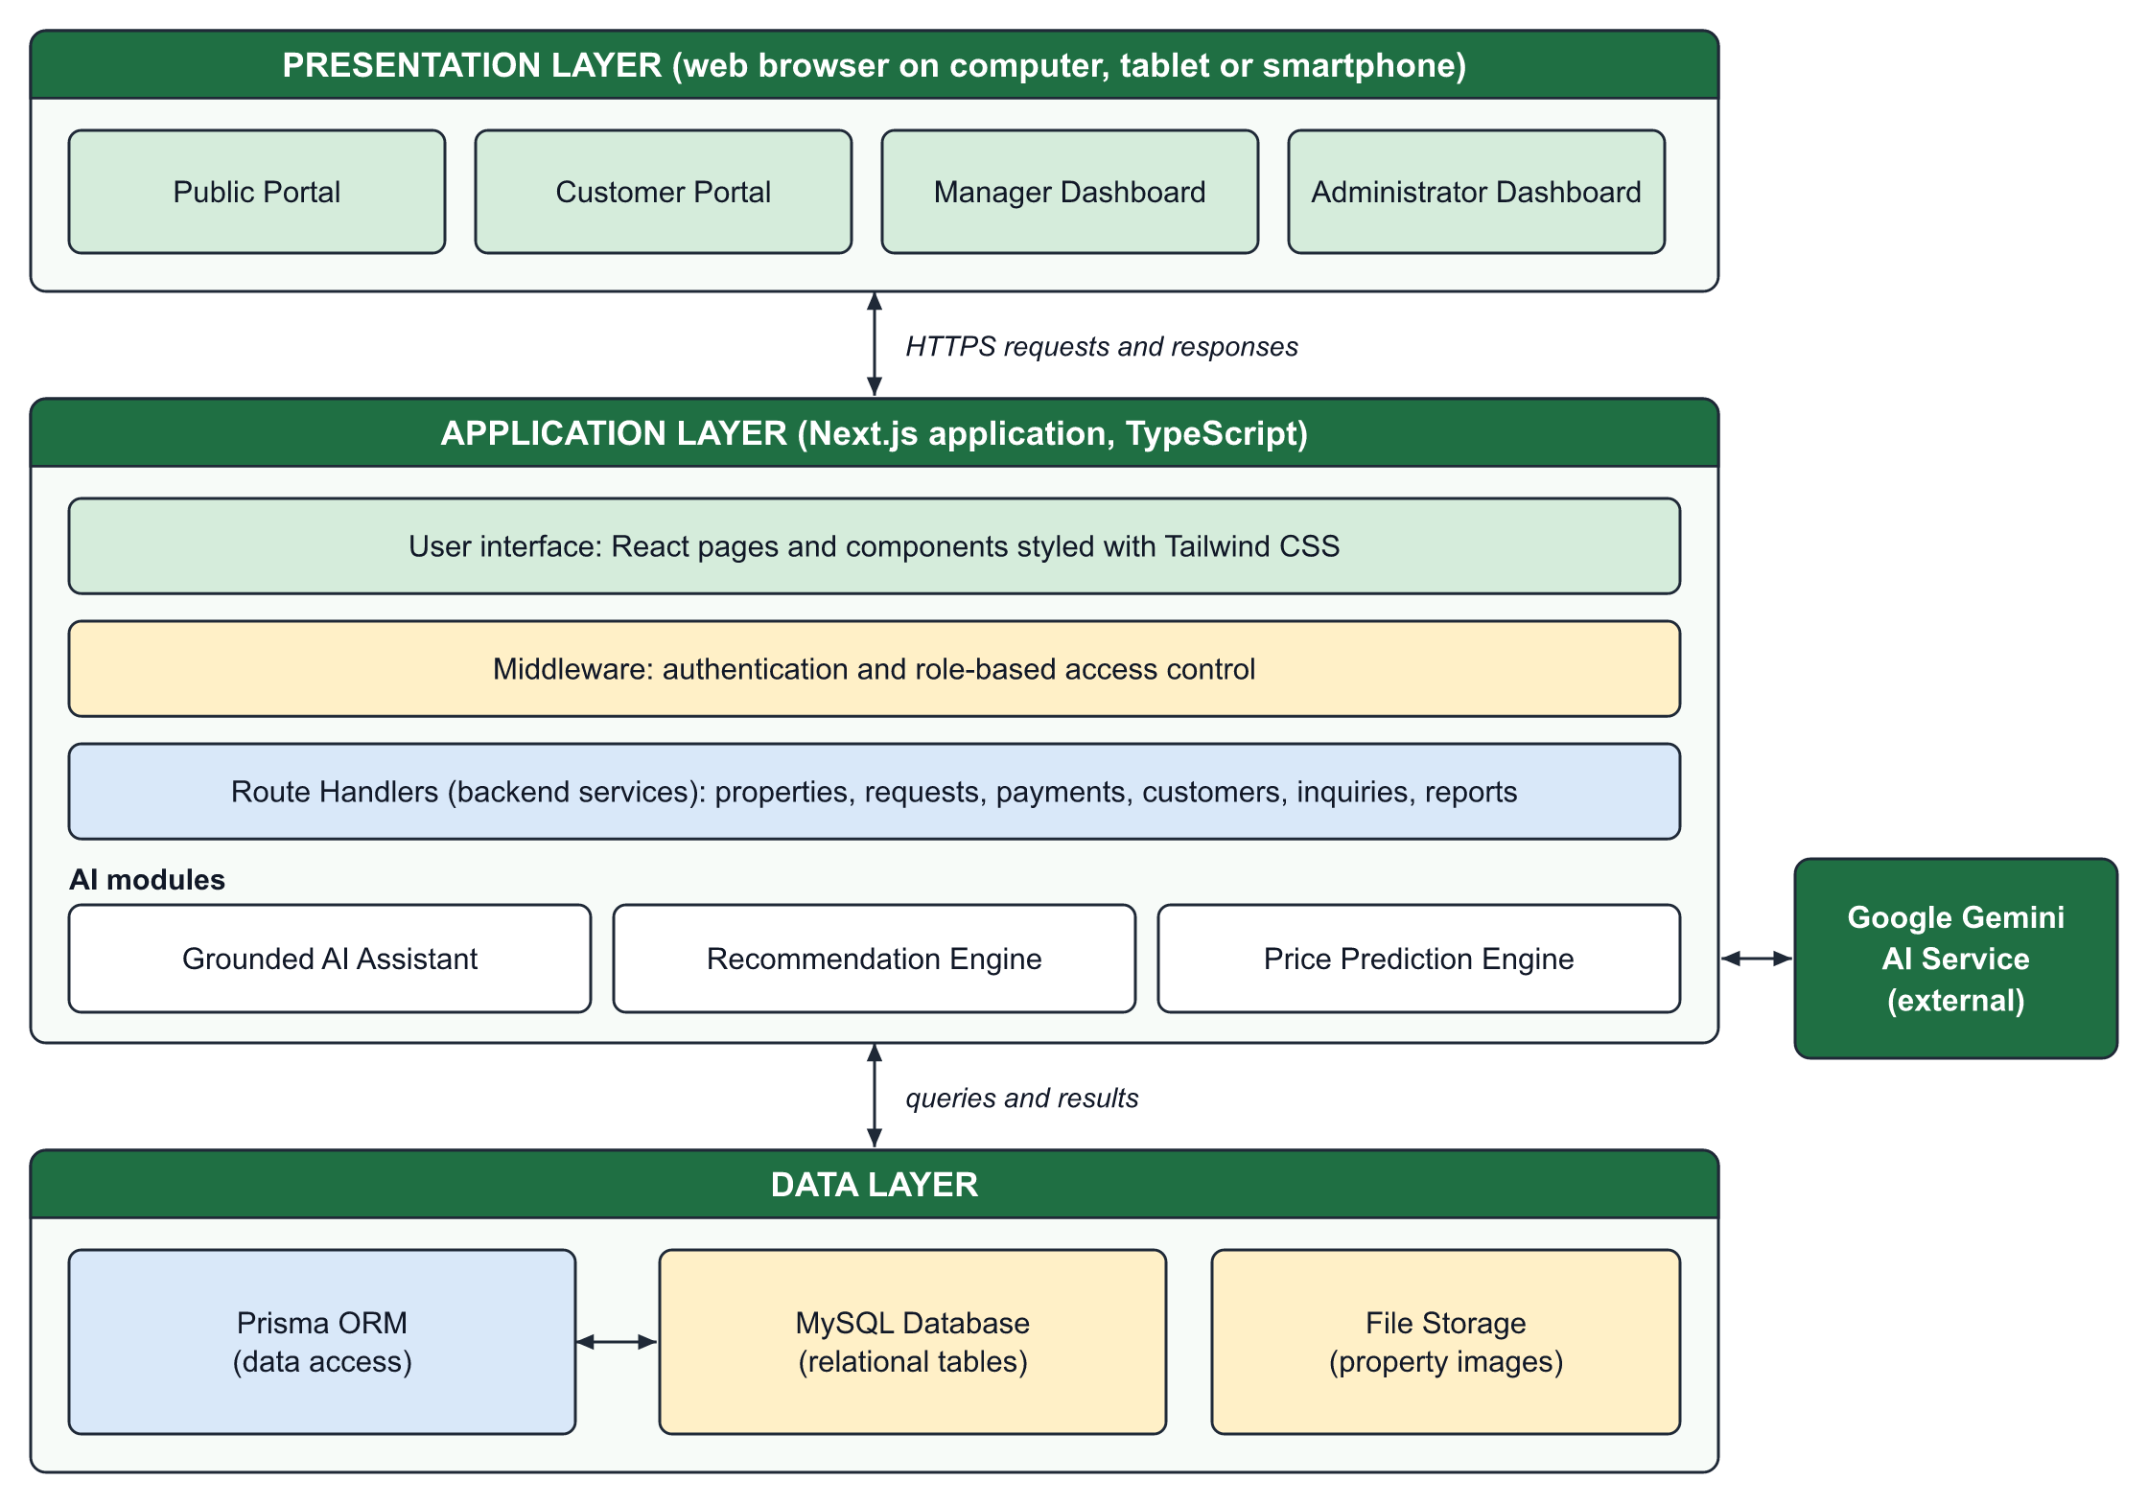
Figure 4.1: Architectural Design of the Proposed System
Table 4.1 summarizes the components of the architecture and the responsibility of each.
Table 4.1: Components of the System Architecture
Component | Layer | Responsibility
Public portal | Presentation | Property search, property details, price prediction and AI assistant for all visitors
Customer portal | Presentation | Favorites, recommendations, rentals, purchases, payments and receipts of one customer
Manager dashboard | Presentation | Properties, customers, rental requests, leases, inquiries and viewings of one manager
Administrator dashboard | Presentation | Users, property approval, sales, ledger, analytics, audit logs and settings
Middleware | Application | Checks the session and the role of the user before a protected page is opened
Route Handlers | Application | Receive requests, validate input, apply the business rules and return data
AI modules | Application | AI assistant, recommendation engine and price prediction engine
Prisma ORM | Data | Maps the application models to tables and executes queries
MySQL database | Data | Stores all structured data of the system
File storage | Data | Stores the image files of properties

This architecture was chosen for three reasons. First, the interface and the backend services share one codebase and one language, which reduces the effort of development and maintenance. Second, every request passes through the middleware and the Route Handlers before it reaches the database, so the business rules of Chapter Three, such as the rule that only the Property Manager approves rental bookings, are enforced in one place. Third, the AI modules are separated from the business logic: the recommendation and price prediction engines run inside the application, and only the AI assistant communicates with an external service, Google Gemini, to which it sends the question together with the relevant property records.
Security design. Security is built into each layer. In the presentation layer a user sees only the menu of the user's own role. In the application layer the middleware refuses a page that belongs to another role, and each Route Handler checks the role again before it changes data, so a request that bypasses the interface is still refused. In the data layer passwords are stored only as hashes, each e-mail address is unique, and foreign keys prevent a request, payment or receipt from referring to a record that does not exist. Sensitive actions of the Administrator are written to the audit log.
Flow of a request. A typical request passes through the layers as follows. The Customer submits a rental booking in the browser; the middleware confirms that the user is logged in as a Customer; the Route Handler validates the dates, checks that the property is still available and saves the request through Prisma; the database stores the record; and the response returns to the browser, where the new status is displayed. The same path is followed by every operation of the system.

4.2 User Interface Design
The user interface is designed around the four actors of the system. Figure 4.2 shows the navigation structure. All users enter through the home page. Public pages are available without an account, and after login the system redirects each user to the area of the user's role: the customer portal, the manager dashboard or the administrator dashboard. A user cannot open an area that belongs to another role.
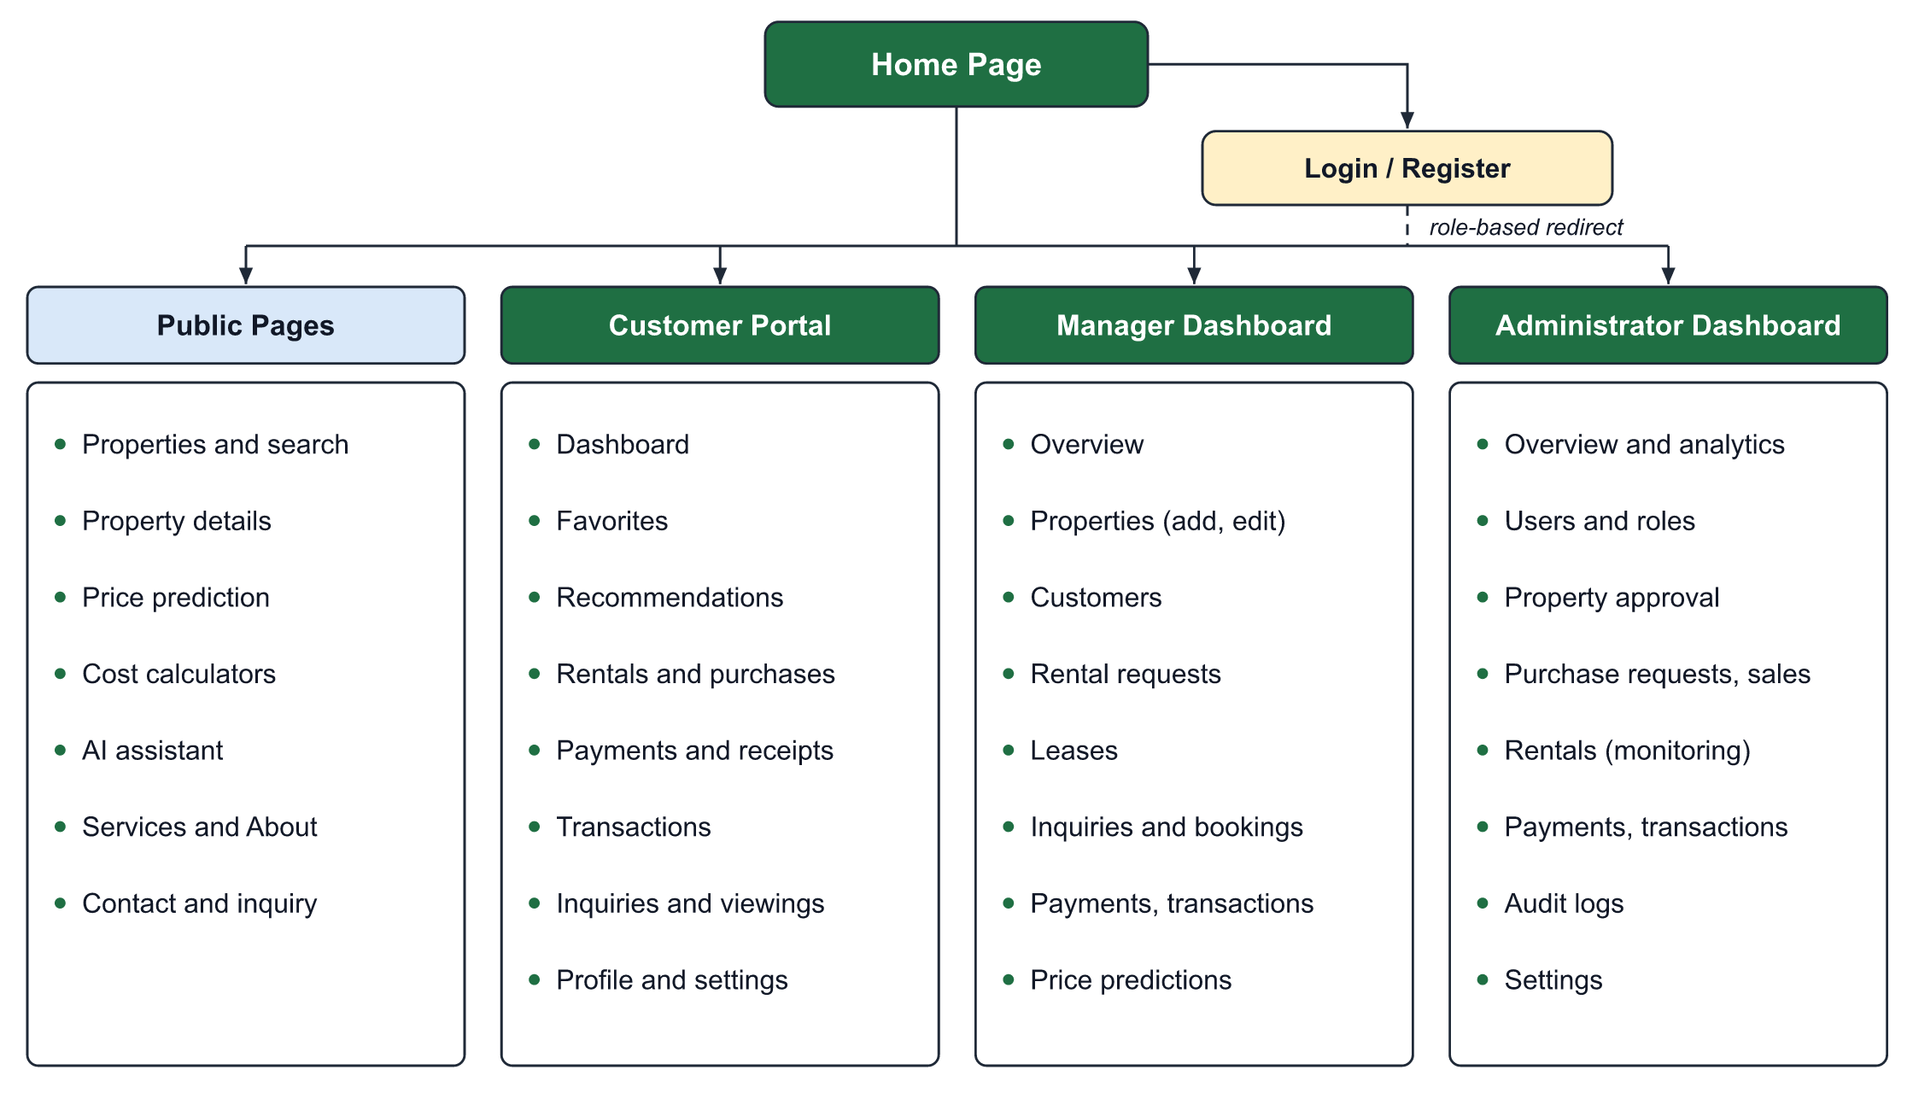
Figure 4.2: Navigation Structure of the User Interface
The interface follows four design principles. Consistency: every page uses the same header, colours, typography and button styles, and the three dashboards share one layout of a sidebar, summary cards and data tables. Simplicity: a visitor can search for a property from the first screen without registering. Responsiveness: the layout adapts to the width of the screen, so tables become cards on small screens. Feedback: the status of every request and payment is displayed with a labelled badge. The interface is presented under the name Kiro-Maal Real Estate. Figure 4.3 shows the implemented home page and the property search interface.

Figure 4.3: Home Page and Property Search Interface
Table 4.2 lists the main screens of the interface, the actor who uses each of them and its purpose.
Table 4.2: Main Screens of the User Interface
Screen | Actor | Purpose
Home page | All users | Entry point with the property search button and the AI assistant
Properties | Public Visitor, Customer | List of published properties with filters and sorting
Property details | Public Visitor, Customer | Specifications, amenities, location, status and actions to rent, buy or inquire
Price prediction | Public Visitor, Customer | Form for the features of a property and the resulting estimate
Login and registration | Registered actors | Sign-in and creation of a customer account
Customer dashboard | Customer | Summary of active leases, pending purchases, saved properties and inquiries
Recommendations | Customer | Properties suggested by the recommendation engine with reasons
Manager overview | Property Manager | Summary cards, today's appointments and pending rental requests
Add property | Property Manager | Multi-step form for details, pricing, images, location and amenities
Rental management | Property Manager | Review of bookings, direct rental creation and lease tracking
Property approval | Administrator | Review of pending properties with approve, reject and publish actions
Requests and sales | Administrator | Confirmation of purchase requests and approval of sales
Transactions | Manager, Administrator | Central ledger with filters by payment method and status

4.3 Database Storage Design
The data of the system are stored in a MySQL relational database. Each entity of the ERD in Chapter Three is stored as one table, each record as one row, and each relationship as a foreign key. The tables are created and changed through the Prisma schema, which keeps the structure of the database and the application code consistent. Property images are not stored inside the database; the image files are kept in the file storage of the application, and only their addresses are stored in the PROPERTY_IMAGES table, which keeps the database small and queries fast. Passwords are never stored in readable form; only their hashes are stored. Table 4.3 lists the data types used.
Table 4.3: Data Types Used in the Database
Data Type | Use in the Proposed System
VARCHAR | Identifiers, names, e-mail addresses, cities, request and receipt numbers
TEXT | Long text such as property descriptions, messages and review notes
INT | Whole numbers such as bedrooms, bathrooms and view counts
DOUBLE | Prices, rent, deposits, areas and geographic coordinates
BOOLEAN | Yes or no values such as is_active, is_furnished and is_read
DATETIME | Dates and times such as created_at, start_date, end_date and paid_at
ENUM | Fixed lists of values such as role, property type and status

4.4 Database Design
The database design converts the conceptual model of Chapter Three into tables that are free from redundancy. This section explains normalization, transforms the ERD into relations and defines the data dictionaries.

4.4.1 Database Normalization
Normalization is the process of organizing data into tables so that each fact is stored once and update anomalies are avoided (Elmasri & Navathe, 2016). It is illustrated below with the rental data of the system, beginning with an unnormalized record in which all the details of a rental are written together: RENTAL (request_no, customer_name, customer_phone, property_title, property_city, manager_name, start_date, end_date, rent_amount, payment_1, payment_2, ...).

4.4.1.1 First Normal Form (1NF)
A table is in first normal form when every field holds a single value and there are no repeating groups. In the unnormalized record the payments form a repeating group. They are therefore moved to a separate table in which each payment is one row: RENTAL (request_no, customer_name, customer_phone, property_title, property_city, manager_name, start_date, end_date, rent_amount) and PAYMENT (payment_id, request_no, amount, payment_method, paid_at).

4.4.1.2 Second Normal Form (2NF)
A table is in second normal form when it is in 1NF and every non-key field depends on the whole primary key. Each table of the system has a single-field primary key, such as rental_request_id, so no field can depend on only part of a key. Junction data are treated in the same way: FAVORITES has its own key, favorite_id, and stores only the two foreign keys and the date.

4.4.1.3 Third Normal Form (3NF)
A table is in third normal form when it is in 2NF and no non-key field depends on another non-key field. In the rental record, customer_phone depends on the customer and property_city depends on the property, not on the rental. These fields are therefore removed to the tables to which they belong, and the rental keeps only foreign keys: USERS (user_id, name, phone, ...), PROPERTIES (property_id, title, city, ...) and RENTAL_REQUESTS (rental_request_id, request_no, customer_id, property_id, manager_id, start_date, end_date, rent_amount, status).
Table 4.4 summarizes the three normal forms and the way in which each is satisfied in the proposed system.
Table 4.4: Summary of the Normal Forms
Form | Rule | Application in the Proposed System
1NF | Every field holds one value; no repeating groups | Payments and property images are stored as separate rows in their own tables
2NF | Every non-key field depends on the whole primary key | Every table has a single-field primary key; junction tables hold only keys and their own data
3NF | No non-key field depends on another non-key field | Customer, manager and property details are stored once and reached through foreign keys

Normalization gives the system three practical benefits. A change, such as a new telephone number of a customer, is made in one place. A record cannot be lost by accident, because deleting a payment does not delete the customer or the property. And the size of the database stays small, because the same text is not repeated in every request.

4.4.1.4 Normalized Tables of the Proposed System
Applying the same steps to all the data of the system produces the normalized tables listed in Table 4.5.
Table 4.5: Normalized Tables of the Proposed System
Table | Primary Key | Foreign Keys
users | user_id | None
properties | property_id | manager_id
property_images | image_id | property_id
favorites | favorite_id | user_id, property_id
search_history | search_id | user_id
recommendations | recommendation_id | user_id, property_id
price_predictions | prediction_id | user_id, property_id
rental_requests | rental_request_id | customer_id, property_id, manager_id
purchase_requests | purchase_request_id | customer_id, property_id, reviewed_by
transactions | transaction_id | customer_id, property_id, rental_request_id, purchase_request_id
payments | payment_id | transaction_id, customer_id
receipts | receipt_id | payment_id, transaction_id
inquiries | inquiry_id | property_id, customer_id, manager_id
appointments | appointment_id | property_id, customer_id, manager_id
reviews | review_id | property_id, user_id
notifications | notification_id | user_id
audit_logs | log_id | user_id

4.4.2 Transforming E-R Diagrams into Relations
The ERD of Chapter Three is transformed into relations by three rules. Each entity becomes a relation whose primary key is the identifier of the entity. Each one-to-many relationship is represented by placing the primary key of the "one" side as a foreign key in the relation of the "many" side. Each many-to-many relationship becomes a relation of its own that contains the keys of both sides. Applying these rules gives the following main relations, in which the primary key is written first and foreign keys are marked (FK).
USERS (user_id, name, email, phone, password_hash, role, is_active, created_at)
PROPERTIES (property_id, manager_id (FK), title, description, type, listing_type, status, price, city, location, bedrooms, bathrooms, area, amenities)
FAVORITES (favorite_id, user_id (FK), property_id (FK), created_at)
RENTAL_REQUESTS (rental_request_id, request_no, customer_id (FK), property_id (FK), manager_id (FK), start_date, end_date, rent_amount, security_deposit, status)
PURCHASE_REQUESTS (purchase_request_id, request_no, customer_id (FK), property_id (FK), reviewed_by (FK), sale_price, status, reviewed_at, completed_at)
TRANSACTIONS (transaction_id, txn_no, type, customer_id (FK), property_id (FK), rental_request_id (FK), purchase_request_id (FK), amount, status)
PAYMENTS (payment_id, transaction_id (FK), customer_id (FK), amount, payment_method, status, transaction_ref, paid_at)
RECEIPTS (receipt_id, receipt_no, payment_id (FK), transaction_id (FK), issued_at)

4.4.3 Data Dictionaries
A data dictionary describes each field of a table by its data type, its constraint and its meaning. Tables 4.6 to 4.11 present the data dictionaries of the six central tables of the system. The field names follow the ERD of Chapter Three; identifiers are stored as text keys generated by the system.
Table 4.6: Data Dictionary of the Users Table
Field | Data Type | Constraint | Description
user_id | VARCHAR | Primary key | Unique identifier of the user
name | VARCHAR | Not null | Full name
email | VARCHAR | Unique, not null | E-mail address used to log in
phone | VARCHAR | Optional | Telephone number
password_hash | VARCHAR | Not null | Hashed password
role | ENUM | Not null | Administrator, Property Manager or Customer
is_active | BOOLEAN | Default true | Active or suspended account
created_at | DATETIME | Not null | Date of registration

Table 4.7: Data Dictionary of the Properties Table
Field | Data Type | Constraint | Description
property_id | VARCHAR | Primary key | Unique identifier of the property
manager_id | VARCHAR | Foreign key | Property Manager assigned to the property
title | VARCHAR | Not null | Title of the listing
description | TEXT | Not null | Description of the property
type | ENUM | Not null | House, apartment, villa, office, land and others
listing_type | VARCHAR | Not null | For sale or for rent
status | ENUM | Default pending | Draft, pending, approved, published, rented, sold, archived
price | DOUBLE | Not null | Sale price or rent
city, location | VARCHAR | Not null | City and district of the property
bedrooms, bathrooms | INT | Not null | Number of bedrooms and bathrooms
area | DOUBLE | Not null | Area in square metres
amenities | TEXT | Optional | List of amenities

Table 4.8: Data Dictionary of the Rental Requests Table
Field | Data Type | Constraint | Description
rental_request_id | VARCHAR | Primary key | Unique identifier of the rental request
request_no | VARCHAR | Unique | Reference number shown to users
customer_id | VARCHAR | Foreign key | Customer who rents
property_id | VARCHAR | Foreign key | Property that is rented
manager_id | VARCHAR | Foreign key | Property Manager who decides on the request
start_date, end_date | DATETIME | Not null | Rental period
rent_amount | DOUBLE | Not null | Rent for one period
security_deposit | DOUBLE | Not null | Deposit paid by the customer
status | ENUM | Default pending | Pending, approved, rejected, active, expired, cancelled

Table 4.9: Data Dictionary of the Purchase Requests Table
Field | Data Type | Constraint | Description
purchase_request_id | VARCHAR | Primary key | Unique identifier of the purchase request
request_no | VARCHAR | Unique | Reference number shown to users
customer_id | VARCHAR | Foreign key | Customer who buys
property_id | VARCHAR | Foreign key | Property that is bought
sale_price | DOUBLE | Not null | Agreed sale price
status | ENUM | Default pending | Pending, payment pending, approved, completed, rejected
reviewed_by | VARCHAR | Foreign key | Administrator who reviewed the request
reviewed_at, completed_at | DATETIME | Optional | Dates of review and completion

Table 4.10: Data Dictionary of the Transactions Table
Field | Data Type | Constraint | Description
transaction_id | VARCHAR | Primary key | Unique identifier of the transaction
txn_no | VARCHAR | Unique | Transaction number
type | ENUM | Not null | Sale or rental
customer_id | VARCHAR | Foreign key | Customer of the transaction
property_id | VARCHAR | Foreign key | Property of the transaction
rental_request_id | VARCHAR | Foreign key, unique | Related rental request, if any
purchase_request_id | VARCHAR | Foreign key, unique | Related purchase request, if any
amount | DOUBLE | Not null | Amount of the transaction
status | ENUM | Default pending | Pending, paid, completed, active, rejected, cancelled

Table 4.11: Data Dictionary of the Payments Table
Field | Data Type | Constraint | Description
payment_id | VARCHAR | Primary key | Unique identifier of the payment
transaction_id | VARCHAR | Foreign key | Transaction settled by the payment
customer_id | VARCHAR | Foreign key | Customer who paid
amount | DOUBLE | Not null | Amount paid
payment_method | VARCHAR | Not null | Card, bank wire, cash or mobile money
status | ENUM | Not null | Pending, paid, failed or refunded
transaction_ref | VARCHAR | Unique | Payment reference
paid_at | DATETIME | Optional | Date and time of payment

Table 4.12: Data Dictionary of the Property Images Table
Field | Data Type | Constraint | Description
image_id | VARCHAR | Primary key | Unique identifier of the image
property_id | VARCHAR | Foreign key | Property to which the image belongs
url | VARCHAR | Not null | Address of the image file in the file storage
is_primary | BOOLEAN | Default false | Marks the main image of the property
sort_order | INT | Default 0 | Position of the image in the gallery

Table 4.13: Data Dictionary of the Favorites Table
Field | Data Type | Constraint | Description
favorite_id | VARCHAR | Primary key | Unique identifier of the saved item
user_id | VARCHAR | Foreign key | Customer who saved the property
property_id | VARCHAR | Foreign key | Property that was saved
created_at | DATETIME | Not null | Date on which the property was saved

Table 4.14: Data Dictionary of the Recommendations Table
Field | Data Type | Constraint | Description
recommendation_id | VARCHAR | Primary key | Unique identifier of the recommendation
user_id | VARCHAR | Foreign key | Customer who receives the recommendation
property_id | VARCHAR | Foreign key | Recommended property
score | DOUBLE | Not null | Matching score from 0 to 100
reasons | TEXT | Not null | Reasons shown to the customer
is_viewed | BOOLEAN | Default false | Whether the customer has seen it

Table 4.15: Data Dictionary of the Price Predictions Table
Field | Data Type | Constraint | Description
prediction_id | VARCHAR | Primary key | Unique identifier of the prediction
user_id | VARCHAR | Foreign key | User who requested the prediction
property_id | VARCHAR | Foreign key, optional | Property concerned, if any
location | VARCHAR | Not null | City or district entered
property_type | ENUM | Not null | Type of the property
area, bedrooms, bathrooms | DOUBLE, INT | Not null | Features entered by the user
predicted_price | DOUBLE | Not null | Estimated market value
min_price, max_price | DOUBLE | Not null | Lower and upper range of the estimate

Table 4.16: Data Dictionary of the Receipts Table
Field | Data Type | Constraint | Description
receipt_id | VARCHAR | Primary key | Unique identifier of the receipt
receipt_no | VARCHAR | Unique | Receipt number shown to users
payment_id | VARCHAR | Foreign key, unique | Payment for which the receipt is issued
transaction_id | VARCHAR | Foreign key, unique | Transaction of the receipt
details | TEXT | Not null | Itemized content of the receipt
issued_at | DATETIME | Not null | Date of issue

Table 4.17: Data Dictionary of the Inquiries Table
Field | Data Type | Constraint | Description
inquiry_id | VARCHAR | Primary key | Unique identifier of the inquiry
property_id | VARCHAR | Foreign key | Property about which the question is asked
customer_id | VARCHAR | Foreign key | User who sent the inquiry
manager_id | VARCHAR | Foreign key | Property Manager who answers
message | TEXT | Not null | Text of the inquiry
response | TEXT | Optional | Answer of the manager
status | ENUM | Default new | New, read, responded or closed

The remaining tables, namely appointments, reviews, search history, notifications and audit logs, follow the same pattern: a generated primary key, the foreign keys shown in Table 4.5, their own descriptive fields and the date of creation.

4.5 Designing Forms and Reports
Forms are the means by which users enter data, and reports are the means by which the system presents stored data. The forms of the system follow common rules: related fields are grouped, required fields are marked, lists are used wherever the possible values are fixed, such as city and property type, and each form is validated before it is saved, with the error shown beside the field. The main forms are the login and registration form, the multi-step property form of the Property Manager, the rental booking form, the purchase request form, the payment form, the inquiry form and the price prediction form. Figure 4.4 shows two of the implemented forms.
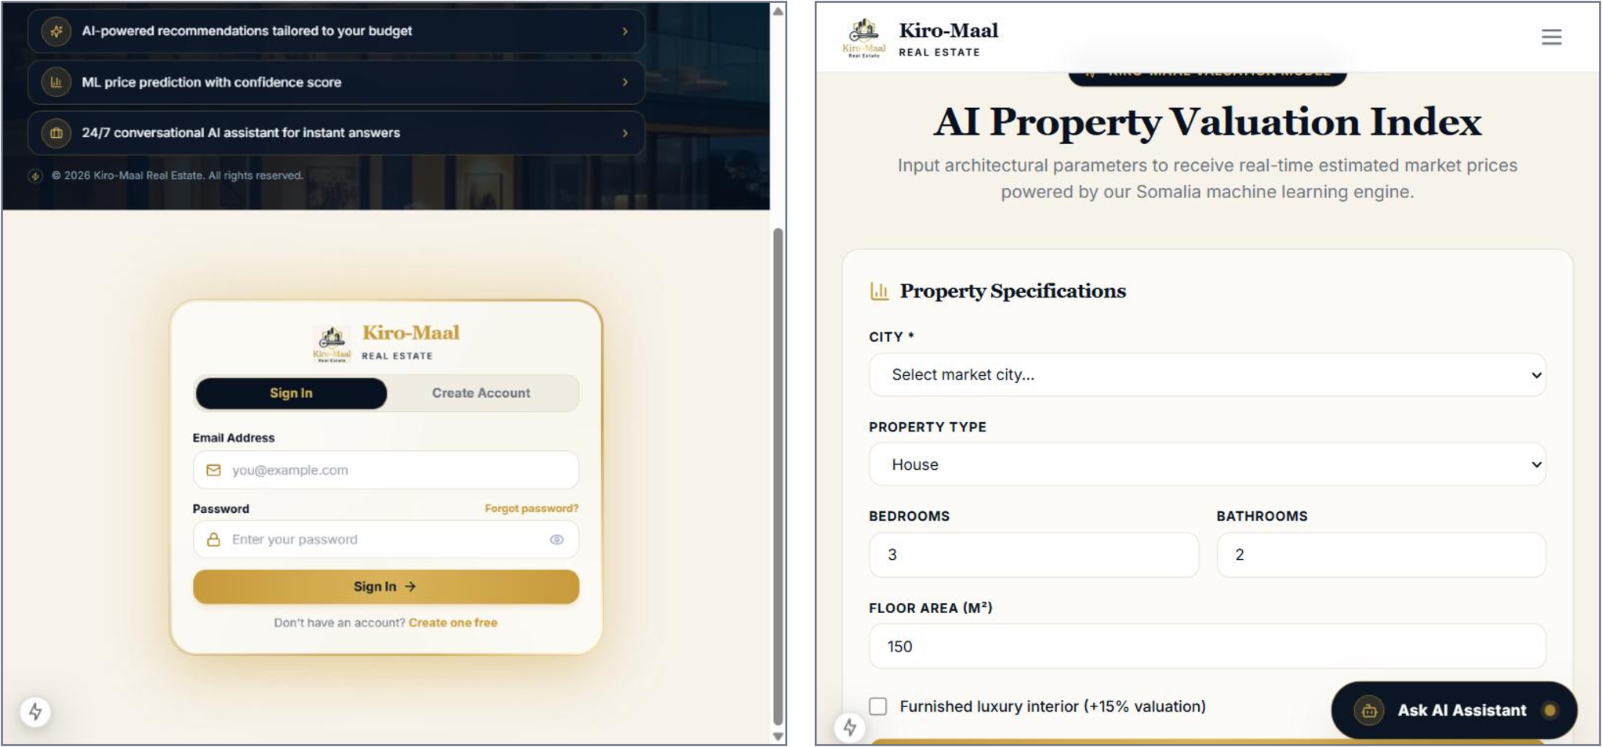
Figure 4.4: Login Form and Price Prediction Form
Table 4.18: Main Forms of the System
Form | User | Main Fields
Registration | Customer | Name, e-mail address, telephone number, password
Login | Registered actors | E-mail address, password
Property | Property Manager | Title, description, listing type, category, price or rent, deposit, images, city, address, amenities
Rental booking | Customer | Rental period, start and end dates, payment method, notes
Direct rental | Property Manager | Property, customer, dates, rent, security deposit, payment status, lease clauses
Purchase request | Customer | Property, notes to the administrator
Payment | Customer | Payment method and confirmation of the amount
Inquiry | Public Visitor, Customer | Name, contact, subject, message
Price prediction | Public Visitor, Customer | City, property type, bedrooms, bathrooms, floor area, furnished
Add customer | Property Manager | Full name, e-mail address, telephone number, optional password

The reports of the system are the role dashboards, the lists of properties, customers, rentals and requests, the central transaction ledger, the analytics of the Administrator and the digital receipt. Lists are presented as tables that can be searched, filtered and sorted, and a status is always shown as a labelled badge. The receipt is designed as a printable document that can be exported as PDF. Figure 4.5 shows the layout designed for the dashboards and for the receipt.
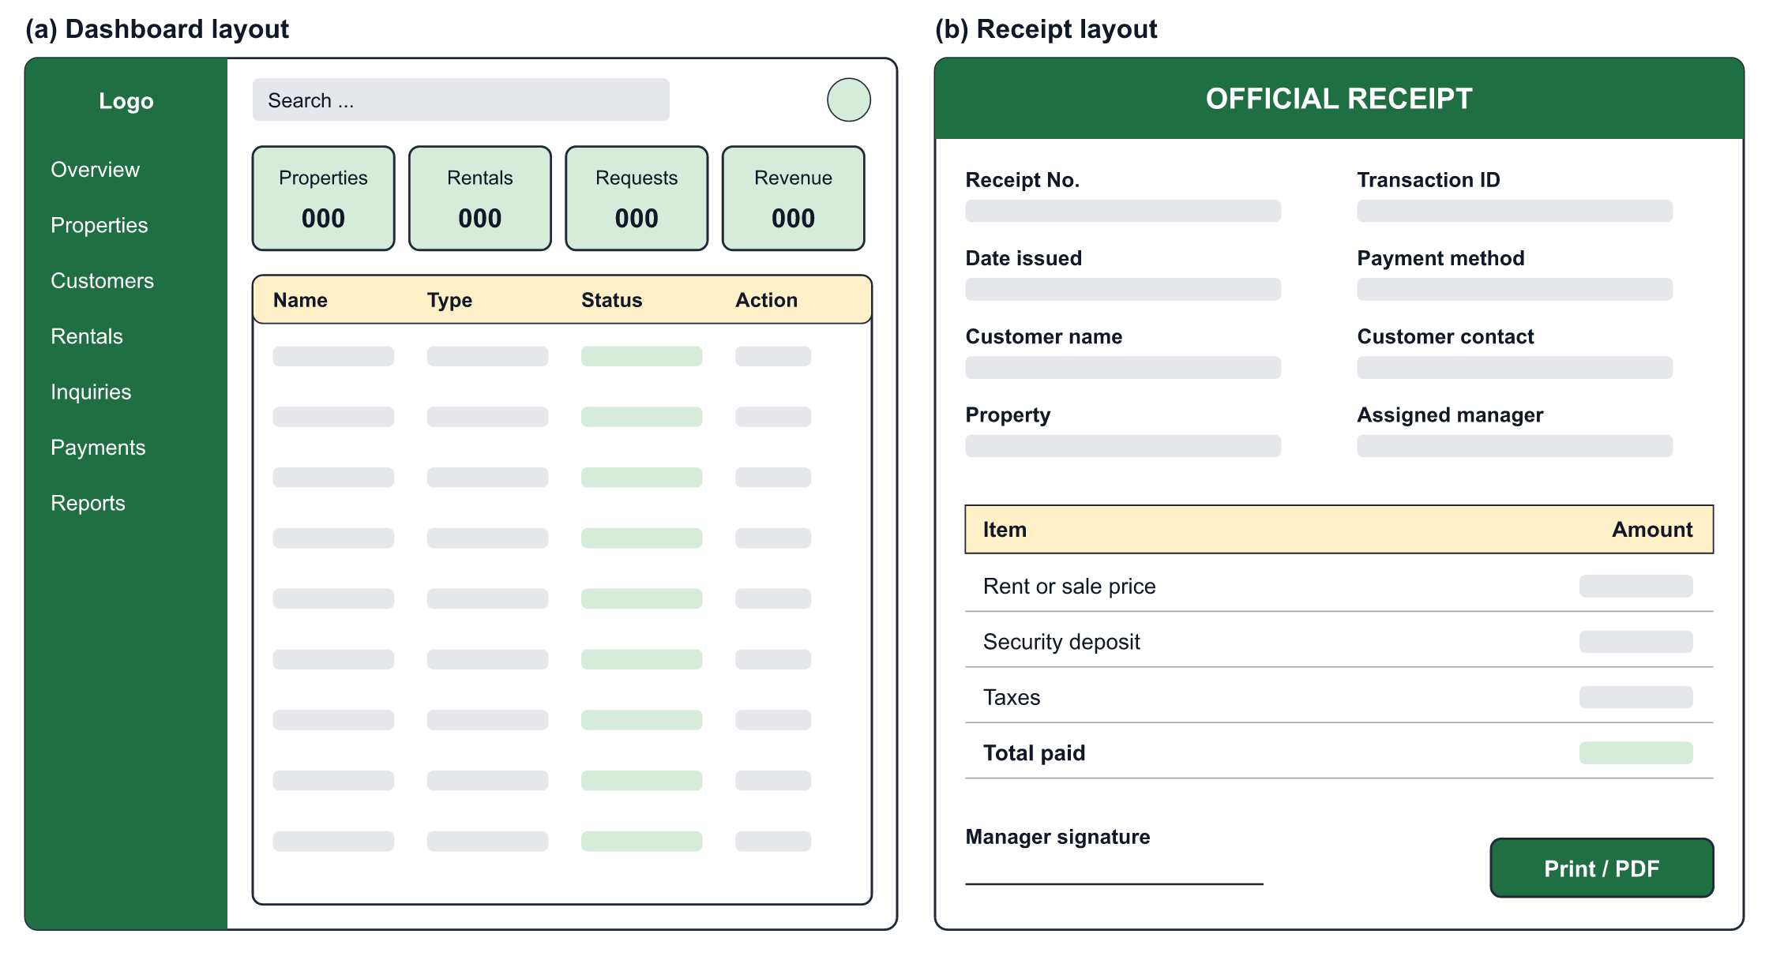
Figure 4.5: Layout Design of the Dashboards and the Receipt
Table 4.19: Main Reports of the System
Report | User | Content
Customer dashboard | Customer | Active leases, pending purchases, saved properties, inquiries
Manager overview | Property Manager | Counts of properties and requests, today's appointments, recent activity
Administrator analytics | Administrator | Transaction value, revenue, active properties, leases, user growth
Transaction ledger | Manager, Administrator | Every deposit, rent payment and purchase, with method and status
Customer directory | Manager, Administrator | Customers with their leases, purchase requests and payments
Receipt | Customer | Itemized amounts, transaction number, customer and manager details
Audit log | Administrator | Administrative actions with the user and the time

4.6 Chapter Summary
This chapter presented the design of the system. The architectural design organized the system into presentation, application and data layers, and the user interface design defined the navigation of the four actors and the principles of the interface. The database storage design and the database design described how data are stored in MySQL, normalized the data to third normal form, transformed the ERD into relations and defined the data dictionaries of the central tables. Finally, the main forms and reports of the system were designed and listed. The next chapter describes how this design was implemented and tested.

