Engduino Simulink Tutorial

1. Getting start

(with version Matlab 2015a)

Simulink is a **visual dataflow language**. Programs are implemented by connecting various blocks together. Blocks are of 3 main types:

* Sources(e.g. constants, inputs, sensors) - these blocks represent entry points of data into the program and only have output ports
* Sinks(e.g. displays, outputs, LEDs) - these blocks represent output points of the program’s data and only have input ports
* Transforms(e.g. mathematical functions) - these blocks represent different operations on data and have both input and output ports

Blocks can be connected by clicking on the output arrow of a block, which will bring up a wiring tool. The Engduino library consists of a collection of sources and sinks that can be connected together by various built-in Simulink transforms and then deployed on the board.

1. Common settings

Make sure you have the Engduino support package installed(Main Window -> Add-Ons -> Get Hardware Support Packages, install the appropriate package).

Here install (Arduino support package)

When deploying models to the Engduino board some Simulink options must be configured after creating a new model(see examples). From the model window, select Tools -> Run on Target Hardware -> Options. Under the “Run on Target Hardware” section set the following:

* Target hardware: Engduino (Main window -> Add-Ons -> Get Hardware Support Packages if this options is not available)

Choose “Arduino Lilypad USB” in version 2015a

* Set Host COM Port: Manually

Automatic works now

* COM port number: COM port the board is connected to

No need for this step now

1. Intro

Simulink is a visual dataflow language. Programs are implemented by connecting various blocks together. Blocks are of 3 main types:

* Sources(e.g. constants, inputs, sensors) - these blocks represent entry points of data into the program and only have output ports
* Sinks(e.g. displays, outputs, LEDs) - these blocks represent output points of the program’s data and only have input ports
* Transforms(e.g. mathematical functions) - these blocks represent different operations on data and have both input and output ports

Blocks can be connected by clicking on the output arrow of a block, which will bring up a wiring tool. The Engduino library consists of a collection of sources and sinks that can be connected together by various built-in Simulink transforms and then deployed on the board.

3. Example 1

* Make sure the board is connected before opening Matlab.
* Click on the Simulink Library button from the main Matlab window and open the Engduino library. Create a new model.
* From the Engduino Library drag a ‘thermistor’ and a ‘rgb_led’ block to the freshly created model.
* Search the Simulink Library, search for and add a ‘Derivative’ and two ‘Compare To Zero’ blocks.
* Double click the comparison blocks and set the operators to ‘<’ and ‘>’ and the output data type to uint8.
* Double click the LED block and set the desired LED index.
* Connect the blocks as in the image below.
* Tools -> Run on Target Hardware -> Prepare to Run and apply the settings described in Section 1.
* You may have to close and reopen the model at this point so that Simulink can load some dependencies.
* Click ‘Deploy to Hardware’. If the build succeeds, touch the temperature sensor on the board and observe one of the LEDs changing to red when the temperature increases(i.e. derivative(temp) > 0) and to blue when it decreases (i.e. derivative(temp) < 0)

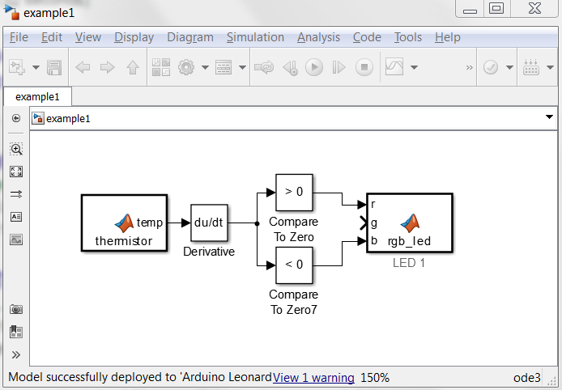

3. Example 2

* As in Example 1, open a new model and drag an ‘ir_send’, an ‘ir_receive’ and a ‘rgb_led’ block from the Engduino library.
* Add a ‘Constant’ and a ‘Compare To Zero’ block from the Simulink library. Double click the blocks and set the constant to 1, the comparison operator to ‘>’ and the data type of the comparison block to uint8.
* Connect them as in the image below, apply the hardware settings, open and close the model, then ‘Deploy to Hardware’
* Plug in a second board into the same USB port then deploy the model again. When the IR transceivers on the two boards face each other a LED should light up.