Simulink-Engduino Tutorial

1. Introduction to Simulink

(with version Matlab 2015a)

Simulink is a **visual dataflow language**. Programs are implemented by connecting various blocks together. Blocks are of 3 main types:

* **Sources**(e.g. constants, inputs, sensors) - these blocks represent entry points of data into the program and only have output ports
* **Sinks**(e.g. displays, outputs, LEDs) - these blocks represent output points of the program’s data and only have input ports
* **Transforms**(e.g. mathematical functions) - these blocks represent different operations on data and have both input and output ports

Blocks can be connected by ***clicking*** on the output arrow of a block, which will bring up a wiring tool. The Engduino library consists of a collection of sources and sinks that can be connected together by various built-in Simulink transforms and then deployed on the board.

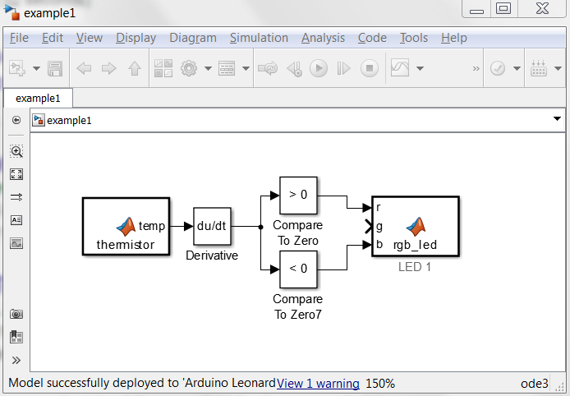

**Sink block**

**Transform blocks**

**Source block**

1. Getting Start - Installation

Make sure you have a valid Simulink license. Start MATLAB.

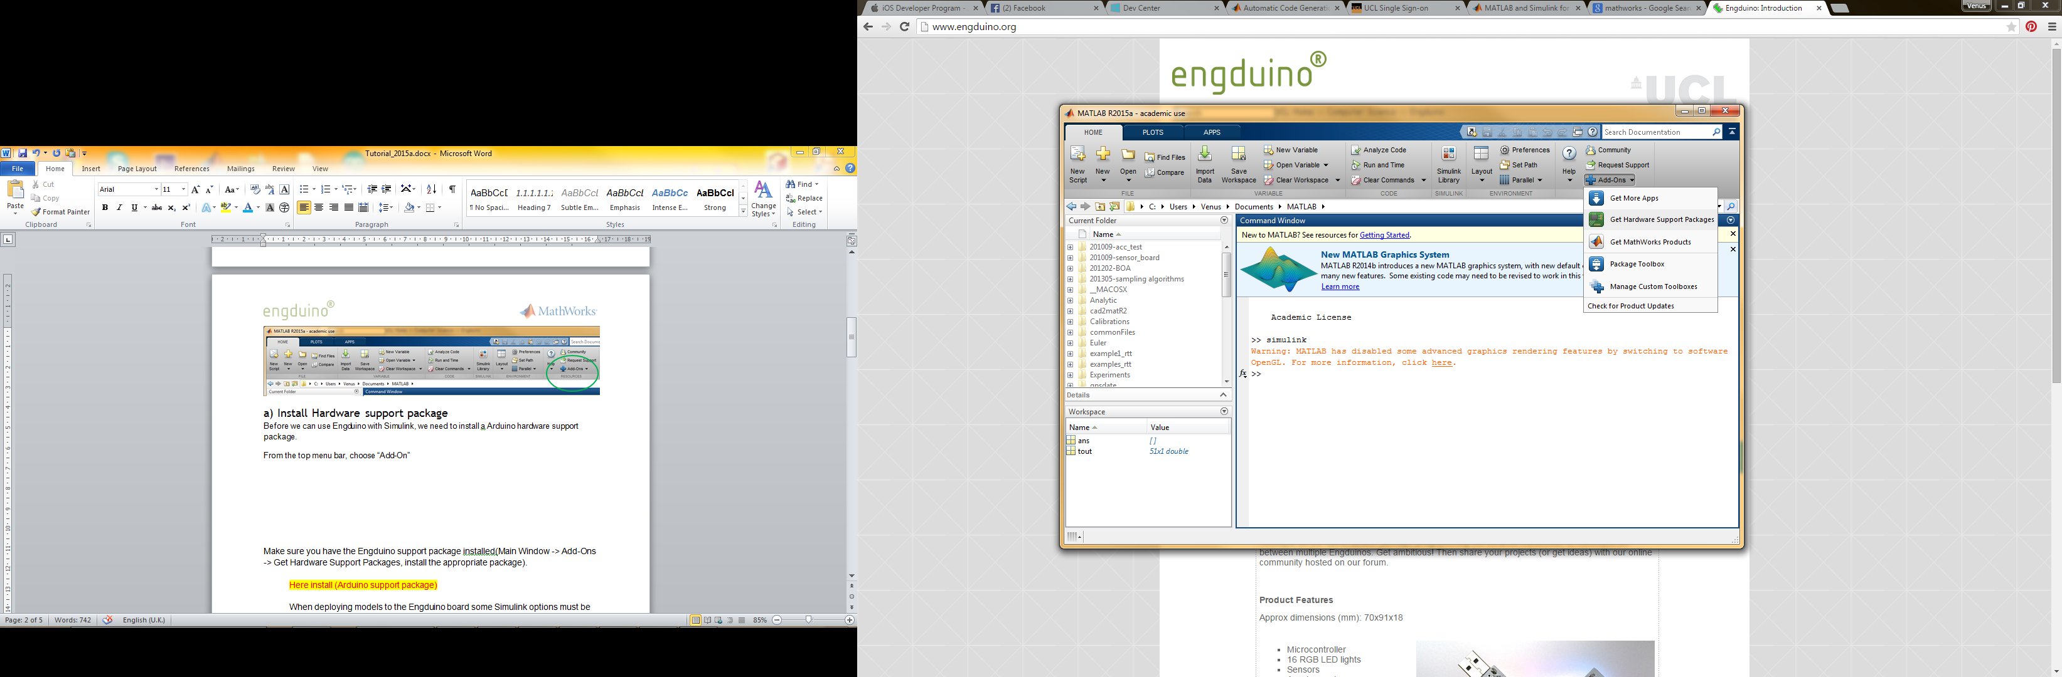

# a) Install Hardware support package

Before we can use Engduino with Simulink, we need to install a Arduino hardware support package.

From the top menu bar, choose **Add-On>>Get Hardware Support Packages**.

Choose **Install from Internet**, then next

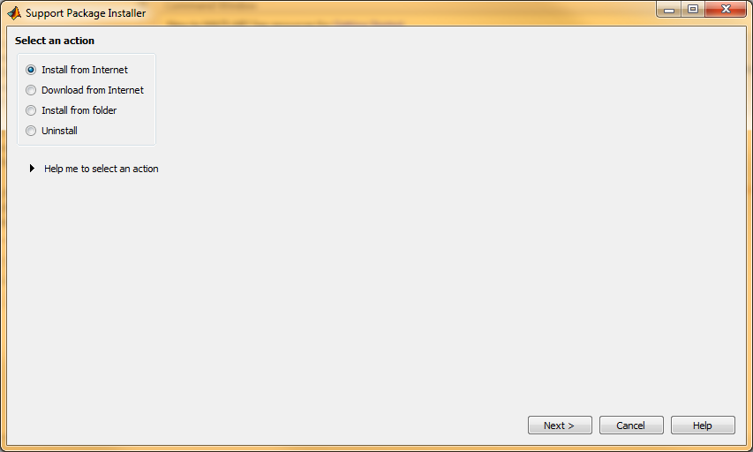

You will see an option to **Arduino,** choose all three packages and press next.

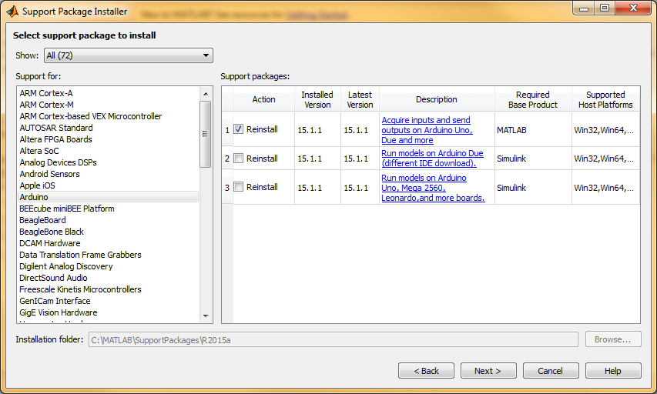

Accept the license terms and conditions and install the package.

b) Download Engduino Matlab examples

You can download the entire Engduino support to date from this location:-

<https://github.com/engduino/Engduino-Extensions>

This contains a MatlabSupport folder with examples running Matlab with Engduino; and a SimulinkSupport folder with Simulink Engduino examples and codes. Unzip the folder to a location on your computer. (e.g. My Documents\MATLAB)

1. Open an example

From the MATLAB top toolbar menu, choose **Open,** navigate to the SimulinkSupport folder you have downloaded in Step 2b). Choose **examples1.slx** to open.You will see these Simulink blocks.

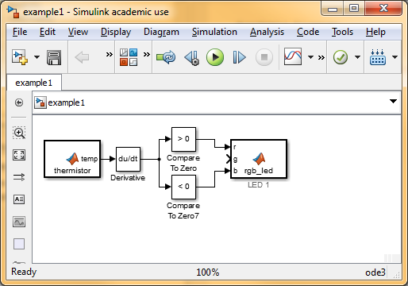

Before we can program the Engduino with Simulink, we need to do some configurations. Navigate to **Tools>>Run on Hardware Target>>Options**

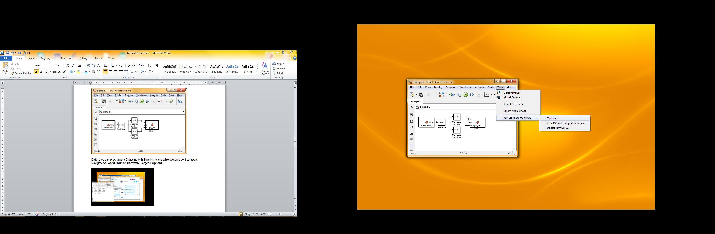

Choose **Arduino LilyPad USB** as Target hardware. The default host COM port should be **Automatically**. Leave this and other setting unchanged**. Apply** this setting and click **OK.**

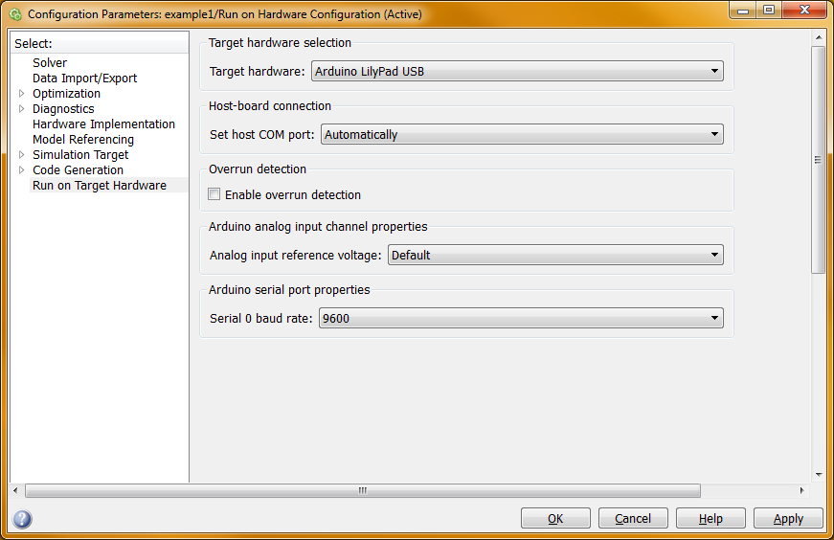

1. Download the blocks to Engduino

Simply press the **Deploy to hardware** button to download the blocks onto Engduino.

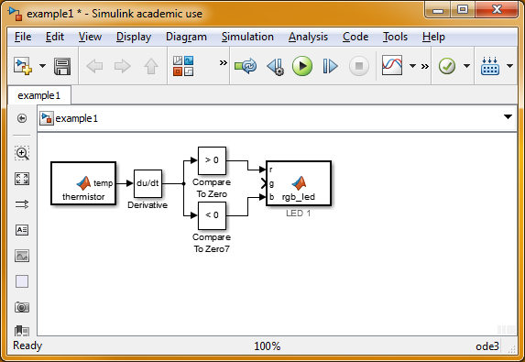

1. Engduino blocks libraries

In R2015a, Engduino is not yet an integrated part of Simulink. Hence you would find the available Engduino blocks in **engduino_drivers.slx.** Simply copy the blocks you want to use to your own Simulink model.

In the future, you would be able to use the Library Browser in Simulink to add the blocks.