Firmware Essentials e4357 Homework 3

Dwayne Dilbeck

https://github.com/jakowisp/FirmwareEssentials_e4357/tree/master/hw3

# Homework requirements from supplied link

1. Write a C code to mbed that controls the leds on another device via serial communication. Example 7.9. The switches from one mbed controls the other device.

# Status

## Time sheet

|  |  |
| --- | --- |
| **Task** | **Time** |
| Transcode example 7.9 | 10minutes |
| Write the equivalent code for Arduino | 2 hour |
|  |  |
|  |  |
|  |  |
|  |  |
| **Total** | **1hours 40 minutes** |

# Issues/Lessons Learned

On Arduino need to be careful you are writing to the correct Serial port

I wasted an hour trying to figure out why the simple code was not seeding the outByte to the mbed. In the end I had mistyped instead of sending the outByte to Serial1 which was connected to the mbed, the outByte was being written to Serial, which is connected to a different serial port.

# Test setup

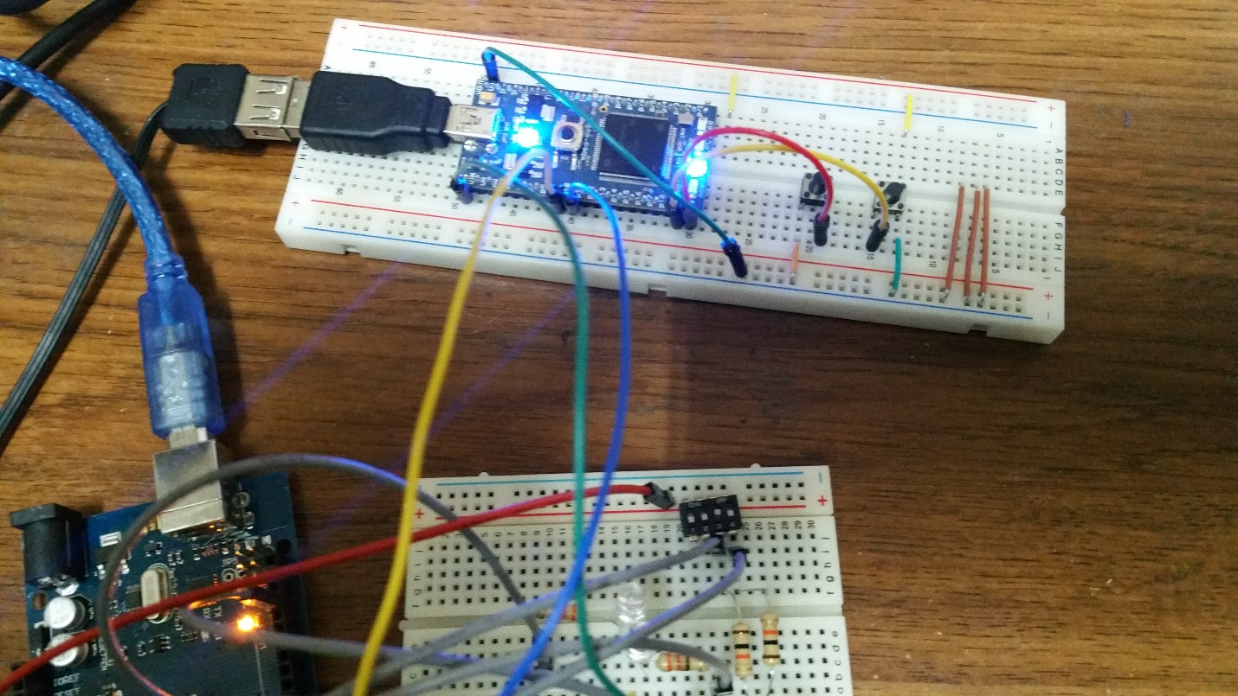

The mbed is at the top and used momentary switched, The Arduino is shown below. The Arduino used dip switched to send the message. In the photo above the Arduino is sending 0xa2, and the mbed is displaying the value.

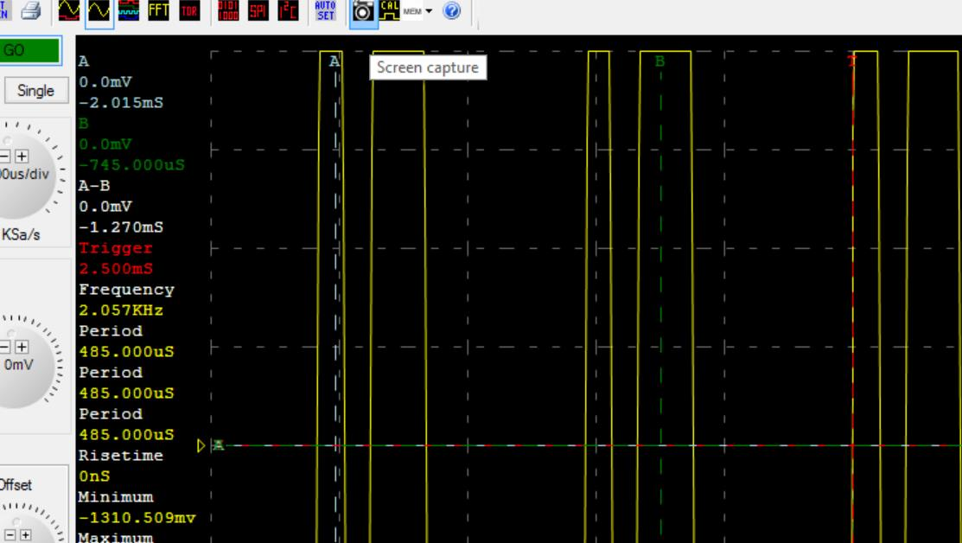

The serial capture from the mbed.

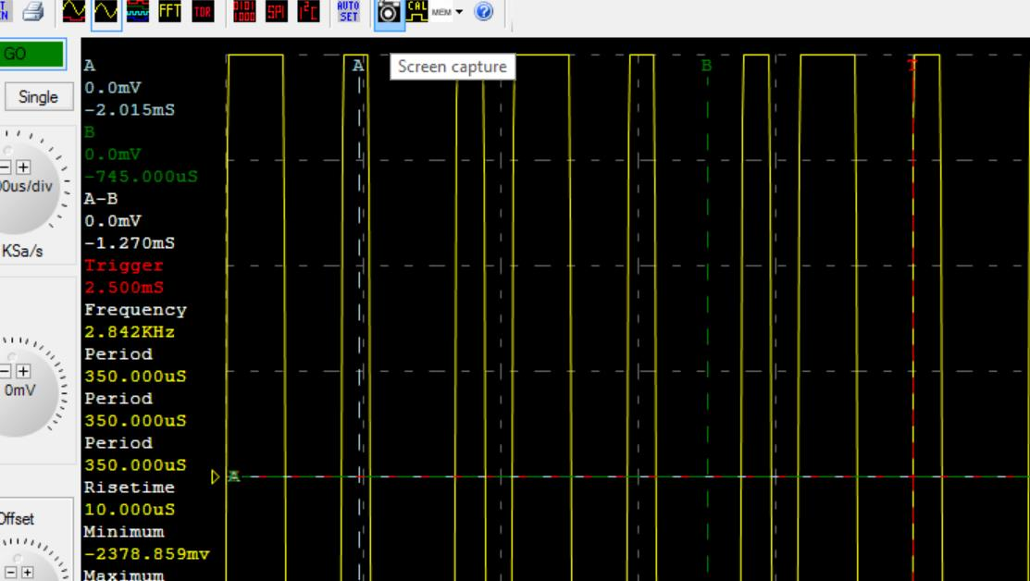

The serial capture to the mbed.