NOTE FOR ENHANCEMENT
Game1: The Scape Room
- Dapat per level ang restart button hindi buong game ang magrerestart once pressed.
- bakit tumatagos si HACKO sa mga objects/barriers? Nagiging design nalang siya at walang nagagawa sa laro. Please do something in that barriers.

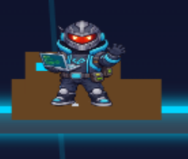
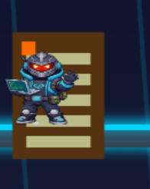

- pakitanggal na din po sana ng flag
- each level, 3 lives katumbas ng 3-outs sana. Ang nangyari kasi sa game, 3 lives for 10 levels na tapos kada isang life katumbas ng up to 5-outs.
- Levels 8-10: pwede po padagdag ng challenge pa or obstacles para magkaroon ng excitement si player na laruin ang game. (suggestion: gawing danger zone yung buong floor since sa taas naman madalas kinukuha yung mga int,chr,etc. then sa taas nalang magdagdag ng flies/enemy or something na pwede makapag bawas ng life ni HACKO)

GAME 8: CLASSROOM RESCUE
- Improve the classroom set-up. Make it a bit realistic and add more things if possible.
- Desk are useless. Pwede ba gawing blocks or obstacle nalang yung desk para mag act as something na pwedeng mahirapan si hacko dumaan anywhere.
- Walang restart button per level.
- Problem: Alex, Prof Byte and Robo doesn’t have a clear relationship. Nagbigay lang sila ng clue that is not understandable enough. Ano kaya pwede ninyong gawing improvement regarding this, where in, each of them is may interaction or connection sana.
- Add indicator kapag nagkakamali or nababawasan ng life si HACKO.
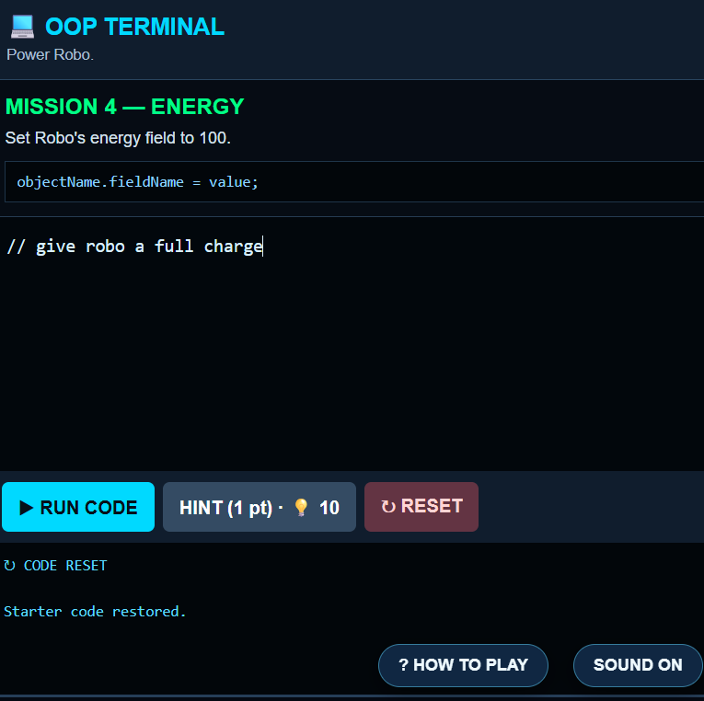
- Sa IDE or kung saan sila sasagot ng code, I suggest na meron na po sana siyang code dati na iaasemble or icocorect nalang ni player (example: nawawalang semicolons, wrong spelling, etc.)

GAME 9: Conditional Labyrinth
- Arrangement of blocks per level: napansin ko po na from level 1-10 is same lang ang arrangement and positioning ng blocks. Baka pwede baguhin per level and magmukha pading labyrinth sana ang gamespace.
- Level 1-4: easy round, kahit wala masyadong challenges.
- Level 5-7: medium round, magkaroon ng konting challenges and pwede kumuha ng life.
- Level 8-10: hard round, baka pwedeng paulanin ng galaxy attact ang gamespace para maging challenge kay Hacko pero dapat pwede din siyang makakuha or makasalo ng life.

GAME 10: BIG BOSS
Minor suggestion: medium, hard and exteme levels since biggest challenge siya ng buong laro

Thanks po!

