Anubis Larch Media Archive playbook
Follow the manual or Copilot-assisted route to calculate workload GPU requirements, prepare a design handoff, obtain a plain-language explanation and save the completed engagement.
Reader key. UI field identifies a screen label. Entered value is literal content. [Button] identifies an action. Checked and blank identify settings.

Customer scenario
A broadcaster continuously analyses incoming video, then uses extracted descriptions to build searchable records. Editors ask a text assistant questions about the archive. Video ingestion and editor queries run together.
All added numbers are explicit fictional customer planning assumptions for a reproducible demonstration. They are not historical measurements or qualified hardware benchmarks. Dense text components use dense8b, one call/request, 2000 input and 500 output tokens unless overridden in the intake table. The assistant uses an existing search/index service outside this AI Factory. Video work runs locally and overlaps assistant demand.

Workflow input register
ID | Scope and exact field | Value | Basis
I01 | Engagement  Customer workload name | Larch Media Archive manual playbook / Larch Media Archive assisted playbook | Entered
I02 | Engagement  Factory users | One organisation | Selected
I03 | Engagement  Do activities run at the same time? | Yes — overlapping demand | Selected
I04 | Video analysis  Component name | Video analysis | Selected
I05 | Video analysis  Application pattern | stream | Selected
I06 | Video analysis  Compute location | In this factory | Selected
I07 | Video analysis  Relationship | Independent | Selected
I08 | Video analysis  Sizing method | Reference capacity for independent work | Selected
I09 | Video analysis  Peak work units per second | 300 | Explicit planning assumption
I10 | Video analysis  Work unit | frame | Explicit planning assumption
I11 | Video analysis  GPUs per reference group | 8 | Explicit planning assumption
I12 | Video analysis  Required GPU memory in GB | 40 | Explicit planning assumption
I13 | Video analysis  H200 work units per second per group | 100 | Explicit planning assumption
I14 | Video analysis  B200 work units per second per group | 160 | Explicit planning assumption
I15 | Video analysis  B300 work units per second per group | 200 | Explicit planning assumption
I16 | Video analysis  Independent reference groups can serve this demand | Checked | Explicit planning assumption
I17 | Video analysis  I accept this reference capacity and its scope | Checked | Explicit planning assumption
I18 | Video analysis  Reference source and conditions | Fictional consultant planning assumption for this demonstration, not measured benchmark evidence. 60 concurrent archived video streams sampled at 5 frames/s. Fixed 1080p analysis model, BF16, independent complete eight-GPU worker groups. | Explicit planning assumption
I19 | Archive search  Component name | Archive search | Selected
I20 | Archive search  Application pattern | retrieval | Selected
I21 | Archive search  Compute location | In this factory | Selected
I22 | Archive search  Relationship | Independent | Selected
I23 | Archive search  Model preset | dense8b | Explicit planning assumption
I24 | Archive search  Peak requests per minute | 40 | Explicit planning assumption
I25 | Archive search  Model calls per request or job | 1 | Explicit planning assumption
I26 | Archive search  Input tokens per model call | 2000 | Explicit planning assumption
I27 | Archive search  Output tokens per model call | 500 | Explicit planning assumption
I28 | Archive search  Search and indexing location | Outside this AI Factory | Selected
I29 | Shared  Infrastructure deployment profile | HGX B300 · Spectrum-X · Enterprise reference design with two network planes | Default or explicitly left blank
I30 | Shared  Sensitivity envelope | ±30% | Default or explicitly left blank
I31 | Shared  Use these planning assumptions | Checked | Default or explicitly left blank
I32 | Shared  Locally retained data in TB / Daily growth in GB | Blank | Default or explicitly left blank
I33 | Shared  Initial dataset to load in TB / Initial loading window in hours | Blank | Default or explicitly left blank
I34 | Shared  Ongoing incoming / outgoing data in GB per day | Blank | Default or explicitly left blank
I35 | Shared  Aggregate storage reads / writes in Gbps | Blank | Default or explicitly left blank
I36 | Shared  East-west payload per GPU in Gbps / Customer datacenter round-trip target in ms | Blank | Default or explicitly left blank
I37 | Shared  Usable link fraction / Initial loading overlap | 0.7 / Yes | Default or explicitly left blank
I38 | Shared  Explanation connection | Manual: deterministic. Assisted: tested DeepSeek connection | Default or explicitly left blank
I39 | Shared  This saved result is public or fictional and may be sent to the selected provider | Checked only for this fictional assisted example | Default or explicitly left blank
Remaining displayed engine defaults: BF16 weights and KV cache, context 8192 tokens, 32 concurrent sequences, 8 GB workspace, compute efficiency 0.35 and memory efficiency 0.50. Host provisions are 256 GB RAM, 3840 GB local disk and 16 CPU cores per workload GPU. The blank growth horizon uses 365 days. Reference sizing does not use text-token equations.

Expected result and process
B300 workload GPUs | B200 workload GPUs | H200 workload GPUs | Selected B300 factory anchor
24 | 24 | 32 | 256
Describe the application → confirm its boundary → enter demand and assumptions → calculate GPU comparisons → prepare design handoff → explain the saved result → complete and retrieve the engagement.
The workload count and factory anchor are separate. Spare compute may support additional work, but it does not establish a qualified tenant count. Outstanding network and shared-storage measurements remain visible in the companion requirements.

Video analysis architecture
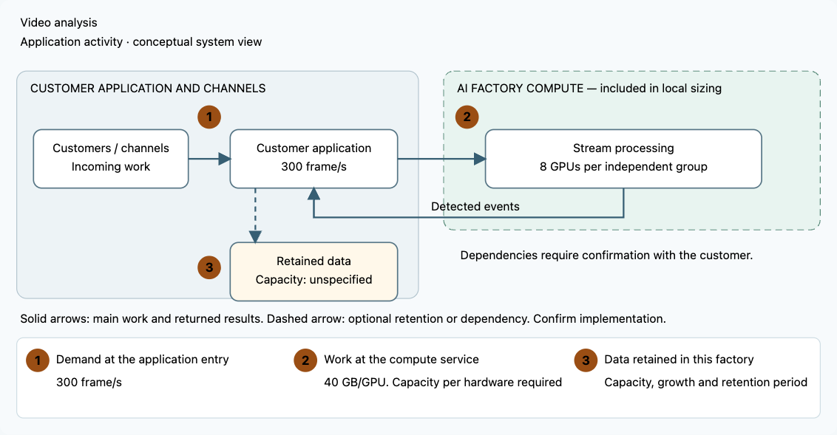

Archive search architecture
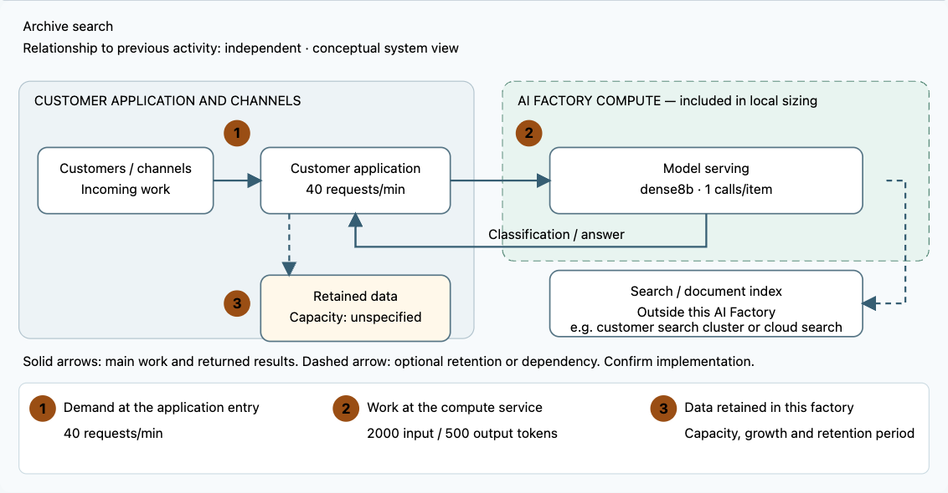

Start and access the workspace
Complete the Mac installation guide in docs/macos-installation-guide.txt. From the repository folder run python3 deploy/local/run.py. Keep the terminal open. On first launch the application creates .anubis/identities.json. Open that private file locally, copy your identity token without quotation marks, and paste it into Access token. Click [Open workspace]. Saved cases persist in .anubis/anubis.sqlite across restarts. Preserve this directory and use the documented backup process.
For Copilot, put the provider API key in the protected backend configuration, never in the chat or input register. Open [AI connections], configure the approved provider and backend environment-variable name, and test the connection. The recorded assisted walkthrough uses DeepSeek deepseek-flash with low reasoning. Connection testing is separate from workload and explanation validation.

Manual workflow
Follow these numbered steps in order. Use a separate engagement name for this route. Input values are the same workload assumptions in both routes. In the assisted route, inspect extracted facts and explicitly enter any specialist reference values in the guided form.
Step | Activity and exact values | Screen reference
1 | Start Anubis and open the local address. Retrieve your private token from .anubis/identities.json. Paste it into Access token and click [Open workspace]. Never share the token. | 
2 | Click [New engagement]. Set Customer workload name = Larch Media Archive manual playbook. Click [Add Continuous processing]. Click [Add Document or search assistant]. Click [Continue].
3 | Set Factory users = One organisation. Set Do activities run at the same time? = Yes — overlapping demand. | 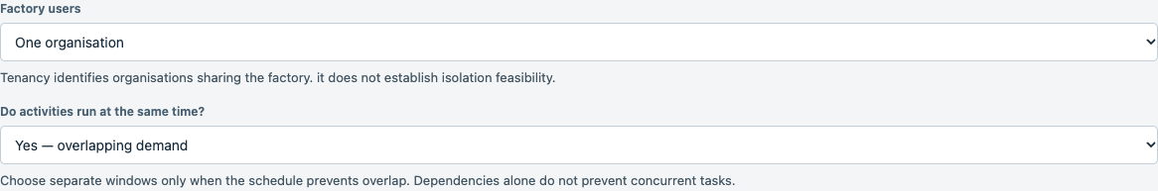
4 | Set Component name 1 = Video analysis. Set Compute location 1 = In this factory. Set Reserve dedicated capacity 1 unchecked. | 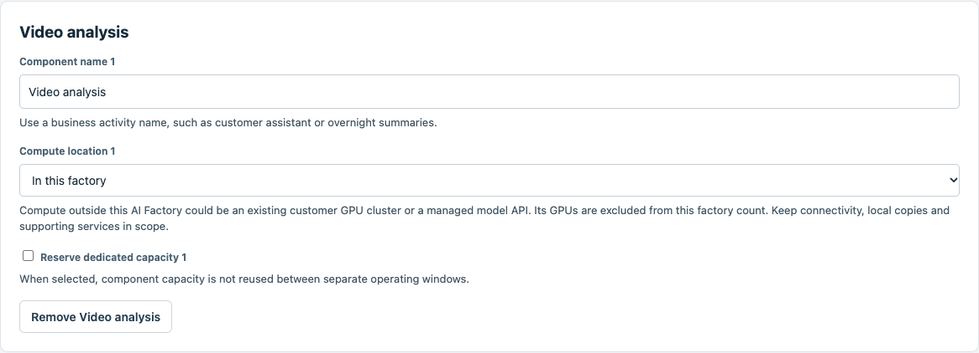
5 | Set Component name 2 = Archive search. Set Compute location 2 = In this factory. Set Reserve dedicated capacity 2 unchecked. Set Relationship 2 = Independent. Set Search and indexing location 2 = Existing service outside this AI Factory. | 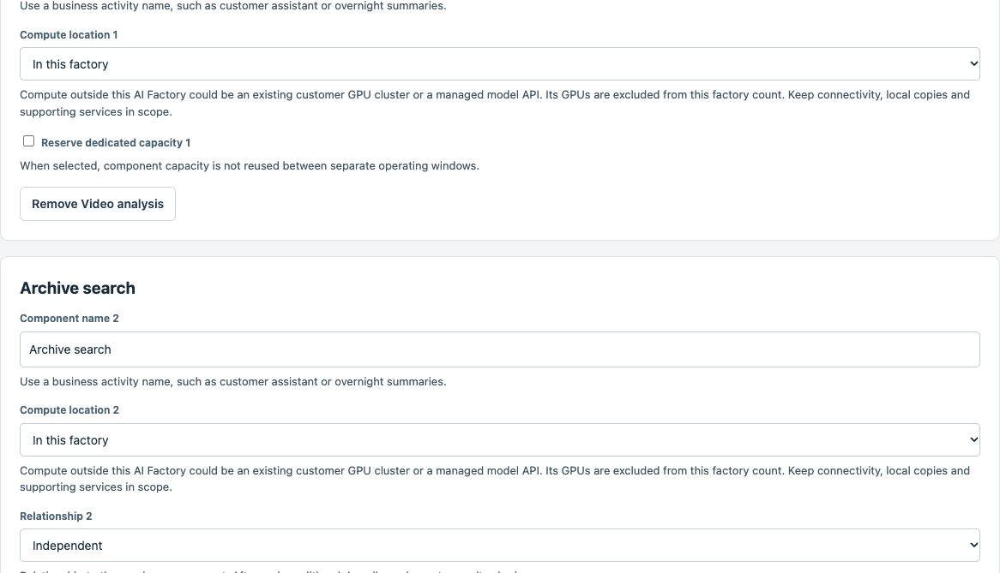
6 | Select [Video analysis]. Set Sizing method = Reference capacity for independent work. This uses complete independent GPU groups and the explicit scenario assumptions.
7 | Set Work unit = frame. Set Peak work units per second = 300. Set GPUs per reference group = 8. | 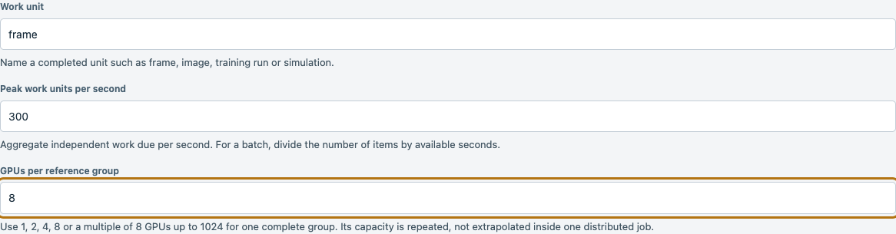
8 | Set Required GPU memory in GB = 40. Set H200 work units per second per group = 100. Set B200 work units per second per group = 160. | 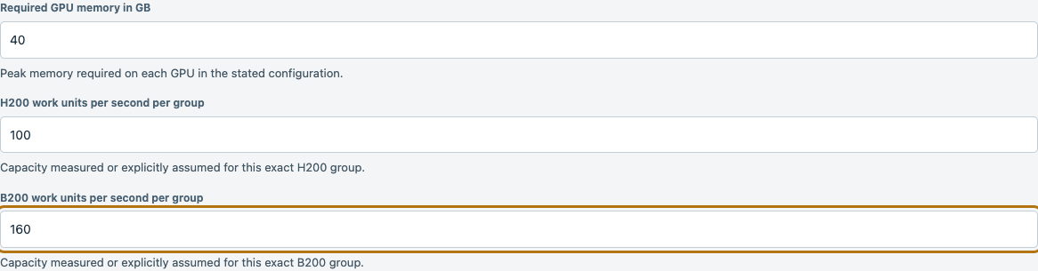
9 | Set B300 work units per second per group = 200. Set Reference source and conditions = Fictional consultant planning assumption for this demonstration, not measured benchmark evidence. 60 concurrent archived video streams sampled at 5 frames/s. Fixed 1080p analysis model, BF16, independent complete eight-GPU worker groups.. | 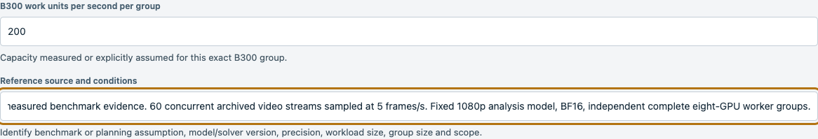
10 | Check Independent reference groups can serve this demand and I accept this reference capacity and its scope. Leave Reference includes local search and indexing unchecked for this component. These example capacities are accepted planning assumptions, not measured benchmark results.
11 | Set Model preset = dense8b. Set Describe demand using = Requests per minute. | 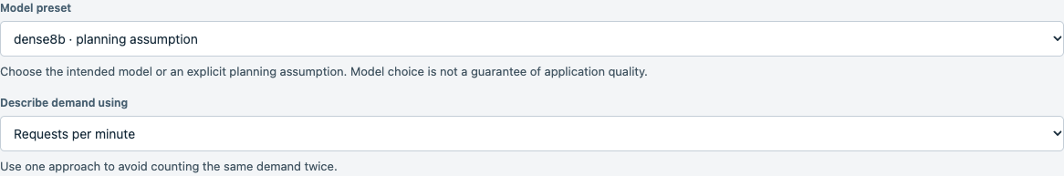
12 | Set Peak requests per minute = 40. Set Model calls per request or job = 1. | 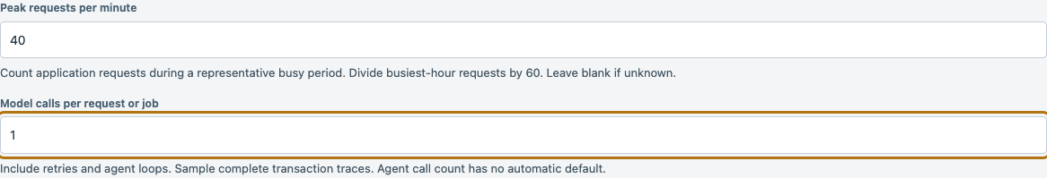
13 | Set Input tokens per model call = 2000. Set Output tokens per model call = 500. | 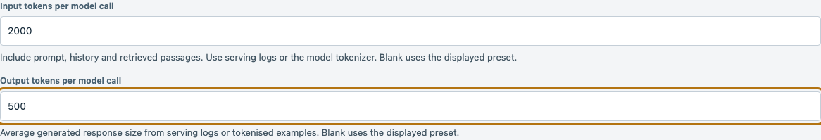
14 | Confirm [GPU estimate inputs are ready]. Retain the displayed B300 enterprise deployment profile and Sensitivity envelope = ±30%. Check Use these planning assumptions. Click [Calculate estimate]. | 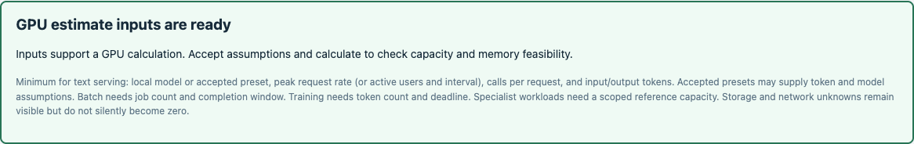
15 | Read the GPU workload comparison. Expected B300 = 24, B200 = 24, H200 = 32 GPUs. These workload counts are separate from the 256 GPU factory deployment anchor. Click [Export result] to save the calculation. | 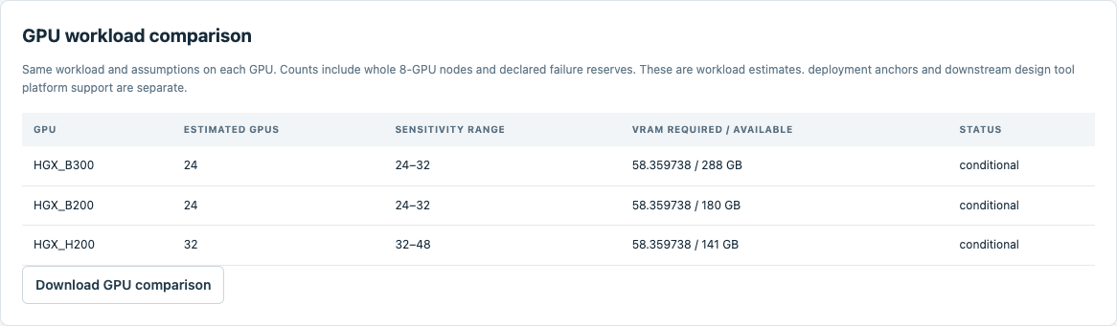
16 | Click [Continue to Design handoff], then [Prepare projection]. Read the executive summary and download the design intake and companion specification. Unresolved network and storage measurements remain explicit. | 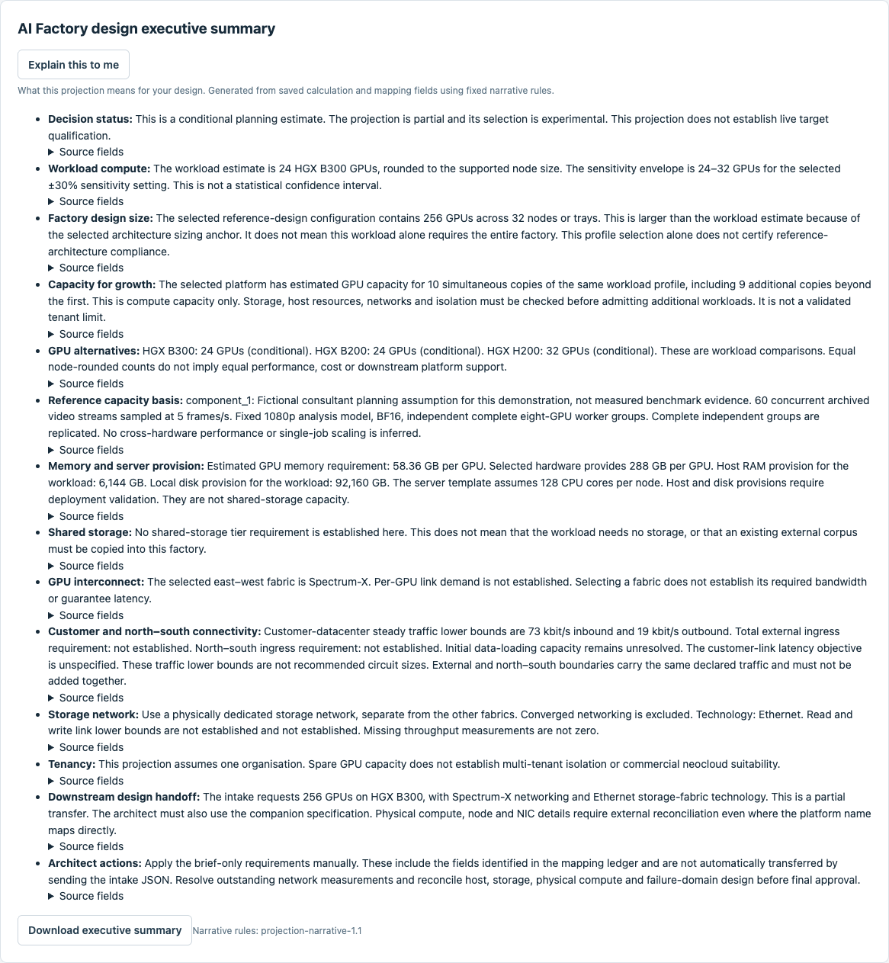
17 | Click [Explain this to me]. Set Explanation connection = Deterministic explanation — no model. Click [Generate explanation]. The saved calculation cannot be changed by this action. | 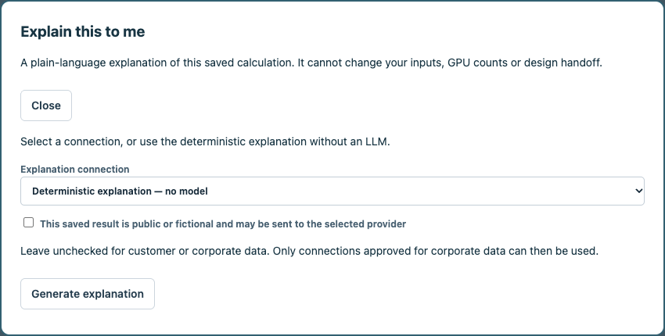
18 | Read the explanation of the workload GPUs, deployment anchor, memory, storage and all network roles. Expand [Source fields and assumptions] to trace the explanation. Click [Download explanation], then [Close]. | 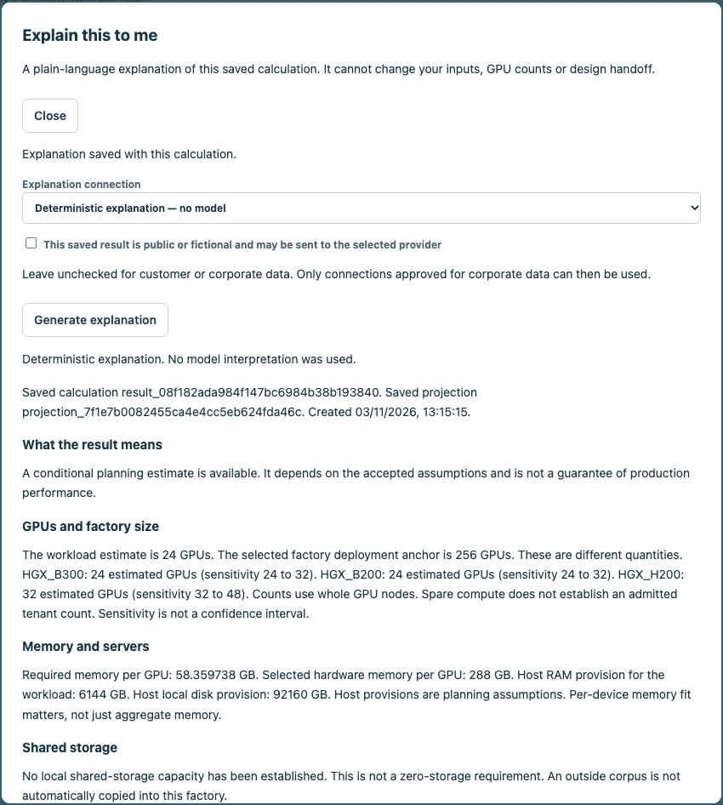
19 | Scroll down within [Explain this to me] to read [Factory networks] and [What to do next]. Expand [Source fields and assumptions] if needed. Click [Download explanation] to save the text. Scroll to the top and click [Close] to continue. | 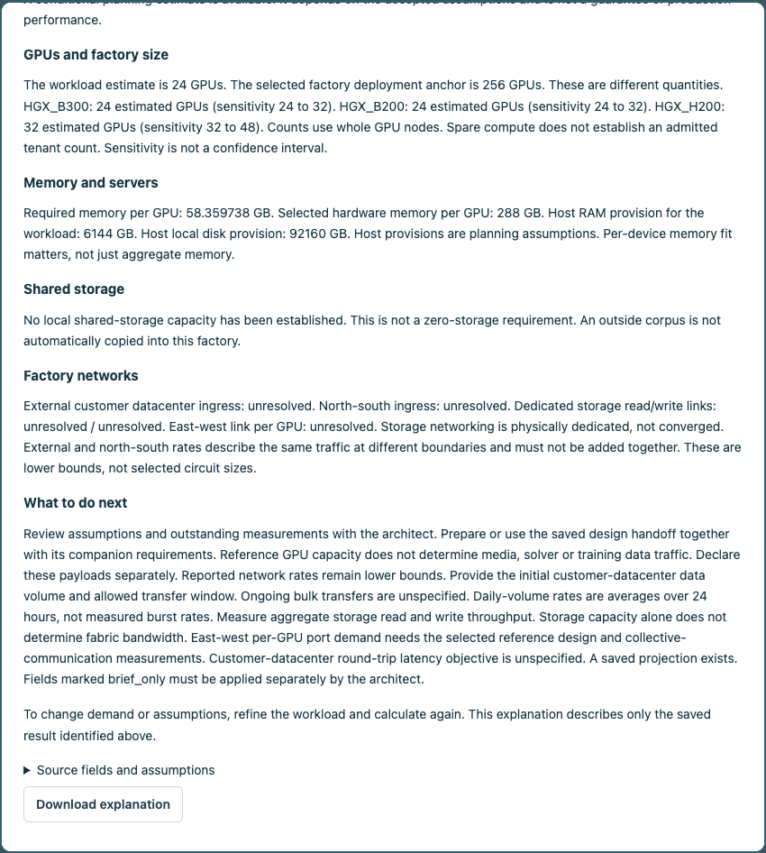
20 | Set Completion notes = Planning requirements and explanation delivered. Outstanding network and storage measurements remain in the companion specification.. Check I confirm that these selected requirements are delivered.. Click [Complete engagement]. | 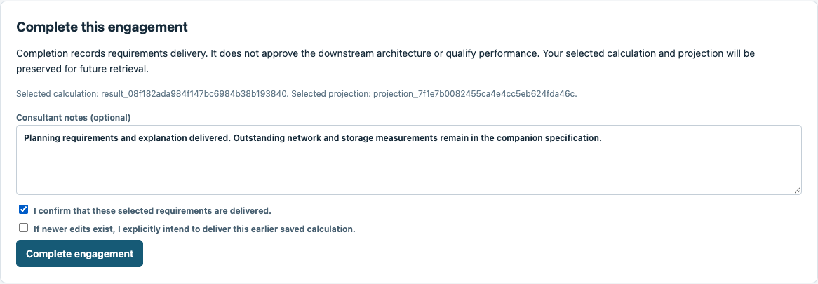
21 | The engagement is complete. Its exact calculation, handoff and explanation remain saved. Use [Cases] to reopen the engagement and [Saved deliverables] to retrieve its documents. | 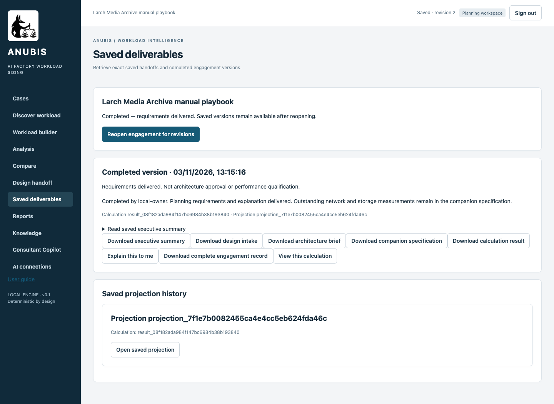

Copilot assisted workflow
Follow these numbered steps in order. Use a separate engagement name for this route. Input values are the same workload assumptions in both routes. In the assisted route, inspect extracted facts and explicitly enter any specialist reference values in the guided form.
Step | Activity and exact values | Screen reference
1 | Start Anubis and open the local address. Retrieve your private token from .anubis/identities.json. Paste it into Access token and click [Open workspace]. Never share the token.
2 | Click [Consultant Copilot]. Set Customer workload name = Larch Media Archive assisted playbook. Set Data classification = Public — permitted for direct provider processing. Click [Start assisted engagement]. | 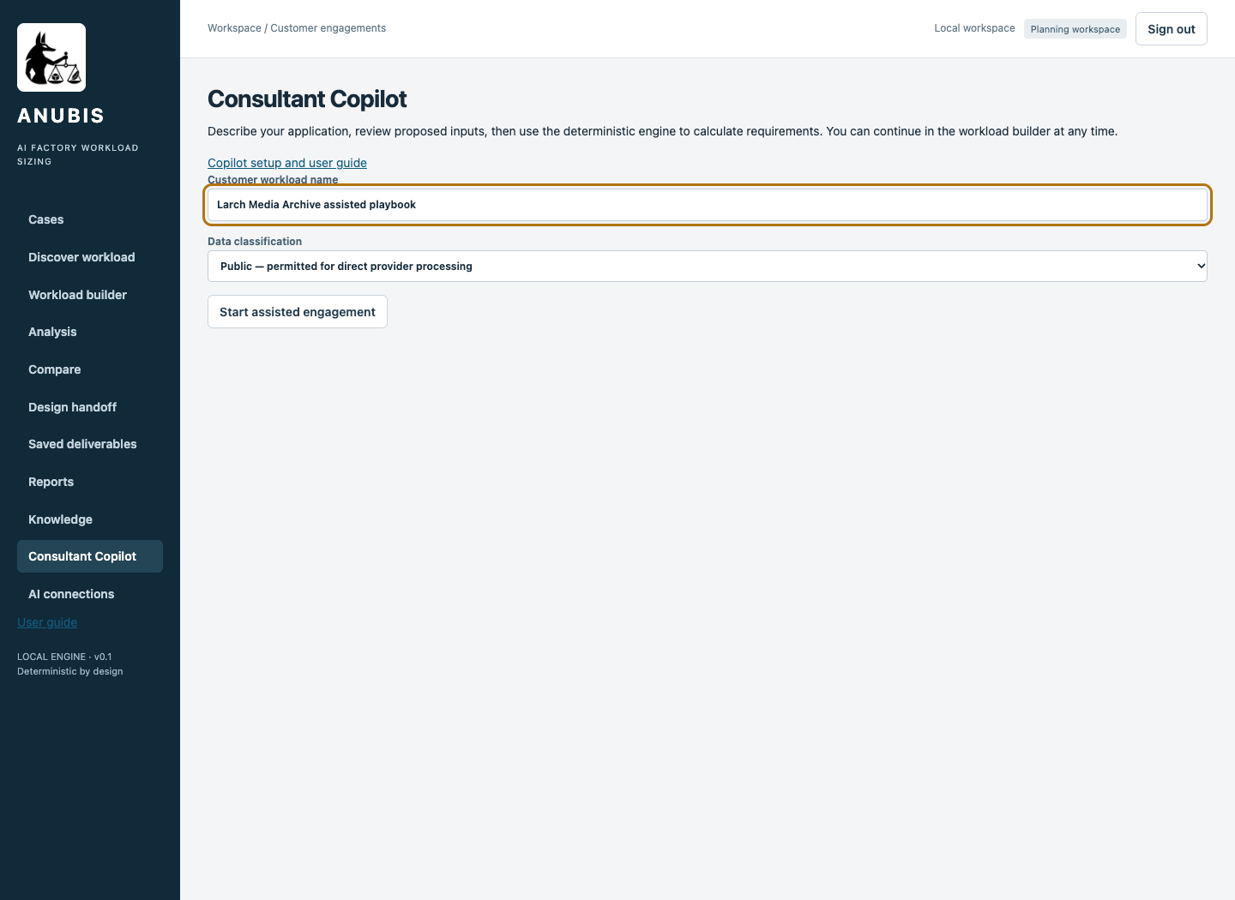
3 | Select your tested connection in Model connection. Enter the following paragraph in What should we know about the workload?: Fictional customer Larch Media Archive. This is a planning exercise. Activities can overlap. A single organisation uses the factory. Use the exact activity name "Video analysis". It analyses video frames continuously. It is not a language model. Compute is inside this AI Factory. Shared capacity within its activity pool. The consultant will enter the workload-specific reference capacity and memory measurements in the guided reference form after reviewing the architecture. Do not use text-token sizing for this activity.. | 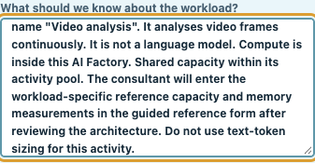
4 | Append the following paragraph to What should we know about the workload?: Use the exact activity name "Archive search". It answers text questions using an existing search system outside this AI Factory. Compute is inside this AI Factory. Shared capacity within its activity pool. Explicit planning assumptions: dense8b, 40 peak requests per minute, 1 model call per request, 2000 input tokens and 500 output tokens per call. . | 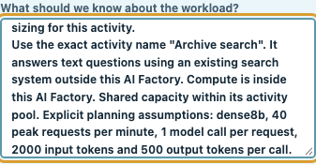
5 | Append the following paragraph to What should we know about the workload?: Do not add other activities or infer local storage from an outside corpus. Unknown storage and network measurements remain unknown.. Click [Ask copilot]. | 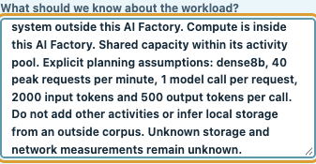
6 | Wait while Copilot interprets the description. The active status indicator confirms that it is still working. Do not submit duplicate requests. | 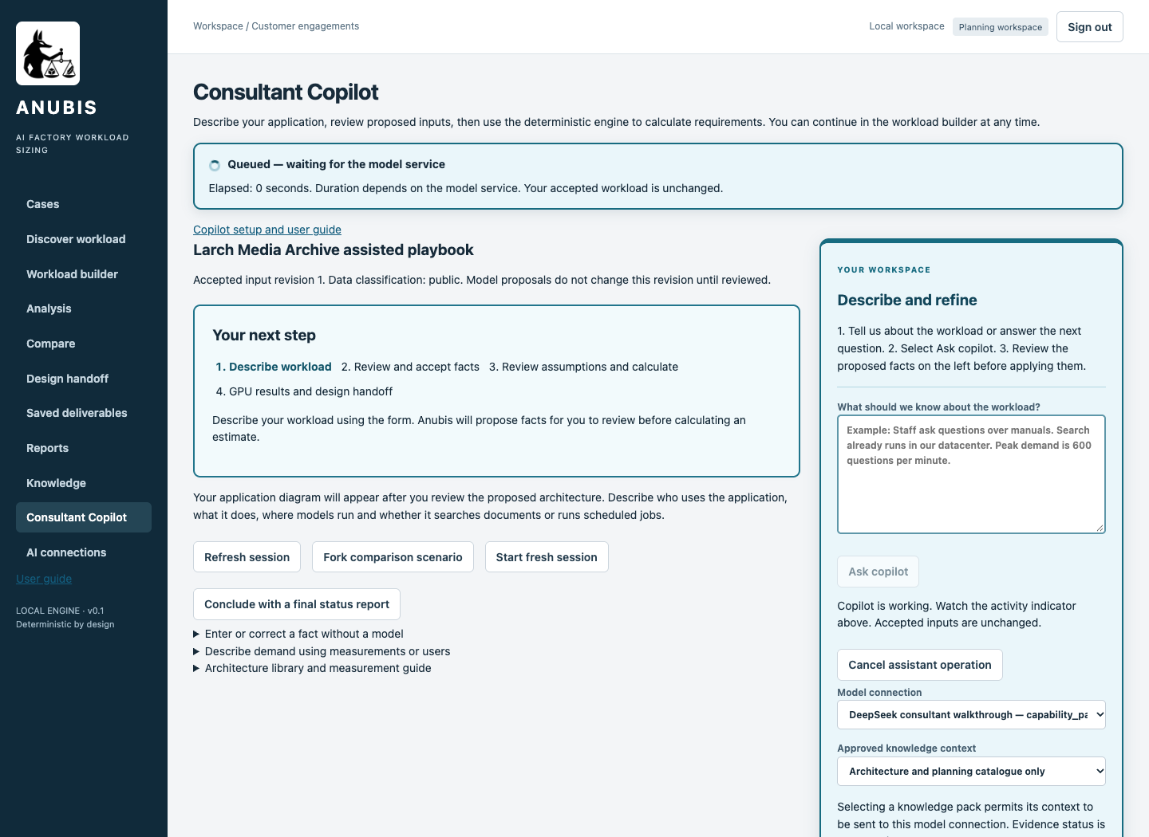
7 | Review the proposed activities, placement, measurements and assumptions against the input register. Check I reviewed the selected values and accept the planning assumptions.. Click [Apply selected]. Specialist reference inputs are entered during the next review. | 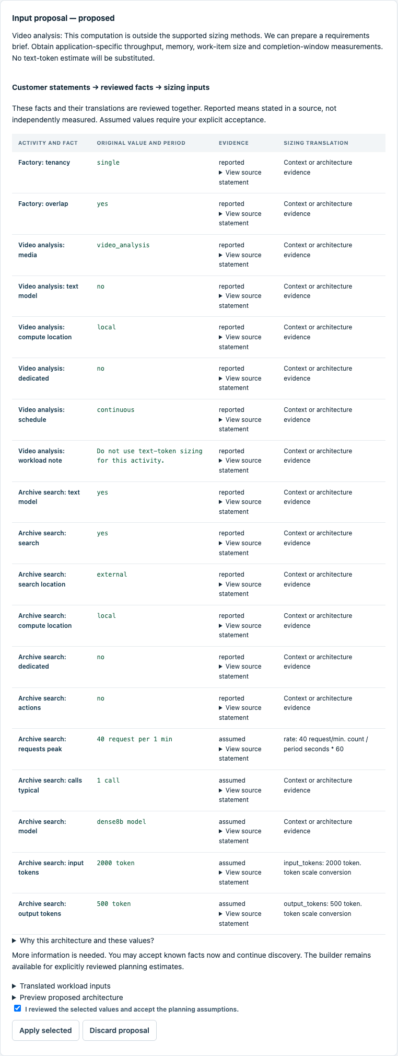
8 | Click [Review and calculate GPU estimate]. The readiness panel names any missing inputs. Complete them in the guided review. Copilot has not invented reference throughput. | 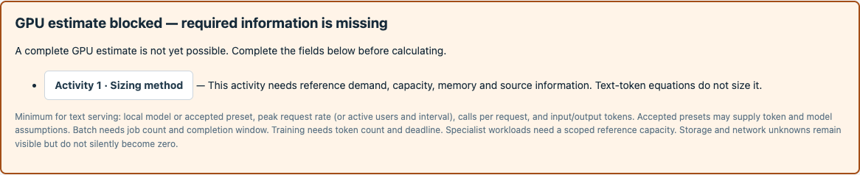
9 | Set Factory users = One organisation. Set Do activities run at the same time? = Yes — overlapping demand. | 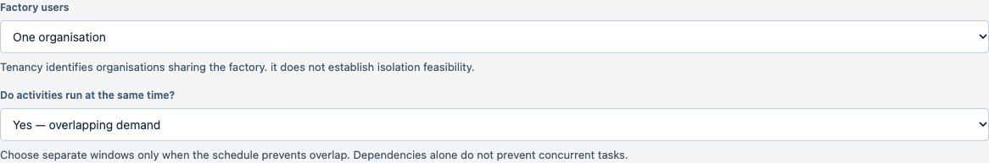
10 | Set Component name 1 = Video analysis. Set Compute location 1 = In this factory. Set Reserve dedicated capacity 1 unchecked. | 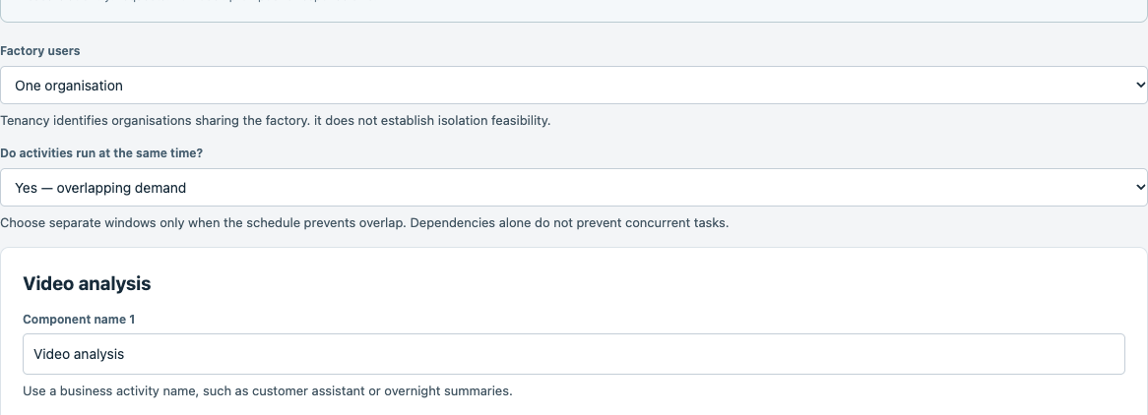
11 | Set Component name 2 = Archive search. Set Compute location 2 = In this factory. Set Reserve dedicated capacity 2 unchecked. Set Relationship 2 = Independent. Set Search and indexing location 2 = Existing service outside this AI Factory. | 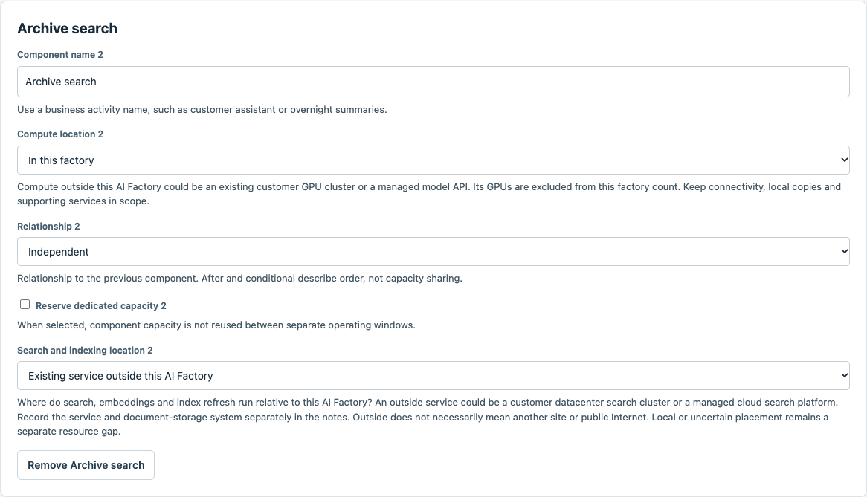
12 | Select [Video analysis]. Set Sizing method = Reference capacity for independent work. This uses complete independent GPU groups and the explicit scenario assumptions.
13 | Set Work unit = frame. Set Peak work units per second = 300. Set GPUs per reference group = 8. | 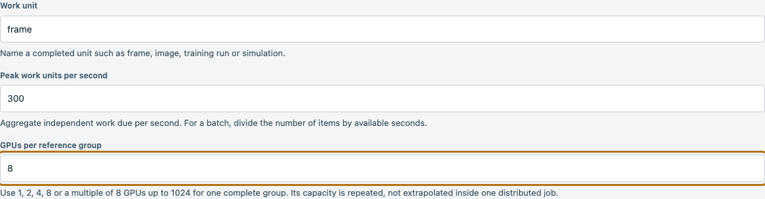
14 | Set Required GPU memory in GB = 40. Set H200 work units per second per group = 100. Set B200 work units per second per group = 160. | 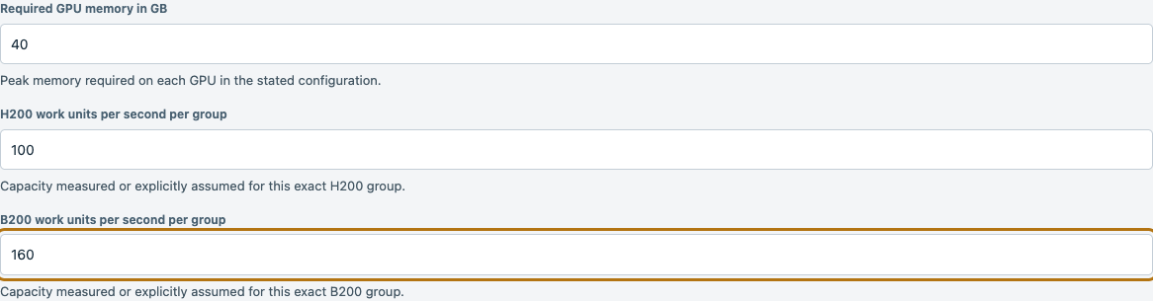
15 | Set B300 work units per second per group = 200. Set Reference source and conditions = Fictional consultant planning assumption for this demonstration, not measured benchmark evidence. 60 concurrent archived video streams sampled at 5 frames/s. Fixed 1080p analysis model, BF16, independent complete eight-GPU worker groups.. | 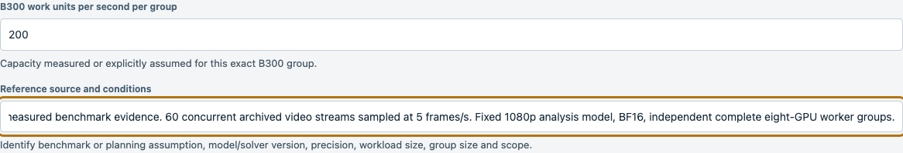
16 | Check Independent reference groups can serve this demand and I accept this reference capacity and its scope. Leave Reference includes local search and indexing unchecked for this component. These example capacities are accepted planning assumptions, not measured benchmark results.
17 | Set Model preset = dense8b. Set Describe demand using = Requests per minute. | 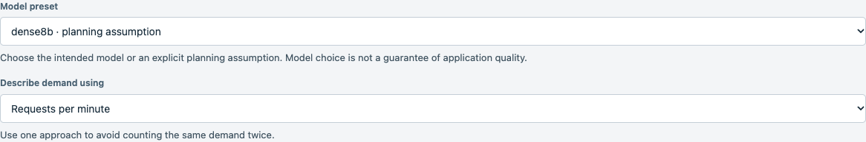
18 | Set Peak requests per minute = 40. Set Model calls per request or job = 1.
19 | Set Input tokens per model call = 2000. Set Output tokens per model call = 500.
20 | Confirm [GPU estimate inputs are ready]. Retain the displayed B300 enterprise deployment profile and Sensitivity envelope = ±30%. Check Use these planning assumptions. Click [Calculate estimate].
21 | Read the GPU workload comparison. Expected B300 = 24, B200 = 24, H200 = 32 GPUs. These workload counts are separate from the 256 GPU factory deployment anchor. Click [Export result] to save the calculation.
22 | Click [Continue to Design handoff], then [Prepare projection]. Read the executive summary and download the design intake and companion specification. Unresolved network and storage measurements remain explicit.
23 | Click [Explain this to me]. Set Explanation connection = DeepSeek consultant walkthrough. Check This saved result is public or fictional and may be sent to the selected provider for this fictional exercise. Click [Generate explanation]. The saved calculation cannot be changed by this action. | 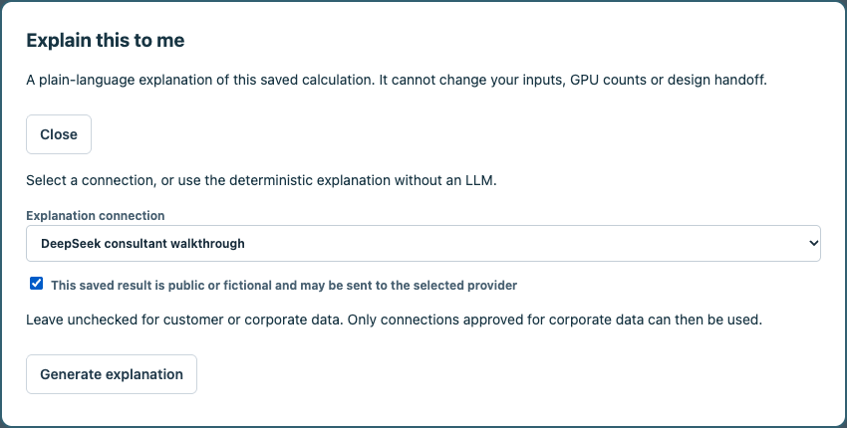
24 | Read the explanation of the workload GPUs, deployment anchor, memory, storage and all network roles. Expand [Source fields and assumptions] to trace the explanation. Click [Download explanation], then [Close]. | 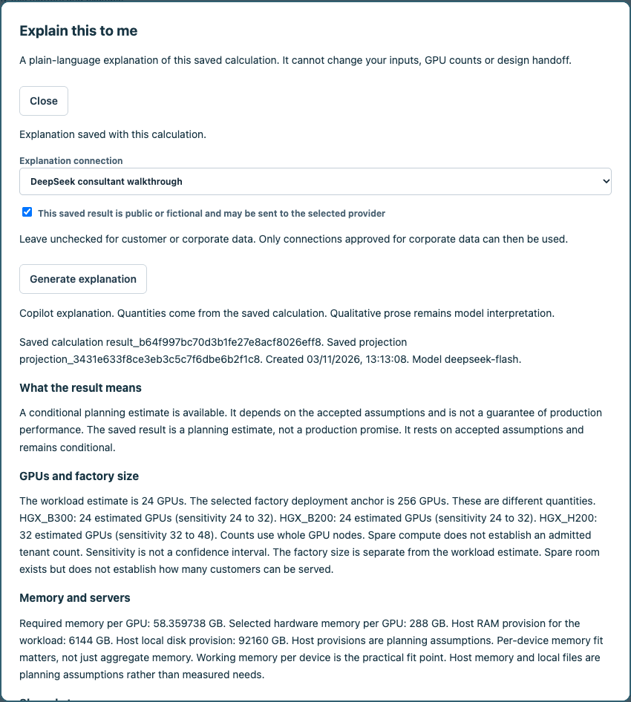
25 | Scroll down within [Explain this to me] to read [Factory networks] and [What to do next]. Expand [Source fields and assumptions] if needed. Click [Download explanation] to save the text. Scroll to the top and click [Close] to continue. | 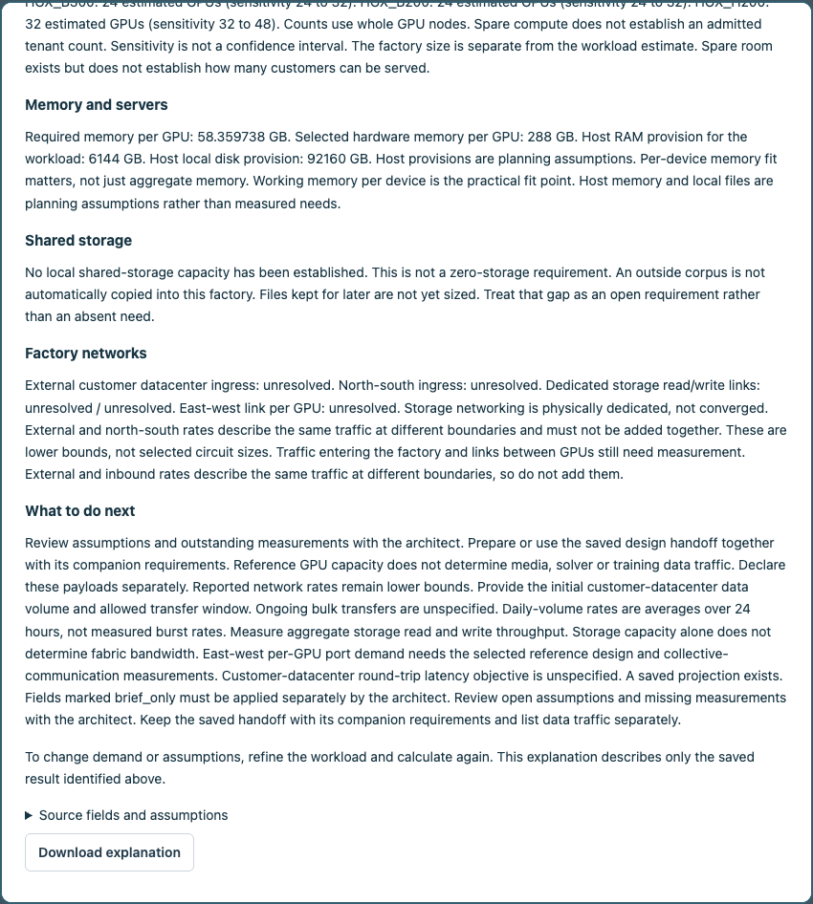
26 | Set Completion notes = Planning requirements and explanation delivered. Outstanding network and storage measurements remain in the companion specification.. Check I confirm that these selected requirements are delivered.. Click [Complete engagement]. | 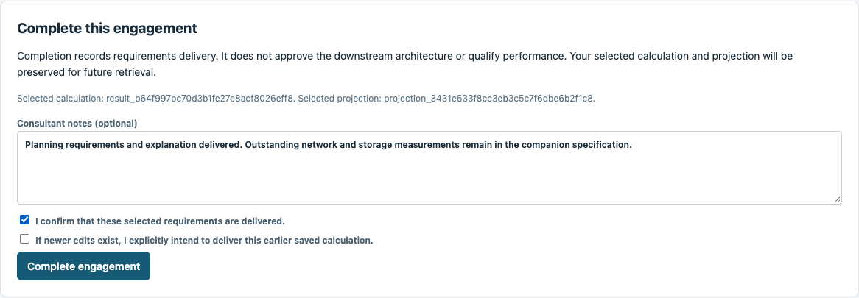
27 | The engagement is complete. Its exact calculation, handoff and explanation remain saved. Use [Cases] to reopen the engagement and [Saved deliverables] to retrieve its documents. | 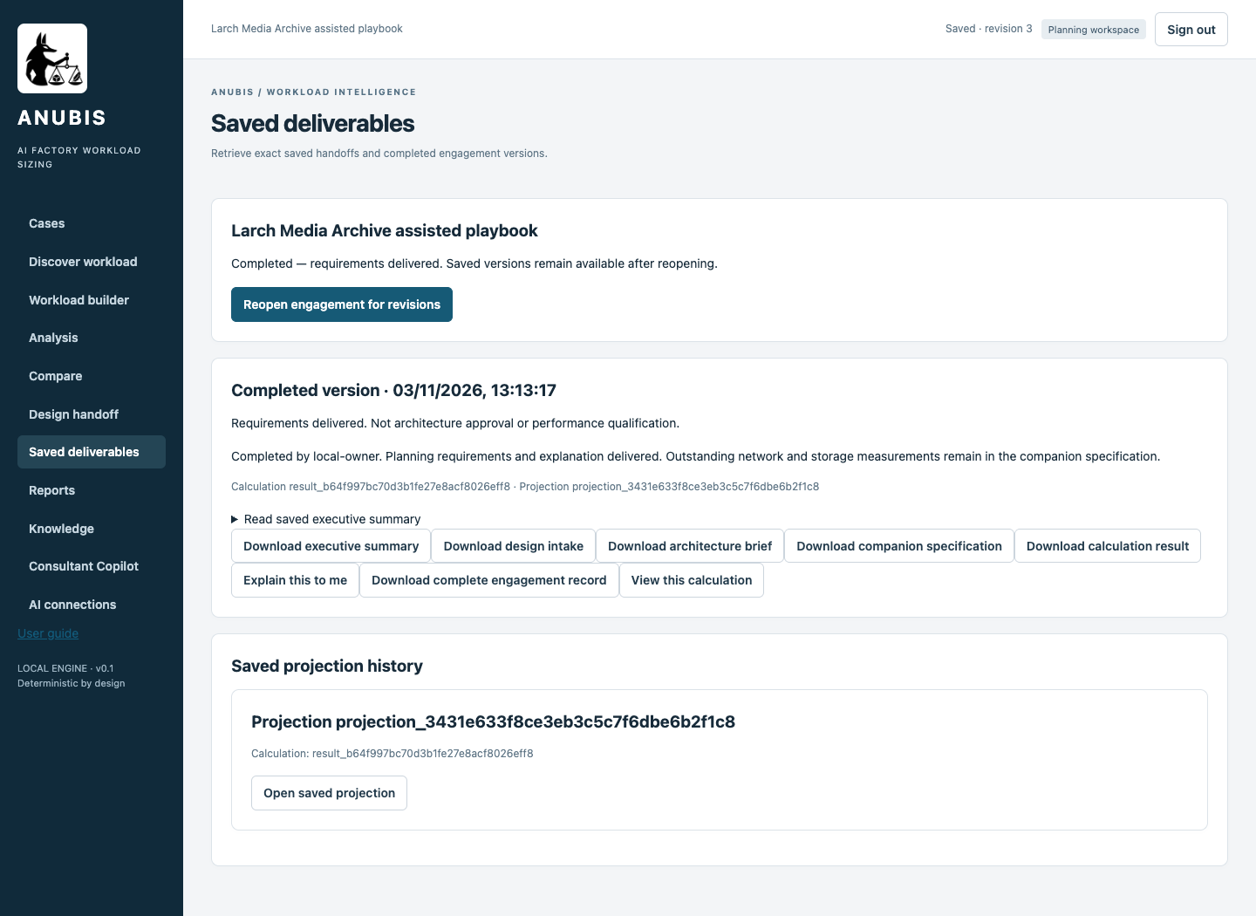

Compare and retrieve the results
Check | Manual route | Copilot assisted route
Workload GPU counts | B300 24, B200 24, H200 32 | B300 24, B200 24, H200 32
Design handoff | Prepared with companion requirements | Prepared with companion requirements
Explanation | Saved deterministic narrative | Saved model-assisted narrative
Completion | Requirements delivered and saved | Requirements delivered and saved
Open the engagement from Cases and select Saved deliverables. Download the saved calculation, intake, brief and companion specification. Explain this to me retrieves narratives associated with that exact result. A later calculation does not update an earlier explanation. Refining demand requires a fresh deterministic calculation.

Appendix Parameter collection guide
ID | Field and meaning | How to obtain or decide it | When unavailable
I01 | Customer workload name  Identifies the two separate saved runs. | Choose the route suffix to avoid mixing results. | Record the unknown or an explicitly accepted assumption. Resolve any field listed by GPU estimate blocked before calculating.
I02 | Factory users  Organisations sharing the factory. | Confirm commercial and organisational scope. Tenancy does not multiply aggregate demand automatically. | Record the unknown or an explicitly accepted assumption. Resolve any field listed by GPU estimate blocked before calculating.
I03 | Do activities run at the same time?  Peak workloads may coincide. | Review schedules and telemetry with the operations owner. | Record the unknown or an explicitly accepted assumption. Resolve any field listed by GPU estimate blocked before calculating.
I04 | Component name  Business activity being sized. Numbered labels follow the order of components in the active route. | Agree a recognisable activity name with the application owner. Use the matching diagram to check its scope. | Record the unknown or an explicitly accepted assumption. Resolve any field listed by GPU estimate blocked before calculating.
I05 | Application pattern  Application behaviour, not a server type. | Walk through a customer task. Identify text serving, retrieval, media processing or solver work. | Record the unknown or an explicitly accepted assumption. Resolve any field listed by GPU estimate blocked before calculating.
I06 | Compute location  Where computation runs relative to this factory. | Confirm the hosting owner and deployment boundary. Outside services do not contribute local model GPUs. | Record the unknown or an explicitly accepted assumption. Resolve any field listed by GPU estimate blocked before calculating.
I07 | Relationship  Order or relationship of activities. This is separate from whether demand overlaps. | Review the business flow with the application owner. Confirm scheduling separately. | Record the unknown or an explicitly accepted assumption. Resolve any field listed by GPU estimate blocked before calculating.
I08 | Sizing method  Analytical text sizing or replication of a complete reference GPU group. | Use analytical sizing for supported language models. Select reference capacity for a scoped specialist workload. | Record the unknown or an explicitly accepted assumption. Resolve any field listed by GPU estimate blocked before calculating.
I09 | Peak work units per second  Aggregate independent work units due per second. | Count peak arriving work. For batch work divide items by available seconds. Camera demand can be cameras multiplied by sampled frames per second. | Record the unknown or an explicitly accepted assumption. Resolve any field listed by GPU estimate blocked before calculating.
I10 | Work unit  Completed unit of work, such as a processed frame or complete simulation. | Define the exact work item, input dimensions, quality settings, precision and success condition with the application owner. | Record the unknown or an explicitly accepted assumption. Resolve any field listed by GPU estimate blocked before calculating.
I11 | GPUs per reference group  GPUs in a complete independently repeatable group. | Read the tested or assumed deployment configuration. Use one, two, four, eight or a multiple of eight GPUs. Do not scale a single larger mesh by adding unrelated groups. | Record the unknown or an explicitly accepted assumption. Resolve any field listed by GPU estimate blocked before calculating.
I12 | Required GPU memory in GB  Peak memory required on each GPU in the reference configuration. | Measure the busiest device with GPU telemetry during representative work. Include weights, working state and buffers. Record the source and margin. | Record the unknown or an explicitly accepted assumption. Resolve any field listed by GPU estimate blocked before calculating.
I13 | H200 work units per second per group  Capacity per complete group on this specific GPU platform, in the same work units per second as demand. | Use a matching measured run or an explicit engineering assumption for this platform. Do not silently translate throughput measured on another GPU. | Record the unknown or an explicitly accepted assumption. Resolve any field listed by GPU estimate blocked before calculating.
I14 | B200 work units per second per group  Capacity per complete group on this specific GPU platform, in the same work units per second as demand. | Use a matching measured run or an explicit engineering assumption for this platform. Do not silently translate throughput measured on another GPU. | Record the unknown or an explicitly accepted assumption. Resolve any field listed by GPU estimate blocked before calculating.
I15 | B300 work units per second per group  Capacity per complete group on this specific GPU platform, in the same work units per second as demand. | Use a matching measured run or an explicit engineering assumption for this platform. Do not silently translate throughput measured on another GPU. | Record the unknown or an explicitly accepted assumption. Resolve any field listed by GPU estimate blocked before calculating.
I16 | Independent reference groups can serve this demand  Whether independent full groups can share the incoming work. | Check that the scheduler can route separate jobs or requests to each group. A single job requiring a larger distributed system does not satisfy this assumption. | Record the unknown or an explicitly accepted assumption. Resolve any field listed by GPU estimate blocked before calculating.
I17 | I accept this reference capacity and its scope  Consultant acceptance of reference scope and assumptions. | Review demand, capacity, memory and group independence together. Reaccept after Copilot refinement only if the reference remains applicable. | Record the unknown or an explicitly accepted assumption. Resolve any field listed by GPU estimate blocked before calculating.
I18 | Reference source and conditions  Source and operating conditions for the capacity assumption. | Record benchmark or engineering-assumption provenance, date, model or solver version, precision, input dimensions, group size and scope. Fictional example values are not measurements. | Record the unknown or an explicitly accepted assumption. Resolve any field listed by GPU estimate blocked before calculating.
I19 | Component name  Business activity being sized. Numbered labels follow the order of components in the active route. | Agree a recognisable activity name with the application owner. Use the matching diagram to check its scope. | Record the unknown or an explicitly accepted assumption. Resolve any field listed by GPU estimate blocked before calculating.
I20 | Application pattern  Application behaviour, not a server type. | Walk through a customer task. Identify text serving, retrieval, media processing or solver work. | Record the unknown or an explicitly accepted assumption. Resolve any field listed by GPU estimate blocked before calculating.
I21 | Compute location  Where computation runs relative to this factory. | Confirm the hosting owner and deployment boundary. Outside services do not contribute local model GPUs. | Record the unknown or an explicitly accepted assumption. Resolve any field listed by GPU estimate blocked before calculating.
I22 | Relationship  Order or relationship of activities. This is separate from whether demand overlaps. | Review the business flow with the application owner. Confirm scheduling separately. | Record the unknown or an explicitly accepted assumption. Resolve any field listed by GPU estimate blocked before calculating.
I23 | Model preset  Language-model size and architecture preset. It is not a quality guarantee. | Use the model registry or serving configuration. Record an explicitly accepted assumption when the model has not been selected. | Record the unknown or an explicitly accepted assumption. Resolve any field listed by GPU estimate blocked before calculating.
I24 | Peak requests per minute  Busy-period application requests per minute. | Count application gateway requests by minute in a representative peak. Divide busiest-hour requests by sixty only when that average is an accepted planning basis. | Record the unknown or an explicitly accepted assumption. Resolve any field listed by GPU estimate blocked before calculating.
I25 | Model calls per request or job  Model invocations per complete customer request, including retries. | Inspect distributed transaction traces or model gateway logs. Count calls across the entire request, including agent loops. | Record the unknown or an explicitly accepted assumption. Resolve any field listed by GPU estimate blocked before calculating.
I26 | Input tokens per model call  Prompt, history and retrieved passages sent to a model call. | Read prompt-token metrics from serving logs or tokenize representative full prompts with the exact model tokenizer. | Record the unknown or an explicitly accepted assumption. Resolve any field listed by GPU estimate blocked before calculating.
I27 | Output tokens per model call  Generated response tokens per model call. | Read completion-token metrics or tokenize representative outputs. Choose a planning distribution with the service owner. | Record the unknown or an explicitly accepted assumption. Resolve any field listed by GPU estimate blocked before calculating.
I28 | Search and indexing location  Location of search, embedding and indexing support. | Ask the search-platform owner where the index is built and queried. Do not infer its footprint from the source-corpus size. | Record the unknown or an explicitly accepted assumption. Resolve any field listed by GPU estimate blocked before calculating.
I29 | Infrastructure deployment profile  Selects factory anchors rather than workload demand. | Architect selects a compatible catalogue profile. | Record the unknown or an explicitly accepted assumption. Resolve any field listed by GPU estimate blocked before calculating.
I30 | Sensitivity envelope  Explores faster and slower throughput assumptions. | Choose the agreed planning sensitivity. It is not a confidence interval. | Record the unknown or an explicitly accepted assumption. Resolve any field listed by GPU estimate blocked before calculating.
I31 | Use these planning assumptions  Accepts the displayed planning defaults. | Review defaults before calculating. | Record the unknown or an explicitly accepted assumption. Resolve any field listed by GPU estimate blocked before calculating.
I32 | Locally retained data in TB / Daily growth in GB  No local shared-storage amount is established. Blank is not zero. | Inventory actual local retained copies. Do not copy an outside corpus into this value. | Record the unknown or an explicitly accepted assumption. Resolve any field listed by GPU estimate blocked before calculating.
I33 | Initial dataset to load in TB / Initial loading window in hours  Initial transfer scope and time remain unresolved. | Obtain transfer volume and the allowed window from the data owner. | Record the unknown or an explicitly accepted assumption. Resolve any field listed by GPU estimate blocked before calculating.
I34 | Ongoing incoming / outgoing data in GB per day  Bulk daily transfer volumes remain unspecified. | Measure ingress and egress counters separately from model token traffic. | Record the unknown or an explicitly accepted assumption. Resolve any field listed by GPU estimate blocked before calculating.
I35 | Aggregate storage reads / writes in Gbps  Dedicated storage fabric throughput remains unresolved. | Measure directional read and write payload peaks. Capacity alone cannot determine bandwidth. | Record the unknown or an explicitly accepted assumption. Resolve any field listed by GPU estimate blocked before calculating.
I36 | East-west payload per GPU in Gbps / Customer datacenter round-trip target in ms  Collective traffic and latency objective remain unresolved. | Use GPU communication telemetry and an agreed RTT objective. | Record the unknown or an explicitly accepted assumption. Resolve any field listed by GPU estimate blocked before calculating.
I37 | Usable link fraction / Initial loading overlap  Accepted network defaults. Storage networking is physically dedicated. | Review usable bandwidth and whether loading coincides with normal operation. | Record the unknown or an explicitly accepted assumption. Resolve any field listed by GPU estimate blocked before calculating.
I38 | Explanation connection  Chooses prose generation without changing the calculation. | Configure an approved provider in AI connections. Backend credentials stay on the server. | Record the unknown or an explicitly accepted assumption. Resolve any field listed by GPU estimate blocked before calculating.
I39 | This saved result is public or fictional and may be sent to the selected provider  Permission to send the saved explanation packet to the chosen connection. | Leave unchecked for corporate data and select a connection approved for that data. | Record the unknown or an explicitly accepted assumption. Resolve any field listed by GPU estimate blocked before calculating.

Appendix Placement and explanation boundaries
Term | Meaning and concrete examples
Outside this AI Factory | Compute, search or storage beyond the capacity being designed. Examples include a customer GPU cluster, managed model API, customer datacenter search cluster, cloud search platform or an existing object store. It does not necessarily mean public Internet or a different site.
Source corpus and index | Original documents and the searchable index have separate storage and compute footprints. Examples include an NFS or SMB share, object storage, SharePoint and an OpenSearch index. Outside data is not automatically a local retained copy or initial transfer volume.
Model explanation | The LLM explains a saved result using a read-only packet. Numeric facts are inserted by the server. Invalid or unavailable model responses fall back to deterministic text. Qualitative prose remains interpretation, not a new engineering decision.
Reference capacity | Specialist counts use the exact per-hardware throughput and memory assumptions in the register. The example values are fictional planning assumptions. A complete independent group can be replicated. No linear scaling of a single larger job is inferred.
Validation scope | Both GUI routes were executed against the application and checked for matching GPU comparisons and saved handoffs. This validates the software workflow. It does not qualify real hardware performance, model quality, latency or live-provider reliability for every future request.

