Anubis Orchid Neocloud playbook
Follow the manual or Copilot-assisted route to calculate workload GPU requirements, prepare a design handoff, obtain a plain-language explanation and save the completed engagement.
Reader key. UI field identifies a screen label. Entered value is literal content. [Button] identifies an action. Checked and blank identify settings.

Customer scenario
A provider hosts twenty customers using text endpoints. Premium customers require dedicated resources. standard customers may share a pool. Both groups can peak together. Model choices vary between customers.
All added numbers are explicit fictional customer planning assumptions for a reproducible demonstration. They are not historical measurements or qualified hardware benchmarks. Dense text components use dense8b, one call/request, 2000 input and 500 output tokens unless overridden in the intake table. The 20 tenants are represented by two aggregate demand pools. Premium capacity is reserved. Tenant count is not multiplied into these already aggregated rates.

Workflow input register
ID | Scope and exact field | Value | Basis
I01 | Engagement  Customer workload name | Orchid Neocloud manual playbook / Orchid Neocloud assisted playbook | Entered
I02 | Engagement  Factory users | Multiple tenants | Selected
I03 | Engagement  Do activities run at the same time? | Yes — overlapping demand | Selected
I04 | Premium model endpoints  Component name | Premium model endpoints | Selected
I05 | Premium model endpoints  Application pattern | direct | Selected
I06 | Premium model endpoints  Compute location | In this factory | Selected
I07 | Premium model endpoints  Relationship | Independent | Selected
I08 | Premium model endpoints  Model preset | dense8b | Explicit planning assumption
I09 | Premium model endpoints  Peak requests per minute | 60 | Explicit planning assumption
I10 | Premium model endpoints  Model calls per request or job | 1 | Explicit planning assumption
I11 | Premium model endpoints  Input tokens per model call | 2000 | Explicit planning assumption
I12 | Premium model endpoints  Output tokens per model call | 500 | Explicit planning assumption
I13 | Premium model endpoints  Reserve dedicated capacity | Checked | Selected
I14 | Standard model endpoints  Component name | Standard model endpoints | Selected
I15 | Standard model endpoints  Application pattern | direct | Selected
I16 | Standard model endpoints  Compute location | In this factory | Selected
I17 | Standard model endpoints  Relationship | Independent | Selected
I18 | Standard model endpoints  Model preset | dense8b | Explicit planning assumption
I19 | Standard model endpoints  Peak requests per minute | 300 | Explicit planning assumption
I20 | Standard model endpoints  Model calls per request or job | 1 | Explicit planning assumption
I21 | Standard model endpoints  Input tokens per model call | 2000 | Explicit planning assumption
I22 | Standard model endpoints  Output tokens per model call | 500 | Explicit planning assumption
I23 | Shared  Infrastructure deployment profile | HGX B300 · Spectrum-X · Enterprise reference design with two network planes | Default or explicitly left blank
I24 | Shared  Sensitivity envelope | ±30% | Default or explicitly left blank
I25 | Shared  Use these planning assumptions | Checked | Default or explicitly left blank
I26 | Shared  Locally retained data in TB / Daily growth in GB | Blank | Default or explicitly left blank
I27 | Shared  Initial dataset to load in TB / Initial loading window in hours | Blank | Default or explicitly left blank
I28 | Shared  Ongoing incoming / outgoing data in GB per day | Blank | Default or explicitly left blank
I29 | Shared  Aggregate storage reads / writes in Gbps | Blank | Default or explicitly left blank
I30 | Shared  East-west payload per GPU in Gbps / Customer datacenter round-trip target in ms | Blank | Default or explicitly left blank
I31 | Shared  Usable link fraction / Initial loading overlap | 0.7 / Yes | Default or explicitly left blank
I32 | Shared  Explanation connection | Manual: deterministic. Assisted: tested DeepSeek connection | Default or explicitly left blank
I33 | Shared  This saved result is public or fictional and may be sent to the selected provider | Checked only for this fictional assisted example | Default or explicitly left blank
Remaining displayed engine defaults: BF16 weights and KV cache, context 8192 tokens, 32 concurrent sequences, 8 GB workspace, compute efficiency 0.35 and memory efficiency 0.50. Host provisions are 256 GB RAM, 3840 GB local disk and 16 CPU cores per workload GPU. The blank growth horizon uses 365 days. Reference sizing does not use text-token equations.

Expected result and process
B300 workload GPUs | B200 workload GPUs | H200 workload GPUs | Selected B300 factory anchor
16 | 16 | 16 | 256
Describe the application → confirm its boundary → enter demand and assumptions → calculate GPU comparisons → prepare design handoff → explain the saved result → complete and retrieve the engagement.
The workload count and factory anchor are separate. Spare compute may support additional work, but it does not establish a qualified tenant count. Outstanding network and shared-storage measurements remain visible in the companion requirements.

Premium model endpoints architecture
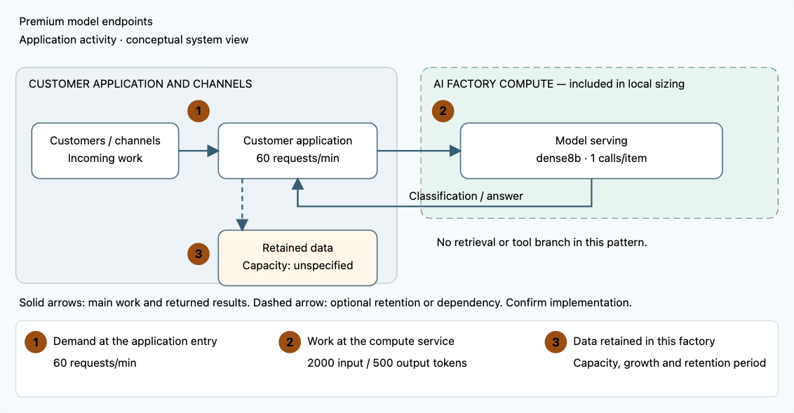

Standard model endpoints architecture
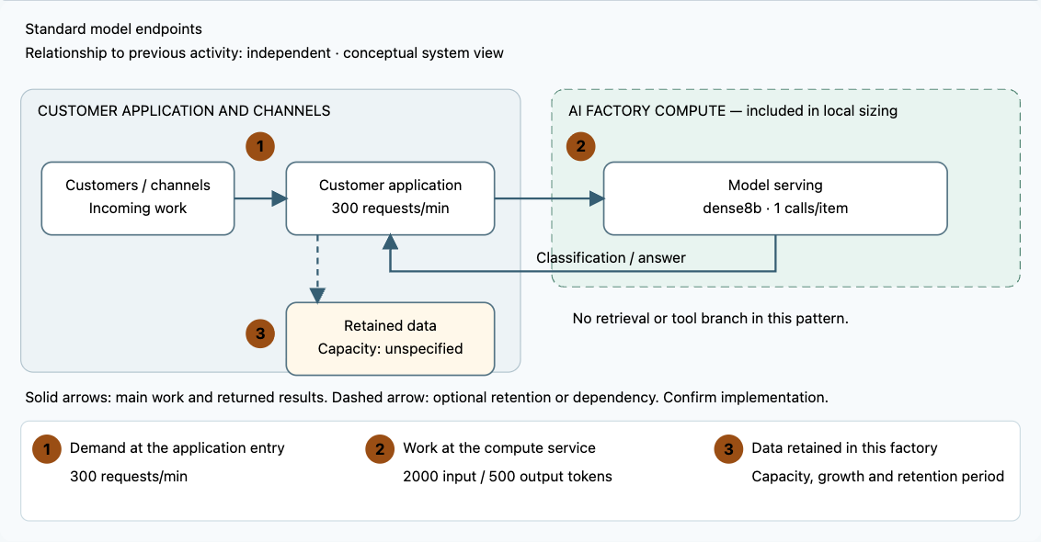

Start and access the workspace
Complete the Mac installation guide in docs/macos-installation-guide.txt. From the repository folder run python3 deploy/local/run.py. Keep the terminal open. On first launch the application creates .anubis/identities.json. Open that private file locally, copy your identity token without quotation marks, and paste it into Access token. Click [Open workspace]. Saved cases persist in .anubis/anubis.sqlite across restarts. Preserve this directory and use the documented backup process.
For Copilot, put the provider API key in the protected backend configuration, never in the chat or input register. Open [AI connections], configure the approved provider and backend environment-variable name, and test the connection. The recorded assisted walkthrough uses DeepSeek deepseek-flash with low reasoning. Connection testing is separate from workload and explanation validation.

Manual workflow
Follow these numbered steps in order. Use a separate engagement name for this route. Input values are the same workload assumptions in both routes. In the assisted route, inspect extracted facts and explicitly enter any specialist reference values in the guided form.
Step | Activity and exact values | Screen reference
1 | Start Anubis and open the local address. Retrieve your private token from .anubis/identities.json. Paste it into Access token and click [Open workspace]. Never share the token. | 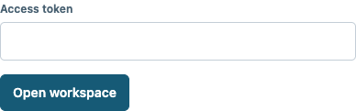
2 | Click [New engagement]. Set Customer workload name = Orchid Neocloud manual playbook. Click [Add Direct model service]. Click [Add Direct model service]. Click [Continue].
3 | Set Factory users = Multiple tenants. Set Do activities run at the same time? = Yes — overlapping demand. | 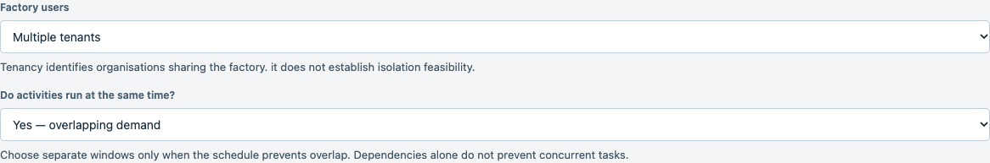
4 | Set Component name 1 = Premium model endpoints. Set Compute location 1 = In this factory. Set Reserve dedicated capacity 1 checked. | 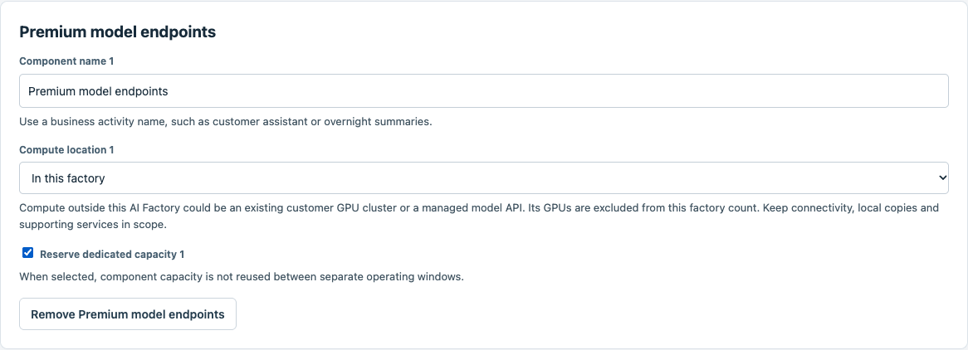
5 | Set Component name 2 = Standard model endpoints. Set Compute location 2 = In this factory. Set Reserve dedicated capacity 2 unchecked. Set Relationship 2 = Independent. | 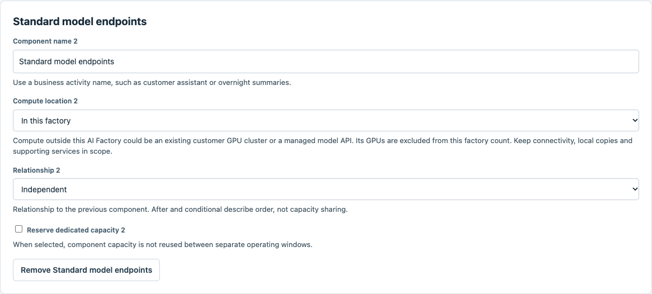
6 | Set Model preset = dense8b. Set Describe demand using = Requests per minute. | 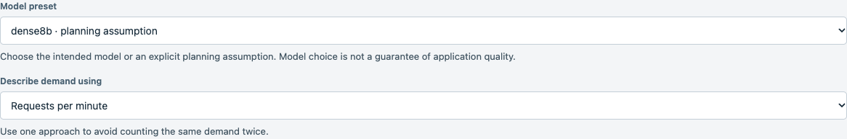
7 | Set Peak requests per minute = 60. Set Model calls per request or job = 1. | 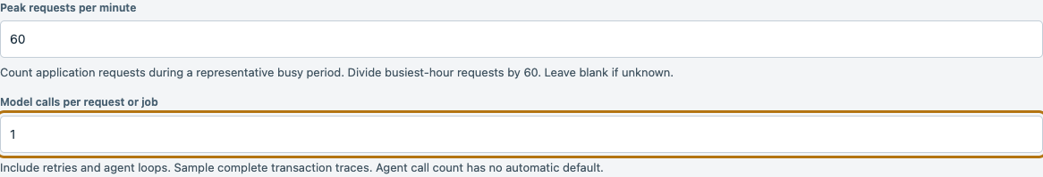
8 | Set Input tokens per model call = 2000. Set Output tokens per model call = 500. | 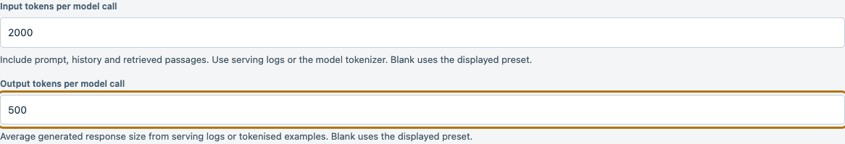
9 | Set Model preset = dense8b. Set Describe demand using = Requests per minute. | 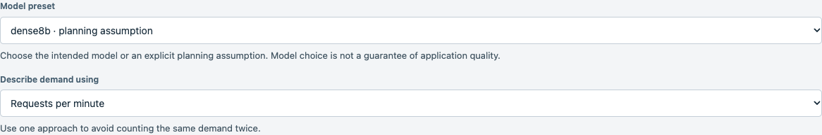
10 | Set Peak requests per minute = 300. Set Model calls per request or job = 1. | 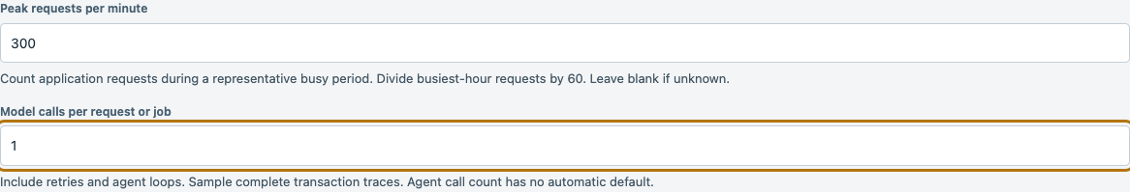
11 | Set Input tokens per model call = 2000. Set Output tokens per model call = 500. | 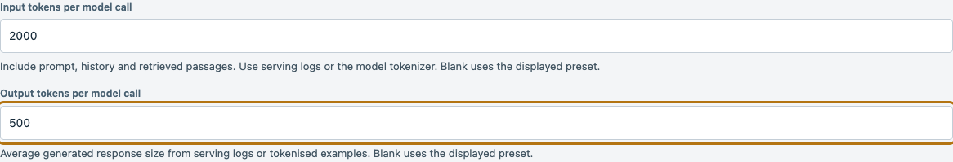
12 | Confirm [GPU estimate inputs are ready]. Retain the displayed B300 enterprise deployment profile and Sensitivity envelope = ±30%. Check Use these planning assumptions. Click [Calculate estimate]. | 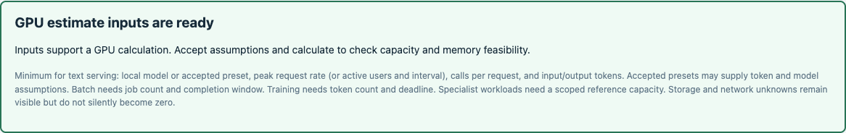
13 | Read the GPU workload comparison. Expected B300 = 16, B200 = 16, H200 = 16 GPUs. These workload counts are separate from the 256 GPU factory deployment anchor. Click [Export result] to save the calculation. | 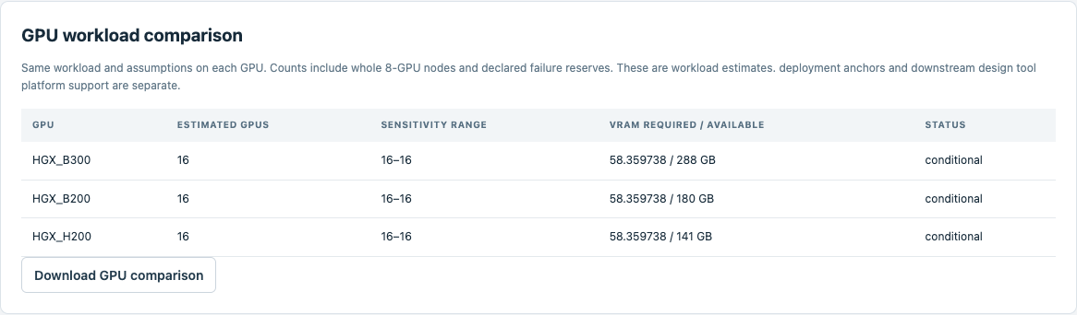
14 | Click [Continue to Design handoff], then [Prepare projection]. Read the executive summary and download the design intake and companion specification. Unresolved network and storage measurements remain explicit. | 
15 | Click [Explain this to me]. Set Explanation connection = Deterministic explanation — no model. Click [Generate explanation]. The saved calculation cannot be changed by this action. | 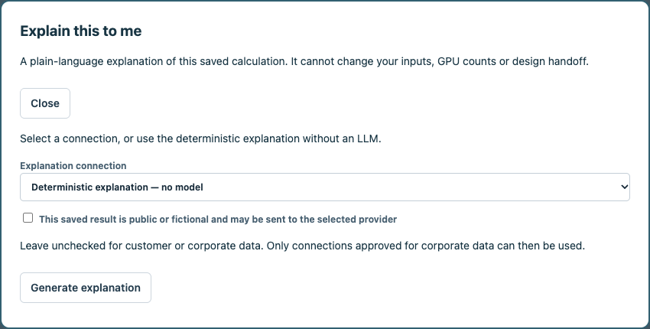
16 | Read the explanation of the workload GPUs, deployment anchor, memory, storage and all network roles. Expand [Source fields and assumptions] to trace the explanation. Click [Download explanation], then [Close]. | 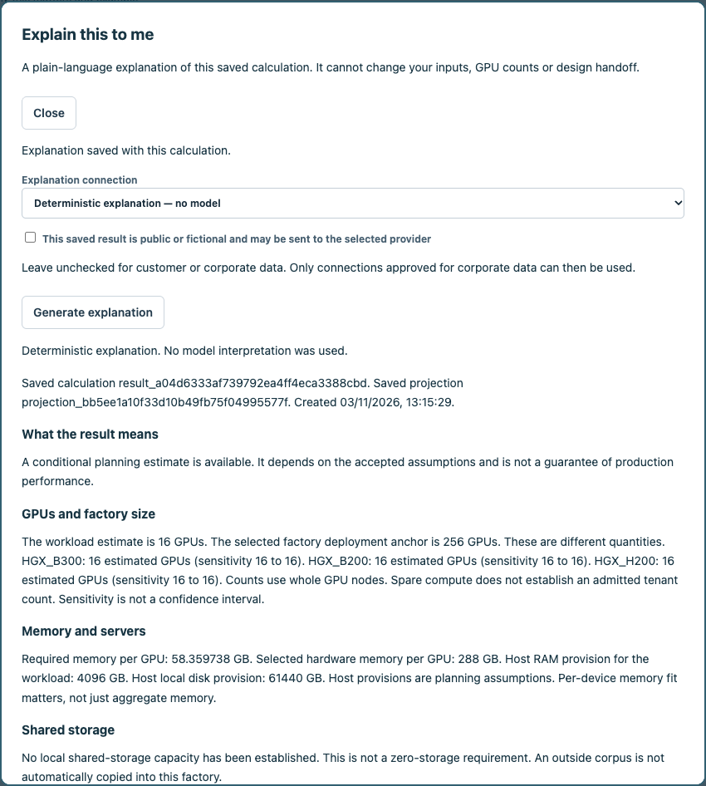
17 | Scroll down within [Explain this to me] to read [Factory networks] and [What to do next]. Expand [Source fields and assumptions] if needed. Click [Download explanation] to save the text. Scroll to the top and click [Close] to continue. | 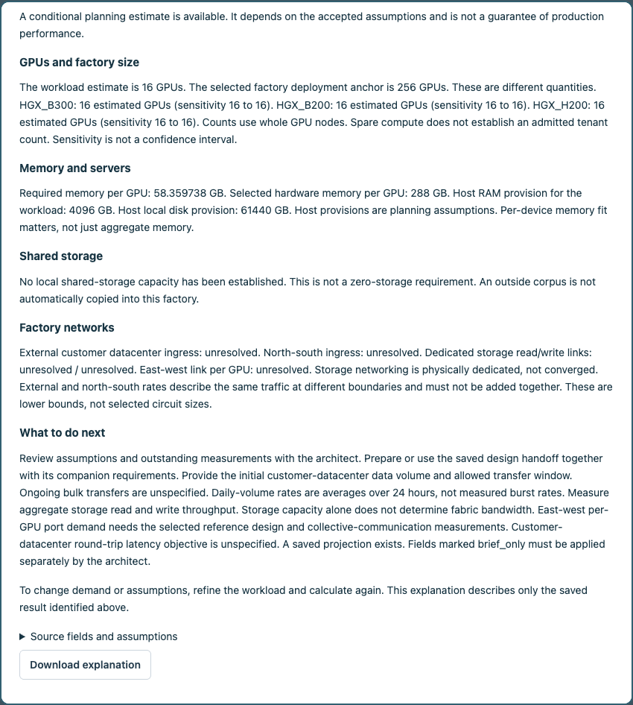
18 | Set Completion notes = Planning requirements and explanation delivered. Outstanding network and storage measurements remain in the companion specification.. Check I confirm that these selected requirements are delivered.. Click [Complete engagement]. | 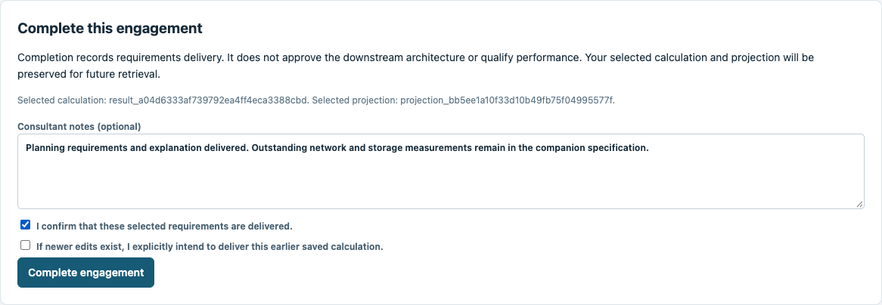
19 | The engagement is complete. Its exact calculation, handoff and explanation remain saved. Use [Cases] to reopen the engagement and [Saved deliverables] to retrieve its documents. | 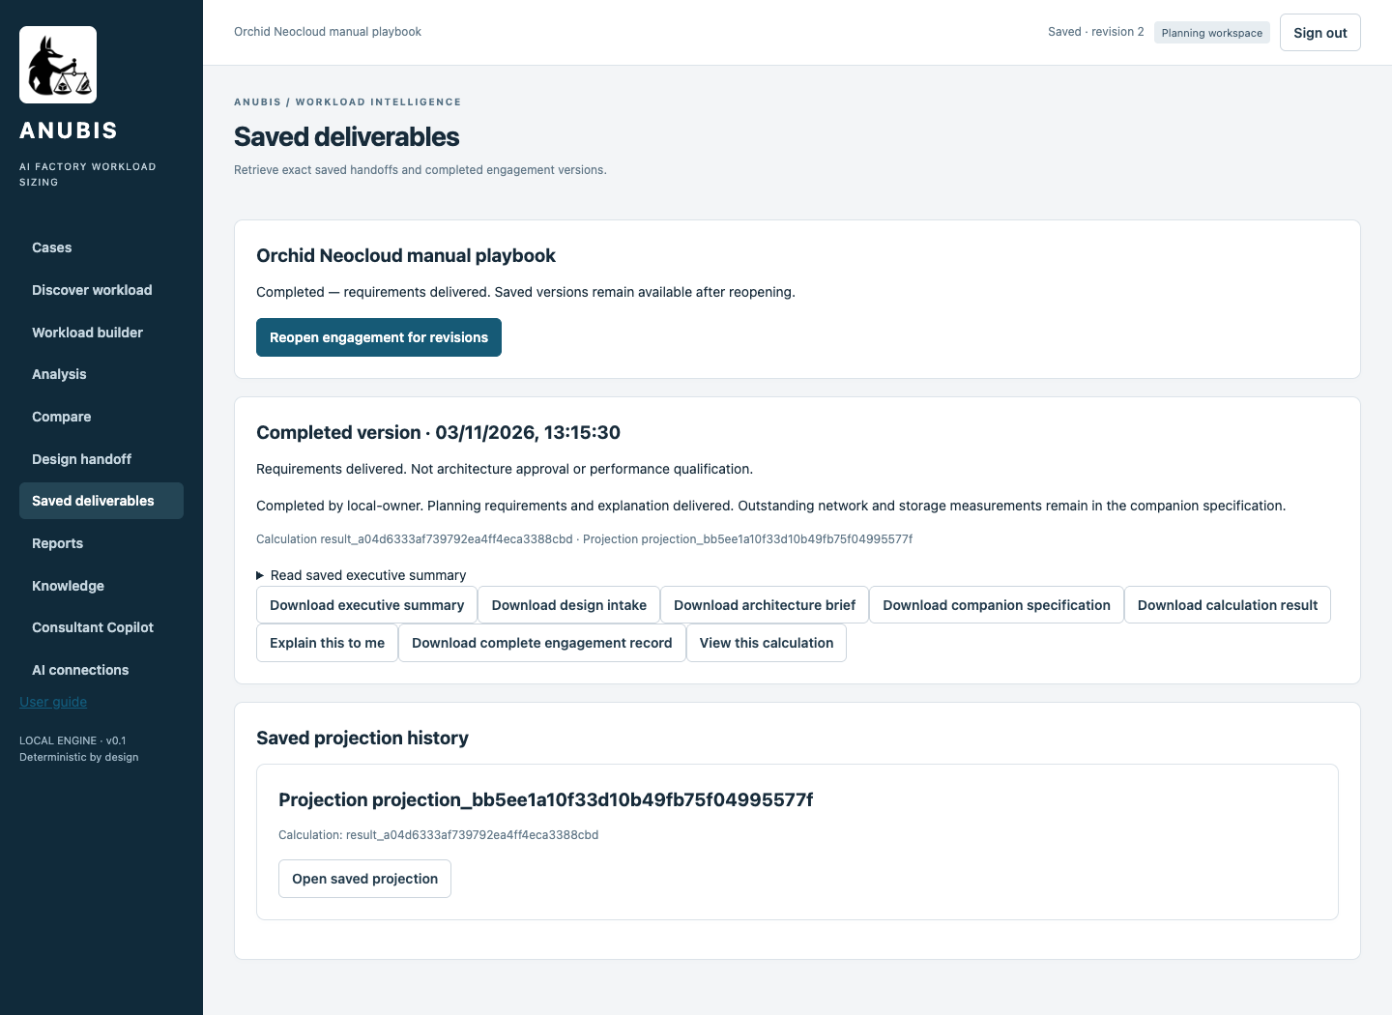

Copilot assisted workflow
Follow these numbered steps in order. Use a separate engagement name for this route. Input values are the same workload assumptions in both routes. In the assisted route, inspect extracted facts and explicitly enter any specialist reference values in the guided form.
Step | Activity and exact values | Screen reference
1 | Start Anubis and open the local address. Retrieve your private token from .anubis/identities.json. Paste it into Access token and click [Open workspace]. Never share the token.
2 | Click [Consultant Copilot]. Set Customer workload name = Orchid Neocloud assisted playbook. Set Data classification = Public — permitted for direct provider processing. Click [Start assisted engagement]. | 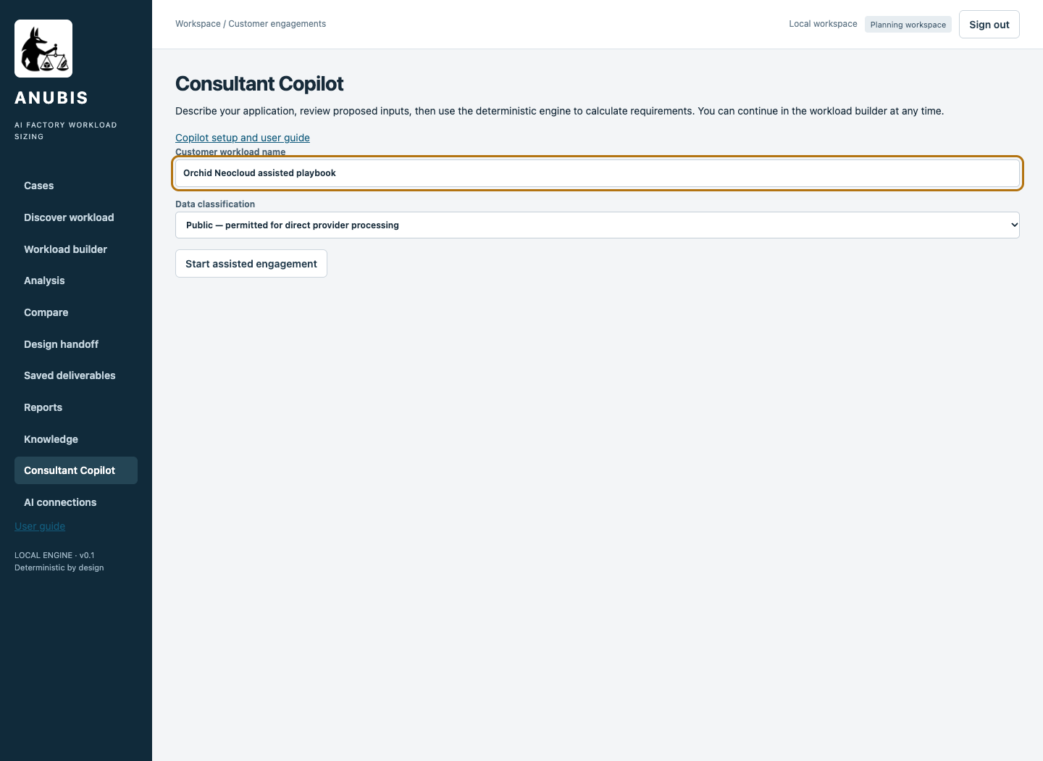
3 | Select your tested connection in Model connection. Enter the following paragraph in What should we know about the workload?: Fictional customer Orchid Neocloud. This is a planning exercise. Activities can overlap. Multiple tenants share the factory. Use the exact activity name "Premium model endpoints". It serves text with a language model. No retrieval or tool orchestration. Compute is inside this AI Factory. Reserve dedicated capacity for this activity. Explicit planning assumptions: dense8b, 60 peak requests per minute, 1 model call per request, 2000 input tokens and 500 output tokens per call. . | 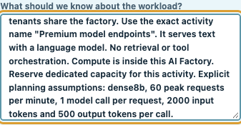
4 | Append the following paragraph to What should we know about the workload?: Use the exact activity name "Standard model endpoints". It serves text with a language model. No retrieval or tool orchestration. Compute is inside this AI Factory. Shared capacity within its activity pool. Explicit planning assumptions: dense8b, 300 peak requests per minute, 1 model call per request, 2000 input tokens and 500 output tokens per call. . | 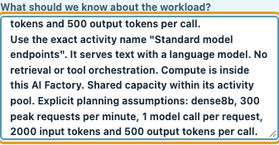
5 | Append the following paragraph to What should we know about the workload?: Do not add other activities or infer local storage from an outside corpus. Unknown storage and network measurements remain unknown.. Click [Ask copilot]. | 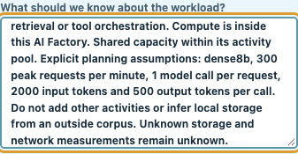
6 | Wait while Copilot interprets the description. The active status indicator confirms that it is still working. Do not submit duplicate requests. | 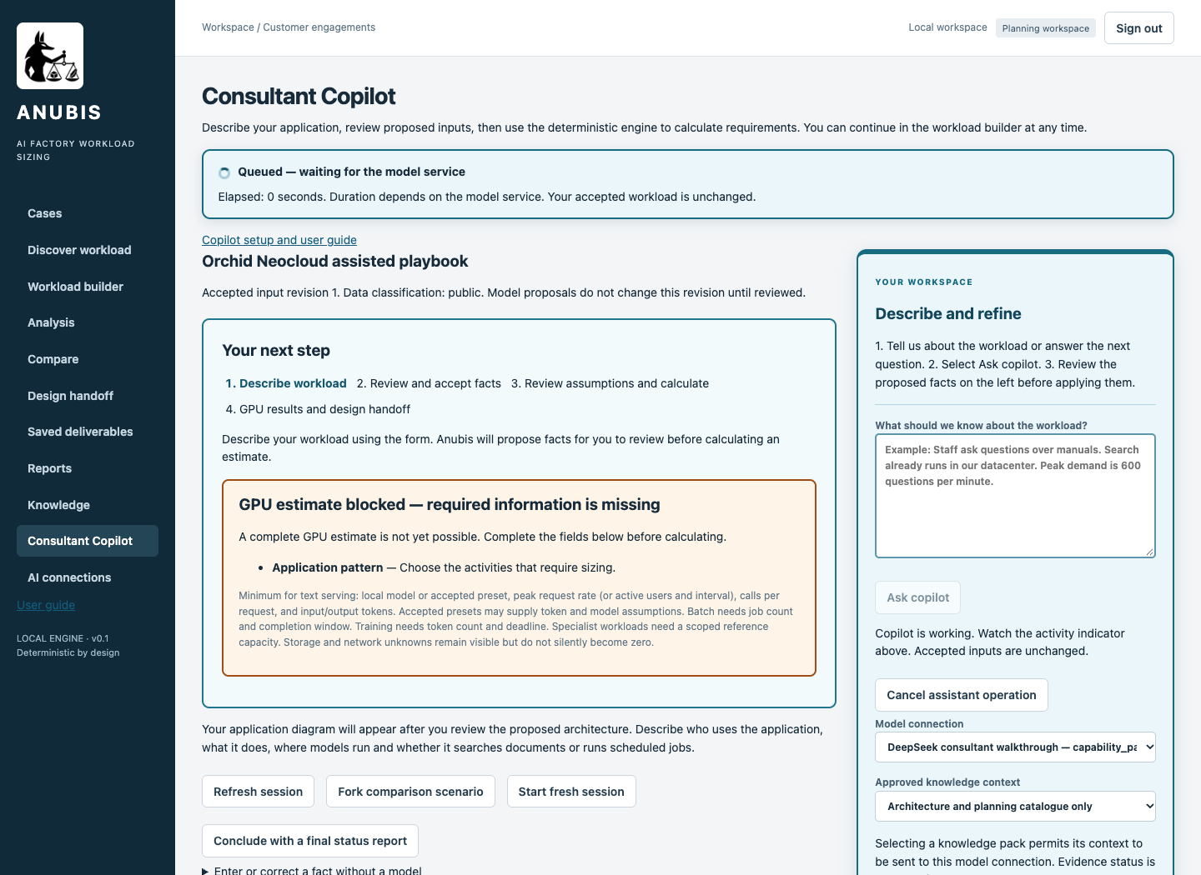
7 | Review the proposed activities, placement, measurements and assumptions against the input register. Check I reviewed the selected values and accept the planning assumptions.. Click [Apply selected]. Specialist reference inputs are entered during the next review. | 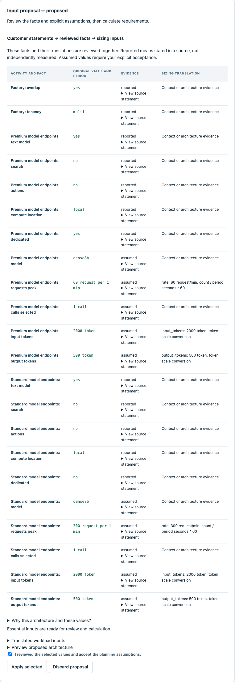
8 | Click [Review and calculate GPU estimate]. The readiness panel names any missing inputs. Complete them in the guided review. Copilot has not invented reference throughput.
9 | Set Factory users = Multiple tenants. Set Do activities run at the same time? = Yes — overlapping demand.
10 | Set Component name 1 = Premium model endpoints. Set Compute location 1 = In this factory. Set Reserve dedicated capacity 1 checked. | 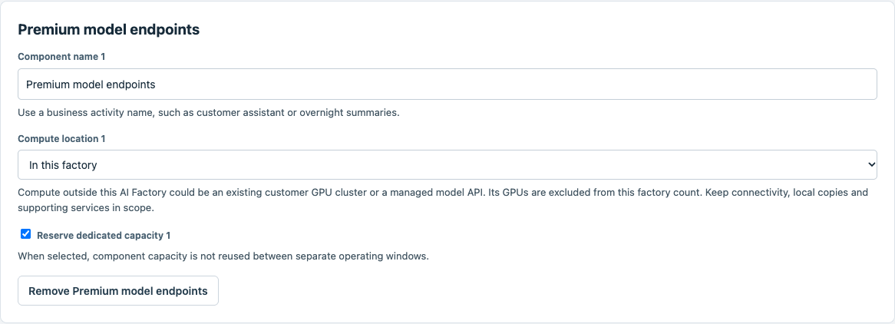
11 | Set Component name 2 = Standard model endpoints. Set Compute location 2 = In this factory. Set Reserve dedicated capacity 2 unchecked. Set Relationship 2 = Independent. | 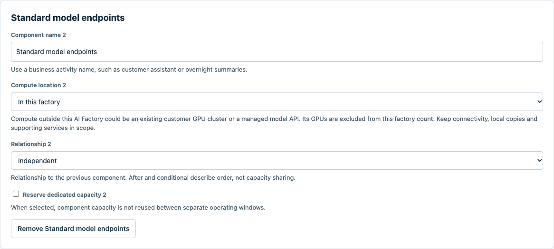
12 | Set Model preset = dense8b. Set Describe demand using = Requests per minute. | 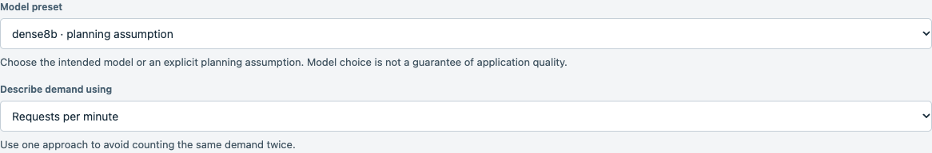
13 | Set Peak requests per minute = 60. Set Model calls per request or job = 1. | 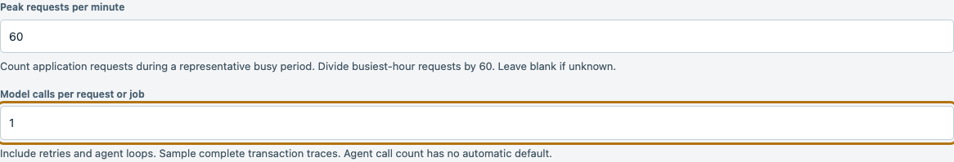
14 | Set Input tokens per model call = 2000. Set Output tokens per model call = 500.
15 | Set Model preset = dense8b. Set Describe demand using = Requests per minute.
16 | Set Peak requests per minute = 300. Set Model calls per request or job = 1.
17 | Set Input tokens per model call = 2000. Set Output tokens per model call = 500.
18 | Confirm [GPU estimate inputs are ready]. Retain the displayed B300 enterprise deployment profile and Sensitivity envelope = ±30%. Check Use these planning assumptions. Click [Calculate estimate].
19 | Read the GPU workload comparison. Expected B300 = 16, B200 = 16, H200 = 16 GPUs. These workload counts are separate from the 256 GPU factory deployment anchor. Click [Export result] to save the calculation.
20 | Click [Continue to Design handoff], then [Prepare projection]. Read the executive summary and download the design intake and companion specification. Unresolved network and storage measurements remain explicit.
21 | Click [Explain this to me]. Set Explanation connection = DeepSeek consultant walkthrough. Check This saved result is public or fictional and may be sent to the selected provider for this fictional exercise. Click [Generate explanation]. The saved calculation cannot be changed by this action. | 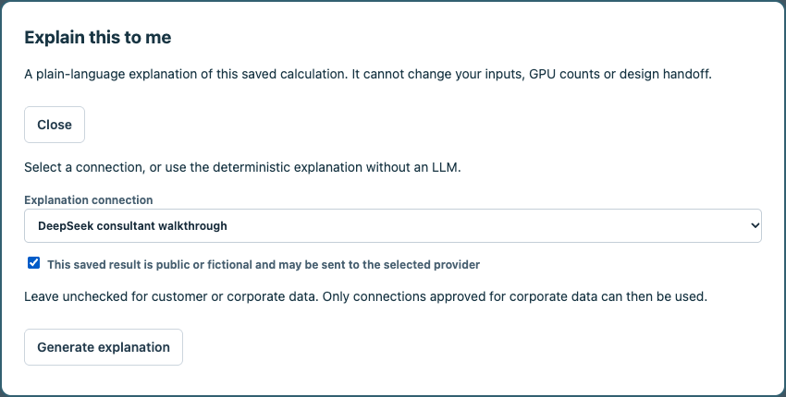
22 | Read the explanation of the workload GPUs, deployment anchor, memory, storage and all network roles. Expand [Source fields and assumptions] to trace the explanation. Click [Download explanation], then [Close]. | 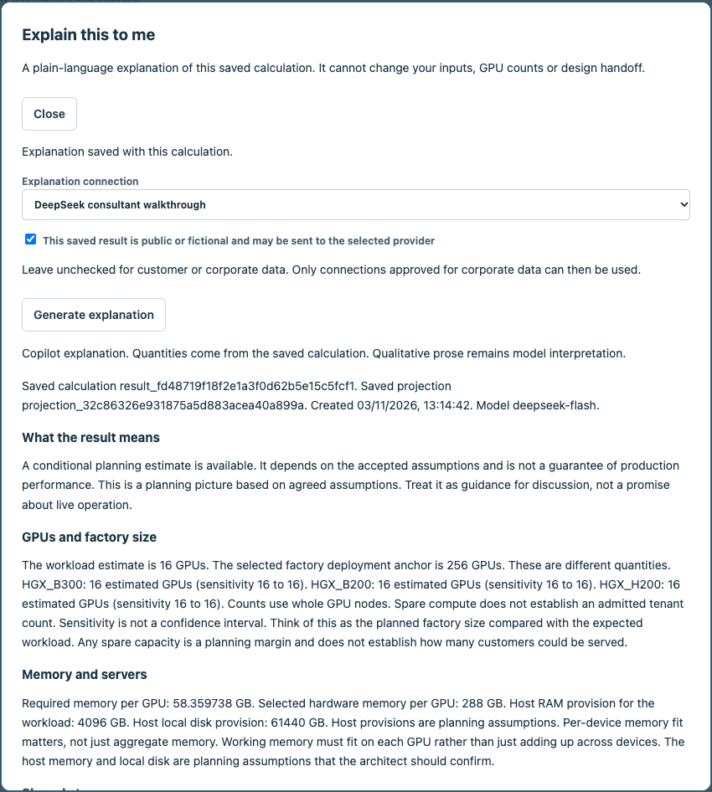
23 | Scroll down within [Explain this to me] to read [Factory networks] and [What to do next]. Expand [Source fields and assumptions] if needed. Click [Download explanation] to save the text. Scroll to the top and click [Close] to continue. | 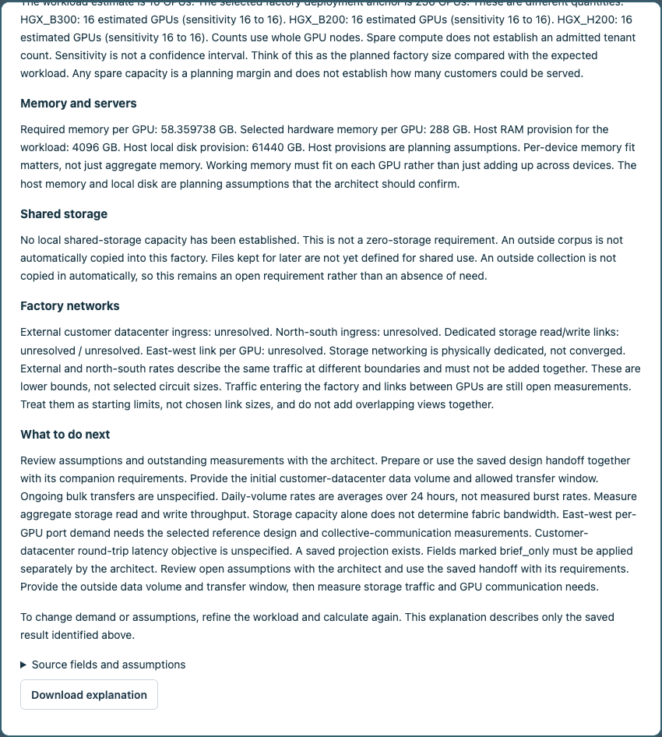
24 | Set Completion notes = Planning requirements and explanation delivered. Outstanding network and storage measurements remain in the companion specification.. Check I confirm that these selected requirements are delivered.. Click [Complete engagement]. | 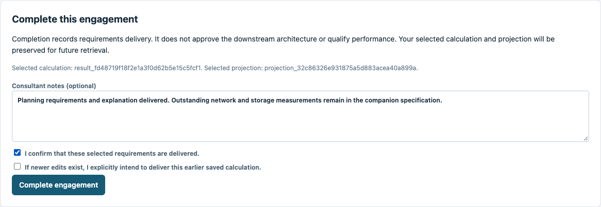
25 | The engagement is complete. Its exact calculation, handoff and explanation remain saved. Use [Cases] to reopen the engagement and [Saved deliverables] to retrieve its documents. | 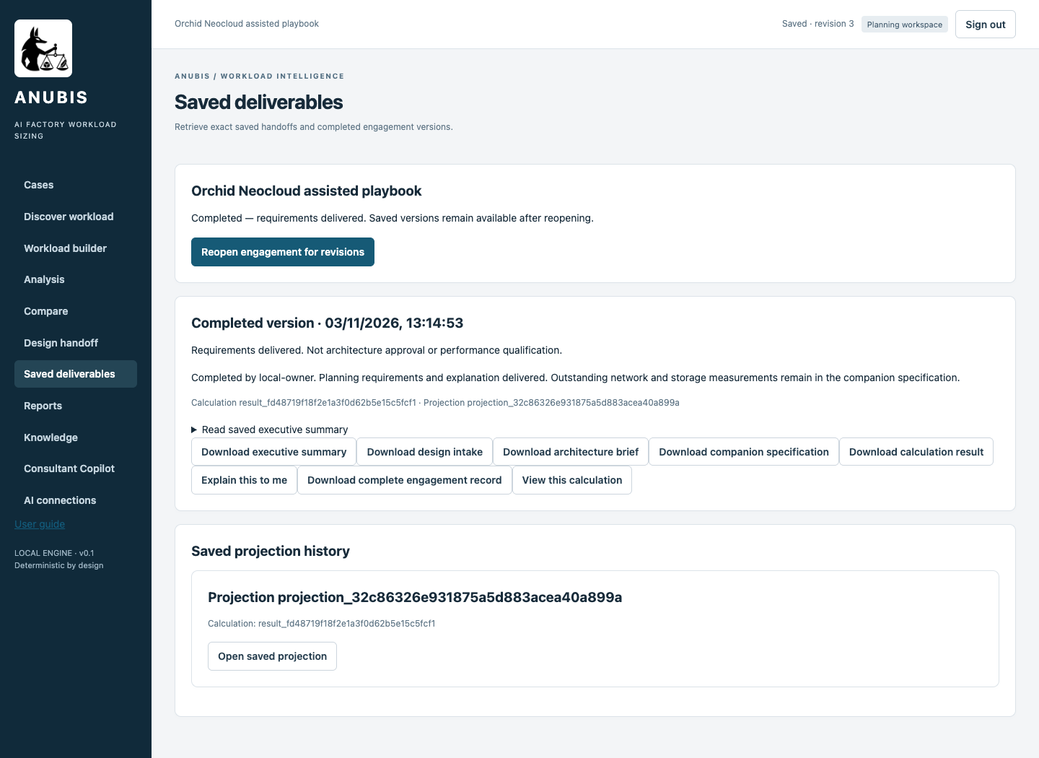

Compare and retrieve the results
Check | Manual route | Copilot assisted route
Workload GPU counts | B300 16, B200 16, H200 16 | B300 16, B200 16, H200 16
Design handoff | Prepared with companion requirements | Prepared with companion requirements
Explanation | Saved deterministic narrative | Saved model-assisted narrative
Completion | Requirements delivered and saved | Requirements delivered and saved
Open the engagement from Cases and select Saved deliverables. Download the saved calculation, intake, brief and companion specification. Explain this to me retrieves narratives associated with that exact result. A later calculation does not update an earlier explanation. Refining demand requires a fresh deterministic calculation.

Appendix Parameter collection guide
ID | Field and meaning | How to obtain or decide it | When unavailable
I01 | Customer workload name  Identifies the two separate saved runs. | Choose the route suffix to avoid mixing results. | Record the unknown or an explicitly accepted assumption. Resolve any field listed by GPU estimate blocked before calculating.
I02 | Factory users  Organisations sharing the factory. | Confirm commercial and organisational scope. Tenancy does not multiply aggregate demand automatically. | Record the unknown or an explicitly accepted assumption. Resolve any field listed by GPU estimate blocked before calculating.
I03 | Do activities run at the same time?  Peak workloads may coincide. | Review schedules and telemetry with the operations owner. | Record the unknown or an explicitly accepted assumption. Resolve any field listed by GPU estimate blocked before calculating.
I04 | Component name  Business activity being sized. Numbered labels follow the order of components in the active route. | Agree a recognisable activity name with the application owner. Use the matching diagram to check its scope. | Record the unknown or an explicitly accepted assumption. Resolve any field listed by GPU estimate blocked before calculating.
I05 | Application pattern  Application behaviour, not a server type. | Walk through a customer task. Identify text serving, retrieval, media processing or solver work. | Record the unknown or an explicitly accepted assumption. Resolve any field listed by GPU estimate blocked before calculating.
I06 | Compute location  Where computation runs relative to this factory. | Confirm the hosting owner and deployment boundary. Outside services do not contribute local model GPUs. | Record the unknown or an explicitly accepted assumption. Resolve any field listed by GPU estimate blocked before calculating.
I07 | Relationship  Order or relationship of activities. This is separate from whether demand overlaps. | Review the business flow with the application owner. Confirm scheduling separately. | Record the unknown or an explicitly accepted assumption. Resolve any field listed by GPU estimate blocked before calculating.
I08 | Model preset  Language-model size and architecture preset. It is not a quality guarantee. | Use the model registry or serving configuration. Record an explicitly accepted assumption when the model has not been selected. | Record the unknown or an explicitly accepted assumption. Resolve any field listed by GPU estimate blocked before calculating.
I09 | Peak requests per minute  Busy-period application requests per minute. | Count application gateway requests by minute in a representative peak. Divide busiest-hour requests by sixty only when that average is an accepted planning basis. | Record the unknown or an explicitly accepted assumption. Resolve any field listed by GPU estimate blocked before calculating.
I10 | Model calls per request or job  Model invocations per complete customer request, including retries. | Inspect distributed transaction traces or model gateway logs. Count calls across the entire request, including agent loops. | Record the unknown or an explicitly accepted assumption. Resolve any field listed by GPU estimate blocked before calculating.
I11 | Input tokens per model call  Prompt, history and retrieved passages sent to a model call. | Read prompt-token metrics from serving logs or tokenize representative full prompts with the exact model tokenizer. | Record the unknown or an explicitly accepted assumption. Resolve any field listed by GPU estimate blocked before calculating.
I12 | Output tokens per model call  Generated response tokens per model call. | Read completion-token metrics or tokenize representative outputs. Choose a planning distribution with the service owner. | Record the unknown or an explicitly accepted assumption. Resolve any field listed by GPU estimate blocked before calculating.
I13 | Reserve dedicated capacity  Whether this activity keeps capacity reserved rather than reusing a pool. | Agree isolation and reservation requirements with the service owner. Tenant count is not automatically a GPU multiplier. | Record the unknown or an explicitly accepted assumption. Resolve any field listed by GPU estimate blocked before calculating.
I14 | Component name  Business activity being sized. Numbered labels follow the order of components in the active route. | Agree a recognisable activity name with the application owner. Use the matching diagram to check its scope. | Record the unknown or an explicitly accepted assumption. Resolve any field listed by GPU estimate blocked before calculating.
I15 | Application pattern  Application behaviour, not a server type. | Walk through a customer task. Identify text serving, retrieval, media processing or solver work. | Record the unknown or an explicitly accepted assumption. Resolve any field listed by GPU estimate blocked before calculating.
I16 | Compute location  Where computation runs relative to this factory. | Confirm the hosting owner and deployment boundary. Outside services do not contribute local model GPUs. | Record the unknown or an explicitly accepted assumption. Resolve any field listed by GPU estimate blocked before calculating.
I17 | Relationship  Order or relationship of activities. This is separate from whether demand overlaps. | Review the business flow with the application owner. Confirm scheduling separately. | Record the unknown or an explicitly accepted assumption. Resolve any field listed by GPU estimate blocked before calculating.
I18 | Model preset  Language-model size and architecture preset. It is not a quality guarantee. | Use the model registry or serving configuration. Record an explicitly accepted assumption when the model has not been selected. | Record the unknown or an explicitly accepted assumption. Resolve any field listed by GPU estimate blocked before calculating.
I19 | Peak requests per minute  Busy-period application requests per minute. | Count application gateway requests by minute in a representative peak. Divide busiest-hour requests by sixty only when that average is an accepted planning basis. | Record the unknown or an explicitly accepted assumption. Resolve any field listed by GPU estimate blocked before calculating.
I20 | Model calls per request or job  Model invocations per complete customer request, including retries. | Inspect distributed transaction traces or model gateway logs. Count calls across the entire request, including agent loops. | Record the unknown or an explicitly accepted assumption. Resolve any field listed by GPU estimate blocked before calculating.
I21 | Input tokens per model call  Prompt, history and retrieved passages sent to a model call. | Read prompt-token metrics from serving logs or tokenize representative full prompts with the exact model tokenizer. | Record the unknown or an explicitly accepted assumption. Resolve any field listed by GPU estimate blocked before calculating.
I22 | Output tokens per model call  Generated response tokens per model call. | Read completion-token metrics or tokenize representative outputs. Choose a planning distribution with the service owner. | Record the unknown or an explicitly accepted assumption. Resolve any field listed by GPU estimate blocked before calculating.
I23 | Infrastructure deployment profile  Selects factory anchors rather than workload demand. | Architect selects a compatible catalogue profile. | Record the unknown or an explicitly accepted assumption. Resolve any field listed by GPU estimate blocked before calculating.
I24 | Sensitivity envelope  Explores faster and slower throughput assumptions. | Choose the agreed planning sensitivity. It is not a confidence interval. | Record the unknown or an explicitly accepted assumption. Resolve any field listed by GPU estimate blocked before calculating.
I25 | Use these planning assumptions  Accepts the displayed planning defaults. | Review defaults before calculating. | Record the unknown or an explicitly accepted assumption. Resolve any field listed by GPU estimate blocked before calculating.
I26 | Locally retained data in TB / Daily growth in GB  No local shared-storage amount is established. Blank is not zero. | Inventory actual local retained copies. Do not copy an outside corpus into this value. | Record the unknown or an explicitly accepted assumption. Resolve any field listed by GPU estimate blocked before calculating.
I27 | Initial dataset to load in TB / Initial loading window in hours  Initial transfer scope and time remain unresolved. | Obtain transfer volume and the allowed window from the data owner. | Record the unknown or an explicitly accepted assumption. Resolve any field listed by GPU estimate blocked before calculating.
I28 | Ongoing incoming / outgoing data in GB per day  Bulk daily transfer volumes remain unspecified. | Measure ingress and egress counters separately from model token traffic. | Record the unknown or an explicitly accepted assumption. Resolve any field listed by GPU estimate blocked before calculating.
I29 | Aggregate storage reads / writes in Gbps  Dedicated storage fabric throughput remains unresolved. | Measure directional read and write payload peaks. Capacity alone cannot determine bandwidth. | Record the unknown or an explicitly accepted assumption. Resolve any field listed by GPU estimate blocked before calculating.
I30 | East-west payload per GPU in Gbps / Customer datacenter round-trip target in ms  Collective traffic and latency objective remain unresolved. | Use GPU communication telemetry and an agreed RTT objective. | Record the unknown or an explicitly accepted assumption. Resolve any field listed by GPU estimate blocked before calculating.
I31 | Usable link fraction / Initial loading overlap  Accepted network defaults. Storage networking is physically dedicated. | Review usable bandwidth and whether loading coincides with normal operation. | Record the unknown or an explicitly accepted assumption. Resolve any field listed by GPU estimate blocked before calculating.
I32 | Explanation connection  Chooses prose generation without changing the calculation. | Configure an approved provider in AI connections. Backend credentials stay on the server. | Record the unknown or an explicitly accepted assumption. Resolve any field listed by GPU estimate blocked before calculating.
I33 | This saved result is public or fictional and may be sent to the selected provider  Permission to send the saved explanation packet to the chosen connection. | Leave unchecked for corporate data and select a connection approved for that data. | Record the unknown or an explicitly accepted assumption. Resolve any field listed by GPU estimate blocked before calculating.

Appendix Placement and explanation boundaries
Term | Meaning and concrete examples
Outside this AI Factory | Compute, search or storage beyond the capacity being designed. Examples include a customer GPU cluster, managed model API, customer datacenter search cluster, cloud search platform or an existing object store. It does not necessarily mean public Internet or a different site.
Source corpus and index | Original documents and the searchable index have separate storage and compute footprints. Examples include an NFS or SMB share, object storage, SharePoint and an OpenSearch index. Outside data is not automatically a local retained copy or initial transfer volume.
Model explanation | The LLM explains a saved result using a read-only packet. Numeric facts are inserted by the server. Invalid or unavailable model responses fall back to deterministic text. Qualitative prose remains interpretation, not a new engineering decision.
Reference capacity | Specialist counts use the exact per-hardware throughput and memory assumptions in the register. The example values are fictional planning assumptions. A complete independent group can be replicated. No linear scaling of a single larger job is inferred.
Validation scope | Both GUI routes were executed against the application and checked for matching GPU comparisons and saved handoffs. This validates the software workflow. It does not qualify real hardware performance, model quality, latency or live-provider reliability for every future request.

