Anubis Nacre Customer Portal playbook
Manual and Copilot assisted workload characterisation
Use either route to describe the same application, inspect its scope and save a final status report. This scenario does not contain enough evidence for a complete GPU sizing or design handoff. Successful use means preserving that limitation and recording the measurements needed next.
Reading this guide: Field label = Value to select or enter. [Button or expandable section]. Unchecked / blank describes a setting. Other text explains why.

The customer application
A portal sends all language-model calls to an external provider. It handles 900,000 requests per day. The proposed factory hosts customer data and integration services, not the model. The customer asks whether this requires local GPUs.

Workflow input register
ID | UI field | Definition and scope | Value or action | Basis
I01 | Customer workload name | Business name identifying this engagement and its saved results. | Nacre Customer Portal — manual playbook / Nacre Customer Portal — assisted playbook | Entered separately for each route
I02 | Application pattern | A recognisable application activity, not a server or individual microservice. Repeated patterns represent distinct demand groups. | Direct model service | Selected from scenario
I03 | Factory users | Whether the factory serves one organisation or multiple tenants. This is not the number of individual users. | One organisation | Scenario fixture arrangement
I04 | Do activities run at the same time? | Whether separate application activities may consume capacity during the same operating window. | Yes — overlapping demand | Scenario fixture arrangement
I05 | Component name 1 | Name of the selected application activity added to the workload. It is not a GPU or physical server. | Hosted text service | Scenario fixture arrangement
I06 | Compute location 1 | Where that activity executes relative to this factory. Each added activity has its own location. An application can combine a factory-hosted model with processing on a customer cluster or cloud API. | Outside this AI Factory (customer cluster or cloud API) | Scenario fixture arrangement
I07 | Reserve dedicated capacity 1 | Whether this activity must keep its own compute allocation instead of reusing capacity across separate operating windows. | Unchecked | Scenario fixture arrangement
I08 | Locally retained data in TB | Logical data retained inside this AI Factory. The guided MVP maps this to shared object storage. It is separate from GPU-server local disks. An outside corpus is excluded unless a local copy is required. | Blank for each activity | Unresolved
I09 | Daily growth in GB | Net additional retained data per day inside the factory. This is different from total traffic or repeatedly read data. | Blank for each activity | Unresolved
I10 | Planning horizon in days | Number of days over which retained-data growth is accumulated for capacity planning. | Blank uses 365 | Default
I11 | Initial dataset to load in TB | Volume to transfer from customer systems into this factory at initial loading. A remote repository’s total size is not automatically the transfer volume. | Blank | Unresolved
I12 | Initial loading window in hours | Time allowed to complete the declared initial data transfer. | Blank | Unresolved
I13 | Ongoing incoming data in GB per day | Additional bulk data entering the factory each day, beyond model-request traffic. | Blank | Unresolved
I14 | Ongoing outgoing data in GB per day | Additional bulk exports leaving the factory each day, beyond model-response traffic. | Blank | Unresolved
I15 | Usable link fraction | Planning share of nominal link capacity available to carry the accounted traffic. A value of 0.7 means 70 percent. | Blank uses 0.7 | Default
I16 | Customer datacenter round-trip target in ms | Desired network round-trip time between customer datacenter and factory boundaries. This is not model response time. | Blank | Unresolved
I17 | Aggregate storage reads in Gbps | Combined peak read payload carried by the dedicated storage network. This is a throughput requirement, not storage capacity. | Blank | Unresolved
I18 | Aggregate storage writes in Gbps | Combined peak write payload, including overlapping initial loading, ingestion and checkpoints when applicable. | Blank | Unresolved
I19 | East-west payload per GPU in Gbps | GPU-to-GPU communication demand attributed to each GPU on the compute fabric. It is not a selected NIC speed. | Blank | Unresolved
I20 | Does initial loading overlap normal operation? | Whether the initial transfer and normal traffic occur concurrently. This controls addition versus separate-window comparison. | Yes — add the demands | Default
I21 | Customer context and measurement notes | Plain-language scope decisions, measurement sources, assumptions and unresolved questions attached to the workload. | A portal sends all language-model calls to an external provider. It handles 900,000 requests per day. The proposed factory hosts customer data and integration services, not the model. The customer asks whether this requires local GPUs. Next measurement: Measure request/response bytes, data storage and locally executed supporting services. | Entered in manual route
I22 | Infrastructure deployment profile | Catalogue hardware and deployment anchor family. It does not describe the customer application. | HGX B300 GPUs · Spectrum-X network · Enterprise reference design with two network planes | Default
I23 | Sensitivity envelope | Starting throughput sensitivity envelope. Not a statistical confidence interval. | ±30% | Default
I24 | Use these planning assumptions | Allows deterministic evaluation of the supplied facts and displayed defaults. | Checked | Explicit review
I25 | Data classification | Whether this information is approved for the configured model provider. | Public — permitted for direct provider processing | Selected for fictional story
I26 | Model connection | Configured backend model service. Provider credentials are not workload inputs. | DeepSeek Flash — low reasoning (pilot) | Selected for captured run
I27 | What should we know about the workload? | Scenario text supplied for interpretation. Its quantities retain their original time and placement boundaries. | A portal sends all language-model calls to an external provider. It handles 900,000 requests per day. The proposed factory hosts customer data and integration services, not the model. The customer asks whether this requires local GPUs. Activity Hosted text service has compute outside this AI Factory and shared capacity. Activities may overlap. This is one organisation. Do not invent model choices, peak rates, token sizes or hardware counts. Keep unprovided measurements unknown. Measure request/response bytes, data storage and locally executed supporting services. | Entered in Copilot route
I28 | I reviewed the selected values and accept the planning assumptions. | Permits applying the proposed fact ledger. It is not a performance qualification. | Checked after factual review | Consultant review
I29 | Reason for concluding now | Reason the investigation is closing now and the evidence needed next. | Measure request/response bytes, data storage and locally executed supporting services. No complete GPU sizing or design handoff is claimed. | Entered in both routes
I30 | I confirm closure with a status report, without delivering a design handoff. | Records report-only closure. No design projection is asserted. | Checked | Explicit confirmation

Your route through the application
Choose application → confirm placement and arrangement → describe available scale → evaluate requirements → review limitations → close with final status report → retrieve saved work. Copilot proposes the description. The consultant reviews it before the same deterministic evaluation.
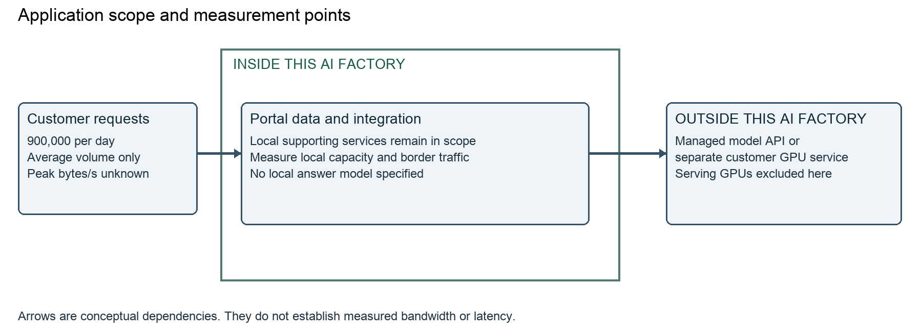
The arrows show conceptual dependencies, not measured throughput or latency. Never recommend local model GPUs merely because the application uses AI.

Start Anubis and obtain your access token
Complete the Mac installation guide at docs/macos-installation-guide.txt. In Terminal, change to the Anubis folder and run python3 deploy/local/run.py. Leave the terminal running. The first launch creates a private .anubis/identities.json file automatically.
In a second Terminal window in the same folder, run open -a TextEdit .anubis/identities.json. Find the local-owner entry. Copy only the token value, without quotation marks. Open http://127.0.0.1:8787, paste it into Access token and click [Open workspace]. Never include a token in a story or screenshot.
Saved cases and closure records reside in .anubis/anubis.sqlite. Restart from the same installation to reuse your history and token. A fresh checkout uses a separate database. Preserve .anubis and follow the installation guide for verified backup and recovery.
For Copilot, first configure an approved connection in [AI connections] using docs/copilot-operation.txt. Store the provider key on the backend. Enter its environment-variable name in the profile, not the key. Run the connection test. The captured run used DeepSeek Flash — low reasoning (pilot) with deepseek-flash. Other models can phrase questions differently.

Manual route step 1
Step | Activity and values | Screen reference
1 | Start Anubis with python3 deploy/local/run.py. Open http://127.0.0.1:8787. Obtain your token from .anubis/identities.json as explained in the access section. Paste it into Access token and click [Open workspace]. | 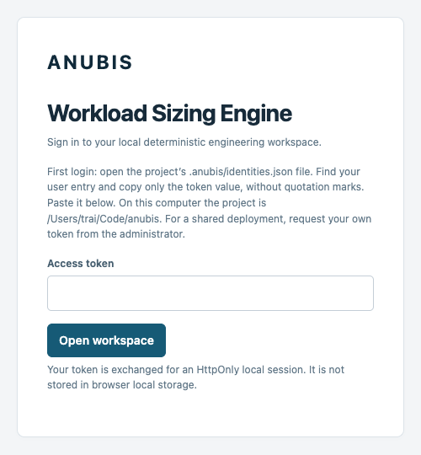
Review □ Clear □ Hesitated □ Needed help □ Blocked Notes __________________________________

Manual route step 2
Step | Activity and values | Screen reference
2 | Click [New engagement]. Set Customer workload name = Nacre Customer Portal — manual playbook. Click [Add Direct model service]. Add each listed activity once, including repeated patterns. Then click [Continue]. | 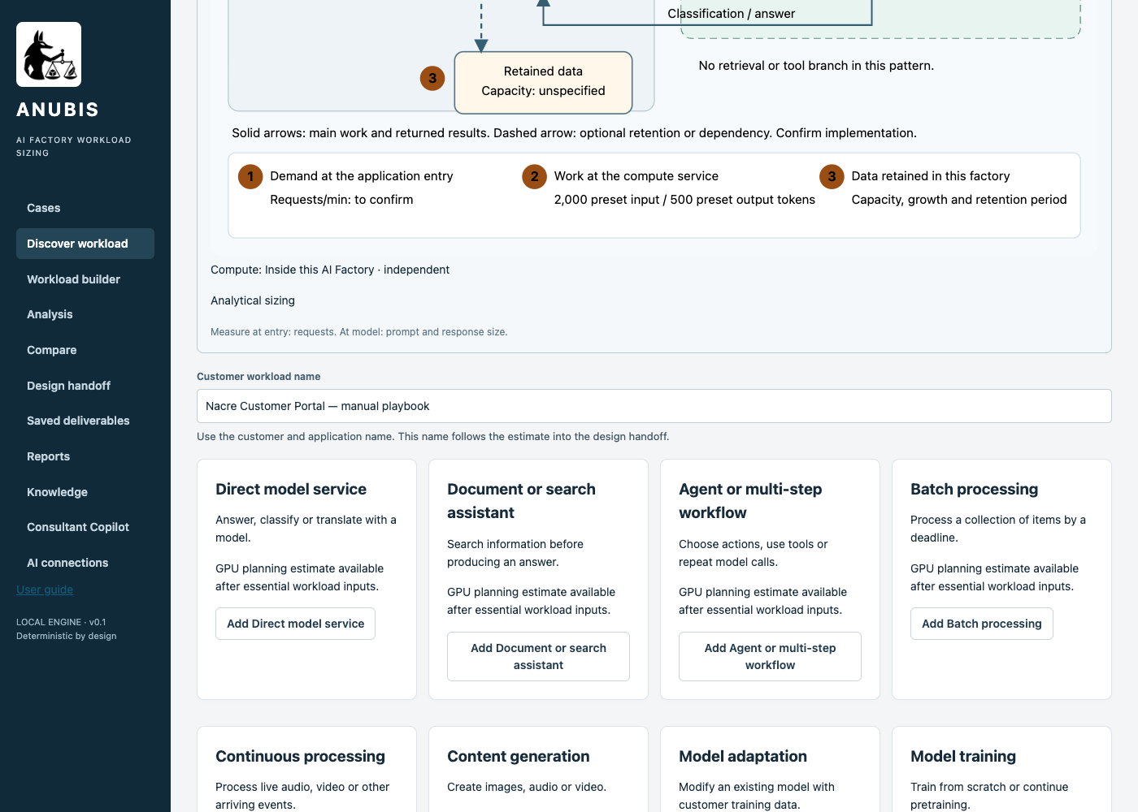
Review □ Clear □ Hesitated □ Needed help □ Blocked Notes __________________________________

Manual route step 3
Step | Activity and values | Screen reference
3 | Set Factory users = One organisation. Set Do activities run at the same time? = Yes — overlapping demand.
Review □ Clear □ Hesitated □ Needed help □ Blocked Notes __________________________________

Manual route step 4
Step | Activity and values | Screen reference
4 | Set Component name 1 = Hosted text service. Set Compute location 1 = Outside this AI Factory (customer cluster or cloud API). Leave or set Reserve dedicated capacity 1 unchecked. | 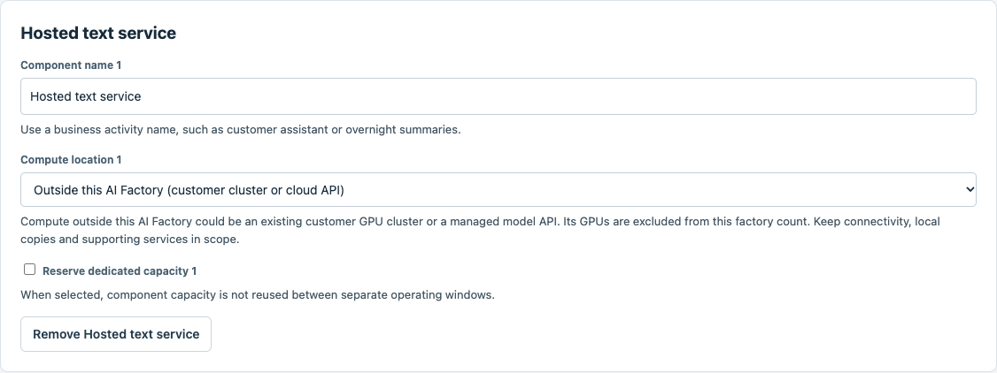
Review □ Clear □ Hesitated □ Needed help □ Blocked Notes __________________________________

Manual route step 5
Step | Activity and values | Screen reference
5 | Select the [Hosted text service] activity in the architecture map. Leave unmeasured numerical fields blank. Read the scope message. Do not substitute text-token assumptions for specialist or outside compute. | 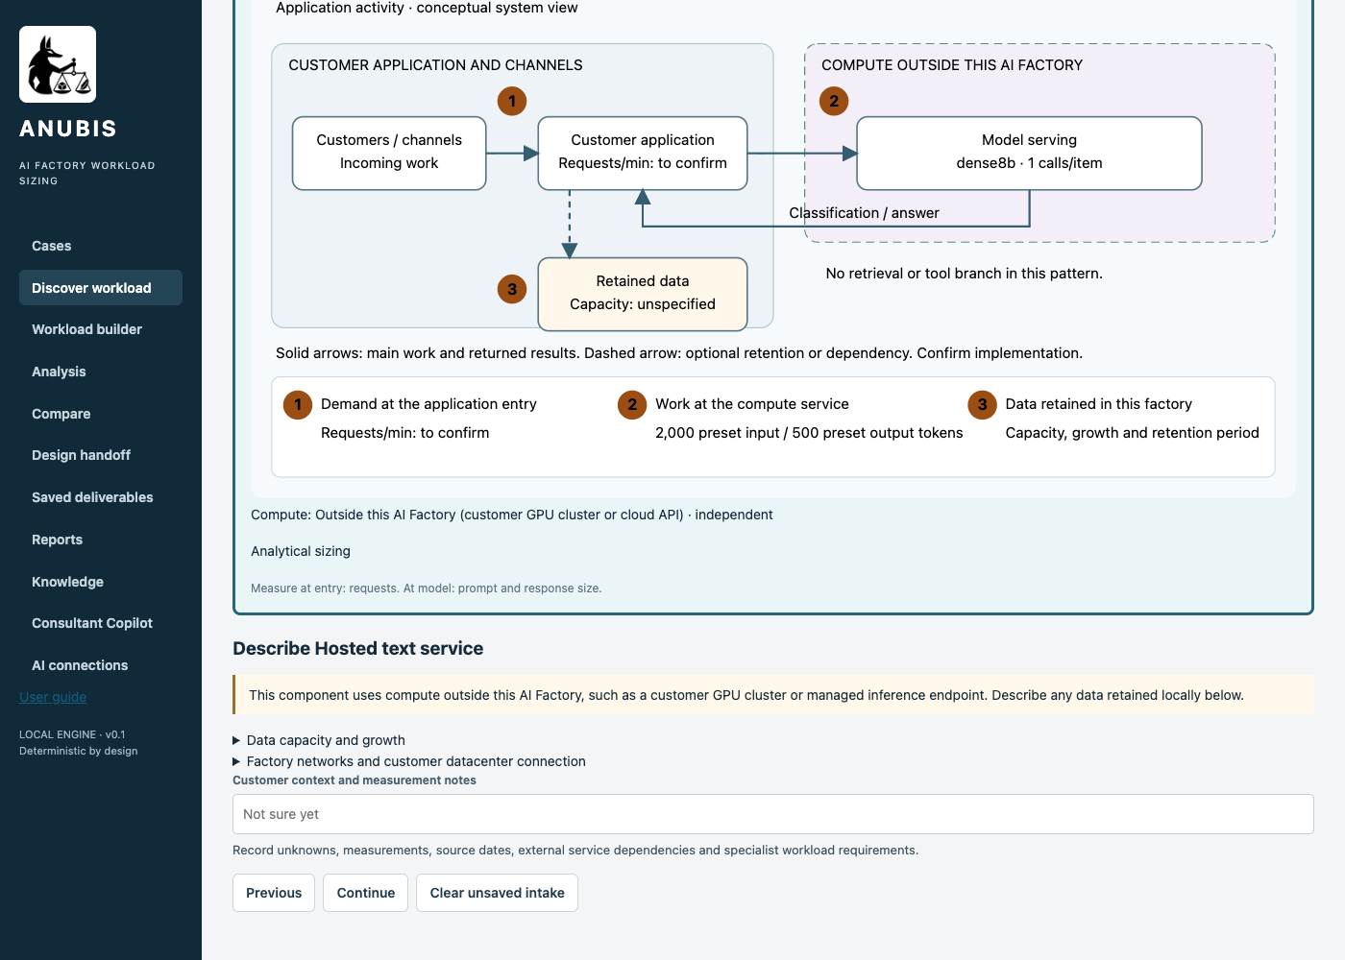
Review □ Clear □ Hesitated □ Needed help □ Blocked Notes __________________________________

Manual route step 6
Step | Activity and values | Screen reference
6 | Expand [Data capacity and growth]. Leave Locally retained data in TB, Daily growth in GB and Planning horizon in days blank. The horizon uses 365 days. No retained capacity or growth is invented. | 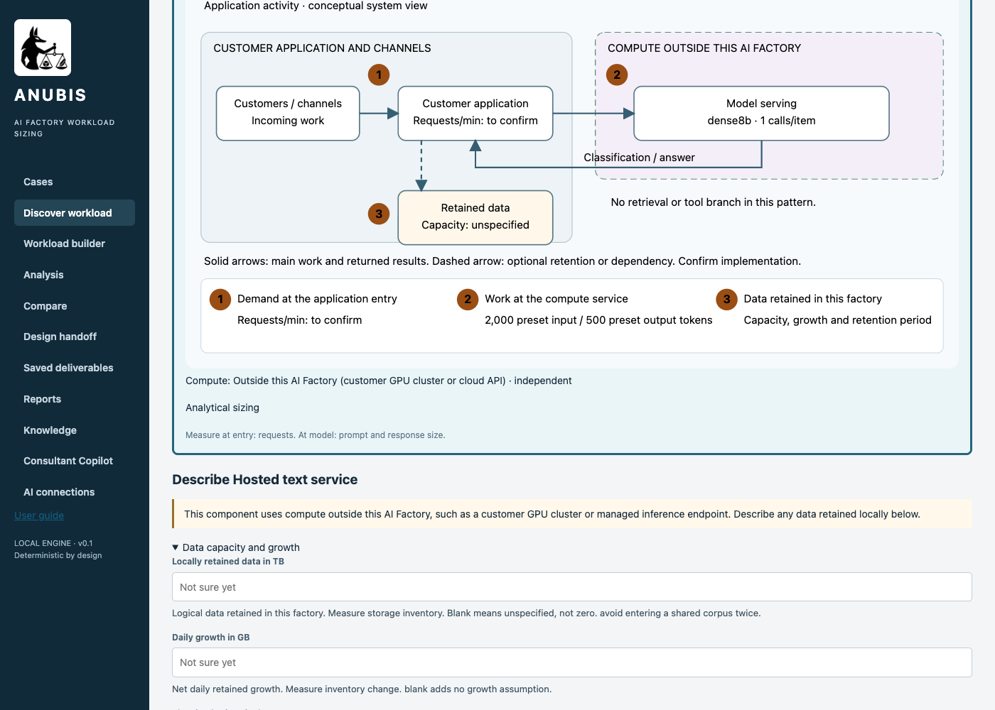
Review □ Clear □ Hesitated □ Needed help □ Blocked Notes __________________________________

Manual route step 7
Step | Activity and values | Screen reference
7 | Expand [Factory networks and customer datacenter connection]. Leave Initial dataset to load in TB, Initial loading window in hours, Ongoing incoming data in GB per day and Ongoing outgoing data in GB per day blank. A customer repository is not automatically an initial transfer. | 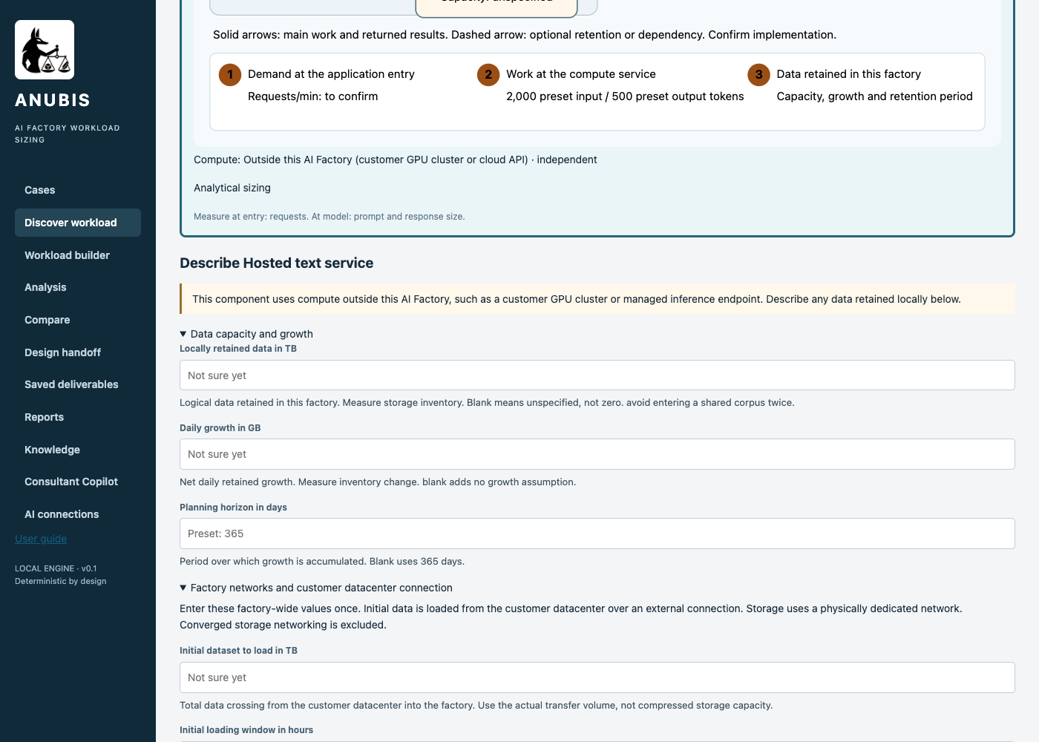
Review □ Clear □ Hesitated □ Needed help □ Blocked Notes __________________________________

Manual route step 8
Step | Activity and values | Screen reference
8 | Leave Usable link fraction blank to use 0.7. Leave Customer datacenter round-trip target in ms, Aggregate storage reads in Gbps, Aggregate storage writes in Gbps and East-west payload per GPU in Gbps blank. Keep Does initial loading overlap normal operation? = Yes — add the demands. | 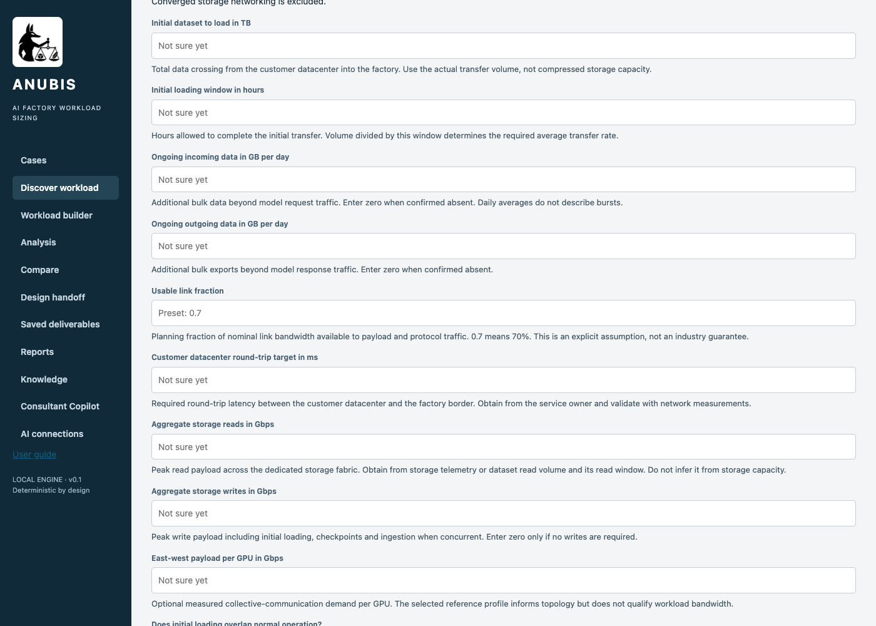
Review □ Clear □ Hesitated □ Needed help □ Blocked Notes __________________________________

Manual route step 9
Step | Activity and values | Screen reference
9 | Set Customer context and measurement notes = A portal sends all language-model calls to an external provider. It handles 900,000 requests per day. The proposed factory hosts customer data and integration services, not the model. The customer asks whether this requires local GPUs. Next measurement: Measure request/response bytes, data storage and locally executed supporting services. Leave local storage and all network measurement fields blank. Click [Continue]. | 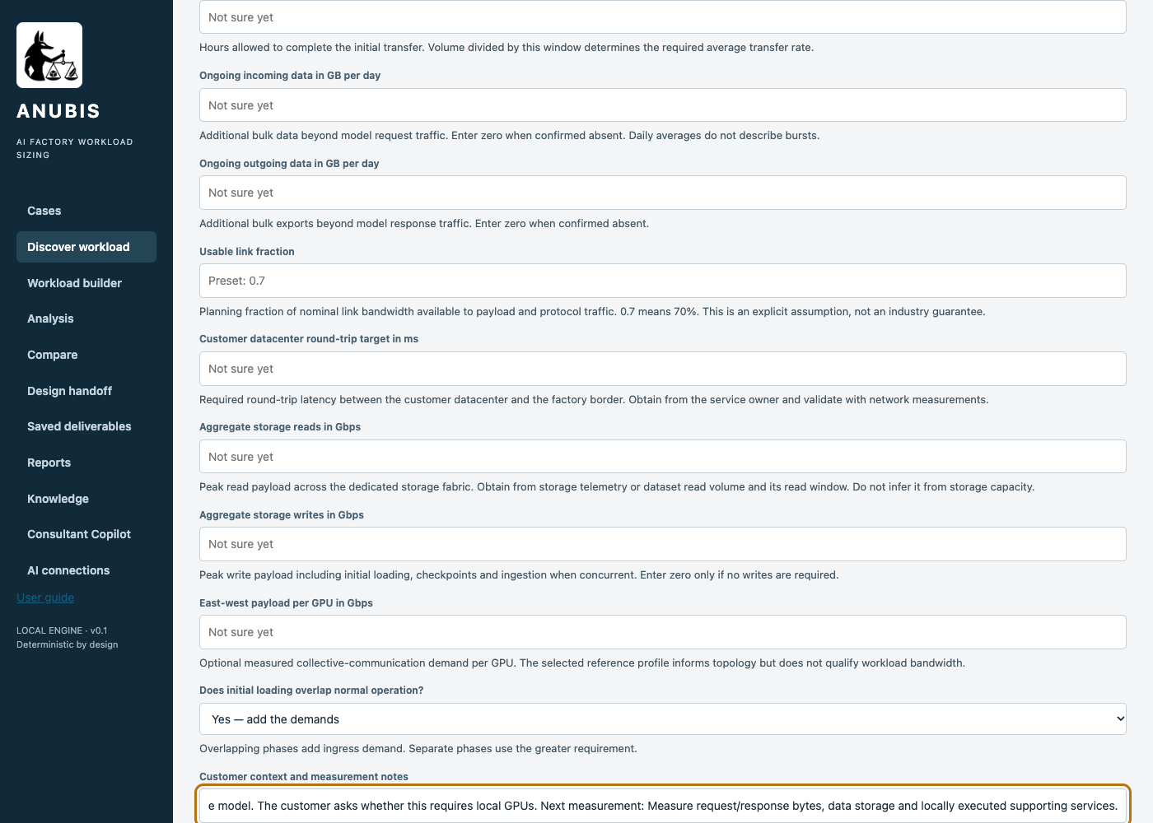
Review □ Clear □ Hesitated □ Needed help □ Blocked Notes __________________________________

Manual route step 10
Step | Activity and values | Screen reference
10 | Review the architecture and unresolved measurements. Retain the deployment profile and ±30% sensitivity default. Check Use these planning assumptions to evaluate the available information. Click [Calculate estimate]. Acceptance does not fill missing measurements. | 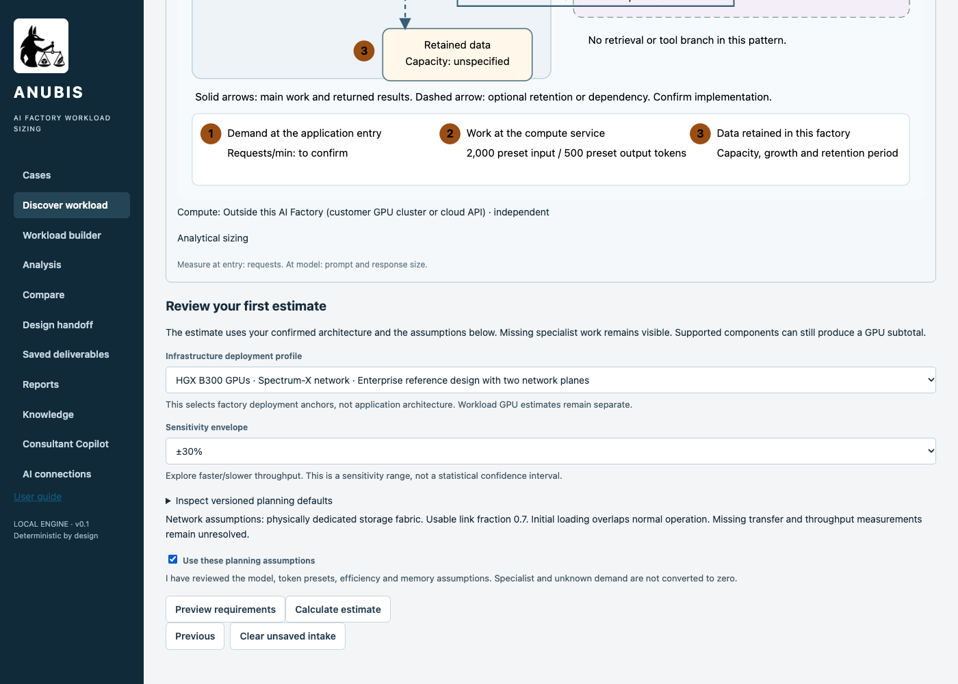
Review □ Clear □ Hesitated □ Needed help □ Blocked Notes __________________________________

Manual route step 11
Step | Activity and values | Screen reference
11 | Read [Your requirements at a glance]. A complete GPU recommendation is not established for the supplied information. Do not interpret missing counts as zero. Click [Export result] to preserve the analysis. | 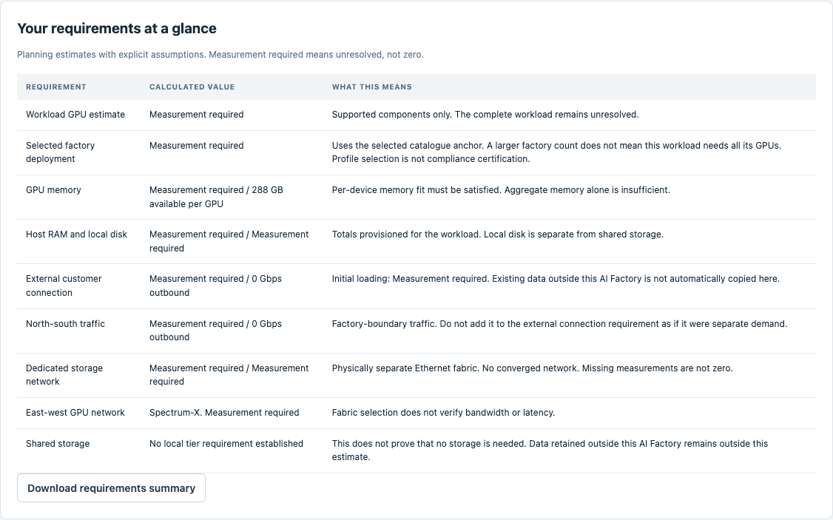
Review □ Clear □ Hesitated □ Needed help □ Blocked Notes __________________________________

Manual route step 12
Step | Activity and values | Screen reference
12 | Review the system map. Each box represents an application activity. The factory boundary distinguishes local work from outside services. | 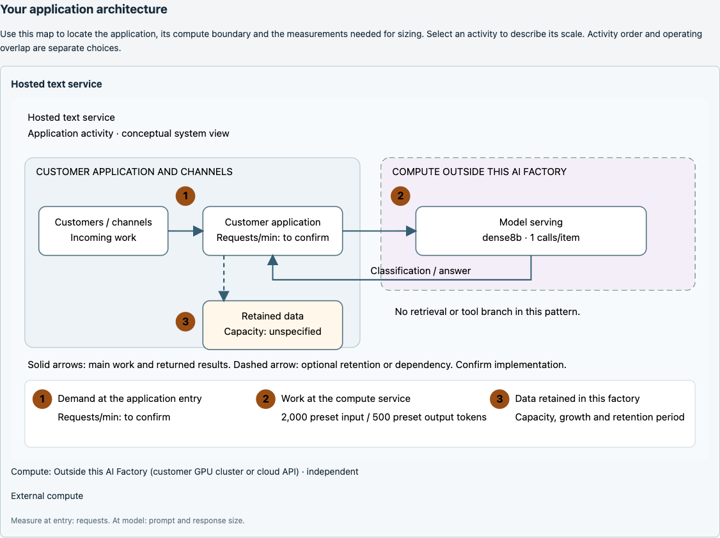
Review □ Clear □ Hesitated □ Needed help □ Blocked Notes __________________________________

Manual route step 13
Step | Activity and values | Screen reference
13 | Click [Continue to Design handoff] when available, or [4. Design handoff]. No resolved candidate means no design projection. Continue with a final status report. | 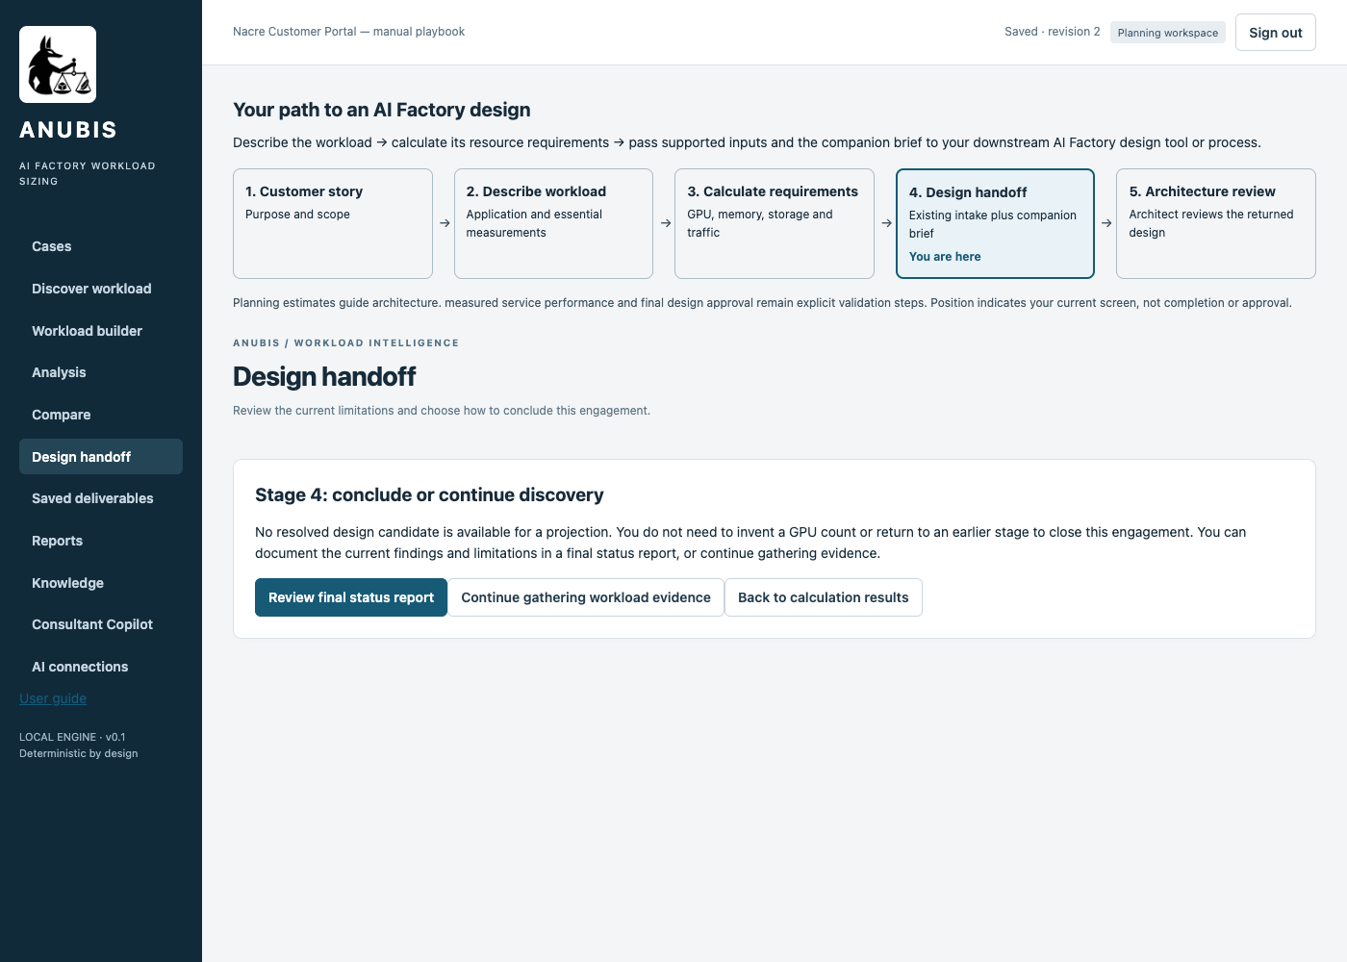
Review □ Clear □ Hesitated □ Needed help □ Blocked Notes __________________________________

Manual route step 14
Step | Activity and values | Screen reference
14 | Click [Review final status report]. Read the findings and missing evidence. This closes the current investigation without claiming a design handoff. | 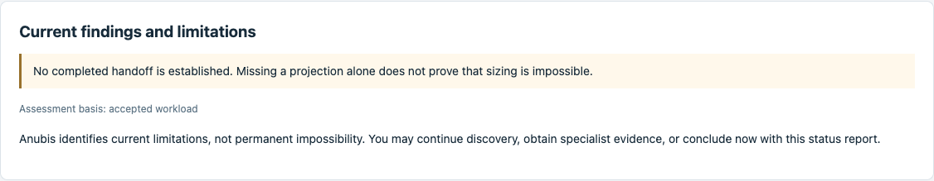
Review □ Clear □ Hesitated □ Needed help □ Blocked Notes __________________________________

Manual route step 15
Step | Activity and values | Screen reference
15 | Set Reason for concluding now = Measure request/response bytes, data storage and locally executed supporting services. No complete GPU sizing or design handoff is claimed. Check I confirm closure with a status report, without delivering a design handoff. Click [Close with final status report]. | 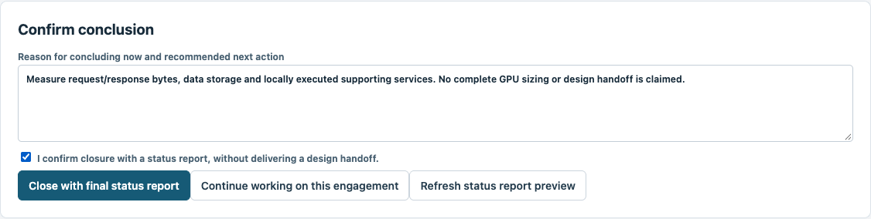
Review □ Clear □ Hesitated □ Needed help □ Blocked Notes __________________________________

Manual route step 16
Step | Activity and values | Screen reference
16 | Click [Download final status report] and [Download complete closure record] to keep the findings. The engagement is closed without a handoff. | 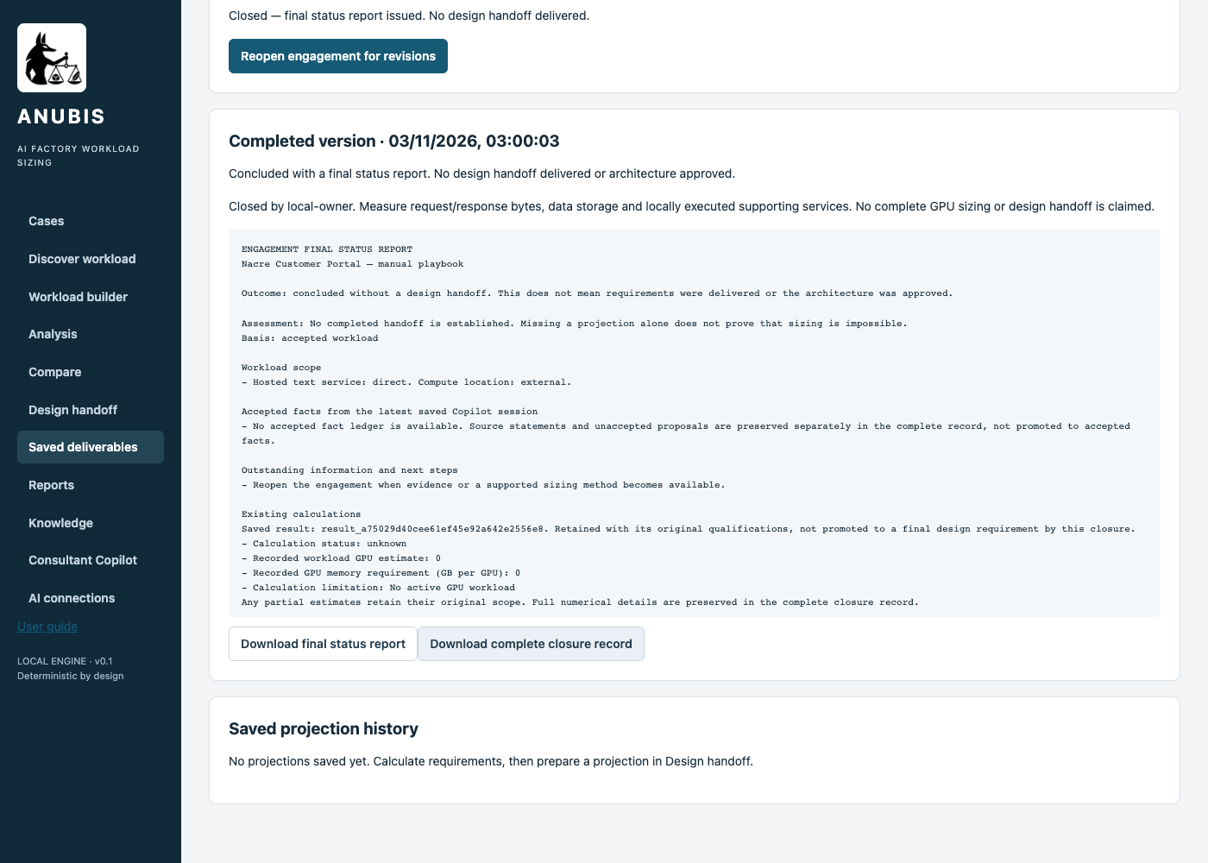
Review □ Clear □ Hesitated □ Needed help □ Blocked Notes __________________________________

Manual route step 17
Step | Activity and values | Screen reference
17 | To retrieve this work later, click [Cases], find Nacre Customer Portal — manual playbook and click [View engagement]. Saved deliverables remain available after a page reload. | 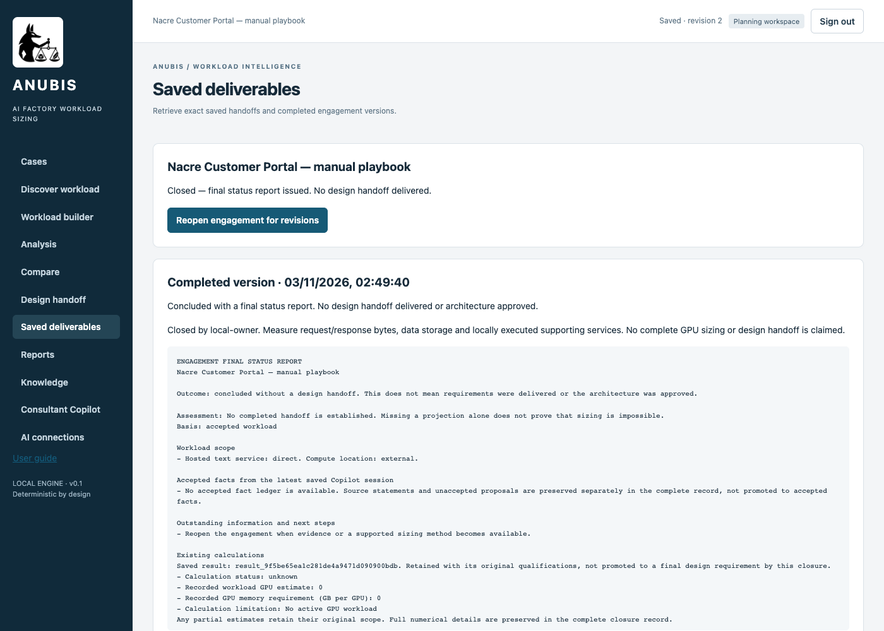
Review □ Clear □ Hesitated □ Needed help □ Blocked Notes __________________________________

Copilot description to enter
Use this full description in What should we know about the workload?. It adds the arrangement already specified in the scenario fixture, without adding numeric measurements.
A portal sends all language-model calls to an external provider. It handles 900,000 requests per day. The proposed factory hosts customer data and integration services, not the model. The customer asks whether this requires local GPUs. Activity Hosted text service has compute outside this AI Factory and shared capacity. Activities may overlap. This is one organisation. Do not invent model choices, peak rates, token sizes or hardware counts. Keep unprovided measurements unknown. Measure request/response bytes, data storage and locally executed supporting services.
Review before applying: Never recommend local model GPUs merely because the application uses AI. Measure request/response bytes, data storage and locally executed supporting services. No default should be presented as a measurement.

Copilot assisted route step 1
Step | Activity and values | Screen reference
1 | Start Anubis with python3 deploy/local/run.py. Open http://127.0.0.1:8787. Obtain your token from .anubis/identities.json as explained in the access section. Paste it into Access token and click [Open workspace].
Review □ Clear □ Hesitated □ Needed help □ Blocked Notes __________________________________

Copilot assisted route step 2
Step | Activity and values | Screen reference
2 | Click [Consultant Copilot]. If an old engagement is displayed, click [Start a new assisted engagement]. Set Customer workload name = Nacre Customer Portal — assisted playbook. Set Data classification = Public — permitted for direct provider processing. Click [Start assisted engagement]. | 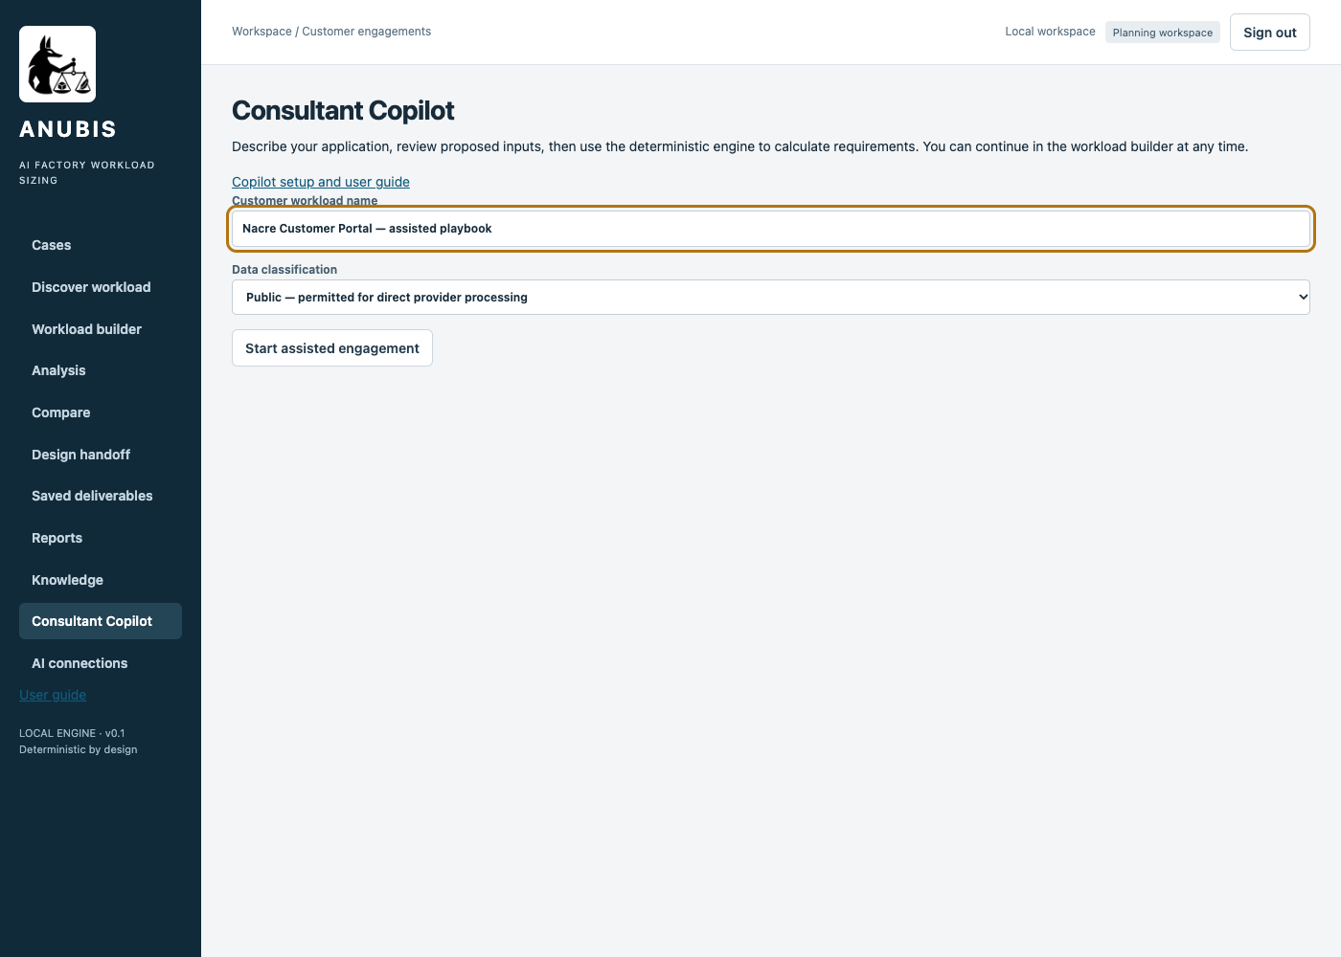
Review □ Clear □ Hesitated □ Needed help □ Blocked Notes __________________________________

Copilot assisted route step 3
Step | Activity and values | Screen reference
3 | Select an approved Model connection. This run uses DeepSeek Flash — low reasoning (pilot). Set What should we know about the workload? = A portal sends all language-model calls to an external provider. It handles 900,000 requests per day. The proposed factory hosts customer data and integration services, not the model. The customer asks whether this requires local GPUs. Activity Hosted text service has compute outside this AI Factory and shared capacity. Activities may overlap. This is one organisation. Do not invent model choices, peak rates, token sizes or hardware counts. Keep unprovided measurements unknown. Measure request/response bytes, data storage and locally executed supporting services. Click [Ask copilot]. | 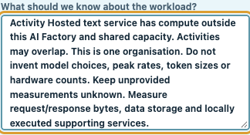
Review □ Clear □ Hesitated □ Needed help □ Blocked Notes __________________________________

Copilot assisted route step 4
Step | Activity and values | Screen reference
4 | The active status indicator means interpretation is still running. Wait for a proposal or a clear error. Do not start duplicate requests. | 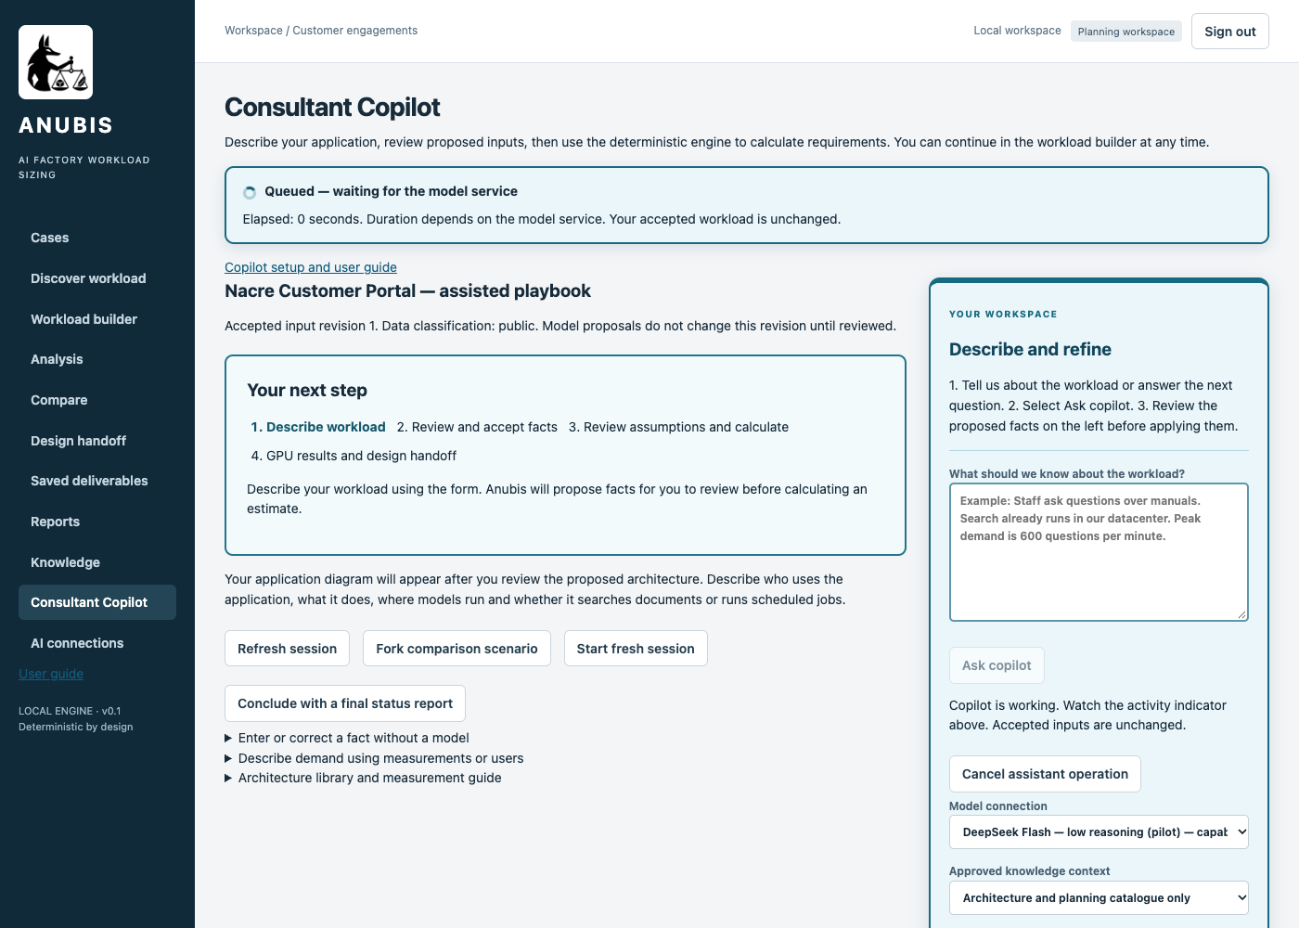
Review □ Clear □ Hesitated □ Needed help □ Blocked Notes __________________________________

Copilot assisted route step 5
Step | Activity and values | Screen reference
5 | If no proposal appears and the provider reports a connection failure, no facts have been accepted. Review the error. The following retry steps apply only to that failure. If your first call succeeds, proceed directly to fact review. | 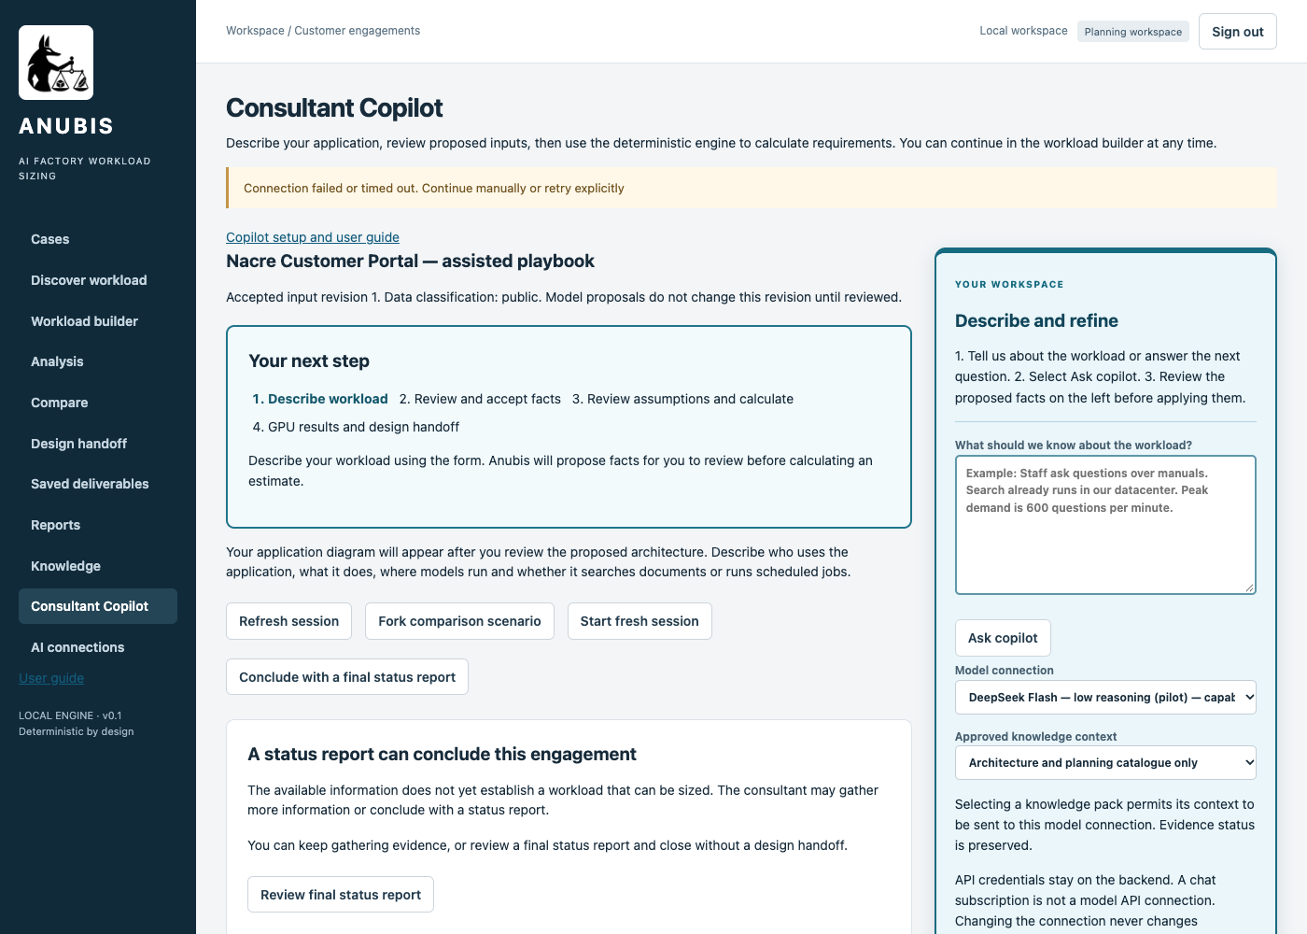
Review □ Clear □ Hesitated □ Needed help □ Blocked Notes __________________________________

Copilot assisted route step 6
Step | Activity and values | Screen reference
6 | If the provider reports a connection failure, verify your connection and retry explicitly with the same description. Click [Ask copilot] once. A retry is a new provider call. | 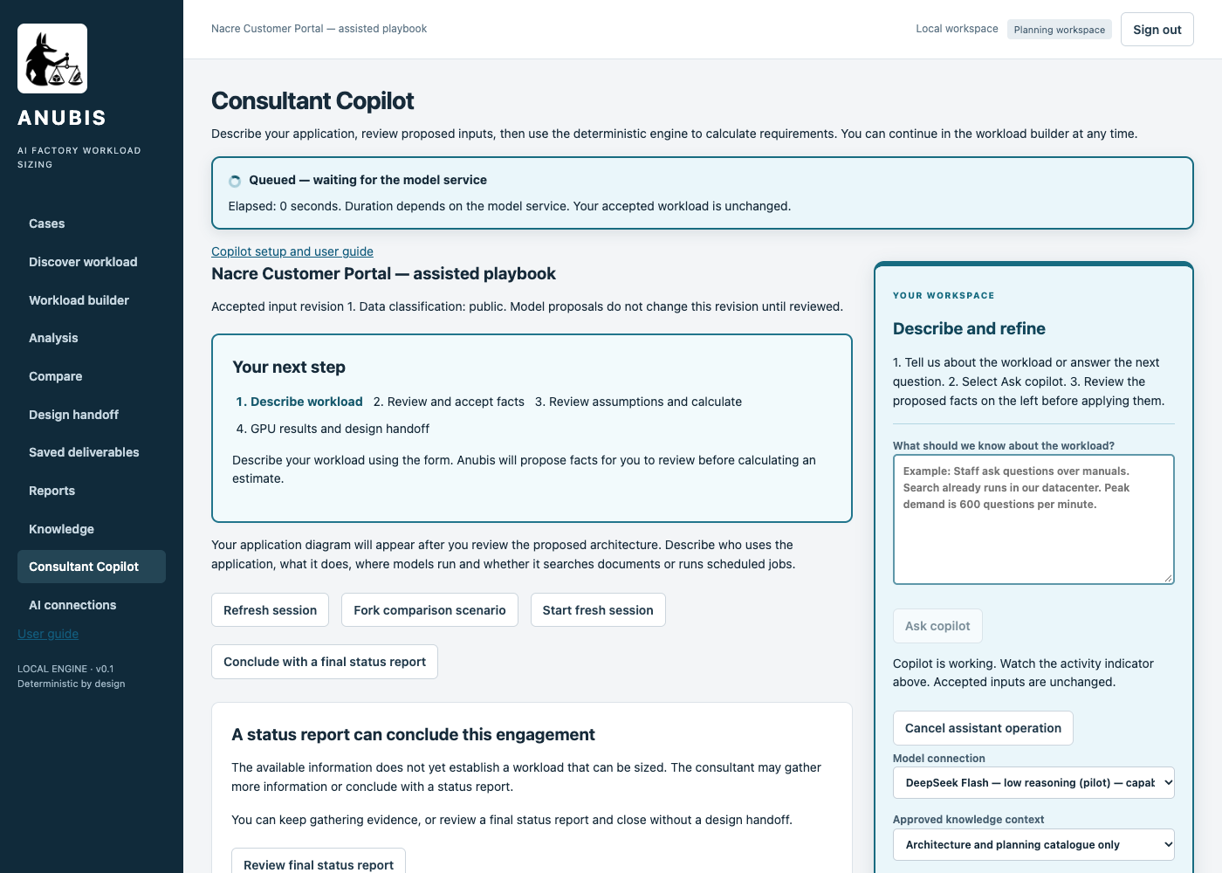
Review □ Clear □ Hesitated □ Needed help □ Blocked Notes __________________________________

Copilot assisted route step 7
Step | Activity and values | Screen reference
7 | Review the returned proposal or follow-up questions. Preserve unknown measurements. Never accept an invented traffic rate or model choice. | 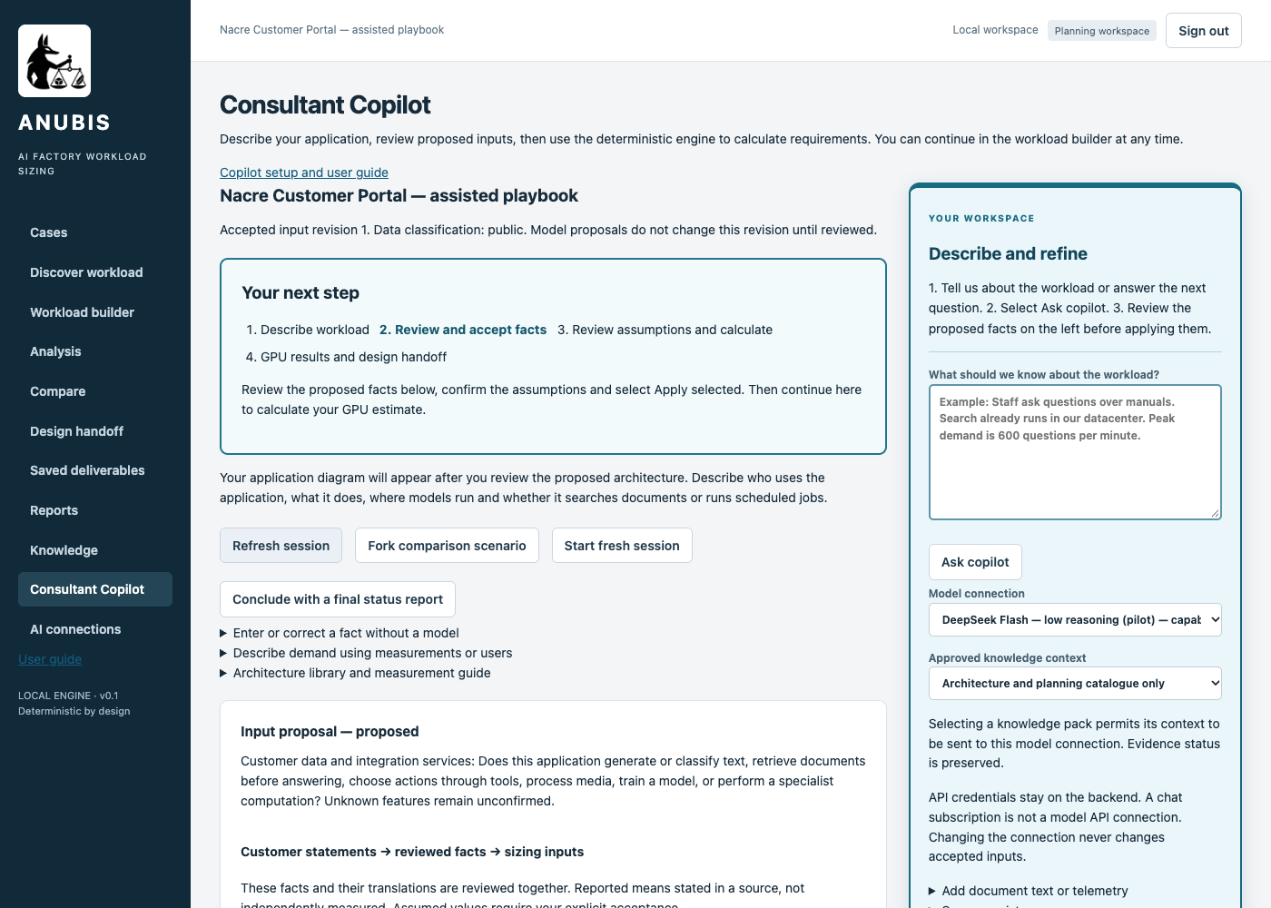
Review □ Clear □ Hesitated □ Needed help □ Blocked Notes __________________________________

Copilot assisted route step 8
Step | Activity and values | Screen reference
8 | Check I reviewed the selected values and accept the planning assumptions. only after the facts match the scenario. Click [Apply selected]. The checks below explain the expected facts. | 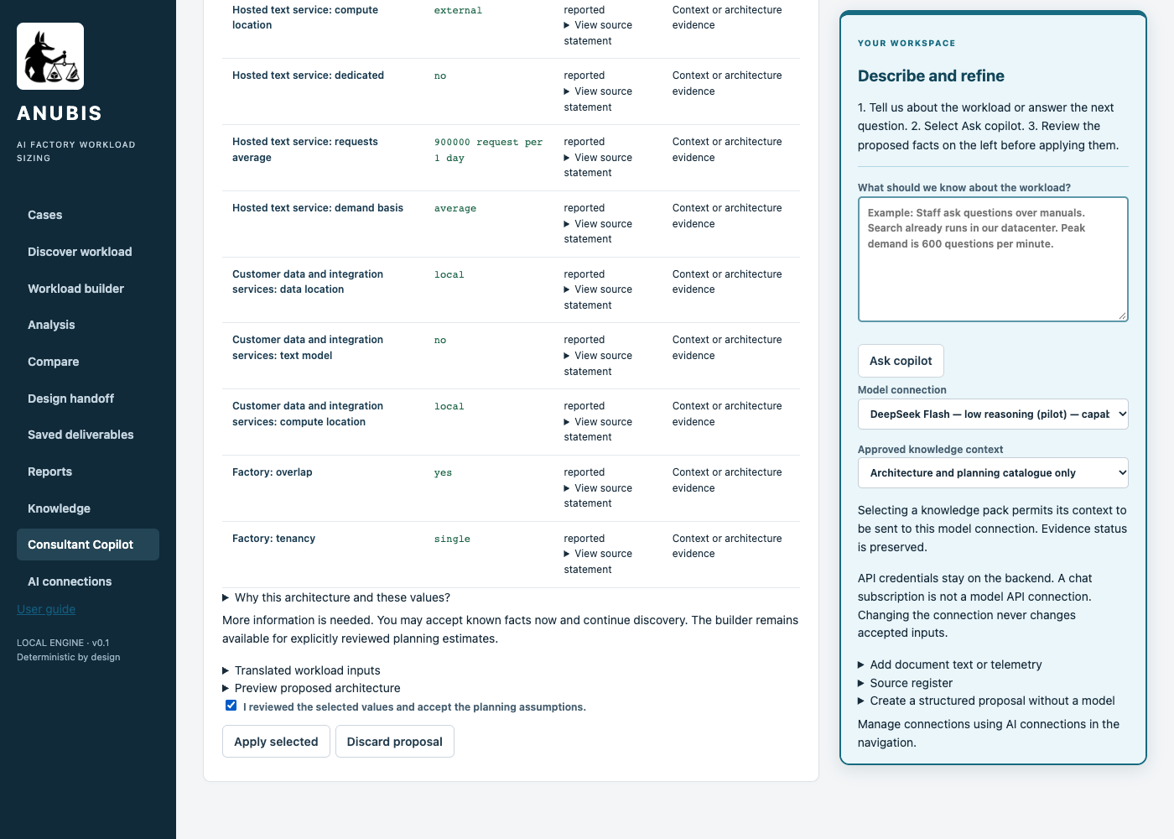
Review □ Clear □ Hesitated □ Needed help □ Blocked Notes __________________________________

Copilot assisted route step 9
Step | Activity and values | Screen reference
9 | Click [Review and calculate GPU estimate]. Inspect the proposed application map and unresolved inputs. The review screen does not establish a GPU requirement. | 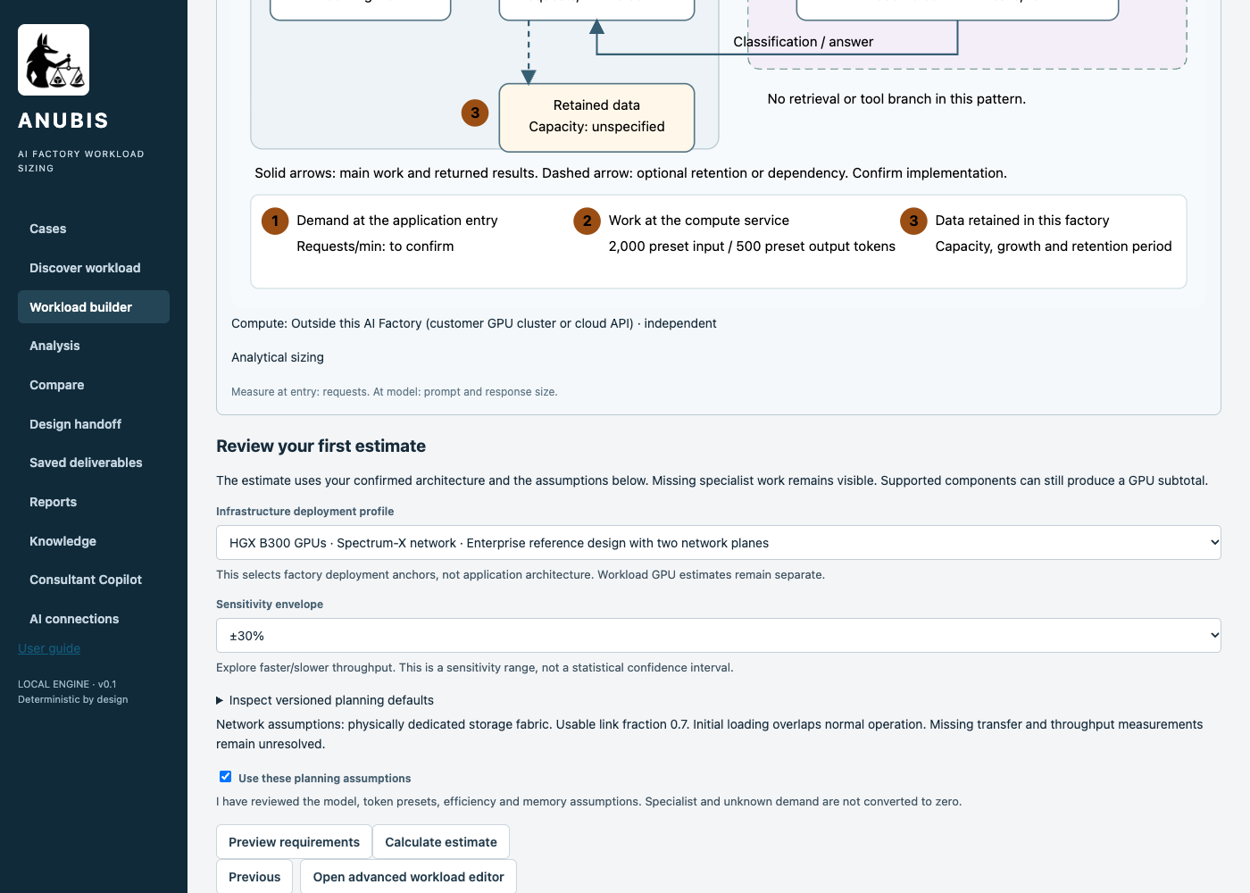
Review □ Clear □ Hesitated □ Needed help □ Blocked Notes __________________________________

Copilot assisted route step 10
Step | Activity and values | Screen reference
10 | Check Use these planning assumptions, then click [Calculate estimate]. Review the unresolved requirements. Click [Export result] to keep the deterministic analysis.
Review □ Clear □ Hesitated □ Needed help □ Blocked Notes __________________________________

Copilot assisted route step 11
Step | Activity and values | Screen reference
11 | Review each activity and its compute placement in the architecture map. Specialist and outside services must stay distinct from local text-model serving. | 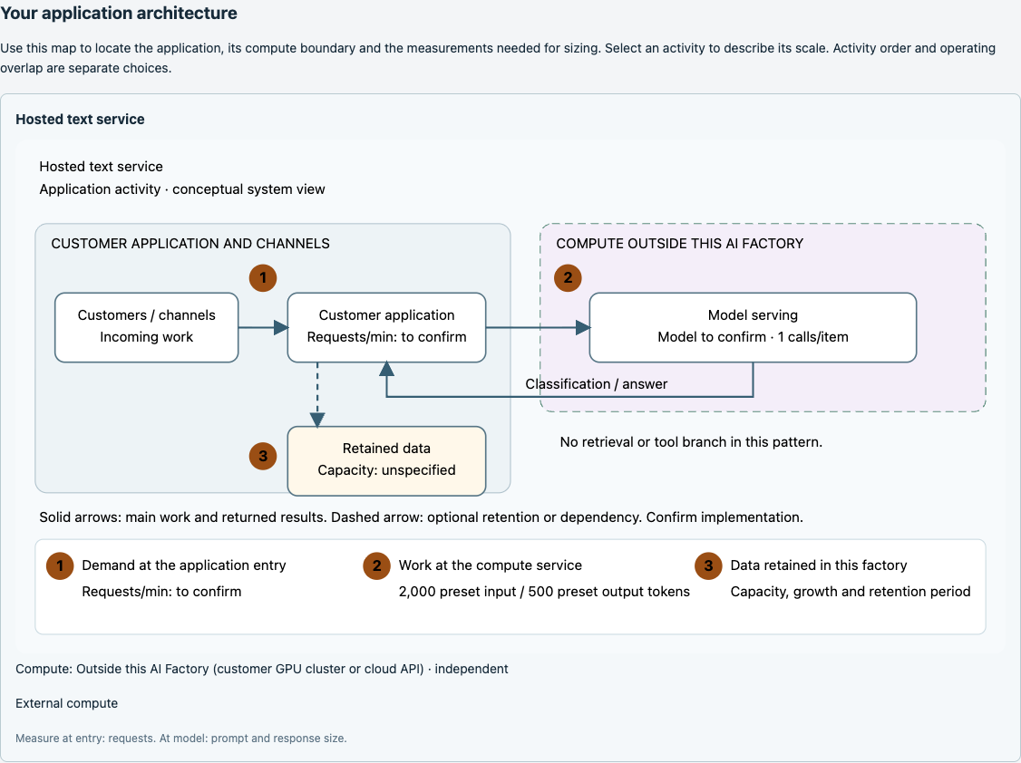
Review □ Clear □ Hesitated □ Needed help □ Blocked Notes __________________________________

Copilot assisted route step 12
Step | Activity and values | Screen reference
12 | Click [Continue to Design handoff] or [4. Design handoff], then [Review final status report]. The correct destination for this incomplete scope is a status report.
Review □ Clear □ Hesitated □ Needed help □ Blocked Notes __________________________________

Copilot assisted route step 13
Step | Activity and values | Screen reference
13 | Set Reason for concluding now = Measure request/response bytes, data storage and locally executed supporting services. No complete GPU sizing or design handoff is claimed. Check I confirm closure with a status report, without delivering a design handoff. Click [Close with final status report]. | 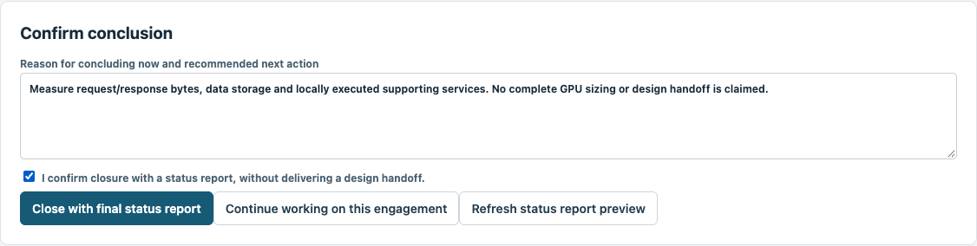
Review □ Clear □ Hesitated □ Needed help □ Blocked Notes __________________________________

Copilot assisted route step 14
Step | Activity and values | Screen reference
14 | Download the [Download final status report] and [Download complete closure record] files. The saved closure is not a design handoff. | 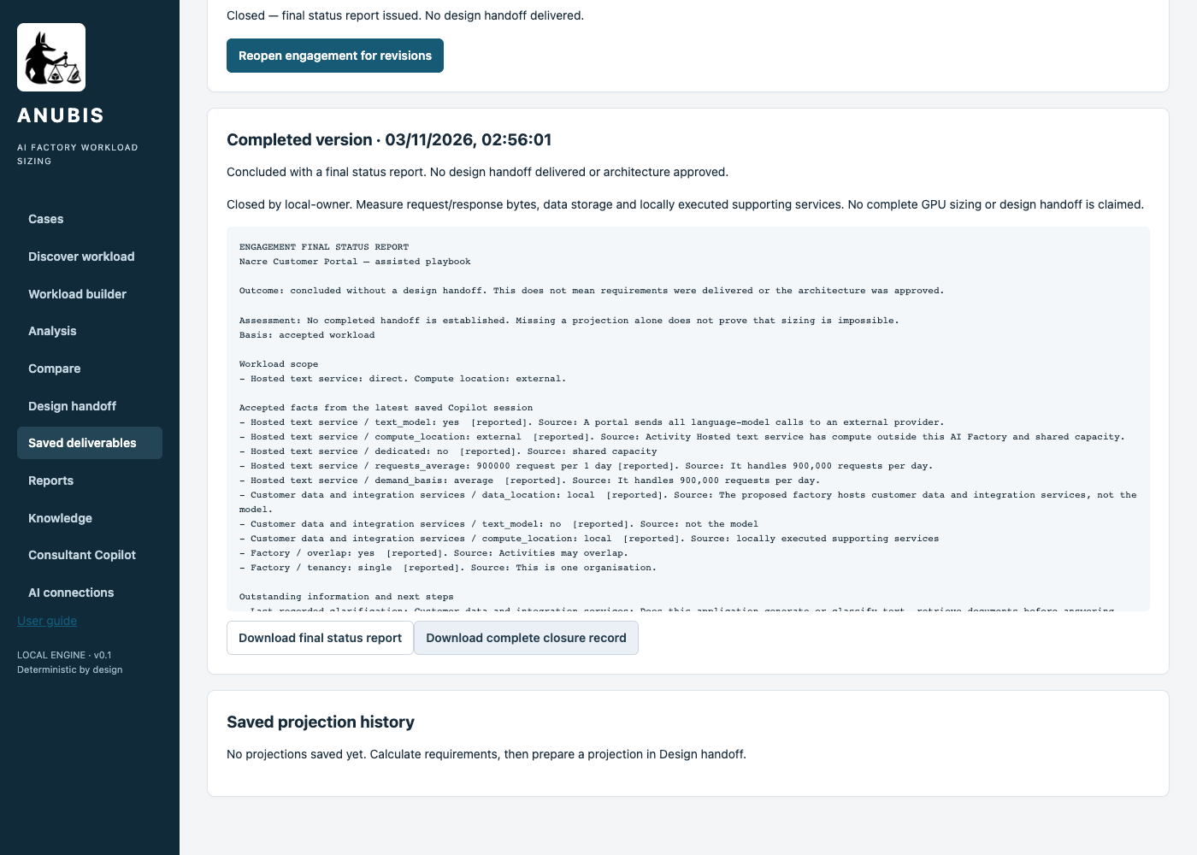
Review □ Clear □ Hesitated □ Needed help □ Blocked Notes __________________________________

Copilot assisted route step 15
Step | Activity and values | Screen reference
15 | Reload the page. Click [Cases], locate Nacre Customer Portal — assisted playbook and click [View engagement]. Verify the saved final status report can be retrieved. | 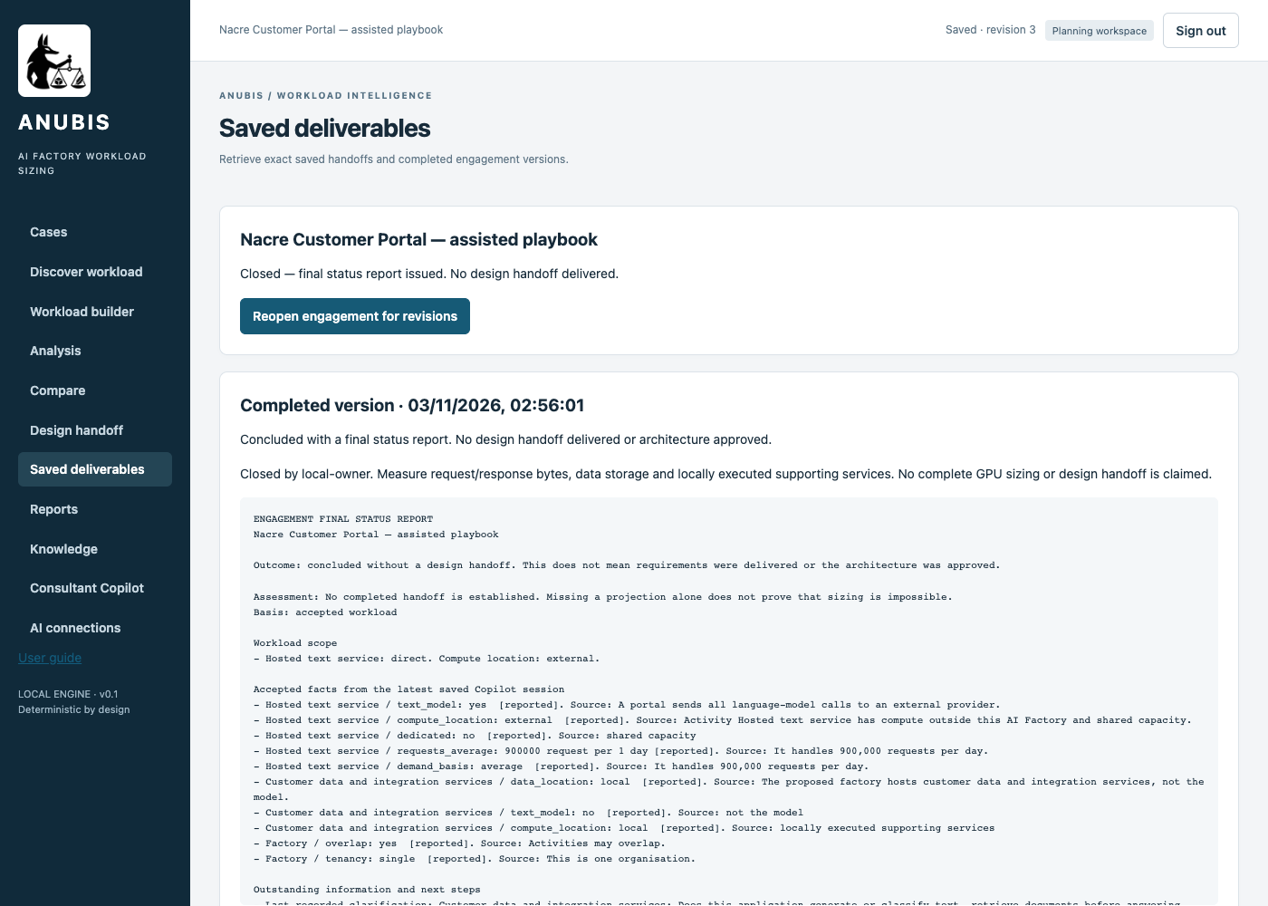
Review □ Clear □ Hesitated □ Needed help □ Blocked Notes __________________________________

Compare the outcomes
Check | Manual route | Copilot assisted route
Planning status | unknown | unknown
Complete candidate count | 0 | 0
Outcome | Closed with final status report | Closed with final status report
GPU counts for B300 B200 H200 | Not established for the complete scope | Not established for the complete scope
Next evidence | Measure request/response bytes, data storage and locally executed supporting services. | Measure request/response bytes, data storage and locally executed supporting services.
A raw zero in an unresolved export does not mean a certified zero-GPU factory. For an outside model, its serving GPUs are excluded from this factory, while local integration, storage and connectivity still need specification. No deployment anchor is recommended from an unknown result.
Manual entry and Copilot interpretation may differ in component names, provenance and retained notes. Compare scope and unresolved requirements rather than expecting identical JSON or identical model wording.

Four network roles and downstream design
Role | What the consultant must establish | Current result
East west | GPU collective communication payload and topology within local compute pools | Unresolved. Do not infer it from a model label.
North south | Payload entering and leaving application services across the factory boundary | Unresolved. Daily requests alone do not establish peak bytes/s.
Customer datacenter connection | Initial transfer volume and window, ongoing bulk traffic and RTT objective | Unresolved. Outside storage does not automatically imply a local copy.
Dedicated storage network | Aggregate concurrent read and write throughput and protocol requirements | Dedicated networking remains the policy. Required bandwidth is unmeasured.
A supported resolved workload can progress to Prepare projection and export design intake plus companion requirements. These four scenarios stop earlier for the stated reasons. Their report-only closure must not be described as a delivered design handoff.

Appendix Parameter collection guide
ID | UI parameter | Definition and scope | How to obtain or decide it | When unknown
I01 | Customer workload name | Business name identifying this engagement and its saved results. | Consultant chooses the name. Use the route suffix to distinguish the two saved records. | Choose a clear unique name.
I02 | Application pattern | A recognisable application activity, not a server or individual microservice. Repeated patterns represent distinct demand groups. | Walk through a business transaction with the application owner. Identify work done locally, outside, and in specialist services. | Choose Other GPU application when no pattern fits.
I03 | Factory users | Whether the factory serves one organisation or multiple tenants. This is not the number of individual users. | Confirm organisational boundaries and operating windows with the service owner. Customer count is not a GPU count. | Leave unspecified. Do not replace unknown with zero.
I04 | Do activities run at the same time? | Whether separate application activities may consume capacity during the same operating window. | Confirm organisational boundaries and operating windows with the service owner. Customer count is not a GPU count. | Leave unspecified. Do not replace unknown with zero.
I05 | Component name 1 | Name of the selected application activity added to the workload. It is not a GPU or physical server. | Confirm the activity, hosting boundary and reservation policy with its owner. Numbering follows the order activities were added. | Leave unspecified. Do not replace unknown with zero.
I06 | Compute location 1 | Where that activity executes relative to this factory. Each added activity has its own location. An application can combine a factory-hosted model with processing on a customer cluster or cloud API. | Confirm the activity, hosting boundary and reservation policy with its owner. Numbering follows the order activities were added. | Leave unspecified. Do not replace unknown with zero.
I07 | Reserve dedicated capacity 1 | Whether this activity must keep its own compute allocation instead of reusing capacity across separate operating windows. | Confirm the activity, hosting boundary and reservation policy with its owner. Numbering follows the order activities were added. | Leave unspecified. Do not replace unknown with zero.
I08 | Locally retained data in TB | Logical data retained inside this AI Factory. The guided MVP maps this to shared object storage. It is separate from GPU-server local disks. An outside corpus is excluded unless a local copy is required. | Storage owner inventories logical local bytes and net retained growth. Use object inventory or filesystem reports. Keep source corpus, index, caches, server disks and retained copies separate. | Leave unspecified. Do not replace unknown with zero.
I09 | Daily growth in GB | Net additional retained data per day inside the factory. This is different from total traffic or repeatedly read data. | Storage owner inventories logical local bytes and net retained growth. Use object inventory or filesystem reports. Keep source corpus, index, caches, server disks and retained copies separate. | Leave unspecified. Do not replace unknown with zero.
I10 | Planning horizon in days | Number of days over which retained-data growth is accumulated for capacity planning. | Storage owner inventories logical local bytes and net retained growth. Use object inventory or filesystem reports. Keep source corpus, index, caches, server disks and retained copies separate. | Leave unspecified. Do not replace unknown with zero.
I11 | Initial dataset to load in TB | Volume to transfer from customer systems into this factory at initial loading. A remote repository’s total size is not automatically the transfer volume. | Network and storage owners supply measured directional payload counters, transfer volume and allowed window. Convert bytes/s to Gbps with bytes/s × 8 / 1e9. Use latency probes for observed RTT and agree the target separately. Daily averages do not establish bursts. | Leave unspecified. Do not replace unknown with zero.
I12 | Initial loading window in hours | Time allowed to complete the declared initial data transfer. | Network and storage owners supply measured directional payload counters, transfer volume and allowed window. Convert bytes/s to Gbps with bytes/s × 8 / 1e9. Use latency probes for observed RTT and agree the target separately. Daily averages do not establish bursts. | Leave unspecified. Do not replace unknown with zero.
I13 | Ongoing incoming data in GB per day | Additional bulk data entering the factory each day, beyond model-request traffic. | Network and storage owners supply measured directional payload counters, transfer volume and allowed window. Convert bytes/s to Gbps with bytes/s × 8 / 1e9. Use latency probes for observed RTT and agree the target separately. Daily averages do not establish bursts. | Leave unspecified. Do not replace unknown with zero.
I14 | Ongoing outgoing data in GB per day | Additional bulk exports leaving the factory each day, beyond model-response traffic. | Network and storage owners supply measured directional payload counters, transfer volume and allowed window. Convert bytes/s to Gbps with bytes/s × 8 / 1e9. Use latency probes for observed RTT and agree the target separately. Daily averages do not establish bursts. | Leave unspecified. Do not replace unknown with zero.
I15 | Usable link fraction | Planning share of nominal link capacity available to carry the accounted traffic. A value of 0.7 means 70 percent. | Network and storage owners supply measured directional payload counters, transfer volume and allowed window. Convert bytes/s to Gbps with bytes/s × 8 / 1e9. Use latency probes for observed RTT and agree the target separately. Daily averages do not establish bursts. | Leave unspecified. Do not replace unknown with zero.
I16 | Customer datacenter round-trip target in ms | Desired network round-trip time between customer datacenter and factory boundaries. This is not model response time. | Network and storage owners supply measured directional payload counters, transfer volume and allowed window. Convert bytes/s to Gbps with bytes/s × 8 / 1e9. Use latency probes for observed RTT and agree the target separately. Daily averages do not establish bursts. | Leave unspecified. Do not replace unknown with zero.
I17 | Aggregate storage reads in Gbps | Combined peak read payload carried by the dedicated storage network. This is a throughput requirement, not storage capacity. | Network and storage owners supply measured directional payload counters, transfer volume and allowed window. Convert bytes/s to Gbps with bytes/s × 8 / 1e9. Use latency probes for observed RTT and agree the target separately. Daily averages do not establish bursts. | Leave unspecified. Do not replace unknown with zero.
I18 | Aggregate storage writes in Gbps | Combined peak write payload, including overlapping initial loading, ingestion and checkpoints when applicable. | Network and storage owners supply measured directional payload counters, transfer volume and allowed window. Convert bytes/s to Gbps with bytes/s × 8 / 1e9. Use latency probes for observed RTT and agree the target separately. Daily averages do not establish bursts. | Leave unspecified. Do not replace unknown with zero.
I19 | East-west payload per GPU in Gbps | GPU-to-GPU communication demand attributed to each GPU on the compute fabric. It is not a selected NIC speed. | Network and storage owners supply measured directional payload counters, transfer volume and allowed window. Convert bytes/s to Gbps with bytes/s × 8 / 1e9. Use latency probes for observed RTT and agree the target separately. Daily averages do not establish bursts. | Leave unspecified. Do not replace unknown with zero.
I20 | Does initial loading overlap normal operation? | Whether the initial transfer and normal traffic occur concurrently. This controls addition versus separate-window comparison. | Network and storage owners supply measured directional payload counters, transfer volume and allowed window. Convert bytes/s to Gbps with bytes/s × 8 / 1e9. Use latency probes for observed RTT and agree the target separately. Daily averages do not establish bursts. | Leave unspecified. Do not replace unknown with zero.
I21 | Customer context and measurement notes | Plain-language scope decisions, measurement sources, assumptions and unresolved questions attached to the workload. | Retain the customer wording, scope and next evidence to collect. Do not transform a daily count into a busy-hour peak. | Leave unspecified. Do not replace unknown with zero.
I22 | Infrastructure deployment profile | Catalogue hardware and deployment anchor family. It does not describe the customer application. | Architect reviews the intended platform and scale anchors. No anchor is recommended when this scenario remains unresolved. | Leave unspecified. Do not replace unknown with zero.
I23 | Sensitivity envelope | Starting throughput sensitivity envelope. Not a statistical confidence interval. | Consultant accepts or refines the planning assumption. A sensitivity band cannot supply missing demand. | Leave unspecified. Do not replace unknown with zero.
I24 | Use these planning assumptions | Allows deterministic evaluation of the supplied facts and displayed defaults. | Read missing inputs and default values before accepting. Unknown results are valid outcomes. | Do not accept assumptions you cannot explain.
I25 | Data classification | Whether this information is approved for the configured model provider. | Use Public only for these fictional scenarios or other approved material. Real customer data needs the appropriate approved profile. | Ask the data owner before sending.
I26 | Model connection | Configured backend model service. Provider credentials are not workload inputs. | Administrator follows docs/copilot-operation.txt, saves the connection and runs Test. Choose an approved enabled profile. | Use the manual route if unavailable.
I27 | What should we know about the workload? | Scenario text supplied for interpretation. Its quantities retain their original time and placement boundaries. | Copy the complete text reproduced in the Copilot instructions. Refine it using customer evidence, not invented sizing values. | Leave unspecified. Do not replace unknown with zero.
I28 | I reviewed the selected values and accept the planning assumptions. | Permits applying the proposed fact ledger. It is not a performance qualification. | Check quotations, model location, tenant groups, unknowns and defaults against the source. Correct mismatches first. | Do not apply an incorrect proposal.
I29 | Reason for concluding now | Reason the investigation is closing now and the evidence needed next. | Consultant agrees the unresolved boundary and next action with the customer. | Leave unspecified. Do not replace unknown with zero.
I30 | I confirm closure with a status report, without delivering a design handoff. | Records report-only closure. No design projection is asserted. | Review the saved findings before confirming. Reopen later when measurements are available. | Continue discovery instead of confirming if needed.

Appendix Placement and storage glossary
Term | Meaning | Concrete examples
Outside this AI Factory | A resource outside the capacity being designed. It may be in the same customer site. | Customer GPU cluster, managed model endpoint, customer search cluster or managed cloud search.
Source documents | Original content from which an index or model input is produced. | Object storage, an NFS or SMB share, SharePoint or a document repository.
Search index | Searchable structure, embeddings and metadata. It has its own storage and compute footprint. | OpenSearch, Elasticsearch or a managed search service.
Local shared data | Data retained inside the factory. It is separate from GPU-server local disks and model cache memory. | Factory object storage or parallel filesystem, selected according to actual throughput and access patterns.
Customer connectivity | Network path between customer systems and the factory. Outside does not require public Internet. | Private WAN, dedicated cloud connectivity or routed Ethernet.
Record compute, retrieval and document-storage placement separately. Never assume corpus size equals index size, local copies or initial transfer volume. High-performance storage requires workload evidence, not a product-name preference.

Appendix Validation and review record
The scenario was selected without replacement from the 16-scenario catalogue on 3 November 2026. Both routes were exercised in the installed application. Screens show fictional engagements. Live Copilot output was reviewed before application. No hardware performance qualification or independent human pilot is implied.
Live provider record: 1 failed request(s) were retained. Explicit retries are documented in the assisted steps. The successful proposal was reviewed by the coding assistant for this walkthrough. A new user must perform their own review. Provider availability and exact wording can vary.
Interpretation review: Outside model preserved. 900000/day retained as average, not peak. Local data/integration context retained without invented local GPU demand.
Success checks: Never recommend local model GPUs merely because the application uses AI. No complete candidate is emitted from missing or unsupported measurements. Closure records remain retrievable after reload. The sixteen-scenario regression is a software boundary check, not sixteen hardware benchmarks.
Step | Observed problem | Expected behaviour | Impact or recovery

