Medicine Taking Schedule

- Anti-inflammatory (Nurofen): 2 tablets, three times a day for one week (No Prescription Needed)
- Strong pain-killer (Panadeine forte): 1-2 tablets, every four hours as needed (eat beforehand to avoid drowsiness or stomach upset) (Prescription)
- Antibiotic (Amoxicillin): 1 tablet, three times a day until finished (Prescription)
- Antibiotic (Clindamycin): 1 tablet, four times a day until finished (Prescription)

Please call our clinic in Chatswood (9411 3868) or Chinatown (9261 2788) or text Dr Adrian Lok (0402 012 082) if you have any questions.
Wisdom tooth extraction
What to do
- Bite on the gauze for half an hour, change to a new piece and bite again.
- Take the prescription pain killers when anaesthetic begins to wear off.
- Place ice packs ASAP, 20 minutes on and 20 minutes off.
- Begin antibiotics the night of the surgery
- Relax, rest and sleep to increase healing.
- Eat normally and drink lots of water.
- Rinse with salty water 5-6 times per day for 5 days starting the day after the surgery.
What to expect in the next few days
- Minor bleeding
- Slight swelling
- Difficulty opening your mouth fully
- Some sore throat
- Some small ulcers
What not to do
- Do not drink through a straw.
- Do not do anything vigorous for a few days.
- Do not skip meals.
Medicine taking schedule
- Anti-inflammatory (Nurofen): 2 tablets, three times a day for one week (No Prescription needed)
- Strong pain-killer (Panadeine forte): 1-2 tablets, every four hours as needed (eat beforehand to avoid drowsiness or stomach upset) (Prescription)
- Antibiotic (Amoxicillin): 1 tablet, three times a day until finished (Prescription)
- Antibiotic (Clindamycin): 1 tablet, four times a day until finished (Prescription)
- Kenalog Orabase: rub onto the region with the ulcer three times a day (Over the counter)

Please call our clinic in Chatswood (9411 3868) or Chinatown (9261 2788) or text Dr Adrian Lok (0402 012 082) if you have any questions.

Extraction
What to do
- Bite on the gauze for half an hour, change to a new piece and bite again.
- Relax, rest and sleep to increase healing.
- Try to eat normally and drink lots of water
- Brush teeth gently starting from the night of the surgery.
What to expect
- Minor bleeding for a few days - if this happens bite on the spare gauze, make up remover or tea bag.
- Slight swelling - is also possible and may depend on the body’s reaction to the healing process. Use ice to prevent this.
- For moderate discomfort, take Ibuprofen (Nurofen) every three to four hours,
What not to do
- Do not drink through a straw.
- Do not do anything vigorous for a few days.
- Do not skip meals.

Please call our clinic in Chatswood (9411 3868) or Chinatown (9261 2788) or text Dr Adrian Lok (0402 012 082) if you have any questions.

Fixed orthodontics
Appointment 1: Records
- Pictures, models, measurements, and x-rays in order for us to document your starting point.
Appointment 1: Extraction of teeth (If required) and placement of orthodontic separators
- If required, simple extractions will be done and you will be fine after the anaesthetic finishes.
- Rubber bands will also be placed between your molar teeth to create space for orthodontic bands
Appointment 2 (after one week): band and bond (placement of full orthodontic appliances either ceramic or metal) or provision of Invisalign alingers.
- The first meal after you place your braces, your teeth may feel a little tender.
- these few days you may experience a few ulcers or small cuts. For this reason, we will give you some orthodontic wax which you remove a small portion and press onto the orthodontic bracket to prevent this.
- Do not eat any sticky or hard foods.
- Do not eat too many lollies, these orthodontic brackets are likely to retain all these sugars and foods.
- Brush your teeth!!!! We will show you how to brush your teeth efficiently when you have braces. There are special toothbrushes that better adapt to these areas.
- If you are getting Invisalign aligners, remember: It will only work if you wear it 23 hours per day.
Appointment 3: Review
- See us one week after placing the braces for a review.
Appointment 4 - finish: Adjustment
- Schedule an appointment every 3-4 weeks for adjustments.
Final appointment
- After the completion of treatment, we will remove the brackets and make a retainer for you.

Payments: We usually ask every patient to pay half of the total amount at their first appointment, followed by a small payment at each appointment until balance is paid and the entire treatment is complete.

Please call our clinic in Chatswood (9411 3868) or Chinatown (9261 2788) or text Dr Adrian Lok (0402 012 082) if you have any questions.

Instructions after getting a plate

What to do
- Wear this plate all the time except for when brushing. Wear it to eat if you can.
- When brushing your teeth, brush the plate as well to clean it.
- Put it in the case when you are not wearing it.
- If you have a maxillary expander as well, turn the screw once/twice per day.
- If your plate has a spring, make sure to activate it once/twice per day.
- See us after one week for a review.
What to expect
- Difficulty talking
- The night that I give you the plate, spend half an hour reading out loud, clearly and carefully. It will get back to normal very soon!
- Too much saliva
- This will likely decrease after about 2-3 days, depending on how fast your body realises it is not food.
Putting it on and taking it off
Remove the plate from the back clips on both sides. Release both sides before fully removing the plate, make sure to remove it as slowly as possible.
What not to do
- Do not play with it using your tongue!
- Do not let it touch hot water.

Please call our clinic in Chatswood (9411 3868) or Chinatown (9261 2788) or text Dr Adrian Lok (0402 012 082) if you have any questions.

Instructions following a filling
What to expect
- Tenderness to biting and minor sensitivity (especially to cold) can last for between one day to up to two weeks. This is normal, as the nerve is slowly adjusting to the new restoration.
- Slight swelling and tenderness in the gum and soft tissues near the area due to the instruments used and anaesthetic injection. This usually decreases after a few days.
What to do
- Floss this area regularly, as the margin between the restoration and tooth can easily attract further bacteria
- Brush using the modified bass technique (45 degree angle) – look at oral hygiene instruction pamphlet

Please call our clinic in Chatswood (9411 3868) or Chinatown (9261 2788) or text Dr Adrian Lok (0402 012 082) if you have any questions

Crown

Appointment 1: Crown preparation and material/shade selection
- During this appointment, we will prepare the tooth and remove a superficial layer of your tooth’s structure in order to create space for a crown.
- We will place a temporary crown onto this tooth, during this time please be careful not to bite on this tooth. Do not floss this region until after the permanent crown has been placed.
Appointment 1: Impression
- During this appointment, we take an impression of the upper and lower teeth, creating a custom-made crown that is perfectly adapted to the margins of your tooth.
Appointment 3: Cementation
- After receiving the crown from the dental technician, we will cement the crown. For the first 30 minutes, we will ask you to bite on a cotton roll to ensure correct seating of this crown. Following this, the cement we use will usually take at least 24 hours to set, during this time do not eat on this tooth.
Appointment 4: Review
- See us after one week for a review.
Please call our clinic in Chatswood (9411 3868) or Chinatown (9261 2788) or text Dr Adrian Lok (0402 012 082) if you have any questions.
Yours sincerely,

Root canal treatment
Appointment 1: Removal of the nerve
- Firstly, we anaesthetise the tooth and open a small access cavity at the top to find the nerve canal openings and remove the nerve as closely to the tip of the tooth as possible. We also measure the length of each canal and place medications into the canal to reduce or eliminate the infection. In special cases, we have to re-do this stage when the infection is severe as the medications have not performed the purpose of removal of the nerve.
Appointment 2: Cleaning of the walls and filling of the canal (usually done after a one week period of minimal to no discomfort)
- Special instruments are used which remove the bacteria and infection from the walls of the canal down to the tip of the tooth. Followed by placement of root canal filling material with pre-mixed sealant to prevent the canal from being infected again and plug the root tip to perform a stronger seal.
Appointment 3: Review
- See us in one week for a review
What to expect
- Following each step, it is normal to feel slightly tender or sore for about two days. Each day should get better, however, if it is still slightly sore after the third day give us a call so we can best advise you on what to do.
- Take some Nurofen if it is uncomfortable. It should get better within two days.

What to do after the tooth has been successfully root canal treated
- We usually highly recommend placement of a crown following the completion of root canal treatment. This is because the tooth is already weakened and can crack easily following loss of the liquid portion from the nerve. After one year, we will assess whether the root canal treatment has been successful and, if suitable, we can place a crown on it. In certain high risk cases, we place a temporary stainless steel band to prevent the tooth from cracking when we are waiting to place the crown.

What not to do
- Do not use the tooth to chew or bite before completion of root canal treatment. Following completion, it is best to avoid chewing harder foods until after the placement of the permanent crown.

Please call our clinic in Chatswood (9411 3868) or Chinatown (9261 2788) or text Dr Adrian Lok (0402 012 082) if you have any questions.

Whitening
What to expect
- This procedure does not cause any permanent damage to your teeth.
Preparation – for one week before and after the whitening procedure
- Use Neutrafleur 5000 toothpaste from Colgate as your normal toothpaste
- At night, rub Sensodyne onto the entire outer surface of your teeth and apply lightly to the area that is close to the gum and let it stay there overnight. Try to not let it touch your tongue.
Step 1 – Whitening toothpaste and mouthwash
- Use any toothpaste with the active ingredient: Hydrogen peroxide (2%)
- Also, use a whitening mouthwash
- An example is colgate optic white
Step 2 - Professional in chair whitening
- If you feel like the degree of whitening is not enough, then do the in chair whitening
- This procedure will be conducted in one day. There are four stages of 15 minutes each and the total should take around one and a half hours.
After the procedure
- Go home and have a good rest/sleep. Usually any sensitivity is unlikely to last beyond a few hours.
Step 2 – continue using the whitening toothpaste
- There are many different strengths for these toothpastes. It is best to try at a lower concentration first. Rinse thoroughly after using these toothpastes.
Step 3 – Take home whitening kit
- When you start to see decreases in the whiteness of your teeth, start using a take home whitening kits. We can make you the tray at our clinic, it will only take a few days. Then, you can purchase the whitening kits and use them as directed.
What not to do
- Avoid dark coloured foods or drinks. These include coffee, tea, red wine, curry, etc. If you cannot avoid coffee, consider drinking it faster when it is not as hot and rinse your mouth thoroughly after.

Please call our clinic in Chatswood (9411 3868) or Chinatown (9261 2788) or text Dr Adrian Lok (0402 012 082) if you have any questions.

Whitening toothpaste and mouthwash

- Any toothpaste with the active ingredient: Hydrogen peroxide (2%). This is the strongest whitening toothpaste available.
  - Use twice per day initially and rinse thoroughly after brushing
  - If sensitivity develops, change to using it at night, with sensodyne toothpaste in the morning
- Also, use a whitening mouthwash such as colgate optic white once per day
- Evaluate the result after 1 month to see if there is the desired improvement. If not, consider in chair or take home whitening.

Please call our clinic in Chatswood (9411 3868) or Chinatown (9261 2788) or text Dr Adrian Lok (0402 012 082) if you have any questions.

Scale and clean
During this procedure, we are removing the calculus and staining from your teeth.
What to expect
- It can feel slightly sensitive. However, regular cleaning of your teeth does not cause any permanent damage.
- Sensitivity for a day or two is normal.. These areas are now exposed to outside stimuli and require a few days for the gum to cover the root again.
- Bleeding from your gums during the clean. Bleeding is a sign of poor hygiene. It only exists if brushing in this area has been poor. In that situation, if you see bleeding when you brush for the days after, do not worry! Keep brushing!
- Shrinking gums – Infected and dirty teeth lead to swollen and red gum. After cleaning and good oral hygiene, the gums are likely to shrink and become pink. Do not worry if this happens to you! This is good. It means that your gum health is improving.
Areas which are frequently missed when brushing
- At the back of the bottom front teeth. This area is usually difficult to clean, as it is quite an awkward position to brush. It’s best to use the first minute when brushing to focus on this area, to prevent it from being missed
- The wisdom teeth: when brushing, close your mouth slightly and pull out your cheek using the middle of your toothbrush. Then brush every part of your wisdom tooth whilst having direct vision from the mirror.
- Between the teeth: If you are less than 30 years old, I would recommend using floss as the spaces between teeth are smaller. However, for all others I would recommend interproximal cleaning devices such as Piksters or Tepe brushes.
What to do
- For areas which the dentist advises to clean more, it is good to brush these areas three times per day for three days before returning to your normal routine. During these three days, do not worry if it bleeds or the gum shrinks. These are good signs!
What not to do
- If you see blood or is uncomfortable when you’re brushing the area, don’t worry. It will be a little uncomfortable when your hygiene is poor. These areas will feel much better when you improve the hygiene.
Do not overbrush
- Use a soft toothbrush, and brush with a gentle massaging circular motion. Do not brush with a scrubbing motion and a hard toothbrush. If you believe that this is you, change to an electric toothbrush and leave it on each surface of the tooth for 10 seconds. Let the electric toothbrush do the moving.
Do not consume too many sugar containing foods or drinks.
- Try and limit these to twice per week. Maybe Wednesday (middle of the week treat) and once on the weekend, that way we can still enjoy when we have our snacks.

Please call our clinic in Chatswood (9411 3868) or Chinatown (9261 2788) or text Dr Adrian Lok (0402 012 082) if you have any questions.

Mild Sensitivity
Sensitivity refers to the uncomfortable feeling from your tooth following cold, hot, or strong biting.
Causes
- It comes as a result of a transmission of a stimulus to the nerve within the tooth.
- There are three main reasons for sensitivity
Overbrushing
- This generally occurs when the gum has been overbrushed and has resorbed due to trauma.
- Use a soft toothbrush. This is the best for the long-term health of your gum, as overbrushing can lead to shrinking gums and removal of tooth structure
- If you cannot brush in a circular motion, change to an electric toothbrush and leave it on each surface of the tooth for 10-15 seconds. Do not move the toothbrush, and let it do the circular motions for you.
Food trap
- Poor oral hygiene between the teeth can lead to loss of bone and gum covering the tooth, resulting in root exposure and direct sensitisation of the nerve.
- If this is an issue, use interproximal cleaning devices such as Piksters or Tepe brushes. These are easier to use and clean the area between teeth better as long as the right size is chosen. I prefer these over floss as it is easier to use and cleans more efficiently.
What to do
- Fix the cause of the sensitivity. This usually takes around three days to resolve.
- Change to use a de-sensitising toothpaste such as Sensodyne or Colgate Pro Relief
- During those three days when the teeth are especially sensitive, rub the de-sensitising toothpaste onto the area for 1 minute and leave overnight. Your saliva will rinse it away and it is not a problem if you swallow a small amount.
Please call our clinic in Chatswood (9411 3868) or Chinatown (9261 2788) or text Dr Adrian Lok (0402 012 082) if you have any questions.
Yours sincerely,

Brushing technique
Technique
- When brushing, aim to have half of the toothbrush on the tooth and half on the gum.
- Aim the toothbrush at a 45-degree angle into the gum and brush in a circular motion gently, as if massaging the tooth.
- Do not scrub back and forth.
Time
- Brushing should take between 3-4 minutes twice per day. To give a good idea about how long that is, consider playing your favourite song when brushing. Brush until the song finishes, and it will be perfect.
Type of toothbrush to use
- Use a soft toothbrush. This is the best for the long-term health of your gum, as overbrushing can lead to shrinking gums and removal of tooth structure
- If you cannot brush in a circular motion, change to an electric toothbrush and leave it on each surface of the tooth for 10-15 seconds. Do not move the toothbrush, and let it do the circular motions for you.
Areas which are frequently missed when brushing
- At the back of the bottom front teeth. This area is usually difficult to clean, as it is quite an awkward position to brush. It requires attention and concentration – It’s best to use the first minute when brushing to focus on this area, to prevent it from being missed
- The wisdom teeth: when brushing, close your mouth slightly and pull out your cheek using the middle of your toothbrush. Then brush every part of your wisdom tooth whilst having direct vision from the mirror.
Cleaning between your teeth
- If you are less than 30 years old, I would recommend using floss as the spaces between teeth are smaller. The best way to floss is to wrap the floss around your two middle fingers. Then, use each index finger to direct the floss. Place one the inside of your tooth, and one on the outside of your tooth. Then, gently lower it between your teeth and follow the curvature of your tooth until it is slightly beneath your gums and follow the same curvature back out. Repeat this twice per surface
- For ages greater than 30, I would recommend interproximal cleaning devices such as Piksters or Tepe brushes. These are easier to use and clean the area between teeth better as long as the right size is chosen. In the front areas, keep the brush straight and place it between your teeth near the gums, in and out three times. In the back areas conduct the same movement except with the brush bent at 90 degrees.
How to brush each area
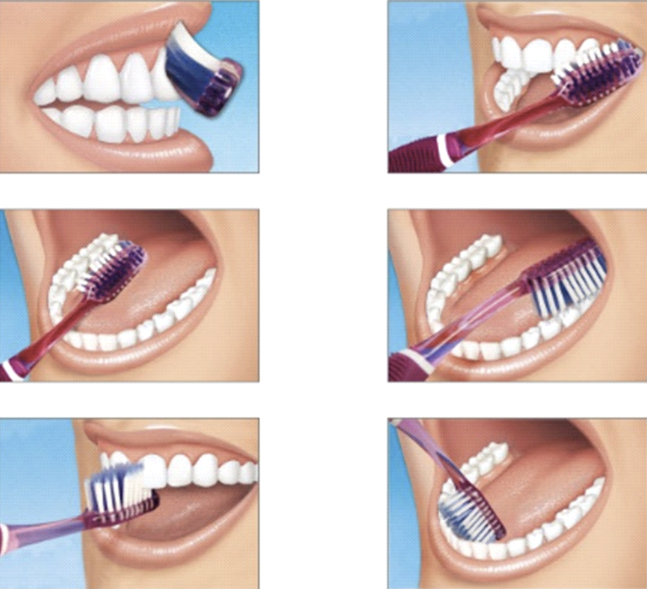

The 45 degree angle and circular motion to brush correctly
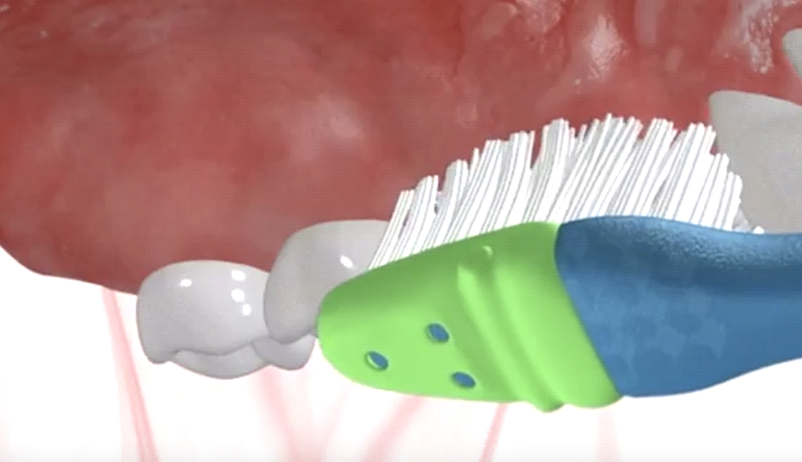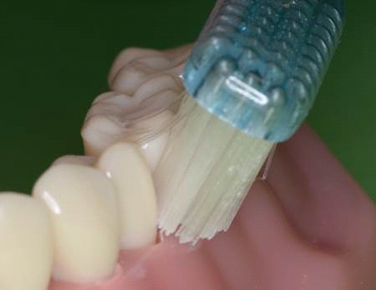

Please call our clinic in Chatswood (9411 3868) or Chinatown (9261 2788) or text Dr Adrian Lok (0402 012 082) if you have any questions.

Deep cleaning for periodontal disease
What it is
- Periodontal disease is the situation when bone is trying to stay away from the food and bacteria in order to maintain a clean environment. As the bone moves further away from the calculus, there is a decrease in bone level that creates a pocket. This is shown in the diagram below
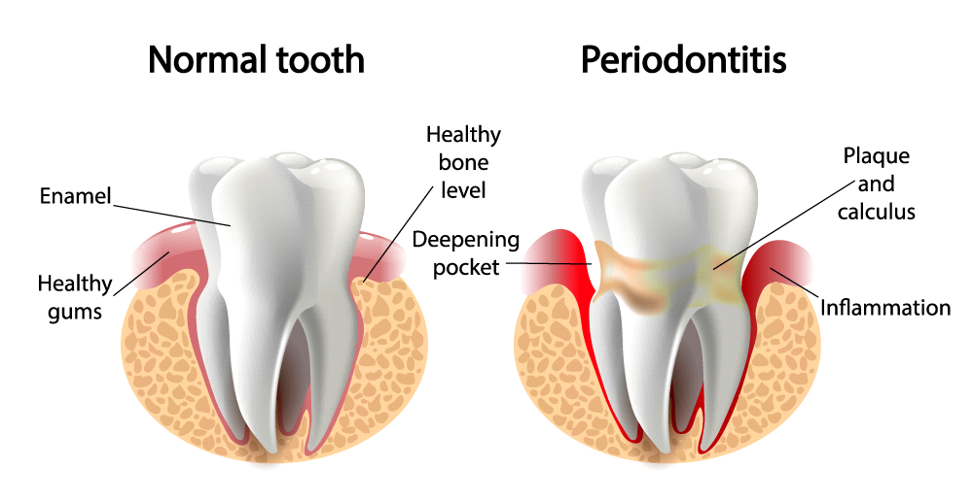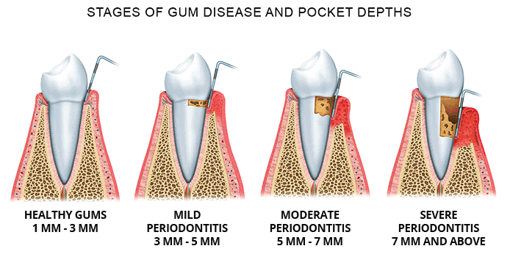

What we are trying to achieve
- Through cleaning the deep areas of the tooth, we are trying to remove all the calculus and bacteria from the root of the tooth
- Following this, we are hoping that the bone and gum will re-attach onto the tooth, and reduce movement and instability.
What to expect
- Sensitivity for a day or two is normal. This is due to the removal of calculus previously covering the roots of your tooth where the gum was previously. These areas are now exposed to outside stimuli and require a few days for the gum to cover the root again.
- Bleeding from your gums during the clean and a few days after the cleaning. Bleeding is a sign of poor hygiene. It only exists if brushing in this area has been poor. In that situation, if you see bleeding when you brush for the days after, do not worry! Keep brushing!
- Shrinking gums – When teeth have poor hygiene, the gums are swollen and red. After cleaning and good oral hygiene, the gums are likely to shrink and become pink.
What to do
- For areas which the dentist advises to clean more, it is good to brush these areas three times per day for three days before returning to your normal routine. During these three days, do not worry if it bleeds or the gum shrinks. These are good signs! The only reason your teeth would shrink is due to over brushing and using a hard toothbrush. For this reason, make sure to use a soft toothbrush!
What not to do
- If you see blood or is uncomfortable when you’re brushing the area, don’t worry. It will be a little uncomfortable when your hygiene is poor. These areas will feel much better when you improve the hygiene.
Do not overbrush
- Use a soft toothbrush, and brush with a gentle massaging circular motion. Do not brush with a scrubbing motion and a hard toothbrush. If you believe that this is you, change to an electric toothbrush and leave it on each surface of the tooth for 10 seconds. Let the electric toothbrush do the moving.
Please call our clinic in Chatswood (9411 3868) or Chinatown (9261 2788) or text Dr Adrian Lok (0402 012 082) if you have any questions.

Temporomandibular Joint Pain
What it is
- In simple terms, you can think of it as inflammation of the joint due to an imbalance in pressures. As certain parts of the joint are overloaded, there is compression of the joint, and overuse of the muscles leading to generalised dull ache.
- Often, you cannot open your mouth, as the disc is swollen, and stuck
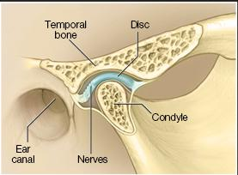

What we are trying to achieve
- We need to unload this joint and relieve the inflammation slowly (this may take a few days, weeks or months)
What to do
- Avoid eating very hard foods
- Don’t chew gum
- Massage the muscles and joint
- Anti-inflammatory (Nurofen): 2 tablets, every four hours for one week (Over the counter)
- Use heat packs in the region
If that doesn’t work
- Occlusal splint (mechanical opening of the joint to unload the region)
What to expect
- Unfortunately, there is no quick, easy fix for TMD. It often takes months to resolve, and will likely come back when stressed or not sleeping enough.
- You may need to come back a few times to check on the progress of the improvement
- It requires constant reminding not to chew hard foods, clench, or grind teeth

Please call our clinic in Chatswood (9411 3868) or Chinatown (9261 2788) or text Dr Adrian Lok (0402 012 082) if you have any questions.

Implant placement

What to do
- Do not eat until after anaesthetic has worn off. Eat on the otherside for 24 hours.
- Start cleaning other teeth as normal the night of the surgery, avoid the implant area for 2 days
- Use warm salt mouthwash three times daily starting from the day after surgery
- Avoid exercise for 2 days after implant placement.
What not to do
- Do not drink through a straw.
- Do not do anything vigorous for a few days.
- Do not skip meals.
Medicine taking schedule
- Anti-inflammatory (Nurofen): 2 tablets, three times a day for one week (No Prescription needed)
- Strong pain-killer (Panadeine forte): 1-2 tablets, every four hours as needed (eat beforehand to avoid drowsiness or stomach upset) (Prescription)
- Antibiotic (Amoxicillin): 1 tablet, three times a day until finished (Prescription)
- Antibiotic (Clindamycin): 1 tablet, four times a day until finished (Prescription)
- Kenalog Orabase: rub onto the region with the ulcer three times a day (Over the counter)

Please call our clinic in Chatswood (9411 3868) or Chinatown (9261 2788) or text Dr Adrian Lok (0402 012 082) if you have any questions.

Invisalign instructions
隐适美矫治器佩带注意事项

When to wear the aligners
何时摘戴矫治器
- You must wear your aligners for 22 hours per day
请务必22 小时佩戴隐适美矫治器
- The only times you should remove your aligners are during eating, drinking and brushing. You can drink cold water with them on.
- 只有在吃饭、喝水和刷牙时才可以摘下矫治器，喝冷水的时候不需要摘下矫治器
Placement and removal of Invisalign
如何摘戴矫治器
- Make sure that each time you put the aligner on, it fits perfectly. We will give you some ‘chewies’ to bite in between each tooth for 5 seconds to make sure. This is particularly important the first day after changing aligners.
- 确保每次您佩戴矫治器时，它都贴合良好。 我们会给您一些“帮助咬合器”，让它们在每颗牙齿之间咬合5秒钟，以确保每颗牙和矫治器都贴合良好。 这在更换矫治器的第一天尤为重要。
- To remove the aligners, use your fingers to pull the aligners slightly off the back teeth, followed by the front teeth.
- 摘下矫治器时，请用手指将其从后牙稍稍拉出，然后再从前牙拉出。
Brushing
关于刷牙及清洁矫治器
- Brush your teeth and the aligner in the morning, at night, and after meals.
- 请于早上、晚上和饭后刷牙及清洁矫治器
Changing of Invisalign aligners
更换矫治器
- After changing your aligner, keep them safe in the boxes that they came in. Often, we have to go back a few aligners to keep going forwards
- 更换矫治器后，请将其放入盒中，因为有时我们还需要根据牙齿移动的进度佩戴回之前的一些以矫治器
- Ensure when you are not wearing your aligners to keep them in the box. If kept in tissues, they will inevitability get lost.
- 确保当您不佩戴矫治器时，将他们保存在盒中。 如果放在餐巾纸中，常常会弄丢。

Please call our clinic in Chatswood (9411 3868) or Chinatown (9261 2788) or text Dr Adrian Lok (0402 012 082) if you have any questions.

Implant Crown insertion

Importance of cleaning dental implants
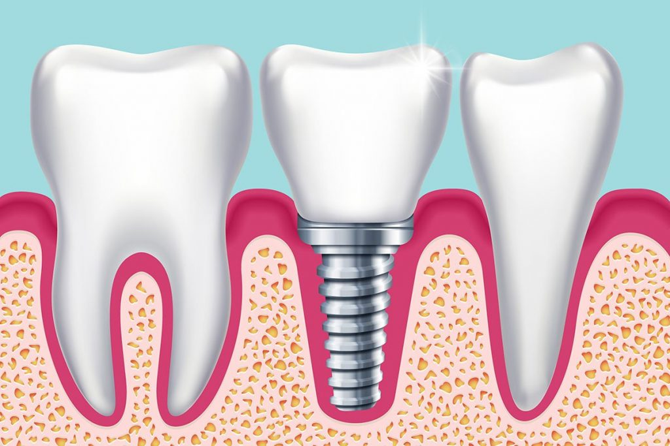
- Although implants cannot experience dental decay or caries, peri-implantitis can still be a problem.
- Peri-implantitis, is the equivalent of ‘gum disease’ or ‘periodontal disease’ for normal teeth
- As shown in the above picture, the roots of natural teeth are much wider than the implant root
- As a consequence, it is easier for food to get stuck in these areas (the main cause of peri-implantitis)

How to clean dental implants
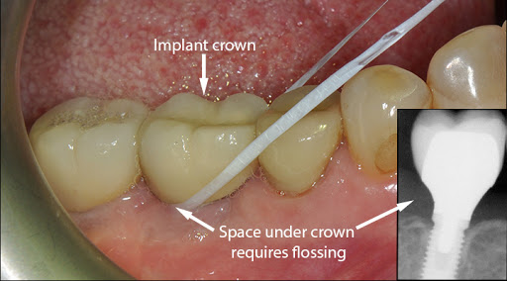

- You must run the floss underneath the implant crown and above the gum until you reach the implant placed within the bone as shown in the picture above
- This will ensure that you prevent food accumulation in this area, preventing peri-implantitis

Please call our clinic in Chatswood (9411 3868) or Chinatown (9261 2788) or text Dr Adrian Lok (0402 012 082) if you have any questions.

Welcome Letter

Dear

Welcome to Lok Dentists! I look forward to providing you with a pleasant and enjoyable experience. Your dental health and smile are my top priority and would love for you to leave our clinic feeling satisfied and cared for.

At our clinic, we follow the latest infection control guidelines with daily Bowie-Dick and Helix tests. We place tracking labels on our instruments and perform routine services for all of our equipment and sterilisers. We also thoroughly clean then dental chairs and surround areas between each patient.

Our staff are highly trained, approachable and very caring. If you have any questions or special requests, please do not hesitate to ask. I look forward to serving you and your family.

Kindest regards,

Lok Dentists Team

Our clinic relies on word of mouth and online reviews to grow, if you had a pleasant experience please refer some of your friends and family to our clinic or write us an online review. We will take great care of them.

