**Name : Mohamed Farag Abd-Elsalam Hassan**

**B.N: 778**

**Date : 23/5/2020**

**Topic:**  **Database System**

**GitHub link :** [**https://github.com/engfarag1/html-project-repository**](https://github.com/engfarag1/html-project-repository)

**GitHub page :  <https://engfarag1.github.io/html-project-repository/>**

**Application brief :** Levels of AbstractionPhysical schema **:**Defines how data is storedConceptual schema or logical schema **:**Defines data in terms of a data modelExternal schema or view level **:**Defines a number of simplified domain-specific views

Problems and Limitations

* Data Management approach poses problems in data resource management
* Developing a large database and installing a DBMS can be difficult and expensive
* More hardware capability is required (storage and memory requirements are higher)
* Longer processing times may result from high-volume transaction processing applications
* The security and integrity of an organization's databases are major concerns of an organization's data resource management effort

## Data Independence

The three different levels of abstraction allow us to:

* Change the file organization without affecting the conceptual schema
* Change the conceptual schema without affecting an application (by adjusting the external schema)

**Screenshots :**

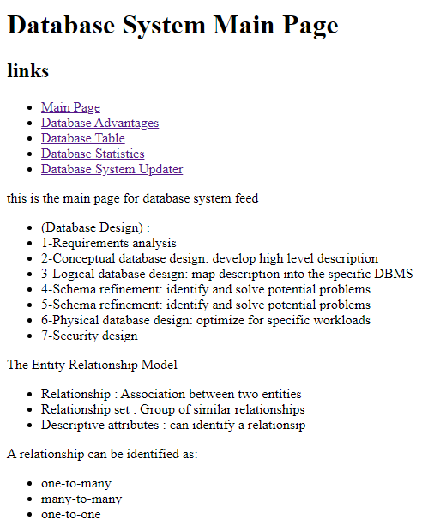

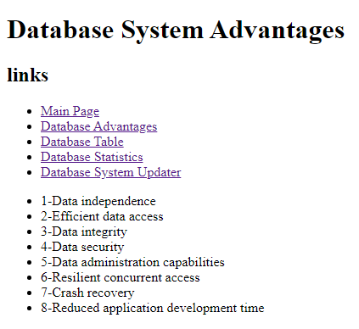

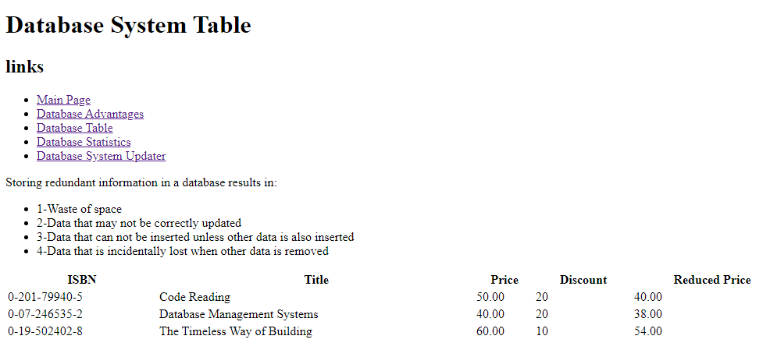

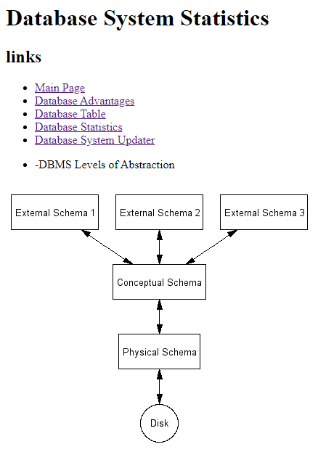

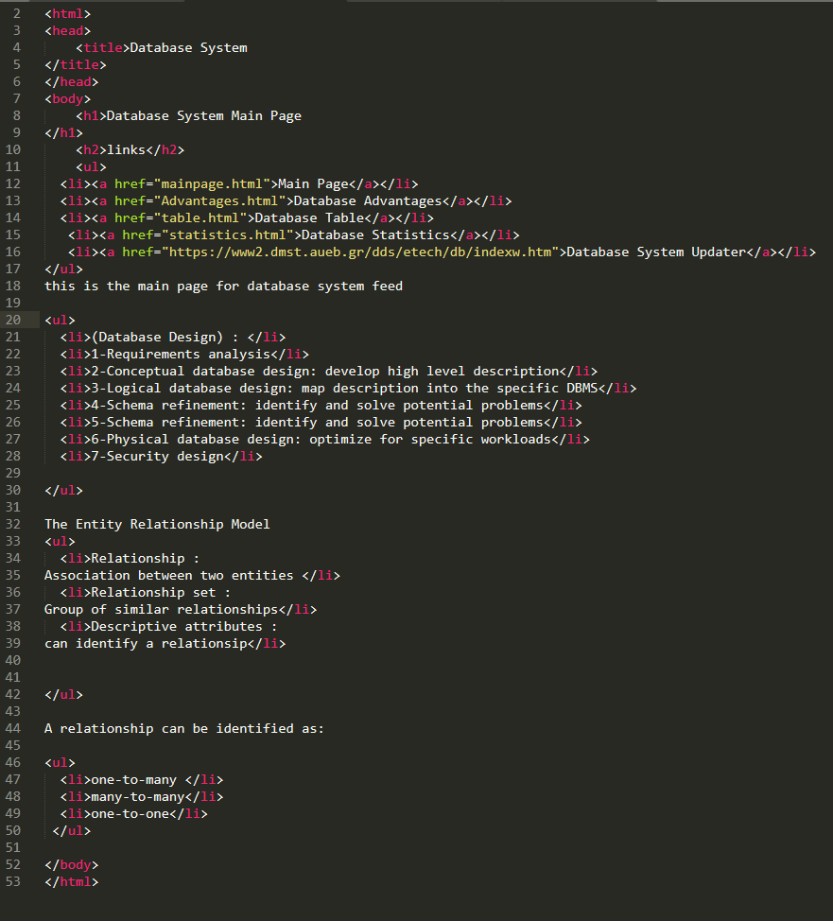**Source Code :**