**Name : Mohamed Farag Abd-Elsalam Hassan**

**B.N: 778**

**Date : 2/7/2020**

**Topic:**  **Database System**

**GitHub link :**

**GitHub page :**

**Application brief :**

Officially, a "database" refers to a set of related data and how it is organized. Access to this data is usually provided through the Database Management System (DBMS) which consists of an integrated set of computer programs that allow users to interact with one or more databases and provides access to all the data in the database (although Limitations may exist that limit access to certain data). The DBMS provides various functions that allow entry, storage and retrieval of large amounts of information and provides ways to manage how this information is organized.

Because of their close relationship, the term "database" is often used incidentally to refer to both the database and the DBMS used to process it.

Outside the professional IT world, the term database is often used to refer to any relevant set of data (such as a spreadsheet or card index) where size and usage requirements usually require the use of a database management system.

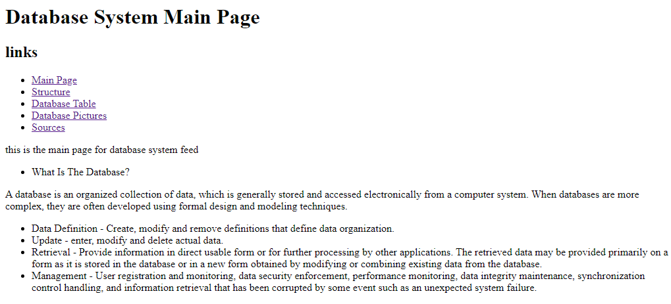**Screenshots :**

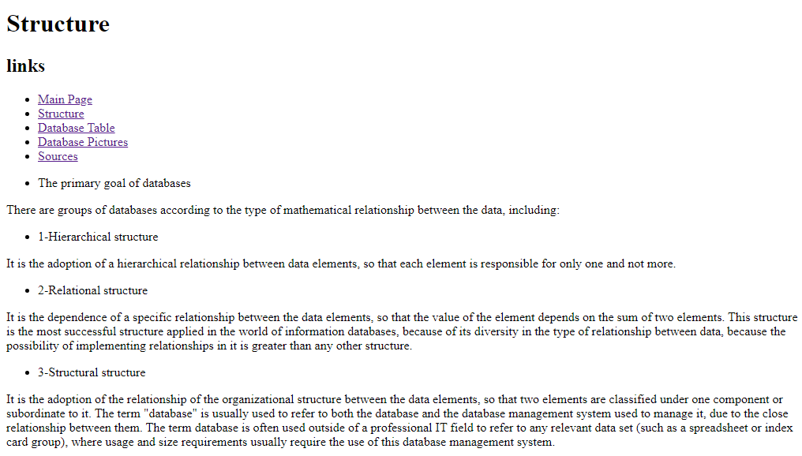

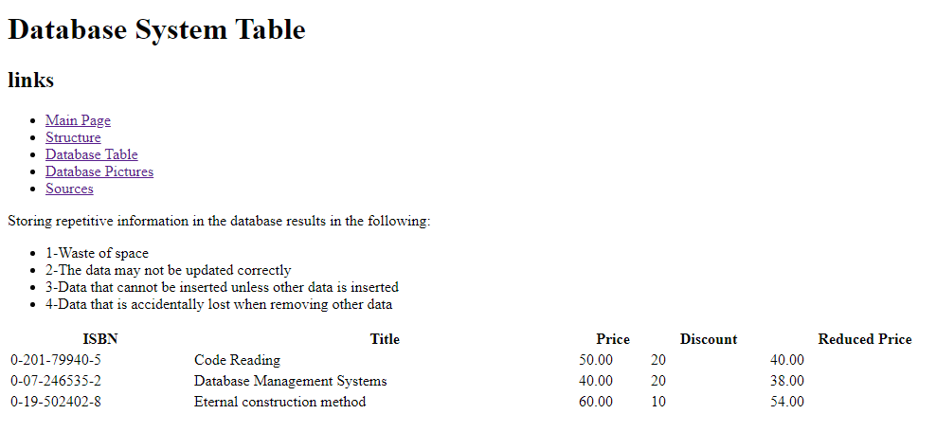

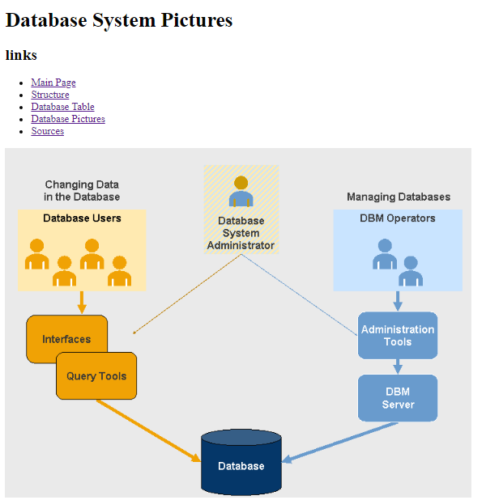

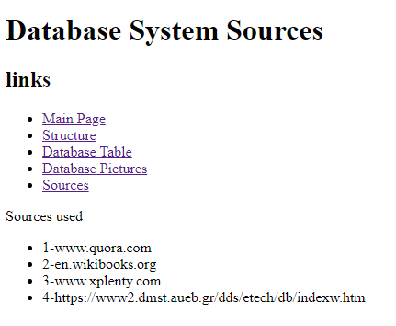

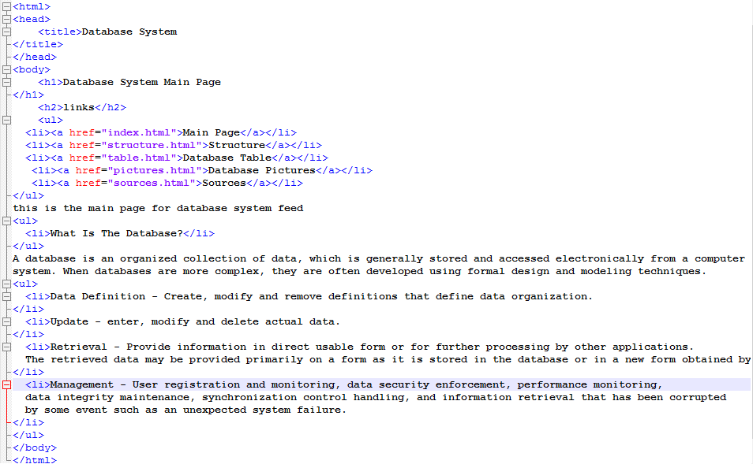**Source Code :**