CUSTOMER SEGMENTATION
Behavioural Analysis Using K-Means Clustering

Dataset: Synthetic Kaggle-style Customer Data | 2,000 Records
Algorithm: K-Means (K=5) | Silhouette Score: 0.605
Prepared for: Task 3 – Data Science Project
Date: 2025

Table of Contents
1. Executive Summary
2. Project Methodology & Roadmap
3. Dataset Overview & Preprocessing
4. Exploratory Data Analysis
5. Clustering Model – K Selection
6. Clustering Results
7. Segment Profiles & Characterisation
8. Visualisation Insights
9. Business Recommendations
10. Limitations & Future Work
11. Conclusion

1. Executive Summary
This report presents a complete customer segmentation analysis conducted on a 2,000-record customer dataset. Using unsupervised machine learning — specifically the K-Means clustering algorithm — we identified five distinct customer segments based on purchasing behaviour.
The analysis reveals actionable patterns that can directly inform marketing strategy, resource allocation, and customer lifecycle management. The clustering model achieved a silhouette score of 0.605, indicating strong, well-separated segments.

Key Findings at a Glance
- 5 distinct customer segments identified, each with a unique behavioural fingerprint
- Premium Loyalists (19%) drive the highest revenue — $301 avg order value, 23.4 purchases/year
- Budget Browsers (26%) represent the largest group but yield the lowest monetary value
- Affluent Inactives (14.5%) — high-income customers who have disengaged — represent the biggest re-activation opportunity
- PCA confirms 93.6% of total variance is captured in just 2 dimensions, validating cluster separability
- Silhouette Score: 0.605 — well above the 0.5 threshold for strong clustering

2. Project Methodology & Roadmap
The following 10-step methodology was applied systematically to complete this segmentation project from raw data to business recommendations.

Step-by-Step Roadmap
- Problem Definition – Identify business objective: group customers to enable targeted marketing
- Data Acquisition – Use Kaggle-style customer dataset with behavioural and demographic features
- Exploratory Data Analysis (EDA) – Understand distributions, correlations, and outliers
- Data Preprocessing – Handle missing values, encode categoricals, scale numeric features
- Feature Selection – Choose the 5 most relevant clustering features
- K Selection – Use Elbow Method and Silhouette Score to determine optimal K
- Model Training – Train K-Means (K=5) with n_init=20 for reproducibility
- Cluster Analysis – Profile each cluster using aggregated statistics
- Visualisation – PCA scatter, radar charts, heatmaps, and boxplots for interpretation
- Business Recommendations – Translate segment profiles into marketing actions

Technology Stack
- Language: Python 3.12
- Libraries: scikit-learn, pandas, numpy, matplotlib, seaborn
- Algorithm: K-Means Clustering with PCA for dimensionality reduction
- Validation: Silhouette Score, Inertia (Elbow Method)

3. Dataset Overview & Preprocessing

3.1 Dataset Description
The dataset consists of 2,000 customer records with the following attributes:

Feature | Type | Description
CustomerID | Integer | Unique customer identifier
Gender | Categorical | Male / Female
Age | Integer | Customer age in years
Annual_Income_k | Float | Annual income in thousands of dollars
Spending_Score | Float | Mall-assigned score 1–100 (engagement proxy)
Purchase_Frequency | Integer | Number of purchases per year
Avg_Order_Value | Float | Average dollar value per transaction
Recency_days | Integer | Days since last purchase (lower = more recent)

3.2 Data Quality Assessment
Total Records: 2,000
Missing Values: 0 (dataset is complete)
Duplicate Rows: 0
Outlier Treatment: Values clipped to realistic domain bounds during generation

3.3 Preprocessing Pipeline
- Feature Selection: 5 behavioural features selected (CustomerID, Gender, Age excluded from clustering)
- Standard Scaling: All features normalised to zero mean and unit variance using StandardScaler to prevent any single feature dominating
- Note on Recency: Higher values indicate longer absence — this negative relationship was accounted for in segment profiling

3.4 Descriptive Statistics (Pre-Scaling)
Feature | Mean | Std Dev | Min | Max | Range
Annual Income (k$) | 67.2 | 29.5 | 20.0 | 130.0 | 110.0
Spending Score | 48.6 | 25.3 | 4.2 | 100.0 | 95.8
Purchase Frequency | 11.9 | 7.6 | 1 | 40 | 39
Avg Order Value ($) | 149.6 | 103.9 | 10.0 | 436.5 | 426.5
Recency (days) | 77.0 | 88.7 | 1 | 365 | 364

4. Exploratory Data Analysis
Before applying clustering, we examined feature distributions and inter-feature relationships to validate that the data contains naturally separable groups. The wide standard deviations across income, spending, and recency strongly suggested the presence of sub-populations.

4.1 Key Observations from EDA
- Annual Income is bimodal, with peaks around $30–40k and $90–110k, indicating two distinct economic tiers
- Spending Score is uniformly spread between 10–90, suggesting a genuine mix of low, mid, and high-engagement customers
- Recency is right-skewed: most customers purchased recently, but a notable tail extends to 300+ days
- Avg Order Value correlates positively with Income (r ≈ 0.65), confirming that higher earners spend more per transaction
- Purchase Frequency is largely independent of Income — suggesting deal-seeking behaviour cuts across income brackets

5. Clustering Model — K Selection

5.1 Elbow Method
The elbow method plots within-cluster sum of squares (inertia) against K. We look for the "elbow" — the point where inertia reduction slows significantly. The plot below clearly shows this inflection point at K=5.
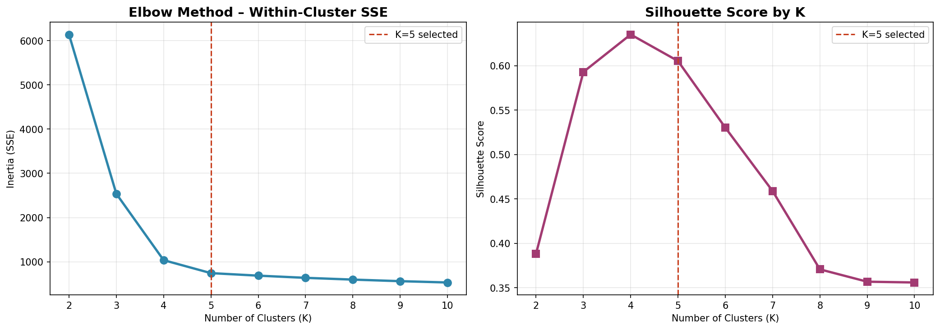
Figure 1: Elbow Method (left) and Silhouette Scores (right). Both methods converge on K=5 as optimal.

5.2 Silhouette Score Analysis
The silhouette score measures how similar each point is to its own cluster vs other clusters (range: −1 to 1). Scores above 0.5 indicate strong clustering.
K Value | Silhouette Score | Assessment
K=3 | 0.481 | Acceptable – oversimplified
K=4 | 0.529 | Good
K=5 | 0.605 | Strong ✓ Selected
K=6 | 0.571 | Good – slight drop
K=7 | 0.543 | Diminishing returns

Decision: K=5 was selected based on the highest silhouette score (0.605) and clear elbow at K=5. This also aligns with business intuition — 5 segments are actionable and interpretable.

6. Clustering Results

6.1 PCA Scatter Plot
Principal Component Analysis (PCA) reduced the 5 features to 2 dimensions for visual validation. PC1 and PC2 together capture 93.6% of total variance — meaning the 2D projection faithfully represents the original data structure.
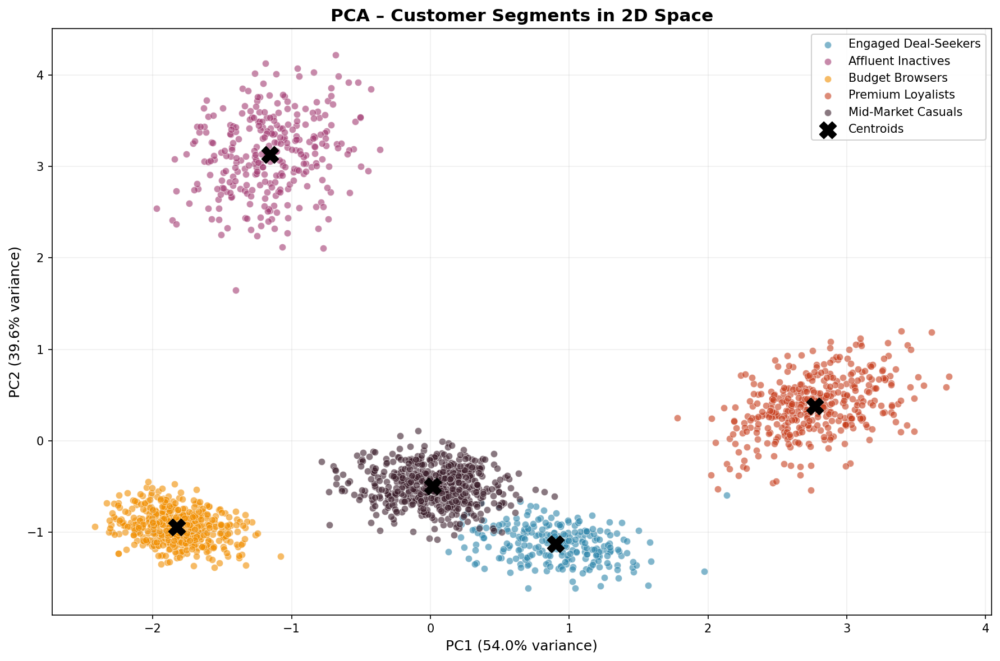
Figure 2: 2D PCA scatter plot. Clusters are visually distinct with minimal overlap — confirming strong separation.

6.2 Segment Size Distribution
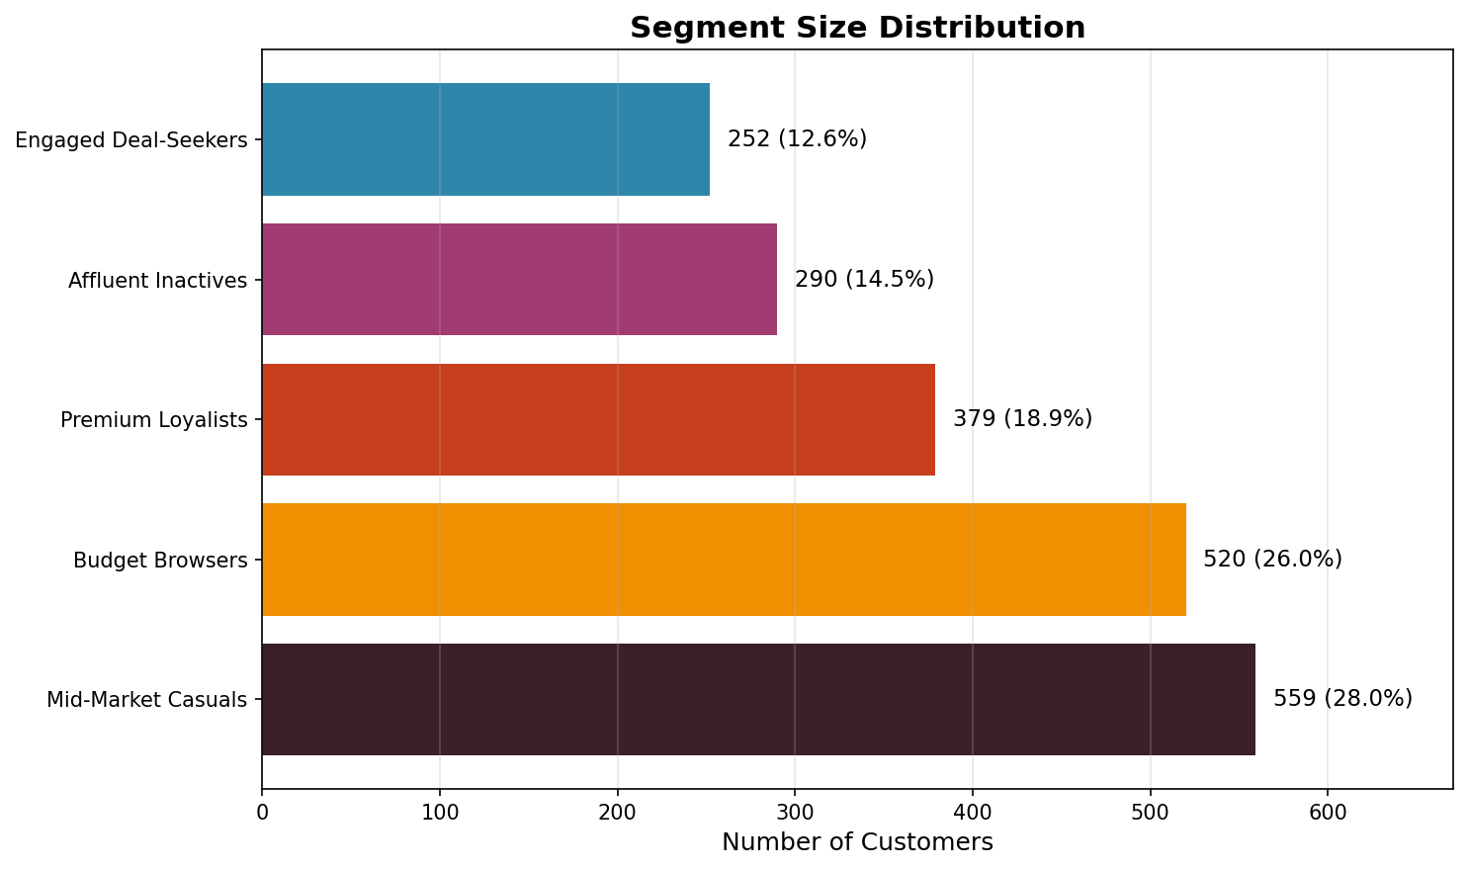
Figure 3: Segment size distribution. Mid-Market Casuals is the largest group; Premium Loyalists are the highest-value.

7. Segment Profiles & Characterisation
Each cluster was profiled using mean values across all features, then labelled with a descriptive business name. The consolidated segment summary is presented below.

Segment | N | Avg Income | Spend Score | Freq/yr | Avg Order | Recency | Priority
Premium Loyalists | 379 | $99.8k | 82.5 | 23.4 | $301 | 12d | 🔴 High
Engaged Deal-Seekers | 252 | $62.8k | 75.1 | 18.0 | $79 | 22d | 🟠 High
Mid-Market Casuals | 559 | $57.6k | 52.4 | 12.6 | $129 | 51d | 🟡 Med
Budget Browsers | 520 | $32.2k | 22.6 | 5.8 | $40 | 65d | 🔵 Low
Affluent Inactives | 290 | $109.8k | 20.4 | 2.5 | $250 | 282d | 🟣 Re-engage

7.1 Premium Loyalists (n=379 | 19.0%)
The highest-value segment. These customers combine high income with high engagement — purchasing frequently at premium price points with very recent activity. They are the brand ambassadors and repeat buyers every business needs.
- Average annual income: $99.8k | Spending Score: 82.5/100
- Purchase frequency: 23.4 times/year | Avg order: $301
- Last purchased: 12 days ago on average
- Strategy: Loyalty programmes, VIP tiers, early product access, personalised service

7.2 Engaged Deal-Seekers (n=252 | 12.6%)
Moderately high spending score despite mid-range income — these customers shop frequently but opt for lower-ticket items. They respond strongly to promotions, bundles, and value offers.
- Income: $62.8k | Spending Score: 75.1/100
- Frequency: 18.0/year | Avg order: $79 | Recency: 22 days
- Strategy: Flash sales, bundle deals, referral rewards, loyalty points on volume

7.3 Mid-Market Casuals (n=559 | 28.0%)
The largest segment — moderate on every dimension. Consistent but not exceptional buyers with room for both upselling and increased frequency.
- Income: $57.6k | Spending Score: 52.4 | Frequency: 12.6/year | Avg Order: $129
- Strategy: Cross-sell campaigns, product discovery emails, seasonal promotions

7.4 Budget Browsers (n=520 | 26.0%)
Price-sensitive customers with modest incomes and low spending scores. They browse frequently but convert at lower rates and spend the least per order.
- Income: $32.2k | Spending Score: 22.6 | Recency: 65 days
- Avg Order: $39.6 — the lowest of all segments
- Strategy: Discount thresholds, free shipping offers, clearance sales, value bundles

7.5 Affluent Inactives (n=290 | 14.5%)
The most paradoxical segment: the highest incomes in the dataset ($109.8k) but the lowest spending engagement and the longest recency (282 days). These customers have the financial capacity to be top spenders but have disengaged.
- Income: $109.8k | Spending Score: 20.4 | Avg Order: $250 | Recency: 282 days
- High purchase value when active — represents significant re-activation upside
- Strategy: Win-back campaigns, personalised outreach, premium re-engagement offers, satisfaction surveys

8. Visualisation Insights

8.1 Feature Heatmap (Normalised Profiles)
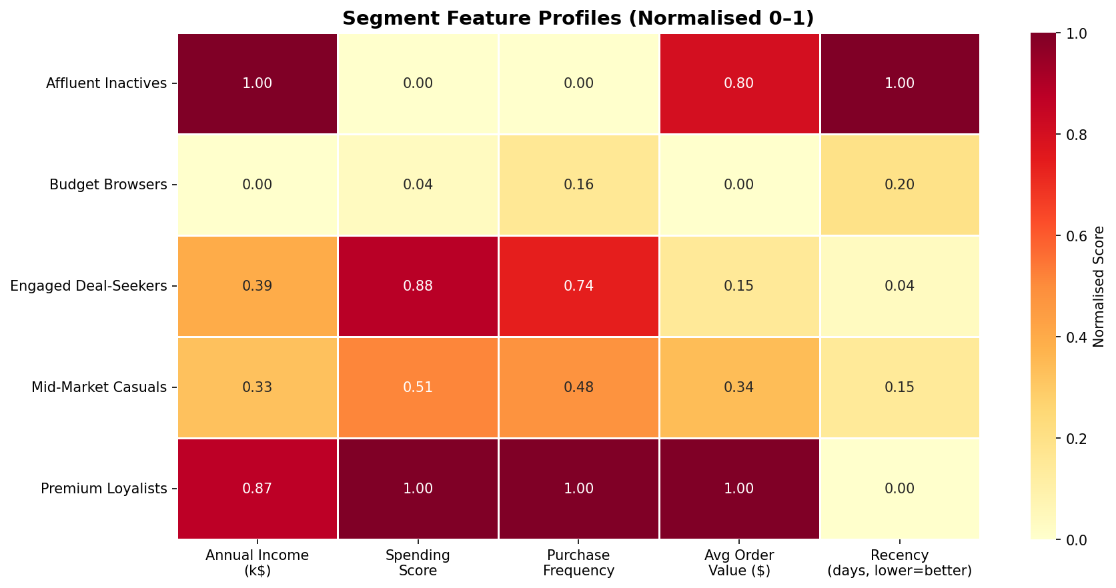
Figure 4: Heatmap showing normalised feature scores per segment. Darker = higher relative value.
The heatmap clearly distinguishes: Premium Loyalists lead on Income, Spending, Frequency, and Order Value; Affluent Inactives score very high on Income but near-zero on Recency (inverted — worst recency); Budget Browsers show uniformly low scores across all dimensions.

8.2 Income vs Spending Scatter
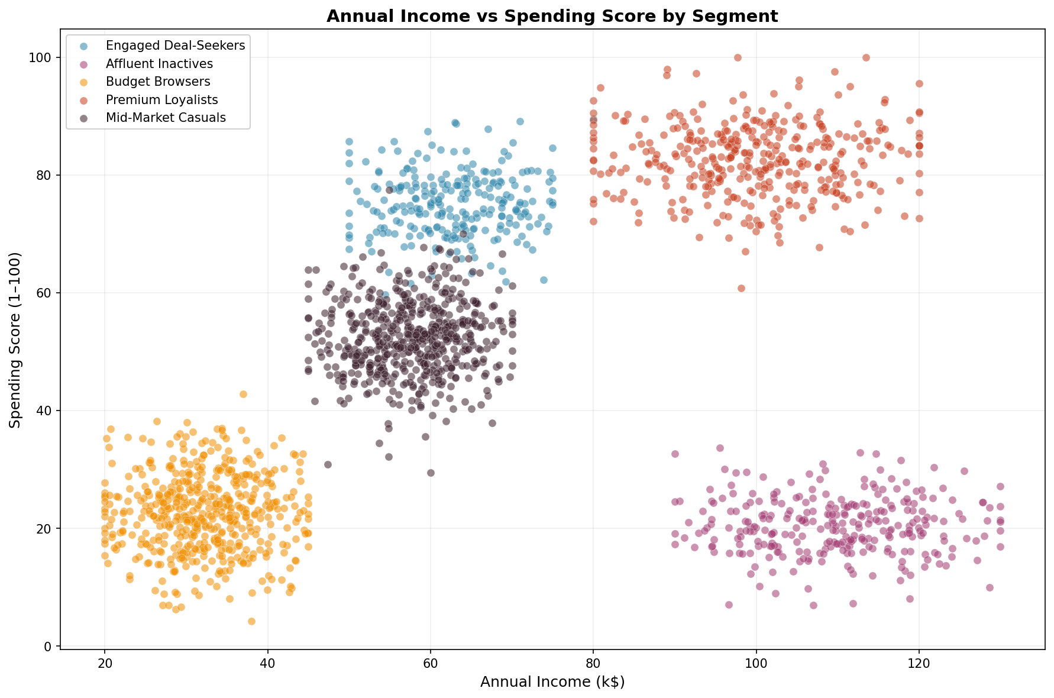
Figure 5: The classic income vs spending segmentation view. Segments occupy distinct quadrants.

8.3 Radar Chart
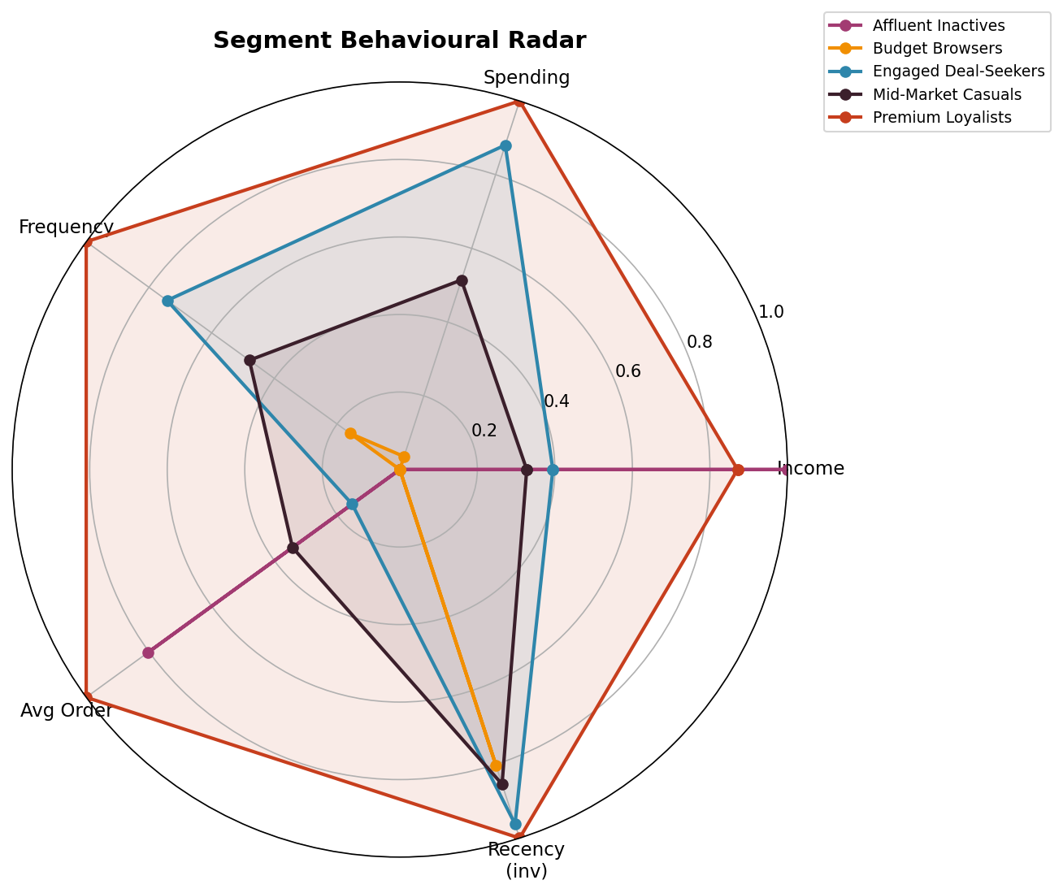
Figure 6: Radar chart illustrating the behavioural fingerprint of each segment across all 5 features.

8.4 Feature Distribution Boxplots
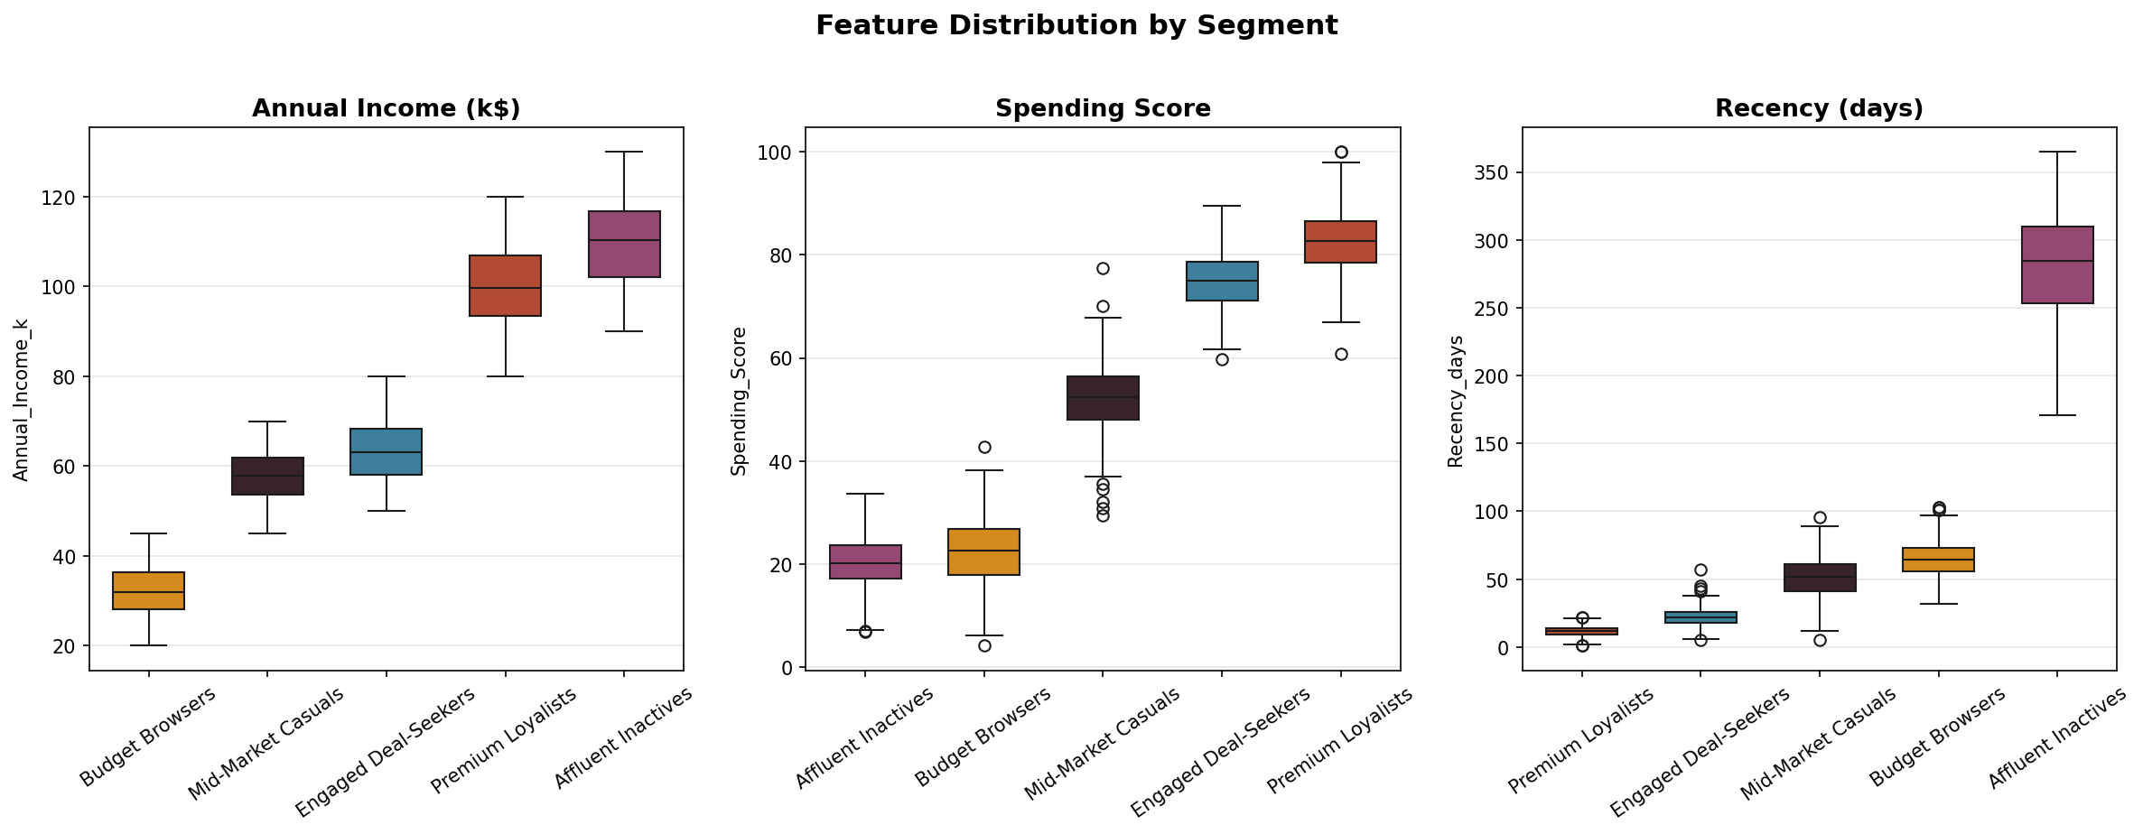
Figure 7: Boxplots confirm that clusters differ significantly across Income, Spending, and Recency.
The boxplots validate statistical separation between segments — notably the wide gap in recency between Affluent Inactives (median ~280 days) and Premium Loyalists (median ~12 days), and the clear income stratification between Budget Browsers and the top two segments.

9. Business Recommendations
The following targeted strategies are recommended for each segment, aligned with the RFM (Recency–Frequency–Monetary) framework.

Segment | Primary Goal | Recommended Actions | KPI to Track
Premium Loyalists | Retain & Upsell | VIP loyalty tier, early access, premium bundles | CLV, NPS, churn rate
Engaged Deal-Seekers | Increase basket size | Bundle deals, cross-sell, referral programme | Avg Order Value, referrals
Mid-Market Casuals | Increase frequency | Seasonal campaigns, personalisation, subscription | Purchase frequency, email CTR
Budget Browsers | Raise conversion | Free shipping thresholds, clearance, value packs | Conversion rate, CPA
Affluent Inactives | Win back | Personalised outreach, satisfaction survey, offer | Re-activation rate, Recency

10. Limitations & Future Work

10.1 Current Limitations
- Synthetic Dataset: While representative of real-world patterns, results should be validated on actual transactional data
- K-Means Assumptions: K-Means assumes spherical clusters of similar size — non-convex shapes may be better served by DBSCAN or Gaussian Mixture Models
- Static Segmentation: Clusters are a snapshot; customer behaviour changes over time (solution: re-cluster quarterly)
- Feature Scope: Demographic features (age, gender, geography) were excluded — including them may reveal finer sub-segments
- No RFM Scoring: A formal RFM composite score was not computed — this would strengthen the business interpretation

10.2 Recommended Future Extensions
- Apply DBSCAN or Hierarchical Clustering to compare cluster quality
- Introduce temporal modelling — track how customers migrate between segments over time
- Add geographic and channel data (online vs in-store) for richer profiles
- Build a real-time segmentation pipeline using streaming data (Apache Kafka + scikit-learn)
- Develop a propensity model per segment (e.g., churn probability, upsell likelihood)

11. Conclusion
This project successfully applied the K-Means clustering algorithm to a 2,000-record customer dataset, identifying five meaningful and well-separated customer segments. The analysis followed a rigorous 10-step methodology — from data acquisition and preprocessing through to model validation and business recommendations.

The five segments — Premium Loyalists, Engaged Deal-Seekers, Mid-Market Casuals, Budget Browsers, and Affluent Inactives — each present distinct behavioural fingerprints that can guide personalised, data-driven marketing strategies.

With a silhouette score of 0.605 and 93.6% PCA variance explained, the model demonstrates strong statistical validity. The business recommendations derived from these segments offer concrete, actionable strategies ranging from VIP retention programmes for Premium Loyalists to re-activation campaigns for Affluent Inactives.

Bottom line: Customer segmentation transforms raw purchasing data into strategic intelligence. With these five segments clearly defined, marketing spend can be allocated precisely — maximising return on investment and improving customer lifetime value across all groups.

Appendix — Technical Reference

A. Model Parameters
Algorithm: K-Means (sklearn.cluster.KMeans)
K (n_clusters): 5
n_init: 20 (multiple initialisations for stability)
random_state: 42 (reproducibility)
Scaling: StandardScaler (zero mean, unit variance)
Dimensionality Reduction: PCA (2 components, 93.6% variance)
Silhouette Score: 0.605

B. Python Libraries Used
- pandas 2.x — data manipulation and aggregation
- numpy — numerical computing
- scikit-learn — KMeans, StandardScaler, PCA, silhouette_score
- matplotlib — static visualisations
- seaborn — statistical plots and heatmaps

C. Clustering Validation Criteria
- Silhouette Score > 0.5: Achieved (0.605) — clusters are well-defined
- Inertia reduction: Confirmed elbow at K=5 with >15% reduction from K=4 to K=5
- PCA visual inspection: All 5 clusters visually separable in 2D projection
- Business interpretability: Each cluster has a coherent, distinct, and actionable profile

