AgenticForge
Technical Design Document
Agentic AI Orchestration Platform for the Enterprise

Milestones M1 – M8 • Phase 1 Build-Out
Prepared for engineers new to the project and to agentic AI systems

Table of Contents
Who This Is For 3
1. What Is AgenticForge? 3
2. Design Philosophy: The Decisions Behind the Architecture 4
3. Technology Stack 8
4. High-Level Design (Target Architecture, Post-M8) 9
5. Milestone-by-Milestone Build-Out 10
6. Data Model 11
7. Key Runtime Flows 16
8. Deployment Topology 19
9. Security & Governance Model (M8) 20
Glossary 21
Page numbers reflect this document's default layout; if content reflows in your Word client, right-click and choose “Update Field,” or use the Navigation Pane (View → Navigation Pane) to jump between sections.

Who This Is For
This document is written for developers who are new to the project — and possibly new to agentic AI systems in general. It explains not just what AgenticForge is, but why it's built the way it is: the alternatives that were on the table at each decision point, and the reasoning for the option that was picked.
Diagrams throughout this document are rendered from Mermaid source, which also renders automatically on GitHub and in most IDEs (VS Code, JetBrains) if you are viewing the original markdown — no external tool needed.
If a term is unfamiliar, check the Glossary at the end of this document before searching elsewhere.

1. What Is AgenticForge?
AgenticForge is an open-source agentic AI orchestration platform for enterprises. In plain terms: it's the infrastructure that lets a company run AI agents — LLM-driven programs that can call tools, query data, and take multi-step actions — safely, observably, and against whichever model provider makes sense, without every team re-solving the same problems of tool integration, tracing, access control, and cost control from scratch.
It is being built incrementally across eight milestones (M1–M8), each one a working, demoable increment rather than a big-bang release.

Goals
- Let an agent call tools (internal APIs, databases, files) through one consistent, standard protocol.
- Support multiple LLM providers (OpenAI, Anthropic, Azure OpenAI, self-hosted Ollama/vLLM) without rewriting agent code to switch providers.
- Make every agent run observable — trace every model call and tool call.
- Support human-in-the-loop (HITL) approval for sensitive tool calls.
- Enforce RBAC, audit logging, and PII handling as first-class concerns, not bolted on at the end.
- Run entirely on a developer laptop via Docker Compose, and move to a managed cloud (Helm/Terraform on AWS/Azure/OKE/GCP) later without rearchitecting.

Non-Goals (for Phase 1 / M1–M8)
- A hosted multi-tenant SaaS control plane (this is the self-hosted engine it would run on).
- A visual, no-code agent builder UI (out of scope — this is the backend).
- Training or fine-tuning models — AgenticForge only calls models.

2. Design Philosophy: The Decisions Behind Architecture
Every non-trivial system sits on a “spectrum” of design choices — there is rarely one objectively correct answer, only trade-offs suited to the problem at hand. This section walks through the major spectrum points an engineer should understand, what AgenticForge chose, and why.

2.1 Service granularity: coarse services, not a microservice-per-domain mesh
Spectrum | Description
One end | A single monolithic process doing everything
Other end | A microservice per business capability (agents-service, tools-service, models-service, runs-service, …)
Chosen | A handful of coarse-grained services, split by runtime concern, not by business entity
AgenticForge has exactly four Python services: orchestrator-api (HTTP surface), orchestrator-worker (agent execution), mcp-server (tool exposure), and ingestion (data pipelines) — plus a shared library (packages/shared) so business entities like Agent, Tool, and Run aren't duplicated or drift across services.
Why: a microservice-per-entity split adds network hops and deployment complexity that a small team doesn't get value from yet. Splitting by runtime concern instead — synchronous request handling vs. long-running async execution vs. tool exposure — maps directly to how each part actually needs to scale and fail independently. This can be split further later if a specific service becomes a bottleneck; the shared schema makes that a lower-risk move than it would be with per-service databases.

2.2 Synchronous API + asynchronous execution
Spectrum | Description
One end | The API handler runs the whole agent loop and blocks until done
Other end | Everything is event-driven with no synchronous surface at all
Chosen | orchestrator-api returns immediately; orchestrator-worker executes off a Redis-backed queue
An agent run can take anywhere from seconds to minutes, and can pause indefinitely waiting on a human approval (see 2.7). A request/response HTTP handler is the wrong shape for that. POST /runs writes a Run row, enqueues a job (via arq, a Redis job queue), and returns 202 Accepted with a run_id immediately. The worker picks the job up, and clients poll or stream (sse-starlette) for status.
Why: decouples “accepting work” from “doing work.” The API stays fast and simple; the worker can be scaled horizontally, retried on failure, and paused/resumed independently of any HTTP connection's lifetime.

2.3 Three kinds of state, three purpose-built stores
An engineer instinct is “we have a database, everything should live in it.” AgenticForge deliberately splits state across three systems:
State | Owner | Why Not the App DB
Business state (Run.status, who requested it, approvals) | AgenticForge's Postgres schema (runs, run_approvals) | This is app data — it belongs here
Execution state (the agent's step-by-step graph position, message history mid-run) | LangGraph's own Postgres checkpointer tables (checkpoints, checkpoint_writes) | LangGraph already has a battle-tested, resumable state format — reimplementing it would be redundant and fragile
Observability state (every LLM call, token, latency, cost, tool span) | Langfuse (its own Postgres + ClickHouse + object storage) | Trace volume is high-cardinality, time-series-shaped data — a different access pattern than transactional business data, and Langfuse already solves querying/visualizing it
Why: each store is optimized for its access pattern. Cramming detailed execution traces into the same transactional schema as Run rows would make that schema a bottleneck for something that's fundamentally a logging/analytics workload. All three happen to live in Postgres locally for operational simplicity (one Postgres server, three schemas/databases) but are logically — and could be physically — separate.

2.4 Tool integration: an open protocol (MCP), not bespoke function-calling
Spectrum | Description
One end | Hand-write a Python function per tool, wired directly into the agent framework's function-calling API
Other end | Adopt a standard protocol for exposing and calling tools, decoupled from any one agent framework or model vendor
Chosen | Model Context Protocol (MCP), via mcp-server (Streamable HTTP transport)
Tools are exposed by mcp-server and consumed by the LangGraph agent in orchestrator-worker through langchain-mcp-adapters. Because MCP is a standard, the same mcp-server could also be pointed at by a different agent framework, or by an external MCP-compatible client (e.g. an IDE), without any change to how tools are defined.
Why: hand-rolled function-calling schemas tend to get tightly coupled to one framework's calling convention. MCP externalizes “what tools exist and how to call them” from “what agent framework is calling them,” which matters a lot in a platform meant to outlive any one framework choice.

2.5 Scaling tool coverage: generate tools from OpenAPI specs, don't hand-write each one
Spectrum | Description
One end | An engineer writes a wrapper function for every internal API endpoint an agent should call
Other end | Any API with an OpenAPI/Swagger spec is automatically turned into a set of callable MCP tools
Chosen | Both, in sequence — manual tools first (M2, to prove the mechanism), then an OpenAPI-to-MCP adapter (M3, to scale coverage)
Why: most enterprises already have OpenAPI specs for their internal services. Auto-generating tool definitions (Tool.input_schema, Tool.tool_key) from those specs means adding a new tool is a registration step (ToolSource row + spec URL), not a code change. Manual tools remain available for cases the spec doesn't capture well (custom auth flows, composite operations).

2.6 Multi-model support: a registry + routing rules, not a hardcoded SDK call
Spectrum | Description
One end | Agent code calls openai.ChatCompletion.create(...) directly
Other end | Every model call goes through a registry that resolves a logical model_key to a provider, with rules that can route by agent, tag, or cost
Chosen | Registry + routing rules (model_providers, model_registry, model_routing_rules tables, M5)
An Agent references a default_model_key, not a provider SDK call. ModelRoutingRule can override that per-condition (e.g. route agent_tag: high_stakes to a specific, more capable/expensive model). langchain-core + provider-specific packages (langchain-openai, langchain-anthropic, langchain-ollama) provide the actual client implementations behind that registry.
Why: avoids vendor lock-in and hardcoded model choices scattered through agent code. Swapping a model, adding a new provider, or changing cost/latency trade-offs becomes a data change, not a code change.

2.7 Human-in-the-loop approval as first-class state
Spectrum | Description
One end | Agents run fully autonomously; risky actions are just… allowed
Other end | Every tool call requires human approval (defeats the purpose of automation)
Chosen | Per-tool requires_approval flag; approval is a modeled, queryable, resumable state (run_approvals, Run.status = paused_hitl)
Why: in an enterprise setting, some actions (e.g. “send this email,” “execute this SQL write”) need a human in the loop, but most don't. Making approval a durable row in Postgres (not an in-memory pause) means a run can sit paused for hours or days, survive a worker restart, and be resumed from its LangGraph checkpoint exactly where it left off once approved.

2.8 Governance designed into the schema from day one, enforced later
Spectrum | Description
One end | Bolt on RBAC/audit/PII handling at the end, once the “real” features work
Other end | Block all feature work until governance is fully built
Chosen | Schema-first: roles, permissions, api_keys, audit_log, pii_findings, and Tool.pii_policy all exist in the M1 schema — but enforcement is hardened at M8
Why: retrofitting audit trails and PII handling onto a schema not designed for them is painful (migrations touching every table, missing historical data). Defining the shape early — even before it's enforced — means M1–M7 features are built against tables that already assume governance will apply, so M8 is about turning on enforcement, not inventing new tables under time pressure.

2.9 Vector search inside the primary database, not a separate vector DB
Spectrum | Description
One end | A dedicated vector database (Pinecone, Weaviate, Qdrant, …)
Other end | Vector columns live in the same Postgres instance as everything else, via the pgvector extension
Chosen | pgvector — the embeddings table lives in the same schema as agents, runs, etc.
Why: at the data volumes this platform starts at, a dedicated vector database is an extra moving part (extra service, extra ops burden, extra consistency-between-two-databases problem) for a benefit (specialized ANN performance at huge scale) the project doesn't need yet. pgvector gives “good enough” similarity search with zero additional infrastructure and transactional consistency with the rest of the data. This is a decision that can be revisited later if scale demands it — nothing else in the architecture depends on vectors living in Postgres specifically.

2.10 Deployment: local Docker Compose now, cloud later, same code
Spectrum | Description
One end | Design for Kubernetes/cloud from day one
Other end | Build only for a laptop, rewrite for production later
Chosen | Docker Compose today; Helm/Terraform layered on top later without application rework
Every service is a container with environment-variable configuration and no compose-specific assumptions baked into application code (no code reaches into docker-compose.yml). That means the same images are what a Helm chart would deploy later — the change at that point is how containers are scheduled and networked, not what's inside them.
Why: local Docker Compose is fast to iterate on and doesn't require cloud credentials or cluster access for a developer to get productive. Since the services are already stateless-and-config-driven, moving to Kubernetes is additive infrastructure work, not an application rewrite.

3. Technology Stack
Layer | Technology | Why This, Not an Alternative
Language / runtime | Python 3.11, uv workspace (monorepo) | One dependency manager and lockfile across all services; uv is fast and workspace-aware, so shared code (packages/shared) is a normal editable dependency, not a copy-pasted module
HTTP API | FastAPI + Uvicorn | Async-native, typed request/response models via Pydantic, automatic OpenAPI docs — which also means orchestrator-api itself is a candidate for MCP tool generation later
Agent execution | LangGraph | Purpose-built for stateful, resumable, multi-step agent workflows with built-in checkpointing — a better fit than a plain LLM-calling loop once HITL pausing and retries are required
Tool protocol | MCP (official Python SDK), Streamable HTTP transport | Open standard for tool exposure, decoupled from any one agent framework (see §2.4)
Job queue | Redis 7 + arq | Lightweight async Python job queue; avoids pulling in a heavier broker (Celery/RabbitMQ) for a workload that's “run this agent job” rather than complex routing topologies
Primary database | PostgreSQL 16 + pgvector | One relational store for business data, ingestion metadata, and vector embeddings (see §2.9)
Schema migrations | Alembic | Standard for SQLAlchemy-based schemas; runs as a one-shot migrate container before app services start
ORM / models | SQLAlchemy 2.0 (async), Pydantic | Typed models shared across services via packages/shared
LLM provider clients | langchain-openai, langchain-anthropic, langchain-ollama (+ Azure OpenAI, vLLM via OpenAI-compatible endpoints) | Consistent langchain-core interface across providers, so the model registry can swap providers without changing call sites
Observability / tracing | Langfuse (self-hosted OSS, v3) | Purpose-built for LLM trace/cost/latency observability; self-hosting keeps trace data (which may include PII) inside the same trust boundary
File parsing (ingestion) | unstructured | Handles heterogeneous document formats (PDF, DOCX, HTML, …) for the RAG ingestion pipeline
Text chunking | langchain-text-splitters | Standard chunking strategies compatible with the rest of the LangChain/LangGraph stack already in use
Semantic / BI layer | Cube.dev | Purpose-built semantic layer for defining metrics once and querying them consistently — from SQL, REST, or an agent tool — rather than agents generating ad hoc SQL against raw tables
Local orchestration | Docker Compose v2 | See §2.10
Target cloud orchestration | Helm + Terraform (AWS/Azure/OKE/GCP) | Layered on later; not implemented in Phase 1
Lint / type-check / test | ruff, mypy, pytest + pytest-asyncio + testcontainers | testcontainers spins up real Postgres/Redis in tests rather than mocking them — consistent with the project's general preference for real dependencies over mocks in integration tests

4. High-Level Design (Target Architecture, Post-M8)
This is where all eight milestones converge. Earlier milestones are subsets of this diagram — see Section 5 for how it's built up incrementally.

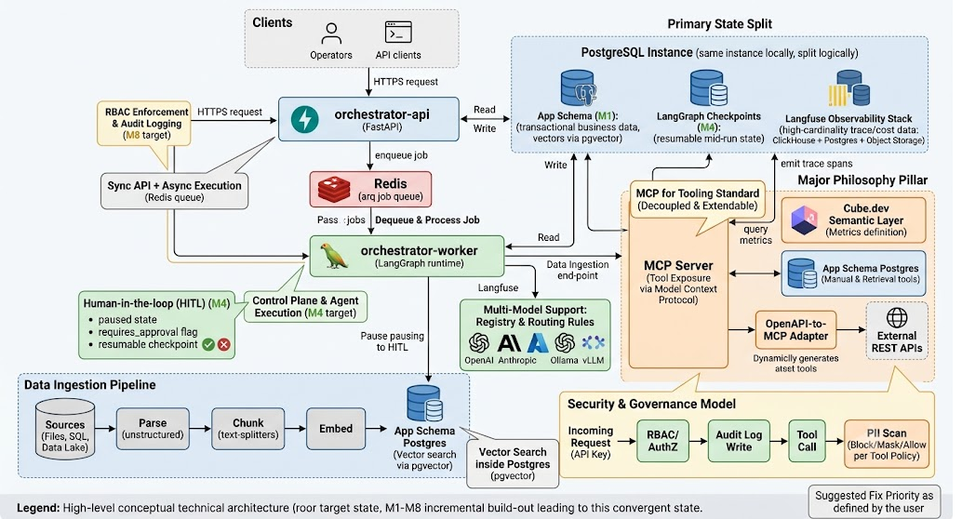
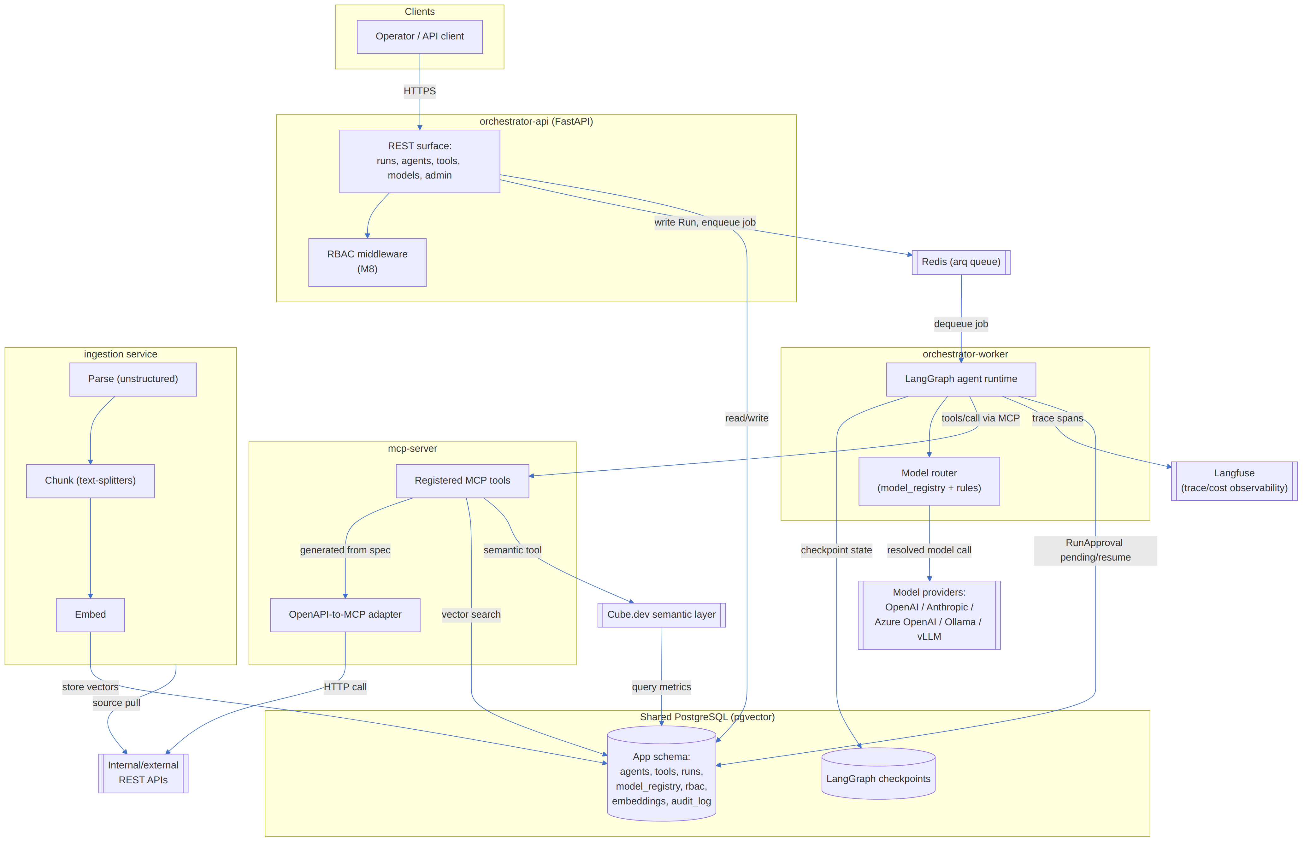
Figure 1. AgenticForge target architecture — all services, stores, and external dependencies.

5. Milestone-by-Milestone Build-Out
Understanding how the system was built up, one working increment at a time, is often more instructive than only seeing the final diagram above. Each milestone is runnable and demoable on its own.
Figure 2. Milestone sequence, M1 through M8.
Milestone | Adds | Status
M1 — Skeleton | Docker Compose stack; Postgres + pgvector; Alembic initial schema (all tables, even future-milestone ones); empty orchestrator-api (/healthz) and mcp-server (no tools registered yet) | Done
M2 — First real tool | One manually-defined MCP tool + one real API call, registered in tools/tool_sources | Planned
M3 — OpenAPI-to-MCP adapter | Given an OpenAPI spec URL, auto-generates MCP tool definitions — scales tool coverage without hand-writing wrappers per endpoint | Planned
M4 — Agent runtime | orchestrator-worker comes online: LangGraph executes agents, calling MCP tools, off the Redis/arq queue; Postgres checkpointing for resumable state; Langfuse wired in for tracing | Planned
M5 — Model registry | model_providers/model_registry/model_routing_rules populated and enforced; multi-provider routing goes live (OpenAI, Anthropic, Azure OpenAI, Ollama, vLLM) | Planned
M6 — RAG ingestion | ingestion service: file/SQL/datalake sources parsed, chunked, embedded into pgvector; a retrieval MCP tool for agents to query it | Planned
M7 — Semantic layer | Cube.dev definitions in semantic-layer/cube, exposed as a queryable metrics layer — including as an agent tool, so agents query defined metrics instead of writing raw SQL | Planned
M8 — Governance hardening | RBAC enforcement (roles/permissions/API keys), audit_log writes on mutating actions, PII detection/masking (pii_findings, Tool.pii_policy) enforced at runtime | Planned

M1 Today (What's Actually Running)
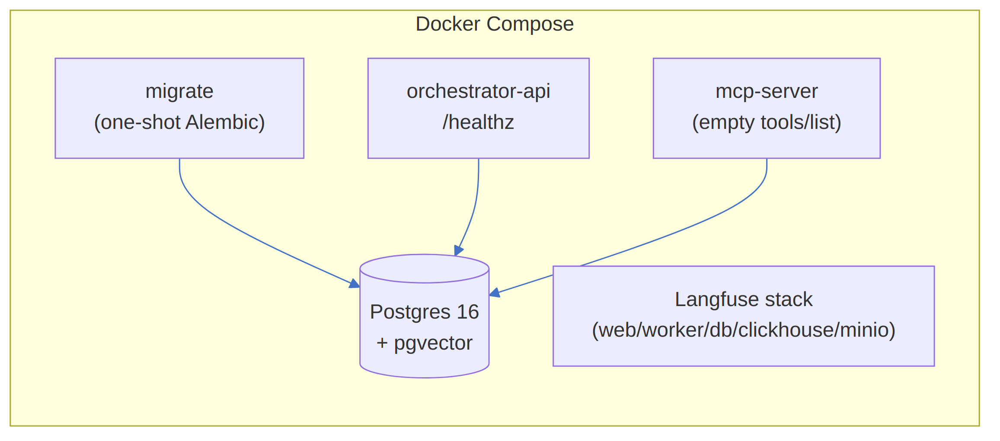
Figure 3. The M1 skeleton, currently running via Docker Compose.

6. Data Model
The schema is defined once in packages/shared, migrated by Alembic, and shared read/write by orchestrator-api, orchestrator-worker, and ingestion. It's grouped here by domain, matching the milestones that populate/enforce each group.

6.1 Agents & Tools (M1–M3)
The core catalog of what agents exist and what tools they can call. A TOOL_SOURCE (OpenAPI spec, manual definition, SQL semantic layer, RAG index, or code execution sandbox) exposes one or more TOOL rows, each carrying a JSON input schema, an approval flag, and a PII policy. AGENT_TOOL is the many-to-many join between agents and the tools they're allowed to call.
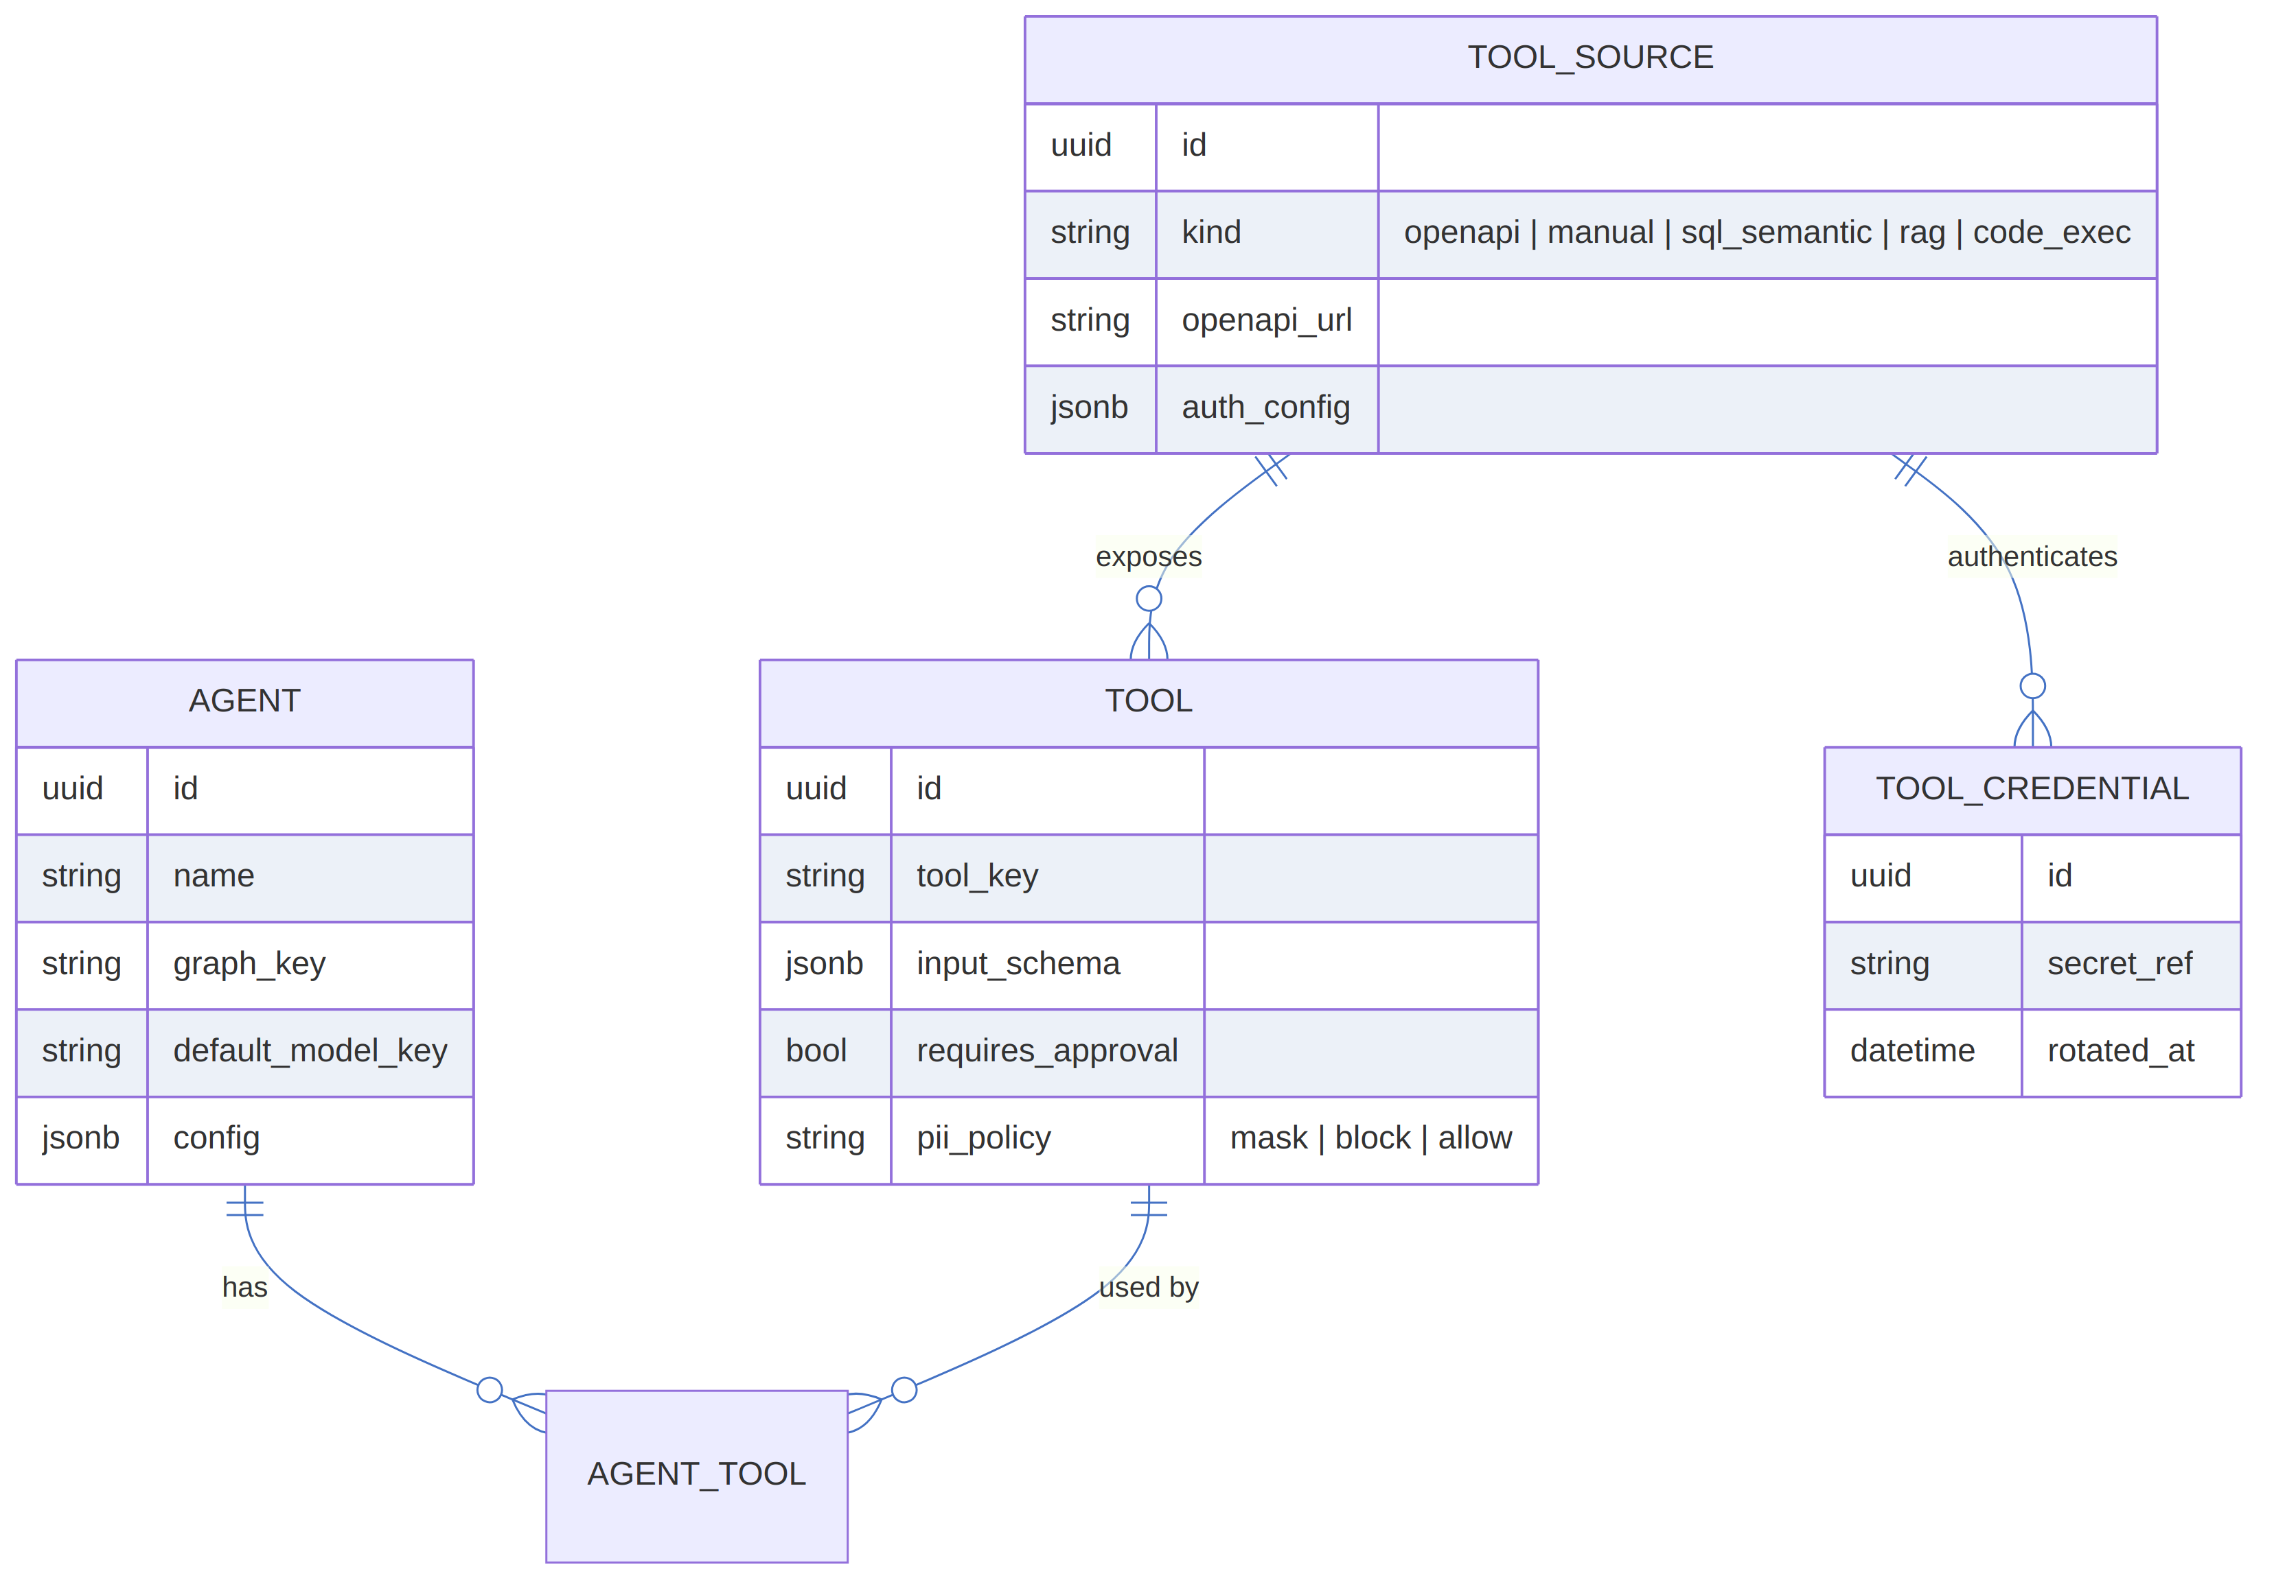
Figure 4. Agents & Tools entity-relationship diagram.

6.2 Model Registry (M5)
A MODEL_PROVIDER (OpenAI, Anthropic, Azure OpenAI, Ollama, vLLM) offers one or more MODEL_REGISTRY_ENTRY rows (chat or embedding models, with context window and cost metadata). MODEL_ROUTING_RULE matches conditions (e.g. an agent tag) to a target model key, so routing logic lives in data rather than code.
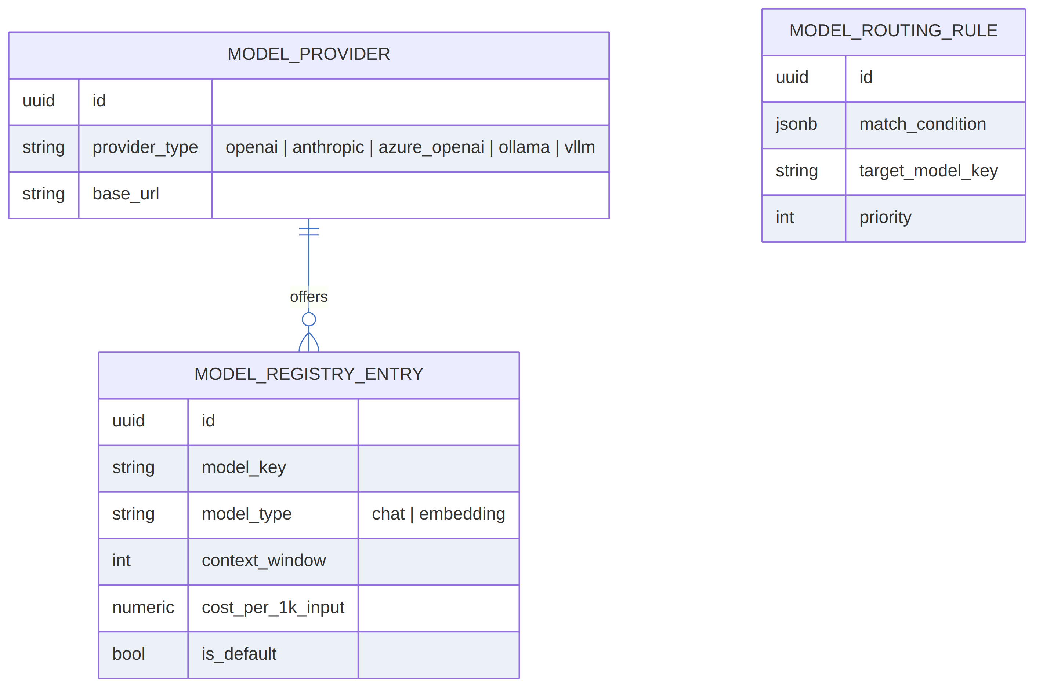
Figure 5. Model Registry entity-relationship diagram.

6.3 Runs & Human-in-the-Loop (M4)
Each RUN (whose id doubles as the LangGraph thread_id) tracks status, input/output, and its Langfuse trace id. A RUN_APPROVAL row gates any tool call flagged requires_approval, holding a pending/approved/rejected status and who decided it.
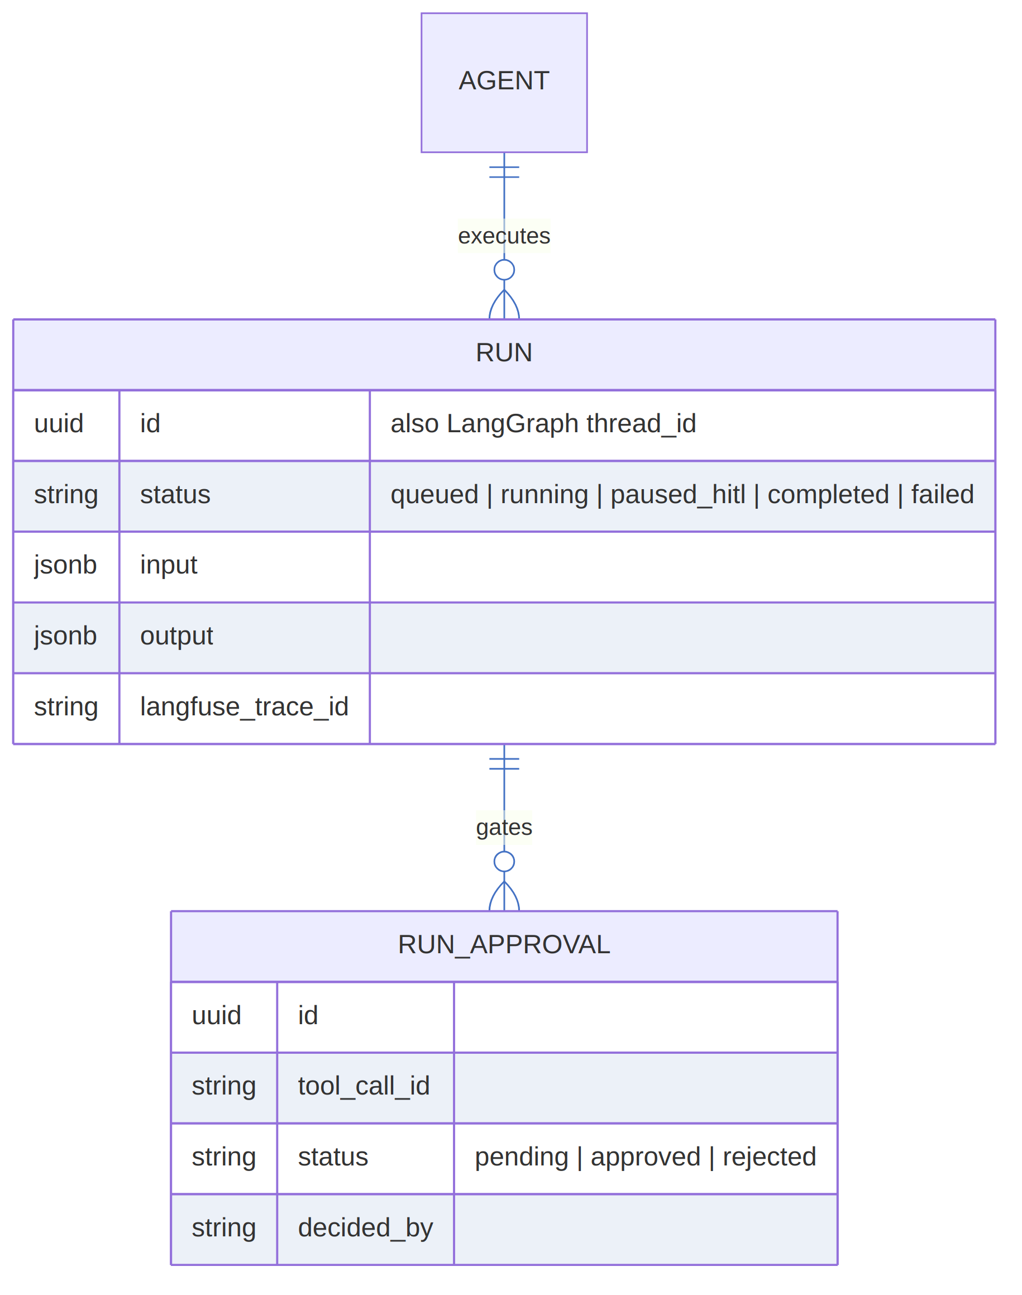
Figure 6. Runs & Human-in-the-Loop entity-relationship diagram.

6.4 Ingestion & RAG (M6)
An INGESTION_SOURCE (file, SQL database, or datalake) produces INGESTION_RUN records tracking rows processed and chunks created, and yields EMBEDDING rows — chunked text plus a 1024-dimension vector — used for retrieval.
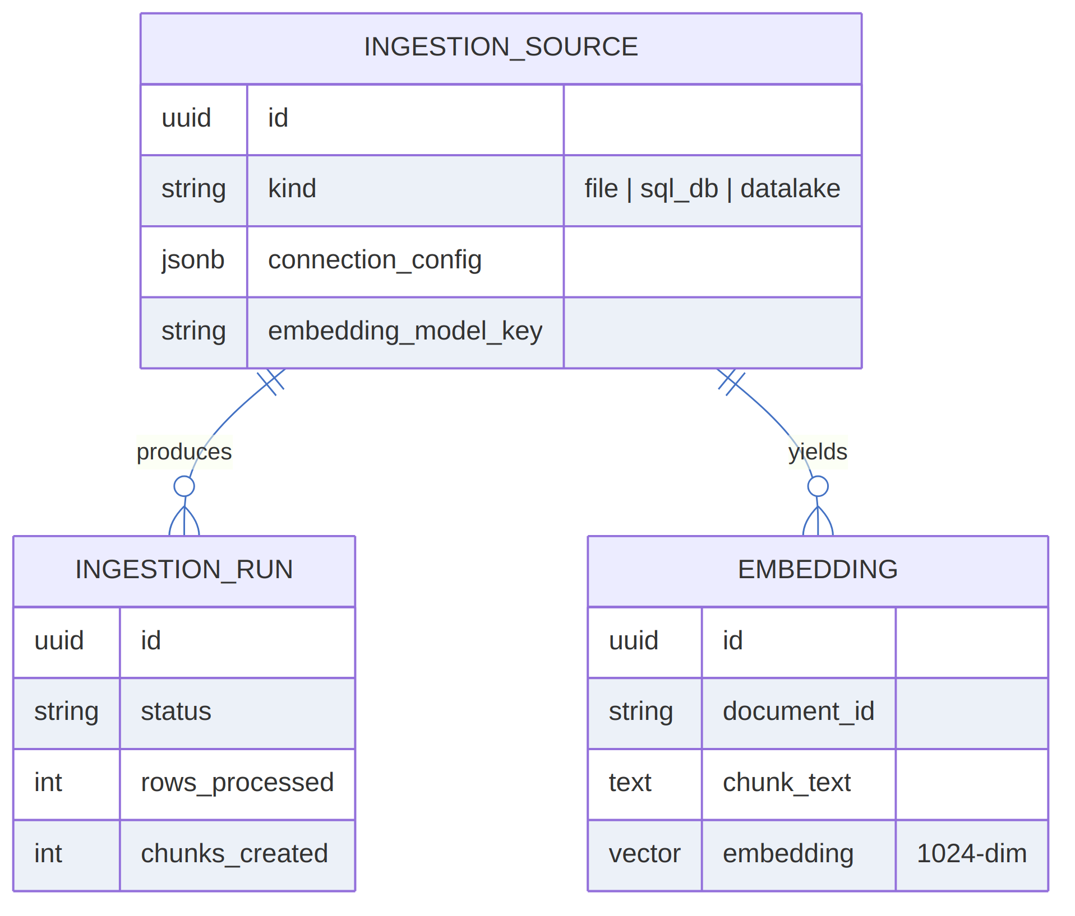
Figure 7. Ingestion & RAG entity-relationship diagram.

6.5 RBAC & Governance (M8)
Standard role-based access control: a ROLE grants PERMISSIONs via ROLE_PERMISSION, and is assigned to API_KEYs. AUDIT_LOG captures before/after state on mutating actions, and PII_FINDING records what entity types were masked or blocked per Tool.pii_policy.
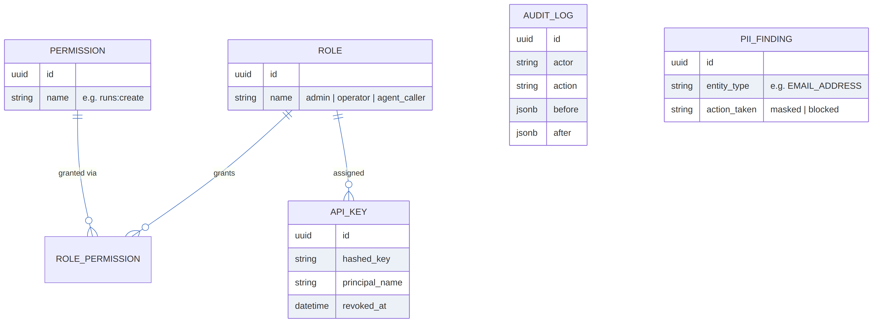
Figure 8. RBAC & Governance entity-relationship diagram.

7. Key Runtime Flows

7.1 Agent Run Lifecycle (with HITL Pause), from M4 Onward
A client posts to /runs; the API writes a Run row and enqueues a job, returning 202 Accepted immediately. The worker dequeues the job, loads or creates a LangGraph checkpoint keyed by thread_id = run_id, and begins the model/tool loop, emitting trace spans to Langfuse along the way. If a requested tool has requires_approval = true, the worker inserts a pending RunApproval, sets Run.status = paused_hitl, and exits — the run stays parked on its checkpoint until a human approves it via the API, at which point a resume job picks execution back up from exactly where it left off.
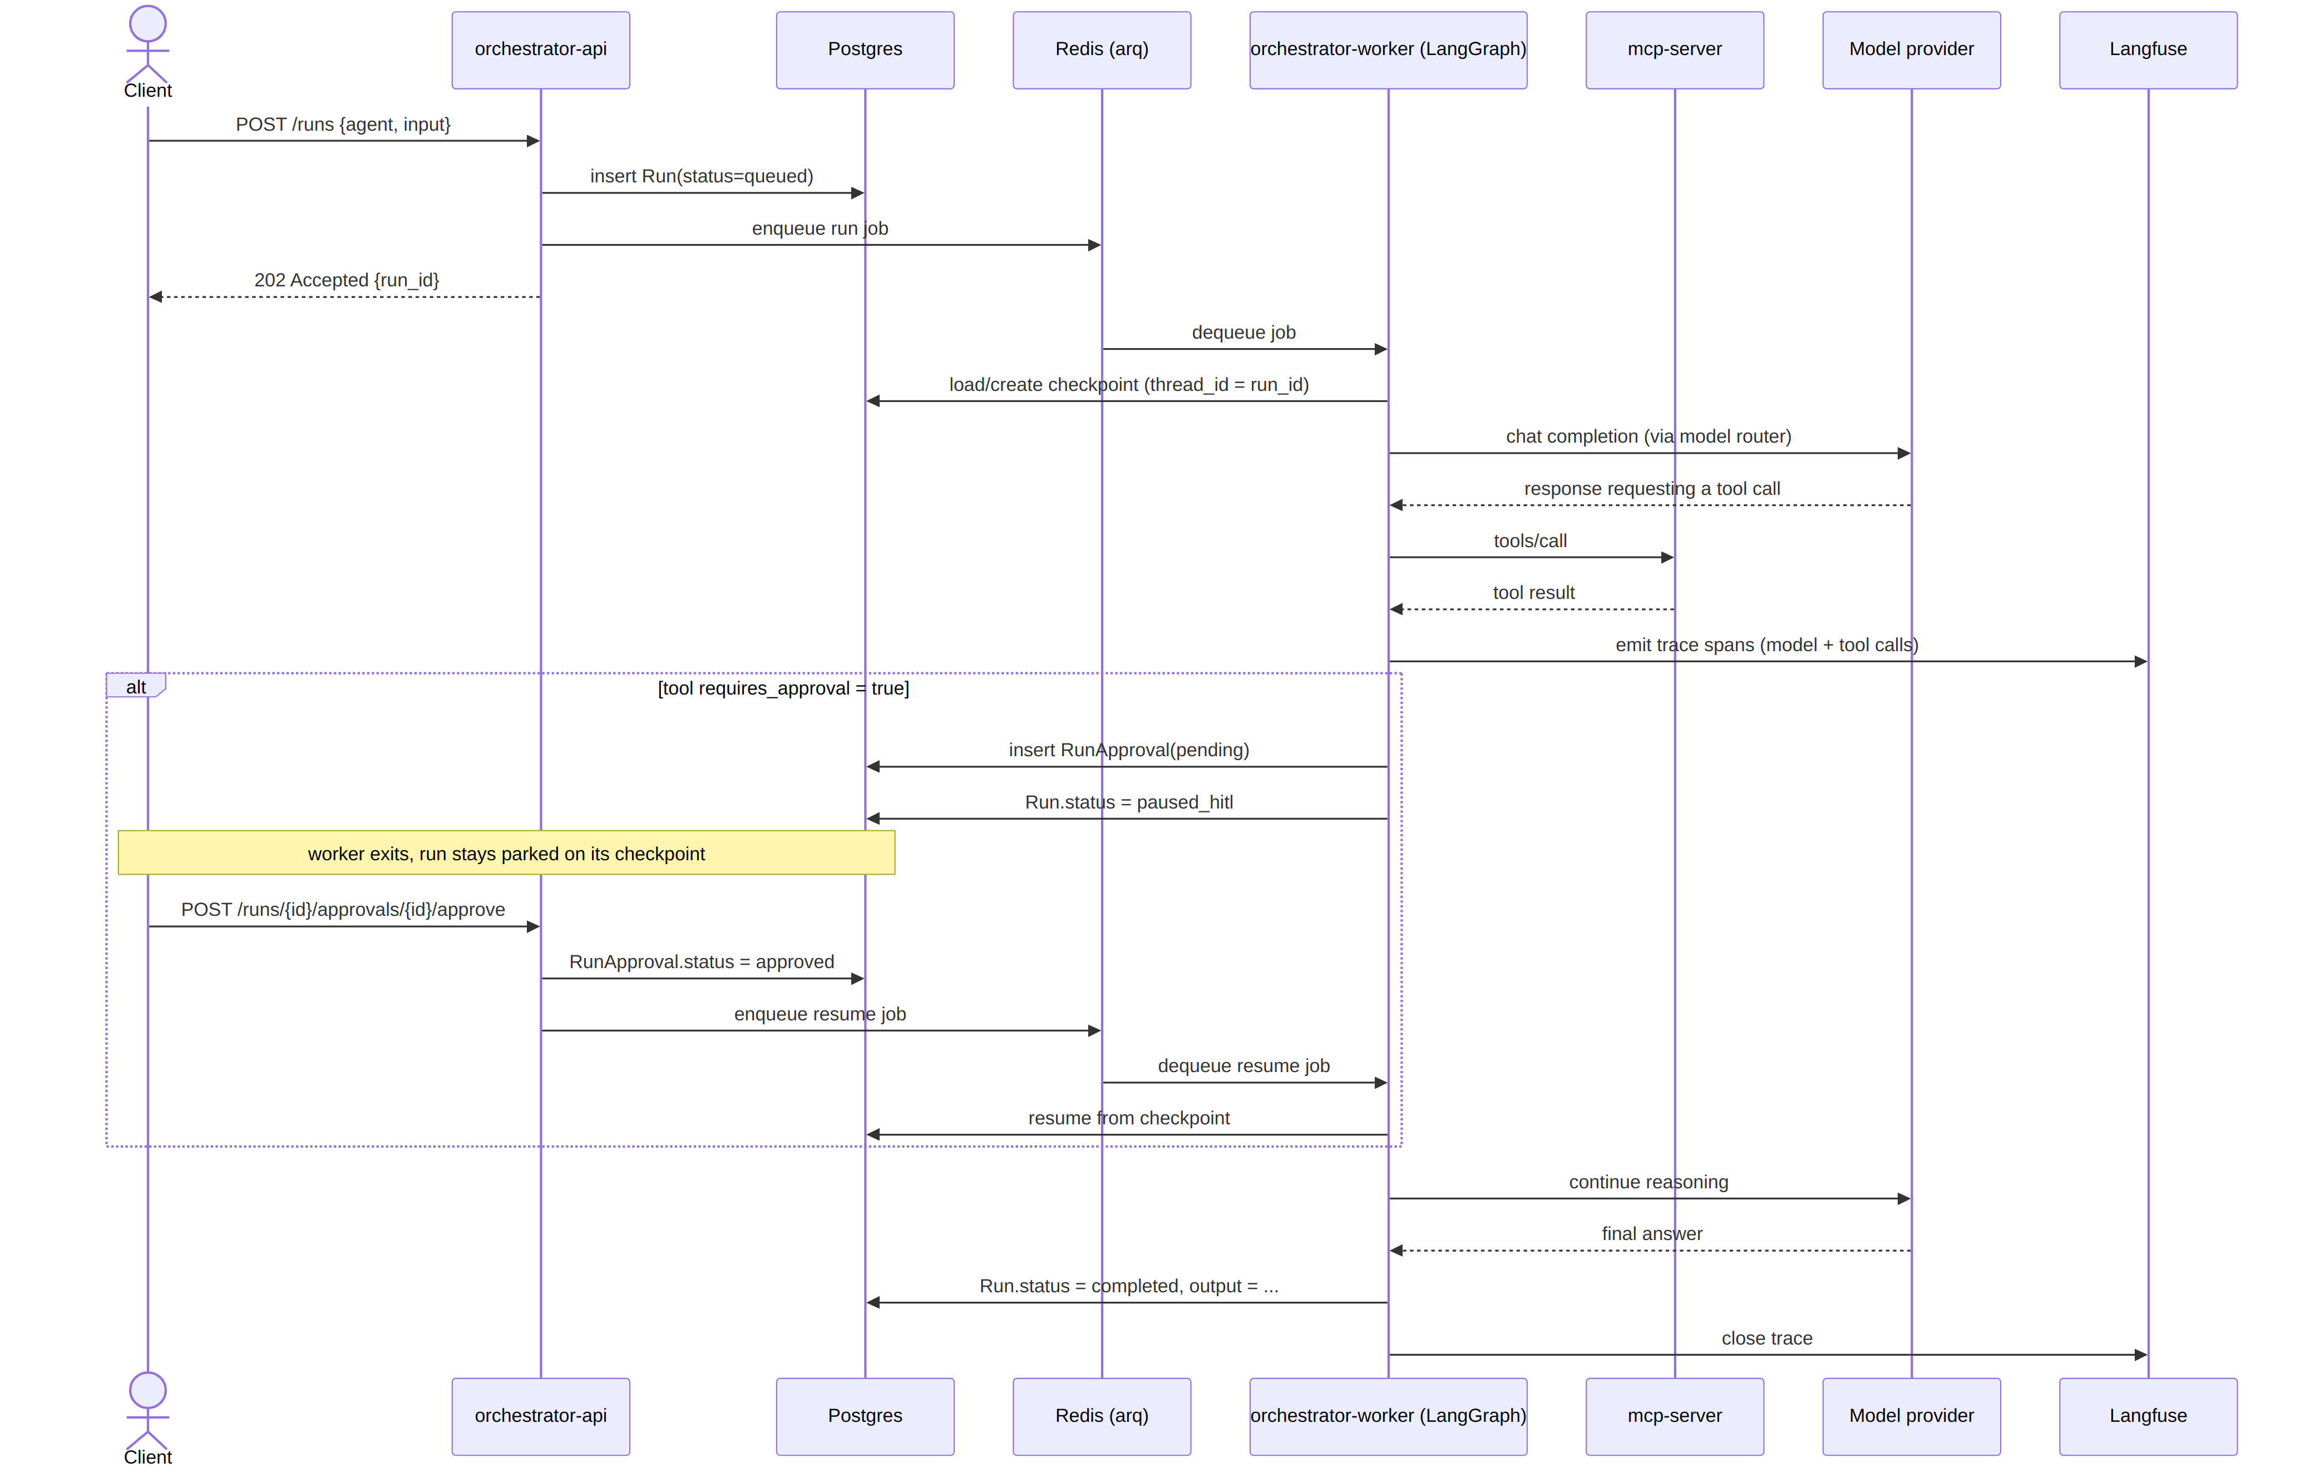
Figure 9. Agent run lifecycle sequence diagram, including a human-in-the-loop pause and resume.

7.2 Turning an OpenAPI Spec into MCP Tools (M3)
An admin registers a ToolSource of kind openapi with a spec URL. The OpenAPI-to-MCP adapter fetches and parses the spec, inserting a Tool row per operation, then registers dynamic handlers with mcp-server. From that point on, any LangGraph agent listing tools sees both manually-defined and generated tools, and calling one routes through the adapter to the target REST API using the stored ToolCredential.
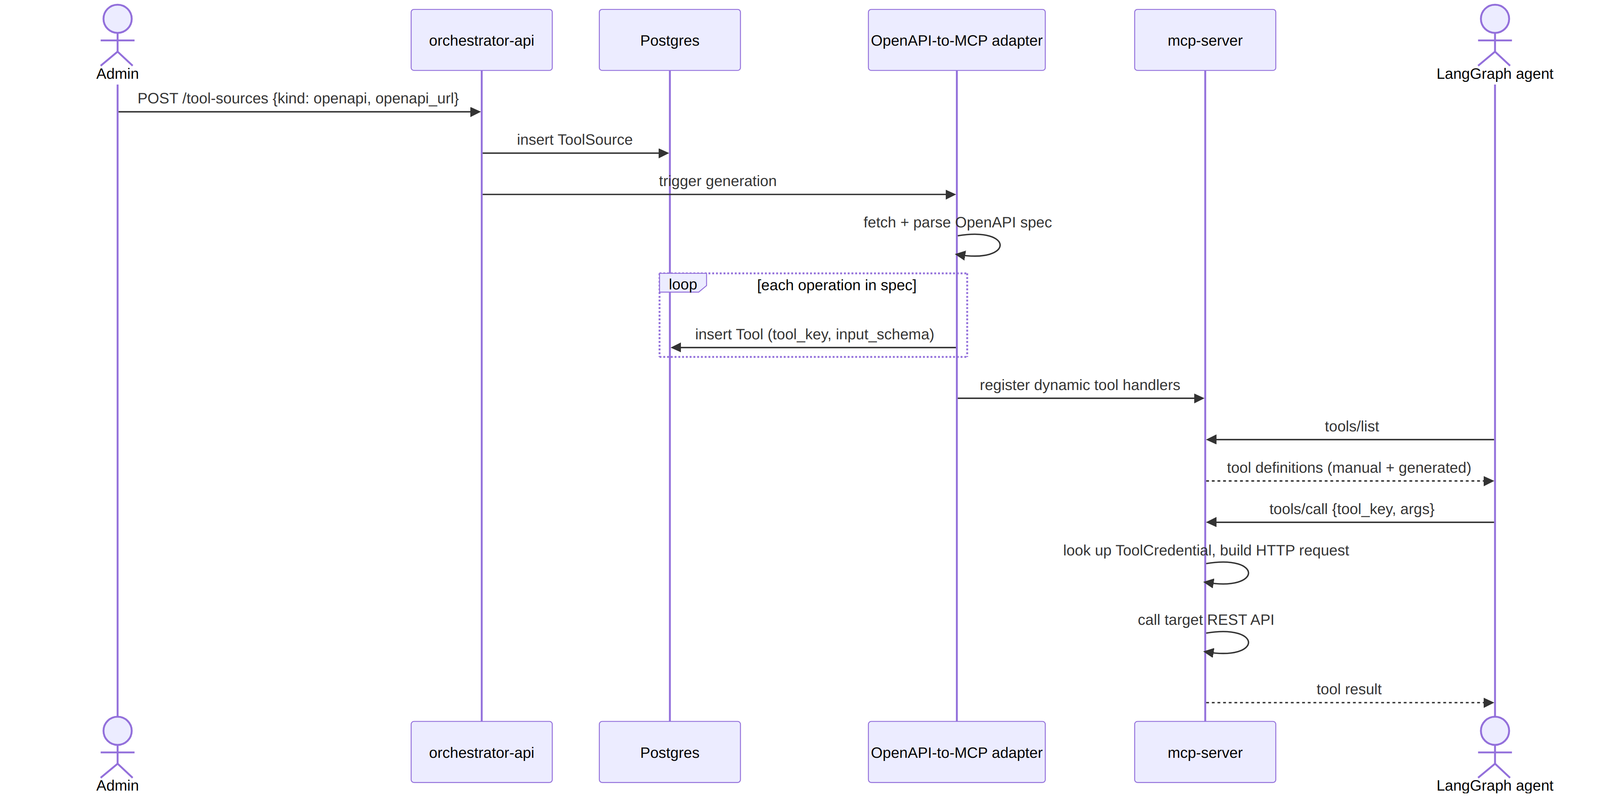
Figure 10. OpenAPI-to-MCP tool generation sequence diagram.

7.3 RAG Ingestion and Retrieval (M6)
An admin registers an IngestionSource. The ingestion service pulls documents, parses them with unstructured, chunks them with langchain-text-splitters, embeds the chunks via the model registry, and stores the resulting vectors in pgvector. Later, during a run, an agent calls the RAG search tool, which performs a vector similarity search against Postgres and returns the top-k chunks as retrieved context.
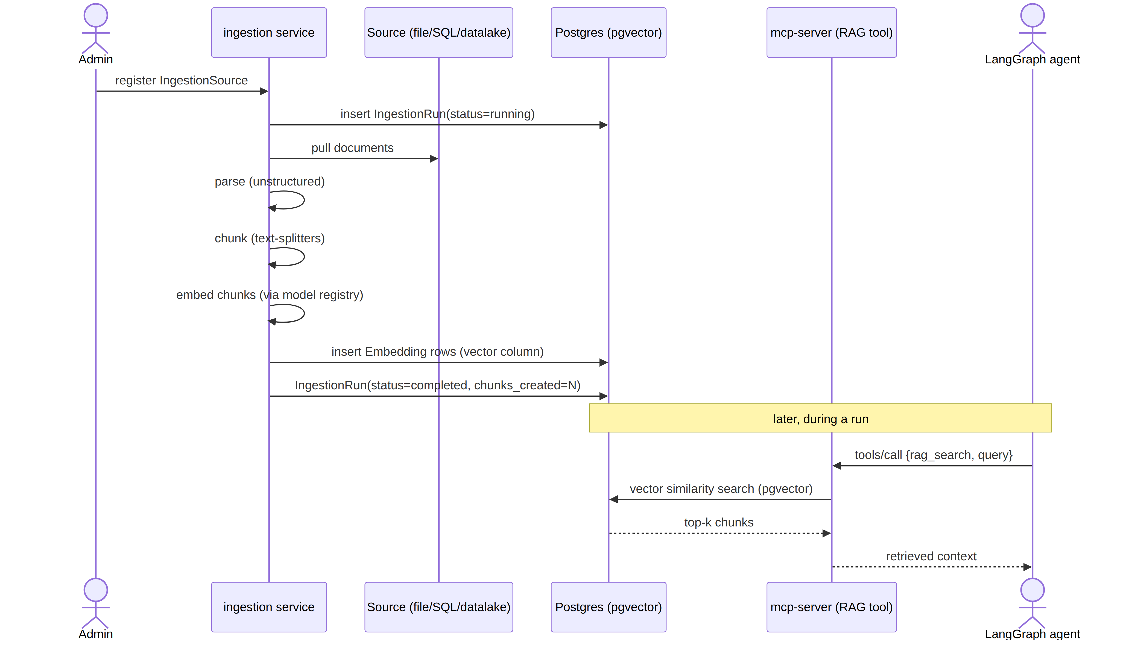
Figure 11. RAG ingestion and retrieval sequence diagram.

8. Deployment Topology

8.1 Today: Local Docker Compose
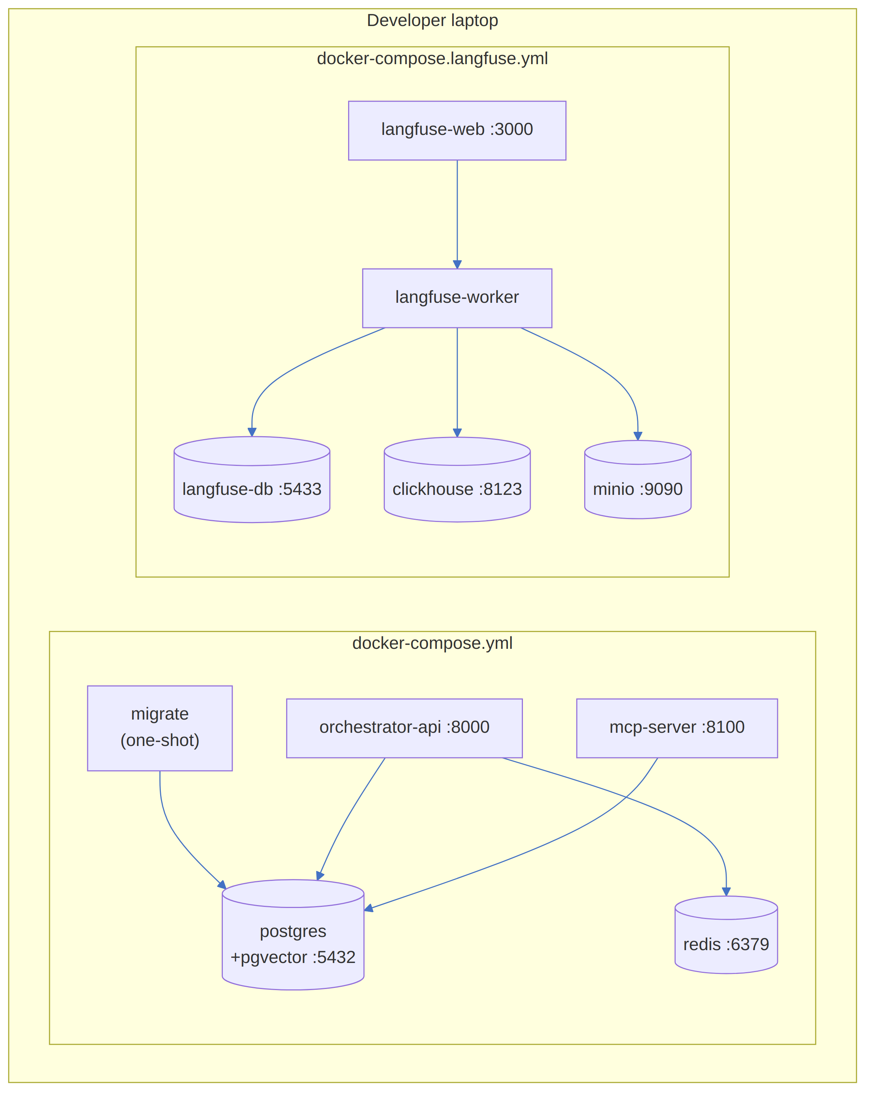
Figure 12. Local Docker Compose topology — app stack and Langfuse stack.
Brought up together with one command (make up), which composes both files so the app stack and the Langfuse stack run side by side without port or volume collisions (separate Postgres instances, separate port ranges).

8.2 Later: Target Cloud Topology (Not Yet Implemented)
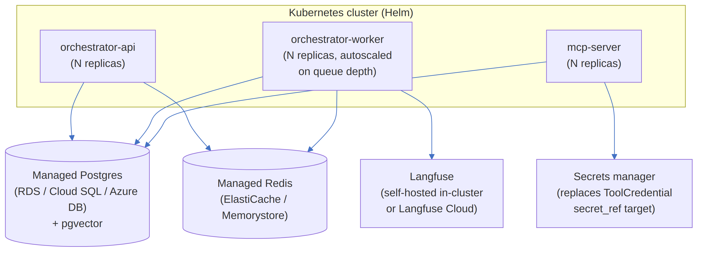
Figure 13. Target Kubernetes/Helm cloud topology.
Why this transition is low-risk: application code already reads all connection info from environment variables (DATABASE_URL, MCP_SERVER_PORT, etc.) — see §2.10. Moving from Compose to Helm changes how those env vars are supplied and how containers are scheduled, not the containers themselves.

9. Security & Governance Model (M8)
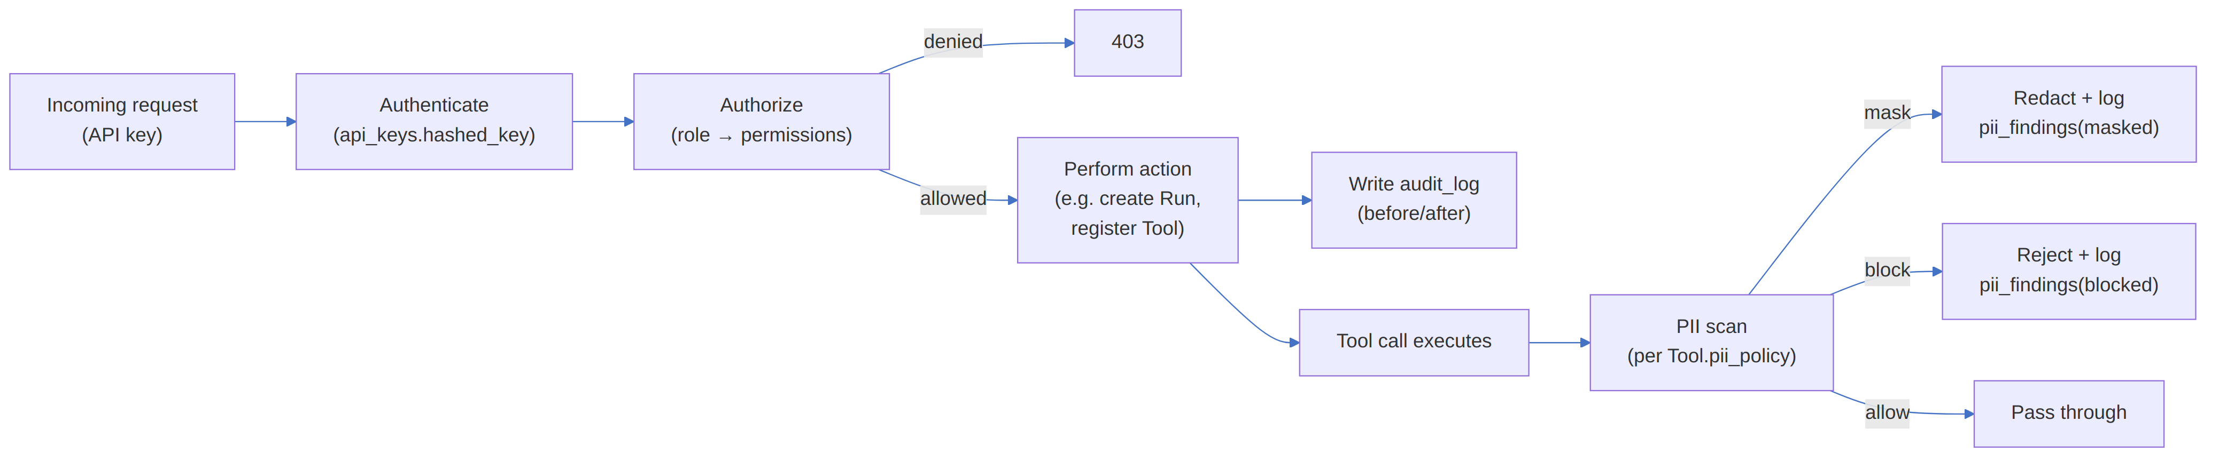
Figure 14. Request-time authentication, authorization, audit, and PII-scan flow.
Even though enforcement lands at M8, every table this flow depends on (api_keys, roles, permissions, role_permissions, audit_log, pii_findings, Tool.pii_policy) exists from M1 — see §2.8.

Glossary
Term | Meaning
Agent | An LLM-driven program that can reason over multiple steps and call tools, defined by a graph_key (which LangGraph graph to run) and a default model
MCP (Model Context Protocol) | An open standard for exposing “tools” (callable actions) to LLM-driven clients over a consistent transport, independent of any one model or agent framework
LangGraph | A framework for building agents as state machines (“graphs”) with built-in support for pausing, resuming, and checkpointing execution state
Checkpointer | The mechanism LangGraph uses to persist an agent's mid-execution state so a run can be paused (e.g. for HITL approval) and resumed later from exactly where it left off
HITL (Human-in-the-loop) | A workflow pattern where certain agent actions require explicit human approval before proceeding
RAG (Retrieval-Augmented Generation) | Improving an LLM's answers by first retrieving relevant chunks of text (via vector similarity search) and including them in the prompt
pgvector | A PostgreSQL extension adding a vector column type and similarity-search operators, used here for RAG retrieval
Langfuse | An open-source LLM observability platform — traces model calls, tool calls, latency, token usage, and cost
Cube.dev | A semantic layer tool: define business metrics once (e.g. “monthly active users”), query them consistently from SQL, REST, or an agent tool
arq | A lightweight async job queue for Python, backed by Redis — used to run agent jobs off the request/response cycle
RBAC (Role-Based Access Control) | Restricting actions based on the role assigned to the calling principal (API key), rather than per-user special-casing
Model registry | The model_providers/model_registry/model_routing_rules tables that let AgenticForge resolve a logical model name to an actual provider/model at call time

