Nama : Rihana Sbiya Shula

Kelas : 5B

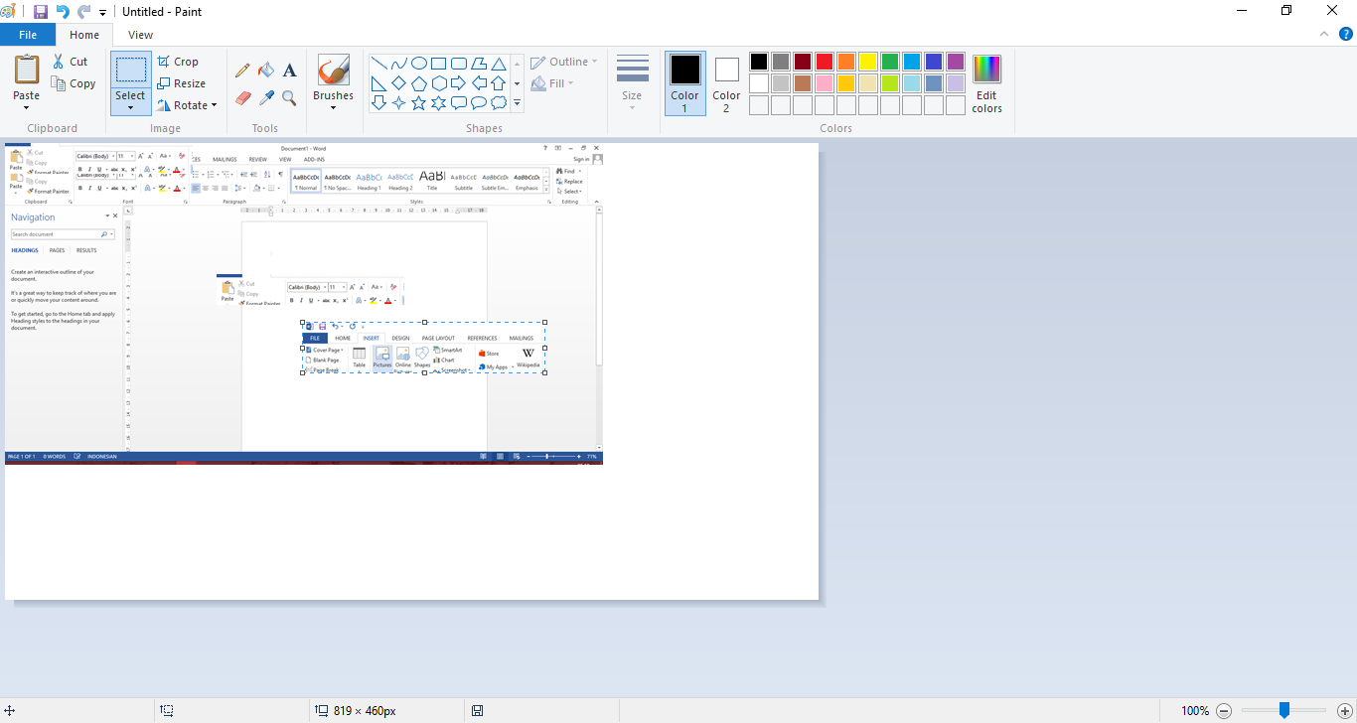

Aplikasi Ms Word

Ikon-ikon standar

Membuat Dokumen baru

Membuka Dokumen Lama

Menyimpan dokumen

Mengatur halaman dokumen

Mencetak Dokumen

Menutup dokumen

Ikon new

Ikon open

Ikon save dan save as

Page Setup

Ikon Print

Ikon close atau exit

|  |  |  |
| --- | --- | --- |
| * Close | * Margin | * Print |
| * Exit | * new | * print preview |
| * File | * Open | * Save |
| * layout | * page setup | * save as |

