# ModelSim

ModelSim is a full-featured VHDL simulator. With VHDL, you can create logic designs consisting of any size. To verify functional operation you need to simulate your design to see whether it works like expected. Therefore, test benches are used. They contain so-called stimuli or test vectors, simply said: values for the input signals. These values are applied to the input signals and then the corresponding output signals are compared with the expected values.

To simulate a specific design one has to provide two kinds of files to the ModelSim simulator: VHDL files that contain your processor design and a testbench file that creates the needed environment. ASIP Meister creates the VHDL files for your processor design automatically and the designer does not have to take care about the VHDL implementation of the processor. We provide the testbench and you can find it in the TEM­PLATE_­PRO­JECT/ModelSim directory (directory structure is explained in Chapter 2.2.2). This testbench generates a reset and a clock signal to the CPU. Furthermore, it contains simulated data- and instruction-memory for the CPU. These simulated memories have to be initialized with memory images that are read from TestData.DM and TestData.IM, before the CPU can start executing the application. The Makefile script creates these memory images automatically during “make sim” or “make dlxsim” and are copied to the ModelSim directory of your current ASIP Meister project (so you are always simulating the last application that was compiled). After the simulation of the application is finished, you will find a memory image of the final data memory TestData.OUT that contains the results of the application if they are stored in data memory.

## Tutorial

### Create a new ModelSim Project

Please be aware that it is important that you start ModelSim in the ModelSim directory of your ASIP Meister project, as shown in Chapter 2.2.2.

On the shell change to the ModelSim directory of your project and invoke “vsim &”. If ModelSim asks for “modelsim.ini” choose the default one like “/Software/ModelSim/ModelSim_6.6d/modeltech/modelsim.ini”

Menu: File > New > Project

Enter a project name e.g. dlx_basis1 and change the project location to the ModelSim directory in your project directory. Confirm the dialog with the OK button.

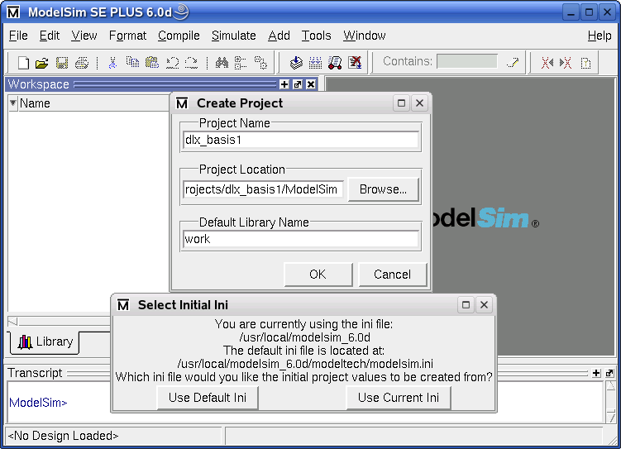

Figure 5‑1: Creating a ModelSim Project

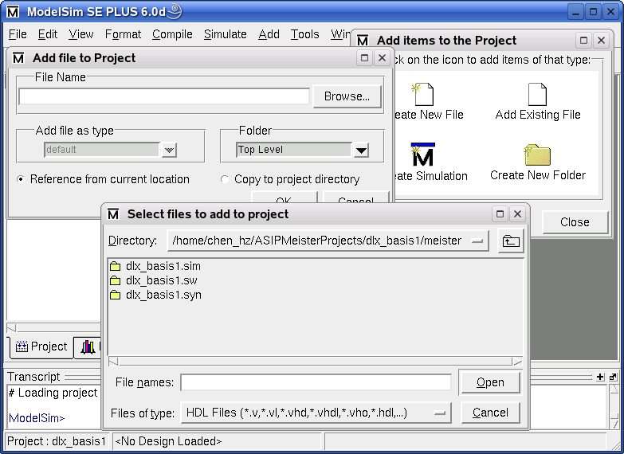

Figure 5‑2: Adding Files to a ModelSim Project

### Adding the Testbench and ASIP Meister CPU files

Choose the icon “Add Existing File”. Browse to the VHDL netlist files for the processor e.g. “meister/ dlx_basis1.syn” directory of your ASIP Meister project. Here you will find the VHDL files for synthesis. There is also a VHDL model of the processor in the .sim directory, but do not use the files of the .sim directory, as they do not work properly. Select all the files and confirm the dialog with “open”. Once again, choose the icon “Add Existing File” to add the testbench files: tb_browstd32.vhd, MemoryMapperTypes.vhd, MemoryMapper.vhd, and Helper.vhd from the ModelSim directory of your current project.

### Compile the project

Menu: Compile > Compile Order > Auto Generate

Every file is compiled and you can see the result of the compile process. ModelSim determines automatically the compile order of the VHDL files. After closing the dialog every file should have a green mark before its name, showing that the compilation was successful (instead of the question marks), shown in Figure 5-4. A green mark with a yellow dot is a warning that usually indicates a problem. So take care about the warnings.

**IMPORTANT**: When you edit your CPU in ASIP Meister and execute HDL Generation, then the VHDL files are regenerated and have to be recompiled. ASIP Meister might even generate new files, that have not been there in the previous set of VHDL files, e.g. for new pipeline registers that are needed for modified MicroOp Descriptions. These new VHDL files are not included into your ModelSim project yet. Also previously needed VHDL files might no longer be needed for a modified ASIP Meister CPU and ModelSim will complain about these files while recompiling. To avoid manually checking every VHDL file, whether it already was included into your project or whether it is a new file, you can do the following: Delete the meister/dlx_basis1.syn directory before executing the HDL Generation; this will make sure that no files that are no longer needed exist. Remove all ASIP Meister VHDL files out of your ModelSim project and after executing the HDL Generation just add the newly created VHDL files from the meister/dlx_basis1.syn directory, like explained in the previous paragraph. Instead of the sub window shown in Figure 5-2, when creating a new project, you can use the menu: File > Add to Project > Existing File.

### Run the simulation

Menu: Simulate > Start Simulation

Open the work library, mark the entry cfg (that is the VHDL configuration for the testbench) in the list (as shown in Figure 5-4) and press OK. That will start the simulation and you will get some other window like “Objects”, “Processes”, “Wave” and a “sim” tab attached to the Workspace.

IMPORTANT: Make sure that no Component Unbound Message is printed while starting the simulation. If such a message is printed, then this is a serious problem within the simulation. Usually it helps to recompile everything and to start the simulation again (menu: Compile > Compile All). However, a new VHDL file, that was automatically created by ASIP Meister, but that is not included into your project yet, can also cause such a message.

Menu: Tools > Tcl > Execute Macro…

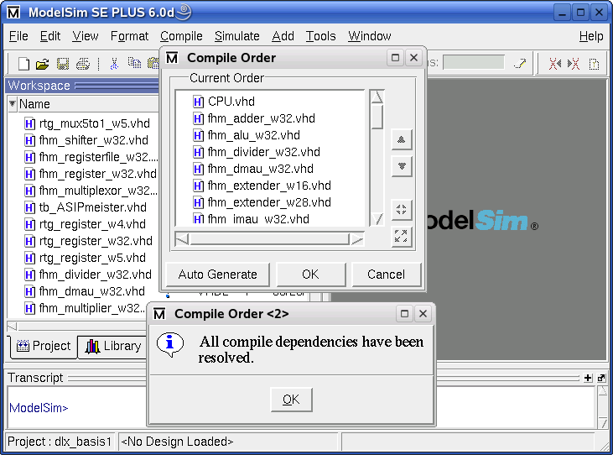

Figure 5‑3: Compiling the Project

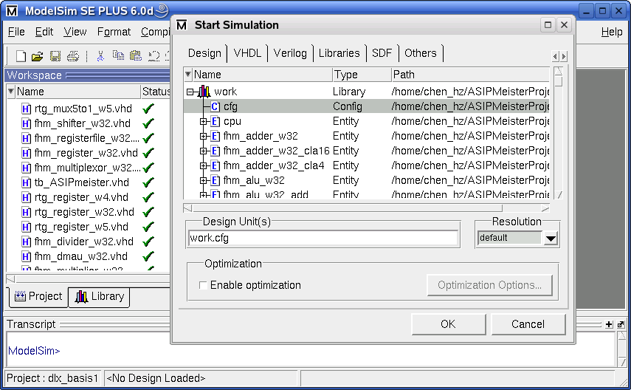

Figure 5‑4: Starting the ModelSim Simulation

Select the wave_vhdl.do file in your ModelSim directory and press OK to load it. The wave-window will be filled with certain signals that are useful to evaluate the simulation of the program running on the processor. These signals are explained in Chapter 5.1.5.

Press the button Run all to run the simulation until it aborts. At the end of a simulation the message “Failure: Simulation End” is printed. The type “Failure” is only used to automatically abort the simulation. This is not a real failure. At the simulation end, the file TestData.OUT is created in your ModelSim directory. It contains the content of the simulated memory after the CPU finished working. Therefore, if your algorithm is storing the result in the memory you can find the values here.

If you want to run another simulation with a modified program or with a modified initial data memory on the same CPU, then execute again “make sim” in the respective application subdirectory to create the new TestData.IM and TestData.DM and afterwards you have to press the buttons restart and run all, like shown in Figure 5-5.

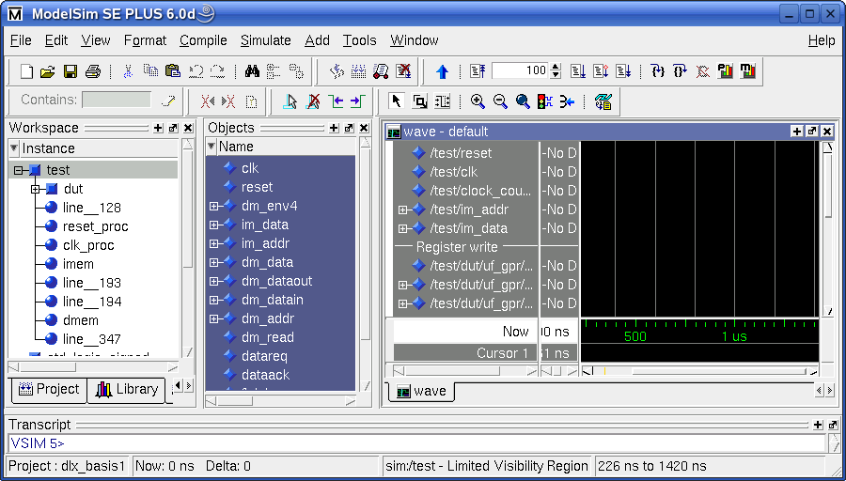

Restart Simulation

Run Simulation for a configurable amount of time

Run all time

Figure 5‑5: Running the ModelSim Simulation

### Statistics of the Simulation

During simulation time, the testbench prints status messages about memory access (Load/Store operations) into the workspace status window. Thus, you can see which operation is being executed and which values are being stored and loaded. The following examples show a read and a write access:

# ClockCycle:23 InstrAddr:0x00000042 DMemAddr:0x0000FFF0 --> 0 (Read)

# ClockCycle:30 InstrAddr:0x00000049 DMemAddr:0x0000FFF4 <-- 0 (Write 32-Bit) (Old value was 45)

The read access is performed in cycle 23 while the currently requested instruction memory address (IM_addr_out) is 0x42. This does not mean, that the corresponding load instruction is fetched into the pipeline in cycle 23 or that this load instruction is placed at IM_addr_out 0x42. Instead, this means that the MEM-Phase of the corresponding load instruction is executed in cycle 23 and that the instruction at address 0x42 is fetched into the pipeline, while this load instruction is performing its MEM phase. The corresponding load instruction is usually placed some instructions before the printed IM_addr_out, unless there was a jump in between. The loaded value is zero in the printed example and this value comes from address 0xFFF0. This is a stack operation, as the stack is starting at address 0xFFFF and growing downwards in our case (but the starting address of the stack might be a subject of changes). The loaded value is zero in this example. The afterwards printed write-example additionally shows which value is placed in the memory location that is to be overwritten.

A more detailed kind of statistics for the simulation is the wave diagram as shown in Figure 5-6. The waves show the internal details of the VHDL model that is simulated. The waves are grouped into five parts, which are explained in Figure 5‑7:. For more details of the memory signals, see Page-47 in [RM].

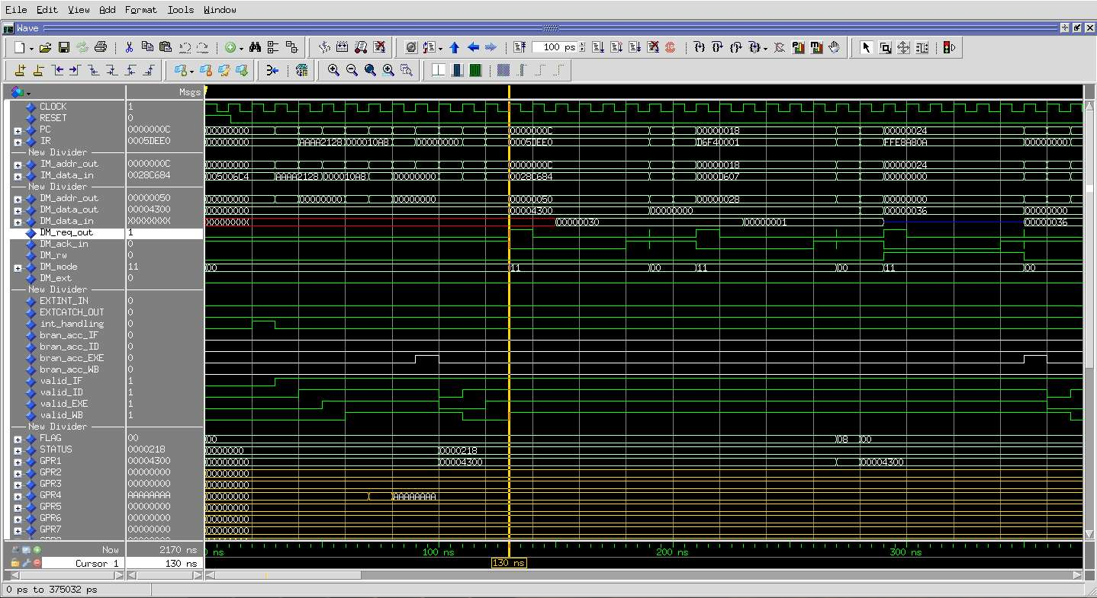

Figure 5‑6: ModelSim Waveforms

To add additional signal to the Wave window (which is very helpful for debugging) you need to enable two views in ModelSim (both are enabled by default):

Menu: View > Workspace

Menu: View > Debug Windows > Objects

| **Signal** | **Explanation** |
| --- | --- |
| RESET | The reset signal of the CPU. This signal is active at the beginning of every simulation to initialize the CPU. |
| CLOCK | The clock signal of the CPU. This signal is helpful to see, when other signal changes are really taken into the CPU, as they are only sampled at the rising edge of the clock. |
| PC | Program counter |
| IR | Instruction register |
| clock_counter | The clock counter counts the number of executed clock cycles since the CPU started running after the initial reset. |
| IM_addr_out | This is the Instruction Memory Address. It shows the address of the instruction that the CPU wants to fetch into its pipeline. |
| IM_data_in | This is the Instruction Memory Data that corresponds to the previous shown im_addr. Therefore, it is the binary representation of the assembly instruction that is fetched by the CPU. |
| DM_addr_out | This is the Address Bus for memory accesses. This bus either contains the address to which some data will be written or the address from which some data will be read. |
| DM_data_out | The Data Bus contains the value that will be written to the memory. |
| DM_data_in | The Data Bus contains the value that will be read from the memory. |
| DM_req_out | This is the request signal from CPU to trigger a read or a write access. |
| DM_ack_in | This is the acknowledge signal, that is activated by the memory controller after a requested write access is finished or after the data bus contains the result of a requested read access. |
| DM_rw | Read from the memory if 0, otherwise write to the memory. |
| DM_mode | This signal determines the read/write mode. The usual values are “11” for “word” and “00” for “byte” read/write. |
| DM_ext | Sign extension signal |
| EXTINT_IN  EXTCATCH_OUT  int_handling | Interrupt Signals |
| bran_acc_IF  bran_acc_ID  bran_acc_EXE  bran_acc_WB  valid_IF  valid_ID  valid_EXE  valid_WB | Pipeline stages information |
| FLAG  STATUS  GPR1... GPR31 | Register file values |

Figure 5‑7: Explanation of the Signals in the ModelSim Waveform

In the “Workspace”, you can choose which instance of your design will be shown in the “Objects” windows. From the Objects window, you can then drag-and-drop signals to the Wave window.

## General Hints

* Change to your ModelSim directory inside your project directory tree and verify that the memory images TestData.IM and TestData.DM are present. The Makefile should have automatically created these files. Furthermore, you need the ModelSim testbench file tb_browstd32.vhd and the configuration script wave_vhdl.do, which are available in the TEMPLATE_PROJECT/ModelSim directory. Please make sure that these files exist in your ModelSim directory before you start the simulation. It keeps you safe from trouble.
* Always invoke ModelSim in the specific ModelSim directory of your current project by executing vsim & in this directory. ModelSim is working with project directories and is searching for information in the directory where it is invoked. After creating new projects all settings will be saved in the project file e.g. projectname.mpf (where mpf stands for ModelSim Project file). To speed up the starting process you can invoke vsim with an option for your project file that you have created in an earlier simulation: “vsim projectname.mpf &”.
* When you compile VHDL files ModelSim creates a local library in the subdirectory work to store the compilation results. This is the main reason why it is important to start ModelSim in the right place. It looks for last project information and for the local library.
* Sometimes you might get compiler errors from the ModelSim VHDL compiler. This is usually not the fault of ASIP Meister or the testbench. Very often, a “recompile all” solves this problem. However, sometimes you will have to create a new project from the scratch to get it working.
* If you open the waves before the simulation is started, then the signals will not be displayed. First start the simulation, and then open the waves.