Pizza Sales Analytics Project
Comprehensive Documentation
This complete structural guide details the continuous development of the Pizza Sales Performance Analytics solution. It details data volume metrics, relational schema definitions via Microsoft SQL Server production Views, extraction/transformation mechanisms inside Power BI Desktop, and deployment parameters for executive front-end report building.
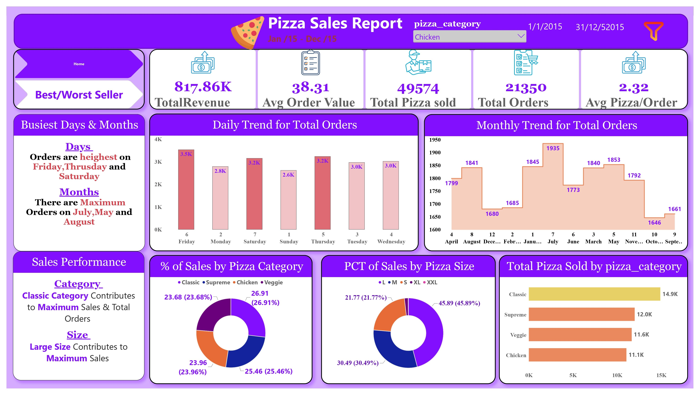

1. Executive Summary & Core Objectives
The operational workflow bridges the gap between transactional databases and C-suite data analytics. The business logic translates row-level store logs into high-level strategic intelligence designed to minimize inventory overhead and match staffing capacity with variable consumer demand curves.
2. Data Granularity & Data Volume Quantification
To ensure high data engineering fidelity, the pipeline processes the corporate sales history for the standard 2015 fiscal period. The structural architecture resolves historical metrics across the following precise data boundaries:
- Total Transaction Volume: 21,350 unique consumer transactions.
- Total Logged Sales Volume: 49,574 individual pizza items.
- Financial Revenue Gross: $817,860.05 accumulated across all items.
- Average Density Parameter: 2.32 average pizzas ordered per checkout transaction.
- Relational Attribute Fields: 12 dynamic relational fields containing structured parameters (Order Dates, Order Times, Unit Prices, Total Item Prices, Pizza Names, Sizes, Categories, and Quantities).
3. Relational Tier Orchestration (Microsoft SQL Server Views)
To insulate front-end BI processing loads from row-level transaction scans, the backend layer utilizes 17 structurally decoupled SQL Server Views. These views handle relational grouping, casting, and multi-factor ranking pipelines:

3.1 Core Strategic KPIs (Views 1 to 5)
-- 1) Global Financial Accumulation View
CREATE OR ALTER VIEW dbo.VW_KPI_1_Total_Revenue AS
SELECT SUM(total_price) [TotalRevenue]
FROM pizza_sales;
GO
TotalRevenue
817860.05083847

-- 2) Average Monochromatic Basket Value
CREATE OR ALTER VIEW dbo.VW_KPI_2_Average_Order_Value AS
SELECT SUM(total_price)/COUNT(DISTINCT order_id) AS [Average Order Value]
FROM pizza_sales;
GO
Average Order Value
38.3072623343546

-- 3) Absolute Quantitative Output View
CREATE OR ALTER VIEW dbo.VW_KPI_3_Total_Pizza_sold AS
SELECT SUM(quantity) [Total Pizza sold]
FROM pizza_sales;
GO
Total Pizza sold
49574
-- 4) Unique Operational Orders Matrix
CREATE OR ALTER VIEW dbo.VW_KPI_4_Total_Orders AS
SELECT COUNT(DISTINCT order_id) AS [Total Orders]
FROM pizza_sales;
GO
Total Orders
21350
-- 5) Structural Basket Density Calculation
CREATE OR ALTER VIEW dbo.VW_KPI_5_Average_Pizza_per_Order AS
SELECT CAST(CAST(SUM(quantity) AS DECIMAL(10,2)) / COUNT(DISTINCT order_id) AS DECIMAL(10,2)) AS [Avg Pizza Per Order]
FROM pizza_sales;
GO
Avg Pizza Per Order
2.32
3.2 Advanced Product Ranking Models (Views 6 to 11)
-- 6) Top 5 Performing SKUs by Sales Volume
CREATE OR ALTER VIEW dbo.VW_KPI_6_Top_5_Total_Q_by_Pizza_Name AS
SELECT TOP 5 pizza_name, SUM(quantity) [Total Quantity]
FROM pizza_sales GROUP BY pizza_name ORDER BY [Total Quantity] DESC;
GO
pizza_name | Total Quantity
The Classic Deluxe Pizza | 2453
The Barbecue Chicken Pizza | 2432
The Hawaiian Pizza | 2422
The Pepperoni Pizza | 2418
The Thai Chicken Pizza | 2371
-- 7) Lowest 5 Performing SKUs by Sales Volume
CREATE OR ALTER VIEW dbo.VW_KPI_7_Worest_5_Total_Q_by_Pizza_Name AS
SELECT TOP 5 pizza_name, SUM(quantity) [Total Quantity]
FROM pizza_sales GROUP BY pizza_name ORDER BY [Total Quantity] ASC;
GO
pizza_name | Total Quantity
The Brie Carre Pizza | 490
The Mediterranean Pizza | 934
The Calabrese Pizza | 937
The Spinach Supreme Pizza | 950
The Soppressata Pizza | 961
-- 8) Top 5 SKUs Ranked by Order Prevalence
CREATE OR ALTER VIEW dbo.VW_KPI_8_Top_5_Total_Orders_by_Pizza_Name AS
SELECT TOP 5 pizza_name, COUNT(DISTINCT order_id) [Total Orders]
FROM pizza_sales GROUP BY pizza_name ORDER BY [Total Orders] DESC;
GO
pizza_name | Total Orders
The Classic Deluxe Pizza | 2329
The Hawaiian Pizza | 2280
The Pepperoni Pizza | 2278
The Barbecue Chicken Pizza | 2273
The Thai Chicken Pizza | 2225
-- 9) Lowest 5 SKUs Ranked by Order Prevalence
CREATE OR ALTER VIEW dbo.VW_KPI_9_Worest_5_Total_Orders_by_Pizza_Name AS
SELECT TOP 5 pizza_name, COUNT(DISTINCT order_id) [Total Orders]
FROM pizza_sales GROUP BY pizza_name ORDER BY [Total Orders] ASC;
GO

pizza_name | Total Orders
The Brie Carre Pizza | 480
The Mediterranean Pizza | 912
The Spinach Supreme Pizza | 918
The Calabrese Pizza | 918
The Chicken Pesto Pizza | 938
-- 10) Top 5 High-Value Revenue Pillars
CREATE OR ALTER VIEW dbo.VW_KPI_10_Top_5_Total_Sales_by_Pizza_Name AS
SELECT TOP 5 pizza_name, SUM(total_price) [Total Sales]
FROM pizza_sales GROUP BY pizza_name ORDER BY [Total Sales] DESC;
GO
pizza_name | Total Sales
The Thai Chicken Pizza | 43434.25
The Barbecue Chicken Pizza | 42768
The California Chicken Pizza | 41409.5
The Classic Deluxe Pizza | 38180.5
The Spicy Italian Pizza | 34831.25

-- 11) Bottom 5 Revenue Drains
CREATE OR ALTER VIEW dbo.VW_KPI_11_Worest_5_Total_Sales_by_Pizza_Name AS
SELECT TOP 5 pizza_name, SUM(total_price) [Total Sales]
FROM pizza_sales GROUP BY pizza_name ORDER BY [Total Sales] ASC;
GO
pizza_name | Total Sales
The Brie Carre Pizza | 11588.4998130798
The Green Garden Pizza | 13955.75
The Spinach Supreme Pizza | 15277.75
The Mediterranean Pizza | 15360.5
The Spinach Pesto Pizza | 15596
3.3 Macro Temporal & Attribute Distribution Segmentations (Views 12 to 17)
-- 12) Daily Time-Series Demand Distribution
CREATE OR ALTER VIEW dbo.VW_KPI_12_Daily_Trend_of_Total_Orders AS
SELECT DATEPART(WEEKDAY,order_date) [Day num], DATENAME(WEEKDAY,order_date) [Day name], COUNT(DISTINCT order_id) [Total Orders]
FROM pizza_sales GROUP BY DATEPART(WEEKDAY,order_date), DATENAME(WEEKDAY,order_date);
GO
Day num | Day name | Total Orders
1 | Sunday | 2624
4 | Wednesday | 3024
2 | Monday | 2794
6 | Friday | 3538
3 | Tuesday | 2973
5 | Thursday | 3239
7 | Saturday | 3158

-- 13) Monthly Seasonal Demand Waves
CREATE OR ALTER VIEW dbo.VW_KPI_13_Monthly_Trend_of_Total_Orders AS
SELECT DATEPART(MONTH,order_date) [MONTH num], DATENAME(MONTH,order_date) [MONTH name], COUNT(DISTINCT order_id) [Total Orders]
FROM pizza_sales GROUP BY DATEPART(MONTH,order_date), DATENAME(MONTH,order_date);
GO
MONTH num | MONTH name | Total Orders
4 | April | 1799
2 | February | 1685
9 | September | 1661
1 | January | 1845
11 | November | 1792
5 | May | 1853
10 | October | 1646
3 | March | 1840
8 | August | 1841
12 | December | 1680
7 | July | 1935
6 | June | 1773
-- 14) Financial Revenue Share Contribution by Category
CREATE OR ALTER VIEW dbo.VW_KPI_14_Percent_of_Sales_by_Pizza_CAT AS
SELECT pizza_category, ROUND(SUM(total_price)*100.0/(SELECT SUM(total_price) FROM pizza_sales),2) [PCT]
FROM pizza_sales GROUP BY pizza_category;
GO
pizza_category | PCT
Chicken | 23.96
Supreme | 25.46
Classic | 26.91
Veggie | 23.68
-- 15) Financial Revenue Share Contribution by Size Matrix
CREATE OR ALTER VIEW dbo.VW_KPI_15_Percent_of_Sales_by_Pizza_Size AS
SELECT pizza_size, ROUND(SUM(total_price)*100.0/(SELECT SUM(total_price) FROM pizza_sales),2) [PST]
FROM pizza_sales GROUP BY pizza_size;
GO
pizza_size | PST
S | 21.77
L | 45.89
XL | 1.72
XXL | 0.12
M | 30.49
-- 16) Volume Output Share by Category
CREATE OR ALTER VIEW dbo.VW_KPI_16_Total_Pizza_Sold_by_Pizza_CAT AS
SELECT pizza_category, SUM(quantity) [Total Pizza Sold/Cat]
FROM pizza_sales GROUP BY pizza_category;
GO

pizza_category | Total Pizza Sold/Cat
Chicken | 11050
Supreme | 11987
Classic | 14888
Veggie | 11649
-- 17) Volume Output Share by Size Dimension
CREATE OR ALTER VIEW dbo.VW_KPI_17_Total_Pizza_Sold_by_Pizza_CAT AS
SELECT pizza_size, SUM(quantity) [Total Pizza Sold/S]
FROM pizza_sales GROUP BY pizza_size;
GO
pizza_category | Total Pizza Sold/Cat
Chicken | 11050
Supreme | 11987
Classic | 14888
Veggie | 11649
4. Semantic Layer Integration (Power BI Data Ingestion Pipeline)
To integrate the database components into Power BI Desktop, follow this deployment sequence:
- Step 1 - Connection Initialization: Launch Microsoft Power BI Desktop and access the Home tab. Select Get Data -> SQL Server to open the connectivity interface.
- Step 2 - Target Server Routing: Supply your target SQL Server Instance Name and enter the active database identifier (e.g., Pizza_DB). Choose Import mode to load rows directly into active RAM for maximum DAX velocity.
- Step 3 - View Selection Protocol: Inside the Navigator window, bypass the raw transaction logs and explicitly choose all 17 pre-compiled production Views (dbo.VW_KPI_1_* to dbo.VW_KPI_17_*).
- Step 4 - Transform Logic Validation: Click Transform Data to evaluate metadata integrity inside Power Query. Validate type casting formats (e.g., order_date as Date, total_price as Currency, and quantities as Integers) to maintain absolute arithmetic alignment.
- Step 5 - Model Commitment: Execute Close & Apply to construct the underlying semantic tables inside the Power BI memory space.
5. Executive Front-End Reporting Dashboard Architecture
The report delivery structure uses a multi-pane grid built to modern corporate standards:
5.1 Dashboard Canvas Page 1: Home & Macro Sales Operations
- Executive KPI Scorecards: High-density numerical cards highlighting Total Revenue ($817.86K), Average Basket ($38.31), Total Orders (21,350), and Density Per Checkout (2.32).
- Daily Transaction Analytics: Area and column combinations revealing structural spikes on Thursdays, Fridays, and Saturdays.
- Monthly Seasonality Matrices: Time-series line chart highlighting massive organic sales density across July, May, and August.
- Categorical & Sizing Proportionality: Segmented donut graphs indicating that Classic Category holds market share over Supreme, Chicken, and Veggie segments.
5.2 Dashboard Canvas Page 2: Product Performance Ranks & Sku Audits
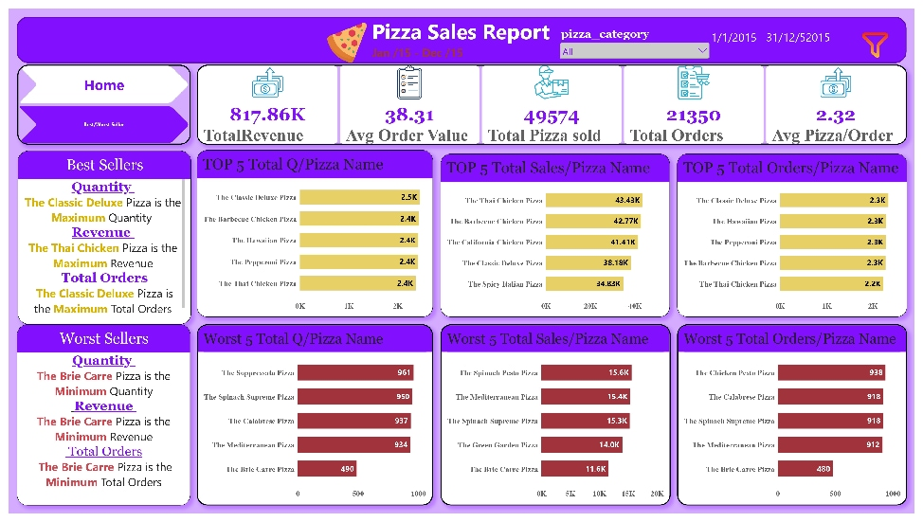
- Top 5 Performing Products Matrix: Highlighting 'The Classic Deluxe Pizza' as the overall quantity champion and 'The Thai Chicken Pizza' as the primary gross revenue pillar ($43.43K).
- Worst 5 Performing Products Matrix: Pinpointing 'The Brie Carre Pizza' as a massive drag across revenue ($11.6K), transaction count (480), and overall output volume.
- Interactive Slicing Arrays: Global responsive multi-select filters mapped to pizza_category and calendar ranges to enable dynamic data discovery.
This technical project manual serves as the primary system documentation guide for the Pizza Sales Enterprise Business Intelligence Architecture framework.
GetHub ink:
https://github.com/enghassanwahba/Data_Analysis_HW_Pizza_Sales_SQL_PowerBI

