EXECUTIVE SUMMARY
ParkSense is a comprehensive, IoT-based smart parking management system designed to alleviate urban parking congestion and enhance operational efficiency. The project successfully integrates a robust Arduino UNO hardware prototype with a user-friendly Android mobile application.
The system's core innovation lies in its dual-layer approach:
- Hardware Automation: The physical gates are controlled by 2 Servo Motors. Access is secured by an RFID Reader (simulating FASTag) for cashless entry authentication. Vehicle flow is managed by 2 IR Sensors (for gate detection) and an Ultrasonic Sensor (specifically for automated exit control), with a Buzzer providing critical audio feedback.
- Software User Interface: The mobile application provides real-time slot availability across different venue categories (Hotels, Malls, Central Parking) and enables advance reservations with integrated navigation. Payments are handled via a simulated FASTag E-Wallet for non-stop, automated transactions.
By eliminating manual ticketing, providing real-time data, and automating entry/exit, ParkSense offers a seamless, secure, and highly efficient solution to modern parking challenges, fulfilling all project objectives related to embedded systems development and IoT application.
ABSTRACT
Rapid urbanization and the exponential increase in vehicle ownership have precipitated a severe crisis in urban mobility. As noted in the project documentation, "The rapid increase in vehicle ownership has led to severe parking congestion in urban areas". Traditional parking management systems, characterized by manual ticketing and cash-based transactions, result in traffic congestion and user frustration.
This project presents "ParkSense," a smart parking solution designed to automate the parking reservation and payment process. The system integrates "RFID (FASTag) technology for seamless payments and an Arduino-based hardware model for physical access control," which "eliminates manual ticketing".
The specific hardware implementation utilizes an Arduino UNO, RFID readers for authentication, IR sensors for gate detection, and ultrasonic sensors for automated exit control. The system bridges the gap between hardware and software, utilizing a mobile application that "allows users to reserve spots, view real-time capacity across various venues (Hotels, Malls, Central Parking), and navigate to their destination".
This report details the design, methodology, and results of the ParkSense system, highlighting the successful integration of embedded systems with mobile application technology.
1. INTRODUCTION
1.1 Background and Overview "Urban areas worldwide face growing challenges in parking management due to increasing vehicle ownership and limited parking infrastructure". The search for parking is a significant contributor to urban traffic congestion. "Smart parking systems offer a solution by automating vehicle detection, access control, and real-time space monitoring".
This project implements a prototype that demonstrates "how IoT integration can transform traditional parking facilities into intelligent, automated systems". The system "combines multiple sensor technologies with automated gate control and user notification mechanisms to provide seamless parking experiences".
1.2 Problem Statement The necessity for the ParkSense system arises from the inefficiencies of current models. "Traditional parking systems suffer from:"
- "Manual cash collection causing long queues at entry/exit".
- "Lack of real-time information regarding parking availability".
- "Fuel wastage while searching for parking spots".
- "Inefficient space management in multi-level parking lots".

1.3 Objectives and Proposed Solution ParkSense addresses these issues through a specific set of solutions:
- Digital Payments: The system uses "Auto-deduction via FASTag e-wallet".
- Pre-booking: It features a "Reserve your slot" function via the mobile app.
- Categorized Sorting: It utilizes "distinct databases for Hotels, Malls, and Centralized Parking".
- Visual UI: The app provides "Animated selection for Two-wheelers and Four-wheelers".

2.METHODOLOGY
The methodology is divided into the Hardware Architecture (The Model) and the Software Architecture (The App).
2.1 Hardware Architecture
"The working model represents the physical entry/exit points". The system integrates several components where "all components connect to the Arduino microcontroller through digital and analog pins, creating an integrated network".
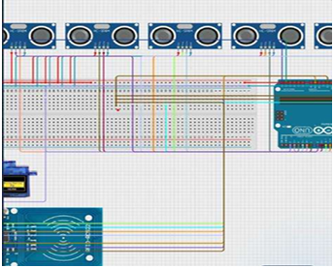
2.1.1 Key Components Used
The hardware implementation relies on the following specific components:
- Arduino UNO: Acts as the "Central processing unit coordinating all system operations".
- RFID Reader (RC522): Used for entry authentication, "The RFID reader emits radio waves that power passive RFID cards when brought into proximity".
- 2 IR Sensors: Deployed for entry and exit gate detection. "When a vehicle interrupts this beam or reflects the IR light back to the receiver," the sensor triggers the gate logic.
- Ultrasonic Sensor (HC-SR04): Specifically used for exit gate control. It calculates distance using the formula:
- Distance = (Speed of Sound × Time) / 2
- 2 Servo Motors: Used for gate operation (Boom Barriers). "Unlike standard motors, servo motors can rotate to specific angles".
- Buzzer: Provides alerts and confirmations.
- Breadboard & 5V Battery: For power distribution and modular connections.
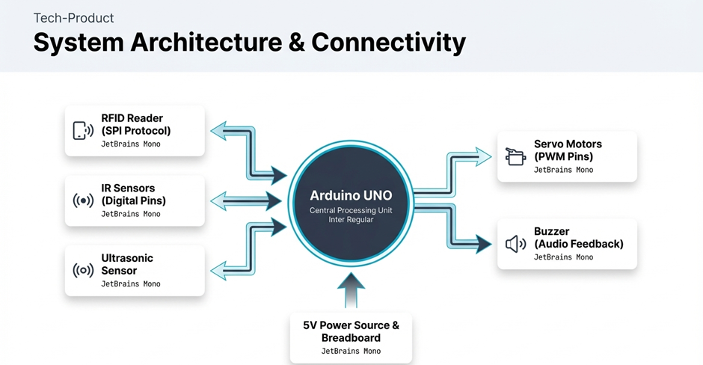

2.1.2 Circuit Wiring Configuration
"The system uses a breadboard for modular connections, facilitating testing and modifications". The connections are configured as follows:
- Ultrasonic Sensor: Trig and Echo pins connected to Arduino digital pins.
- IR Sensors: Output pins connected to digital input pins.
- Servo Motors: Signal wires connected to PWM-enabled pins (e.g., Pin 9).
- RFID Module: Connected via SPI protocol (SDA, SCK, MOSI, MISO).
- Important wiring considerations: "All components share common ground connection".
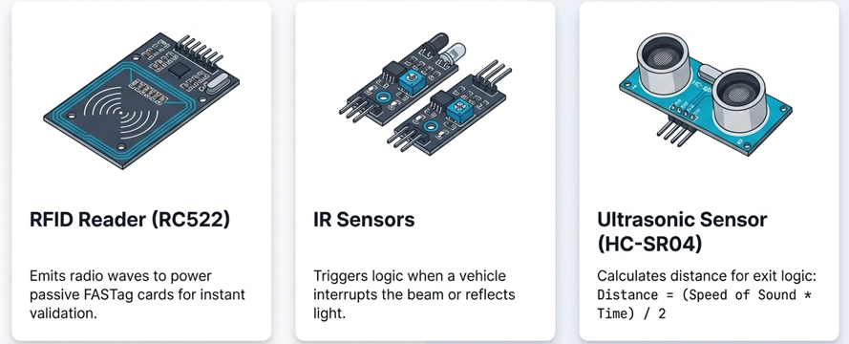
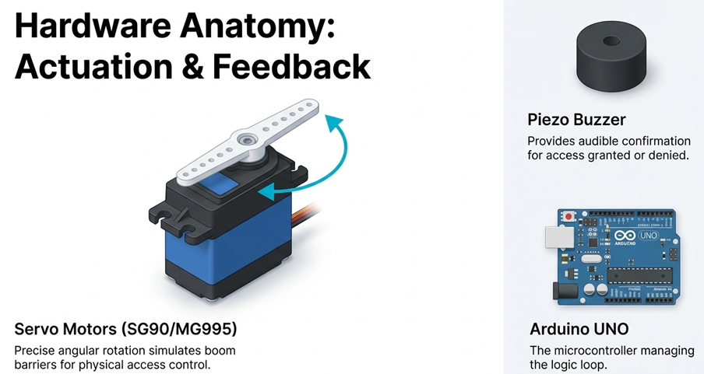
2.2 Software Architecture (The ParkSense App)
"The ParkSense application serves as the interface between the user and the parking infrastructure".

2.2.1 User Registration and Authentication
"The security of the ParkSense app is maintained through a robust authentication system". "New users must register to create a unique identity linked to their vehicle". The registration form collects:
- "Vehicle Number: Essential for license plate recognition backup".
- "Phone Number: For OTP verification and notifications".
- "FASTag ID: The unique RFID tag ID associated with the vehicle for payment processing".
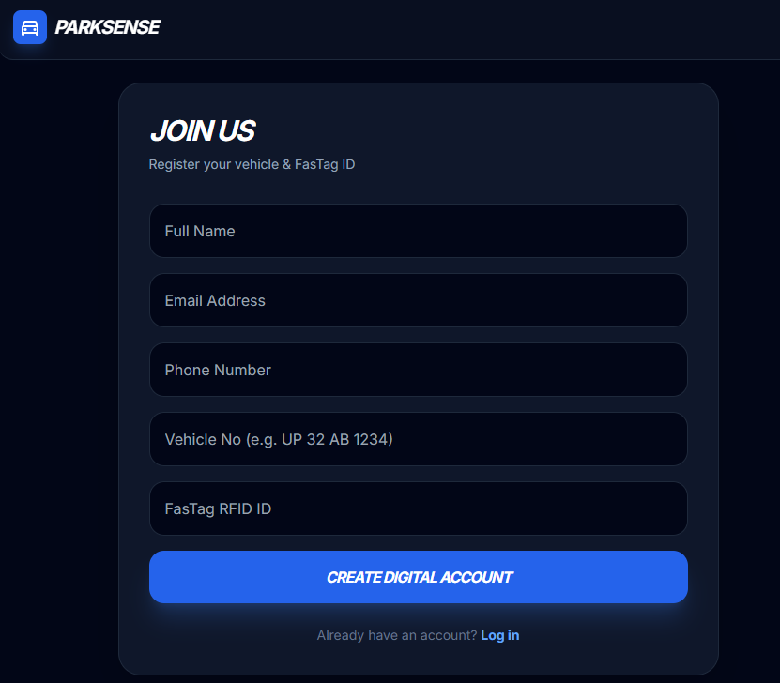

2.2.2 FASTag E-Wallet Integration "The core feature of ParkSense is the integrated FASTag wallet". The dashboard displays "Current Balance" and "Transaction History". "To ensure users never get stuck at a gate due to low balance, a 'Top-Up' button is available". It offers payment via "UPI (Unified Payments Interface)", "E-Banking", or "QR Code".
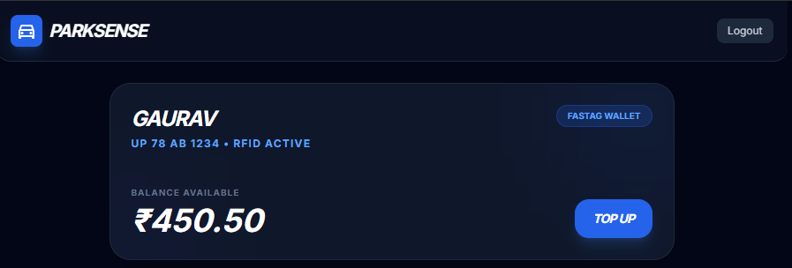

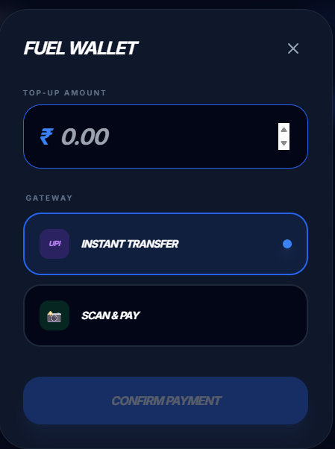

2.2.3 Reservation Logic and Categorization "To make finding a parking spot easy, the app categorizes locations into three distinct types using a Drop-Down Menu approach:"
- "Hotels and Restaurants"
- “Shopping Complexes and Malls”
- “Centralized Parkings”

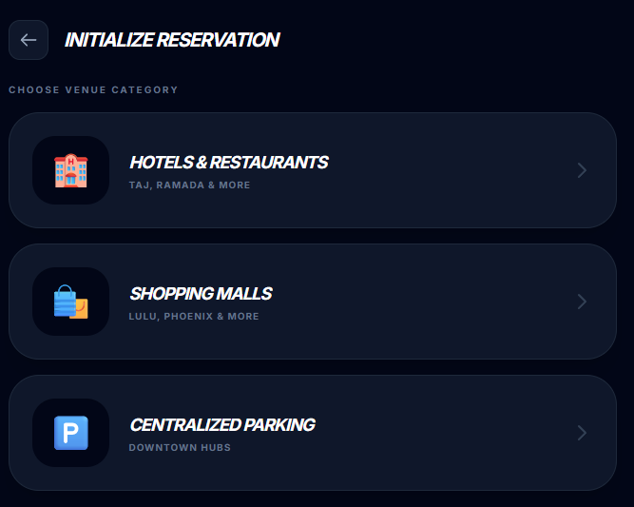
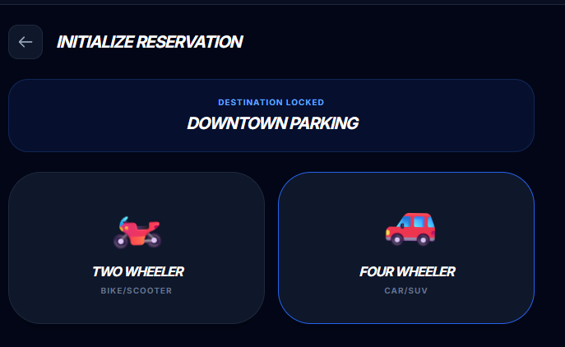
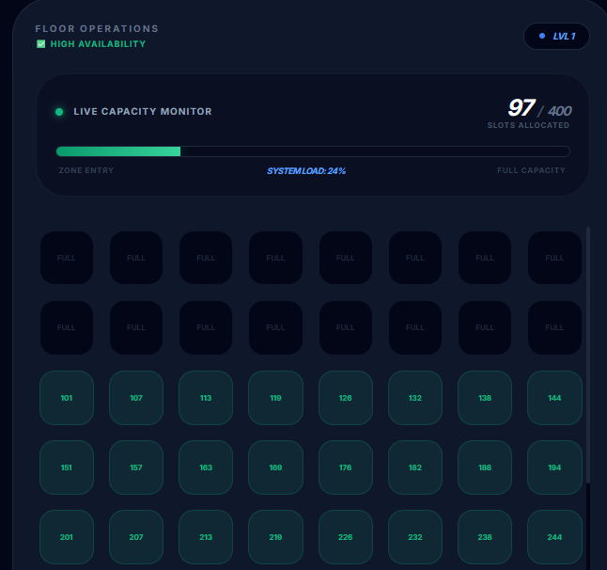

When selecting a vehicle, the app uses an "Interactive UI" that displays "An animated Bike icon for Two-Wheelers" and "An animated Car icon for Four-Wheelers". The logic ensures that "Selecting the vehicle type automatically filters the available floors (levels) compatible with that vehicle".
3. RESULTS AND DISCUSSION
3.1 Operational Flow (Hardware Logic)
The system operates based on a specific logic flow designed for security and automation.
3.1.1 Entry Mechanism
- Authentication: The process begins when a vehicle approaches the entry gate. The "RFID reader emits radio waves" to scan the user's card.
- Gate Actuation: The entry gate opens only after valid RFID card detection.
- Closure Logic: As the vehicle passes through, the IR sensor detects vehicle presence and closes the entry gate automatically behind the car.
- Feedback: The buzzer provides sound indications for successful access granted or denied.
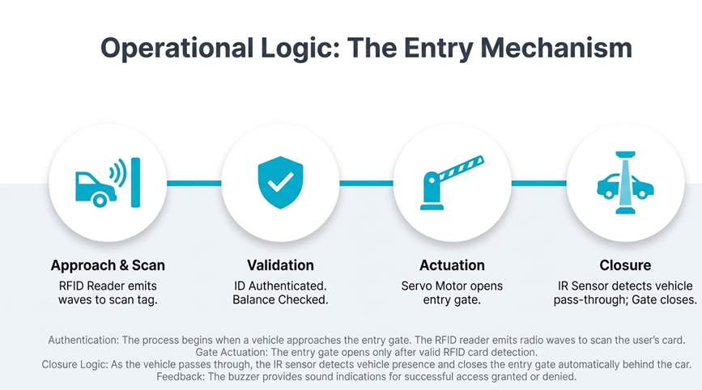

3.1.2 Exit Mechanism
- Detection: When a vehicle approaches the exit, the Ultrasonic sensor detects vehicle distance at the exit.
- Gate Actuation: Based on the distance threshold, the exit gate opens automatically.
- Closure Logic: The gate closes after the vehicle passes, ensuring security is maintained.
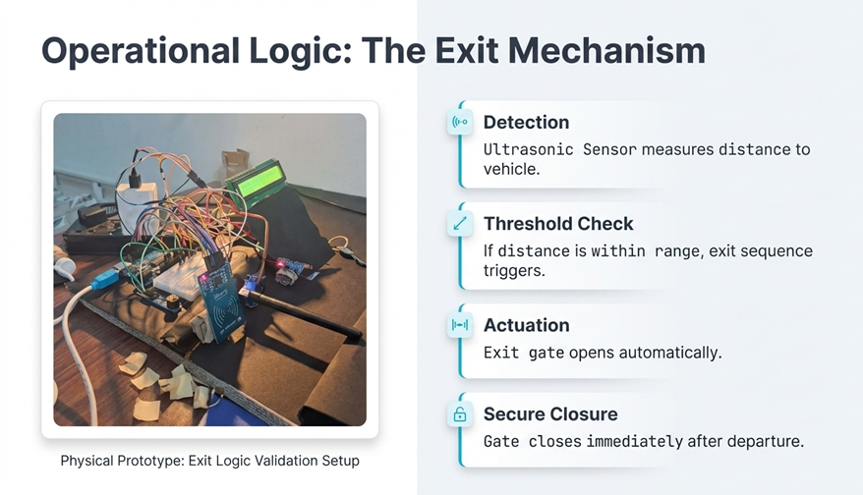

3.2 Application Workflow Results
The application successfully handles the reservation logic:
- Booking Confirmation: "Once the user selects the Location and Vehicle type, the system checks the Current_Count < Max_Capacity condition". "If successful, the specific slot number is reserved (e.g., Slot A-45)".
- Navigation: "Immediately after confirmation, the app transitions to the Navigation Screen". A "'Navigate' Button: Launches Google Maps/Mapbox API to provide turn-by-turn directions to the entry gate".

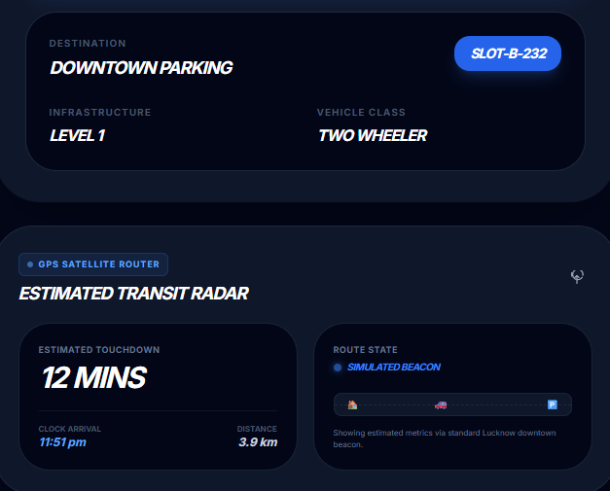

3.3 Discussion of Benefits
The implementation provides several advantages:
- Reduced Congestion: "Automated systems minimize time spent searching for parking spaces, reducing traffic congestion".
- Enhanced Security: "RFID authentication prevents unauthorized access and vehicle theft".
- Environmental Benefits: "Reduced fuel consumption from decreased parking search time lowers emissions".
- Data Collection: "System generates usage data for facility optimization".

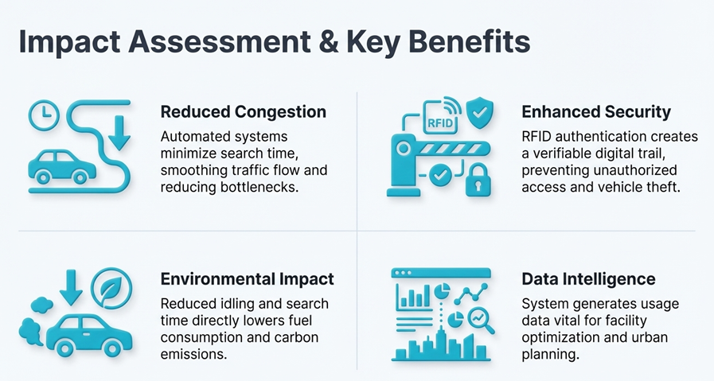

4. CONCLUSION AND FUTURE SCOPE
4.1 Conclusion
"ParkSense successfully demonstrates a working model of a smart city parking solution". "By integrating Arduino hardware for physical simulation and a robust Android app for user interaction, the system bridges the gap between hardware automation and user convenience".
The specific categorization of parking lots allows for organized traffic flow, while the FASTag integration ensures cashless, non-stop entry and exit. The prototype successfully validated the logic where the entry is secured via RFID and the exit is automated via ultrasonic distance sensing.
On a personal level, the development of this project was highly educational. This project helped me improve my skills in Embedded Systems, IoT, Arduino Programming, and Sensor Interfacing. It provided practical experience in connecting distinct hardware components to create a cohesive, functional system.

4.2 Future Enhancements
Future iterations of the project will focus on:
- "License Plate Recognition (LPR): Using cameras to double-check the vehicle identity alongside RFID".
- "EV Charging Integration: Adding a filter to find parking spots with Electric Vehicle charging stations".
- "Dynamic Pricing: Increasing parking rates during peak hours to manage demand in the Centralised Parking zones".
- "Cloud Connectivity: Remote monitoring and management via cloud platforms".

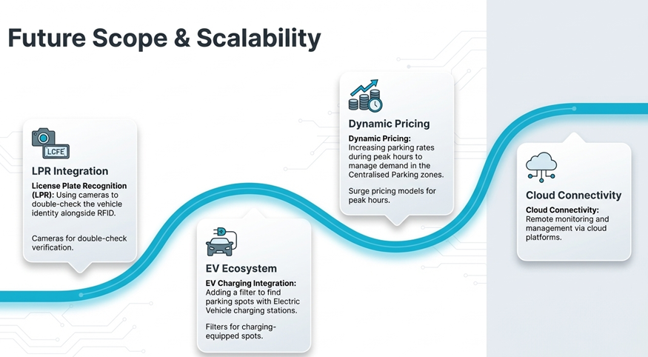

BIOGRAPHY OF THE AUTHOR
Anendra Narayan Dixit
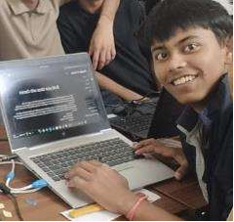
I am currently pursuing a B.Tech (1st Year) in Electrical Engineering at Central University Of Karnataka. With a keen interest in the Internet of Things (IoT), Embedded Systems, and Mobile Application Development, I have dedicated my academic research to solving urban infrastructure problems through technology.
This project, "ParkSense," represents a culmination of my work in integrating hardware automation with user-centric software solutions. I have expertise in Arduino programming, Android App development, and sensor integration. I am aspire to contribute further to the development of Smart Cities and sustainable technological solutions in the future.
Contact:
- Ph no.: +91 7899849290
- Email: enigmatic.anendrandixit@gmail,com
- LinkedIn: Anendra Narayan Dixit

-- END OF REPORT --

