|  |  |
| --- | --- |
| **Topic** | Oracle SQL Language Fundamentals I |
| **Document Name** | SQL03-EX-01-05 |
|  |  |

## Exercise SQL03-EX-01:

**Definiton :** Write followig SQL queries:

* Add a colum to employees table named MAX_SALARY.
* Update MAX_SALARY with maximum salary amount with subquery.
* Delete employee who have minimum salary using subquery.

**SQL:**

ALTER TABLE EMPLOYEES

ADD MAX_SALARY NUMBER;

UPDATE EMPLOYEES

SET MAX_SALARY = (SELECT MAX(salary) FROM employees);

DELETE FROM EMPLOYEES

WHERE SALARY = (SELECT MIN(SALARY) FROM EMPLOYEES);

**Screenshot:**

* MAX_SALARY column eklendi ve tüm column max salary olan 24000 ile update edildi.

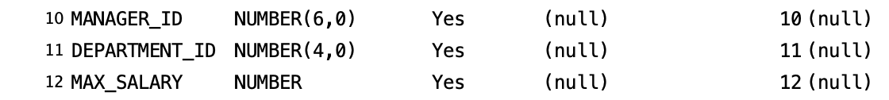

* EMPLOYEE_ID 132 olanın salary en düşüktü o satır silindi

**metin, yazı tipi, ekran görüntüsü, makbuz içeren bir resim

Açıklama otomatik olarak oluşturuldu**

## Exercise SQL03-EX-02:

**Definiton :** Write followig SQL queries:

* Define index (named DPR_NAME_IDX) on DEPARTMENT_NAME column of DEPARTMENTS table.
* Define constraint (named CNSTR_SALARY) on employee salary. (Salary must be between 1000$ and 100.000$)
* Drop defined index.
* Enable, disable, drop defined constraint.

**SQL:**

CREATE INDEX DPR_NAME_IDX

ON DEPARTMENTS (DEPARTMENT_NAME);

ALTER TABLE EMPLOYEES

ADD CONSTRAINT CNSTR_SALARY

CHECK (SALARY BETWEEN 1000 AND 100000);

DROP INDEX DPR_NAME_IDX;

ALTER TABLE EMPLOYEES

DISABLE CONSTRAINT CNSTR_SALARY;

ALTER TABLE EMPLOYEES

ENABLE CONSTRAINT CNSTR_SALARY;

ALTER TABLE EMPLOYEES

DROP CONSTRAINT CNSTR_SALARY;

**Screenshot:**

metin, ekran görüntüsü, yazı tipi içeren bir resim

Açıklama otomatik olarak oluşturuldu

## Exercise SQL03-EX-03:

**Definiton :** Create a table from EMPLOYEES with distinct department_id column. Add department_name to that table. With DEPARTMENTS table, update department_name for included department_ids and insert department_id and department_name values for not included rows. Use MERGE keyword.

**SQL:**

CREATE TABLE MY_DISNT_TABLE AS SELECT DEPARTMENT_ID, DEPARTMENT_NAME FROM DEPARTMENTS;

MERGE INTO MY_DISNT_TABLE m

USING DEPARTMENTS d ON (m.DEPARTMENT_ID = d.DEPARTMENT_ID)

WHEN MATCHED THEN UPDATE SET m.DEPARTMENT_NAME = d.DEPARTMENT_NAME

WHEN NOT MATCHED THEN INSERT (DEPARTMENT_ID, DEPARTMENT_NAME) VALUES (d.DEPARTMENT_ID,

d.DEPARTMENT_NAME);

**Screenshot:**

metin, ekran görüntüsü, yazı tipi, beyaz içeren bir resim

Açıklama otomatik olarak oluşturuldu

## Exercise SQL03-EX-04:

**Definiton :** Using **WITH** keyword, do following jobs:

* Firstly select first_name, last_name, job_id, department_id from employees table whoes job_id starts with ‘S’.
* Additionally select job_title and min-max salary amount.
* Add department_name to that query.
* Lastly concat first_name and last_name with space as full_name alias and list with other selected columns.

**SQL:**

SELECT

CONCAT(e.first_name, ' ') || e.last_name AS full_name,

e.first_name,

e.last_name,

e.job_id,

e.department_id,

j.job_title,

j.min_salary,

j.max_salary,

d.department_name

FROM

employees e

JOIN

jobs j ON e.job_id = j.job_id

JOIN

departments d ON e.department_id = d.department_id

WHERE

e.job_id LIKE 'S%'

ORDER BY

full_name;

**Screenshot:**

WITH ile yapmaya çalıştığımda sürekli SQL sorgusunu böyle bitiremezsin diye bir hata aldım. Bundan dolayı bu query ile yaptım

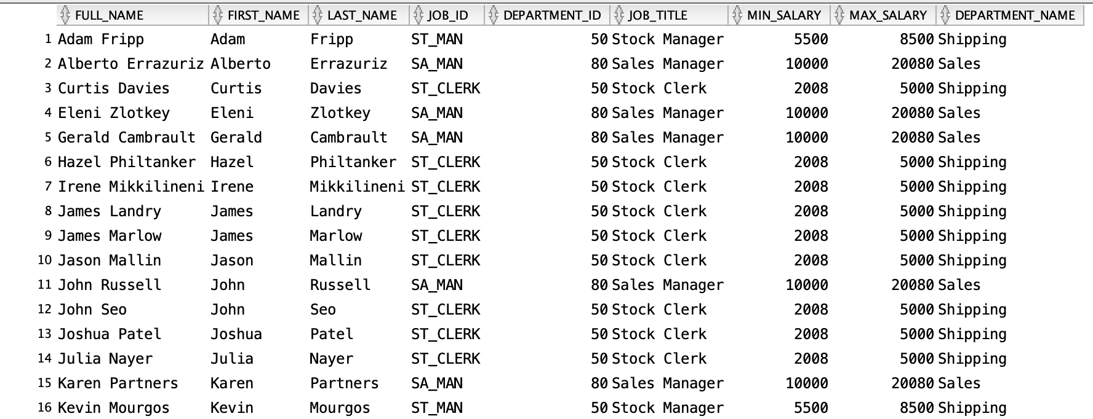

## Exercise SQL03-EX-05:

**Definiton :** Search for COMMIT and ROLLBACK keywords and explain them.

**COMMIT** and **ROLLBACK** are two essential SQL keywords used to manage database transactions.

**COMMIT:** The COMMIT statement permanently saves the changes made by the current transaction to the database. Once a COMMIT is issued, all changes within the transaction become permanent. The transaction ends successfully.

BEGIN TRANSACTION;

UPDATE customers SET credit_limit = 10000 WHERE customer_id = 123;

INSERT INTOorders (customer_id, order_date) VALUES (123, GETDATE());

COMMIT;

**The COMMIT comand statement makes these changes permanent**

**ROLLBACK**: The ROLLBACK statement undoes all changes made by the current transaction. The database is restored to its state before the transaction began. The transaction is terminated unsuccessfully.