|  |  |
| --- | --- |
| **Topic** | ORACLE Analytic SQL |
| **Document Name** | AnalyticSQL01-EX-01-05 |
|  |  |

## Exercise EX -01:

**SQL:**

SELECT

e1.department_id,

LISTAGG(e1.first_name || ' ' || e1.last_name, ', ') WITHIN GROUP (ORDER BY e1.first_name, e1.last_name) AS Employees

FROM

employees e1

GROUP BY

e1.department_id

ORDER BY

e1.department_id;

**Screenshot:**

LISTAGG komutu ile DEPARMENT_ID aynı olan çalışanların FIRST_NAME ve LAST_NAME değerlerini birleştirerek aynı satırda yazmamızı sağlıyor.

metin, ekran görüntüsü, yazı tipi, cebir içeren bir resim

Açıklama otomatik olarak oluşturuldu

## Exercise EX -02:

**SQL:**

SELECT

employee_id,

first_name,

last_name,

job_id,

hire_date,

salary,

COALESCE(LAG(salary, 1) OVER (PARTITION BY job_id ORDER BY hire_date), 0) AS Preceding_Salary,

COALESCE(LEAD(salary, 1) OVER (PARTITION BY job_id ORDER BY hire_date), 0) AS Following_Salary,

salary +

COALESCE(LAG(salary, 1) OVER (PARTITION BY job_id ORDER BY hire_date), 0) +

COALESCE(LEAD(salary, 1) OVER (PARTITION BY job_id ORDER BY hire_date), 0) AS Total_Salary

FROM

employees

ORDER BY

job_id,

hire_date;

**Screenshot:**

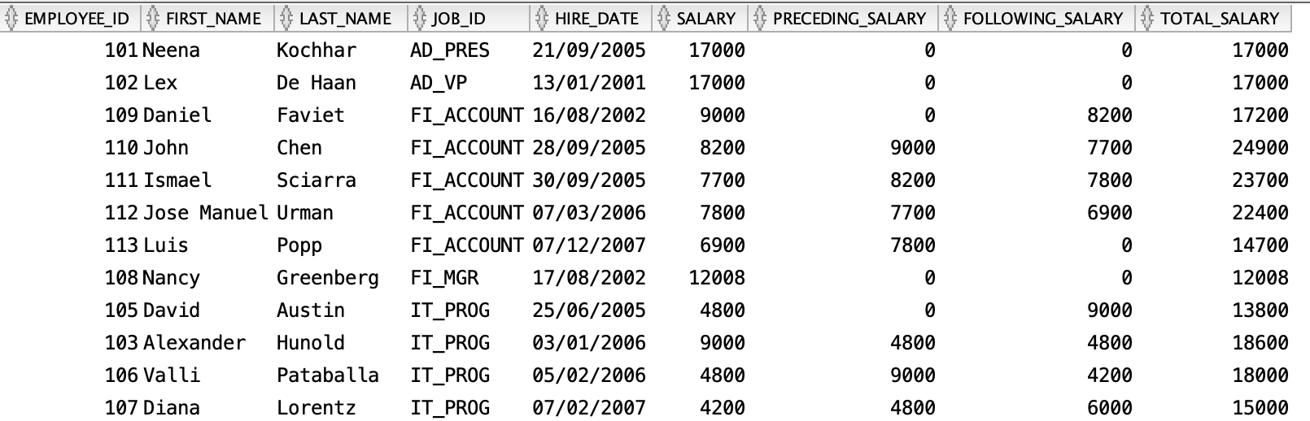

## Exercise EX -03:

**Definiton :** List employees’ salary orders in their department and exclude higest salaried employee.

(Hint: ROW_NUMBER)

**SQL:**

SELECT

EMPLOYEE_ID,

FIRST_NAME,

LAST_NAME,

DEPARTMENT_ID,

SALARY

FROM (

SELECT

EMPLOYEE_ID,

FIRST_NAME,

LAST_NAME,

DEPARTMENT_ID,

SALARY,

ROW_NUMBER() OVER (PARTITION BY DEPARTMENT_ID ORDER BY SALARY DESC) AS SALARY_RANK

FROM

EMPLOYEES

) RANKED_SALARY

WHERE

SALARY_RANK > 1

ORDER BY

DEPARTMENT_ID,

SALARY_RANK;

**Screenshot:**

**DEPARMENT_ID olanlar da SALARY en yüksek olanları exclued etti.**

**metin, yazı tipi, ekran görüntüsü, beyaz içeren bir resim

Açıklama otomatik olarak oluşturuldu** 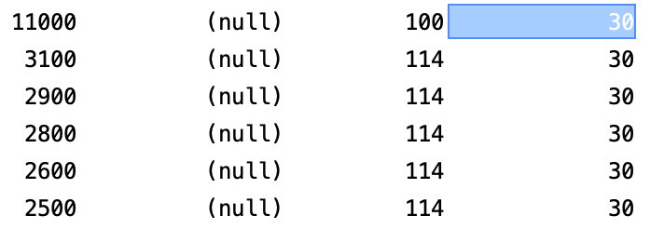

## Exercise EX -04:

**Definiton :** Listemployees’ hire order according to hiredate year value.

**SQL:**

SELECT

EMPLOYEES.*,

EXTRACT(YEAR FROM HIRE_DATE) AS HIRE_YEAR

FROM

EMPLOYEES

ORDER BY

HIRE_DATE;

**Screenshot:**

metin, ekran görüntüsü, yazı tipi, sayı, numara içeren bir resim

Açıklama otomatik olarak oluşturuldu

## Exercise EX -05:

**SQL:**

SELECT

employee_id,

first_name,

last_name,

salary,

LAG(salary, 1, NULL) OVER (ORDER BY hire_date) AS Previous_Salary, **#bir önceki salary**

LEAD(salary, 1, NULL) OVER (ORDER BY hire_date) AS Next_Salary **#bir sonraki salary**

FROM

employees

ORDER BY

hire_date;

**Screenshot:** Lex’in hire_date 2001, Daniel hire_date 16/08/2002, Nancy hire_date 17/08/2002, John hire_date 01/10/2004 bu hire_date verisine göre işlemleri yapıyor

metin, ekran görüntüsü, menü, sayı, numara içeren bir resim

Açıklama otomatik olarak oluşturuldu