

**Faculty of engineering Shoubra Benha University**

# Research Article / Research Project / Literature Review

in fulfillment of the requirements of

|  |  |
| --- | --- |
| **Department** | Engineering Mathematics and Physics |
| **Division** | ------------ |
| **Academic Year** | 2019-2020 Preparatory |
| **Course name** | Computer |
| **Course code** | ECE001 |

**Title: -**

**Build a website on recent computer engineering topics**

By:

|  |  |  |  |
| --- | --- | --- | --- |
|  | Name | Edu mail | B.N |
| 1 |  |  |  |

## Approved by:

|  |  |
| --- | --- |
| Examiners committee | Signature |
| Dr. Ahmed Bayoumi |  |
| Dr. Shady Elmashed |  |
| Dr. Abdelhamid Attaby |  |

**Name :**

**B.N:**

**Date :**

**Topic:**

**Github link :**

**Github page :**

**Application brief :**

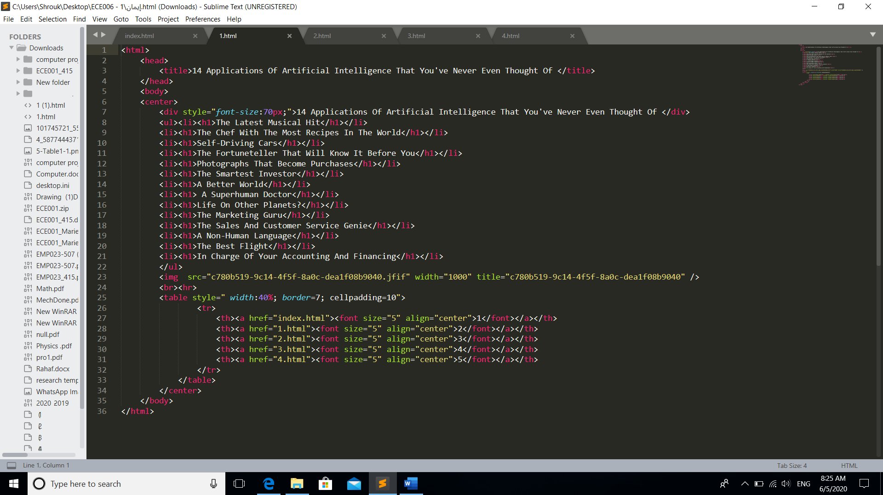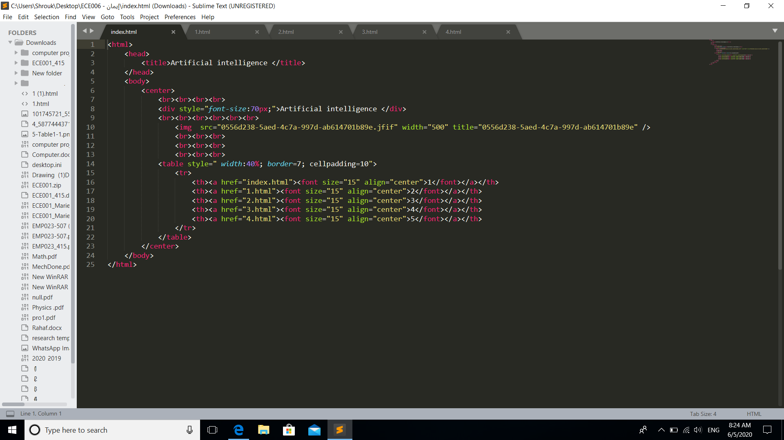**Screenshots :**

