LAB 6: Virtual LAN (VLANs)

Objectives
- Create and configure VLANs in Cisco packet tracer.
- Study the Router on a Stick Configuration.
- Learn to Configure native VLAN in Cisco packet tracer and Fix native VLAN mismatch.

Introduction to VLANs
Technically, VLAN (virtual local area network) is also known as a virtual LAN. This technology can logically partition and isolate one or more physical LANs into multiple broadcast domains. And each broadcast domain is regarded as one VLAN. Generally, only devices under the same VLAN can communicate with each other. Why VLAN is used? Before VLAN, there was a single broadcast domain over the specified network, which is called LAN (local area work). Just like the following LAN application topology showed, to communicate with host B, host A will broadcast its ARP (address resolution protocol) request to all the switches and other hosts over the same local area network.
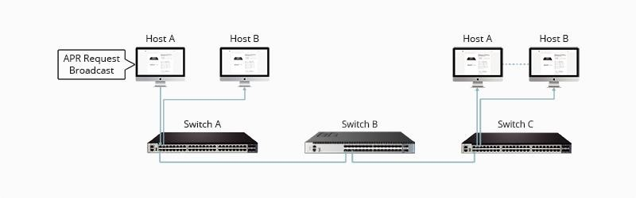
Figure 6.1 LAN overheads

How VLAN works
Here is step by step details of how VLAN works:
- VLANs in networking are identified by a number.
- A Valid range is 1-4094. On a VLAN switch, you assign ports with the proper VLAN number.
- The switch then allows data that needs to be sent between various ports having the same VLAN.
- Since almost all networks are larger than a single switch, there should be a way to send traffic between two switches.
- One simple and easy way to do this is to assign a port on each network switch with a VLAN and run a cable between them.

VLAN Ranges
Here are the important ranges of VLAN:

Range | Description
VLAN 0-4095 | Reserved VLAN, which cannot be seen or used.
VLAN 1: | This is a default VLAN of switches. You cannot delete or edit this VLAN, but it can be used.
VLAN 2-1001: | It is a normal VLAN range. You can create, edit, and delete it.
VLAN 1002-1005: | These ranges are CISCO defaults for token rings and FDDI. You cannot delete this VLAN.
VLAN 1006-4094: | It is an extended range of VLANs.

Characteristics of VLAN
Here are the important characteristics of VLAN:

- Virtual LANs offer a structure for making groups of devices, even if their networks are different.
- It increases the broadcast domains possible in a LAN.
- Implementing VLANs reduces the security risks as the number of hosts which are connected to the broadcast domain decreases.
- This is performed by configuring a separate virtual LAN for only the hosts having sensitive information.
- It has a flexible networking model that groups users depending on their departments instead of network location.
- Changing hosts/users on a VLAN is relatively easy. It just needs a new port-level configuration.
- It can reduce congestion by sharing traffic as individual VLANs work as separate LANs.
- A workstation can be used with full bandwidth at each port.
- Terminal reallocations become easy.
- A VLAN can span multiple switches.
- The link of the trunk can carry traffic for multiple LANs.

Types of VLANs
Here are the important types of VLANs
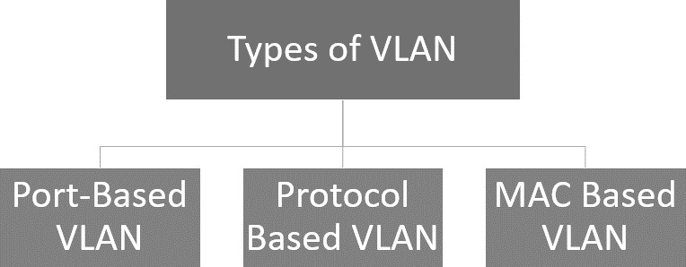
Figure 6.2 Types of VLAN

Port-Based VLAN
Port-based VLANs group virtual local area networks by port. In this type of virtual LAN, a switch port can be configured manually to a member of the VLAN.
Devices that are connected to this port will belong to the same broadcast domain that is because all other ports are configured with a similar VLAN number.
The challenge of this type of network is to know which ports are appropriate to each VLAN. The VLAN membership can’t be known just by looking at the physical port of a switch. You can determine it by checking the configuration information.

Protocol Based VLAN
This type of VLAN processes traffic based on a protocol that can be used to define filtering criteria for tags, which are untagged packets.
In this Virtual Local Area Network, the layer-3 protocol is carried by the frame to determine VLAN membership. It works in multi-protocol environments. This method is not practical in a predominately IP-based network.

MAC Based VLAN
MAC Based VLAN allows incoming untagged packets to be assigned virtual LAN and, thereby, classify traffic depending on the packet source address. You define a Mac address to VLAN mapping by configuring mapping the entry in MAC to the VLAN table.
This entry is specified using the source Mac address proper VLAN ID. The configurations of tables are shared among all device ports.

Difference between LAN and VLAN
Here is an important difference between LAN and VLAN:

LAN | VLAN
LAN can be defined as a group of computer and peripheral devices that are connected in a limited area. | A VLAN can be defined as a custom network that is created from one or more local area networks.
The full form of LAN is Local Area Network | The full form of VLAN is Virtual Local Area Network.
The latency of the LAN is high. | The latency of VLAN is less.
The cost of LAN is high. | The cost of a VLAN is less.
In LAN, the network packet is advertised to each and every device. | In VLAN, the network packet is sent to only a specific broadcast domain.
It uses a ring, and FDDI (Fiber Distributed Data Interface) is a protocol. | It uses ISP and VTP as a protocol.

Advantages of VLAN
Here are the important pros/benefits of VLAN:

- It solves a broadcast problem.
- VLAN reduces the size of broadcast domains.
- VLAN allows you to add a layer of security.
- It can make device management simple and easier.
- You can make a logical grouping of devices by function rather than location.
- It allows the creation of groups of logically connected devices that act like they are on their network.
- You can logically segment networks based on departments, project teams, or functions.
- VLAN helps to geographically structure your network to support growing companies.
- Higher performance and reduced latency.
- VLANs provide increased performance.
- Users may work on sensitive information that must not be viewed by other users.
- VLAN removes the physical boundary.
- It lets you easily segment your network.
- It helps you to enhance network security.
- You can keep hosts separated by VLAN.
- You do not require additional hardware and cabling, which helps you to save costs.
- It has operational advantages because of changing the IP subnet of the user in software.
- It reduces the number of devices for a particular network topology.
- VLAN makes managing physical devices less complex.

Disadvantages of VLAN
Here are the important cons/ drawbacks of VLAN:

- A packet can leak from one VLAN to another.
- An injected packet may lead to a cyber-attack.
- Threats in a single system may spread a virus through a whole logical network.
- You require an additional router to control the workload in large networks.
- You can face problems in interoperability.
- A VLAN cannot forward network traffic to other VLANs.

Application/Purpose of VLAN
Here are the important uses of VLAN:

- VLAN is used when you have 200+ devices on your LAN.
- It is helpful when you have a lot of traffic on a LAN.
- VLAN is ideal when a group of users needs more security or is being slowed down by many broadcasts.
- It is used when users are not on one broadcast domain.
- Make a single switch into multiple switches.

Working with VLANs
We will create VLAN 10 and VLAN 20 in this lab. It is always a good practice to give names to the VLANs as this makes it easier for the admins to manage the configured VLANs. The best way to give a name is according to their role in the network e.g. if there is a VLAN that handles traffic for the voice of IP then we can give the name 'voice' to the VLAN and another way of assigning a name is according to the departments in the organization like Sales, marketing, etc.
In a case of a network outage or any issue with the VLANs, admins can easily identify the VLANs with names, which makes their work easier.

Creating VLANs

We can use the following command to create VLAN 10 and 20 and give them a name.

For VLAN 10
Switch(config)#vlan 10 Switch(config-vlan)#name Admin Switch(config-vlan)#no shutdown

For VLAN 20
Switch(config)#vlan 20 Switch(config-vlan)#name Sales Switch(config-vlan)#no shutdown

Checking the Created VLANs
Once we are done creating the VLANs, we can check the created VLANs with the command Switch#show VLAN brief
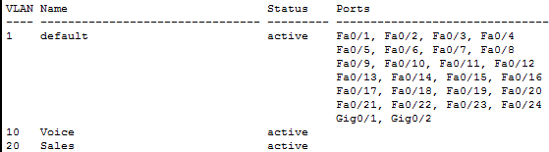

Assigning ports to VLANs:
You can see in the image above that although we have created the VLANs however to use those VLANs, we have to assign ports to VLAN. By default, all ports are assigned to VLAN 1 We will assign 1 port to VLAN 10 and 5 ports to VLAN 20.

If we want to assign multiple ports to a single VLAN then we can use the interface range command and include the range of ports that we want to add to any VLAN

Switch(config)#interface fastEthernet 0/1
Now Assign port and make it access meaning PC are connected to the switch)
Switch(config-if)#switchport mode access
Now make the switch port part of VLAN-10
Switch(config-if)#switchport access vlan 10

To assign multiple ports to any VLAN use the range command, given below:

Assigning RANGE of ports to any VLAN Switch(config)#interface range fastethernet 0/2 – 6 Switch(config-if-range)#switchport mode access Switch(config-if-range)#switchport access vlan 20

Now, we can see in the image below that assigned ports are appearing in front of VLAN 10 and 20
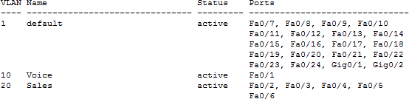

Inter VLAN routing in packet tracer

Each VLAN represents a separate network so to enable routing from one VLAN to another VLAN; we have to either use a layer 3 switch or Router.
On a single router interface, we can create sub-interfaces and configure those interfaces to accept traffic from specific VLANs so we can use only one interface that is connected to the Switch for routing purposes.
After configuring the sub-interfaces, we have to assign a default gateway on the end device so the default gateway would be the IP address of the sub-interface specified for the same VLAN of the end device.
Now the traffic will travel within Switch when communicating with the end device in the same VLAN and traffic will travel through the Router when communicating with devices on other VLANs.

Assigning IP to created VLANs
Give IP to the designated VLAN in configuration mode and assign it a IP

Switch(config)#interface vlan 10

Do not assign the IP 192.168.10.1 to any switch as it will be used for Router sub-interface for inter- VLAN-routing.

Switch(config-if)#ip address 192.168.10.2 255.255.255.0 Switch(config-if)#no shutdown

Connecting PC to VLANs
Now as the VLANs are now created connect PCs to the designated VLANs and assign them IP address accordingly and Gateway of the same VLAN, in our case it is 192.168.10.1 the address of the VLAN 10 on the switch.

Inter VLAN routing in packet tracer
Each VLAN represents a separate network so to enable routing from one VLAN to another VLAN; we have to either use a layer 3 switch or Router.
On a single router interface, we can create sub-interfaces and configure those interfaces to accept traffic from specific VLANs so we can use only one interface that is connected to the Switch for routing purposes.
After configuring the sub-interfaces, we have to assign a default gateway on the end device so the default gateway would be the IP address of the sub-interface specified for the same VLAN of the end device.
Now the traffic will travel within Switch when communicating with the end device in the same VLAN and traffic will travel through the Router when communicating with devices on other VLANs.
Please check section 2 ‘router on a stick’ part to properly configure inter-VLAN routing.

Router on A Stick:
'Router on a Stick' allows routing between VLANs with only one interface. Each VLAN represents a different Subnet. In general, routers can take traffic from only one subnet and transfer it to another subnet. And we can assign only one IP Address to a router interface. 'Router on a stick' allows us to create sub-interfaces, and assign IP Addresses to those sub- interfaces. To make it work, we have to create a truck connection between the Switch and a router so that traffic from multiple VLANs can be sent to the Router.
If we create a route between VLANs without the 'Router on a Stick' method, then we have to waste interfaces on the switches and routers. And if we enable routing between multiple VLANs then it will become practically inefficient as the switches and the routers will use those multiple interfaces.

The image below is an alternative method for allowing routing between VLANs. As you can see, we are using two interfaces on both the Router and a switch to allow routing between VLANs. We have not created a sub-interface in the below figure.
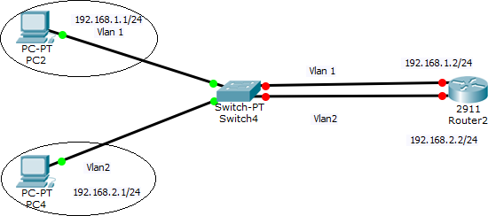
You can see that we have to use extra interfaces for each VLAN. So, it becomes practically non-efficient if we have multiple VLANs. Hence, 'Router on a Stick' is a perfect solution for routing between VLANs with just one router interface.
The simpler way to do routing between VLANs is by using a Layer 3 Switch. We just have to create virtual interfaces for each VLAN and assign them IP Addresses from the same network. A Layer 3 Switch will then enable routing between VLANs as it has routing capabilities as well. However, Layer 3 Switch is quite expensive so it might not be an affordable option for small office networks.
In the below lab, we will configure a 'Router on a Stick' that would allow routing between the VLANs. Some of the important concepts in this lab are – creating sub-interfaces, using the encapsulation dot1Q command to encapsulate the traffic, and mentioning the VLAN number to ascertain for which VLAN the sub-interface should respond.
Draw the figure on the Packet tracer, as shown below to start configuring Router on a stick configuration in the packet tracer.

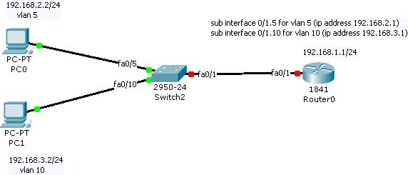

Native VLAN and Mismatch:
Native VLAN – Native VLAN allows untagged traffic to be part of one particular VLAN. Native VLAN functionality is used when untagged traffic is received on the trunk connection of the Switch.
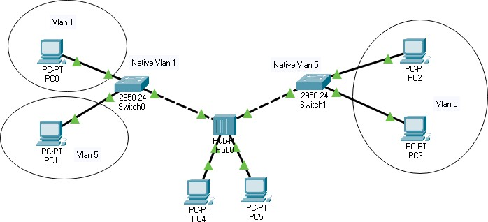
In the above image, you can see that the Hub is connected to the Switch. VLAN and tagging are switching technology and as Hub is unable to tag the traffic then what will happen if PC 4 and PC 5 which are connected to the Hub send the traffic? In that case, we have to specify native VLAN on both of the switch interfaces that are connected to Hub, and that will help when the Switch will receive the untagged traffic on those interfaces then it will be part of the specified VLAN which we have configured as Native VLAN.
Although Hubs are not in use now a day's however in a small organization where the budget is low and organizations cannot afford to spend money on new network equipment and they want to use the old network devices then network admin may have to work with such topologies.
In small networks, speed is not the priority for the company so using the device as a hub does not harm the network.
Another network scenario, in which native VLAN is used commonly, is shown below. IP phones are used commonly in companies these days, they allow daisy-chaining of end devices like PC which saves the interfaces and saves the extra cost of the telecom.
Daisy-chaining the PC is an efficient solution as an organization does not have to buy extra switches to implement IP phones.
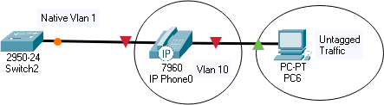
PC 6 cannot tag the traffic so we have to configure Native VLAN to route the traffic generated by the PC on the desired VLAN. However, the Cisco IP phone can tag the traffic so native VLAN will only be used by the PC.

By default, native VLAN is configured as 1 on all the interfaces however, in case we want to route traffic to another VLAN then we have to change the native VLAN accordingly.
To check the native VLAN that is configured, we can use the command 'show interfaces trunk'

To configure the native VLAN or to change the default native VLAN, we have to use the following command.
Switch(config)#interface FastEthernet 0/24 Switch(config-if)#switchport trunk native vlan 5
We have to enter into interface configuration mode and then use the command shown above; we have to specify the VLAN number where we want to redirect untagged traffic. In the above example, traffic will be routed to VLAN 5.

Native VLAN mismatch
Native VLAN mismatch happens when interfaces of the Switch are configured with different native VLANs and in that case, traffic generated by the PC will be routed to both VLANs which will cause issues in the network.
The good thing about the Switch is that it detects the native VLAN itself and the following message is displayed on the Command-line interface of the device.
— %CDP-4-NATIVE_VLAN_MISMATCH: Native VLAN mismatch
discovered on FastEthernet0/24 (5), with Switch FastEthernet0/24 (1) —

To fix the Native VLAN mismatch, we have to configure the same native VLAN on all interfaces that are connected to the Hub so that the traffic generated will only be redirected to one VLAN.

In this lab, we have intentionally created a native VLAN mismatch so you can learn and practice fixing the mismatch by assigning the same Native VLAN on both switches.
You will be able to see the mismatch message on the CLIs of both of the switches.

VLAN Lab Challenge
This section details how to configure router-on-a-stick inter-VLAN routing. You can see in the figure that the router is not in the center of the topology but instead appears to be on a stick near the border, hence the name.

In Figure 6.4, the R1 GigabitEthernet 0/0/1 interface is connected to the S1 FastEthernet 0/2 port. The S1 FastEthernet 0/1 port is connected to the S2 FastEthernet 0/1 port. These are trunk links that are required to forward traffic within and between VLANs.
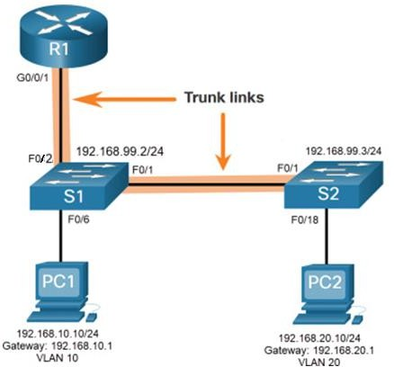
Figure 6.4 Router-on-a-Stick Topology

To route between VLANs, the R1 GigabitEthernet 0/0/1 interface is logically divided into three subinterfaces, as shown in Table 6.1. The table also shows the three VLANs that will be configured on the switches.
Table 6.1 Router R1 Sub-interfaces
Sub-interface | VLAN | IP Address
G0/0/1.10 | 10 | 192.168.10.1/24
G0/0/1.20 | 20 | 192.168.20.1/24
G0/0/1.30 | 99 | 192.168.99.1/24
Assume that R1, S1, and S2 have initial basic configurations. Currently, PC1 and PC2 cannot ping each other because they are on separate networks. Only S1 and S2 can ping each other, but they but are unreachable by PC1 or PC2 because they are also on different networks.

To enable devices to ping each other, the switches must be configured with VLANs and trunking, and the router must be configured for inter-VLAN routing.

S1 VLAN and Trunking Configuration
Complete the following steps to configure S1 with VLANs and trunking:

- Step 1. Create and name the VLANs. First, the VLANs are created and named, as shown in Example 1. VLANs are created only after you exit out of VLAN subconfiguration mode.

Example 6.1 Create and Name VLANs
S1(config)# vlan 10
S1(config-vlan)# name LAN10 S1(config-vlan)# exit S1(config)# vlan 20
S1(config-vlan)# name LAN20 S1(config-vlan)# exit S1(config)# vlan 99
S1(config-vlan)# name Management
S1(config-vlan)# exit
S1(config)#

- Step 2. Create the management interface. Next, the management interface is created on VLAN 99 along with the default gateway of R1, as shown in Example 6.2.

Example 6.2 Create the Management Interface
S1(config)# interface vlan 99
S1(config-if)# ip add 192.168.99.2 255.255.255.0
S1(config-if)# no shut
S1(config-if)# exit
S1(config)# ip default-gateway 192.168.99.1
S1(config)#
- Step 3. Configure access ports. Next, port Fa0/6 connecting to PC1 is configured as an access port in VLAN 10, as shown in Example 4-3. Assume PC1 has been configured with the correct IP address and default gateway.

Example 6.3 Configure Access Ports
S1(config)# interface fa0/6
S1(config-if)# switchport mode access S1(config-if)# switchport access vlan 10 S1(config-if)# no shut
S1(config-if)# exit
S1(config)#

- Step 4. Configure trunking ports. Finally, ports Fa0/1 connecting to S2 and Fa05 connecting to R1 are configured as trunk ports, as shown in Example 6.4.

Example 6.4 Configure Trunking Ports
S1(config)# interface fa0/1
S1(config-if)# switchport mode trunk
S1(config-if)# no shut S1(config-if)# exit S1(config)#
S1(config)# interface fa0/2

S1(config-if)# switchport mode trunk
S1(config-if)# no shut
S1(config-if)# end

S2 VLAN and Trunking Configuration
The configuration for S2 is similar to S1, as shown in Example 6.5.

Example 6.5 S2 Configuration
S2(config)# vlan 10
S2(config-vlan)# name LAN10 S2(config-vlan)# exit S2(config)# vlan 20
S2(config-vlan)# name LAN20 S2(config-vlan)# exit S2(config)# vlan 99
S2(config-vlan)# name Management
S2(config-vlan)# exit
S2(config)#
S2(config)# interface vlan 99
S2(config-if)# ip add 192.168.99.3 255.255.255.0
S2(config-if)# no shut S2(config-if)# exit S2(config)#
S2(config)# ip default-gateway 192.168.99.1
S2(config)#
S2(config)# interface fa0/18
S2(config-if)# switchport mode access S2(config-if)# switchport access vlan 20 S2(config-if)# no shut
S2(config-if)# exit
S2(config)#
S2(config)# interface fa0/1
S2(config-if)# switchport mode trunk
S2(config-if)# no shut S2(config-if)# exit S2(config-if)# end

R1 Sub-interface Configuration
The router-on-a-stick method requires you to create a subinterface for each VLAN to be routed.
A subinterface is created using the interface interface_id.subinterface_id global configuration mode command.
Note:
The subinterface syntax is the physical interface followed by a period and a subinterface number.
Although not required, it is customary to match the subinterface number with the VLAN number.

Each subinterface is then configured with the following two commands:
- encapsulation dot1q vlan_id [native]: This command configures the subinterface to respond to 802.1Q encapsulated traffic from the specified vlan-id.
The native keyword option is only appended to set the native VLAN to something other than VLAN 1.
- ip address ip-address subnet-mask: This command configures the IPv4 address of the subinterface. This address typically serves as the default gateway for the identified VLAN.
Repeat the process for each VLAN to be routed. Each router subinterface must be assigned an IP address on a unique subnet for routing to occur.

When all subinterfaces have been created, enable the physical interface using the no shutdown interface configuration command. If the physical interface is disabled, all subinterfaces are disabled.

In the configuration in Example 6.6, the R1 G0/0/1 subinterfaces are configured for VLANs 10, 20, and 99.

Example 4-6 R1 Subinterface Configuration
R1(config)# interface G0/0/1.10
R1(config-subif)# description Default Gateway for VLAN 10
R1(config-subif)# encapsulation dot1Q 10 R1(config-subif)# ip add 192.168.10.1 255.255.255.0 R1(config-subif)# exit
R1(config)#
R1(config)# interface G0/0/1.20
R1(config-subif)# description Default Gateway for VLAN 20
R1(config-subif)# encapsulation dot1Q 20 R1(config-subif)# ip add 192.168.20.1 255.255.255.0 R1(config-subif)# exit
R1(config)#
R1(config)# interface G0/0/1.99
R1(config-subif)# description Default Gateway for VLAN 99
R1(config-subif)# encapsulation dot1Q 99 R1(config-subif)# ip add 192.168.99.1 255.255.255.0 R1(config-subif)# exit
R1(config)#
R1(config)# interface G0/0/1
R1(config-if)# description Trunk link to S1
R1(config-if)# no shut R1(config-if)# end R1#
NOTE: We did not provide Router interface an IP address. We can give it an IP address of 192.168.1.1, it can serve as a Gateway for VLAN1. If we connect any PC over VLAN1 with similar network addresses. You can try this at the end.

Verify Connectivity Between PC1 and PC2
The router-on-a-stick configuration is complete after the switch trunk and the router subinterfaces have been configured. The configuration can be verified from the hosts, router, and switch.
From a host, verify connectivity to a host in another VLAN using the ping command. It is a good idea to first verify the current host IP configuration using the ipconfig Windows host command, as shown in Example 6.7.

Example 6.7 Verify Windows Host Configuration
C:\Users\PC1> ipconfig Windows IP Configuration Ethernet adapter Ethernet0:
Connection-specific DNS Suffix . :
Link-local IPv6 Address : fe80::5c43:ee7c:2959:da68%6 IPv4 Address : 192.168.10.10
Subnet Mask : 255.255.255.0
Default Gateway : 192.168.10.1 C:\Users\PC1>

The output confirms the IPv4 address and default gateway of PC1. Next, use ping to verify connectivity with PC2 and S1, as shown in Figure 6.4.

The ping output successfully confirms that inter-VLAN routing is operating, as shown in Example 6.8.

Example 6.8 Verify Inter-VLAN Routing by Pinging from PC1
C:\Users\PC1> ping 192.168.20.10
Pinging 192.168.20.10 with 32 bytes of data:
Reply from 192.168.20.10: bytes=32 time<1ms TTL=127 Reply from 192.168.20.10: bytes=32 time<1ms TTL=127
`Ping statistics for 192.168.20.10:
Packets: Sent = 4, Received = 4, Lost = 0 (0% loss). Approximate round trip times in milli-seconds: Minimum = 0ms, Maximum = 0ms, Average = 0ms C:\Users\PC1>
C:\Users\PC1> ping 192.168.99.2
Pinging 192.168.99.2 with 32 bytes of data: Request timed out.
Request timed out.
Reply from 192.168.99.2: bytes=32 time=2ms TTL=254 Reply from 192.168.99.2: bytes=32 time=1ms TTL=254 | Ping statistics for 192.168.99.2:
Packets: Sent = 4, Received = 2, Lost = 2 (50% loss).
Approximate round trip times in milli-seconds: Minimum = 1ms, Maximum = 2ms, Average = 1ms
C:\Users\PC1>

Router-on-a-Stick Inter-VLAN Routing Verification
In addition to using ping between devices, the following show commands can be used to verify and troubleshoot the router-on-a-stick configuration.
- show ip route
- show ip interface brief
- show interfaces
- show interfaces trunk
As shown in Example 6.9, verify that the sub-interfaces are appearing in the routing table of R1 by using the “show ip route” command. Notice that there are three connected routes (C) and their respective exit interfaces for each routable VLAN. The output confirms that the correct subnets, VLANs, and subinterfaces are active.

- Example 4-9 Verify Subinterfaces Are in Routing Table
R1# show ip route | begin Gateway Gateway of last resort is not set
192.168.10.0/24 is variably subnetted, 2 subnets, 2 masks
C 192.168.10.0/24 is directly connected, GigabitEthernet0/0/1.10 L 192.168.10.1/32 is directly connected, GigabitEthernet0/0/1.10
192.168.20.0/24 is variably subnetted, 2 subnets, 2 masks
C 192.168.20.0/24 is directly connected, GigabitEthernet0/0/1.20 L 192.168.20.1/32 is directly connected, GigabitEthernet0/0/1.20
192.168.99.0/24 is variably subnetted, 2 subnets, 2 masks
C 192.168.99.0/24 is directly connected, GigabitEthernet0/0/1.99 L 192.168.99.1/32 is directly connected, GigabitEthernet0/0/1.99

Another useful router command is show ip interface brief, as shown in Example6.10. The output confirms that the subinterfaces have the correct IPv4 address configured, and that they are operational.

- Example 4-10 Verify Subinterface IP Addresses and Status
R1# show ip interface brief | include up
GigabitEthernet0/0/1 | unassigned | YES unset up | up
Gi0/0/1.10 | 192.168.10.1 | YES manual up | up
Gi0/0/1.20 | 192.168.20.1 | YES manual up | up
Gi0/0/1.99 | 192.168.99.1 | YES manual up | up
R1#

Sub-interfaces can be verified using the show interfaces subinterface-id command, as shown in Example 6.11.

- Example 4-11 Verify Details of the Subinterface

R1# show interfaces g0/0/1.10
GigabitEthernet0/0/1.10 is up, line protocol is up Hardware is ISR4221-2x1GE, address is 10b3.d605.0301 Description: Default Gateway for VLAN 10
Internet address is 192.168.10.1/24
MTU 1500 bytes, BW 100000 Kbit/sec, DLY 100 usec,

reliability 255/255, txload 1/255, rxload 1/255 Encapsulation 802.1Q Virtual LAN, Vlan ID 10. ARP type: ARPA, ARP Timeout 04:00:00 Keepalive not supported
Last clearing of "show interface" counters never R1#
The misconfiguration could also be on the trunking port of the switch. Therefore, it is also useful to verify the active trunk links on a Layer 2 switch by using the show interfaces trunk command, as shown in Example 6.12.

The output confirms that the link to R1 is trunking for the required VLANs.

NOTE
Although VLAN 1 was not explicitly configured, it was automatically included because control traffic on trunk links will always be forwarded on VLAN 1.
- Example 6.12 Verify Trunk Link Status

S1# show interfaces trunk
Port Mode Encapsulation Status Native vlan Fa0/1 on 802.1q trunking 1
Fa0/5 on 802.1q trunking 1 Port Vlans allowed on trunk
Fa0/1 1-4094
Fa0/5 1-4094
Port Vlans allowed and active in management domain Fa0/1 1,10,20,99
Fa0/5 1,10,20,99
Port Vlans in spanning tree forwarding state and not pruned Fa0/1 1,10,20,99
Fa0/5 1,10,20,99 S1#

PACKET TRACER—CONFIGURE ROUTER-ON-A-STICK INTER-VLAN ROUTING
In this Packet Tracer activity, we check for connectivity prior to implementing inter-VLAN routing. Then you configure VLANs and inter-VLAN routing. Finally, you enable trunking and verify connectivity between VLANs.

Further commands for interVLAN routing are also defined but not used in this lab For Routing the data Over Router
Router(config)# ip route 192.168.10.0 255.255.255.0 FastEthernet0/0.10
Router(config)# ip route 192.168.20.0 255.255.255.0 FastEthernet0/0.20.

