

Name: ABDUL WAHAB
Roll No: (SP23909)

CLASS: BSSE-5B
DEPARTMENT: SOFTWARE ENGINEERING
SUBJECT: CN-FINAL

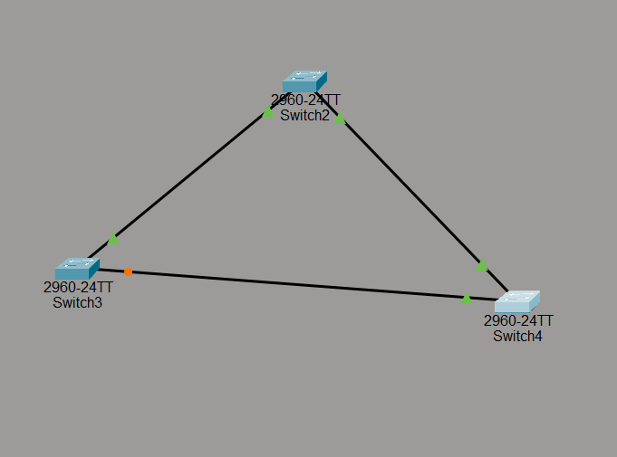

SWITCH 1 CONFIG:
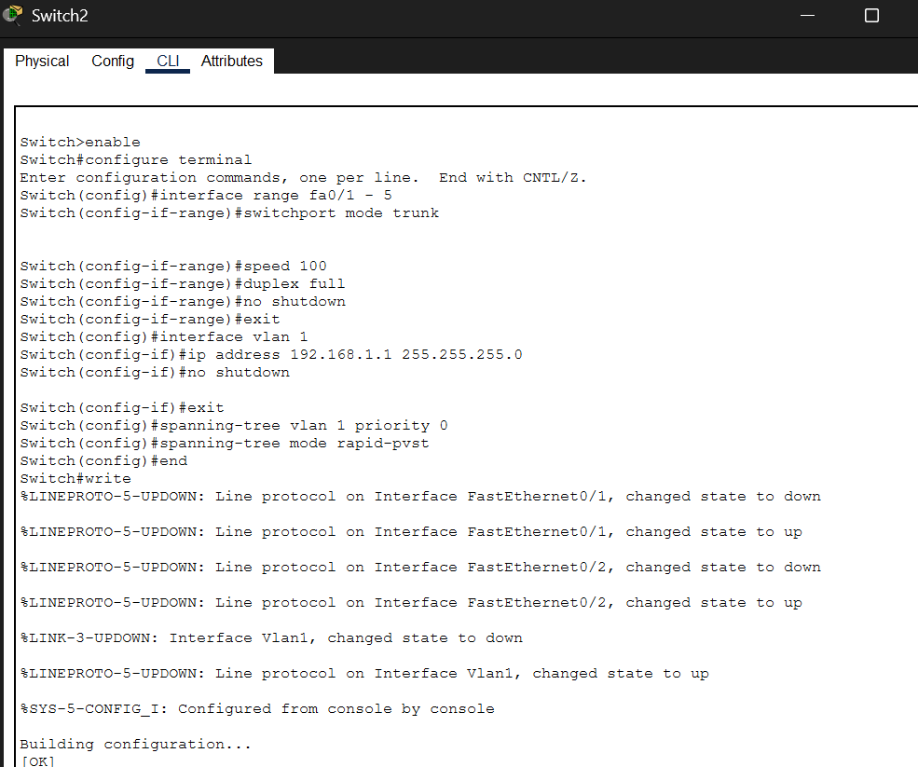

SWITCH 2 CONFIG:
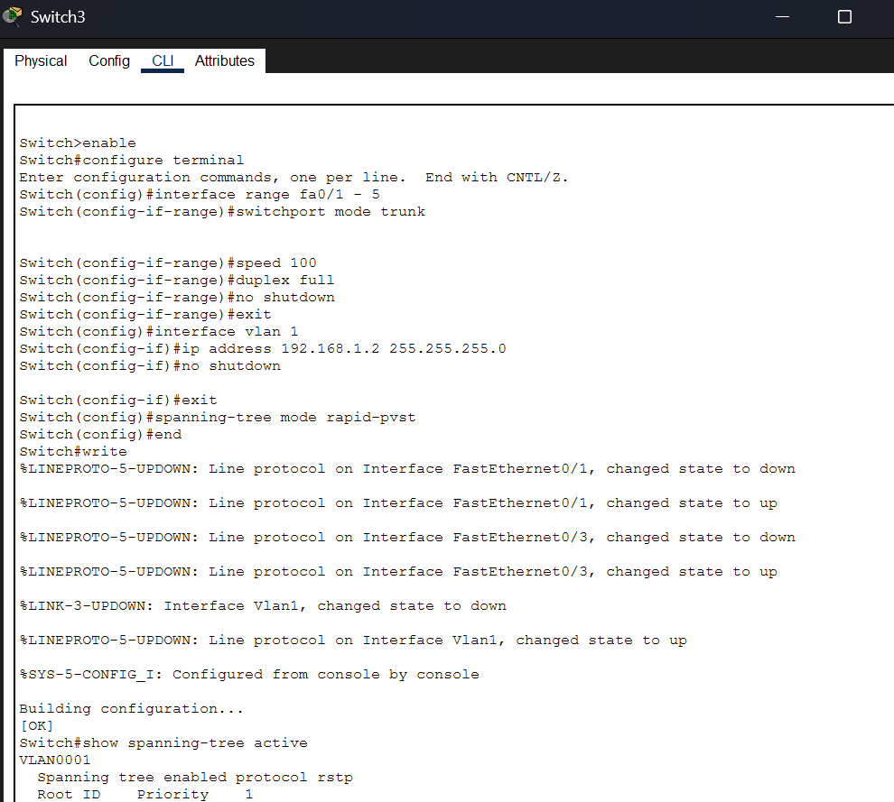
SWITCH 3 CONFIG:
