# 1

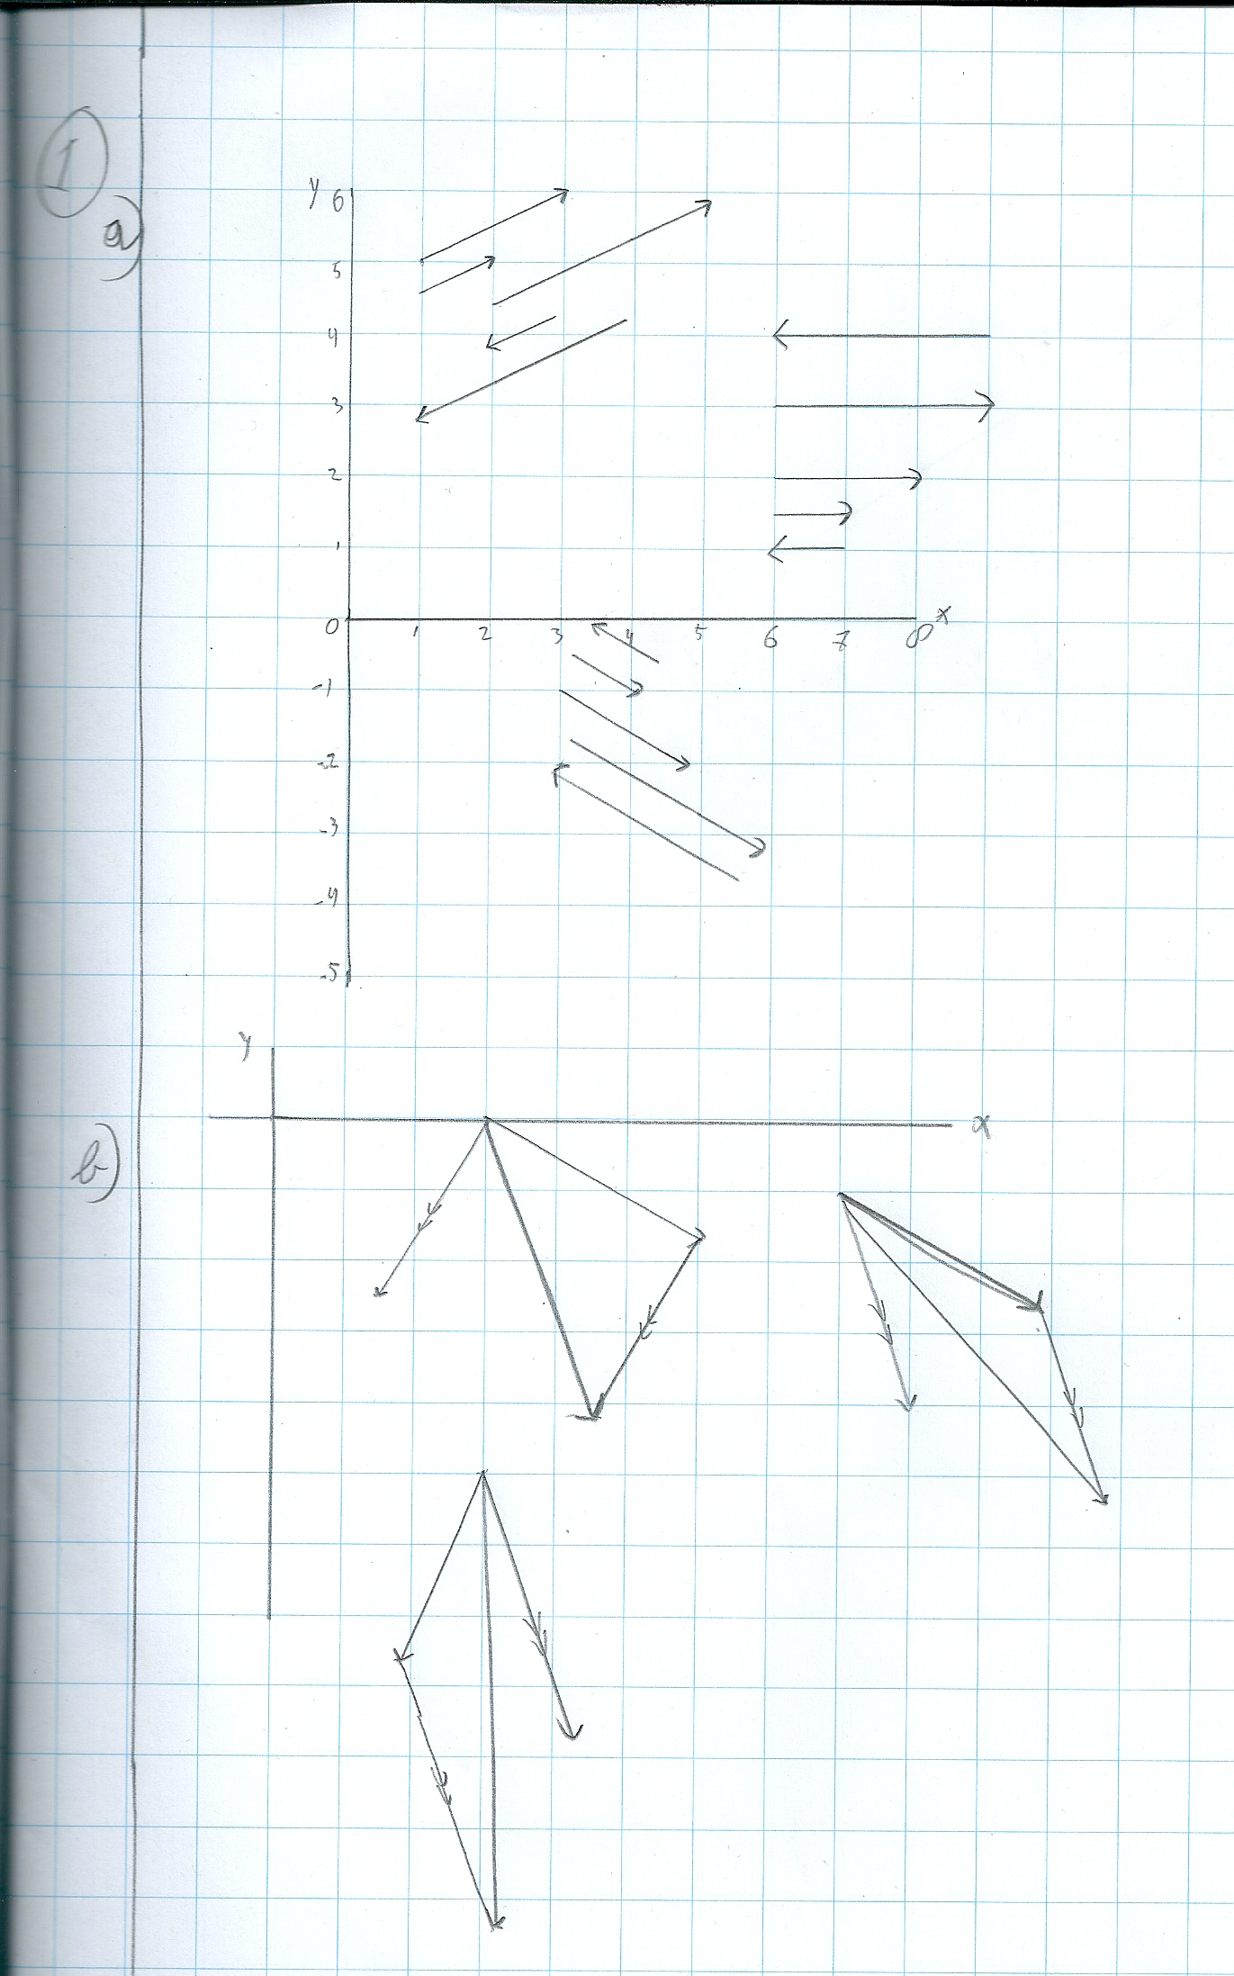

# 2

## a)

public static void from1To2(double x1, double y1, double x2, double y2, out double a, out double b)

{

double dx = x2 - x1;

double dy = y2 - y1;

if (dx == 0)

{

throw new Exception("divide by 0");

}

//y = ax + b;

b = dy / dx;

a = y1 - b * x1;

}

public static void from2To3(double a, double b, out double[] steun, out double[] richting)

{

steun = new double[2];

richting = new double[2];

steun[0] = 0;

steun[1] = a;

richting[0] = 1;

richting[1] = b;

}

public static void from3To1(double[] steun, double[] richting, out double x1, out double y1, out double x2, out double y2)

{

x1 = steun[0];

y1 = steun[1];

x2 = x1 + richting[0];

y2 = y1 + richting[1];

}

## b)

|  |  |  |
| --- | --- | --- |
| **1** | **2** | **3** |
| A(6,3) en B(2,8) | y= -1.25x+10.5 | $$\left({x \atop y}\right)=\left({0 \atop 10.5}\right)+λ\left({1 \atop -1.25}\right)$$ |
| (0,6.34) en (1,12.68) | y= 6.34 x + 6.34 | $$\left({x \atop y}\right)=\left({0 \atop 6.34}\right)+λ\left({1 \atop 6.34}\right)$$ |
| (3,3) en (4,4) | y= x | $$\left({x \atop y}\right)=\left({3 \atop 3}\right)+λ\left({1 \atop 1}\right)$$ |
| C(0.34, 0.62) en D(0.34,1.62) | Verticale lijn op positie 0.34 | $$\left({x \atop y}\right)=\left({0.34 \atop 0.62}\right)+λ\left({0 \atop 1.62}\right)$$ |
| (0,64) en (1,96) | y= 32 x + 64 | $$\left({x \atop y}\right)=\left({0 \atop 64}\right)+λ\left({1 \atop 32}\right)$$ |
| (0.04, 3.34) en (0.04, 4.55) | Verticale lijn op positie 0.04 | $$\left({x \atop y}\right)=\left({0.04 \atop 3.34}\right)+λ\left({0 \atop 1.21}\right)$$ |
| E(234,445) en F(612,823) | y= x+211 | $$\left({x \atop y}\right)=\left({0 \atop 211}\right)+λ\left({1 \atop 1}\right)$$ |
| (0,0) en (1,1) | y = x | $$\left({x \atop y}\right)=\left({0 \atop 0}\right)+λ\left({1 \atop 1}\right)$$ |
| (4,2) | Is een punt | $$\left({x \atop y}\right)=\left({4 \atop 2}\right)+λ\left({0 \atop 0}\right)$$ |