
CLOUD COMPUTING
Assignment 01
Gitea • GitHub • Git LFS • GitHub Pages

Department | Software Engineering
Assignment No | 01
Subject | Cloud Computing
Submitted To | Sir Waqas Saleem
Submitted by | Sidra Iftikhar
Semester | 05
Registration No | FA24B1-SE-063
Submission Date | 02-10-2026

Task 1: Install Gitea and Push a Repository from the Ubuntu Server

Step 1.1: Install and Run Gitea on the Ubuntu Server
2. Update the Ubuntu package index and install Docker Engine and curl. On Ubuntu, the required package name is docker.io:
sudo apt update -y
sudo apt install -y docker.io curl
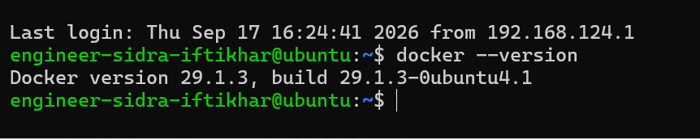
Fig. 1: Docker version check on the Ubuntu server
3. Create the system-wide Docker CLI plug-in directory and download the Docker Compose plug-in for an x86_64 Ubuntu server:
sudo mkdir -p /usr/local/lib/docker/cli-plugins sudo curl -SL https://github.com/docker/compose/releases/latest/download/docker-compose-linux x86_64 -o /usr/local/lib/docker/cli-plugins/docker-compose
sudo chmod +x /usr/local/lib/docker/cli-plugins/docker-compose
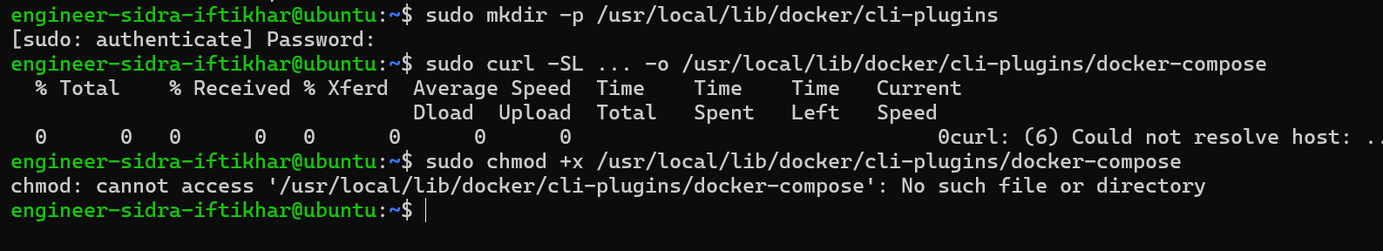
Fig. 2: Docker Compose plug-in download attempt (network error)
4. Start the Docker service and add your current Ubuntu account to the docker group:
sudo systemctl start docker
sudo usermod -aG docker $USER
exit
Completely sign out of the Ubuntu server and reconnect so that the new group membership takes effect. Opening only a new terminal tab is not sufficient.
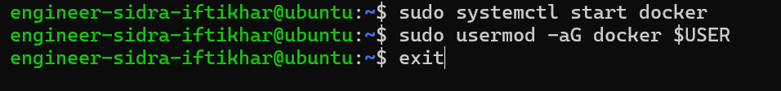
Fig. 3: Docker service started and user added to docker group
5. Verify the Git, Docker, and Docker Compose installations:
ssh <github-username>@<ubuntu-server-ip>
git --version
docker --version
docker compose version
Do not continue until all three commands display their installed versions.
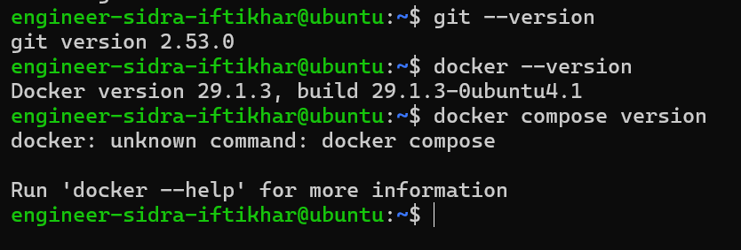
Fig. 4: Git and Docker versions verified
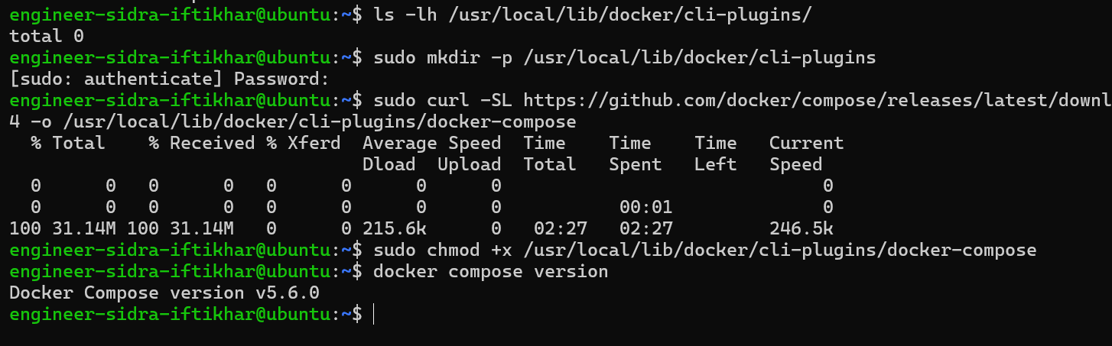
Fig. 5: Docker Compose plug-in installed successfully (v5.6.0)
6. Clone the instructor-provided Gitea setup repository on the Ubuntu server:
cd ~
git clone https://github.com/WaqasSaleem97/Gitea.git
cd Gitea
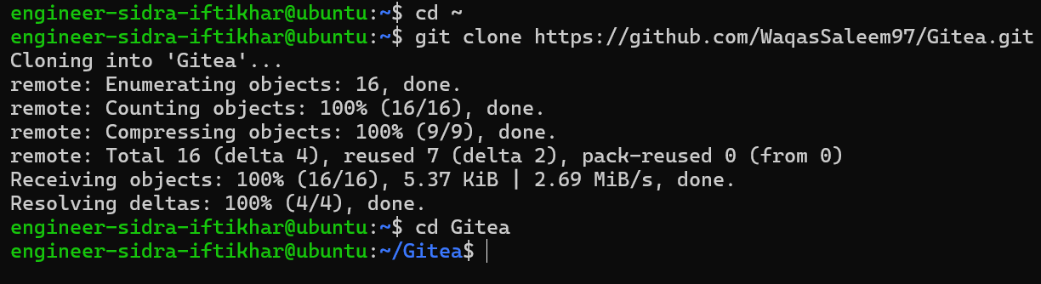
Fig. 6: Cloning the Gitea setup repository
7. Use the existing compose.yaml without changing its server URL or port settings. Start Gitea and PostgreSQL:
docker compose up -d
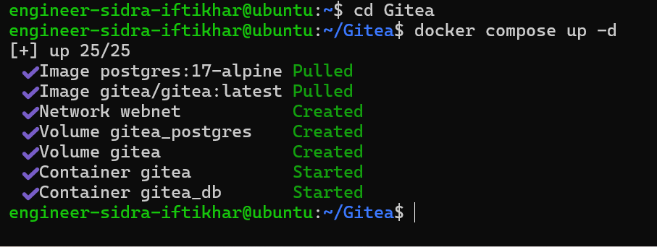
Fig. 7: Gitea and PostgreSQL containers started
8. Confirm that both containers are running:
docker compose ps
9. Confirm that Gitea responds locally on port 3000:
curl -sS -o /dev/null -w "Gitea HTTP status: %{http_code}\n" http://127.0.0.1:3000/
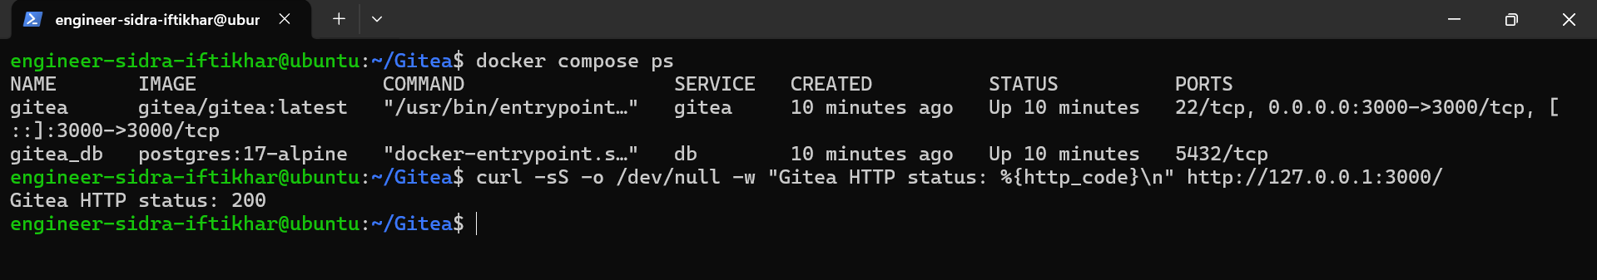
Fig. 8: Containers running and Gitea HTTP status 200
10. Display the Ubuntu server's IP address:
ip addr
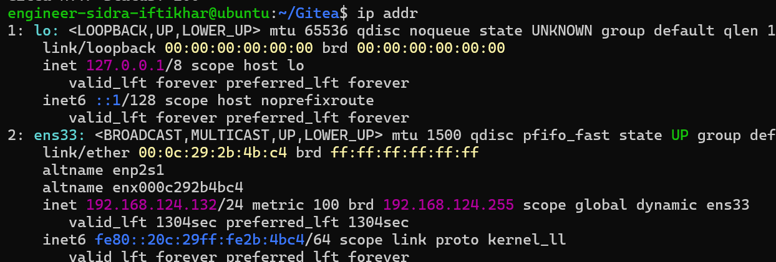
Fig. 9: Ubuntu server IP address

Step 1.2: Create and Push the Initial Repository
1. In Gitea, create an empty public repository named exactly Assignment01.
2. Do not initialize it with a README, .gitignore, or license.
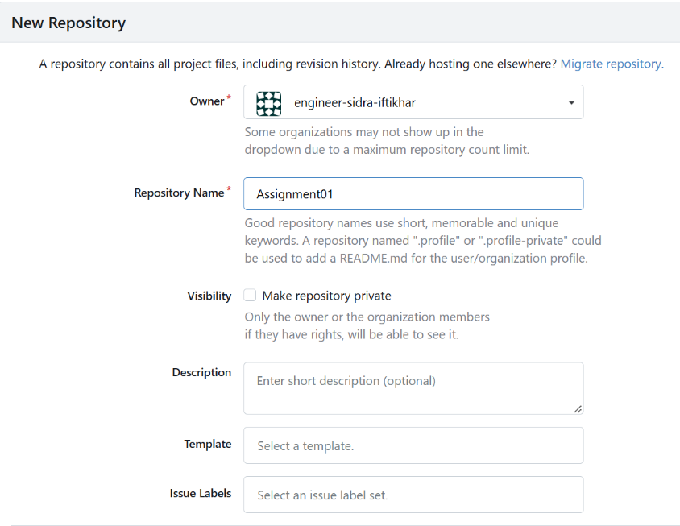
Fig. 10: New Repository form in Gitea
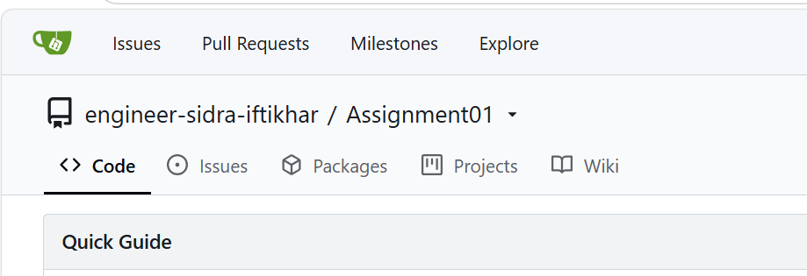
Fig. 11: Empty Assignment01 repository in Gitea
3. On the same Ubuntu server, create a separate local repository outside both the Gitea directory and the existing CC repository:
cd ~
mkdir Assignment01
cd Assignment01
git init
git branch -M main
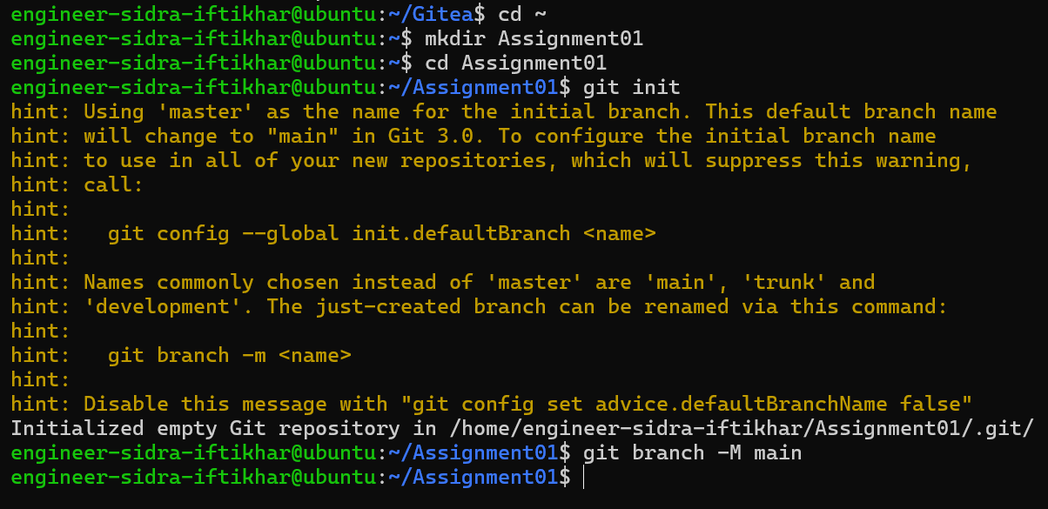
Fig. 12: Local repository initialised on branch main
4. Create a README.md containing:
■ your full name; and
■ your registration number.
Fig. 13: README.md created with name and registration number
5. Commit the README:
git add README.md
git commit -m "Add student information"
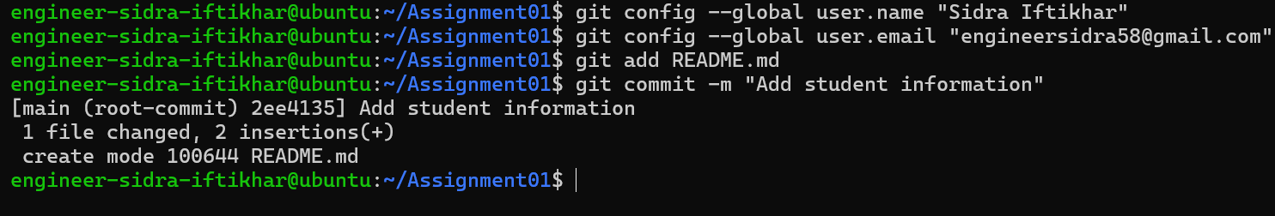
Fig. 14: README committed to local repository
6. In Gitea, generate a personal access token:
■ Open your profile menu and select Settings.
■ Open Applications and then Manage Access Tokens.
■ Use ubuntu-server-token as the token name.
■ Give the token read-and-write repository permission (write:repository).
■ Copy the generated token. Do not place it in a command, remote URL, or screenshot.
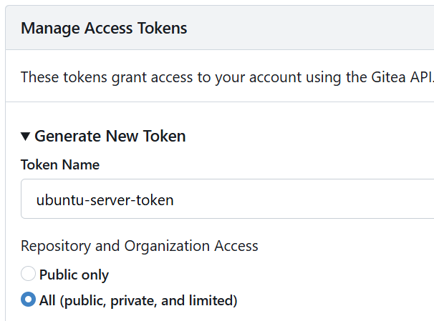
Fig. 15: Gitea access tokens page
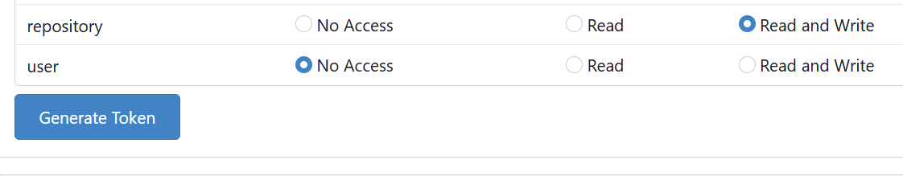
Fig. 16: Token permissions set to Read and Write
7. Because Gitea and Git are running on the same Ubuntu server, add the local Gitea address as the gitea remote. Include your Gitea username, but do not include the personal access token:
git remote add gitea http://@127.0.0.1:3000//Assignment01.git
The git remote add command only records the repository address; it does not contact Gitea or perform authentication.
8. Verify that the remote URL contains your username but does not contain a password or token:
git remote -v
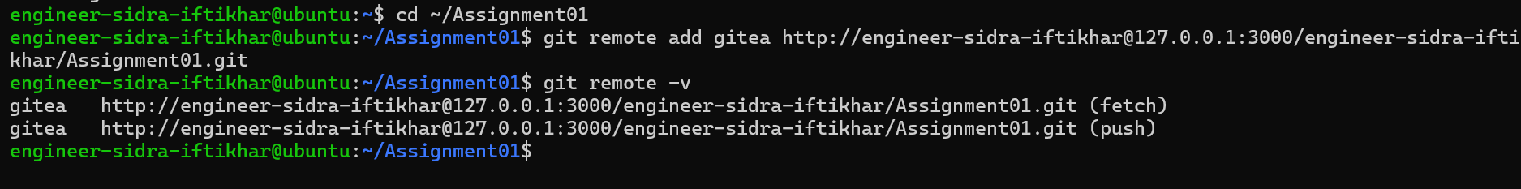
Fig. 17: Gitea remote added and verified
9. Push the initial commit:
git push -u gitea main
10. When Git displays the password prompt, paste the Gitea personal access token and press Enter: Password for 'http://@127.0.0.1:3000':
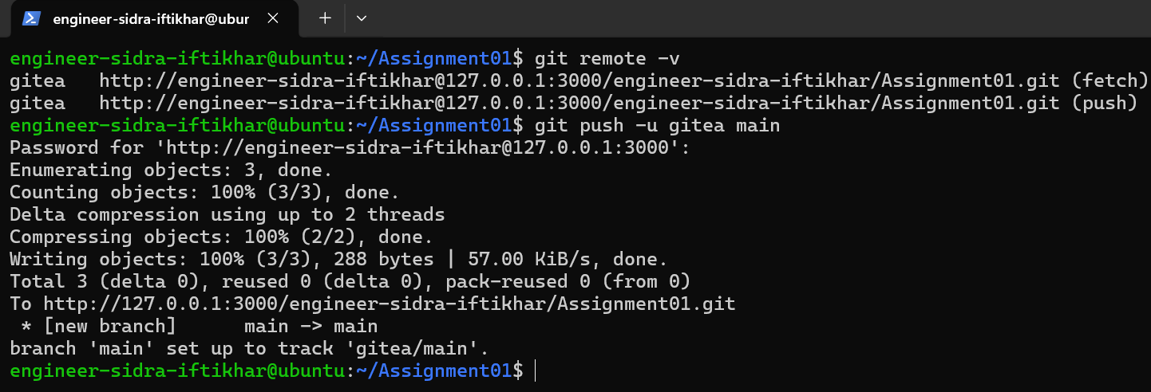
Fig. 18: Initial commit pushed to Gitea

Step 1.3: Verify the Gitea Repository
1. Open the Assignment01 repository in Gitea.
2. Confirm that the repository owner and repository name are visible.
3. Confirm that the repository is public.
4. Confirm that the rendered README.md shows your full name and registration number. 5. Keep the Gitea URL visible in the browser.
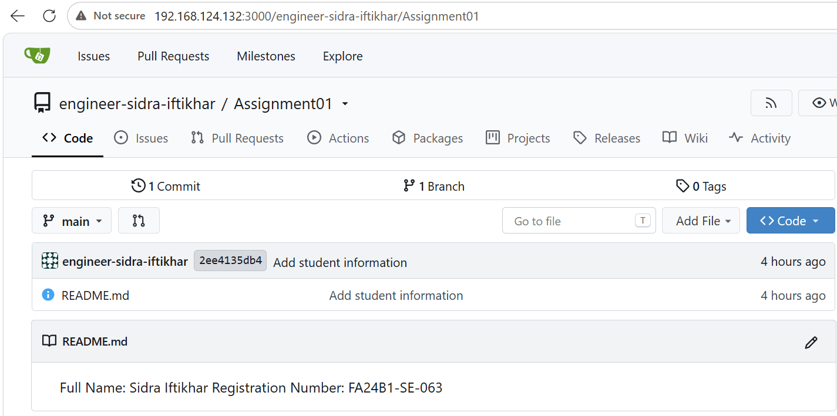
Fig. 19: Repository verified in Gitea (public)

Task 2: Push the Same Repository to GitHub

Step 2.1: Create the GitHub Repository and Verify Both Remotes
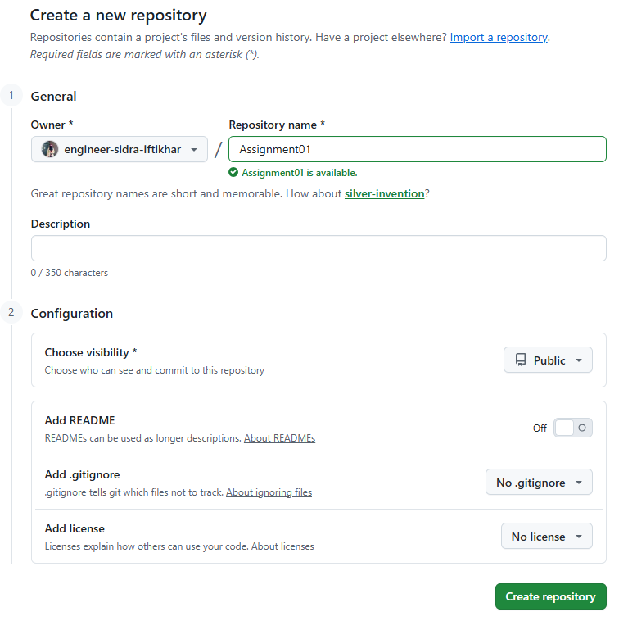
Fig. 20: Creating the Assignment01 repository on GitHub
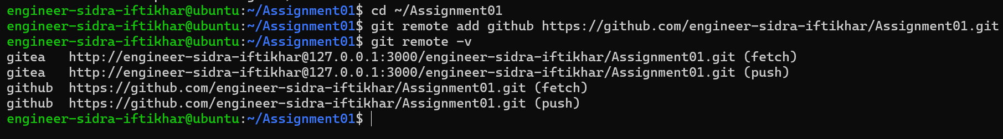
Fig. 21: Both Gitea and GitHub remotes verified

Step 2.2: Push to GitHub
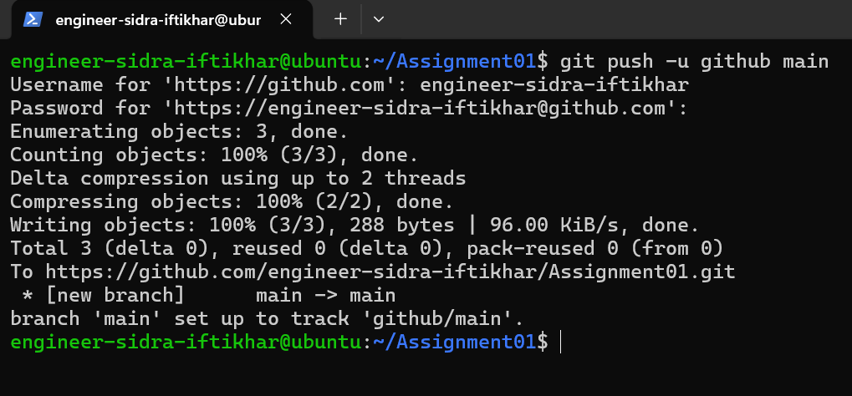
Fig. 22: Pushing the repository to GitHub

Step 2.3: Verify the GitHub Repository
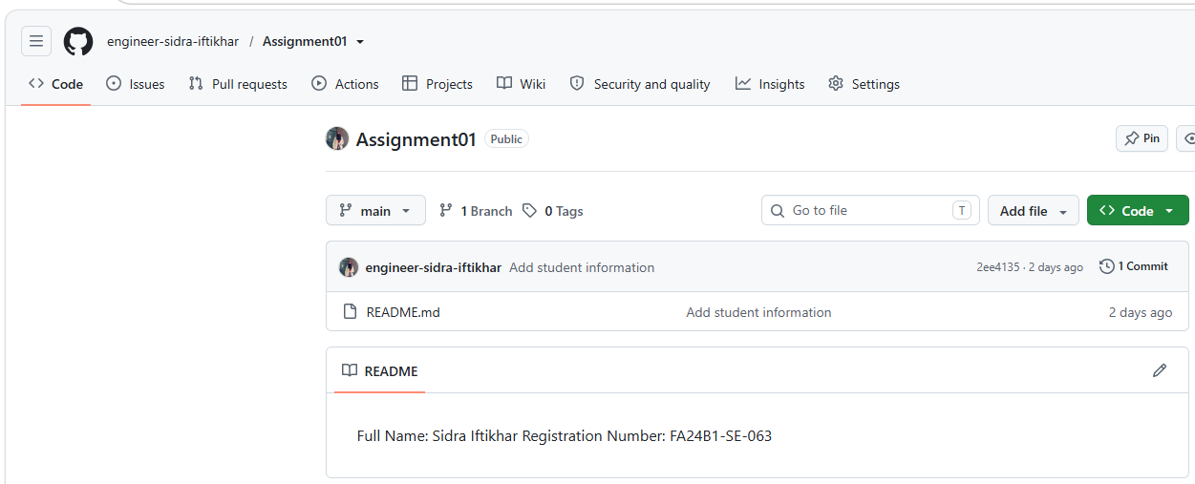
Fig. 23: Repository verified on GitHub

Task 3: Track Three Large Files with Git LFS

Step 3.1: Configure Git LFS
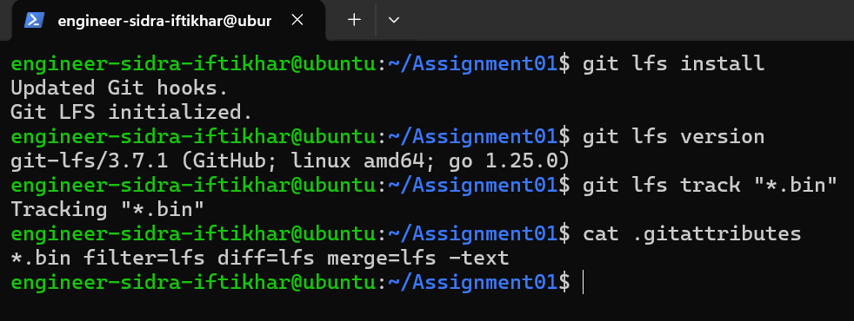
Fig. 24: Git LFS installed and *.bin tracked

Step 3.2: Create and Verify Three LFS Files
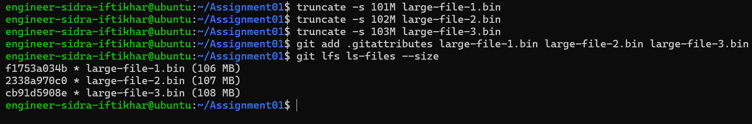
Fig. 25: Three large files tracked with Git LFS

Step 3.3: Commit and Push the LFS Files
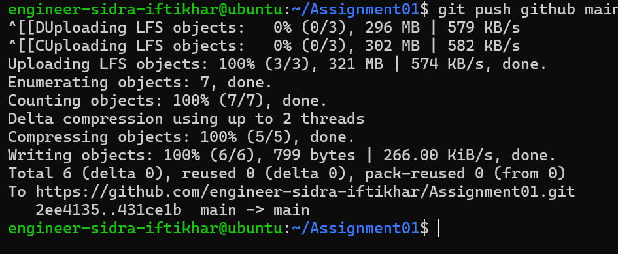
Fig. 26: LFS files pushed to GitHub

Task 4: Create a Portfolio or CV with GitHub Pages

Step 4.1: Create and Push the Portfolio Repository
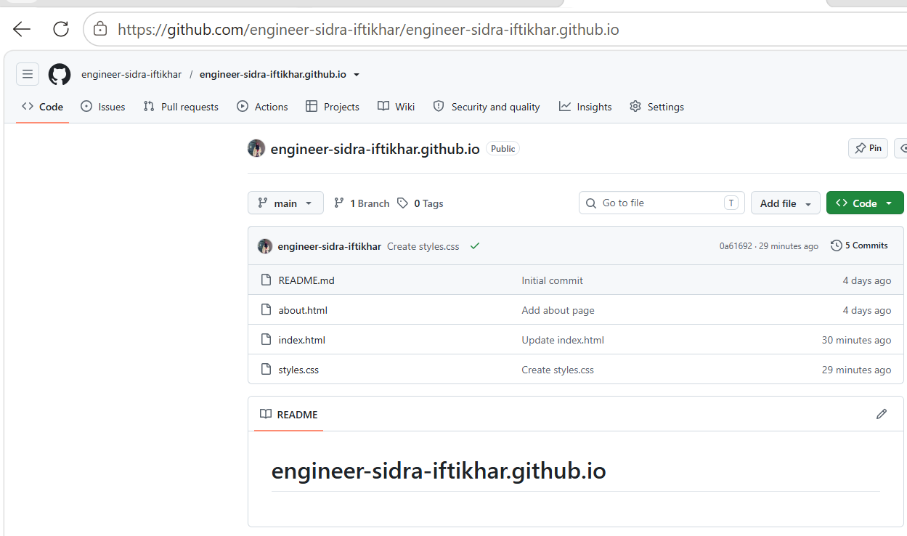
Fig. 27: Portfolio repository on GitHub
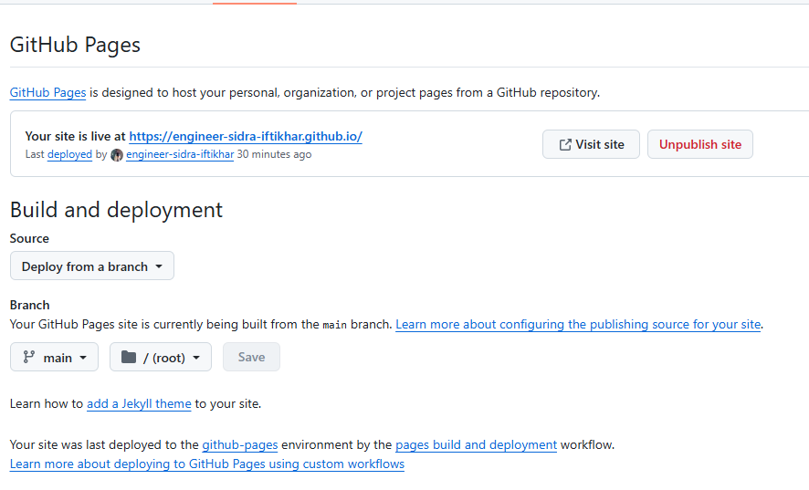
Fig. 28: GitHub Pages site published
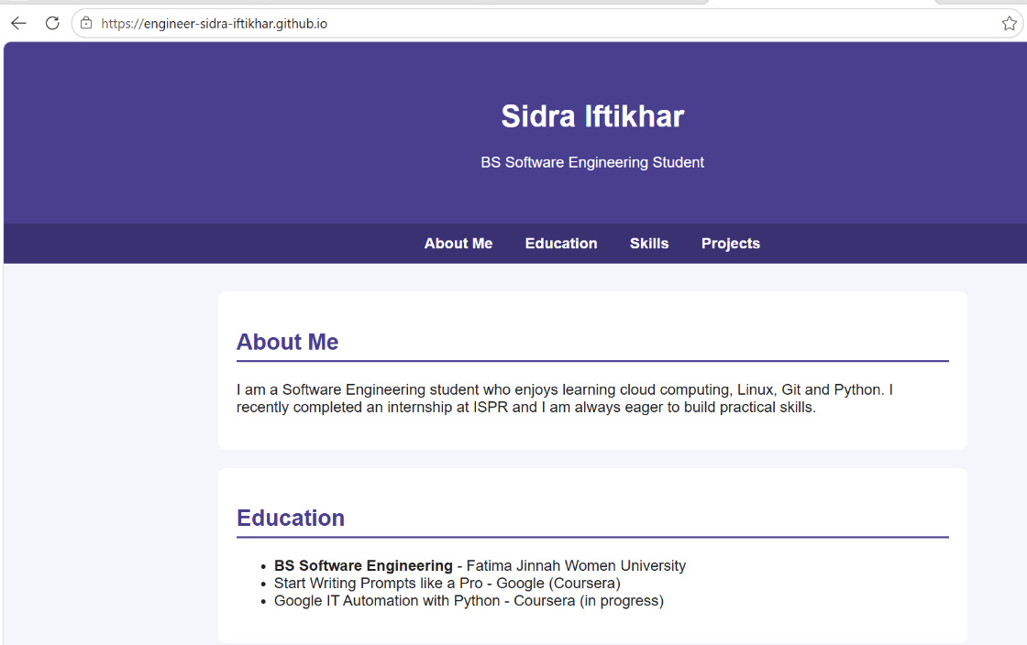
Fig. 29: Portfolio home page header
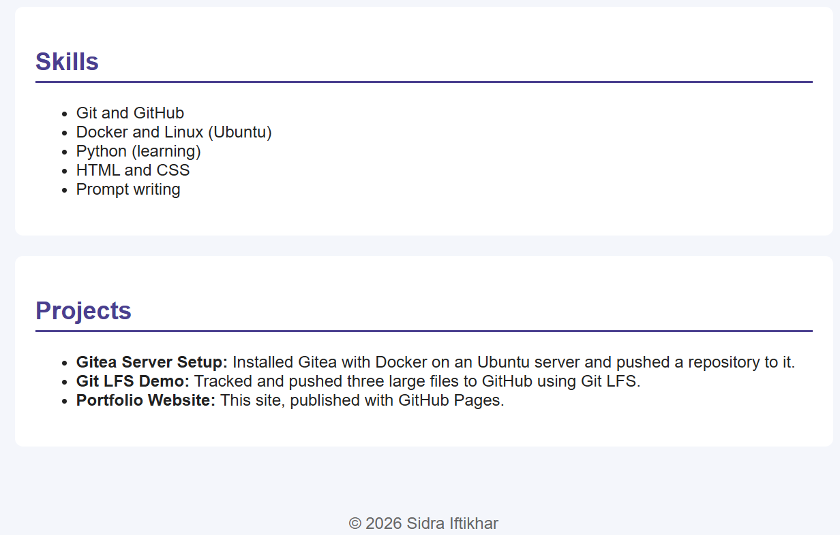
Fig. 30: Portfolio Skills section

