**COLLEGE LOGO **

**AN INTERNSHIP REPORT**

**ON**

**DYNAMIC WEB PAGE DESIGNING USING REACT JS**

*Submitted by*

**GOHEL YASH HITESHBHAI ( 211020107506 )**

***Student of***

**Bachelors of Engineering**

*in*

Computer Engineering

**COLLEGE LOGO  **

**DECLARATION**

I hereby affirm that the content within this Internship Report is my own original work and has not been previously submitted for any academic qualification or certification at any other educational institution or organization.

Additionally, I assure that the material I have presented does not violate any existing copyright laws.

Gohel Yash Hiteshbhai



**COLLEGE LOGO  **

**CONFIRMATION LETTER**

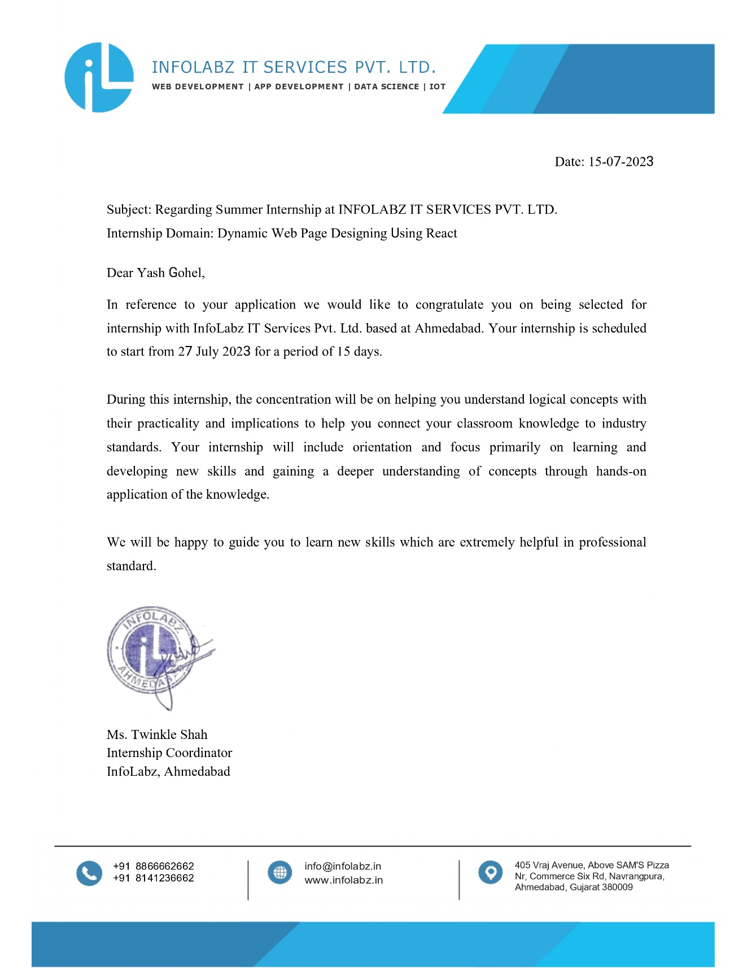

**II**

**COLLEGE LOGO  **

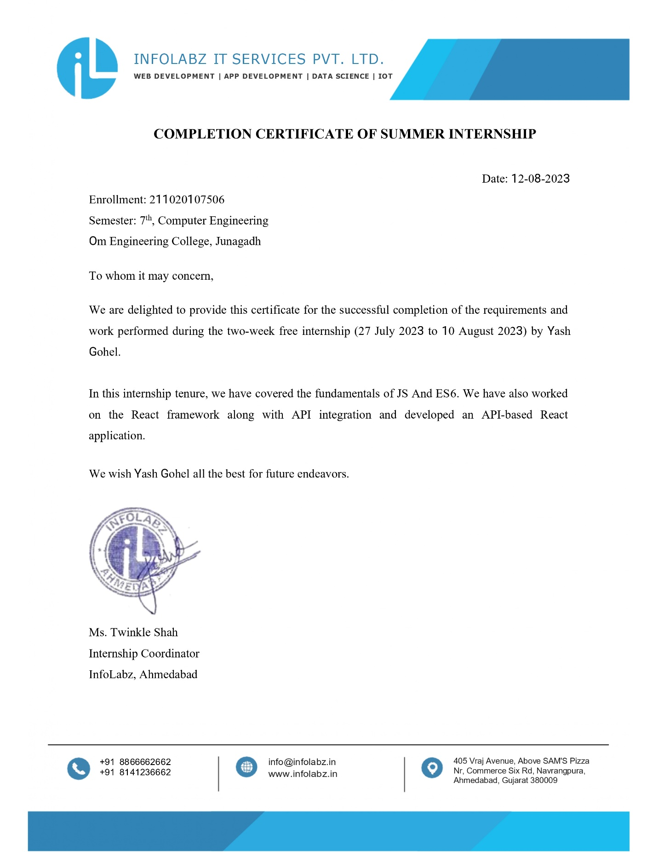**CERTIFICATE OF COMPLETION**

**COMPANY PROFILE**

Established in 2016, incorporation with our parent IT company, INFOLABZ IT SERVICES PVT. LTD. has managed to make it's own position in IT Sector. We are involved in Web Development, App Development, Progressive Web Application Development, IOT solutions, Graphics & Designing, Digital Marketing, Domain & Hosting services, SMS services etc.

In the span of seven years we have managed to deliver all projects on time with utmost accuracy to our clients across the globe. We have dedicated teams of experienced andhard working developers. Our developers who are always willing to take new challenges and looking forward to learn new things, are heart of this company.

Our objective is to sustain with exponential growth in IT industry. Our mission is to deliver the best with top notch quality every quarter and vision is to develop a product with one of its kind concept which could be used by millions of people.

**TABLE OF CONTENT**

|  |  |  |
| --- | --- | --- |
| **WEEK / DAY NO** | **CONTENT** | **PAGE NO** |
|  | **Declaration** | **I** |
|  | **Confirmation Letter** | **II** |
|  | **Completion Certificate** | **III** |
|  | **Company Profile** | **IV** |
|  |  |  |
| **WEEK 1** | **27 JULY 2023** | **1** |
|  | * INTRODUCTION TO JS |  |
|  | * INTRODUCTION TO ES6 |  |
|  | * OBJECTS |  |
|  |  |  |
| **WEEK 1** | **28 JULY 2023** | **03** |
|  | * JS Functions & Arrow Functions |  |
|  | * Async Function |  |
|  | * BitCoin API |  |
|  |  |  |
| **WEEK 1** | **31 JULY 2023** | **05** |
|  | * Covid API – Data fetching and mapping |  |
|  | * USER INPUT 1 : JS Pop Up Boxes |  |
|  | * USER INPUT 2 : Form to Variable |  |
|  |  |  |
| **WEEK 1** | **01 AUGUST 2023** | **07** |
|  | * Form to table |  |
|  | * JS Arrays |  |
|  |  |  |
| **WEEK 1** | **02 AUGUST 2023** | **08** |
|  | * Task Assignment |  |
|  | * Covid Data Search |  |
|  | * Mutual Fund API |  |
|  |  |  |
| **WEEK 2** | **03 AUGUST 2023** | **10** |
|  | * React Environment setup ( Node JS installation ) |  |
|  | * First React App |  |
|  | * Functional Components |  |
|  | * Class Components |  |
|  |  |  |
| **WEEK 2** | **04 AUGUST 2023** | **12** |
|  | * Variable Data Map |  |
|  | * Object Map |  |
|  |  |  |
| **WEEK 2** | **07 AUGUST 2023** | **13** |
|  | * React Props |  |
|  | * React Bootstrap |  |
|  |  |  |
| **WEEK 2** | **08 AUGUST 2023** | **14** |
|  | * React Hooks : UseEffect and UseState |  |
|  | * API data fetch with react |  |
|  |  |  |
| **WEEK 2** | **09 AUGUST 2023** | **16** |
|  | * ASSIGNMENT TASK |  |
|  | * API BASED REAL TIME NEWS WEB APPLICATION |  |
|  |  |  |
| **WEEK 2** | **10 AUGUST 2023** | **19** |
|  | * Project & conclusion |  |