DxD Photography Website Update

The redesign of the DxD Photography website will require minor changes to all pages except the “Our Work” page. The “Our Work” page will need a major redesign for which the details are identified later in this document.

The current website address is http://www.dxdphotography.com and the IP address is 198.65.244.92.

UserID: dxdpho
Domain name: dxdphotography.com
Web server: w3w35020
IP address: 198.65.244.92

http://dxdphotography.com/stats/

Username: dxdpho
Password: melanie1

The account name is dxdpho and the password is melanie1. It is currently hosted on AT&T. The AT&T webhost does not have very good services to work with. The SQL server is probably not adequate, since it is the freebie SQL express. At least that is what I’ve been told. Maybe you can take a look at it and see if it would meet our needs. If not, I can move it to EDT Hosting, as Karen suggested.

Each of the following pages shows a page of the website as it currently exists. Listed below the screen shot is a description of the changes I would like to have made. I believe most of the changes are simple HTML code changes. My understanding is that code can be added that will help Google and other search engines find this website. The key phrases would be
Equine photography
Pet photography
Pet portraits

In addition to the actual changes to the website, I believe Karen explained the need for a simple user interface that I can use for adding and/or removing photographs and galleries. Although I’ve worked in software development for over 20 years, my knowledge of web development is skimpy at best, so anything that would make it easier for me to maintain the website would be most helpful.
SPLASH PAGE

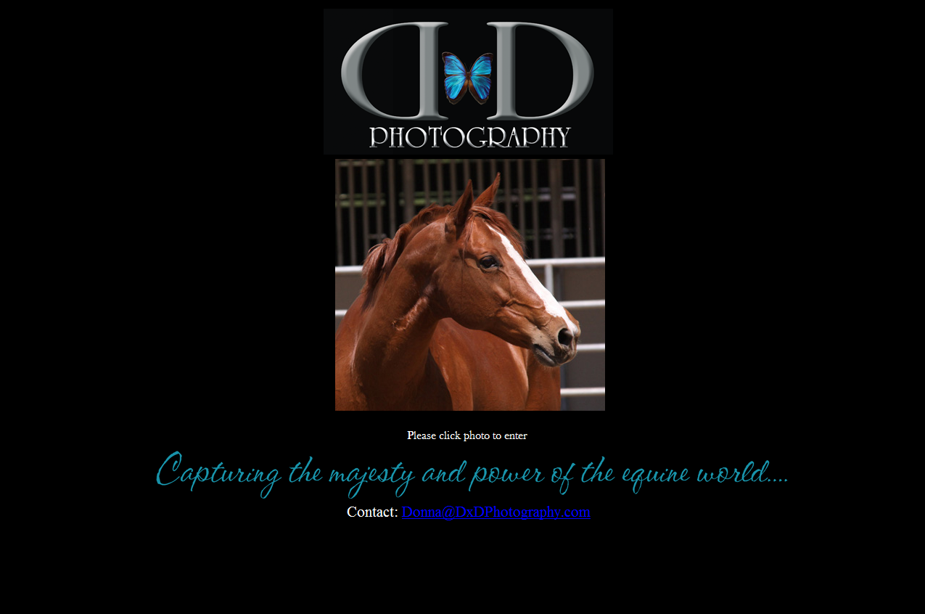

- Change the text “Capturing the majesty and power of the equine world…”
to “Equine and Pet Portraits and Event Photography” and change the font to be similar to the logo’s font if possible.

- Add a second photograph to this page to the right of the horse picture. I’ll provide a picture of a dog.

- Change the “Please click photo to enter” to “Click photo to enter”.

- Remove line “Contact: Donna@DxDPhotography.com”

HOME PAGE

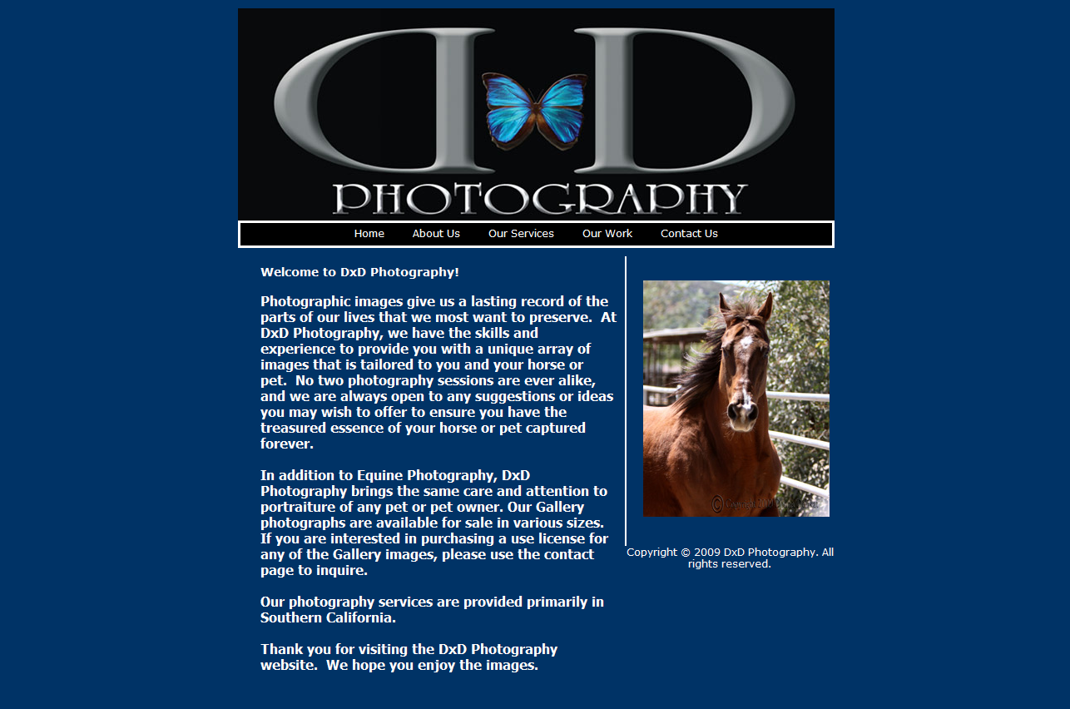

- Change the text to read as follows:
Photographic images give us a lasting record of the parts of our lives that we most want to preserve. At DxD Photography, we have the skills and experience to provide you with a unique array of images that is tailored to you and your horse or pet. No two photography sessions are ever alike, and we are always open to any suggestions or ideas you may wish to offer to ensure you have the treasured essence of your horse or pet captured forever.

Our Gallery Photographs are available for sale in various sizes. If you are interested in purchasing a use license for any of the Gallery images, please use the contact page to inquire.

Our photography services are provided primarily in Southern California.

Thank you for visiting the DxD Photography website. We hope you enjoy the images.

- Remove “2009” from Copyright line under the picture.

- Change horse picture to cat picture, which I will provide when you’re ready.
ABOUT US PAGE

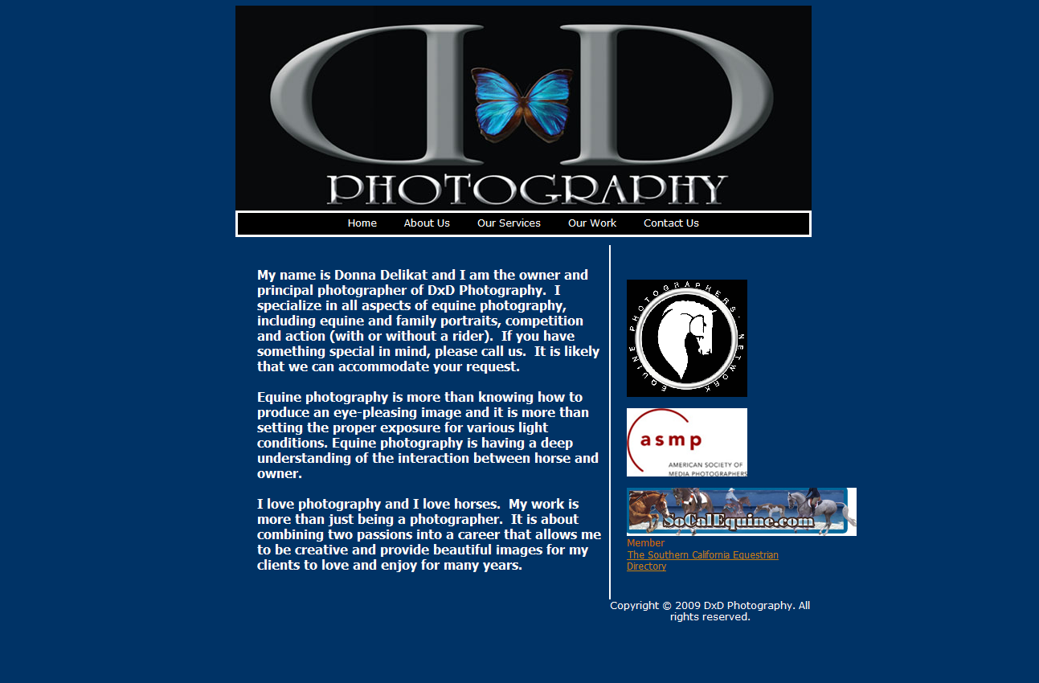

- Move ASMP logo to the top and make it a little larger, since it is the most important organization.
Clarification: I want to keep all three logos, but I want the asmp logo to be on top.

- Change first paragraph to read
My name is Donna Delikat and I am the owner and principal photographer of DxD Photography. I specialize in all aspects of equine and pet photography, including equine and pet portraits, competition and action (with or without a rider). If you have something special in mind, please call us. It is likely that we can accommodate your request.

- Delete second paragraph.

- Change last paragraph to read

I love photography and I love animals. My work is more than just being a photographer. It is about combining two passions into a career that allows me to be creative and provide beautiful images for my clients to love and enjoy for many years.

- Remove “2009” from the copyright at the bottom of the page.
OUR SERVICES PAGE

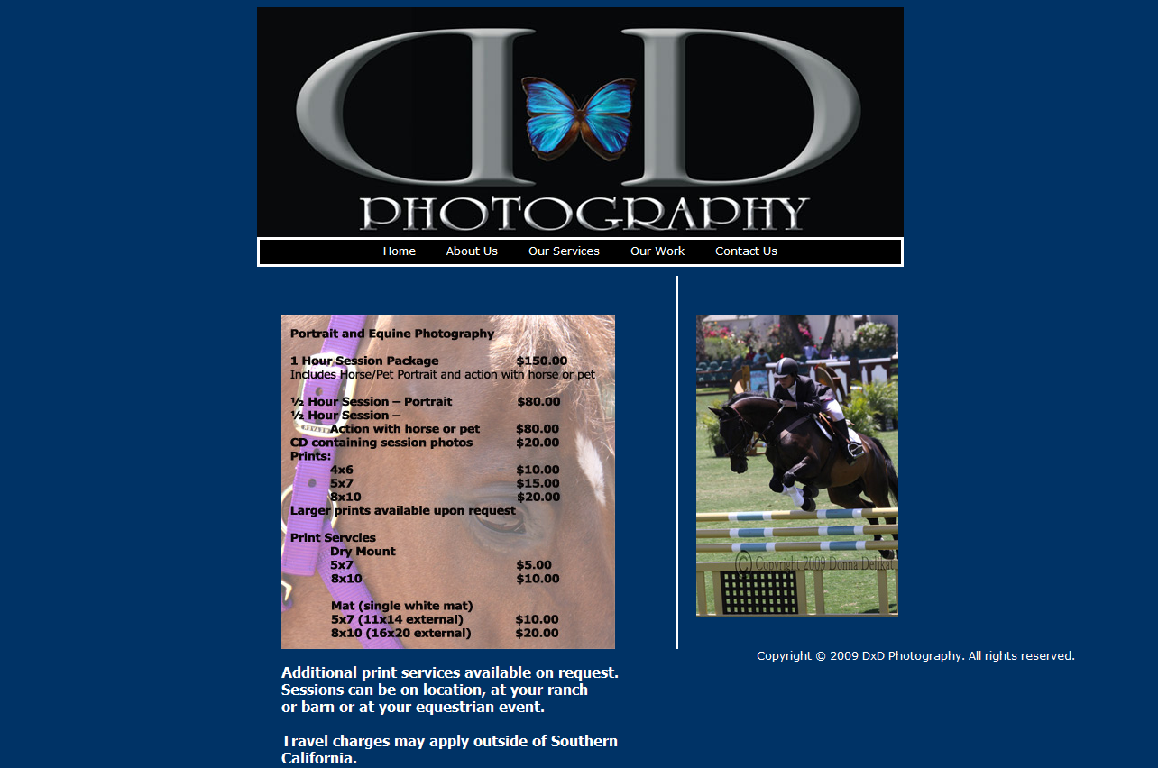

- Change the name of the page to “Services”.

- Change the wording above the price list to “Pet Portrait and Equine Photography”.

- Change the sentence under the price list to read

Additional print services available on request. Sessions can be on location at your home or ranch.

Travel charges may apply outside of Southern California.

- Remove “2009” from the Copyright line at the bottom right of the page.

OUR WORK PAGE

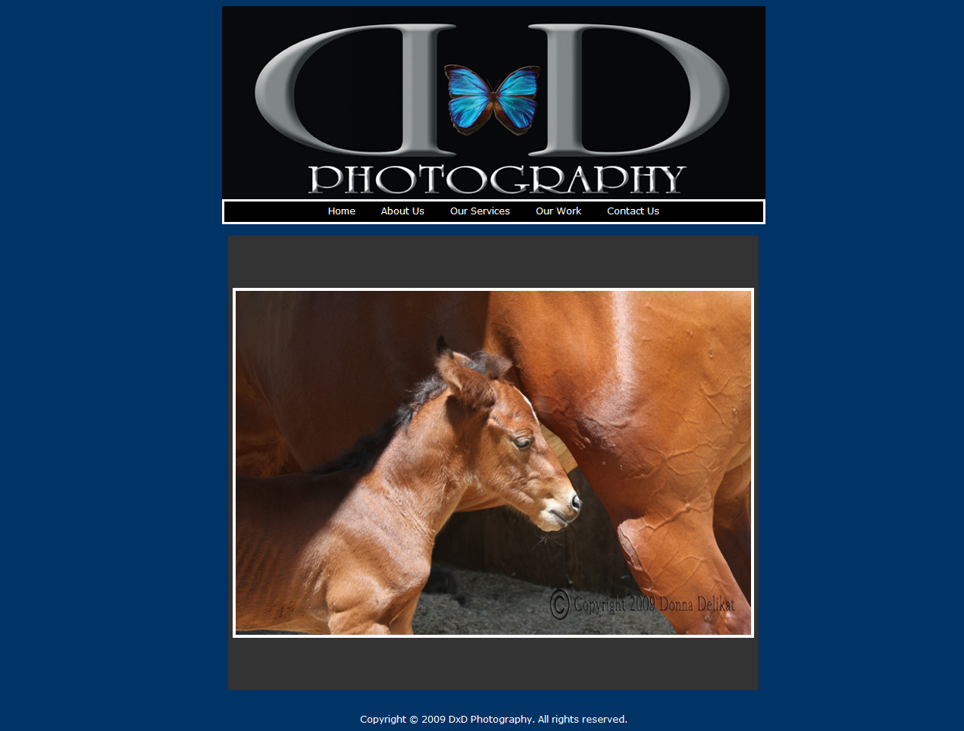

An example of the Gallery and slide show for this page can be seen at the website: http://www.suzannesphoto.com
Under Galleries and Arabians, there are thumbnails and a slide show. This is the type of display to be used for the “Galleries” page.

- Change the name of “Our Work” to Galleries and provide a dropdown list of the galleries to choose from.

- Currently there will be 3 Galleries in our list:
Equine Portraits
Pet Portraits
Event Photography

- Remove the year “2009” from the Copyright line at the bottom of the page.
CONTACT US PAGE

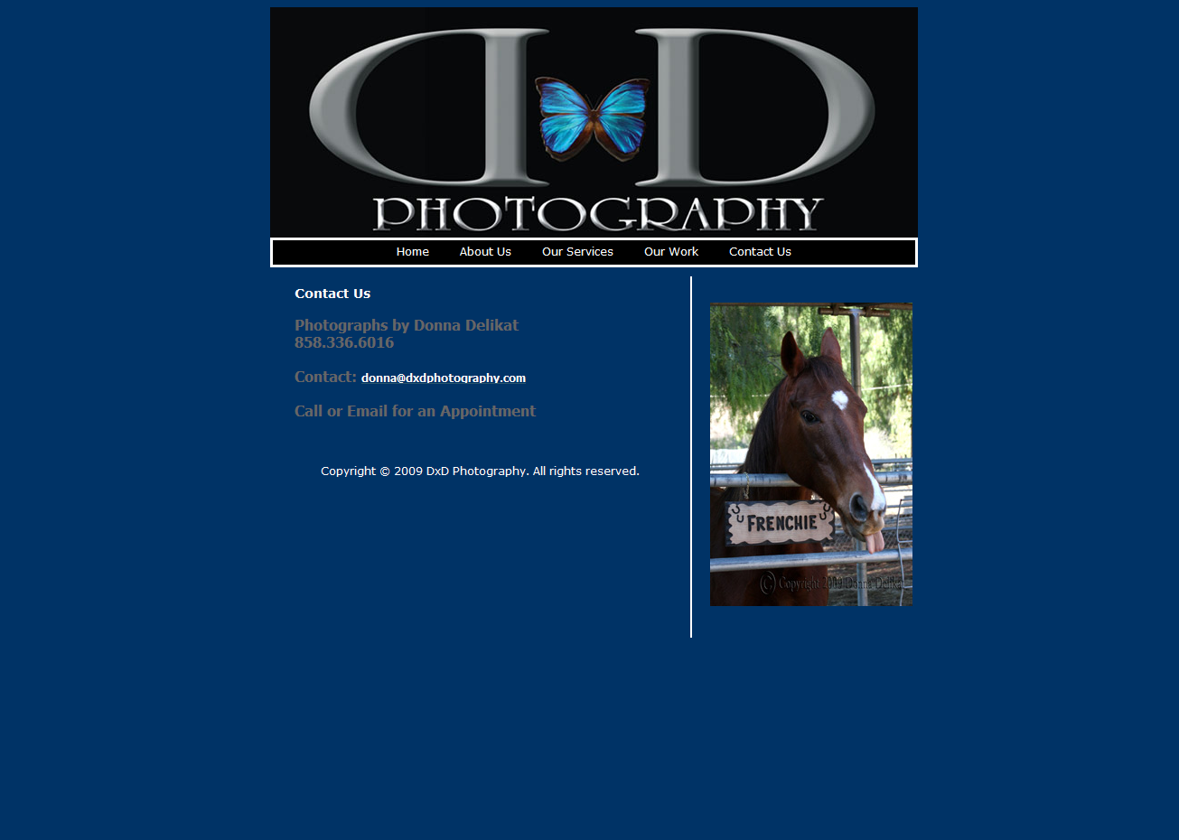

1. Remove “2009” from the Copyright line and update the names of the pages.

