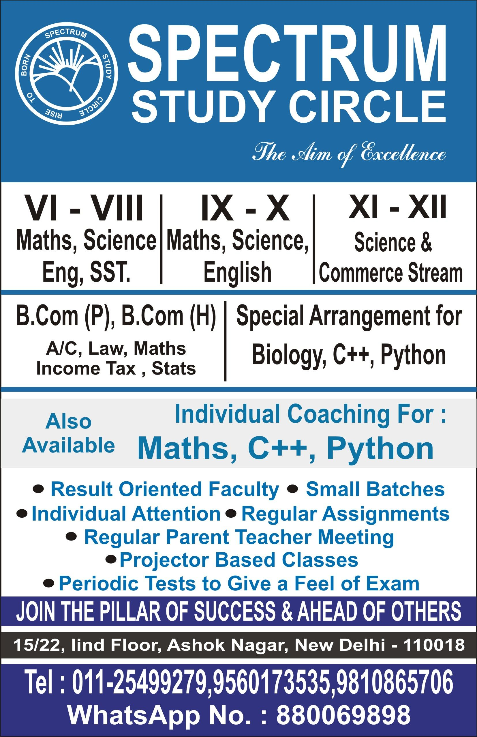

* **Tuck Shop**

All Is Well

Phone #

Whatsapp#

Nothing Makes A Student More Productive, Then The “LAST MINUTE”

Address: In Holy Child School, Near Masjid Quba THQ Hospital Road, Talagang

New Batch Is Starting From October

Timing: 3:00PM-5:00PM

5:00PM-7:00PM

Math’s, Chemistry, Physics, Computer, English

Projector

Based Classes for Matric & Inter Students

1st Year, 2nd Year

(FSC Pre Engineering, Pre Medical, ICS)

Math’s, Physics, English, Chemistry, Computer, Biology

Pre-Nineth, 9th, 10th (Matric)

Math’s, Physics, English Chemistry, Computer, Biology

P.G to 8th

All subjects