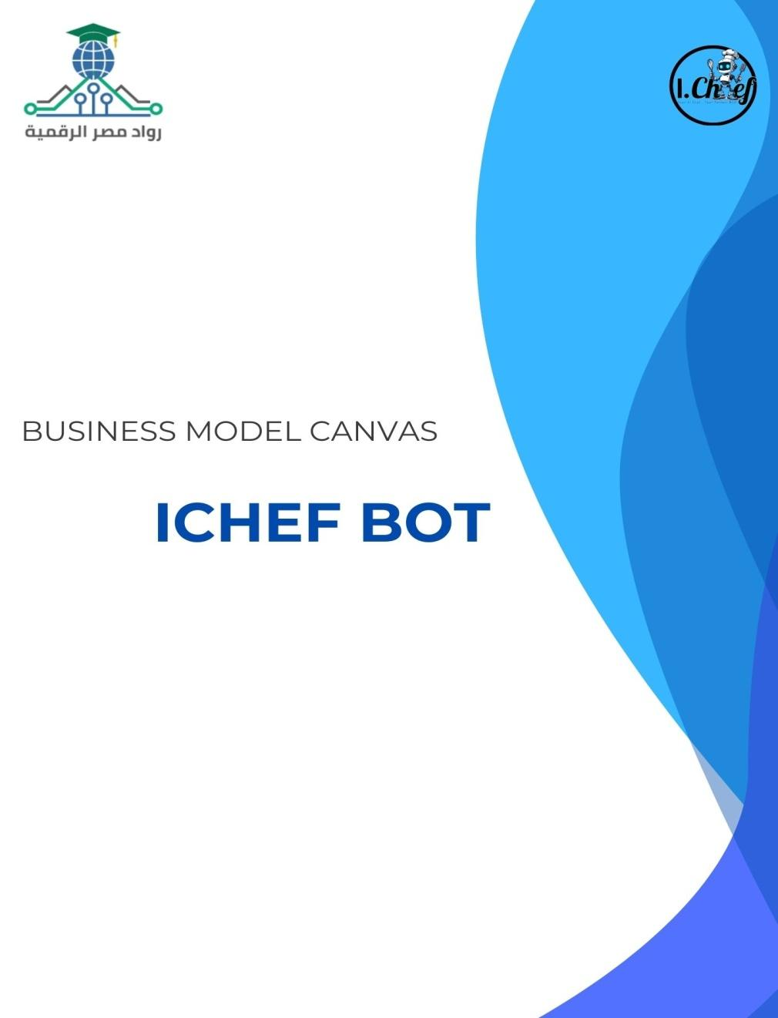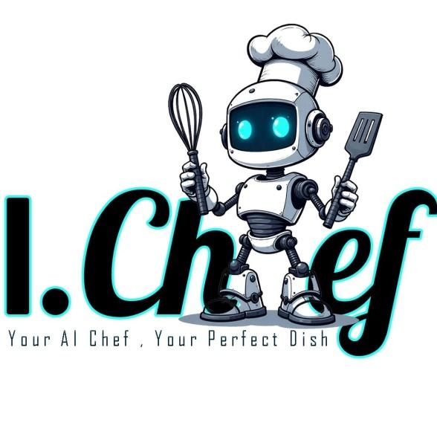

**Group:**YAT458A_ALX2_DRT1_S1

**Under supervision of:**

**Moemen El Badri**

**Submitted by:**

**Rewaa Ahmed Mohamed Harraz**

**Rahma youssef salah eldin**

**Nada Mohi Eldeen Ali**

**Amr Aly Abdel Aziz Mohamed Kotb**

**Amr Khaled abdel Mohsen**

**Abdelrahman Ahmed Saeed**

Contents

SWOT Analysis 4

Bussiness Canvas Model 5

**Key Partners** 5

**Key Activities** 5

**Value Proposition** 5

**Customer Relationships** 5

**Customer Segments** 5

**Channels** 5

**Key Resources** 6

**Cost Structure** 6

**Revenue Streams** 6

Segmentation, Targeting, Positioning-STP 7

1. Segmentation 7

2. Targeting 7

3. Positioning 8

4. Digital Marketing Execution 8

5. KPIs to Measure Success 8

PEST Analysis 9

Content strategy 10

FACEBOOK MARKETING STRATEGY 10

LINKEDIN MARKETING STRATEGY 14

Instagram Content Strategy 16

**I.Chef**

Vision:

To be the go-to solution for individuals seeking innovative and simple ways to prepare healthy and delicious meals using the ingredients they have, creating joyful and fulfilling food experiences in their daily lives

Mission:

To offer innovative and easy-to-follow recipes that enhance users meal experiences, utilizing only the ingredients they have, ensuring health and variety, and bringing happiness and comfort to every meal through personalized food solutions

Instagram link:<https://www.instagram.com/ichef2025?igsh=ajFvOGFobXFoNGtl&utm_source=qr>

Facebook link:<https://www.facebook.com/share/19tMvru44h/?mibextid=wwXIfr>

LinkedIn link:<https://www.linkedin.com/company/ichef2025/>

**Direct competitors**



|  |  |
| --- | --- |
| **Strengths** | **Weaknesses** |
| Available in Arabic | There is no way to makethe food |
| product quantity, purchase date and expiration date- | Uncomfortable interface for the eyes |
| Make a shopping list | Not available on Google Play |



Wanna Cook

|  |  |
| --- | --- |
| **Strengths** | **Weaknesses** |
| Available in Arabic | Doesn’t give exact recipe tailored for you |
| Available on Google Play | Too many ads in user interface |
| Distinctive visual identity | no specific dates for updates |
| Split meals for children and healthy meals for two people |  |
| Drinks and desserts are available |  |
| Fan meals are available- |  |
| Available food culture countries |  |
| You can easily add  ingredients |  |



**Indirect competitors**

|  |  |
| --- | --- |
| **Strengths** | **Weaknesses** |
| Provides short engaging videos demonstrating cooking steps | Not available in Arabic |
| Filter recipes by food type | Doesn’t offer the feature of adding available components |
| Make a shopping list | Inclusion of readily unavailable ingredients |

**Alternative services**

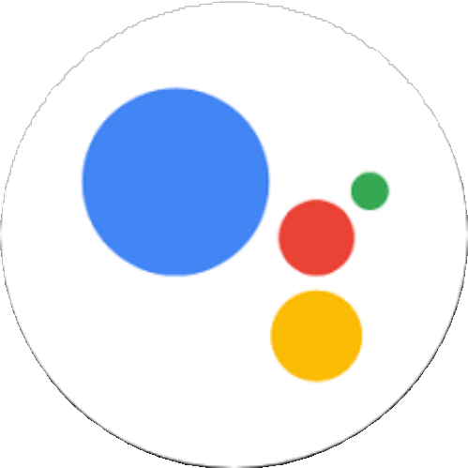

|  |  |  |
| --- | --- | --- |
| **Google assistant** | **Talabat** | **Youtube** |
| Provides recipes based on user inquiries | Delivers food when the user is unable to prepare a meal | Contains rich, searchable cooking content. |

# SWOT Analysis

|  |  |
| --- | --- |
| STRENGHTS | WEAKNESSES |
| * Providing recipes based on the client's ingredients and tools specifically. * Request missing components from delivery orders Smart IoT fridge notifies your phone when items are running low. * The app shows fridge contents instantly * Tracks calories based on your weight and goal, like a personal nutrition coach. | * Limited budget * Lack of a programmer in the team * Poor time management |
| OPPORTUNITY | CHALLENGES |
| * Competitors analyzed to determine added value. Create strong social media content. * There is a real need for the idea. | * Economic Changes * Rising Costs of Technical Services Rapid Technological Developments |

# Bussiness Canvas Model

## **Key Partners**

- AI technology providers (for NLP and recipe recommendation algorithms)

- Recipe databases and culinary content creators

- Food brands and kitchen appliance companies (for potential sponsorships)

- Grocery delivery services (for affiliate partnerships)

- Marketing agencies and social media influencers

## **Key Activities**

- Development and continuous training of the AI bot

- Integration with databases for updated recipe content

- Marketing and customer acquisition campaigns

- Managing partnerships and business development

- Regular updates based on user feedback and technological advancements

## **Value Proposition**

- Personalized and instant recipe suggestions based on user preferences, available ingredients, and dietary needs

- Reduces meal planning time and food waste

- Accessible 24/7 through multiple digital platforms (mobile, web, social media)

- Offers a seamless, fun, and interactive cooking experience

## **Customer Relationships**

- Self-service through the intuitive AI bot interface

- Personalized user experiences and tailored recipe suggestions

- Building a community through challenges, rewards, and social sharing

- Offering premium support for paid subscribers

## **Customer Segments**

- Busy professionals seeking quick meal ideas

- Students looking for easy, affordable recipes

- Fitness enthusiasts requiring customized meal plans

- Families needing efficient meal planning solutions

- Home cooks interested in discovering new recipes

## **Channels**

- Mobile application (iOS & Android)

- Website platform

- Social media platforms (Instagram, TikTok, Facebook Messenger)

- Email newsletters with curated recipe collections

- Partnerships with grocery delivery services and e-commerce platforms

## **Key Resources**

- AI development team and technical infrastructure (servers, APIs)

- Culinary content (recipes, videos, blogs)

- Marketing and social media teams

- Customer support team

- Financial resources for operational and marketing expenses

## **Cost Structure**

- Initial development and continuous improvement of AI technology

- Hosting, servers, and database maintenance

- Content creation and licensing fees

- Marketing campaigns and influencer partnerships

- Salaries and operational expenses

- Customer support services

## **Revenue Streams**

- Freemium model: free basic features with premium subscription plans for advanced services (meal planning, nutrition tracking)

- In-app advertisements and sponsored recipes

- Affiliate marketing with grocery delivery and kitchen equipment companies

- Selling data insights (in compliance with privacy regulations) for food brands and market researchers

**Notes for Financial Focus:**

- Include estimated startup costs vs. break-even point.

- Estimate monthly revenue from premium users and advertisers.

- Highlight marketing ROI (return on investment) for digital campaigns.

- Consider potential funding rounds or partnerships for scaling.

# Segmentation, Targeting, Positioning-STP

## 1. Segmentation

Segmentation divides the Egyptian market into groups based on demographic, psychographic, behavioral, and geographic criteria, tailored to local cooking needs and iChef's AI-driven personalization.

Market Segments:

- Busy Professionals

Demographics: 25-40 years, middle-high income, urban sectors (tech, finance) Psychographics: Time-pressed, tech-savvy, values convenience

Behavioral: Frequent users of Talabat, active on Instagram, WhatsApp Geographic: Major urban hubs: Cairo, Alexandria, Giza

- Students

Demographics: 18-25 years, university students, low income

Psychographics: Budget-conscious, experimental, trend-driven

Behavioral: Heavy TikTok/Instagram users, shares content

Geographic: Areas near universities: Nasr City, Dokki

- Fitness Enthusiasts Demographics: 20-35 years, moderate income, gym-goers Psychographics: Health-focused, goal-oriented

Behavioral: Tracks calories, follows fitness influencers

Geographic: Urban centers: Cairo, 6th of October

- Families

Demographics: 30-45 years, parents, moderate income

Psychographics: Family-oriented, seeks variety, time-conscious

Behavioral: Plans meals, grocery delivery users, Facebook active

Geographic: Suburban/urban areas: New Cairo, Sheikh Zayed

## 2. Targeting

Targeting prioritizes segments based on size, profitability, and alignment with iChef's strengths.

Primary Targets:

- Busy Professionals: High demand for quick recipes, income for premium, strong urban presence.

- Fitness Enthusiasts: Needs calorie tracking & personalized meal plans.

Secondary Targets:

- Students: Fits freemium model and drives TikTok virality.

- Families: Needs meal planning support and ideal for grocery affiliate revenue.

## 3. Positioning

iChef Bot differentiates through Arabic flavor, user-friendly design, smart tech, and affordability.

Positioning Statement: "For busy professionals and fitness enthusiasts in Egypt who need quick, healthy, and budget-friendly meals, iChef Bot is the AI-powered cooking assistant that delivers personalized Arabic recipes based on your ingredients and goals, offering a seamless, engaging experience on your phone."

Key Differentiators: - Arabic & Local Flavor - Seamless User Experience - Smart Technology - Community Focus - Affordable Accessibility

## 4. Digital Marketing Execution

Busy Professionals: Instagram Reels, WhatsApp meal tips, Facebook ads. Fitness Enthusiasts: YouTube tutorials, fitness influencer collabs. Students: TikTok challenges, low-budget ads. Families: Facebook Lives, email newsletters.

## 5. KPIs to Measure Success

- Segmentation Accuracy via app analytics.

- Targeting ROI via downloads and CPA.

- Positioning Validation via social sentiment and NPS.

- Engagement Rates via TikTok, Instagram, Facebook.

6. Challenges & Mitigation

- Limited Budget: Organic TikTok, Instagram, micro-influencers.

- Competitor Noise: Highlight Arabic support, local recipes, IoT.

- Economic Instability: Offer freemium model, grocery affiliate revenues.

# PEST Analysis

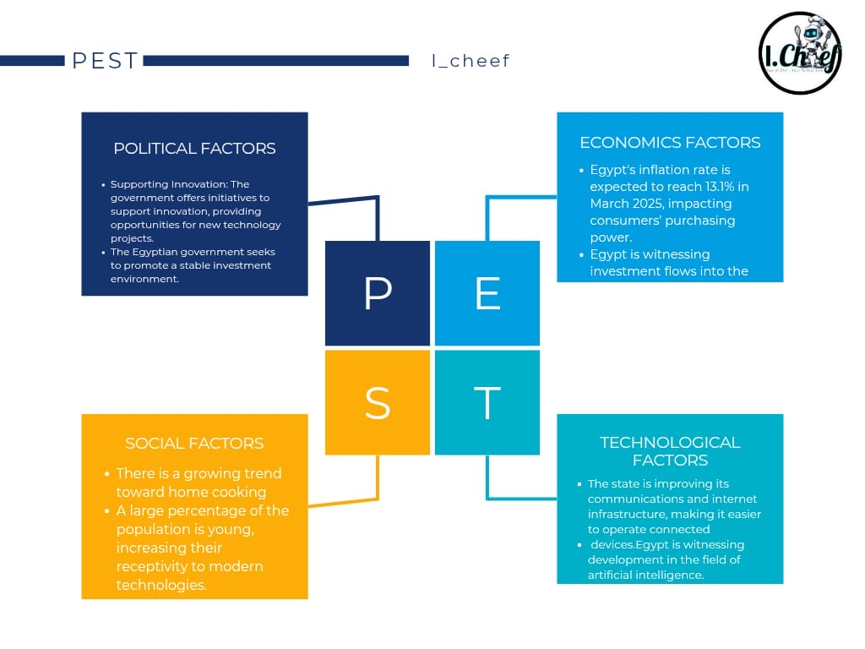

# Content strategy

I-Chef’s Facebook & LinkedIn Digital Marketing Strategy

* **Primary Objectives**

1. **Brand Awareness:** Position I-Chef as an innovative and valuable resource for food lovers.
2. **Community Building:** Establish a strong, interactive audience that trusts the brand.
3. **Thought Leadership:** Showcase expertise in food-tech to attract investors, media, and key industry players.
4. **Pre-Launch Engagement:** Build anticipation so that when the app is launched, there is already demand.
5. **Content Monetization Potential:** Prepare for future monetization through sponsorships, partnerships, and premium content.

## FACEBOOK MARKETING STRATEGY

**Audience Persona (Who Are We Targeting?)**

**Primary Audience:**

* Busy professionals & parents looking for **quick, creative meal ideas**
* Food enthusiasts who love **experimenting with new recipes**
* Young adults interested in **trendy, budget-friendly cooking**
* Health-conscious individuals looking for **nutritional insights**

**Secondary Audience:**

* Home cooks who **struggle with meal planning**
* Food bloggers & influencers looking for **collaborations**
* Entrepreneurs & tech enthusiasts interested in **food-tech innovations**

**Key Content Themes**

**Storytelling (Emotional Connection)**

* Share relatable kitchen struggles & how I-Chef will solve them.
* Example Post: *“Tired of cooking the same meals every day? Here’s how I-Chef can help bring creativity back into your kitchen.”*

**Educational Content (Authority & Value)**

* “How to store food properly to reduce waste”
* “5 kitchen hacks that will save you time”

**Interactive & Community-Driven Content**

* Cooking challenges: *“Use only 3 ingredients! What can you cook?”*
* Polls: *“What’s your favorite comfort food?”*

**Behind-the-Scenes (Brand Transparency & Trust)**

* Showcase the journey of developing I-Chef.
* *“Here’s what’s happening behind the scenes as we build the first AI-powered chef in your pocket!”*

**User-Generated Content (Social Proof & Engagement)**

* Feature home chefs & food bloggers who engage with I-Chef.

**Influencer Collaborations (Virality & Credibility)**

* Partner with **Egyptian food influencers** to **boost visibility**.

**Live Cooking Sessions (Real-Time Engagement)**

* Weekly **Facebook Live Q&A sessions** with professional chefs.
* Example: *“Join us LIVE this Friday as Chef Ahmed shares his top meal prep tips!”*

**Call-to-Action (Engagement & Lead Generation)**

* “Tag a friend who NEEDS this cooking hack!”
* “Comment below and we’ll send you a free meal plan!”

**Facebook 3-Month Content Calendar Sample**

|  |  |  |  |  |  |  |  |  |  |  |  |  |  |  |  |  |  |  |  |  |
| --- | --- | --- | --- | --- | --- | --- | --- | --- | --- | --- | --- | --- | --- | --- | --- | --- | --- | --- | --- | --- |
| | **Week** | **Monday** | **Wednesday** | **Friday** | **Sunday** | | --- | --- | --- | --- | --- | | 1 | Story: "How I-Chef was born" | Poll: "What’s your biggest cooking struggle?" | **Live**: Cooking Challenge | Share a trending recipe | | 2 | Kitchen Hack Video | BTS: Building I-Chef | Influencer Collab | Story: A real user’s experience | | 3 | Quiz: "What’s your cooking personality?" | AI in FoodTech Insight | **Live**: Chef Q&A | Engagement Post: "Share your best food hack!" | |

|  |  |  |  |  |  |  |  |  |  |  |  |  |  |  |  |  |  |  |  |  |  |  |  |  |  |  |  |  |  |  |  |  |  |  |  |  |  |  |  |  |  |  |  |  |  |  |  |  |  |  |  |  |  |  |  |  |  |  |  |  |  |  |  |  |  |  |  |  |  |  |  |  |  |  |  |
| --- | --- | --- | --- | --- | --- | --- | --- | --- | --- | --- | --- | --- | --- | --- | --- | --- | --- | --- | --- | --- | --- | --- | --- | --- | --- | --- | --- | --- | --- | --- | --- | --- | --- | --- | --- | --- | --- | --- | --- | --- | --- | --- | --- | --- | --- | --- | --- | --- | --- | --- | --- | --- | --- | --- | --- | --- | --- | --- | --- | --- | --- | --- | --- | --- | --- | --- | --- | --- | --- | --- | --- | --- | --- | --- | --- |
| |  |  |  |  |  | | --- | --- | --- | --- | --- | | **Week** | **Monday (Storytelling & Education)** | **Wednesday (Community & Interactive)** | **Friday (Live & Video Content)** | **Sunday (Growth & Viral Content)** | | **Week 1** | 🔹 *How I-Chef Was Born:* The story behind the idea & its vision | 🔹 **Poll:** "What’s your biggest cooking struggle?" (e.g., time, creativity, health) | 🔹 **Live Session:** Meet the team – answering questions about I-Chef | 🔹 *Trending Recipe Challenge:* “Try this dish & tag us!” | | **Week 2** | 🔹 *Relatable Problem:* “How many times have you asked ‘What should I cook today?’” (Engagement Post) | 🔹 *Quiz:* "What’s your cooking personality?" (Casual, experimental, gourmet?) | 🔹 **Live Cooking Demo:** A chef makes a dish with audience suggestions | 🔹 *User-Generated Content:* Reposting best dishes from followers | | **Week 3** | 🔹 *Behind the Scenes:* “Here’s what we’re working on for I-Chef’s future” | 🔹 **Debate Post:** "Team Sweet vs. Team Spicy – which do you prefer?" | 🔹 **Live AMA (Ask Me Anything):** "Everything you want to know about AI in cooking" | 🔹 *Feature a food influencer* trying out an I-Chef concept | | **Week 4** | 🔹 *Success Story:* “Meet Sara, a working mom who struggles with meal planning” | 🔹 **Community Post:** “What’s the best cooking hack you’ve ever learned?” | 🔹 **Live Collab with a Chef:** "Quick & easy dinner ideas" | 🔹 *Cooking Meme or Fun Fact* (Engagement Post) | | **Week 5** | 🔹 *Pain Point Post:* “Why do meal plans often fail? Here’s how I-Chef will change that” | 🔹 **This or That:** "Fried vs. Grilled – what’s your go-to?" | 🔹 **Live Poll:** "Choose ingredients for our next recipe!" | 🔹 *TikTok-style food trend video* | | **Week 6** | 🔹 *Founder’s Journey:* “Why we started I-Chef & our vision” | 🔹 **Challenge:** “Cook with only 5 ingredients – tag us!” | 🔹 **Live Workshop:** “How to make cooking faster & easier” | 🔹 *Collab with a Micro-Influencer* (Shoutout to their recipe) | |  |  |  |  |  | |  |  |  |  |  | | **Week 7** | 🔹 FoodTech Insights: “How AI is already changing the food industry” | 🔹 Food Confessions: “What’s your weirdest food habit?” | 🔹 Live Interview with a Nutritionist | 🔹 Behind-the-Scenes Video: How we’re building I-Chef | | **Week 8** | 🔹 *Kitchen Hacks:* “Top 5 ways to save time while cooking” | 🔹 **User Submission Day:** Feature best recipe ideas from followers | 🔹 **Live Product Update:** Sneak peek into I-Chef’s upcoming features | 🔹 *Recap of Best Content from the Month* | | **Week 9** | 🔹 *Cooking Psychology:* “Why do we crave comfort food?” | 🔹 **Opinion Post:** "What’s your ultimate lazy meal?" | 🔹 **Live: Chef’s Tips for Beginners** | 🔹 *Viral Food Trend Repost* | | **Week 10** | 🔹 *Problem-Solution Post:* "Struggling with healthy eating? Here’s how I-Chef can help" | 🔹 **Fan Feature:** "Meet our most engaged follower!" | 🔹 **Live Giveaway:** "Win a free meal plan from I-Chef!" | 🔹 *Quick Hack Video:* “Did you know this trick?” | | **Week 11** | 🔹 *Food Myth Busting:* "Is freezing food bad for nutrients?" | 🔹 **Interactive Game:** “Name this dish with emojis” | 🔹 **Live Chat with a Food Blogger** | 🔹 *Major Announcement about I-Chef* | | **Week 12** | 🔹 *User Story:* "How I-Chef helped Ahmed plan better meals" | 🔹 **Community Challenge:** "Try cooking in 20 minutes!" | 🔹 **Live AMA (Final Pre-Launch Event)** | 🔹 *“What’s Next for I-Chef?” Post* | |

**Pro Tip:**  
Use **Facebook Groups** to create a **community around I-Chef**. Example: *“The I-Chef Cooking Club”* where members share cooking tips & engage with the brand directly.

**Facebook Advertising Strategy**

**Goal:** Drive awareness and engagement  
**Best Ad Types:**

* **Video Ads** → Show how I-Chef solves problems
* **Engagement Ads** → Boost interaction & community growth
* **Lead Generation Ads** → Collect emails for early app access

**Targeting Strategy:**  
**Interest-based targeting**: Food lovers, home cooks, working professionals  
**Lookalike Audiences**: People similar to engaged followers  
**Retargeting**: Users who watched videos or interacted with posts

## LINKEDIN MARKETING STRATEGY

**Audience Persona (Who Are We Targeting?)**

**Primary Audience:**

* **Tech investors & startup enthusiasts** looking for innovation in food-tech.
* **Food industry professionals** interested in AI’s impact on the culinary world.

**Secondary Audience:**

* **B2B potential partners** (e.g., nutritionists, meal-kit delivery services).
* **Entrepreneurs & executives** who follow startup trends.

**Key Content Themes**

**Thought Leadership Articles**

* *“How AI is Revolutionizing the Food Industry”*
* *“Why the Future of Cooking is Personalized AI”*

**Behind-the-Scenes Startups Insights**

* Share the challenges & milestones of building I-Chef.
* *“Here’s what we learned in our first 6 months of building I-Chef.”*

**Industry Trends & Research-Based Content**

* Data-driven reports on food-tech.

**Founders’ Personal Branding (Humanizing the Brand)**

* Team stories, investor insights, and collaboration opportunities.

**Networking & Partnerships**

* Connect with relevant professionals for collaborations.

**LinkedIn 3-Month Content Calendar Sample**

|  |  |  |
| --- | --- | --- |
| **Week** | **Tuesday** | **Thursday** |
| **1** | Article: "The Rise of AI in FoodTech" | Founder’s Journey: "Why We Started I-Chef" |
| **2** | Industry Report: "The Future of AI in Cooking" | Case Study: How AI is Used in Global Kitchens |
| Week | Tuesday (Industry Insights & Thought Leadership) | Thursday (Engagement & Professional Growth) |
| Week 1 | 🔹 The Future of AI in FoodTech: How Smart Cooking is Evolving | 🔹 Founder’s Story: The challenges of building I-Chef |
| Week 2 | 🔹 Case Study: How AI is transforming the food industry globally | 🔹 Open Discussion: “What’s one kitchen innovation you wish existed?” |
| Week 3 | 🔹 Behind-the-Scenes: How we’re developing I-Chef | 🔹 Networking Post: "Tag someone who should join the FoodTech revolution" |
| Week 4 | 🔹 Infographic: The biggest food-tech trends in 2024 | 🔹 Poll: "Would you trust an AI-powered meal planner?" |
| Week 5 | 🔹 Success Stories: What food startups are getting right | 🔹 Collaboration Post: “Looking for partners in the food industry” |
| Week 6 | 🔹 AI vs. Human Chefs: The debate on food innovation | 🔹 Q&A Post: "Ask us anything about I-Chef’s development" |
| Week 7 | 🔹 Investor Insight: Why FoodTech is the next big industry | 🔹 Networking Post: “Who are the top voices in AI & food tech?” |
| Week 8 | 🔹 Product Development: “Here’s what we’ve built so far” | 🔹 Recruitment Call: Looking for testers & collaborators |
| Week 9 | 🔹 Market Research: “How consumer behavior is changing in the kitchen” | 🔹 Live LinkedIn Event: Panel discussion on AI & food trends |
| Week 10 | 🔹 Data-Backed Article: "The ROI of AI in meal planning" | 🔹 Industry Debate: “What’s more important – convenience or nutrition?” |
| Week 11 | 🔹 Feature a Startup Mentor: What they think of I-Chef | 🔹 Recap: The biggest lessons from our journey |
| Week 12 | 🔹 Big Announcement: "What’s next for I-Chef?" | 🔹 Call to Action: “Join our mission to change how people cook” |

**Final Takeaways & Growth Strategies**

**Facebook Focus:** Build **an engaged community** that is excited for I-Chef’s launch.  
**LinkedIn Focus:** Establish **thought leadership & attract potential investors/partners**.  
**Cross-Promotion:** Repurpose high-performing content between platforms.

**Paid Growth Strategy:**

* Facebook: Engagement ads → Video views ads → Retargeting ads.
* LinkedIn: Sponsored articles + InMail campaigns for investor outreach.

**By the end of this 3-month plan, I-Chef will have:**  
✔ A **highly engaged audience** excited for the launch  
✔ **Established authority** in the food-tech industry  
✔ Potential **investors, partners, and early adopters**

## Instagram Content Strategy

**Key Themes:**

1. **Showcasing AI-Driven Recipe Innovations:**
2. **Creative Recipe Creations**
3. **Collaborations with Famous Egyptian Chefs:**
4. **User feedback & Content Recycling:**

**Content Formats:**

* **Feed Posts:** Static posts, carousels, reels, and IGTV sessions (3 times per week).
* **Stories:** Daily behind-the-scenes, polls, Q&As, and interactive elements.
* **Language:** All captions and on-screen text in local Arabic with culturally relevant hashtags.

**Instagram 3-Week Content Calendar Sample**

|  |  |  |  |
| --- | --- | --- | --- |
| **Week** | **Day** | **Content type & Details** | **Stories**  **(Additional Engagement)** |
| **1** | Monday | poster: logo and app teaser | rhetorical question about the app |
| Wednesday | reel: launching the app | check out the latest reel |
| Friday | reel: Content recycling and stitch | meal prep difficulties |
| **2** | Monday | Tutorial AI feature & recipe showcase | Quick tutorials; BTS snaps of recipe creation; interactive poll. |
| Wednesday | Content Recycling with Local Twist. | Snippets from original posts with added commentary; opinion poll. |
| Friday | poster: Behind-the-scenes team vibe | Team snapshots; mini-interviews; candid moments. |
| **3** | Monday | poster: fanbase suggestion | Teasers from the collaboration; BTS prep clips; “Ask the Chef”. |
| Wednesday | memes | Quick facts about local trends; interactive quizzes; polls. |
| Friday | Recap & Call-to-Action. | Recap stories; thank-you messages; final poll/Q&A. |

**YouTube Content Strategy**

**Key Themes:**

1. **AI-Powered Recipe Demos & Tutorials:**
2. **Behind-the-Scenes & Team Vlogs:**
3. **Collaborative Series with Famous Egyptian Chefs & Dietitians:**
4. **Local Culinary Trends & Cultural Integration:**

**Content Formats:**

* **Long-Form Videos:** 8–15 minute tutorials, vlogs, and interviews (3 times per week).
* **Shorts & Community Posts:** Daily snippets, teasers, and interactive polls to maintain viewer engagement.
* **Language:** Videos and community posts in local Arabic to ensure cultural resonance.

**Survey link :** <https://docs.google.com/forms/d/e/1FAIpQLScfOKzwUucGJbNmv4h9EJice9d48dFFcfVeowN0vPHEVS2-ug/viewform?usp=sharing>

Results

