https://www.youtube.com/watch?v=gmcl83jdzyk&list=PLnp2L0_DrK7dtH3WXlhAQ30lHNgaDeWma By Sachin(Agentic AI And Fullstack Coding) from youtube.

Command for workspace to keep all project:
- ng new name_project --create application false
To create application inside project:
- ng new application host-app
- ng new application product-app
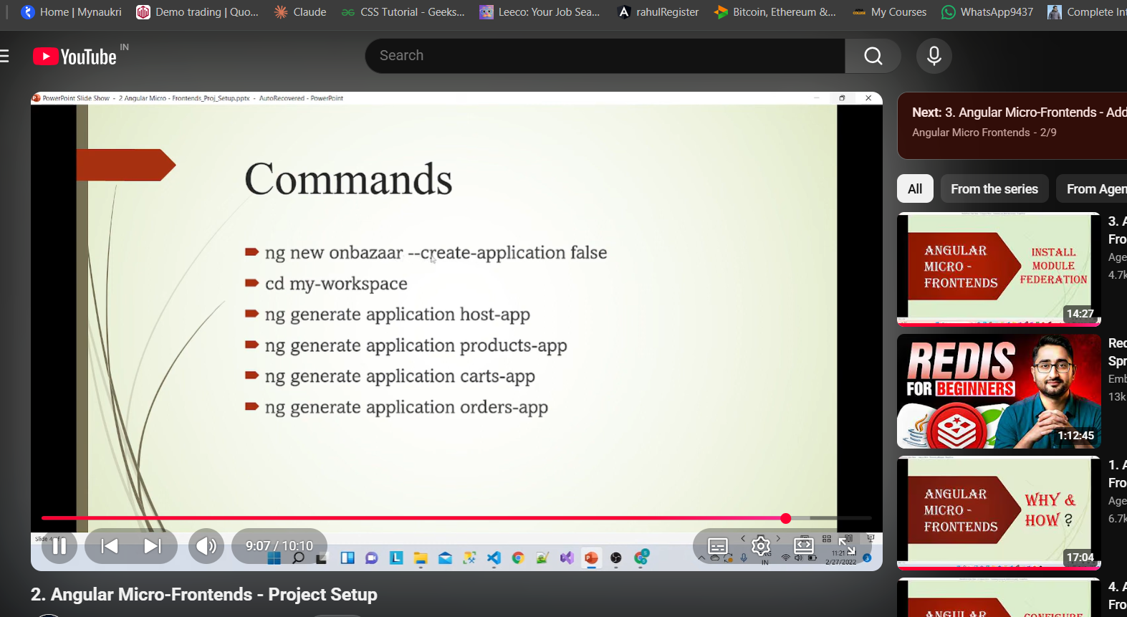

https://www.youtube.com/watch?v=7VlN7_YtHKs&list=PLnp2L0_DrK7dtH3WXlhAQ30lHNgaDeWma&index=3 (Add module federation)

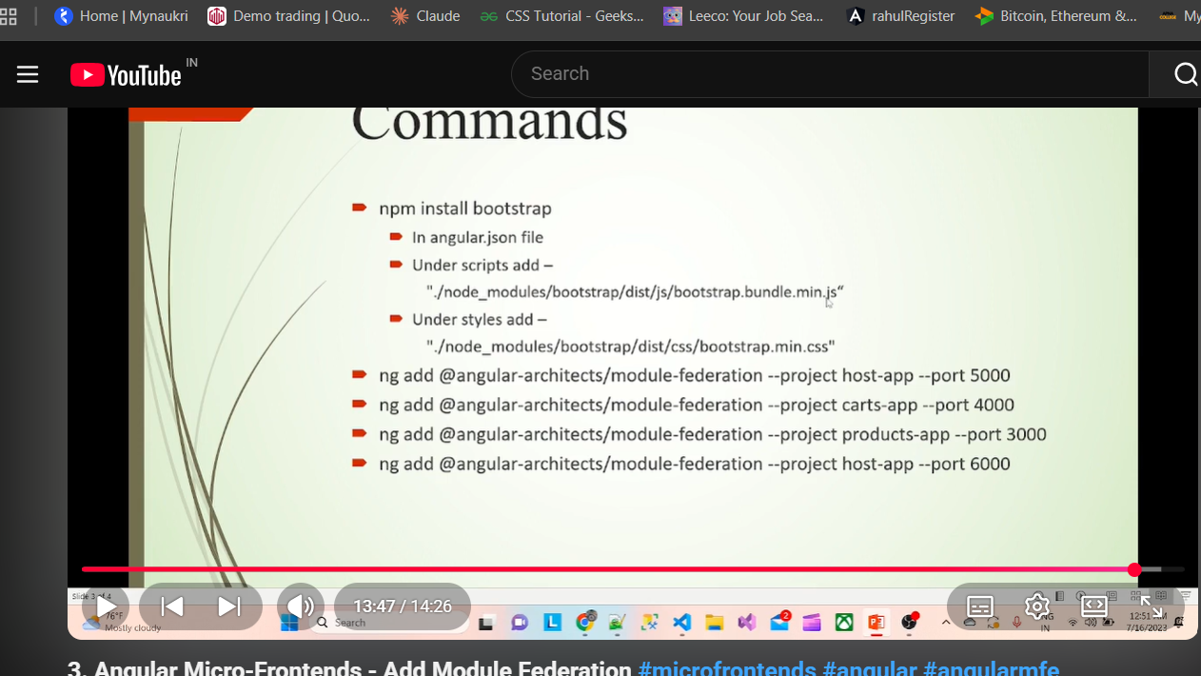
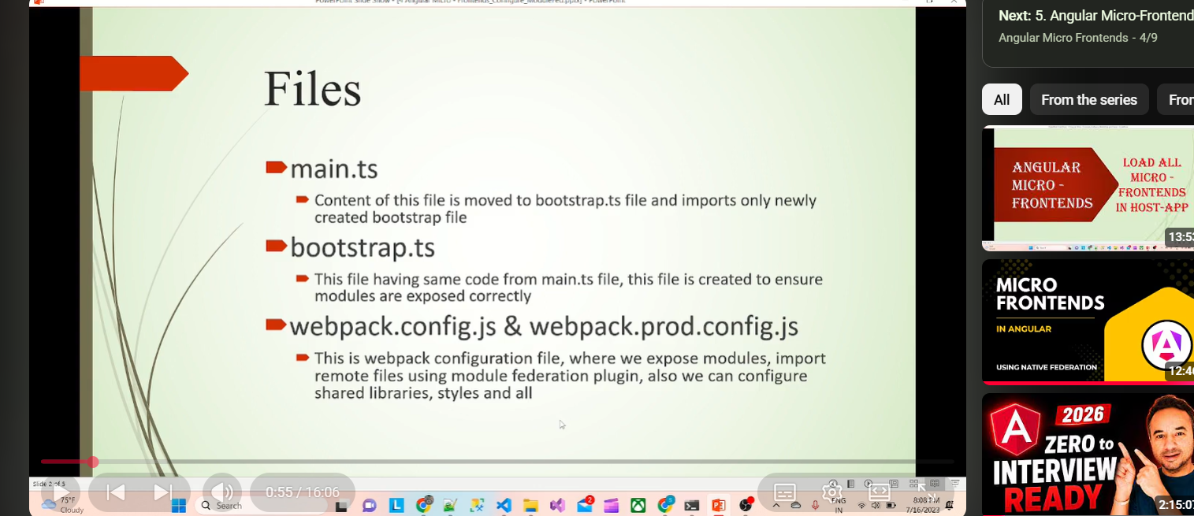

(Command to add specific module for specific project)
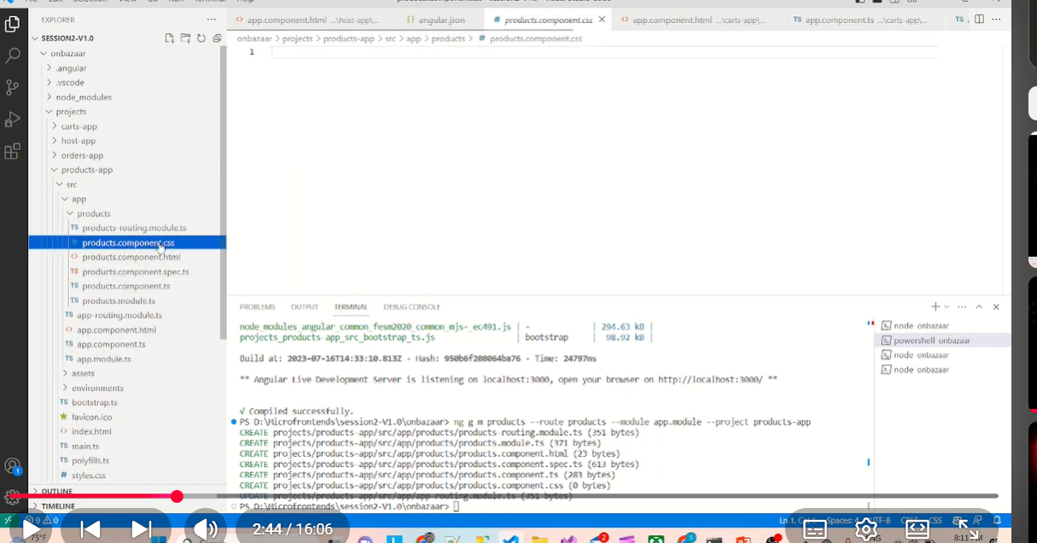

# Angular Microfrontend (Nx + Module Federation) Interview Questions & Answers

## 1. What is a Microfrontend?

**Answer:**

A Microfrontend is an architecture where a large frontend application is divided into multiple smaller, independent applications. Each application is owned by a separate team and can be developed, tested, and deployed independently.

**Example:**

* Host Application
* Product Application
* Order Application
* View Application

Each application is loaded by the Host only when required.

---

## 2. Why do we use Microfrontends?

**Answer:**

We use Microfrontends because:

* Large applications become easier to manage.
* Different teams can work independently.
* Faster development.
* Independent deployment.
* Better scalability.
* Easier maintenance.

---

## 3. What is the Host Application?

**Answer:**

The Host is the main Angular application that loads all remote applications.

Its responsibilities are:

* Routing
* Header
* Sidebar
* Authentication
* Loading remote applications
* Shared layout

The Host does not contain all business features. It loads them dynamically.

---

## 4. What is a Remote Application?

**Answer:**

A Remote is an independent Angular application exposed to the Host using Module Federation.

Examples:

* Product
* Order
* View
* Admin

Each remote has its own codebase, build process, and deployment.

---

## 5. What is Module Federation?

**Answer:**

Module Federation is a Webpack feature that allows one application to load code from another application at runtime without rebuilding the Host.

It enables:

* Runtime loading
* Code sharing
* Independent deployment
* Shared libraries

---

## 6. What is remoteEntry.js?

**Answer:**

Every remote generates a file called **remoteEntry.js**.

It contains:

* Exposed modules
* Shared libraries
* Configuration required by the Host

The Host downloads this file first and then loads the required Angular module.

---

## 7. How does Module Federation work?

**Answer:**

1. User opens the Host.
2. Host loads normally.
3. User clicks Product.
4. Host downloads Product's remoteEntry.js.
5. Product module is loaded dynamically.
6. User can use the Product application.

No rebuild of the Host is required.

---

## 8. How do you run Microfrontends locally?

**Answer:**

Example:

* Host → localhost:4200
* Product → localhost:4201
* Order → localhost:4202
* View → localhost:4203

The Host loads each remote using Module Federation.

---

## 9. How are Microfrontends deployed?

**Answer:**

Even if all applications are inside one Nx Monorepo, each application is built separately.

Example:

* nx build host
* nx build product
* nx build order
* nx build view

Each build creates its own deployment package.

---

## 10. If Product changes, do you deploy everything?

**Answer:**

No.

Only the Product application is rebuilt and deployed.

The Host and other remotes remain unchanged.

This is one of the biggest advantages of Microfrontends.

---

## 11. What happens if one remote crashes?

**Answer:**

Only that remote fails.

Example:

* Host → Running
* Order → Running
* View → Running
* Product → Failed

The Host can display a friendly error message like:

"Unable to load Product. Please try again later."

Other applications continue working.

---

## 12. What happens if the Host crashes?

**Answer:**

If the Host crashes, none of the remote applications can be loaded.

The Host is responsible for loading all remotes.

---

## 13. What are Shared Libraries?

**Answer:**

Shared libraries are common dependencies shared between the Host and remotes.

Examples:

* Angular
* RxJS
* Angular Material

Benefits:

* Avoid duplicate downloads
* Smaller bundle size
* Better performance

---

## 14. What is Nx?

**Answer:**

Nx is a Monorepo build system used to manage multiple Angular applications and libraries in a single repository.

It provides:

* Code sharing
* Faster builds
* Dependency graph
* Incremental builds
* Better project organization

---

## 15. What is a Monorepo?

**Answer:**

A Monorepo is a single Git repository containing multiple applications and shared libraries.

Example:

* Host
* Product
* Order
* View
* Shared UI Library

All projects are managed in one repository.

---

## 16. Monorepo vs Microfrontend

**Answer:**

Monorepo is a repository structure.

Microfrontend is a frontend architecture.

A Monorepo can contain multiple Microfrontends.

---

## 17. Microfrontend vs Microservice

**Answer:**

Microfrontend:

* Frontend architecture
* Angular/React/Vue
* Splits the UI
* Runs in the browser

Microservice:

* Backend architecture
* Spring Boot/.NET/Node.js
* Splits backend functionality
* Runs on the server
* Communicates using REST APIs, gRPC, Kafka, or RabbitMQ

---

## 18. How do remotes communicate?

**Answer:**

Remotes can communicate using:

* Shared services
* RxJS Subjects
* Browser Custom Events
* NgRx Store
* APIs

Avoid direct dependencies between remotes.

---

## 19. Who controls routing?

**Answer:**

The Host controls the main routing.

Examples:

* /product
* /order
* /view

When a user navigates to a route, the Host loads the appropriate remote.

---

## 20. Why use Lazy Loading?

**Answer:**

Lazy loading loads a remote only when the user visits that feature.

Benefits:

* Faster initial page load
* Reduced bundle size
* Better performance

---

## 21. How is Authentication handled?

**Answer:**

Usually, the Host manages authentication.

Responsibilities include:

* Login
* JWT token
* User session
* Authorization

The Host shares authentication information with remotes.

---

## 22. How is CI/CD managed?

**Answer:**

Each application can have its own CI/CD pipeline.

Example:

1. Developer pushes Product code.
2. Product build runs.
3. Product tests run.
4. Product is deployed.

Other applications are not affected.

---

## 23. What are the advantages of Microfrontends?

**Answer:**

* Independent development
* Independent deployment
* Better scalability
* Easier maintenance
* Team ownership
* Faster releases
* Technology flexibility (in some architectures)

---

## 24. What are the disadvantages of Microfrontends?

**Answer:**

* More complex setup
* Version compatibility issues
* Communication between remotes
* Deployment coordination
* Shared dependency management
* More monitoring and debugging effort

---

## 25. Explain your Microfrontend project.

**Answer (Interview Ready):**

"In my project, we used an Nx Monorepo with Angular Module Federation. We had one Host application and multiple remote applications such as Product, Order, and View. The Host managed routing, authentication, and the common layout, while each remote handled its own business functionality.

Although all applications were stored in a single repository, each one was built and deployed independently. The Host dynamically loaded each remote using its remoteEntry.js file. If one remote was updated, only that application was rebuilt and deployed without affecting the others. If a remote failed to load, the Host and the remaining remotes continued to work, and we displayed a user-friendly error message. This architecture allowed different teams to develop and release features independently while keeping the application scalable and maintainable."

"We use singleton:true to ensure Angular is loaded only once, strictVersion:true to prevent incompatible library versions from being shared, and requiredVersion:'auto' so Webpack automatically uses the version defined in package.json. Together, these settings help avoid duplicate Angular runtimes, version conflicts, and manual version management."

Follow: https://github.com/amarkumarram/MicrofrontendTutorial/tree/host-app?tab=readme-ov-file and Youtube https://www.youtube.com/playlist?list=PL1UWPWOy5UlfLWfSstHBW-iVu6RWJtrG-
What is Webpack 5?
Webpack 5 is the latest major version of Webpack, released in 2020. It introduces several new features, optimizations, and changes aimed at improving performance, reducing bundle sizes, and enhancing module management.
Key Features and Improvements in Webpack 5:
- Module Federation:
  - A significant new feature that enables sharing code and dependencies between different applications at runtime.
  - Allows multiple projects or microfrontends to share modules without bundling everything together, making dynamic code loading possible.
- Improved Caching:
  - Webpack 5 comes with better caching capabilities, making builds faster by using persistent caching of modules.
- Automatic Dependency Management:
  - Webpack 5 can automatically manage shared dependencies between different parts of an application, reducing duplicate code.
- Tree Shaking Improvements:
  - Enhances the process of removing unused code from the final bundle, leading to smaller bundle sizes.
- Better Asset Management:
  - It introduces an improved way to handle assets like images, fonts, and other static files, making asset optimization more efficient.
- WebAssembly (Wasm) Support:
  - Webpack 5 improves support for WebAssembly modules, allowing developers to integrate Wasm more easily with JavaScript.
In Summary:
- Webpack is a tool for bundling and optimizing web applications.
- Webpack 5 is the latest version that brings new features like Module Federation for microfrontends, better caching, and performance improvements. It significantly simplifies the sharing of code between different parts of a web application.

1. What is a Microfrontend?
- Microfrontend is an architectural style where a large web application is divided into smaller, independent parts (micro-applications or microfrontends), each responsible for a specific feature or section of the user interface.
- Each microfrontend can be developed, tested, and deployed separately, which is similar to the microservices approach on the backend, where different services handle different parts of an application.
2. Why Use Microfrontends?
Microfrontends address challenges that arise when building large web applications, such as:
- Scaling Development: When many developers work on the same codebase, it can become difficult to manage changes. By breaking the app into smaller pieces, teams can work independently.
- Independent Deployments: Each microfrontend can be updated or deployed separately without affecting the entire application.
- Technology Flexibility: Different teams can use different frameworks or libraries (e.g., React, Angular, Vue) for their parts of the app.
- Easier Maintenance: Smaller codebases are easier to maintain, test, and debug.
3. How Do Microfrontends Work?
Microfrontends work by splitting the user interface into multiple mini-applications, each responsible for a specific part of the app. Here’s how they typically function:
- Each microfrontend is built as a separate app: It can have its own repository, tech stack, and build process.
- The microfrontends are then integrated into a single UI: This is done using various techniques, such as embedding them into a main application shell or using client-side composition techniques.
- Communication and state sharing: Microfrontends can communicate with each other when necessary, using shared services, events, or custom APIs.
What is Module Federation?
Module Federation is a feature introduced in Webpack 5 that allows microfrontends to share code and resources at runtime. It facilitates the dynamic loading of modules between applications without needing to bundle all code together.
How Module Federation Works in Microfrontends
- Expose and Consume Code Dynamically: With Module Federation, you can configure one microfrontend to expose components, modules, or services, and another microfrontend can consume these.
- Share Dependencies: Avoids loading multiple versions of the same library by sharing dependencies between microfrontends.
- Remote Modules: Microfrontends can act as "remotes" that provide code, while others act as "hosts" that load and use that code.
6. How Are Microfrontends and Module Federation Related?
Module Federation provides the mechanism for implementing a microfrontend architecture:
- Microfrontends use Module Federation to share components, libraries, or even entire features between different parts of the application.
- It allows dynamic code loading at runtime, making it possible to integrate microfrontends seamlessly without rebuilding the whole app.
In microfrontend architecture, monorepo and multi-repo are two different ways of organizing and managing the codebase. They describe how the code for different microfrontends is stored and handled in source control.
1. Monorepo (Single Repository)
- Description: All microfrontends are stored in a single repository, with each microfrontend existing as a separate folder or package. The monorepo contains the entire codebase for the application, including all microfrontends and shared libraries.
- Advantages:
  - Easier Code Sharing: Shared code and libraries can be easily reused across different microfrontends since everything is in one place.
  - Consistent Development Practices: Ensures consistent tooling, build processes, and code standards across all microfrontends.
  - Simplified Dependency Management: Managing dependencies is more straightforward since everything is in the same repository.
  - Atomic Changes: Changes that affect multiple microfrontends can be made in one commit, reducing coordination overhead.
- Challenges:
  - Scaling the Repository: As the application grows, the size of the repository can become difficult to manage.
  - Longer Build Times: Large monorepos may have longer build and test cycles.
  - Complex CI/CD Pipelines: Ensuring the right parts of the code are built and tested can be more complex in a monorepo.
2. Multi-Repo (Multiple Repositories)
- Description: Each microfrontend is stored in its own separate repository. This means there is a different repository for each microfrontend, as well as possibly for shared libraries.
- Advantages:
  - Independent Development and Deployment: Teams can work independently on different microfrontends, with their own release cycles.
  - Better Isolation: Issues in one microfrontend are less likely to affect others since they are developed separately.
  - Scalable Codebase: Since each repository is smaller, it is easier to manage as the application scales.
- Challenges:
  - Code Duplication: Sharing code between different microfrontends is more difficult, leading to potential duplication.
  - Dependency Management: Ensuring consistent versions of shared libraries across multiple repositories can be challenging.
  - Complex Coordination: Changes that impact multiple microfrontends may require coordination across different repositories, making it harder to maintain consistency.
How They Relate to Microfrontend Architecture
- In a monorepo, the microfrontends share the same repository, making it easier to share code and maintain consistency. However, build processes may need to be optimized to avoid building everything at once.
- In a multi-repo, each microfrontend is isolated, allowing for independent development and deployment, but making it harder to maintain consistency and share code.
Which Approach to Use?
- Monorepo: Suitable when teams are small, the codebase is relatively simple, or there is a need for tight integration and consistent tooling.
- Multi-Repo: Better for large teams working on separate parts of the application, where each microfrontend can have its own lifecycle and tech stack.
In a microfrontend setup, you can still share code using tools like Module Federation in Webpack 5, whether using a monorepo or a multi-repo structure
SIMPLE:
Here’s a simple explanation of monorepo and multi-repo in the context of microfrontends:
Monorepo
- All microfrontends are stored in a single repository.
- Advantages: Easier to share code and manage dependencies. Consistent development environment.
- Challenges: Can become large and harder to manage as the project grows.
Multi-Repo
- Each microfrontend has its own separate repository.
- Advantages: Teams can work independently and deploy separately. Easier to scale.
- Challenges: Sharing code is harder. Keeping dependencies in sync can be tricky.
Both approaches can be used in microfrontend architecture, depending on the team's needs and project structure.
Monorepo and multi-repo describe how the codebase is managed in a microfrontend architecture, whereas the different types of microfrontends (like component-based, page-based, etc.) describe how the microfrontends are integrated into the application.
How Monorepo/Multi-Repo and Microfrontend Types Differ:
- Monorepo vs. Multi-Repo:
  - Monorepo: All microfrontends are kept in a single repository. This approach is about storing all the code in one place.
  - Multi-Repo: Each microfrontend has its own separate repository. This approach is about splitting the code across multiple places for better isolation.
- Microfrontend Types:
  - Component-Based: Different microfrontends provide individual components (e.g., buttons, forms).
  - Page-Based: Each microfrontend represents an entire page or section.
  - Route-Based: Different routes load different microfrontends.
  - Layout-Based: Different microfrontends fill different sections of a common layout.
How They Relate:
- Monorepo/Multi-Repo is about how the code is stored and managed.
- Microfrontend types are about how the application is built and integrated.

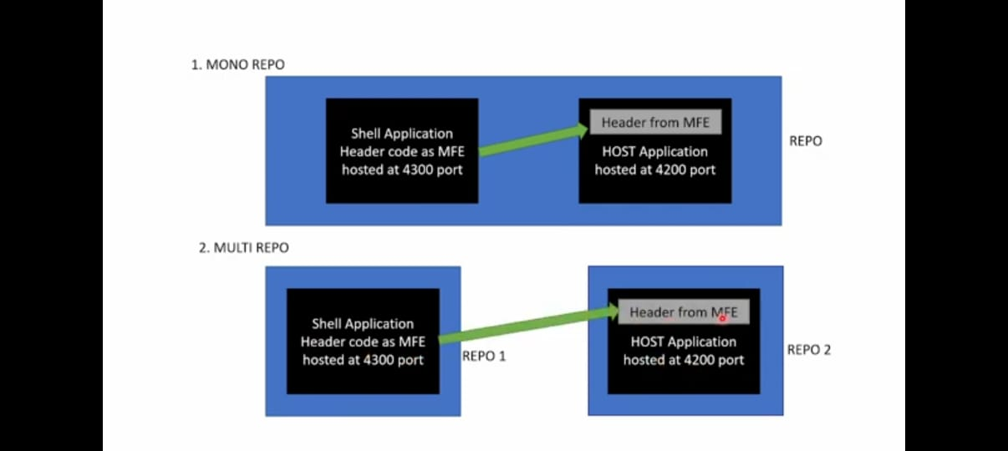

Summary of Commands:
- Create workspace: ng new mono-workspace --createApplication="False" (It will create a workspace, not an application.)
- Navigate to workspace: cd mono-workspace
- Generate host app: ng g application host-app --routing --style=scss (1st app)
- Generate microfrontend app: ng g application mfe-app --routing --style=scss (2nd app)
- Run app: ng serve host-app -o (Use -o to open the app in the default browser.)
- Install Webpack: npm install webpack webpack-cli --save-dev (Inside workspace)
- Add Module Federation: ng add @angular-architects/module-federation --project host-app --port 4220 (After running this command, we will get one file webpack.config.js.)
- Create component: ng generate component component-name --project=project-name (Replace component-name and project-name with your desired names.)

