POLLS MANAGEMENT PLUGIN FOR DOTCMS 2.2.x

With this plugin you can handle in a dotCMS way (Structures, macros, relationships) the polls and their votes.

BACKEND
Configuring a Polls Management portlet you can add and see your polls into the system.
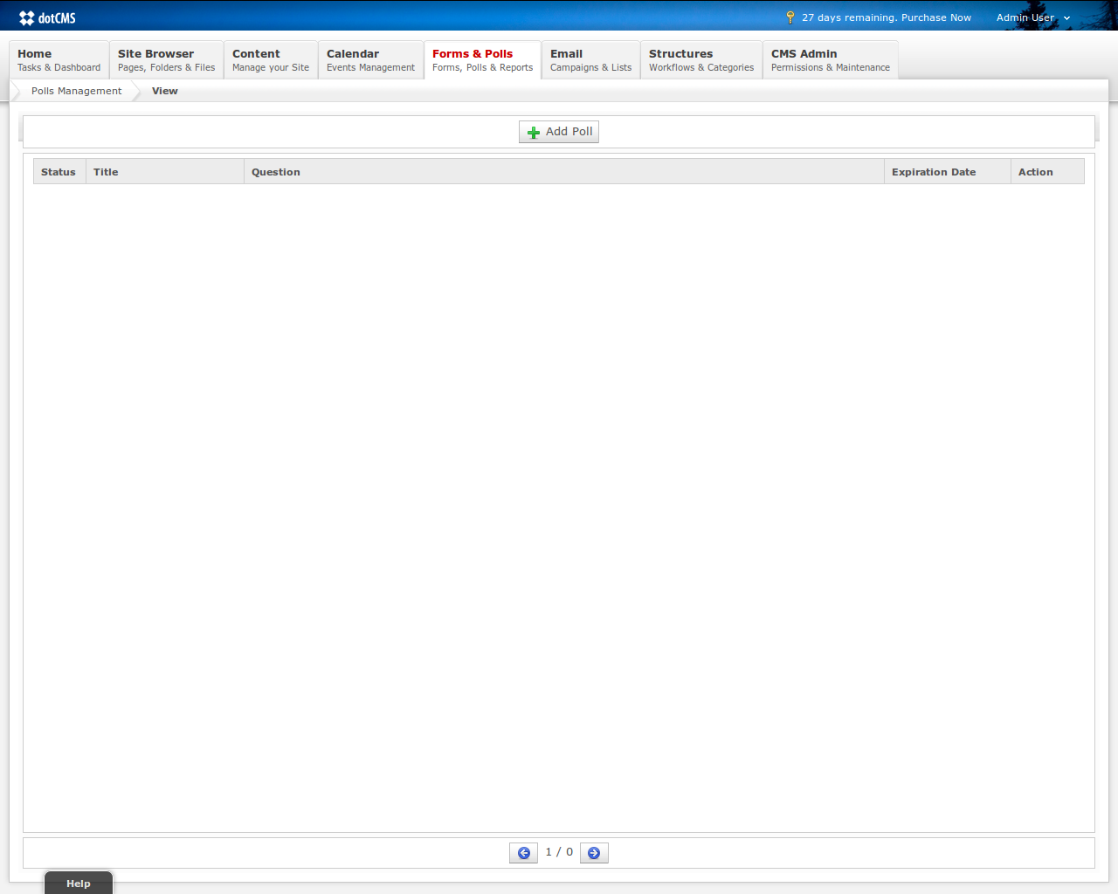
Clicking on “Add Poll” the system open a popup for adding a new Poll.
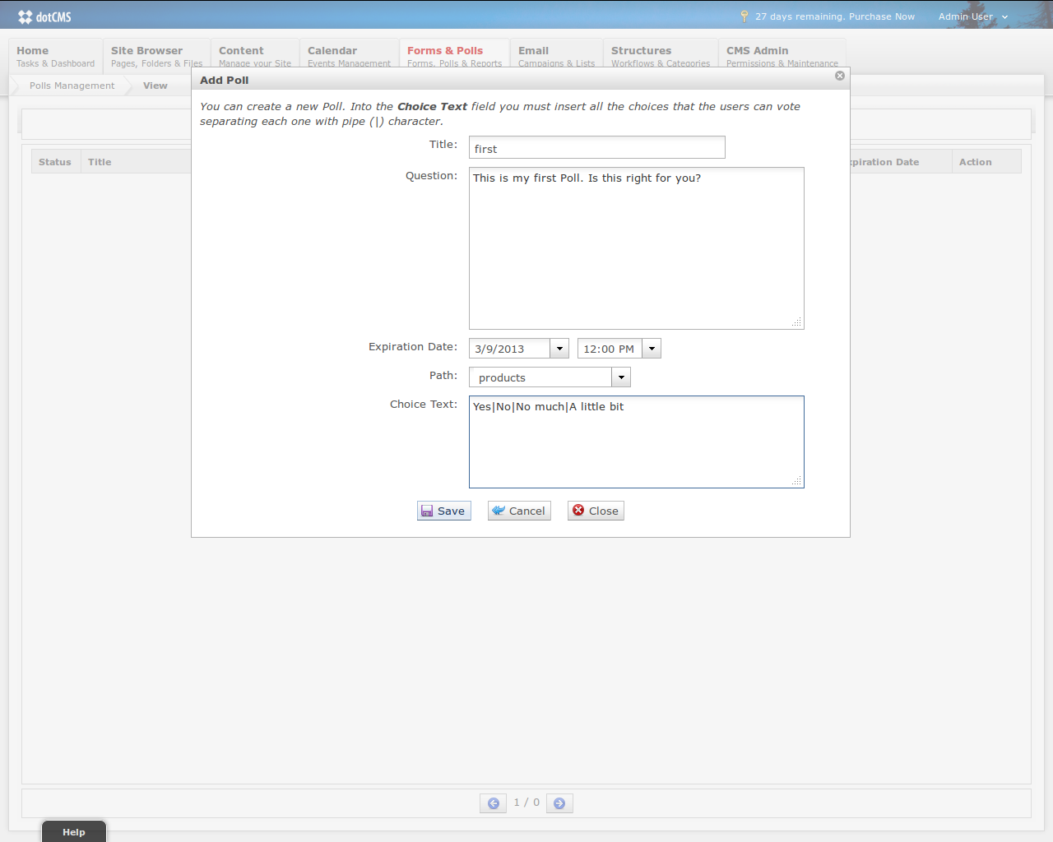
How can you see, the choices must be inserted separated by pipe char (|). When the Poll is saved (a green message will appear on popup), clicking on “close” you can see the new polls list with the new poll.
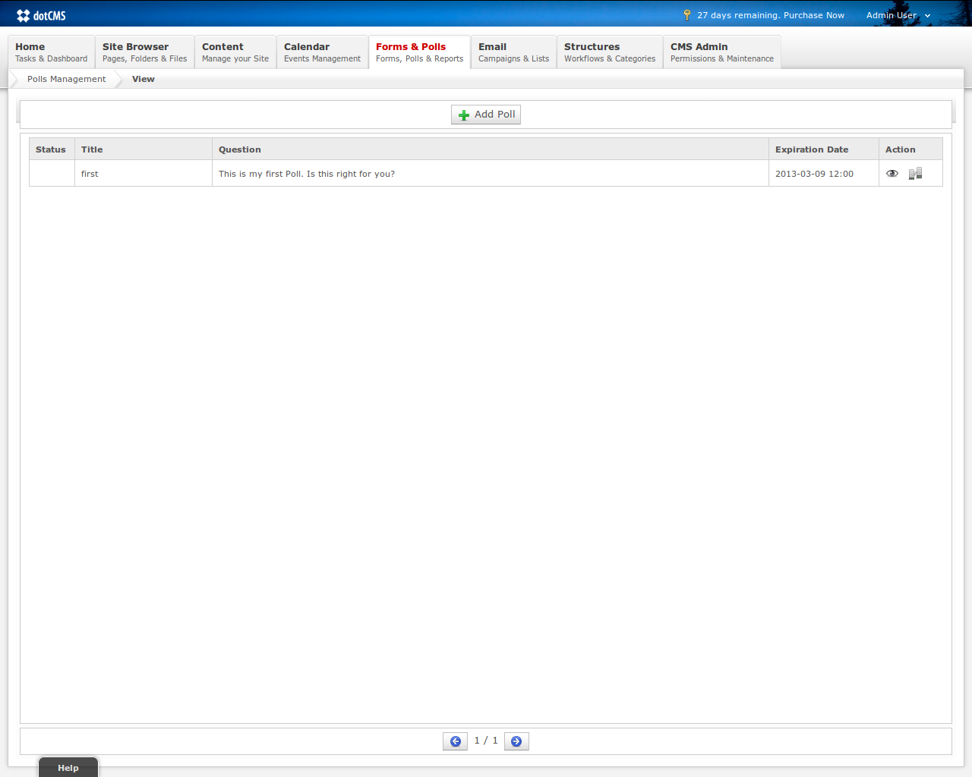
In this list, if the poll is not expired, you can see two links into the Action column:
- View Votes: this link open a popup with votes for each poll's choice (this link appear also if the poll is expired);
- Publish Remote: if the plugin is deployed into a remote environment (later we'll see the plugin.properties in detail) than you can directly publish remotely.
FRONTEND
We have two velocity macro that can be used for show at the end users our poll:
- viewPoll($title, $showVotes): if we add this marco in a container than show the poll specified by title and allow users to vote: if the boolean $showVotes is true than after the voting the macro shows up the votes situation in percentage for each choice.
- viewPollVote($title): show only the votes for given poll.
Let's create a new container for this functionality:
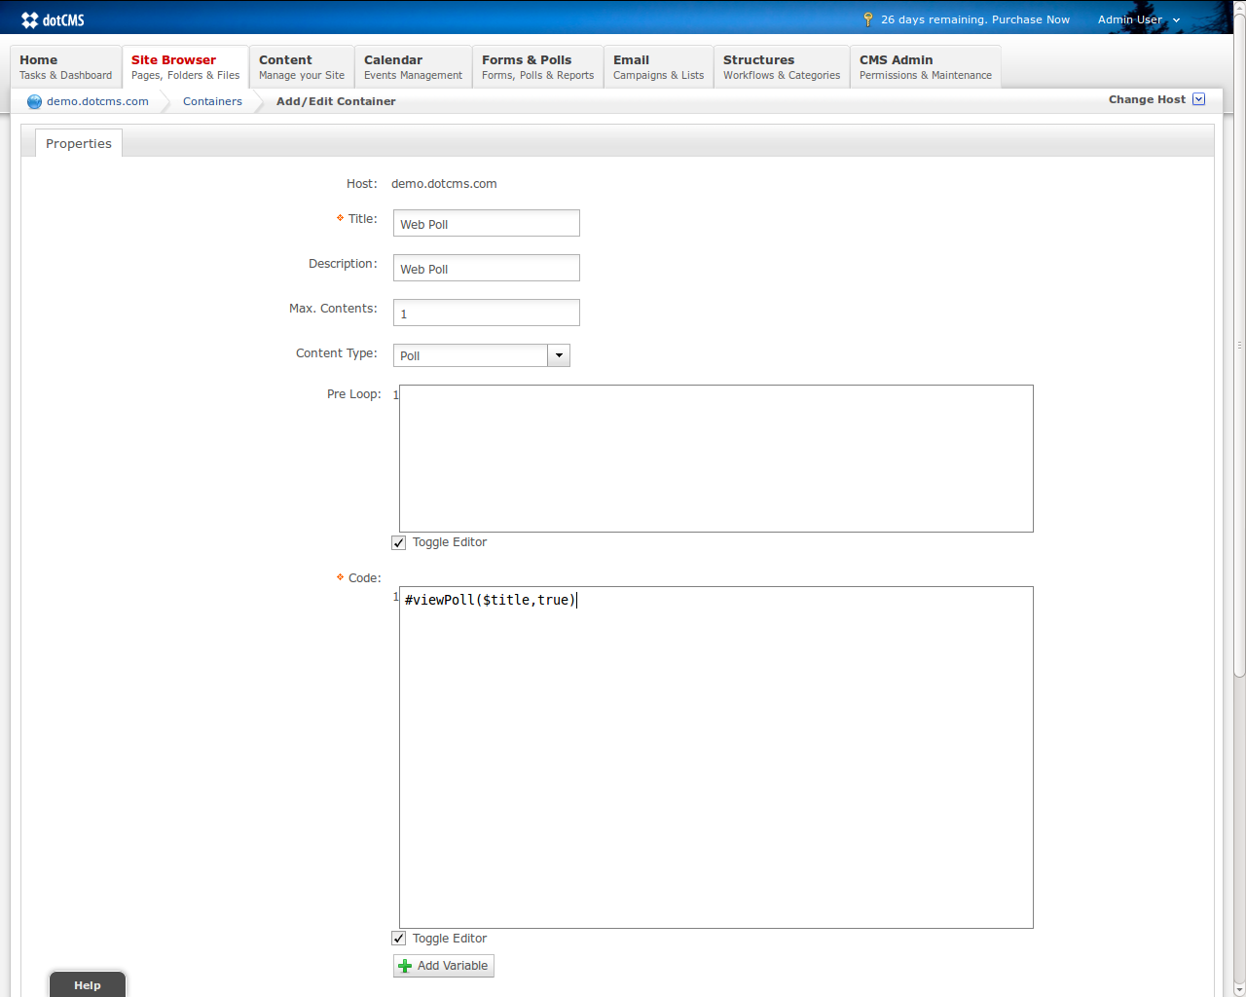
Let's create a new template...
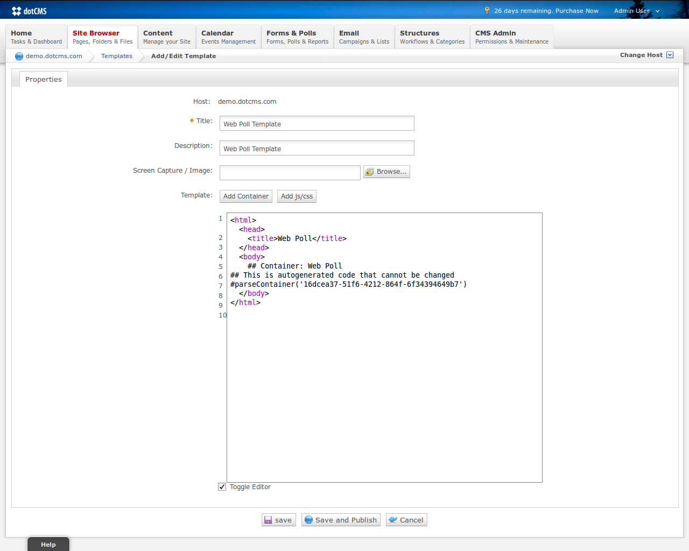
Now the html page where we're going to add a poll created in the first part of this document...
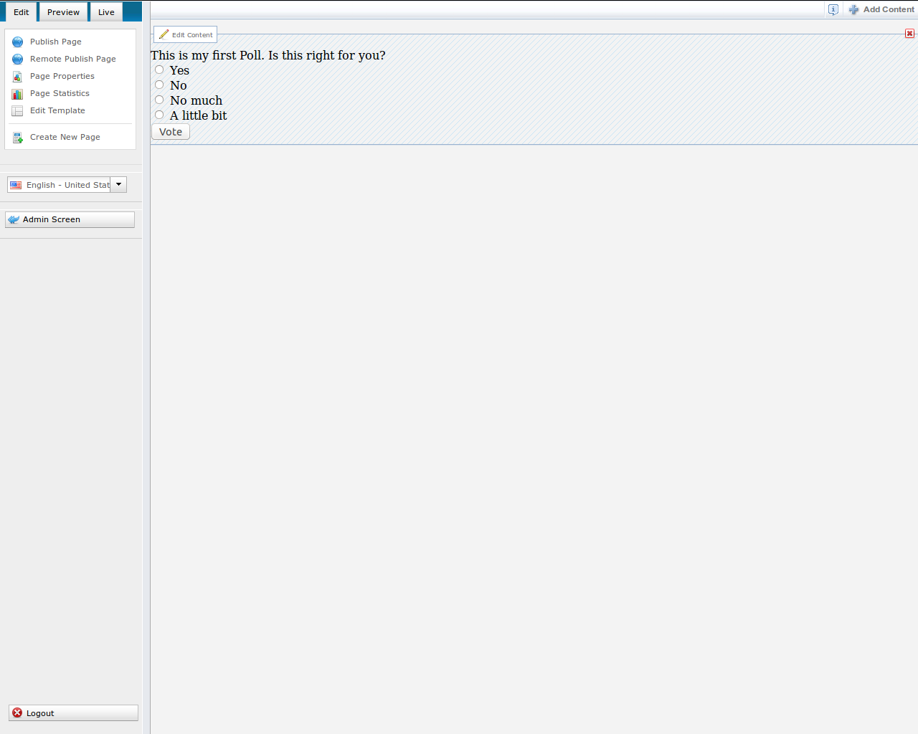
By publishing the html page, if we go in frontend without logged in, than we can vote and the result is this:
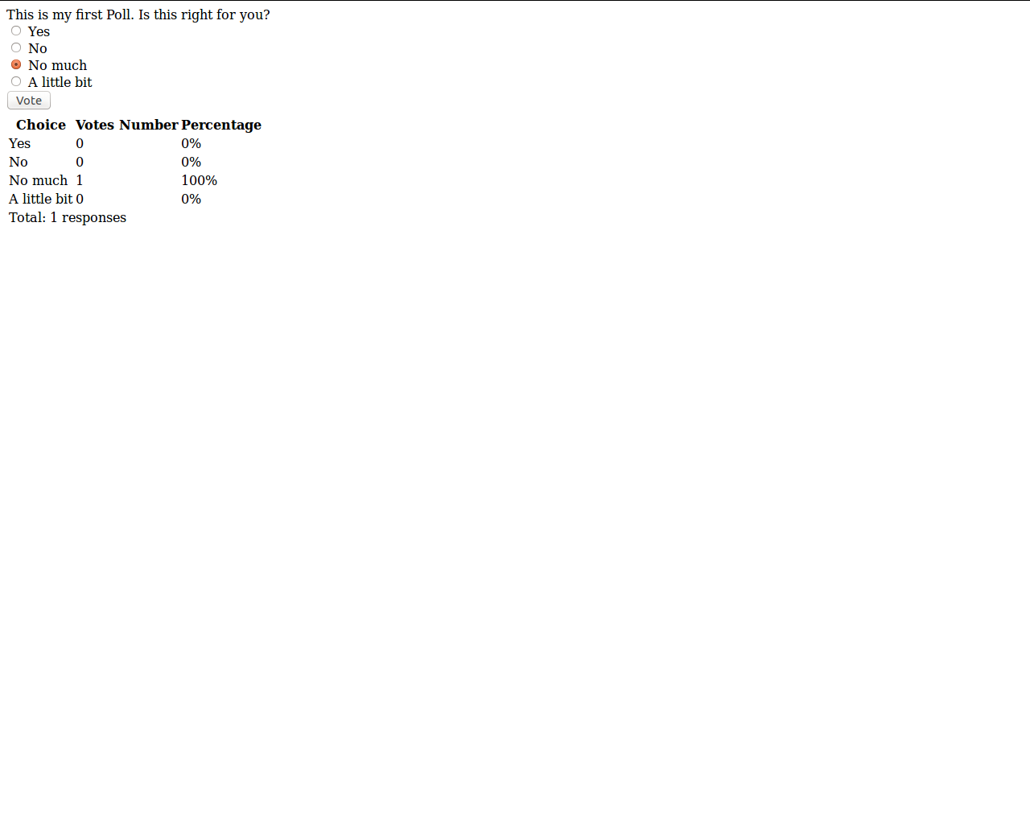
If we try to re-vote into the same session the system don't allow us.
CONFIGURATION
How we told before this plugin is compatible with the dotCMS 2.2.x version for one reason: the possibility to publish remotely a poll. In this way the configuration looks like very useful.
The plugin.properties has a several number of properties that allow us to use this plugin in every situation.
The plugin.remote.enabled property is used for this capability: if setted to false, than we don't see the publish remote icon into the polls list.

JOBS
There are 3 jobs, each one can be enabled or not. Let's explain their features:
- ExpiredPollsJob: search for all the polls that are expired and disables them. Into the polls list we can see the difference (the image is later into the document): if the plugin is into a remote environment (plugin.remote.enabled=true) than it tries to publish the expired poll ONLY if this poll exists on the receiver servers;
- GetVotesFromCSVJob: this job could be enabled only on sender servers and it is useful if, for example, we have cases where we can work only on sender servers and we use the receivers server for frontend only: in that cases we can't update the receivers and we need a mechanism for keep the votes stored on receivers and put all into the senders for example for statistical works;
- PutVotesIntoCSVJob: his job could be enabled only on receiver servers and it is useful if, for example, we have cases where we can work only on sender servers and we use the receivers server for frontend only.
