

Negotiation Skills Training

Negotiation Skills
A Field Handbook

5-Day Trainee Companion to the 88-Slide Deck
Strategy · Empathy · Outcome

SAUDI POST
Strategy & Transformation
2026 · Workshop Edition

FOREWORD
From SPL Strategy & Transformation
Every commercial agreement SPL signs — with a customer, a supplier, or an internal stakeholder — leaves a margin on the table that most negotiators overlook. The research is consistent: across B2B contracts, negotiation skill drives an 8 to 12 percent swing in deal value. On a SAR 100 million procurement spend, that is SAR 8 to 12 million recovered or surrendered at the table. On a multi-year customer contract, it is the difference between a relationship that compounds and one that quietly erodes.
This handbook is the second of three deliverables commissioned by SPL's Strategy & Transformation sector for the 2026 Negotiation Skills program. The first is the 88-slide deck used in the five-day workshop. The third is the student handout — a fillable workbook that trainees carry through the sessions. This book sits between them: a narrative companion that explains why each slide matters, what the techniques look like in practice at SPL, and how the moves stack up across a real negotiation.
The book follows the workshop's five-day arc exactly. Chapter One lays the foundations — what negotiation really is, the three types, the four elements, and the three pillars. Chapter Two introduces the Thomas-Kilmann framework and the five styles. Chapter Three puts those styles to work in six live scenarios, then steps back to cover graphical models, anchoring, difficult counterparts, and the strategy triangle. Chapter Four — the longest — covers tactical empathy from Chris Voss, the five-stage timeline, the 80 percent preparation principle, SWOT, BATNA, ZOPA, anchoring tactics, mirroring and labeling, the accusation audit, the power of "No" and "That's Right," calibrated questions, defusing emotions, and closing. Chapter Five closes with body language, persuasion, Cialdini's six levers, objection handling, and the three goals of every negotiation.
Each chapter includes two or three original case studies set at SPL — scenarios the deck does not cover but that the field will recognize. The case studies are not parables; they are working examples of techniques in action, with the moves named and the outcomes shown.
Whether you attended the workshop or are reading it cold, this book serves as your recap and reinforcement. It stands alone — every concept is explained from first principles. Either way, the goal is the same: a fundamental skill for success in business and life.

HOW TO USE THIS BOOK
A Field Companion, not a Textbook
This is a field handbook, not a textbook. Read it with a pen in hand and a real negotiation in mind. The structure mirrors the five-day workshop, one chapter per day, but the book is also designed for dipping — each section stands on its own, and the case studies can be read in any order.

Three ways to read it
01 Cover to cover, in the five-day order. This is how trainees typically read it the week after the workshop — refreshing each day's concepts in sequence and reading the case studies for the first time.
02 By topic, using the table of contents. If you have a specific negotiation coming up — such as a price renegotiation, a difficult term, or a stalled deal — go straight to the relevant section. The case studies at the end of each chapter are indexed by the scenario type they address.
03 Start with case studies, then step back to the concepts. Each case study names the techniques it uses; if a technique is unfamiliar, jump back to the section that explains it. This is the fastest path from problem to playbook.

What you will find in each chapter
■ A chapter opener with a narrative hook — a short anecdote that grounds the concepts in a real SPL moment.
■ Six to ten sections explaining the deck's concepts in narrative prose, with recreated diagrams from the deck where they help.
■ Two or three original SPL case studies, each 500 to 800 words, showing the techniques applied end-to-end.
■ Callout boxes for definitions, key takeaways, and warnings.
■ A chapter close that restates the three big ideas and bridges to the next chapter.

What you will not find
■ Self-check questions or fill-in exercises. These live in the student handout — this book is the explanation, not the workbook.
■ Facilitator notes. Those live in the instructor guide. This book is for trainees.
■ Academic citations beyond the foundational sources (Thomas-Kilmann, Fisher-Ury, Voss, Cialdini, Mehrabian, Tversky-Kahneman). The reading list at the back points to the full literature.

A note on SPL specificity
The case studies are set at SPL, but the names, deal values, and outcomes are illustrative — they are composites drawn from common B2B negotiation patterns at Saudi Post, not descriptions of specific real negotiations. The techniques, however, are real and field-tested. Apply them within SPL's governance envelope: the DOA matrix, procurement approval thresholds, the contract review board, the code of conduct, and the audit trail. Every concession is documented. Every anchor is sourced. Every close signed within DOA.

Table of Contents
Three ways to read it 3
What you will find in each chapter 3
What you will not find 3
A note on SPL specificity 4
Chapter 1 10
Foundations of Negotiation 10
1.1 The Working Definition 11
1.2 Three Types of Negotiation 11
Distributive — dividing the pie 11
Integrative — expanding the pie 12
Mixed — claim then create 12
1.3 Four Elements of the Process 12
1.4 Negotiation vs. Bargaining 13
Bargaining — the souk, ends at the signature 13
Negotiation — the boardroom, starts at the signature 13
1.5 Three Strategic Axes — Price × Terms × Relationships 14
Price — the tactical axis 14
Terms — the hidden axis 14
Relationships — the compounding axis 15
1.6 Three Pillars — Information, Time, Power 15
Pillar I — Information 15
Pillar II — Time 16
Pillar III — Power 16
1.7 Why These Skills Matter at SPL 16
Case Study 1 — The Fuel Surcharge Standoff 17
Case Study 2 — The Postage Rate Pushback 18
Chapter 1 Close — The Program Thesis 19
Chapter 2 21
Styles & Scenarios 21
2.1 Four Outcome Styles 21
Win/Win — collaborative 22
Win/Lose — competitive 22
Lose/Win — accommodating 22
Lose/Lose — avoiding 23
2.2 Thomas-Kilmann — Two Dimensions, Five Styles 23
Dimension A — Assertiveness (Y-axis) 24
Dimension B — Cooperativeness (X-axis) 24
2.3 The Five Styles — When to Use Each 24
Competing — "take it or leave it" 24
Collaborating — "help me understand…" 24
Compromising — "let's split the difference" 24
Avoiding — "let me get back to you" 25
Accommodating — "whatever works for you" 25
2.4 There Is No 'Best' Style 25
2.5 The Video Example — Watch and Deconstruct 25
Q1 — Who is the stronger party? 26
Q2 — What negotiation style was used? 26
Case Study 3 — The Vendor's Friday Discount 26
Case Study 4 — The Internal Budget Fight 28
Chapter 2 Close — Choosing the Right Style 29
Chapter 3 30
Scenario Analysis & Strategy 30
3.1 Six Live Scenarios — The Field Drills 30
Scenario 1 — Procurement Review: "take it or leave it" 30
Scenario 2 — Client Meeting: "more flexible terms" 31
Scenario 3 — Deadlocked Deal: silence on both sides 31
Scenario 4 — Negotiating Prices: counter the anchor 31
Scenario 5 — Handling Difficult Terms: exclusive 24-month clause 31
Scenario 6 — Time Management: the Friday 4:55 PM demand 31
3.2 Graphical Models — Boundary and Flow 32
3.3 Anchoring — The First Number Wins 32
3.4 Difficult Counterparts — Read the Pattern, Not the Words 33
3.5 The Strategy Triangle — Goals Without Destroying the Relationship 34
Top vertex — your goals 35
Bottom-left — their interests 35
Bottom-right — the relationship 35
3.6 Four Outcome Models — Value × Relationship 35
Case Study 5 — The SaaS Auto-Renewal Trap 36
Case Study 6 — The Last-Minute Demand 37
Chapter 3 Close — Choosing the Right Style Determines the Outcome 39
Chapter 4 40
Stages, Preparation & Voss Techniques 40
4.1 Tactical Empathy — Chris Voss and the FBI Playbook 40
4.2 Active Listening — Reactive vs Active 41
4.3 Mirroring and Labeling — Two Repeatable Techniques 42
Mirroring — repeat the last 1 to 3 words 42
Labeling — name the emotion 42
4.4 The Accusation Audit — Pre-empt the Attack 43
4.5 The Five Stages — Preparation Is 80% of the Outcome 43
Stage 1 — Preparation (pre-meeting) 44
Stage 2 — Opening (first 10 minutes) 44
Stage 3 — Bargaining (bulk of session) 44
Stage 4 — Closing (last 10 minutes) 44
Stage 5 — Implementation (post-meeting) 45
4.6 SWOT — Know Your Position Before You Negotiate 45
4.7 Market Information — Three Buckets 46
Bucket 1 — Other Party 46
Bucket 2 — Competitors 46
Bucket 3 — Market 46
4.8 Setting Goals — Three Tiers 46
Tier 1 — Ideal (+15%) 47
Tier 2 — Realistic (±0%) 47
Tier 3 — Walk-away (−10%) 47
4.9 BATNA — Your Real Fallback 47
Three-step workflow 48
4.10 ZOPA — Zone of Possible Agreement 48
Worked example — when no deal is the right outcome 49
ZOPA chart — when a deal is possible 49
4.11 The Power of 'No' and 'That's Right' 50
The Power of 'No' 50
The Power of 'That's Right' 50
4.12 Calibrated Questions — How and What, Never Why 50
Three workhorses 51
Three application scenarios 51
4.13 Defusing Emotions and Closing the Deal 52
Defusing emotions 52
Closing the deal 52
Case Study 7 — The Delivery Slip Escalation 52
Case Study 8 — The Walk-Away That Wasn't 54
Chapter 4 Close — Preparation Is 80% of the Outcome 55
Chapter 5 57
Body Language, Persuasion & Close 57
5.1 Body Language — The 7-38-55 Rule 57
7% — Words 58
38% — Tone of Voice 58
55% — Body Language 58
5.2 Dealing with Difficult People 59
5.3 Persuasion vs Manipulation — and the Orange Story 59
The Orange Story 59
5.4 Cialdini's Six Principles of Persuasion 60
Lever 1 — Reciprocity (90) 61
Lever 2 — Scarcity (85) 61
Lever 3 — Liking (80) 61
Lever 4 — Social Proof (75) 61
Lever 5 — Authority (70) 61
Lever 6 — Consistency (65) 61
5.5 Handling Objections — Feel · Felt · Found 62
Step 1 — Feel 62
Step 2 — Felt 62
Step 3 — Found 62
5.6 Explore Before You Respond — and the Three Goals 62
Three goals for every negotiation 63
5.7 Closing the Negotiation — Recap · Write · Sign 63
Case Study 9 — The Three-Year Framework Agreement 63
Case Study 10 — The Difficult Director 66
Chapter 5 Close — Prepare · Empathize · Close 67
Volume 01 — Foundational (read first) 69
1. Never Split the Difference · Chris Voss · 2016 69
2. The Art of Negotiation · Michael Wheeler · 2013 69
Volume 02 — Strategic (read last) 69
3. Bargaining for Advantage · G. Richard Shell · 1999 69
4. Influence: The Psychology of Persuasion · Robert Cialdini · 1984 (revised 2006) 70
Volume 03 — Foundational Source 70
5. Getting to Yes · Roger Fisher & William Ury · 1981 (3rd edition 2011) 70
Volume 04 — The Science 70
6. Thinking, Fast and Slow · Daniel Kahneman · 2011 70
Program structure 72
Sources 72
SPL governance 73

Chapter 1

Foundations of Negotiation
An SPL procurement manager — call him Faisal — walks into a renegotiation with a strategic supplier. He has prepared for the price. He has not prepared for the relationship. The supplier opens with a 6 percent increase, holds firm, and refuses to justify the figure. Faisal matches the assertiveness, argues the facts, and walks out with a 4 percent increase and a supplier who will be slow to return his calls for the next six months. Faisal is competent. Faisal is also unprepared for two-thirds of what negotiation actually is.
This chapter builds the shared vocabulary that every later chapter assumes. Six concepts: what negotiation really is, the three types, the four elements, the difference from bargaining, the three strategic axes, and the three pillars. By the end of the chapter, you should be able to look at any upcoming negotiation at SPL, name its type, list its four elements, identify which pillar will decide the outcome, and explain why winning on price alone is tactical, not strategic.

1.1 The Working Definition
Most people, when asked to define negotiation, will say something about getting the best price. The definition used throughout this program is narrower and more useful:
WORKING DEFINITION · USED THROUGHOUT THIS PROGRAM
An interactive process for reaching agreement on a specific issue through mutual concessions.
Two words do the heavy lifting. Interactive means a two-way exchange — offers, reasoning, and concessions flow both ways. A one-sided extraction is not negotiation; it is an ultimatum. Mutual concessions mean both sides give something. If only one side concedes, the deal may close, but the relationship will not survive it — and at SPL, where the same suppliers and customers come back deal after deal, the relationship is the portfolio.
The definition is deliberately narrow. It excludes pure bargaining (price-only haggling that ends at the signature) and pure accommodation (yielding to preserve goodwill, which is not negotiation but capitulation). It also excludes manipulation — one-sided gain disguised as mutual concession — which we will address separately in Chapter Five. What it includes is every meaningful commercial conversation at SPL where both sides have something to give and something to want.

1.2 Three Types of Negotiation
Not every negotiation is the same shape. The deck identifies three types, and the type you are in determines the moves available. Mismatch the type to the stakes, and you will leave value on the table — or burn a relationship for a one-time win.

Distributive — dividing the pie
Distributive negotiation is zero-sum. The value is fixed; one winner takes more, the other takes less. The classic image is the souk — the price is the only variable, the relationship does not survive the deal, and the negotiation ends at the signature. Distributive moves have a place: one-off transactions where you will never see the counterparty again, surplus disposal, spot purchases. But at SPL, where most supplier and customer relationships outlive any single deal, distributive negotiation is the exception, not the rule.

Integrative — expanding the pie
Integrative negotiation is about value creation. Both sides gain because the negotiation expands the pie rather than dividing it. The classic image is the boardroom — all agreement terms are on the table (price, payment, scope, term, SLAs, termination), the relationship outlasts the deal, and the negotiation starts at the signature. Integrative moves require trust, time, and the discipline to surface interests rather than positions. They are the right choice for any strategic SPL relationship.

Mixed — claim then create
Mixed negotiation is the real-world default. Both dynamics are at play — you claim value first (distributive), then create more (integrative). Most B2B deals at SPL fall into this category. In a logistics contract renegotiation, you claim on the fuel-surcharge line item, then create by bundling last-mile delivery with returns processing. In a customer contract, you claim on the rate card, then create by extending the term in exchange for volume commitments. Mixed negotiation requires fluency in both modes — and wisdom to know which mode you are in at any given moment.

1.3 Four Elements of the Process
Before any negotiation can begin, four elements must be present. If any is missing, you are not actually negotiating — you are just talking, posturing, or extracting. The four elements are parties, subjects, interests, and communication.

Parties
.
Subjects
Interests
.
Communication
.

Figure 1.1 — The four elements. All four must be present before negotiation can begin.
01 Parties — two or more actors with the authority to decide and commit their organization. If the person across the table cannot sign, you are not negotiating; you are briefing.
02 Subject — a clearly defined issue on the table. What is being decided, by when, with what scope. Vague subjects produce vague deals — and vague deals drift.
03 Interests — the underlying needs behind stated positions, not just the numbers being quoted. The customer says they want a 10 percent discount; their interest may be cash-flow timing. The supplier says they need a 24-month term; their interest may be capacity predictability.
04 Communication — a live channel through which offers, reasoning, and concessions flow. Email is a communication channel; so is a 30-minute video call. A one-way PowerPoint presentation is not.
The discipline is to verify all four before you walk in. If the person across the table cannot sign, escalate or reschedule. If the subject is vague, send a one-page agenda in advance. If you do not know their interests, surface them with calibrated questions (Chapter Four). If the channel is wrong, change it. A deal that needs three rounds of bargaining should not be done over email.

1.4 Negotiation vs. Bargaining
The two words are used interchangeably in casual speech. In this program, they are not the same thing, and confusing them can cost relationships. The distinction is not academic — it determines whether the deal you close today will still be honored in eighteen months.

Bargaining — the souk ends at the signature
Bargaining is transactional. It focuses only on price. It has a short-term orientation. It is transaction-based. The image is the souk — the negotiation ends at the signature, and the relationship, such as it was, ends with it. Bargaining has a place: spot purchases, one-off transactions, surplus disposal. It has no place in strategic SPL relationships.

Negotiation — the boardroom, starts at the signature
Negotiation is relational. It covers all agreement terms — price, payment, scope, SLAs, change orders, and termination. It builds relationships. It is outcome-based. The image is the boardroom — the negotiation starts at the signature because the relationship that produced the deal is the one that will deliver it. Negotiation is the right mode for any SPL deal where the counterparty will be back.
STRATEGIC VERDICT
Bargaining ends at the signature. Negotiation starts at the signature. Confusing them costs relationships — and at SPL, the relationship is the portfolio.

1.5 Three Strategic Axes — Price × Terms × Relationships

Successful negotiation requires a strategy covering three axes: price, terms, and relationships. Winning on price alone is tactical, not strategic. The three axes are not equally weighted, and the weight shifts with the deal.
Figure 1.2 — The three strategic axes. Optimize all three; never one at the expense of the others.

Price — the tactical axis
Price is the number on the invoice — what you pay or charge per unit, per month, or per year. It is tactical, easily benchmarked, and the axis most negotiators over-invest in. Price matters; it is not the only thing that matters. A 3 percent price win on a contract with onerous payment terms may cost more than the price saved.

Terms — the hidden axis
Terms are everything in the contract that is not the price: payment terms, delivery SLAs, scope boundaries, change-order rules, termination rights, IP ownership, liability caps, and indemnities. Terms shape the deal's real cost over its life. A 5 percent price discount, paired with a 90-day payment term (instead of 60), is a price increase disguised as a concession. At SPL, where contracts run three to five years on average, terms hide more value than price reveals.

Relationships — the compounding axis
Relationships are built on trust, repeat business, references, and escalation paths. A strong relationship compounds across deals — the supplier who trusts you gives you the early-warning call when their costs are about to rise; the customer who trusts you gives you the renewal at the original terms. A burned relationship costs the next ten deals. At SPL, where the supplier and customer base is concentrated, and reputations travel, the relationship axis is the most undervalued and the most expensive to neglect.
STRATEGIC VERDICT
Strategy = Price × Terms × Relationships. Optimize all three; never one at the expense of the others. Winning on price alone is tactical, not strategic.

1.6 Three Pillars — Information, Time, Power
Beneath the three axes sit three asymmetric forces every negotiator leverages: information, time, and power. They are asymmetric because the side that holds more of any one gains disproportionate advantage — and the side that neglects any one loses the table.
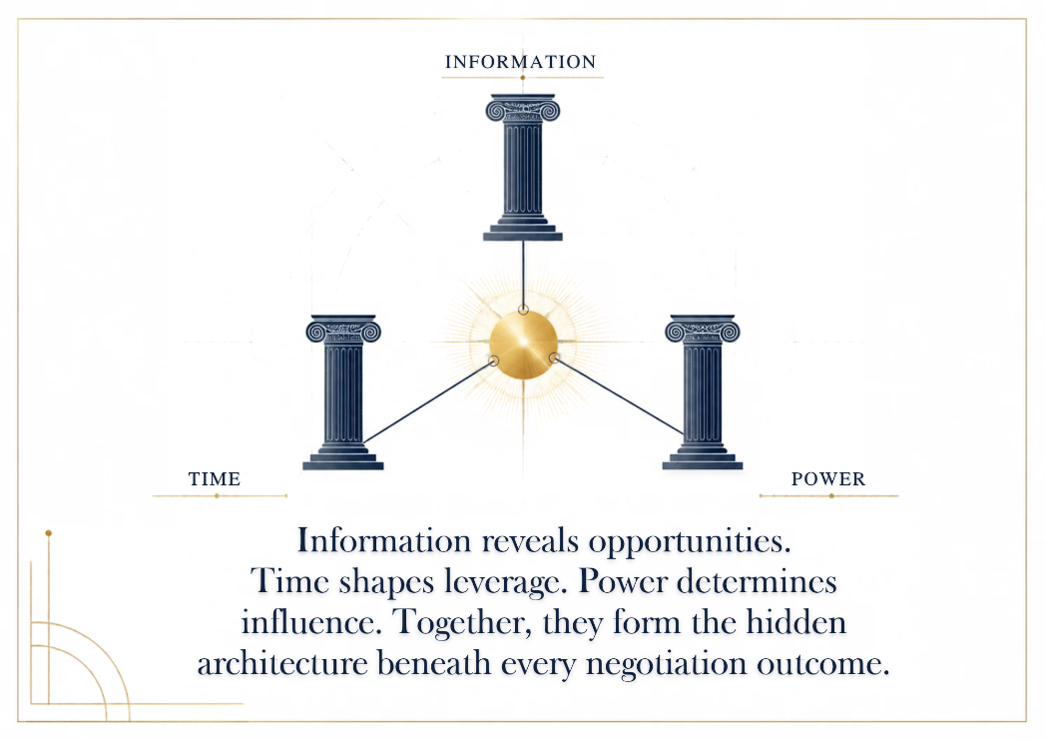

Figure 1.3 — The three pillars. Leverage all three. Neglect one, lose the table.

Pillar I — Information
The side that knows more decides more. Map their quarter-end (when do they need this signed?), their BATNA (what is their real fallback?), their boss (who signs, who pushes, who is incentivized?), and their alternatives (who else are they talking to?). Knowledge asymmetry is the cheapest leverage you can buy — it costs only homework. The homework is rarely done, which is why it is so cheap.

Pillar II — Time
Deadlines force concessions — usually yours. The discipline is to surface the other side's deadline ("When do you need this signed?") and protect your own. Whoever needs the deal signed first loses. A deadline is a number with a cost; that cost is paid in concessions, and the side that hides its deadline pays the least.

Pillar III — Power
Power is perceived leverage, not actual leverage. Authority, alternatives, and reputation combine to form the power you project at the table. The projection matters as much as the substance: a negotiator who believes they have no power will concede as if they have none, regardless of their actual position. Power is a story both sides tell themselves — make sure your story is at least as good as theirs.
LEVERAGE ALL THREE
Information × Time × Power. Neglect one, lose the table. Most negotiators prepare one (usually price). The negotiators who win prepare for all three.

1.7 Why These Skills Matter at SPL
Negotiation skills are the highest-leverage soft skills in business. Empirical findings, replicated across studies, show an 8 to 12 percent swing in deal value attributable to negotiation skills in B2B contracts, controlling for industry and deal size. For SPL, that translates directly: on SAR 100 million of annual procurement spend, an 8 to 12 percent swing is SAR 8 to 12 million recovered or surrendered at the table every year. On the customer side, the same swing applies to revenue retained or eroded.
Three outcomes make the case. First, goal capture — achieving your goals on the best terms, securing scope and SLAs that move the business case from acceptable to advantageous. Second, margin protect — reducing procurement costs and protecting pricing on customer contracts, with every concession priced and never given. Third, relational equity — building sustainable relationships that compound across the next ten deals. The three outcomes are not independent; they reinforce each other. Goal capture without margin protect is a discount. Margin protect without relational equity is a burn. Relational equity without goal capture is a friendship.
The program's thesis is simple: it is a fundamental skill for success in business and life. The rest of this book is the working-out of that thesis over five days.

Case Study 1 — The Fuel Surcharge Standoff
CASE STUDY
The Fuel Surcharge Standoff
An SPL procurement manager renegotiates a 3-year logistics contract when fuel costs spike 18%.
Faisal has served as SPL's procurement manager for national logistics contracts for four years. The contract with the incumbent carrier — call them NationalLogistics — is up for renewal. Fuel costs have risen 18 percent since the contract was signed. NationalLogistics has been reliable: 98.7 percent on-time delivery, no lost-shipment incidents in three years, and a relationship that has absorbed two scope changes without complaint. Two competitors have submitted bids 7 percent below NationalLogistics's current rate.
Faisal's first instinct is to bargain — push NationalLogistics to match the competitor bids or walk. He prepares his price case: the competitor quotes, the fuel-cost delta, the market rate. He walks into the renegotiation with NationalLogistics's account director and opens with: "We have two bids 7 percent below your current rate. We need you to match."
The account director does not blink. "Our rate reflects a 98.7 percent on-time delivery record. The competitors you're quoting cannot match that — and you know it. We will hold our rate."
Faisal is at a fork. He can escalate (match Competing with Competing — assertive, distributive, likely to burn the relationship). He can yield (accept the incumbent's rate — accommodating, leaves 7 percent on the table). Or he can apply what this chapter taught him: identify the type, verify the elements, work the three axes, leverage the three pillars.
He chooses the third path. The type is Mixed — there is distributive value to claim (the 7 percent) and integrative value to create (the relationship). The four elements are present: parties (both can sign), subject (the renewal), interests (NationalLogistics wants capacity predictability; Faisal wants cost discipline), communication (face-to-face). The three axes: price is the headline number, but terms (the SLA, the scope, the term length) and relationship (three years of reliable delivery) are both in play.
Faisal reframes. "I hear you on the on-time record — that's why we're talking about renewal and not transition. Let me ask: if we extended the term from three years to five, and locked in a volume commitment of plus-10 percent, what would that do to your rate?"
The account director pauses. A five-year term with a volume commitment is capacity predictability — NationalLogistics's underlying interest. She comes back with a 4 percent reduction on the base rate, a fuel-surcharge cap at 12 percent (below the current 18 percent spike), and a 24-month price lock. Faisal accepts.
The outcome: a 4 percent price reduction (not the 7 percent Faisal opened with), a fuel-surcharge cap that protects SPL from further spikes, a 24-month price lock, and a five-year relationship with a reliable supplier. The hidden teaching point — the one Faisal nearly missed — is that reliability has a dollar value. The 7 percent the competitors offered was real, but it bought a 95 percent on-time delivery risk that SPL's operations could not absorb. The 4 percent Faisal accepted bought 98.7 percent certainty plus a fuel cap.
The lesson: identify the type (Mixed), verify the elements, work the axes (not just price), leverage the pillars (Faisal used Information — he knew NationalLogistics's capacity-predictability interest — and Time — he offered a longer term in exchange for a price lock). Bargaining would have left 4 percent on the table or burned the relationship. Negotiation captured both.

Case Study 2 — The Postage Rate Pushback
CASE STUDY
The Postage Rate Pushback
An SPL customer success manager handles a customer threatening to move to a competitor over a rate increase.
Lina oversees customer success for SPL's enterprise parcel accounts. One of her largest customers — a national e-commerce retailer — receives the annual rate increase notice: 6 percent, in line with the market. Within an hour, the customer's procurement director emails Lina: "This is unacceptable. We're getting quotes from [competitor]. Match last year's rate or we transition in 90 days."
Lina's first instinct is defensive — the rate increase is justified, fuel and labor costs are up, and the customer has had three years of stable pricing. She drafts a reply listing the justifications. Then she remembers Chapter One: bargaining ends at the signature, negotiation starts at it. The customer's stated position is "match last year's rate." Their interest is almost certainly not the 6 percent — it is budget predictability. The procurement director has a number in her own budget for next year, and the increase blows it.
Lina picks up the phone instead of replying by email. She opens with a label: "It sounds like this increase has put you under real pressure with your own budget cycle." Silence. The procurement director — primed for a fight — pauses, then says: "Yes. My CFO approved a 2 percent increase. Six is not something I can take back to him."
Now Lina knows the real interest: the customer's internal budget is set at plus-2 percent. The 6 percent market rate is not the issue; the 4-point gap is. Lina has several moves. She can hold at 6 (Competing — burns the relationship). She can match last year's rate (Accommodating — leaves 6 percent on the table). Or she can trade: a 2 percent increase (matching the customers’ budget) in exchange for a 24-month price lock and a volume commitment.
She offers the trade. "I can't match last year's rate — the cost base genuinely doesn't allow it. But I can do 2 percent this year, locked for 24 months, if you commit to a 15 percent volume increase. That gives your CFO the budget number he approved, and it gives us the volume to absorb the 4-point gap."
The procurement director takes the offer to her CFO. The CFO accepts — 2 percent is what he approved, the 24-month lock removes next year's budget risk, and the volume commitment is consistent with the retailer's growth plan. The deal closes at 2 percent, not 6 — but Lina has bought two years of price stability and a deeper volume relationship, where the alternative was a 90-day transition to a competitor and the loss of a strategic account.
The lesson: surface interests, not positions. The customer's position was "match last year's rate." Their interest was "stay within an internal plus-2 budget." Bargaining on the position would have cost the account. Negotiating on the interest saved it — and locked in two years of revenue.

Chapter 1 Close — The Program Thesis
Three big ideas from this chapter. First, the working definition: negotiation is an interactive process aimed at reaching an agreement on a specific issue through mutual concessions — interactive and mutual are the load-bearing words. Second, the three types: distributive (divide the pie), integrative (expand it), and mixed (claim then create — most B2B at SPL). Third, the three pillars: information (knows more, decides more), time (deadlines force concessions, usually yours), and power (perceived leverage drives outcomes).
The program's thesis — the line that closes the deck's first chapter — is this: it is a fundamental skill for success in business and life. The next four chapters work out that thesis. Day Two introduces the Thomas-Kilmann framework and its five styles. Day Three puts those styles to work in six live scenarios. Day Four adds preparation discipline and Chris Voss's tactical empathy. Day Five closes with body language, persuasion, and the close.
“Negotiation is a fundamental skill for success in business and life.” — Program Thesis

Chapter 2

Styles & Scenarios
An SPL account manager — call her Sara — has defaulted to one style for two years. When a customer pushes back on price, she accommodates. When a supplier tightens terms, she accommodates. When an internal stakeholder escalates, she accommodates. The result: 14 deals closed in 24 months, all signed, all below margin target, and a quiet erosion of the relationship capital she thought she was building. Sara is not weak. She is using the wrong default.
This chapter introduces the Thomas-Kilmann framework — five negotiation styles plotted along two dimensions (assertiveness and cooperativeness). The framework's most useful property is not the five styles but the principle behind them: there is no single best style. The right style depends on the situation and the importance of the relationship. Sara's mistake was not accommodation per se; it was making accommodation the default. By the end of this chapter, you should be able to name the style you are using in any negotiation, identify the style being used against you, and choose the right style for the stakes.

2.1 Four Outcome Styles
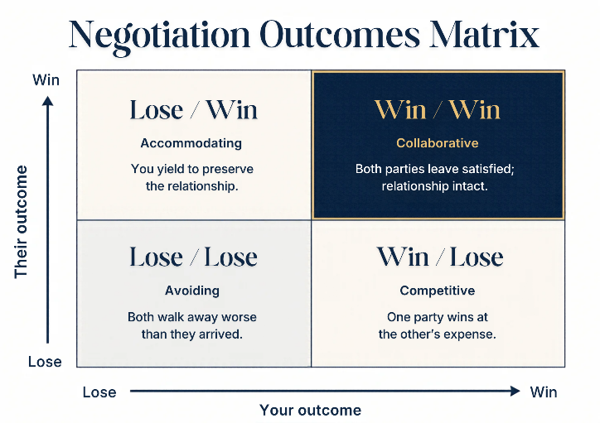
Before the five styles, the four outcomes. Every negotiation ends in one of four quadrants — your outcome × their outcome. The quadrants are not equally desirable, and naming the one you are heading for is the first move of strategic negotiation.

Figure 2.1 — The four outcome quadrants. Every negotiation ends in one of these.

Win/Win — collaborative
Both parties leave satisfied; the relationship remains intact. This is the integrative outcome — the pie was expanded, both sides gained, and the deal will hold. Win/Win is the right target for any strategic SPL relationship where the counterparty will return. It is also the hardest outcome to engineer; it requires surfacing interests, trading across axes, and the discipline to walk away from a Win/Lose that would pay more in the short term.

Win/Lose — competitive
One party wins at the other's expense. This is the distributive outcome — the pie was divided, and one side took more. Win/Lose has a place: in one-off transactions where the relationship does not survive the deal. It is the wrong outcome for any SPL strategic relationship, because the relationship's long-term costs outweigh the short-term win. The deck's word for this outcome is Pyrrhic — the deal closes, the relationship burns.

Lose/Win — accommodating
You yield to preserve the relationship. This is Sara's default. Lose/Win is sometimes the right choice — when the relationship matters more than this single deal, when you are buying goodwill for a future negotiation, or when the cost of the negotiation itself exceeds the value at stake. But making Lose/Win the default concedes leverage deal after deal, and the leverage you concede compounds against you.

Lose/Lose — avoiding
Both walk away worse than when they arrived. Lose/Lose is the ego outcome — the deal collapses, both sides lose the value they were negotiating over, and the relationship is damaged. The most common Lose/Lose at SPL is an internal negotiation that escalates to a senior leader who imposes a solution neither side wanted. Avoid Lose/Lose by walking away early (Avoiding as a style is not the same as Lose/Lose as an outcome) — but if you do walk, walk clean.

2.2 Thomas-Kilmann — Two Dimensions, Five Styles
The Thomas-Kilmann framework, developed by Kenneth Thomas and Ralph Kilmann in 1974, plots five negotiation styles along two dimensions: assertiveness (how hard you push for your own interests) and cooperativeness (how hard you work for theirs). The framework is fifty years old because it works — it gives negotiators a vocabulary for the moves they already make and a map for the moves they should make instead.
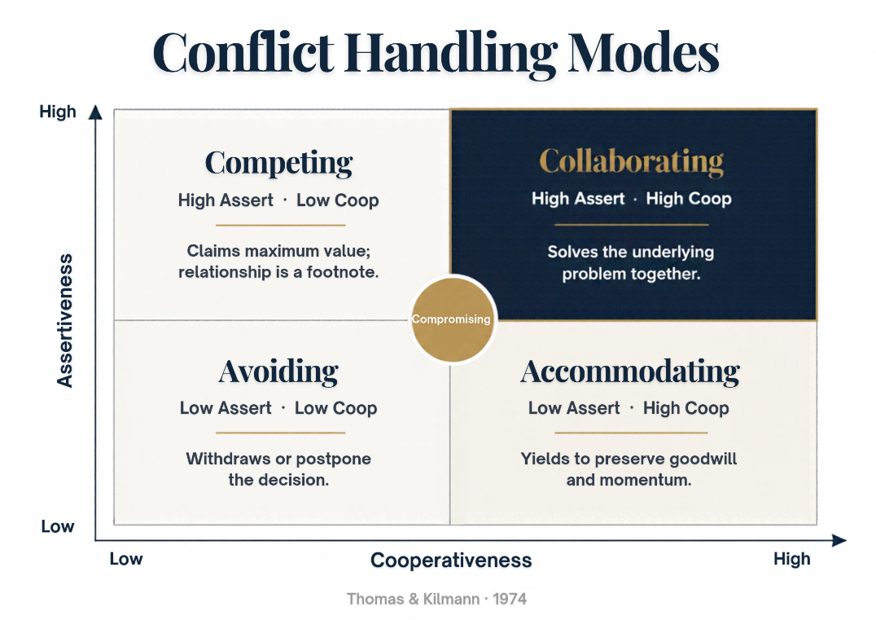
Figure 2.2 — The Thomas-Kilmann Style Matrix. Assertiveness × Cooperativeness. Five styles, four quadrants.
The two axes are independent. You can be high on assertiveness and low on cooperativeness (Competing), high on both (Collaborating), low on both (Avoiding), or low on assertiveness and high on cooperativeness (Accommodating). The middle of the matrix is Compromising — moderate on both axes, splitting the difference. The framework does not rank the styles. It maps them. The right style fits the situation.

Dimension A — Assertiveness (Y-axis)
Assertiveness is how hard you push for your own interests. High assertiveness: you stake your position and hold firm. Low assertiveness: you let the other side set the agenda. Assertiveness is not aggressiveness — a quiet negotiator can be highly assertive simply by holding the line. The assertive move is the one that says: this is what I need, and I will not concede it without something in return.

Dimension B — Cooperativeness (X-axis)
Cooperativeness is how hard you work for the other party's interests. High cooperativeness: you trade and create, seeking moves that benefit both sides. Low cooperativeness: you claim and hold, treating the negotiation as zero-sum. Cooperativeness is not a weakness. A high-cooperation negotiator can be highly assertive (Collaborating is high on both). The cooperative move says: I am willing to give if I get.

2.3 The Five Styles — When to Use Each
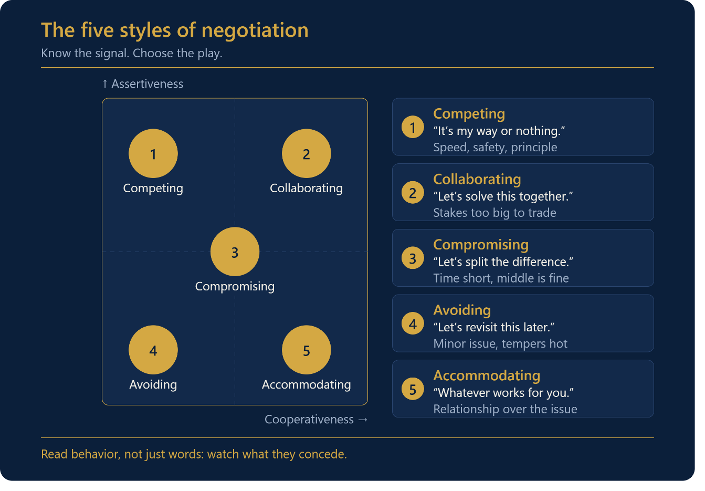
Each of the five styles has a canonical signal — a phrase that, when you hear it, tells you which style is in play. Learning these signals is the fastest way to recognize the style being used against you.

Competing — "take it or leave it"
Assertive and uncooperative. Competing for maximum value; the relationship is a footnote. Use it when the deal is one-off and the relationship does not matter — surplus disposal, spot purchases, last-resort deadlines. Avoid it for any strategic SPL relationship. The signal is the ultimatum: "This is our final offer." The countermove is in Chapter Three.

Collaborating — "help me understand…"
Assertive and cooperative. Collaborating solves the underlying problem together — both sides gain, and the relationship remains intact or is strengthened. Use it when both the stakes and the relationship are high — for strategic supplier renewals, key customer contracts, and internal cross-functional deals. The signal is the question: "Help me understand what's behind that." Collaborating takes time; it is the wrong style when speed matters more than optimality.

Compromising — "let's split the difference"
Moderate on both axes. Compromising splits the difference — both sides give up something to reach agreement. Use it when speed matters more than optimality, when the relationship is incidental, or when the negotiation is small. The signal is the proposal: "Let's meet in the middle." Compromising is the right default for low-stakes, high-volume negotiations; it is the wrong default for strategic ones.

Avoiding — "let me get back to you"
Unassertive, uncooperative. Avoiding means postponing or withdrawing — you do not engage. Use it when the cost of negotiating exceeds the value of the deal, when you need more information, or when emotions are too high for productive talk. The signal is the deflection: "Let me get back to you on that." Avoiding is not losing — sometimes the right outcome is no deal, and Avoiding is the style that gets you there cleanly.

Accommodating — "whatever works for you"
Unassertive, cooperative. Accommodating yields to build goodwill — you concede to preserve the relationship. Use it when the relationship matters more than this single deal, when you are buying goodwill for a future negotiation, or when you are wrong and need to acknowledge it. The signal is the concession: "Whatever works for you." Accommodating as a default concedes leverage; Accommodating as a choice builds it.

2.4 There Is No 'Best' Style
The principle that gives the framework its power: there is no single best style. The right style depends on the situation and the importance of the relationship. The deck distills routing into three rules.
THREE ROUTING RULES
High stakes + long relationship → Collaborate. The deal matters, and the counterparty will be back. Invest the time.
Low stakes + speed → Compromise. The deal is small, and the relationship is incidental. Find a number both parties can live with.
No deal is better than a bad deal → Avoid. The floor is breached; the terms are unacceptable. Walking away is the strategic move.
The three rules cover most routing decisions. The exceptions are deals that fall between the rules — moderate stakes with a moderate relationship, or speed with a strategic counterparty. For those, the principle is the same: pick the style that fits the situation, not the one that fits your default. Sara's mistake was not that she accommodated; it was that she accommodated every time. The cure is not to stop accommodating — it is to add the other four styles to the repertoire and choose.

2.5 The Video Example — Watch and Deconstruct
The workshop includes a three-minute video clip of a negotiation. The video is not a model — it is a case. Trainees watch it once with three observation prompts: power dynamics (who controls the clock, the agenda, and the alternatives?), style in use (where do they sit on the TK matrix?), and tactics (what specific moves do you see — anchoring, mirroring, silence, concessions?). After the viewing, the group deconstructs it using two questions.

Q1 — Who is the stronger party?
Hint: power is rarely the louder voice. The louder party is often the weaker one — volume is a tell that they have run out of substantive moves. Stronger ≠ louder. Stronger = willing to walk. The party that can credibly walk away holds the power, regardless of who is doing the talking. Watch the video to see who sets the agenda, who controls the timing, and who has the better alternative if the deal collapses.

Q2 — What negotiation style was used?
Name it on the TK matrix. Choose from Competing, Collaborating, Compromising, Avoiding, or Accommodating. The naming matters because it forces precision — "they were difficult" is not a style; "they were Competing" is. Once you have named the style, you can choose the counter-move from Chapter Three's scenario library.
The video drill builds the pattern-recognition muscle that separates experienced negotiators from beginners. Beginners see each negotiation as a unique event. Experienced negotiators see patterns — and patterns have countermoves. The six scenarios in Chapter Three are the most common patterns; the video is the practice.

Case Study 3 — The Vendor's Friday Discount
CASE STUDY
The Vendor's Friday Discount
A supplier offers a 3% discount if SPL signs by Friday; the price is 12% above market.
Khalid, an SPL procurement specialist, is finalizing a parts contract. The supplier's account manager — call him Tariq — calls on Wednesday afternoon: "I can give you a 3 percent discount if you sign by Friday. After that, the offer's off the table." Khalid needs the parts; the lead time on alternatives is six weeks. But the supplier's price is 12 percent above market, and the 3 percent discount barely dents the gap.
Khalid's first instinct is to be flattered — Tariq is offering him something. His second instinct is to be suspicious — why the Friday deadline? Then he remembers the framework. He names the style: Tariq is Competing. The signal is the ultimatum ("after that, the offer's off the table"). Competing against Competing would escalate — Khalid would counter with his own ultimatum, and the negotiation would either collapse or close at a price Khalid does not want.
Khalid thinks about the routing rules. Stakes: moderate — the parts matter, but the contract is not strategic. Relationship: incidental — Tariq's firm is one of three suppliers Khalid could use, and the relationship does not need to outlast this deal. The right style is not Competing (escalates) and not Accommodating (concedes 9 percent above market). The right style is Compromising — low stakes, speed matters. But Compromising does not mean splitting the difference between Tariq's discounted price and the market price. It means finding a number both can live with, on terms that work for both.
Khalid makes his counter-move. "Tariq, I appreciate the discount. But 3 percent off a price that's 12 percent above market still leaves us 9 percent over. I can sign by Friday — but not at that price. Here's what I can do: I'll commit to a 12-month term and a volume of 10,000 units, in exchange for a price at market plus 2 percent. That's a 10-point move from where you are, and it gives you a year of locked-in volume."
Tariq pauses. The Friday deadline was a sales tactic — quarter-end pressure, not a real cutoff. The 12-month term and the volume commitment are real value to his firm. He comes back with market plus 4 percent, 12-month term, 8,000 units. Khalid accepts. The deal closes Friday at market plus 4 percent—8 points below Tariq's opening, 4 points above market —with a 12-month lock.
The lesson: matching style with style escalates; matching style with situation de-escalates. Tariq opened with Competing. Khalid did not match — he routed to Compromising (the right style for the stakes) and made a counteroffer that gave Tariq something real (term and volume) in exchange for the price move. If Khalid had matched Competing with Competing, the negotiation would have collapsed. If he had Accommodated, SPL would have paid 9 percent above market. The right style won the deal.

Case Study 4 — The Internal Budget Fight
CASE STUDY
The Internal Budget Fight
SPL IT vs Finance on a software renewal — Finance wants a 15% cut, IT wants to renew at current terms.
Reem runs IT portfolio management at SPL. The enterprise software contract — with the vendor SoftCorp — is up for renewal. SoftCorp's offer: same price as last year, a three-year term, auto-renewal. Reem wants to sign. Hossam, SPL's Finance business partner for IT, blocks the renewal: "Budget is cut 15 per cent across IT software spend. Either SoftCorp reduces by 15, or we transition to a competitor."
Reem's first instinct is to argue the facts — the competitor's product is weaker, the transition cost is significant, the 15 per cent cut is unrealistic. Hossam's first instinct is to hold the line — Finance has set the budget, and IT needs to live within it. Both are about to enter a Lose/Lose: the negotiation escalates to the CFO, who imposes a solution neither wants.
Reem recognizes the pattern. This is an internal negotiation — it feels lower-stakes than an external deal, but it is not. The relationship (Reem and Hossam will work together for years) is high-stakes, and the outcome (the software SPL runs on for the next three years) is high-stakes. The right style is Collaborating — high stakes, long relationship. Reem stops arguing the facts and starts surfacing interests.
"Hossam, help me understand the 15 per cent. Is it a hard target, or is it a budget envelope that could flex if I can show cost predictability over a longer term?" Hossam, primed for a fight, pauses. "The CFO wants IT software spend flat or down for the next fiscal year. The 15 is the number that gets us there. If you can show me flat or down over three years instead of one, I can take that to her."
Now Reem knows the real interest: cost predictability over three years, not a 15 per cent cut in year one. She goes back to SoftCorp with a different ask: a 5 per cent reduction in year one, flat in years two and three, in exchange for a three-year commitment and a volume increase. SoftCorp agrees — the three-year lock is worth more to them than the 5 per cent, and the volume increase offsets it. Reem brings the deal back to Hossam: 5 percent down in year one (within the 15 percent target), flat for two more years (predictability), three-year term (lock).
Hossam takes it to the CFO. The CFO accepts — the deal meets the budget envelope over three years, even though it does not hit the 15 percent in year one. The renewal closes. The relationship between Reem and Hossam survives — they will work together on the next renewal without the scar tissue of an escalated fight.
The lesson: internal negotiations feel lower-stakes — they aren't. The same framework applies: identify the style, route by stakes and relationship, surface interests. Reem's Collaborating move ("help me understand the 15 percent") turned a budget fight into a budget conversation, and the conversation produced a deal both sides could sign.

Chapter 2 Close — Choosing the Right Style
Three big ideas from this chapter. First, the four outcomes: Win/Win (collaborative), Win/Lose (competitive, Pyrrhic), Lose/Win (accommodating, concedes leverage), and Lose/Lose (avoiding, ego over outcome). Second, the five Thomas-Kilmann styles: Competing (high assert/low coop), Collaborating (high/high), Compromising (med/med), Avoiding (low/low), and Accommodating (low/high). Third, the principle: there is no best style — the right style depends on the situation and the importance of the relationship.
The chapter takeaway is the line that closes the deck's second chapter: choosing the right style determines the outcome of the negotiation. Day Three puts that principle to work in six live scenarios — the patterns you will see most often at SPL and the counter-moves for each.
“Choosing the right style determines the outcome of the negotiation.” — Section 02 Conclusion

Chapter 3

Scenario Analysis & Strategy
An SPL supplier manager — call him Tariq — treated every negotiation as a price fight. Across 14 deals over two years, he pushed on price every time, conceded on price when he had to, and never surfaced any interest. The result: an average of 6 percent left on the table per deal, two suppliers who stopped returning his calls, and one customer who churned to a competitor offering the same price but with better terms. Tariq is not incompetent. He is pattern blind.
This chapter is the cure for pattern-blindness. It walks through six live scenarios — the patterns you will see most often at SPL — and the counter-moves for each. It then steps back to cover graphical models, anchoring, difficult counterparts, the strategy triangle, and the four outcome models. By the end of the chapter, you should be able to recognize each pattern within thirty seconds of seeing it, name the counter-move, and execute it.

3.1 Six Live Scenarios — The Field Drills
The six scenarios are the workshop's field drills. Each follows a pattern with a corresponding counter-move. Run the drills live: read the cue, identify the style or strategic read, and choose the counter-move. The case studies at the end of this chapter show how to apply the scenarios from start to finish.

Scenario 1 — Procurement Review: "take it or leave it"
The supplier rep says: "This is our final offer — take it or leave it." The strategic read: Competing. The signal is the ultimatum. The counter-move depends on your routing — if the relationship is incidental and you have a real alternative, walk. If the relationship matters or you do not have a real alternative, do not match Competing with Competing. Reframe with a calibrated question ("What would have to be true for us to find a number that works for both sides?") or introduce a new variable (volume, term, scope) to break the single-axis loop.

Scenario 2 — Client Meeting: "more flexible terms"
The client keeps pushing for "more flexible terms" but will not define what "flexible" means. The strategic read: the stated position is vague; the real interest is hidden. Three counter-moves. First, quantify "flexible" — ask for specific dimensions (payment terms? delivery SLA? scope-change rights? renewal?). Second, ask calibrated questions — "What would flexible look like in the contract clause?" Third, map stated versus real goals — the stated goal is flexibility, but the real goal may be cash-flow timing, risk transfer, or executive pressure. Surface the real goal and trade against it.

Scenario 3 — Deadlocked Deal: silence on both sides
A deal is stuck — both sides have stopped returning calls. The strategic read: the negotiation has hit a single-axis deadlock (usually price). Three counter-moves. First, reframe it as a joint problem — stop talking about "your price" versus "my price" and start talking about "how do we both make this work." Second, use "How do we…?" questions — calibrated questions hand the problem to the other side. Third, trade a small concession for momentum — offer one named, small concession paired with a request, and the deadlock breaks.

Scenario 4 — Negotiating Prices: counter the anchor
The seller opens at $120; your market ceiling is $95. The strategic read: the seller has anchored high, expecting you to negotiate down to $107 (which would feel like a win but is still 12 above your ceiling). Three counter-moves. First, anchor at $80 with logic — counter-anchor low by citing a comparable. The first reasoned number wins the range. Second, do not split the difference — splitting rewards the inflated anchor. Third, trade price for terms — concede on price only in exchange for a named term (volume, payment, length, scope).

Scenario 5 — Handling Difficult Terms: exclusive 24-month clause
The contract includes an exclusive 24-month clause you cannot accept. The strategic read: the term is unacceptable as written, but the underlying interest (the supplier wants commitment) is acceptable. Three counter-moves. First, isolate the term — pull it out of the bundle and negotiate it separately, never as part of a package deal. Second, offer a sunset clause — trade the 24 months for a shorter exclusivity window with a review point at 12. Third, trade exclusivity for volume — accept exclusivity only in exchange for a volume commitment from the counterparty.

Scenario 6 — Time Management: the Friday 4:55 PM demand
It is 4:55 PM on Friday. The other side just added a new demand. Strategic read: the demand is a pressure tactic meant to extract a concession when you are tired and want to leave. Three counter-moves. First, refuse to rush — name the dynamic ("I notice this just came in — I won't decide under time pressure"). Pacing is leadership, not delay. Second, schedule a follow-up — defer the new demand to Monday ("Let's park this and pick it up first thing Monday, fresh eyes"). Third, trade the new demand for a clock extension — conditional ("I'll consider this if we extend the closing to next Friday"). Turn the demand into leverage.

3.2 Graphical Models — Boundary and Flow
Before the techniques, two graphical models. The first model is the boundary — every negotiation has a start, a middle (where convergence happens), and an end. The boundary defines what is in scope and what is off the table for this round. Setting the boundary is the first move in every negotiation: "Today we're discussing the price and the term. Payment terms and SLAs we'll handle in the next round." A negotiator who lets the boundary drift ends up negotiating everything at once, which means negotiating nothing well.
The second model is the canonical four-phase flow: Open (frame the agenda, first 10 minutes), Bargain (trade concessions, the bulk of the session), Close (confirm terms, last 10 minutes), and Implement (deliver and review, post-meeting). Every negotiation follows this shape — from a five-minute price haggle to a nine-month enterprise contract. The discipline is knowing which phase you are in. Most negotiators skip Opening (they dive straight into Bargaining) and drift past Closing (they leave terms ambiguous). Both mistakes cost deals.

3.3 Anchoring — The First Number Wins
Anchoring is the most-studied negotiation tactic in behavioral economics. The foundational work is Tversky and Kahneman (1974 ): the anchoring-and-adjustment heuristic. The finding: the first credible number sets the range, and all subsequent numbers gravitate toward it. The anchor works even when arbitrary — experimental subjects asked to write down the last two digits of their Social Security number subsequently bid higher on items when their number was high. Reasoned anchors beat round ones. The pull effect is real, predictable, and exploitable on both sides of the table.
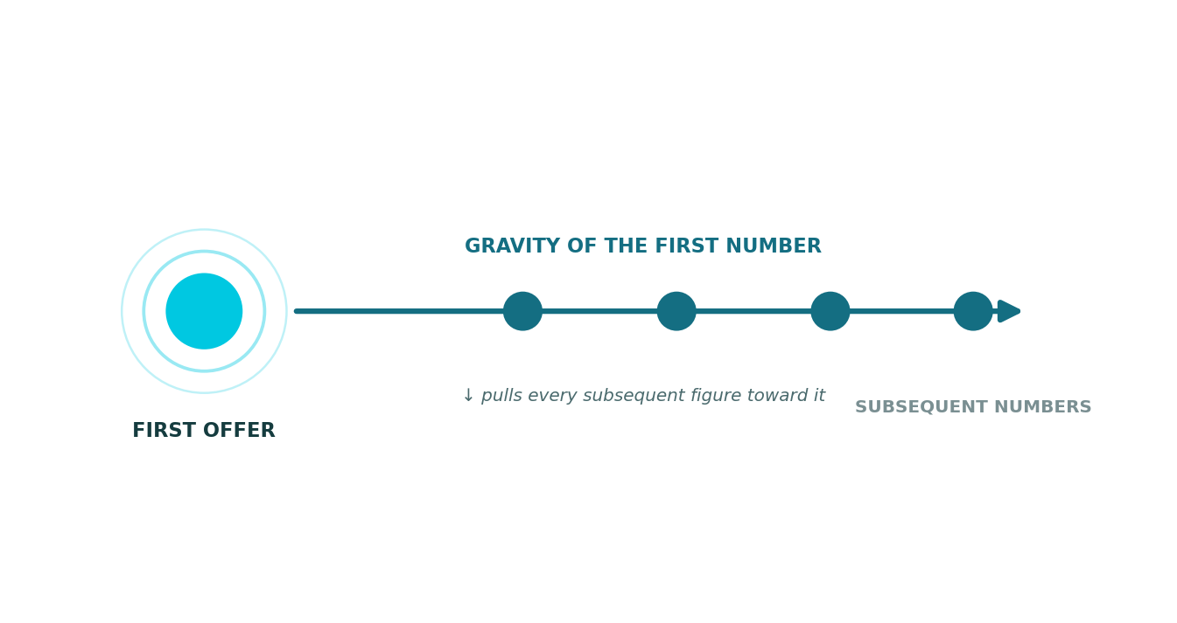
Figure 3.1 — The anchor pull effect. The first offer warps every subsequent figure toward it.
Three anchoring tactics. First, odd numbers beat round numbers — $97K feels researched, while $100K feels guessed. Odd numbers signal homework; round numbers signal an estimate. Second, cite a comparable — "Market median for this scope is $X." Anchors with a reference beat anchors alone because the reference shifts the gravity. Third, range-anchor when a point-anchor would be too aggressive — "We're looking at $95 to $105K." The range gives the other side room to land within your zone, which feels like a win for them.
CHEAPEST CREDIBILITY MOVE: ODD NUMBERS
Pair every anchor with a one-sentence rationale. The cheapest credibility move in negotiation is using odd numbers—they signal homework.
Counter-anchoring is the defensive move. When the other side anchors first, your counter-anchor must be reasoned, not reactive. "That number is too high" is reactive; "Market median for this scope is $X, based on [comparable], and we're targeting $Y" is reasoned. The reasoned counter-anchor resets the range; the reactive one concedes it.

3.4 Difficult Counterparts — Read the Pattern, Not the Words
Some counterparts are difficult. They repeat the same demand verbatim. They refuse to justify the number. They personalize the dispute ("You people always…"). These are signs of a stuck counterpart — and the stuckness is data, not an insult. Read the pattern, not the words. Three countermoves.
01 Label the dynamic aloud. "It seems like we're circling the same number." The label names the pattern and forces the counterpart to either break it or acknowledge it. Most counterparts, when you name their pattern, break it.
02 Introduce a new variable. Volume, term, scope — break the single-axis loop. If you have been arguing about price for 30 minutes, the deadlock is structural; adding a new axis gives both sides room to move.
03 Use silence. Most counterparts fill it — and reveal. After your counter-offer, do not speak. Count to ten in your head. The counterpart will almost always fill the silence with information: a justification, a concession, or an interest they had not stated.
READ THE PATTERN, NOT THE WORDS
Difficult behavior is data. The repetition, the refusal, the personalization — they are signals of a stuck negotiation, not insults. Diagnose the pattern, then break it with the label, the variable, or the silence.

3.5 The Strategy Triangle — Goals Without Destroying the Relationship
The strategy triangle is the most useful model in the deck for thinking about hardline moves. Three vertices: your goals (top), their interests (bottom-left), and the relationship (bottom-right). Every hardline move pulls one vertex. The discipline is to protect the other two.
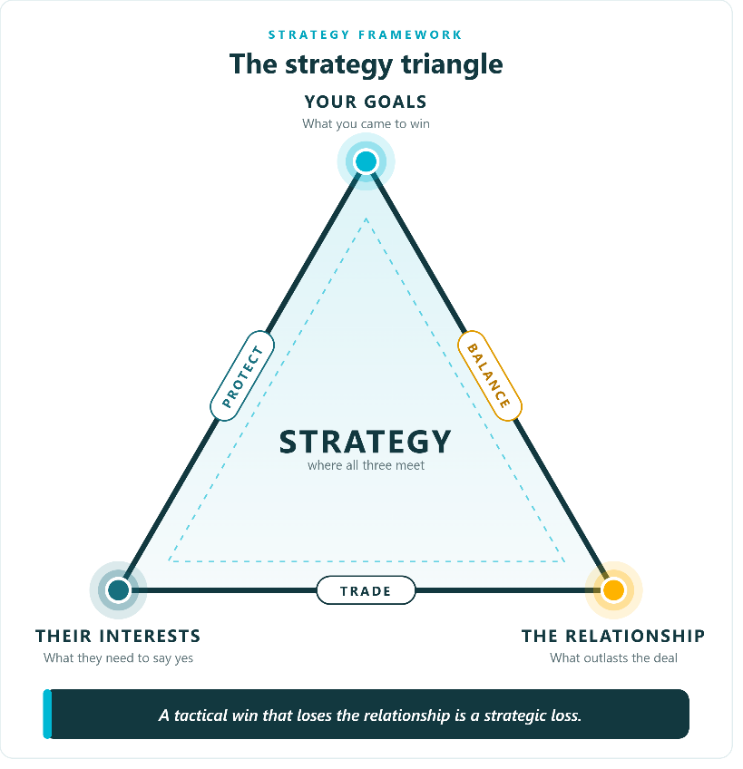
Figure 3.2 — The strategy triangle. Every hardline move pulls one vertex; protect the other two.

Top vertex — your goals
The outcome you came for — price, scope, terms. Hardline moves pull this vertex: you push hard on price, hold the line on scope, and stake your position. There is nothing wrong with pulling this vertex; the discipline is to do it deliberately, knowing which other vertex you are risking.

Bottom-left — their interests
Identify the underlying need behind their stated position. Surface it, trade against it, never attack it. Attacking their interests ("Your request is unreasonable") burns the relationship without advancing your goals. Trading against their interests ("I can't meet that price, but I can extend the term — would that help your capacity planning?") moves both parties.

Bottom-right — the relationship
The portfolio of future deals. A burned relationship costs more than this single transaction can cover. The strategic verdict: a tactical win that loses the relationship is a strategic loss. At SPL, where the same suppliers and customers return deal after deal, the relationship vertex is the one most often sacrificed to capture short-term goals — and the one whose sacrifice costs the most.

3.6 Four Outcome Models — Value × Relationship
The four outcome models compare the four negotiation outcomes across two dimensions: joint value created and relationship health, each on a 0 to 100 scale. The chart makes the case that Win/Lose is seductive but Pyrrhic — the deal closes, the relationship burns.
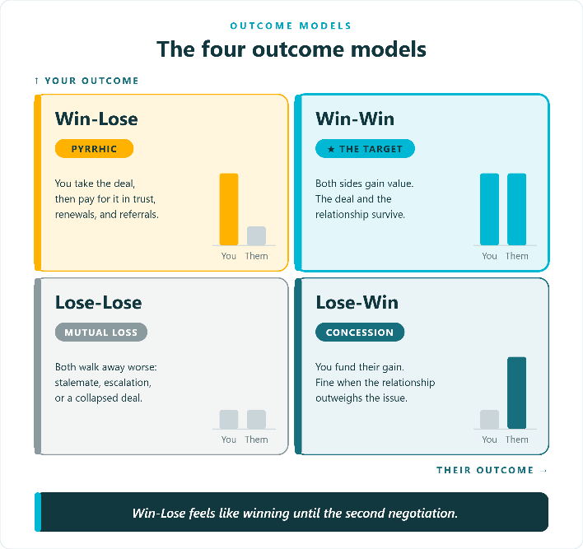
Figure 3.3 — The four outcome models. Win-Win dominates on both axes; Win-Lose is Pyrrhic.
Win-Win scores 90 on joint value and 95 on relationship — the best outcome on both axes. Win-Lose scores 55 on value but only 20 on relationship — the deal extracts value, but the relationship does not survive. Lose-Win scores 40 on value and 60 on relationship — you concede leverage, but the relationship survives. Lose-Lose scores 15 and 10 — both sides lose, and the relationship is damaged. The strategic lesson: Win-Lose looks like a short-term win but is Pyrrhic in the medium term. At SPL, where relationships compound, Win-Win is the only sustainable target for strategic deals.

Case Study 5 — The SaaS Auto-Renewal Trap
CASE STUDY
The SaaS Auto-Renewal Trap
SPL is mid-negotiation on a 7-figure SaaS contract; the vendor won't budge on auto-renewal.
Nora oversees enterprise software procurement at SPL. The contract — with the vendor CloudSoft — is a 7-figure annual SaaS agreement covering 4,000 users. CloudSoft's renewal proposal includes an auto-renewal clause that Nora cannot accept. SPL policy prohibits auto-renewal on contracts above SAR 5 million; the clause would force the contract through Legal review every year instead of allowing planned renegotiation.
CloudSoft's account director — call him Marcus — has refused to drop the clause three times. "It's standard. Every customer signs it. We can't make an exception." The negotiation is heading toward Competing (Nora threatens to walk) versus Competing (Marcus holds the line), a Lose/Lose in the making — SPL loses the software, CloudSoft loses a 7-figure account.
Nora applies the strategy triangle. Top vertex: her goal is a renewal without auto-renewal. Bottom-left: CloudSoft's interest — what is it? Not the clause itself; the clause is a position. Marcus's interest is renewal predictability and reduced churn risk. Bottom-right: the relationship — CloudSoft has been a good vendor, and SPL's users are dependent on the platform. A burned relationship here is a strategic loss.
Nora stops arguing the clause and starts working the triangle. She uses the B2B three-move play from the deck. First, invite No: "Marcus, would it be a disaster for CloudSoft if we dropped auto-renewal entirely?" Marcus, primed for a fight, pauses. "It would make my renewal forecast harder. But it's not a disaster, no." Now Nora knows: the clause is not a deal-breaker for CloudSoft; it is a forecast convenience. She has the room to move.
Second, introduce sunset: "What if we replaced auto-renewal with a 90-day renewal notice? You get the forecast lead time; we get the option to renegotiate without the auto-trigger." Marcus takes the idea internally. CloudSoft comes back: they will accept 90-day notice, but they want a 24-month minimum commitment in exchange.
Third, trade for volume: Nora accepts the 24-month commitment but trades it for a 5 percent volume discount — SPL commits to 4,400 users (10 percent above current) in exchange for the price reduction. CloudSoft agrees. The deal closes: no auto-renewal, 90-day notice, 24-month commitment, 5% discount, 10% volume increase.
The outcome: SPL gets a policy-compliant contract with a price reduction. CloudSoft gets a 24-month commitment, a volume increase, and a forecast lead time that serves the underlying interest the auto-renewal clause was meant to address. The relationship is intact — Nora and Marcus will negotiate the next renewal without the scar tissue of a Competing-against-Competing fight.
The lesson: positions are not interests. CloudSoft's position was "auto-renewal is non-negotiable." Their interest was "renewal predictability." Trading on the position would have collapsed the deal; trading on the interest closed it. The strategy triangle protected all three vertices: Nora got her goal (no auto-renewal), CloudSoft got their interest (predictability via 90-day notice + 24-month term), and the relationship survived.

Case Study 6 — The Last-Minute Demand
CASE STUDY
The Last-Minute Demand
It's 4:55 PM on Thursday; the other side just added a new demand.
Faisal is closing a logistics contract. After three weeks of negotiation, the deal is essentially done — price, term, SLA, and scope are all agreed. The signing call is scheduled for Thursday at 4:30 PM. At 4:55 PM, with 25 minutes left in the call, the supplier's commercial director — who has not been on any of the previous calls — joins and says: "Before we sign, we need one more thing. We need SPL to commit to a minimum daily volume of 5,000 parcels, or the rate doesn't hold."
Faisal's first instinct is to engage — the demand is small relative to the deal, and he wants to close. His second instinct is to be angry — the demand is a pressure tactic, injected at 4:55 PM on a Thursday by someone who has not been involved. He recognizes the pattern: this is Scenario 6 from the deck. The strategic read: the demand is a pressure tactic, designed to extract a concession when Faisal is tired and wants to leave.
Faisal makes the first counter-move: refuse to rush. "Director, I notice this is the first time this requirement has come up, and it's now 4:55 on a Thursday. I'm not going to decide on a minimum daily volume under time pressure. That's not how we do business at SPL." Pace control, named aloud. The commercial director pauses — the tactic has been called.
Faisal makes the second counter-move: schedule a follow-up. "Here's what I propose. We close the deal as negotiated today — price, term, SLA, and scope are all agreed. The minimum daily volume is a new requirement, and we'll discuss it on Monday morning, fresh eyes, with the operations team who would actually have to commit to the volume. If it makes sense for both sides, we'll add it as an amendment."
The commercial director pushes back: "The rate doesn't hold without the volume commitment." Faisal makes the third counter-move: trade the new demand for a clock extension. "Then we don't have a deal today. The rate we negotiated was based on the scope we negotiated, not on a daily volume commitment that was never mentioned. If the rate now depends on volume, we need to reopen the rate negotiation — and we'll need a two-week extension to do that properly. Your call: we sign today at the agreed rate, or we extend the closing by two weeks and reopen."
The commercial director, who has now been on the call for 12 minutes and has a flight at 6:30, calculates. The minimum daily volume was a throw-in — a tactic his commercial team had suggested to extract a marginal concession. Reopening the rate negotiation for two weeks is not worth the marginal volume gain. He drops the demand. The deal closes at 5:08 PM at the originally negotiated terms.
The lesson: pace control is leadership, not delay. Faisal did not refuse to negotiate the volume commitment; he refused to negotiate it under time pressure. By naming the tactic, deferring the demand, and trading the demand for a clock extension, he turned the pressure tactic into leverage. The supplier walked away with the deal they had originally negotiated; Faisal walked away with the deal they had originally negotiated. The Thursday 4:55 PM demand added nothing — which is exactly what it should have added.

Chapter 3 Close — Choosing the Right Style Determines the Outcome
Three big ideas from this chapter. First, the six scenarios are not random — they are patterns with counter-moves. Procurement review (Competing), client meeting (surface interests), deadlocked deal (reframe + trade), price counter (counter-anchor + trade for terms), difficult terms (isolate + sunset + trade), time pressure (refuse to rush + defer + trade). Second, anchoring is the most researched tactic in negotiation; the first reasoned number wins the range, and odd numbers signal homework. Third, the strategy triangle — your goals × their interests × the relationship — protects the deal from tactical wins that lose the relationship.
Day Four introduces preparation discipline and Chris Voss's tactical empathy. The five-stage timeline, the 80 percent preparation principle, SWOT, BATNA, ZOPA, anchoring tactics, mirroring, labeling, the accusation audit, and calibrated questions. The techniques stack — that is why this is a five-day program, not a five-minute tip sheet.
“Choosing the right style determines the outcome of the negotiation.” — Section 03 Conclusion

Chapter 4

Stages, Preparation & Voss Techniques
An SPL sales director — call him Omar — walked into a Q2 deadline negotiation with a strategic customer without a BATNA. The customer, a national retailer, had been an SPL parcel customer for five years. The renewal was due at quarter-end. The customer's procurement director knew Omar was under pressure to close before Q2 book-close. Eighteen minutes into the call, Omar had signed away 11% of the rate, locked in a 36-month term he did not want, and conceded a service-level penalty he had no operational plan to meet. Omar is not stupid. He was unprepared — and preparation was 80 percent of the outcome.
This chapter is the longest in the book because it covers the workshop's longest day. It covers tactical empathy from Chris Voss, the five-stage timeline, the 80% preparation principle, SWOT, market information, the three-tier goal set, BATNA, ZOPA, anchoring tactics, mirroring, labeling, the accusation audit, the power of "No" and "That's Right," calibrated questions, defusing emotions, and the close. The techniques stack — by the end of the chapter, you will see how a single negotiation can use eight of them in sequence.

4.1 Tactical Empathy — Chris Voss and the FBI Playbook
Chris Voss was the FBI's lead international kidnapping negotiator from 1996 to 2003. The cases he handled were high-stakes in the most literal sense — lives on the line, no do-overs, and the counterparty often irrational or hostile. The techniques he developed, collected in his 2016 book Never Split the Difference, work in B2B negotiation because they work in kidnappings. Both are high-stakes, emotional, and one-shot. Both reward the negotiator who can read and shape emotion without being captured by it.
THREE TAKEAWAYS FROM VOSS
Tactical empathy over logic. Understand their emotion before you argue the math. Emotion is data — name it before you process it.
Let them say 'No' first. A 'No' is a safety cue — it lets them relax. A 'Yes' extracted under pressure is a 'Yes' that won't survive signing.
Calibrated questions beat demands. How/What questions invite solutions; Why questions accuse.
The unifying idea is tactical empathy — empathy used as a tactic, not as a feeling. Voss is not asking you to feel sorry for the other side. He is asking you to understand them well enough to move them. The empathy is instrumental; the understanding is real. The techniques that follow — mirroring, labeling, the accusation audit, the power of "No" and "That's Right," and calibrated questions — are all expressions of tactical empathy.

4.2 Active Listening — Reactive vs Active
Most negotiators listen at 25 percent efficiency. They form their reply while the other side is speaking — two monologues taking turns. Active listening, the trained alternative, operates at 90 percent efficiency. The active listener listens to understand the underlying need, reflects it back, and then asks. The two states look similar from the outside; they produce completely different negotiations.
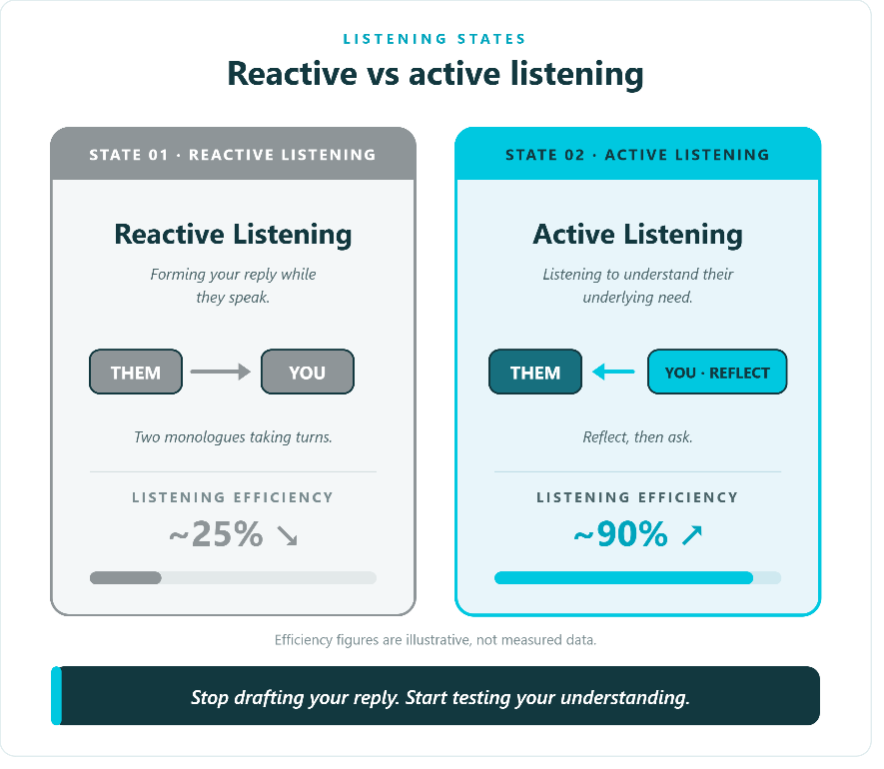
Figure 4.1 — Reactive vs Active listening. Reactive listens to reply; active listens to understand.
The reactive listener hears the words and prepares a counter. The active listener hears the words, the tone, the pause, and the underlying interest — then reflects ("So if I'm hearing you correctly, the issue is X") and asks ("What would have to be true for X to be resolved?"). The reflection is the move that demonstrates listening. Most counterparts, when they hear their position accurately reflected, will confirm and elaborate — and the elaboration is where the interests surface.
TRAIN THE MUSCLE
Most negotiators listen at 25 % efficiency. Aim for 90 %. The technique: reflect, then ask. The proof of listening is the reflection.

4.3 Mirroring and Labeling — Two Repeatable Techniques
Mirroring and labeling are Voss's two lowest-risk, highest-frequency techniques. Both are silence-based — the silence after a mirror or a label is when the counterpart reveals. Both work because they hand control of the conversation to the counterpart while keeping control of the framing with you.

Mirroring — repeat the last 1 to 3 words
Mirroring means repeating the last one to three words of the counterpart's sentence as a question, using a calm, slightly rising tone, then pausing. The counterpart will almost always elaborate — and that elaboration is information you would not otherwise have gotten.
MIRRORING — EXAMPLE EXCHANGE
Counter: "We can't go any lower than $98."
You (mirror): "Lower than $98?" ⏸ Silence — let them fill the gap.
The mirror invites the counterpart to justify, elaborate, or qualify. In this case, the counterpart will likely explain why $98 is the floor — and that explanation is leverage for your next move.

Three rules for mirroring. First, use a calm, slightly rising tone — not sarcastic or aggressive. Second, the silence after the mirror is the point — let them fill it. Most negotiators are uncomfortable with silence and break it themselves; the discipline is to hold. Third, limit mirrors to three or four per conversation. Beyond that, the technique becomes noticeable, and the counterpart feels manipulated.

Labeling — name the emotion
Labeling is naming the counterpart's emotion aloud, using "It seems like…" or "It sounds like…" — never "You are…" The label gives the emotion a name, allowing the counterpart to confirm, correct, or elaborate. The label also defuses the emotion — once named, an emotion loses much of its power.
LABELING — EXAMPLE EXCHANGE
Counter: "This proposal is a non-starter."
You (label): "It seems you're frustrated with how this is structured." ⏸ Silence — let them confirm or correct.
The label does two things: it shows you are listening (which builds rapport) and forces the counterpart to either confirm the emotion (which lets you address it) or correct it (which gives you more information).

Three rules for labeling. First, start with "It seems like…" or "It sounds like…" — never "You are…" The first is an observation; the second is an accusation. Second, label the emotion, not the position ("It seems like you're frustrated," not "It seems like you don't like the price"). Third, after labeling, go silent. Let them confirm or correct. The silence is where the technique works.

4.4 The Accusation Audit — Pre-empt the Attack
The accusation audit is Voss's pre-emptive strike. The technique: list the worst things the counterpart could say about you before they say them. The audit defuses the attack by naming it first — once the accusation is on the table and voiced by you, the counterpart cannot use it as leverage.
THREE LINES AN AUDIT MIGHT INCLUDE
"You're likely to think we're nickel-and-diming you."
"It probably feels like we're slow-walking this."
"You may suspect we're not committed to the partnership."

The audit works because it deprives the counterpart of the moral high ground. If they were going to accuse you of nickel-and-diming, they cannot — you have already said it. If they were going to question your commitment, they cannot — you have already raised the question. The audit also signals self-awareness, which builds credibility. The rule: use it once, early — never defensively. A defensive audit (deployed after the attack has already landed) reads as excuse-making. A preemptive audit (deployed before the attack) reads as confidence.

4.5 The Five Stages — Preparation Is 80% of the Outcome
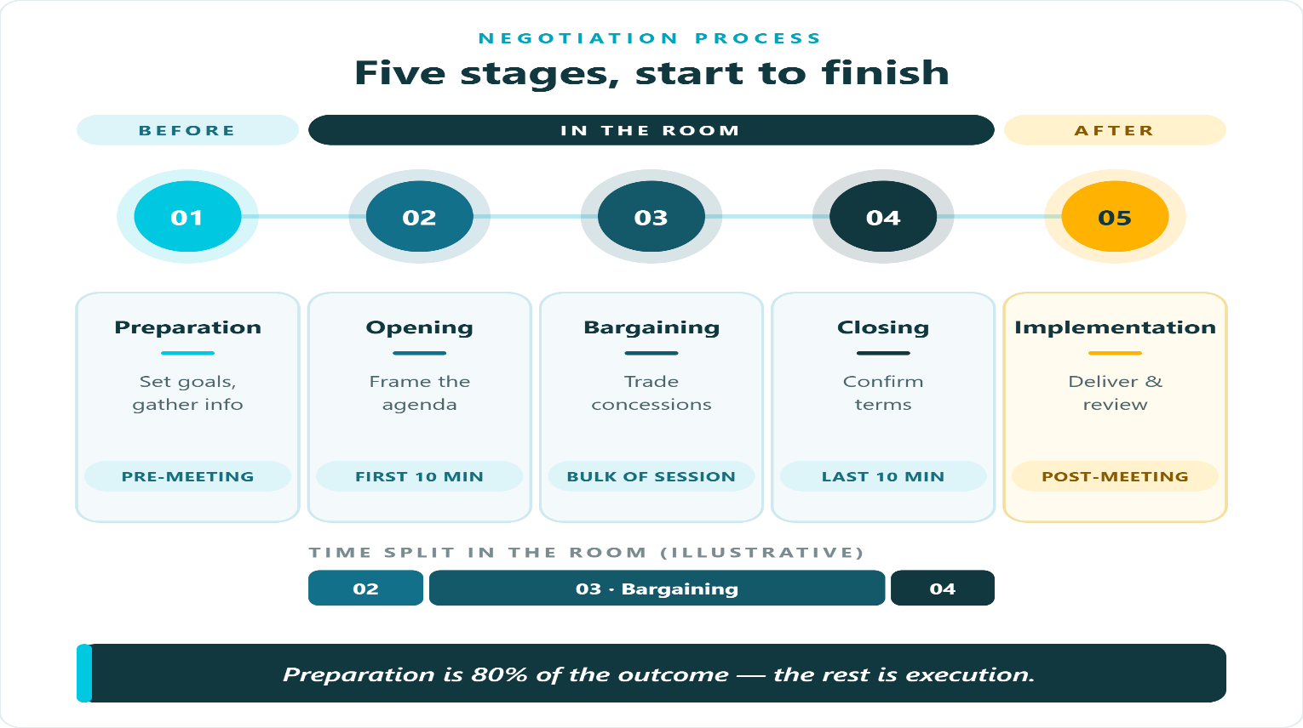
The empirical finding: 80 percent of negotiation outcomes are decided before the meeting begins. The five-stage timeline — Preparation, Opening, Bargaining, Closing, Implementation — operationalizes this finding. Most negotiators spend 20 % of their time on preparation and lose deals as a result. Omar, the sales director in the chapter opener, spent 0 percent on preparation and lost 11 % of margin in 18 minutes.

Figure 4.2 — The five stages. Preparation is 80% of the outcome; the rest is execution.

Stage 1 — Preparation (pre-meeting)
Set goals (three tiers — Ideal, Realistic, Walk-away), gather information (about the other party, competitors, and the market), determine BATNA (your real fallback), and determine ZOPA (the overlap where both sides can sign). Preparation is where the deal is won or lost — the meeting is just execution. The four preparation tasks are covered in the next six sections.

Stage 2 — Opening (first 10 minutes)
Frame the agenda. Confirm the subject, the parties, and the time available. Set the boundary (what is in scope and what is off the table for this round). Most negotiators skip Opening and dive straight into Bargaining — which means they negotiate everything at once and end up negotiating nothing well.

Stage 3 — Bargaining (bulk of session)
Trade concessions. The discipline: pair each concession with a request. The techniques from earlier in this chapter — mirroring, labeling, anchoring, and calibrated questions — are applied here. The bargaining phase is where tactical empathy does its work.

Stage 4 — Closing (last 10 minutes)
Confirm the terms. Recap each term aloud — both sides hear the same summary. Capture it in writing immediately (verbal deals drift; written deals hold). Sign the agreement. The close is part of the negotiation, not the end of it — a sloppy close costs the deal.

Stage 5 — Implementation (post-meeting)
Deliver and review. The deal is not done when it is signed; it is done when it is delivered. Implementation is where the relationship either compounds (the deal delivers as promised) or erodes (the deal overpromised and underdelivered).

4.6 SWOT — Know Your Position Before You Negotiate
SWOT — Strengths, Weaknesses, Opportunities, Threats — is the most recommended preparation tool in business and the most underused. The discipline is simple: audit your side of the table before you walk in. The audit takes 30 minutes and saves most negotiators from the surprise that costs them the deal.
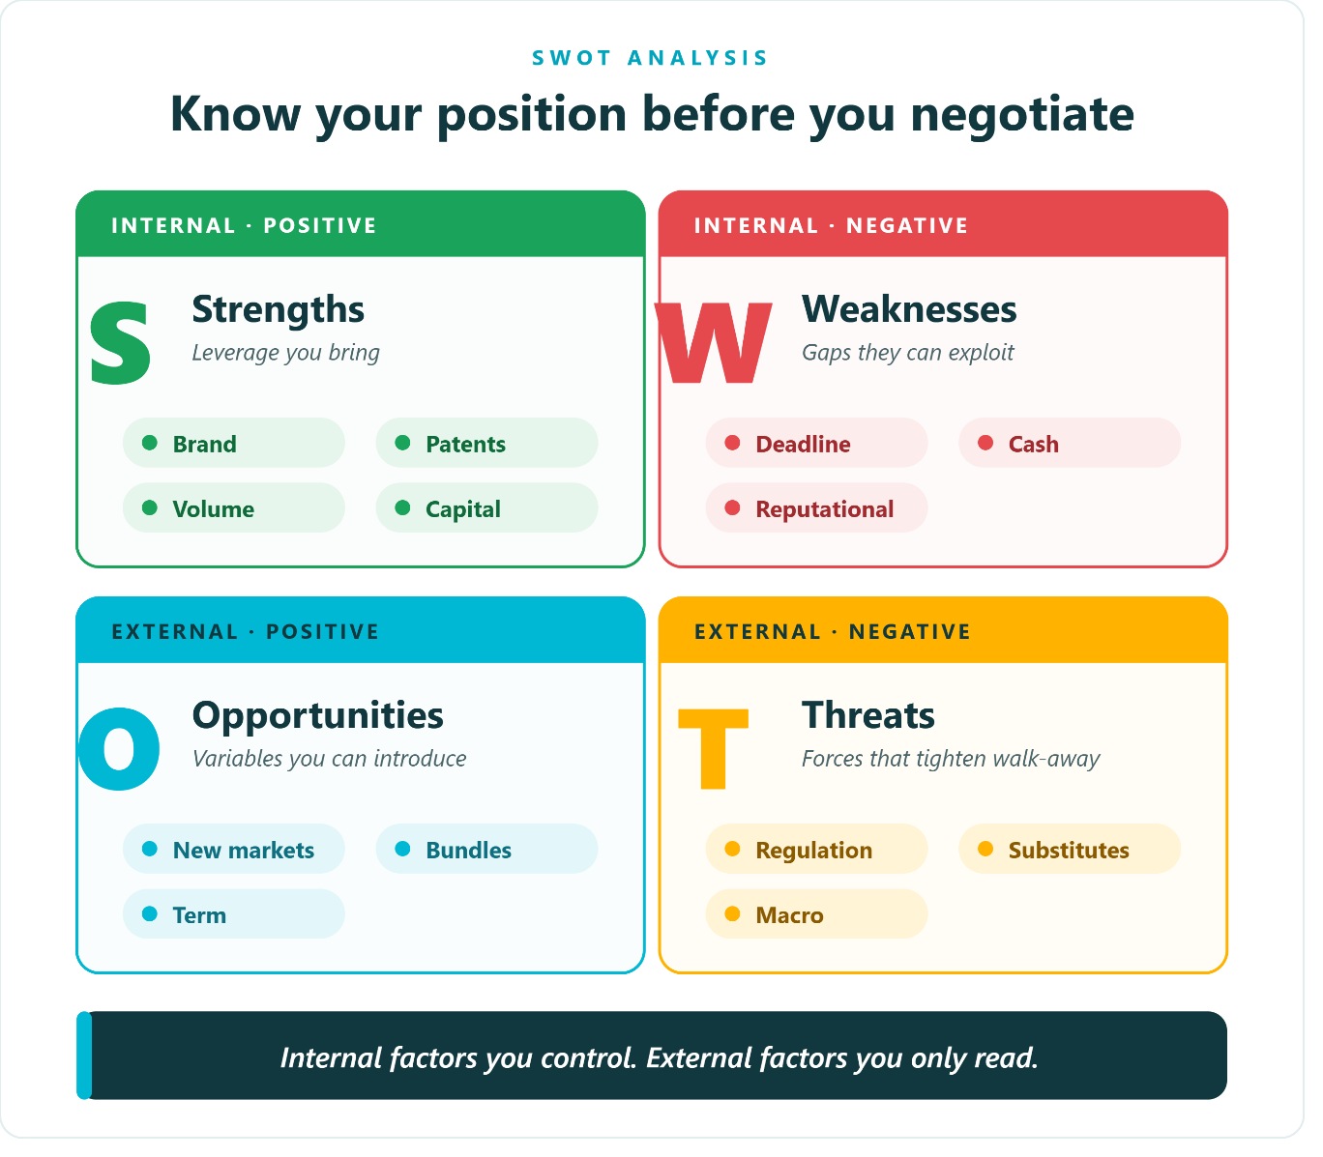
Figure 4.3 — SWOT. Strengths (internal positive), Weaknesses (internal negative), Opportunities (external positive), Threats (external negative).
For each quadrant, name at least three items. Strengths: leverage you bring — brand, patents, volume, capital, exclusive relationships. Weaknesses: gaps the other side can exploit — deadline pressure, cash constraints, reputational issues, dependency. Opportunities: variables you can introduce — new markets, bundles, term extensions, scope additions. Threats: external forces that tighten your walk-away — regulation, substitutes, macro conditions, competitor moves.
The SWOT is not a checklist; it is a diagnostic. The output is not the grid itself but the strategic read it produces: where is your leverage, where is your exposure, what variables can you introduce, and what external forces are working against you? Omar, the sales director from the chapter opener, did not run a SWOT. If he had, his Threats quadrant would have included "customer knows I have a Q2 book-close deadline" — and he would have prepared a countermeasure before walking in.

4.7 Market Information — Three Buckets
Knowledge asymmetry is the cheapest leverage you can buy. The cost is homework; the leverage is decisive. Three buckets, one-page brief.

Bucket 1 — Other Party
What is their quarter-end (when do they need this signed)? What is their BATNA (what is their fallback if this deal collapses)? Who is their boss (who signs, who pushes, and who is incentivized)? These three questions — quarter, BATNA, and boss — surface most of what you need to know about the other side's constraints.

Bucket 2 — Competitors
What are they quoting for the same scope? Get three quotes — premium, mid, and bottom. The premium quote tells you the ceiling; the bottom quote tells you the floor; the mid quote tells you the market. Use the comparable to anchor ("Market median for this scope is $X") and to counter-anchor ("Your price is 12 percent above market median").

Bucket 3 — Market
Where is pricing trending over six months? Direction (up, flat, or down), volatility (bandwidth — how much the price moves in a typical quarter), and substitutes (what else the buyer can do — including doing nothing). The market trend tells you whether to lock in (prices rising) or hold off (prices falling); the volatility tells you whether to commit to a fixed or indexed price; the substitutes tell you how much pricing power the seller actually has.

4.8 Setting Goals — Three Tiers
Walk into every negotiation with three numbers in your head: Ideal, Realistic, Walk-away. The three tiers are not aspirations; they are preparation. Each tier has a job.

Tier 1 — Ideal (+15%)
The outcome if everything breaks your way. Push for it; do not expect it. The Ideal is the opening anchor — the number you put on the table first, with a rationale. The Ideal should be aggressive enough to anchor the range but credible enough to be reasoned.

Tier 2 — Realistic (±0%)
The outcome you would happily sign for. This is your anchor in the room — the number you have reasoned your way to, based on your SWOT, your market information, and your BATNA. The Realistic is the target; the negotiation is the path to it.

Tier 3 — Walk-away (−10%)
The number below which you leave the table. Floor — non-negotiable. The discipline: write your
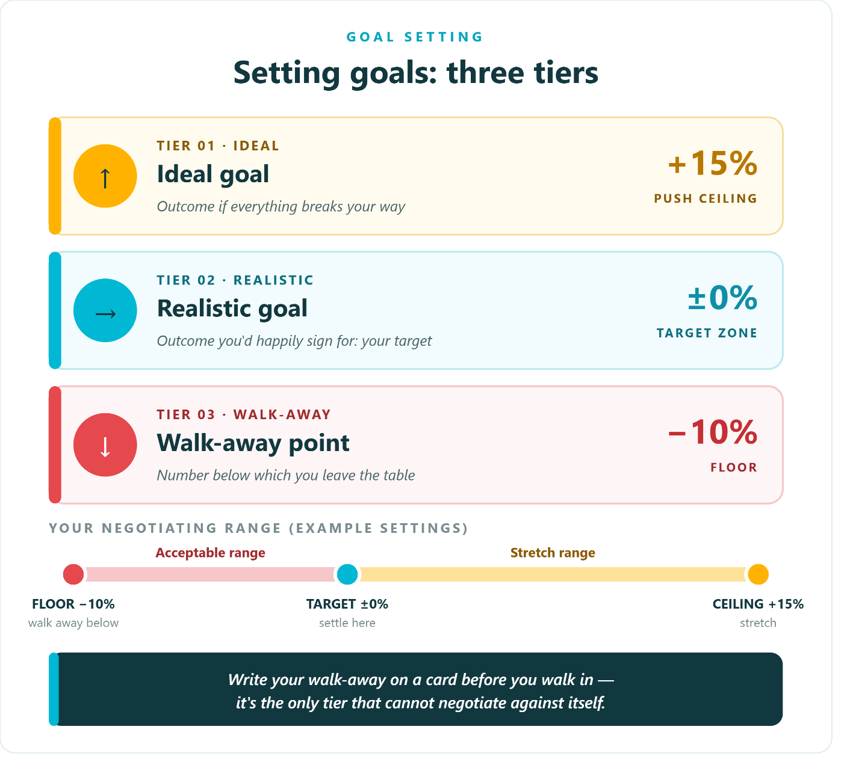
Set your walk-away on a card before you walk in. It is the only tier that cannot negotiate against itself. Once you are in the room, fatigue and pressure will try to move your walk-away downward the card is the anchor that holds.
Figure 4.4 — Three-tier goals. Ideal (+15%), Realistic (±0%), Walk-away (−10%).

WRITE YOUR WALK-AWAY ON A CARD
It's the only tier that cannot negotiate against itself. The card is the anchor that holds when fatigue and pressure try to move your walk-away downward.

4.9 BATNA — Your Real Fallback
BATNA — Best Alternative to a Negotiated Agreement — is the single most important concept in negotiation preparation. Coined by Roger Fisher and William Ury in their 1981 book Getting to Yes, BATNA is your fallback if the deal collapses. The strength of your BATNA equals your strength at the table. A negotiator with a strong BATNA can walk away; one without one cannot. Omar, the sales director from the chapter opener, had no BATNA — he had to close before Q2 book-close, and the customer knew it. The 11 percent margin he surrendered was the cost of lacking a BATNA.
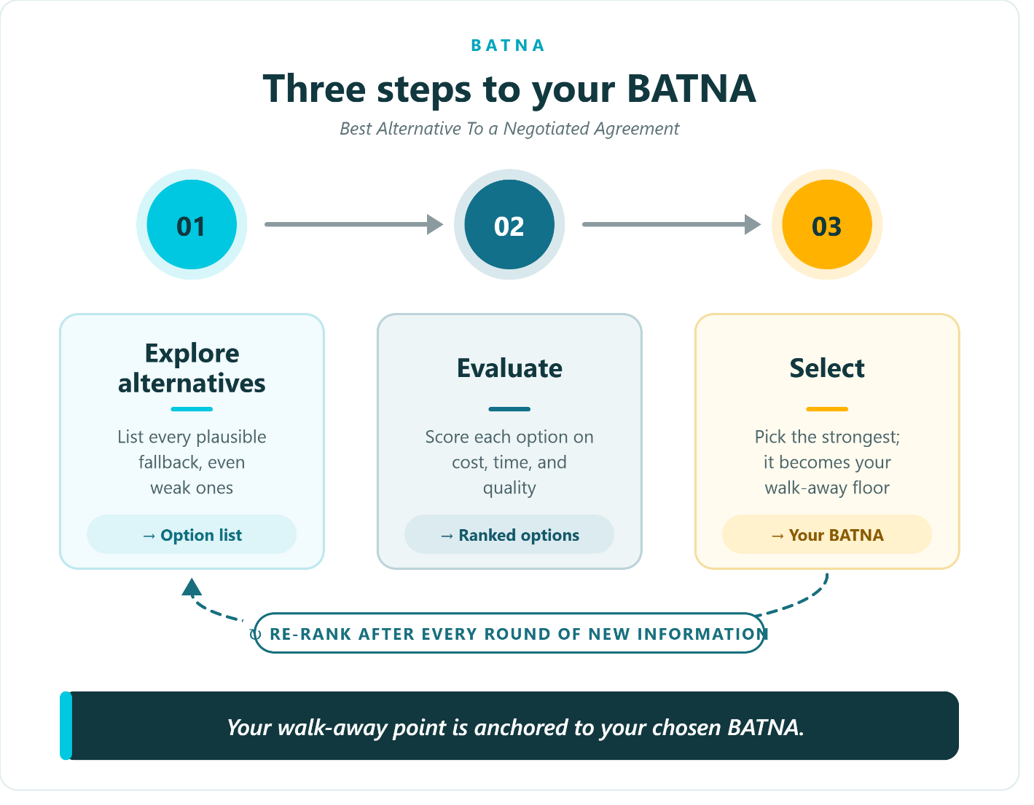
Figure 4.5 — Building your BATNA. Three steps: Explore, Evaluate, Select.

Three-step workflow
01 Explore alternatives. List every plausible fallback, even the weak ones. Brainstorm broadly before filtering — include the embarrassing ones. The discipline is to generate, not to judge. Most negotiators skip this step because the obvious alternatives are weak; the non-obvious ones brainstorming surfaces sometimes aren't.
02 Evaluate. Score each alternative on cost, time, and quality using a simple three-column scorecard. The scorecard forces precision — "the competitor is cheaper" becomes "the competitor is 8 percent cheaper but 4 weeks slower and 2 quality tiers down."
03 Select. Pick the strongest — that becomes your walk-away floor. Walk-away = chosen BATNA. This is the most commonly skipped step. Most negotiators do steps 1 and 2 in their heads and never convert the analysis into a single number. Re-rank after every round of new information.
BATNA MUST BE REAL
Your BATNA must be REAL (not hypothetical), CURRENTLY AVAILABLE (not theoretical), and QUANTIFIED (a number, not a feeling). A hypothetical BATNA is not a BATNA — it is a wish.

4.10 ZOPA — Zone of Possible Agreement
ZOPA — Zone of Possible Agreement — is the companion concept to BATNA. It was also coined by Fisher and Ury in 1981. ZOPA is the overlap between your walk-away and theirs. No overlap, no deal. The discipline is to map the ZOPA before you walk in — and to recognize, when there is no ZOPA, that the correct outcome is no deal.

Worked example — when no deal is the right outcome
Seller wants 100. Buyer wants 90. The seller's floor is 100; the buyer's ceiling is 90. There is a 10-unit gap with no overlap. The correct outcome is no deal. Splitting the difference at 95 is not a strategy — it is a capitulation in which both sides give up something they should not.
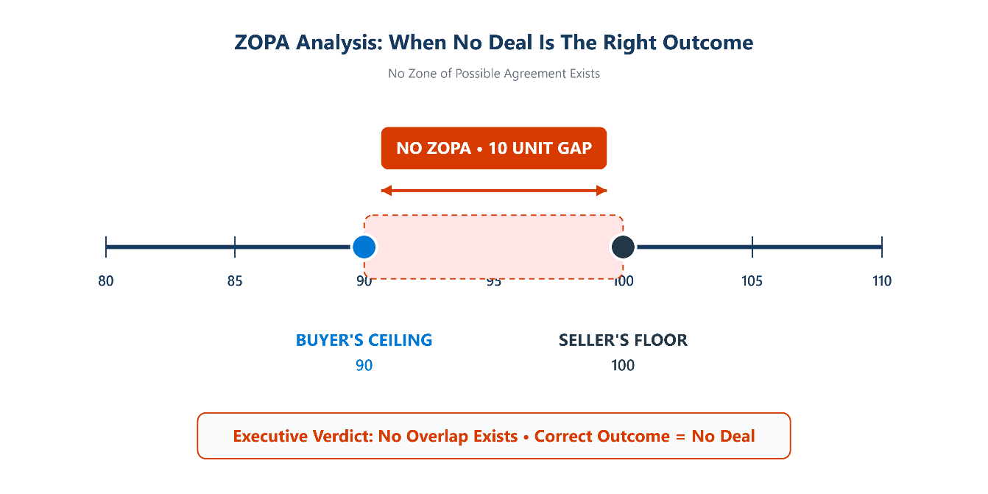
Figure 4.6 — ZOPA worked example. Seller 100, Buyer 90, no overlap, no deal.

ZOPA chart — when a deal is possible
Now a case where there is a ZOPA. Seller's range: walk-away 90, ideal 120. Buyer's range: walk-away 105, ideal 70. The overlap — the ZOPA — is 90 to 105. Any deal in that range is acceptable to both sides. The negotiation is the path to a number inside the ZOPA.
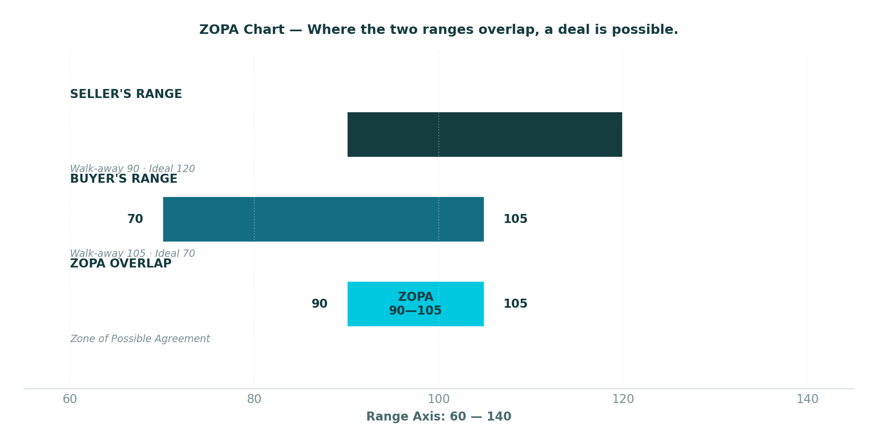
Figure 4.7 — ZOPA chart. Seller 90–120, Buyer 70–105, ZOPA overlap 90–105.
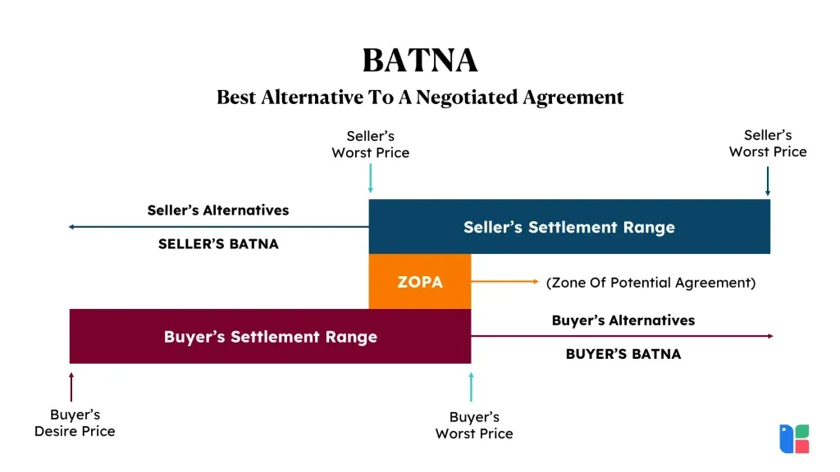
The ZOPA discipline has two parts. First, map your own range (walk-away and ideal) before the negotiation. Second, estimate the other side's range using your market information — their walk-away is your ceiling; their ideal is your floor. The overlap, if any, is your negotiation space. The non-overlap, if any, is your signal to walk.

4.11 The Power of 'No' and 'That's Right'
Two Voss insights that upend conventional wisdom. The first: a "No" from the counterpart is not a rejection — it is a safety cue. The second: "That's right" is the response you want, not "You're right." Both insights work by reframing what the counterpart is signaling.

The Power of 'No'
A "No" lets the counterpart relax. It is a safety cue — they have established a boundary, and now they can engage without fear of being trapped. A "Yes" extracted under pressure will not survive signing — the counterpart agrees to escape the negotiation, then walks back the agreement at the next opportunity. The technique: invite the "No." "Have you given up on this option?" invites a "No" — and the "No" opens the conversation. Reframe: "No" is a starting position, not a rejection.

The Power of 'That's Right'
Summarize the counterpart's position until they say "that's right." "That's right" means they feel understood — and a counterpart who feels understood is one who will move. "You're right" is the trap — it means they want to move on without agreeing. The technique: summarize their position accurately (the summary proves you have been listening), then wait. If they say "that's right," you're aligned; if they say "you're right," you're not.

4.12 Calibrated Questions — How and What, Never Why
Calibrated questions start with "How" or "What" — never "Why." "Why" sounds accusatory ("Why are you asking for that?"); "How" and "What" invite solutions ("How would that work?" "What would have to be true for that to be possible?"). A calibrated question hands the problem to the counterpart — they have to think of the solution, which gives you information and gives them ownership.

Three workhorses
CALIBRATED QUESTION — WORKHORSE
"How am I supposed to do that?" — When they ask you to do something unreasonable, hand the problem back. Use this for: demands you can't meet, scope creep, and unreasonable deadlines.
CALIBRATED QUESTION — SELF-INTEREST
"How do I ensure I get what I want?" — Reframe their demand as a shared interest. Use it for: asymmetric asks, vague requests, and hand-wavy commitments.
CALIBRATED QUESTION — IMPROVEMENT
"What can I do to improve the situation?" — Invites the counterpart to hand you the script. Use this for: stalled rounds, repair after a misstep, and closing toward 'that's right.'

Three application scenarios
B2B application — SPL is in mid-negotiation on a 7-figure SaaS contract; the vendor will not budge on auto-renewal. Three moves: invite No ("Would it be a disaster if we dropped auto-renewal entirely?"), introduce sunset (use the No to introduce a sunset clause), and trade for volume (trade auto-renewal for a volume discount). The case study at the end of this chapter shows this play end to end.
PMO application — internal negotiation. Engineering says a feature can't ship before Q3; Sales has already promised it to a top customer for Q2. Three calibrated moves: "How am I supposed to deliver this in Q2 with the current team?" / "What would have to be true for Q2 to be feasible?" / "What's the biggest risk if we slip to Q3?" Internal negotiations feel lower-stakes — they aren't. Don't argue; ask.
Time application — your director wants a 30-day delivery, but your team's realistic estimate is 60 days. Three calibrated moves: "How would the team need to be restructured to hit 30 days?" / "What scope could we trade to hit the 30-day date?" / "What's the cost of compromising quality to make the date?" The calibrated question reframes the deadline as a joint problem — you keep the goal, you trade the path.

4.13 Defusing Emotions and Closing the Deal
Two endgame skills. The first is defusing emotions — yours and theirs — when the negotiation heats up. The second is closing — the discipline that turns a verbal agreement into a signed deal.

Defusing emotions
The reactive state is to match their tone, argue the facts, and defend your position. The trained state is to label the emotion, pause, and acknowledge before responding. The shift is from reaction to reflection. Emotion is data — name it before you process it. The labeling technique from Section 4.3 is the move: "It seems like you're frustrated with how this is going." Then silence. Let them confirm or correct. Then respond — to the underlying interest, not the surface emotion.

Closing the deal
Three steps. First, recap every term aloud — so both sides hear the same summary. Misalignment surfaces now, not after signing. "Let me make sure we're aligned: price is X, term is Y, SLA is Z, payment is N days, scope is…" Second, capture it in writing immediately — verbal deals drift, written deals hold. Send the recap email the same day, before memory diverges. Third, sign the agreement — commitment converts the deal. Sign within the DOA. The close is part of the negotiation, not the end of it.
RECAP · WRITE · SIGN
The close is part of the negotiation, not the end. A sloppy close costs the deal — verbal terms drift, unwritten terms disappear, and unsigned deals collapse.

Case Study 7 — The Delivery Slip Escalation
CASE STUDY
The Delivery Slip Escalation
An SPL customer escalates a 2-day delivery slip to the SPL CEO.
Maha oversees key account management for SPL's enterprise parcel customers. One of her largest — a national pharmacy chain — experiences a 2-day delivery slip on a critical shipment of temperature-controlled pharmaceuticals. The shipment arrives Thursday instead of Monday. The pharmacy's logistics director — call him Fawzi — escalates he emails Maha, copying the SPL CEO and his own CEO, demanding a full investigation, a service credit, and a meeting within 48 hours.
Maha's first instinct is to defend. The slip was caused by a weather event; SPL's SLA includes a force-majeure clause; the customer signed the SLA. She drafts a reply listing the justifications. Then she remembers Chapter Four: emotion is data — name it before you process it. Fawzi is not asking for an investigation; he is asking to be heard. His CEO is copied because he is under internal pressure; the email signals that he needs to show his CEO he is on top of this.
Maha picks up the phone. She opens with a label: "Fawzi, it sounds like this slip has put you under real pressure with your own team and your CEO." Silence. Fawzi, primed for a fight, pauses. "Yes. My CEO is asking why SPL didn't deliver on Thursday, and I don't have a good answer. The pharmacy operations team is asking me whether we can rely on the SLA. I need to be able to tell them something."
Now Maha knows the real interest: Fawzi needs something to tell his CEO and his operations team. The investigation and the service credit are positions; the interest is a credible explanation. Maha does not argue the force-majeure clause. She does not defend. She applies the B2B/PMO calibrated-question play: "How would a 24-hour recovery plan work for your team — and what would we need to change to make that possible?" The question reframes the demand as a joint problem.
Fawzi takes the bait. "A 24-hour recovery plan would need three things: a root-cause explanation I can send to my CEO, a credit against next month's invoice that shows we take the SLA seriously, and a commitment that future temperature-controlled shipments get a 12-hour buffer." Maha agrees to all three. She sends the root-cause explanation (weather event, with documentation) within four hours. She applies a 5 percent credit against next month's invoice (within her DOA). She commits to a 12-hour buffer on future temperature-controlled shipments, with a weekly status report to Fawzi.
Fawzi takes the package to his CEO. His CEO accepts — the explanation is credible, the credit is a gesture of accountability, the buffer is a real fix. The relationship survives. Fawzi sends Maha a private thank-you: "You handled that better than I would have."
The lesson: emotion is data — name it before you process it. Maha's first instinct (defend) would have escalated the fight. Her trained response (label, pause, acknowledge, then ask) turned an escalation into a recovery. The calibrated question ("How would a 24-hour recovery plan work?") handed the problem to Fawzi and let him define the solution—giving him ownership and Maha a package she could deliver. The CEO-CC'd email wasn't an attack; it signaled that Fawzi needed help. The label named it; the question solved it.

Case Study 8 — The Walk-Away That Wasn't
CASE STUDY
The Walk-Away That Wasn't
An SPL buyer almost walks from a deal without a real BATNA — and the vendor calls the bluff.
Yousef runs IT procurement at SPL. He is negotiating a 3-year contract for an enterprise analytics platform — call the vendor DataNexus. The negotiation has lasted six weeks. DataNexus's commercial director—call her Sara—has held firm at SAR 4.2 million per year. Yousef's walk-away is SAR 3.8 million. The gap is SAR 400K, and negotiations are stalled.
Frustrated, Yousef plays his trump card: "If you can't get to 3.8, we're going to walk. We have a competitor who's willing to do this at 3.6." Sara pauses, then says: "Yousef, I respect that. Before you walk, can I ask — have you evaluated the competitor's platform against your requirements?"
Yousef has not. The competitor—call them InsightPro—sent a quote for SAR 3.6 million, but Yousef hasn't conducted a feature comparison, a reference check, or a transition-cost analysis. He was using the competitor's quote as leverage, not as a real alternative. Sara knows this—the analytics platform market is small, and she knows InsightPro's product is weaker in the regulatory reporting module that SPL needs.
Yousef is caught. If he says yes (he has evaluated), Sara will ask for the evaluation, and he will have to admit he has not. If he says no (he has not evaluated), he has admitted his walk-away is a bluff. He says: "We're in the process of evaluating." Sara, calm, says: "Then this isn't a walk-away yet. Let's give you the time to evaluate properly. We'll hold our 4.2 quote for 30 days while you compare. If InsightPro is genuinely a fit, we'll match. If not, we'll have the conversation about 3.8."
Yousef takes the 30 days. He runs the evaluation. InsightPro's quote is 3.6 million, but the regulatory reporting module is missing — building it would cost SAR 600K and add 4 months to the implementation. The transition cost is another SAR 300K. Total cost of the InsightPro alternative: SAR 4.5 million in year one, with a 4-month delay. DataNexus at 4.2 is the better deal. Yousef signs at 4.2.
The lesson: walking away without a BATNA is a wish, not a strategy. Yousef thought he had a BATNA (InsightPro at 3.6). He did not — he had a quote, not a BATNA. A real BATNA must be REAL (the alternative must exist), CURRENTLY AVAILABLE (the alternative must be ready to sign, not theoretical), and QUANTIFIED (the total cost must be calculated, including transition and gaps). Yousef's BATNA failed all three tests. Sara, the experienced negotiator, called the bluff with a calibrated question ("Have you actually evaluated?") and offered a 30-day window — a generous move that gave Yousef a graceful exit and locked in the deal at her anchor price.
The fix: run the BATNA workflow before you walk in. Step 1 — explore alternatives (Yousef listed one, InsightPro; he should have listed three). Step 2 — evaluate (Yousef skipped this entirely; he should have done the feature comparison, the reference check, and the transition-cost analysis). Step 3 — select (Yousef never selected a chosen BATNA; he had a quote, not a walk-away floor). Without the workflow, the walk-away is a bluff. With the workflow, the walk-away is a strategy — and you do not have to use it, because the other side can see it is real.

Chapter 4 Close — Preparation Is 80% of the Outcome
Three big ideas from this chapter. First, tactical empathy — Voss's three takeaways: tactical empathy over logic, let them say "No" first, and calibrated questions beat demands. The techniques (mirroring, labeling, accusation audit, calibrated questions) are all expressions of tactical empathy. Second, the five-stage timeline with the 80 percent preparation principle — Preparation, Opening, Bargaining, Closing, Implementation. The preparation stack (SWOT, market information, three-tier goals, BATNA, ZOPA, anchoring) is what fills the 80 percent. Third, the calibrated question is the workhorse of the bargaining phase — How and What, never Why.
Day Five closes the program with body language, persuasion, and the close. Topics include Mehrabian's 7-38-55 rule, dealing with difficult people, persuasion versus manipulation, Cialdini's six levers, objection handling using Feel/Felt/Found, the three goals of every negotiation, and the final close.
“Preparation is 80% of the outcome — the rest is execution.” — Section 04 Conclusion

Chapter 5

Body Language, Persuasion & Close
An SPL senior account manager — call him Hassan — lost a strategic customer in his second year on the job. The deal was good. The terms were good. The price was good. The customer's procurement director walked out of the closing meeting, saying: "We'll think about it." They never came back. Hassan asked his director what went wrong. The director had been in the room. Her feedback: "Your body contradicted your words. You said the deal was strong, but your posture was closed, your eye contact was avoidant, and your hands were under the table. They didn't believe you."
This chapter closes the program with what words alone cannot convey. It covers body language (Mehrabian's 7-38-55 rule), dealing with difficult people, persuasion versus manipulation, Cialdini's six levers, objection handling with Feel/Felt/Found, the three goals of every negotiation, and the close. By the end of the chapter, the techniques from Days One through Four are wrapped in a nonverbal and persuasive layer that makes them land.

5.1 Body Language — The 7-38-55 Rule
Albert Mehrabian, Professor Emeritus of Psychology at UCLA, published his research on message consistency in 1971. The finding, simplified for the field: when a message is inconsistent — when the words say one thing and the tone or body says another — the recipient weights the message as 7 percent words, 38 percent tone of voice, and 55 percent body language. The percentages are not absolute (they apply specifically to inconsistent messages about feelings and attitudes), but the principle is robust: when your body contradicts your words, the body wins.
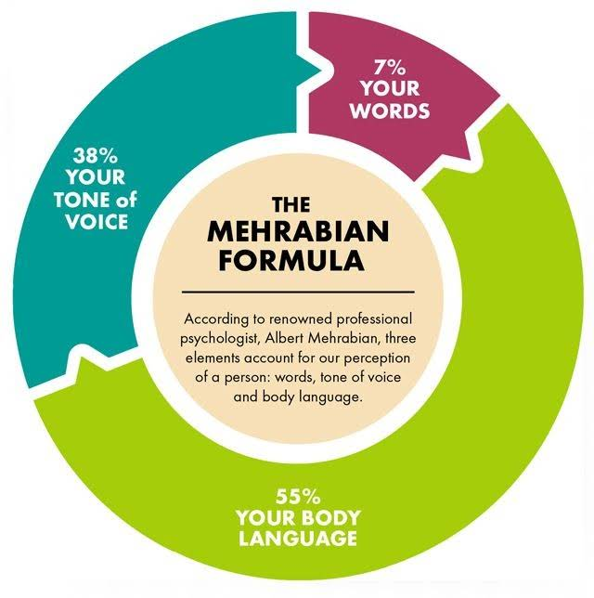
Figure 5.1 — Mehrabian's 7-38-55 rule. When the message is inconsistent, the body wins.

7% — Words
What you say — the literal content. Most negotiators over-invest here. The script matters, but it is the smallest channel in the message. A perfect script delivered with the wrong tone and body will lose to a mediocre script delivered with the right tone and body.

38% — Tone of Voice
How you say it — pace, pitch, volume, and pauses. The carrier of your intent. A slow, low-pitched, paused delivery signals confidence; a fast, high-pitched, filler-filled delivery signals anxiety. The trained move is to slow down — most negotiators speak too fast under pressure, and that speed leaks anxiety.

55% — Body Language
What your body does — posture, eye contact, hand placement, and facial expression. The dominant signal in face-to-face negotiation. The trained move: open posture (shoulders back, hands visible), steady eye contact (not staring, but not avoidant), and deliberate hand placement (on the table, not under it). Hassan's mistake — closed posture, avoidant eye contact, and hands under the table — signaled that he did not believe his own words. The customer read the body, not the script.

5.2 Dealing with Difficult People
Difficult counterparts are part of the job. The deck distills field wisdom into two rules. Rule 1: stay calm. Your emotional state is the only variable you fully control. If you match their tone, you have already lost the room. Rule 2: focus on interests. Difficult behavior usually masks an unstated interest — a deadline, a boss, a budget, or a need to save face. Diagnose the interest behind the behavior.
TWO RULES THAT SURVIVE EVERY DIFFICULT-COUNTERPART SCENARIO
Rule 1 — Stay calm. Pause, breathe, and silently label the emotion before responding. Calm is a strategic choice, not a personality trait.
Rule 2 — Focus on interests. Difficult behavior is data. Their interest is the leverage. Diagnose the interest behind the behavior, then trade against it.

The strategic move: their behavior is data, and your response is strategy. The difficult counterpart is not your enemy; they are a negotiator under constraints you have not yet surfaced. The label ("It seems like there's a lot riding on this for you") surfaces the constraint. The calibrated question ("What would have to be true for us to find a number that works?") counters it.

5.3 Persuasion vs Manipulation — and the Orange Story
Persuasion and manipulation use the same tools. The difference lies in intent and outcome. Persuasion aims for mutual value — both sides would do the deal again, and the relationship survives. Manipulation aims for one-sided gain — one side regrets, and the relationship burns for a one-time win. At SPL, where the relationship is the portfolio, manipulation is not just unethical; it is uneconomic. The deal you close by manipulation costs you the next ten.

The Orange Story
Two sisters fight over one orange. They compromise; each takes half. One sister squeezes her half for juice, and the other grates hers for peel. Both could have had 100 % of what they wanted — their positions overlapped (each wanted the orange), but their interests did not (one wanted the juice, the other wanted the peel). The compromise — splitting the difference — left value on the table because neither sister asked the other what they wanted the orange for.
POSITIONS VS INTERESTS
Positions: "I want the orange." Interests: "I want the juice" or "I want the peel." Surface interests, not positions. The Orange Story is the parable of integrative negotiation — the pie was expandable, but the sisters split it because they bargained over positions instead of negotiating over interests.

5.4 Cialdini’s Six Principles of Persuasion
Robert Cialdini, Regents' Professor Emeritus of Psychology at Arizona State University, published Influence: The Psychology of Persuasion in 1984. The book identifies six levers of influence — the cognitive shortcuts people use to decide whether to say yes. The levers are amoral; they can be used to persuade (mutual value) or to manipulate (one-sided gain). The deck ranks the six by their typical effectiveness in B2B negotiation.
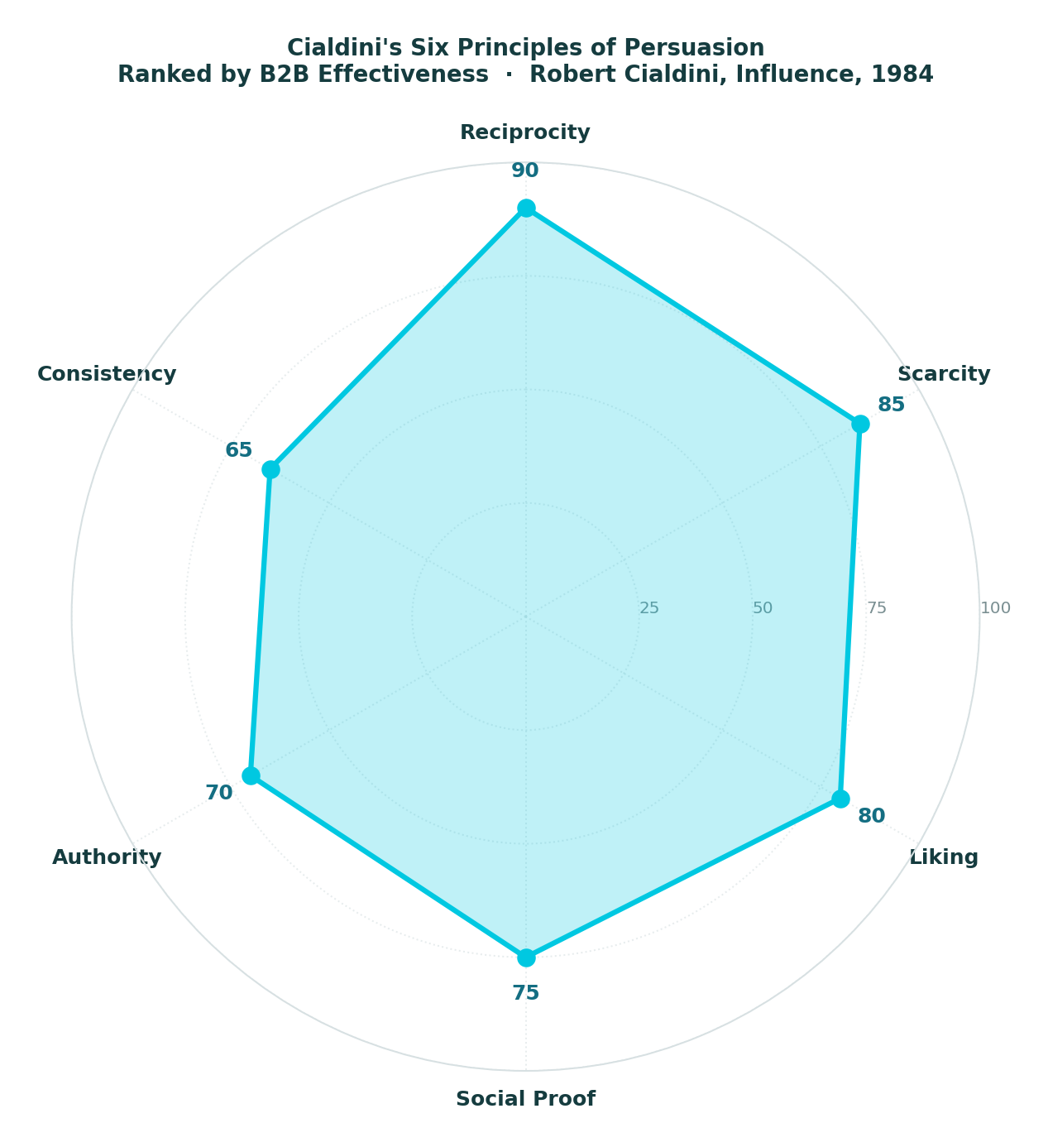
Figure 5.2 — Cialdini's Six Principles of Persuasion, ranked by B2B effectiveness.

Lever 1 — Reciprocity (90)
Concede slowly to invite return. The discipline: concede slowly, not freely; pair every concession with a request; the first concession sets the reciprocity clock. A concession given freely is a gift; a concession given slowly, paired with a request, is a trade. The trade is what makes the relationship sustainable.

Lever 2 — Scarcity (85)
Real limits increase perceived value. The discipline: explicitly constrain time, scope, or quantity; scarcity must be real, or it backfires; pair with reciprocity ("This rate holds until Friday"). Invented urgency is manipulation; real scarcity is information. The discipline is to know the difference and never blur it.

Lever 3 — Liking (80)
Rapport opens every door. The discipline: find a genuine, shared interest before business begins; subtly mirror pace and posture; praise specific, recent actions — not general traits. Liking is not about being charming; it is about being present. The counterpart who feels seen is the one who moves.

Lever 4 — Social Proof (75)
Case studies lower perceived risk. The discipline: cite specific named case studies; quote one strong example, not three weak ones; the example must be comparable (same industry, scope, and stakes). Social proof works because the counterpart does not have to be the first; the discipline is to make the proof credible.

Lever 5 — Authority (70)
One cited expert beat three. The discipline: cite specific named experts, not vague "industry leaders"; quote one data point, not three (over-quoting reads as desperate); authority transfers poorly — only your own credentials fully land. The discipline is to use authority sparingly; the more you cite, the less weight each citation carries.

Lever 6 — Consistency (65)
Prior commitments are free leverage. The discipline: surface their prior public commitments early; secure small commitments in writing before the big ask; use their words against them ("As your team noted in the RFP…"). Consistency works because the counterpart wants to appear consistent; the discipline is to surface the prior commitment before the ask, not after.

5.5 Handling Objections — Feel · Felt · Found
A repeatable structure for any price, scope, or term objection. Three steps: validate, normalize, reframe. The structure works because it does not argue the objection — it absorbs it, then redirects it.

Step 1 — Feel
"I understand how you feel." Validate the emotion without agreeing with the substance. Validation is not capitulation; it is acknowledgment. The counterpart who feels heard is the one who will listen to the reframe.

Step 2 — Felt
"I felt the same way." Normalize the concern — you have been in their shoes. This normalization builds rapport and lowers the counterpart's defenses. The reframe that follows lands more easily because the counterpart no longer feels alone in their concern.

Step 3 — Found
"But I found that…" Reframe using a third-party data point or new evidence. The reframe is not an argument; it is a reframe — a new angle on the same concern. "I found that customers who initially pushed back on this term ultimately renewed under it because [data point]." The reframe closes the loop — the objection is absorbed, normalized, and redirected.
VALIDATE → NORMALISE → REFRAME
Feel → Felt → Found. The structure works because it does not argue against the objection — it absorbs it, then redirects it. The counterpart who feels heard is the one who will listen to the reframe.

5.6 Explore Before You Respond — and the Three Goals
Feel/Felt/Found is the response structure. Sometimes the right move isn't to respond at all—it is to explore. Three calibrated questions to surface the real reason behind the objection.
01 Diagnose — "Just so I understand — what's behind that concern?" Open the objection up; let them name the real issue.
02 Isolate — "If we resolved that, would the rest work for you?" Confirm this is the only blocker — or surface the others.
03 Surface — "Has something changed since we last spoke?" Catch external triggers — a new boss, a competitor quote, a budget cut.
Most objections are smokescreens for an unstated concern. Diagnose before you treat. The Feel/Felt/Found response addresses the real objection; the explore questions help you determine whether the stated objection is the real one.

Three goals for every negotiation
Beyond any single deal, three goals shape every negotiation. Achieving goals (outcome axis) — the price, the scope, and the signature. Maintaining the relationship (relationship axis) — the portfolio of future deals. Efficiency and time (efficiency axis) — the cost of the negotiation itself, in meetings, cycles, and opportunity cost. The discipline: pick all three. Trade anyone, and the deal costs more than it saves. A deal that wins on outcome but burns the relationship is a strategic loss. A deal that preserves the relationship but concedes the outcome is a friendship. A deal that closes fast but on the wrong terms is a Pyrrhic victory.

5.7 Closing the Negotiation — Recap · Write · Sign
The close is the discipline that turns a verbal agreement into a signed deal. Three steps, in order, every time. First, recap every term aloud — both sides hear the same summary. "Let me confirm we're aligned: price is X, term is Y, SLA is Z, payment is N days, and scope is the items on the attached list." Misalignment surfaces now, not after signing. Second, capture it in writing immediately — verbal deals drift, written deals hold. Send the recap email the same day, before memories diverge. Third, sign the agreement — commitment converts the deal. Sign within DOA.
THE CLOSE IS PART OF THE NEGOTIATION, NOT THE END OF IT
Recap · Write · Sign. A sloppy close costs the deal — verbal terms drift, unwritten terms vanish, and unsigned deals collapse. The close is the discipline that turns a verbal agreement into a signed deal.

Case Study 9 — The Three-Year Framework Agreement
CASE STUDY
The Three-Year Framework Agreement
Closing a 3-year framework agreement with a strategic SPL supplier — using the full stack.
Reem is closing a 3-year framework agreement with a strategic SPL supplier — call them LogisticsPlus — for national parcel delivery. The deal is worth SAR 280 million over three years. It is the largest logistics contract Reem has run. She has six weeks to close. This case study walks through the full stack — every technique from the five days applied in sequence.
Preparation (Stage 1, 80 % of the outcome). Reem runs a SWOT. Strengths: SPL is the largest parcel customer in the market; volume is real leverage. Weaknesses: SPL's current contract expires in 8 weeks; transition to a new supplier would take 16 weeks. Opportunities: a 3-year term with a volume commitment; bundling last-mile with returns. Threats: LogisticsPlus's two main competitors are both quoting aggressively; the market is consolidating.
Three-tier goals. Ideal: SAR 240M over 3 years, 3-year term, 99% SLA, 60-day payment. Realistic: SAR 260M, 3-year term, 98.5% SLA, 45-day payment. Walk-away: SAR 280M, 3-year term, 97% SLA, 30-day payment. Reem writes the walk-away on a card.
BATNA. Reem explores three alternatives: Competitor A (cheaper, weaker SLA, 16-week transition), Competitor B (similar price, 12-week transition, limited geographic coverage), in-house fleet (SAR 60M capital expenditure, 18-month build, not viable). She evaluates each on cost, time, and quality. She selects Competitor B as her chosen BATNA — walk-away floor is SAR 280M at Competitor B's quality level. The BATNA is real, currently available, and quantified.
ZOPA. Reem's range: walk-away SAR 280M, ideal SAR 240M. LogisticsPlus's range (estimated from market information): walk-away SAR 250M, ideal SAR 290M. ZOPA: SAR 250M to SAR 280M. Any deal in that range is acceptable to both sides.
Anchor. Reem opens at SAR 248M — below her ideal, above LogisticsPlus's estimated walk-away, with a cited comparable (Competitor A's quote). The anchor is reasoned, not reactive. She pairs it with a one-sentence rationale: "Based on Competitor A's quote of SAR 245M for similar scope, and adjusting for your 98.5% SLA, we're targeting SAR 248M for the 3-year term."
Opening (Stage 2, first 10 minutes). Reem sets the agenda: "Today we're discussing the framework: price, term, SLA, payment, scope. We'll handle the annexes — fuel surcharge, change-order process, termination — in the next round." She sets the boundary, and LogisticsPlus's commercial director—let's call him Karim—agrees.
Bargaining (Stage 3, bulk of session). Karim counters at SAR 285M. Reem mirrors him: "SAR 285M?" Then she stays silent. Karim explains: "Our cost base has gone up; fuel is 14% higher than when we last priced; the 98.5% SLA requires additional capacity." Reem now understands Karim's interests: recovering fuel costs and committing capacity for the SLA. She labels them: "It sounds like the fuel-cost exposure, and the SLA capacity commitment are the two things driving the number." Karim confirms.
Reem makes a trade: "I can move on price if we address both. Here's what I propose: a fuel-surcharge cap at 12% — above that, the rate holds; below that, you pass through the savings. And a 3-year volume commitment of [X] parcels per year, with a 5% buffer for peak season. That gives you fuel-cost recovery and predictable capacity for the SLA. In exchange, I need the rate at SAR 258M."
Karim counters at SAR 268M. Reem uses the calibrated-question workhorse: "How am I supposed to do that?" Invited to help solve the problem, Karim replies: "I can't get to 258, but I can get to 262 if you extend the term to 4 years." Reem checks her goals: 4 years is longer than her ideal term (3 years), but 262 is within her ZOPA. She accepts.
Closing (Stage 4, last 10 minutes). Reem recaps every term aloud: "Price SAR 262M per year, 4-year term, 98.5% SLA, 45-day payment, fuel-surcharge cap at 12%, volume commitment [X] with 5% peak buffer, change-order process per annex B, termination per annex C. Aligned?" Karim confirms. Reem sends a recap email that day, copying both legal teams. The contract is drafted within two weeks, and Karim signs within DOA. The deal closes.
Implementation (Stage 5, post-meeting). The 4-year term delivers. LogisticsPlus meets the 98.5% SLA in year one. When fuel spikes in year two, the surcharge cap saves SPL SAR 4M. The volume commitment gives LogisticsPlus the predictability to invest in additional capacity. The relationship compounds: they renegotiate the year-four extension six months early, on terms that work for both sides.
The lesson: the techniques work together — which is why this is a 5-day program, not a 5-minute tip sheet. Reem used SWOT (Day 4), three-tier goals (Day 4), BATNA (Day 4), ZOPA (Day 4), anchoring with rationale (Day 3), mirroring (Day 4), labeling (Day 4), calibrated questions (Day 4), the strategy triangle (Day 3 — protect all three vertices), Cialdini's Consistency lever (Day 5 — Karim had publicly committed to a 5-year relationship at a previous industry panel), and the close (Day 5 — recap, write, sign). No single technique won the deal. The stack did.

Case Study 10 — The Difficult Director
CASE STUDY
The Difficult Director
An internal negotiation with a senior SPL director who keeps changing requirements mid-project.
Salem manages a program for an SPL digital-transformation initiative. The program sponsor — call him Director Al-Otaibi — keeps changing requirements mid-project. Three scope changes in six weeks have each derailed the delivery plan. Salem's team is demoralized; the program is 4 weeks behind, and the steering committee is asking questions.
Salem's first instinct is to escalate — go to the steering committee, document the scope changes, and ask for a ruling. His second is to argue — push back on the next change request and force a confrontation. He rejects both. Escalation would damage his relationship with the director, who is also his sponsor and performance reviewer. Arguing would damage the relationship and likely fail, since the director has more positional authority.
Salem applies Day Five's two rules for dealing with difficult people. Rule 1: stay calm. He pauses, breathes, and silently labels the emotion: he is frustrated, and that frustration is data, not a strategy. Rule 2: focus on interests. The director's constant scope changes are data. What interest underlies them? Salem considers that the director is new to the role (4 months), this is his first visible initiative, and he is under pressure to show results. The changes are not arbitrary; they are the director's attempt to make the program more impressive while it is underway.
Salem requests a 30-minute one-on-one. He opens with a label: "Director, it seems there's a lot of pressure on this program to show results quickly." Silence. The director — expecting pushback on the latest change request — pauses. "Yes. The CEO asked me last week when the first milestone would be visible. I need to show progress."
Now, Salem understands the real interest: the director needs to show progress to the CEO. The scope changes are about positions; visibility is the interest. Salem does not argue about the change-request process. Instead, he uses the PMO calibrated-question play: "How am I supposed to deliver the original scope with these changes and still hit the milestone?" The question returns the problem to the director.
Invited to solve it, the director pauses. "What would have to be true for us to hit the milestone?" Salem replies: "Lock the scope for the next 6 weeks. Put the change requests in a backlog and sequence them after the milestone. We deliver the original scope, hit the milestone, and you have something visible to show the CEO. Then we revisit the changes."
The director thinks it over. Milestone visibility is what he needs; the scope changes are nice-to-have, not need-to-have. He agrees: "Lock the scope for 6 weeks. I'll tell the CEO we have a visible milestone at week 6. The change requests wait."
Salem applies the close — recap, write, sign. He recaps aloud: "Scope locked for 6 weeks, original deliverables, milestone at week 6, change requests in backlog, revisit at week 7." The director confirms. Salem sends a recap email that same day, copying the director and the steering committee to put the scope lock on the record. The director replies all with a one-word confirmation: "Agreed."
The milestone is reached in week 6, and the director presents it to the CEO. The CEO is satisfied. The change requests return in week 7—now sequenced, not chaotic —and Salem's team can absorb them. The program recovers. Salem and the director preserve their relationship and work together for the next two years without the scar tissue of an escalated fight.
The lesson: internal negotiations may feel lower-stakes, but they aren't. The same framework applies: stay calm, focus on interests, label the emotion, ask calibrated questions, and recap and write. Salem's difficult director wasn't difficult; he was a negotiator facing a constraint Salem hadn't yet surfaced: pressure from the CEO to show visible progress. The label named it; the calibrated question helped solve it; the close locked it in. The techniques work together — even internally, even with a difficult director, and even when the instinct is to escalate.

Chapter 5 Close — Prepare · Empathize · Close
Three big ideas from this chapter. First, Mehrabian's 7-38-55 rule — when the message is inconsistent, the body wins. Train the body: open posture, steady eye contact, deliberate hand placement, and a slow pace. Second, Cialdini's six levers — Reciprocity, Scarcity, Liking, Social Proof, Authority, Consistency. The levers are amoral; the discipline is to use them to persuade (mutual value), not to manipulate (one-sided gain). Third, objection handling with Feel/Felt/Found — validate, normalize, reframe. The structure absorbs the objection and redirects it.
Over five days, the program has built a stack: foundations (Day 1), styles (Day 2), scenarios (Day 3), preparation and tactical empathy (Day 4), and body language and persuasion (Day 5). The stack is what makes the techniques work — no single technique wins a negotiation; the stack does. Case Study 9, the three-year framework agreement, showed the stack applied end-to-end. Case Study 10, the difficult director, showed it applied internally. The case studies are not parables; they are working examples of the techniques in action, with the moves named and the outcomes shown.
The program thesis — the line that opens and closes the deck — is this: it is a fundamental skill for success in business and life. The five days are the working out of that thesis. The book is the explanation. The student handout is the practice. The field is where the techniques are tested.
“It is a fundamental skill for success in business and in life.” — Program Thesis

PREPARE · EMPATHIZE · CLOSE
End of Chapter 5 · End of the Field Handbook

RECOMMENDED READING
Annotated Reading List
Six books. The four from the deck, plus two foundational texts that the deck references but does not list. Read in order: Voss first (the playbook), Wheeler second (the meta-strategy), then Shell (the styles), then Cialdini (the levers), then Fisher and Ury (the source), then Kahneman (the why).

Volume 01 — Foundational (read first)

1. Never Split the Difference · Chris Voss · 2016
The playbook. Chris Voss was the FBI's lead international kidnapping negotiator from 1996 to 2003; the techniques in the book were developed in cases where lives were on the line and there were no do-overs. The book covers tactical empathy, mirroring, labeling, the accusation audit, the power of "No" and "That's Right," and calibrated questions. Read it first — it is the most immediately applicable negotiation book in the literature and the source for Day 4 of this program.

2. The Art of Negotiation · Michael Wheeler · 2013
The meta-strategy. Wheeler teaches at Harvard Business School and frames negotiation as an improvisational art — the discipline is not to follow a script but to adapt in real time to a counterpart who is also adapting. The book complements Voss: where Voss gives you techniques, Wheeler gives you the mindset that determines which technique to use when. Read it second — after Voss has shown you the moves, Wheeler shows you the dance.

Volume 02 — Strategic (read last)

3. Bargaining for Advantage · G. Richard Shell · 1999
The styles. Shell, also at Wharton, offers a negotiation-style assessment that complements the Thomas-Kilmann framework from Day 2 — where Thomas-Kilmann plots behavior on assertiveness and cooperativeness, Shell adds information-leverage as a third dimension. The book rounds out the styles and is the source for much of the BATNA/ZOPA discipline. Read it third — after Voss and Wheeler have given you the techniques and the mindset, Shell gives you the self-knowledge to know which style fits you.

4. Influence: The Psychology of Persuasion · Robert Cialdini · 1984 (revised 2006)
The levers. Cialdini's six principles — Reciprocity, Scarcity, Liking, Social Proof, Authority, Consistency — are the foundation for Day 5 of this program. The book is the foundational text on the psychology of compliance: why people say yes and how to make them say yes ethically. Read it fourth — after you have the techniques, the mindset, and the styles. Cialdini gives you the persuasive layer that makes the techniques land.

Volume 03 — Foundational Source

5. Getting to Yes · Roger Fisher & William Ury · 1981 (3rd edition 2011)
The source. The Harvard Negotiation Project's foundational text, the origin of BATNA and ZOPA — the two concepts that anchor Day 4 of this program. The book's principles: separate the people from the problem, focus on interests, not positions, invent options for mutual gain, and insist on objective criteria. Read it fifth — after Voss, Wheeler, Shell, and Cialdini have given you the techniques and frameworks, Fisher and Ury give you the source code.

Volume 04 — The Science

6. Thinking, Fast and Slow · Daniel Kahneman · 2011
The why. Kahneman, a Nobel laureate in behavioral economics, explains the cognitive biases that make anchoring work, framing matter, and our intuitions unreliable. The book is the source for the Tversky-Kahneman anchoring-and-adjustment heuristic referenced throughout Days 3 and 4. Read it last — after the techniques, the mindset, the styles, the levers, and the source code. Kahneman explains why all of it works. The book is long and dense; read it in segments alongside the others, not before them.

READ ORDER
1. Voss — Never Split the Difference (the playbook)
2. Wheeler — The Art of Negotiation (the meta-strategy)
3. Shell — Bargaining for Advantage (the styles)
4. Cialdini — Influence (the levers)
5. Fisher & Ury — Getting to Yes (the source)
6. Kahneman — Thinking, Fast and Slow (the why)

Colophon

Negotiation Skills — A Field Handbook
5-Day Trainee Companion to the 88-Slide Deck
SPL Corporate Training Program · 2026 · Workshop Edition
Strategy · Empathy · Outcome

End of Handbook

