Setup the Java/JDK

Download and setup the java on the build box and setup the java as the environment path variable and check the java setup by seeing the version

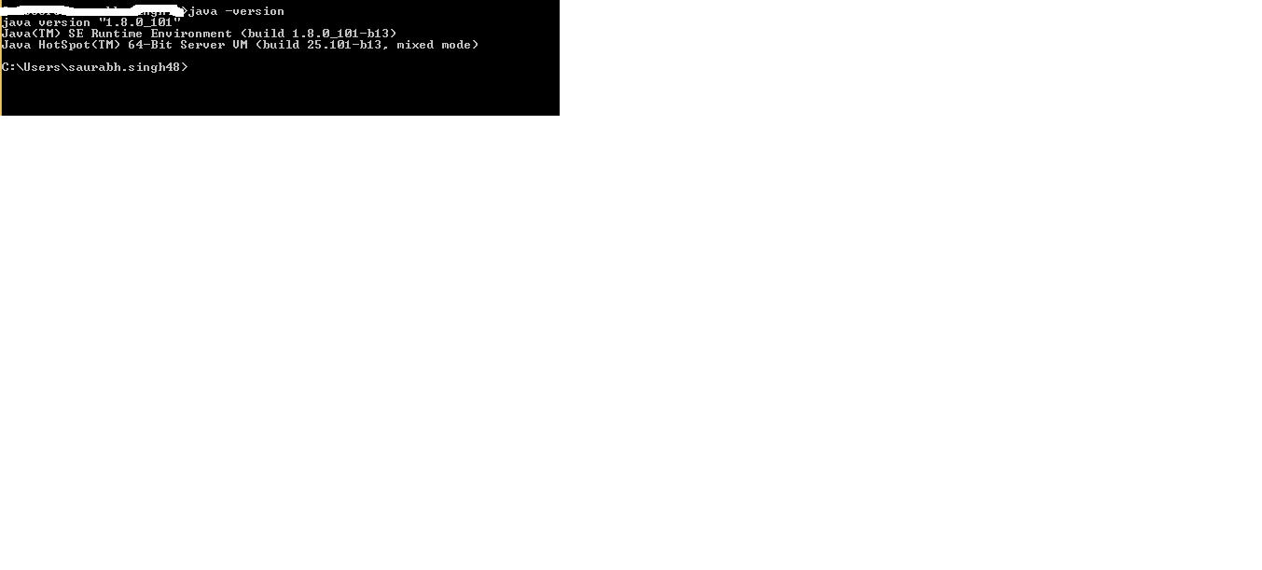

Setup the Maven

Download the maven package from <https://maven.apache.org/> and defined path in the environment variable for maven

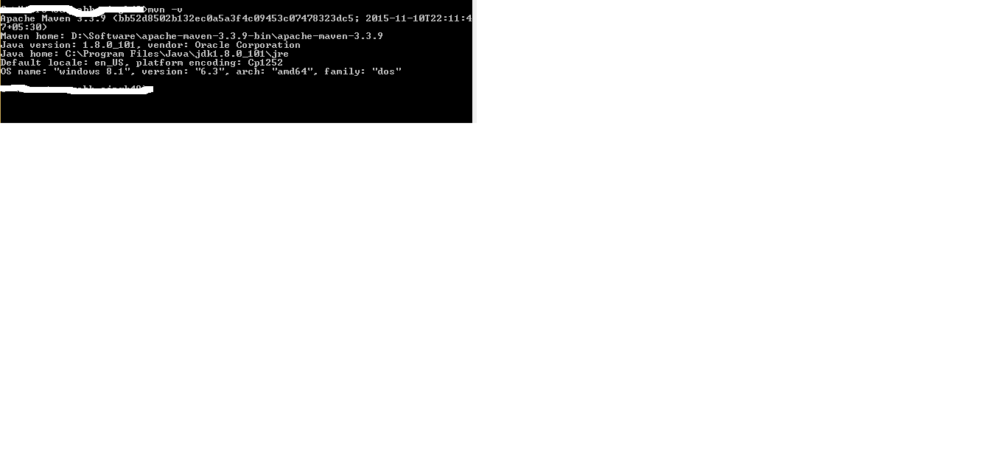

Register in github in <https://github.com>

Click on New Respistory

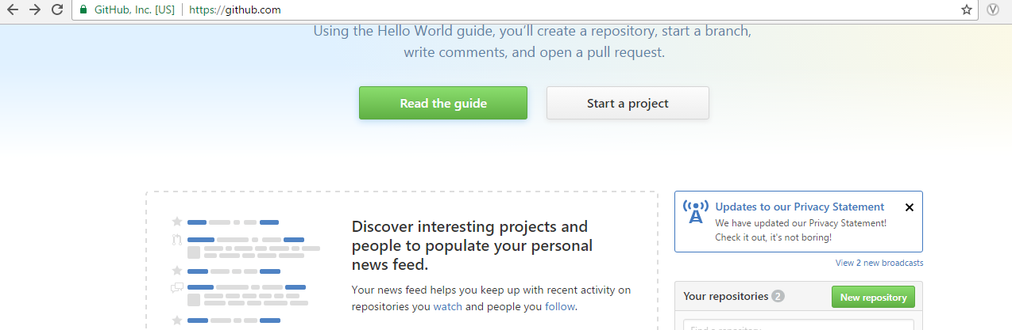

Create a repository where you want to create the application repository i.e. Jenkins_Assisgnment

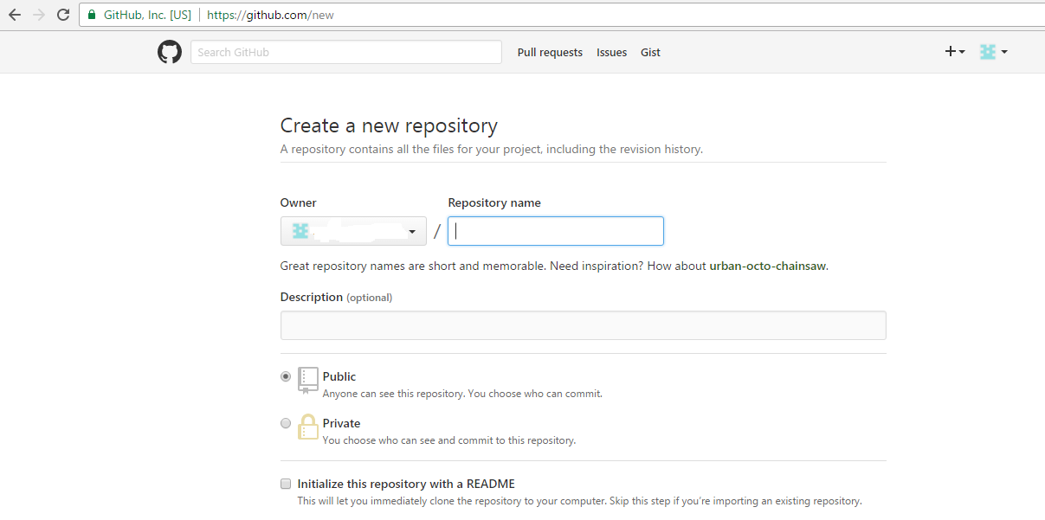

Open Git bash command after setup and clone the repository in the local drive

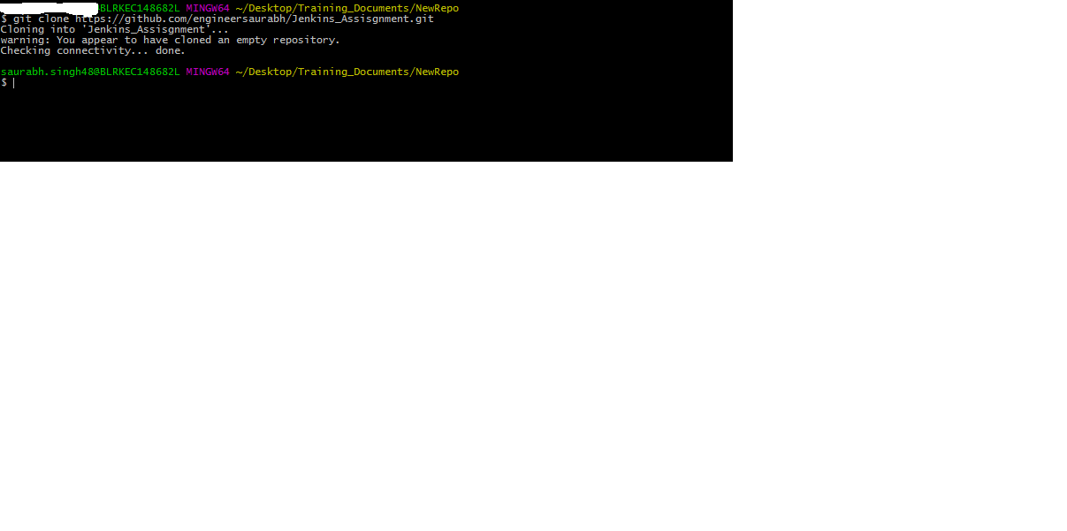

git add .

git commit –m “ this is my Jenkins project “

git push

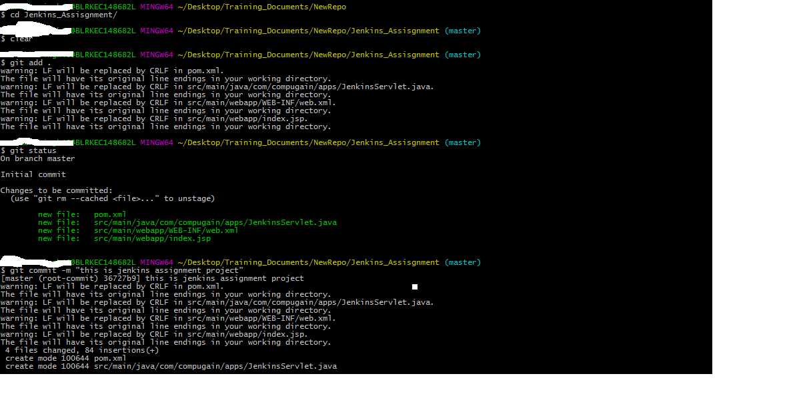

File check-in in the repository

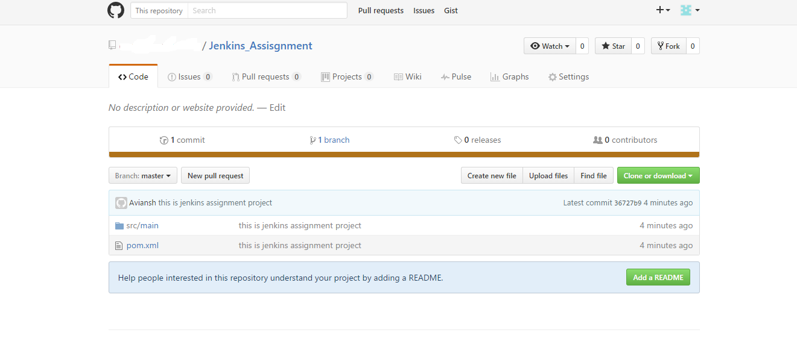

Setup the Jenkins

URL - <https://jenkins.io/>

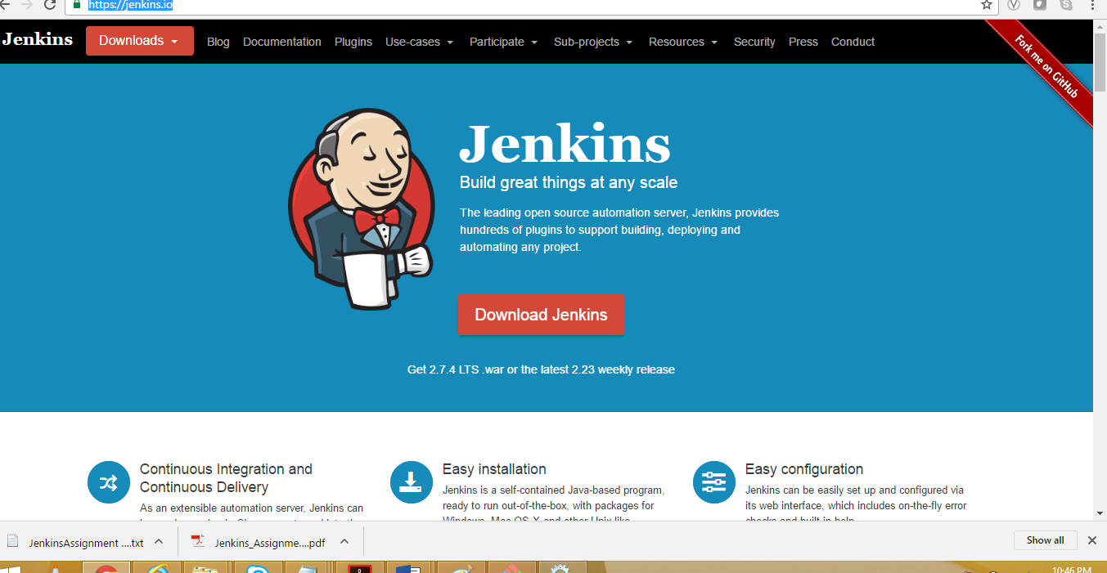

Downloaded the window versions and make the setup on the environment

Setup the Jenkins on the window environment and Jenkins is running as services

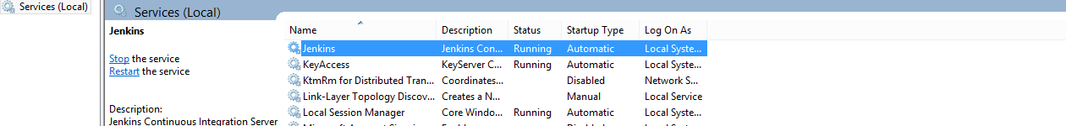

Jenkins Dashboard

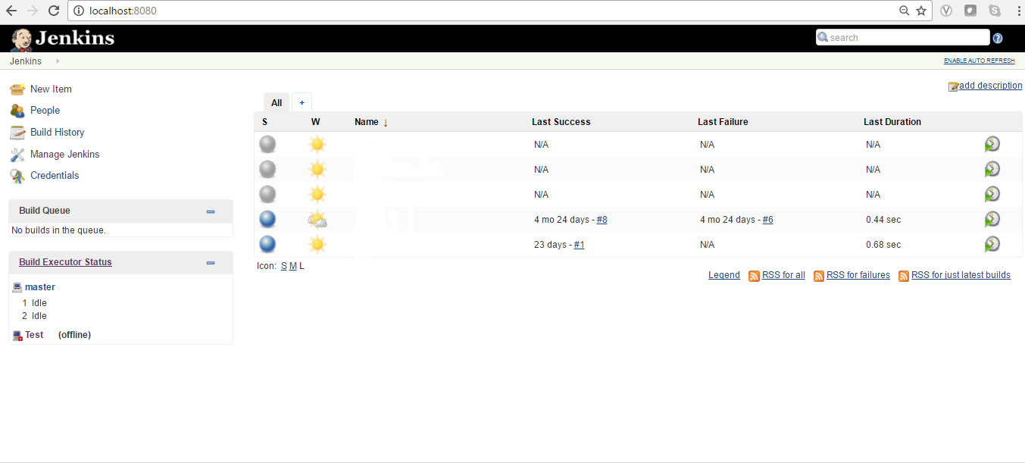

Click on Mange Jenkins for adding the plugin which is required lik egit build and other Jenkins build pipeline workflow plugin

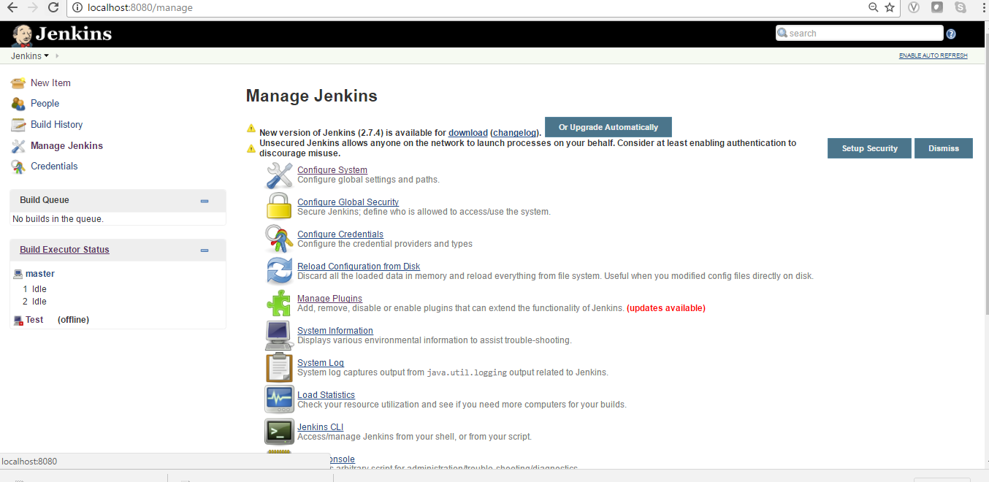

Search for github plugin and add the plugin and restart the jenkins

