**Note: Submit only screenshot of the output**

1. Install NodeJS

Check if node is installed on your machine or not through cmd

Check node and npm version

Solution:

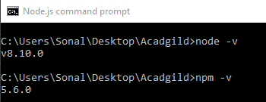

2. Install the IDE Visual studio code

Create a new folder in vs code editor

Create a package.json file using node command

Run the project.

Solution:

1)Create a directory my-app for your new app and navigate into it.

2)Use the ‘npm init’ command to create a package.json file for your app.

3)Press ‘Enter’ to accept default values

4)Observe that ‘package.json’ is created in ‘my-app’ directory. Check its contents

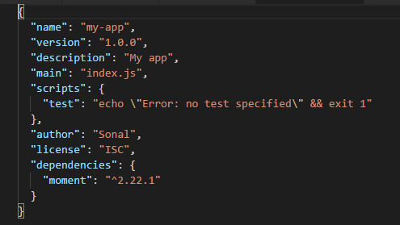

5) As an example, let us install the Moment JavaScript library in the my-app directory

a) --save option adds a ‘dependencies’ entry within package.json and includes a reference to ‘moment’ library.

npm install moment –save

b) To use the library you call the require() function. Add the following code in index.js in the my-app:

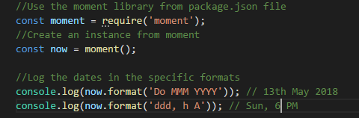

c) For running the app, navigate to the my-app folder and execute ‘node index’ as shown below:

