**Assignment 22: CRUD Operations using POSTMAN**

**Case Study 2: Note_Taking_App**

1. Creating a new Note using POST /notes API

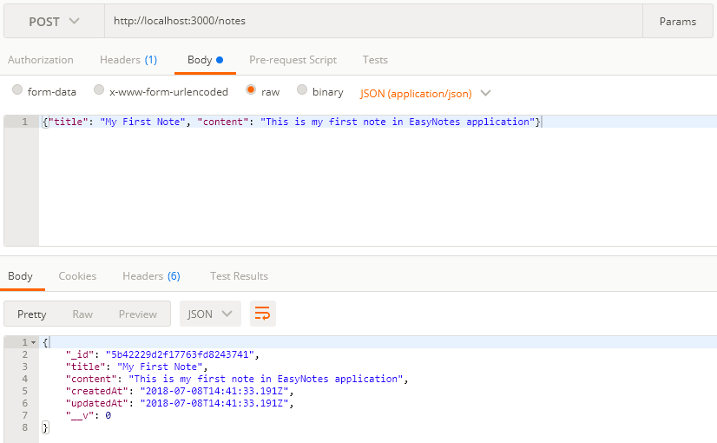

1. Retrieving all Notes using GET /notes API

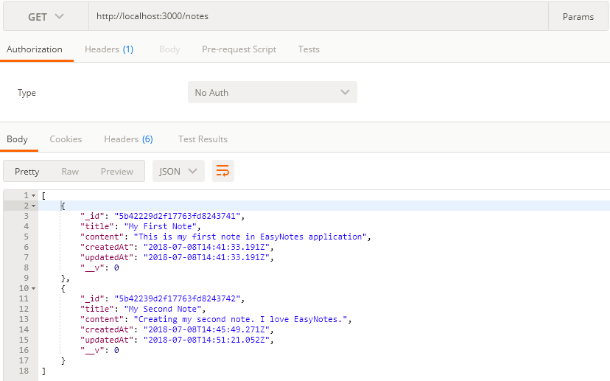

1. Retrieving a single Note using GET /notes/:noteId API

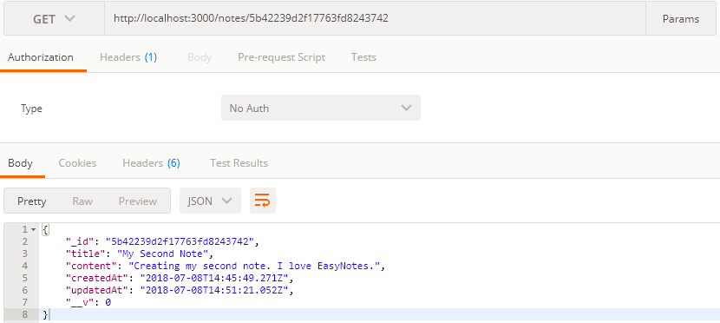

1. Updating a Note using PUT /notes/:noteId API

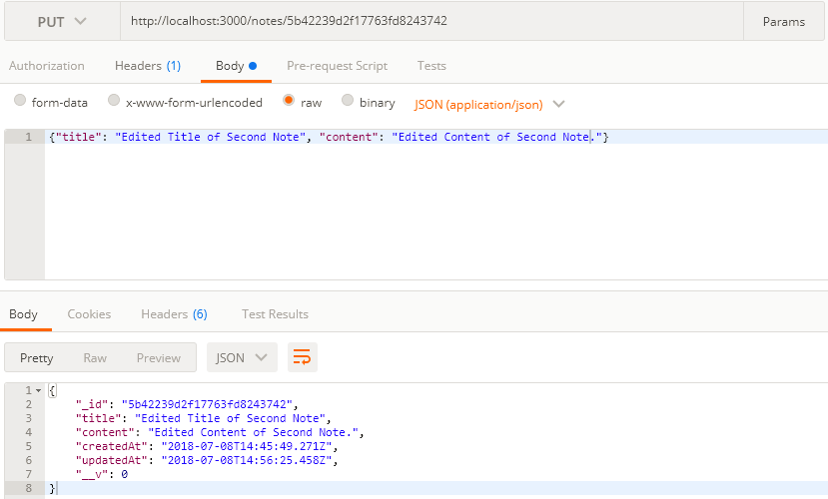

1. Deleting a Note using DELETE /notes/:noteId API

