Aayush Logistics and Order Tracking System
Full Stack Web Application Project Documentation

Group No: 12
Members:
Kshitija Renuke
Chaitanya Awasthi
Sayuj Pillai
Arohi

Technology Stack: React, Node.js, Express.js and MongoDB

1 Project Overview
Aayush Logistics is a full-stack logistics and order tracking system. It helps transport clients book goods deliveries, submit payment details, track shipments with LR numbers, and access delivery documents. The platform also provides an admin dashboard for payment verification, order management, live tracking updates, document management, and client monitoring.

2 Problem Statement
In traditional logistics operations, transport bookings, payment confirmations, shipment updates, and delivery documents are often handled manually through calls and paper records. This makes it difficult for clients to know the current shipment status and for administrators to manage multiple transport orders efficiently.

3 Objectives
- Create a digital platform for transport order booking and management.
- Allow clients to track deliveries using a unique LR number.
- Provide secure role-based access for clients and administrators.
- Enable admin payment verification and automatic LR number generation.
- Maintain delivery documents such as invoices, bills, and delivery receipts.
- Provide real-time or manually updated shipment location tracking using maps.

4 Users and Roles
Role | Main Responsibilities
Client | Register, login, book transport, submit payment details, view orders, track shipments, and download documents.
Admin | View all orders, verify payments, generate LR numbers, assign vehicle and driver, update tracking, upload documents, and manage clients.

5 Complete Project Workflow
The project follows the below end-to-end workflow from a client booking to completed delivery.
Step | Workflow Activity | System Result
1 | Client registers or logs in | Client dashboard is opened.
2 | Client books a transport order | Order is created with Booked status.
3 | Client submits payment reference or screenshot | Payment status becomes Pending Verification.
4 | Admin reviews payment details | Admin verifies or rejects payment.
5 | Admin verifies payment | System generates a unique LR number, for example ALR-2026-0001.
6 | Admin assigns driver and vehicle | Shipment is ready for pickup.
7 | Admin or driver updates shipment status and location | Client can view status timeline and map tracking.
8 | Goods are delivered | Order status changes to Delivered.
9 | Admin uploads invoice or delivery receipt | Client can view and download delivery documents.

6 Order Status Flow
Booked → Payment Verified → Picked Up → In Transit → Delivered
If a payment is not accepted, the payment status changes to Rejected and the client can update payment details.

7 Key Modules
Module | Description
Authentication | Secure registration and login with JWT authentication and bcrypt password hashing.
Client Dashboard | Shows total orders, active shipments, delivered orders, pending payment, and recent orders.
Transport Booking | Collects pickup, delivery, goods, vehicle, and payment details from the client.
Order Management | Allows clients to view their orders and administrators to manage every order.
Payment Verification | Admin verifies payment details and the system generates a unique LR number.
Shipment Tracking | Shows order status timeline, tracking history, current location, and map view.
Document Management | Admin uploads invoice, bill, and delivery receipt; client can view or download them.

8 Technology Stack
Layer | Technologies Used | Purpose
Frontend | React.js, Vite, Tailwind CSS | Responsive user interface and dashboard screens.
Backend | Node.js, Express.js | REST APIs, business logic, authentication, and server handling.
Database | MongoDB, Mongoose | Stores users, orders, tracking history, and document details.
Authentication | JWT, bcrypt | Secures user login and role-based access.
Maps | Leaflet, OpenStreetMap | Displays shipment and delivery location tracking.
File Upload | Multer | Uploads invoices, bills, payment screenshots, and delivery receipts.
Charts | Recharts | Displays dashboard order and shipment statistics.

9 System Architecture
The React frontend communicates with the Express backend through REST APIs. The backend validates JWT tokens, checks user roles, processes business rules such as payment verification and LR number generation, and stores data in MongoDB. Uploaded documents are stored in the uploads folder and served through secure document routes.
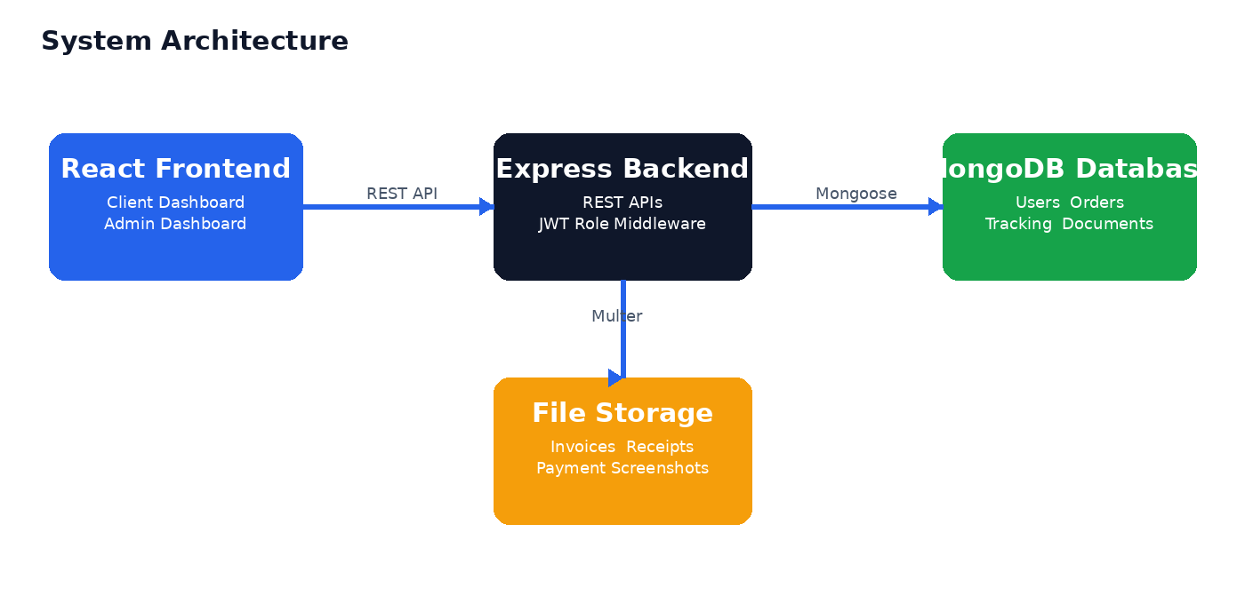
Component | Role in System
React Frontend | Client and admin screens, navigation, forms, maps, charts, and document views.
Express Backend | API routes, controller logic, validation, authentication, and role authorization.
MongoDB Database | Persistent storage for users, orders, tracking updates, and documents.
Uploads Folder | Stores documents and payment screenshots uploaded through the application.

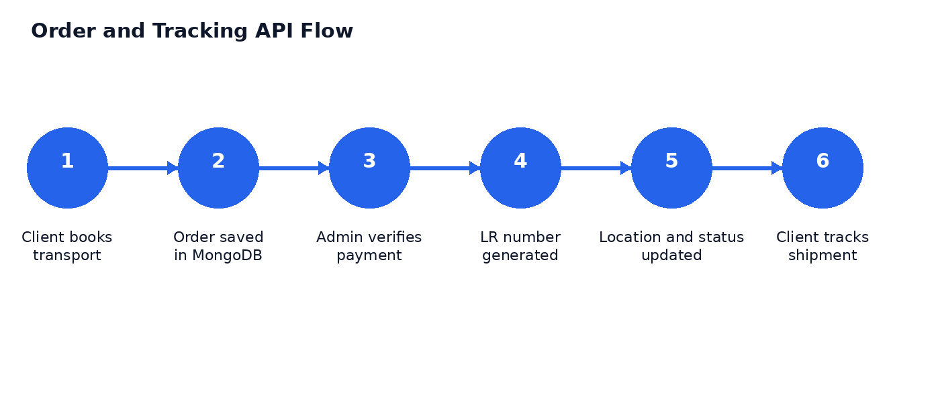

10 Database Collections
Collection | Important Fields
Users | name, email, phone, password, role, createdAt
Orders | clientId, lrNumber, pickupDetails, deliveryDetails, goodsDetails, paymentStatus, shipmentStatus, currentLocation
Tracking Updates | orderId, locationName, latitude, longitude, status, remarks, updatedAt
Documents | orderId, documentType, fileName, fileUrl, uploadedAt

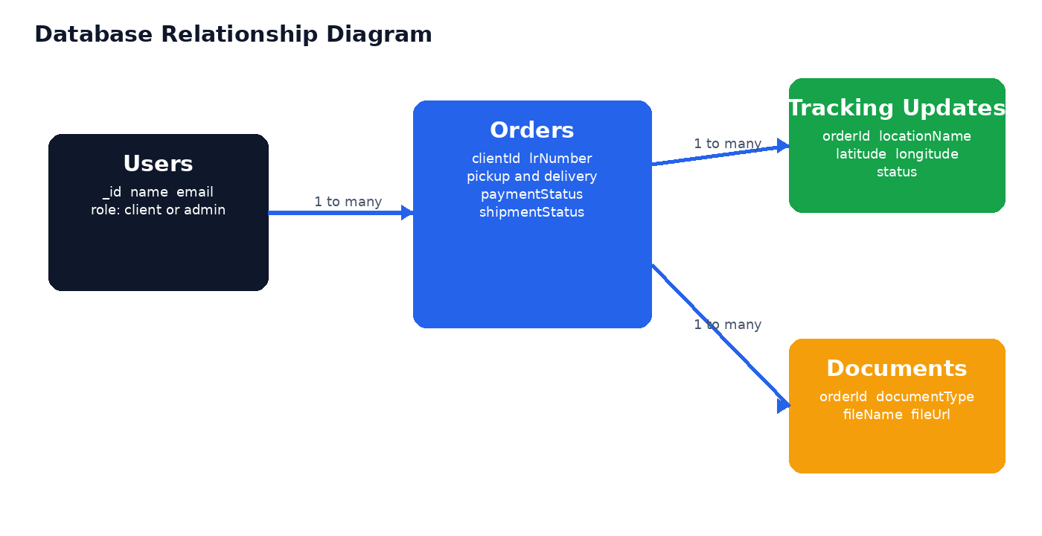

11 Main API Modules
Module | Main API Actions
Authentication | Register user, login user, fetch current user details
Orders | Create order, view orders, view order details, update order, update status, track by LR number
Payments | View pending payments, verify payment, reject payment
Tracking | Add tracking update and view tracking history
Documents | Upload document, view documents, download document, delete document
Statistics | Fetch admin dashboard statistics and client dashboard statistics

12 Installation and Run Steps

Backend Setup
- cd backend
- npm install
- cp .env.example .env
- npm run seed
- npm run dev
Backend environment example: PORT=3000, MONGO_URI=mongodb://127.0.0.1:27017/aayush_logistics, JWT_SECRET=aayush_logistics_secret_2026

Frontend Setup
- cd frontend
- npm install
- cp .env.example .env
- npm run dev
Frontend environment example: VITE_API_URL=http://localhost:3000/api

13 Demo Login Credentials
User Type | Email | Password
Admin | admin@aayushlogistics.com | admin123
Client | kshitija@example.com | client123
Client | rohan@example.com | client123

14 Output and Result
The project successfully provides separate client and admin portals. A client can book and track a shipment, while an admin can verify payment, generate an LR number, update delivery progress, and upload final documents. The dashboard, tracking records, payment management, and document system are connected to the local MongoDB database through the Express backend.

15 Future Scope
- Integrate a real online payment gateway.
- Add GPS tracking from a dedicated driver mobile application.
- Add email and SMS notifications for shipment status updates.
- Move document storage to Cloudinary or another cloud storage service.
- Deploy the frontend and backend using Vercel and Render for public access.

16 Conclusion
Aayush Logistics digitizes the core workflow of a transport business. It improves transparency for clients through order tracking and provides administrators with one platform for payment verification, delivery updates, document management, and client records.

